EGI-InSPIRE

Training Web site

EU DELIVERABLE: M302

Document identifier: | input.doc
Date: | 27/07/2010
Activity: | NA3
Lead Partner: | University of Edinburgh
Document Status: | DRAFT
Dissemination Level: | Confidential
Document Link:

Abstract
xxxxxx

Copyright notice:
Copyright © Members of the EGI-InSPIRE Collaboration, 2010. See www.egi.eu for details of the EGI-InSPIRE project and the collaboration.
EGI-InSPIRE (“European Grid Initiative: Integrated Sustainable Pan-European Infrastructure for Researchers in Europe”) is a project co-funded by the European Commission as an Integrated Infrastructure Initiative within the 7th Framework Programme. EGI-InSPIRE began in May 2010 and will run for 4 years.
This work is licensed under the Creative Commons Attribution-Noncommercial 3.0 License. To view a copy of this license, visit http://creativecommons.org/licenses/by-nc/3.0/ or send a letter to Creative Commons, 171 Second Street, Suite 300, San Francisco, California, 94105, USA. The work must be attributed by attaching the following reference to the copied elements: “Copyright © Members of the EGI-InSPIRE Collaboration, 2010. See www.egi.eu for details of the EGI-InSPIRE project and the collaboration”.
Using this document in a way and/or for purposes not foreseen in the license, requires the prior written permission of the copyright holders.
The information contained in this document represents the views of the copyright holders as of the date such views are published.

Delivery Slip
 | Name | Partner/Activity | Date
From | Dr David Fergusson | UEDIN NA3 | 27/7/10
Reviewed by | Moderator:  Reviewers:
Approved by | AMB & PMB

Document Log
Issue | Date | Comment | Author/Partner
1.0 | 27/7/10 | First draft | Dr David Fergusson/UEDIN
2.0
3.0
4.0

SUMMARY

Table of contents
1. Introduction 4
1.1. Purpose 4
1.2. Application area 4
1.3. References 4
1.4. Document amendment procedure 4
1.5. Terminology 4
2. EXECUTIVE SUMMARY 5
3. Web site training services 6
3.1. Migration of user interfaces 6
3.1.1. ARCHITECTURE REVISION: 6
3.1.2. MODULARISATION: 7
3.1.3. IMPLEMENTATION 7
3.2. Training Events 8
3.3. Training Materials 9
3.4. Trainers Information 10
3.5. Contacts and Input forms 12
4. Conclusions 14

Introduction

Purpose
This document describes the migration of training support services into the EGI web site.

Application area
This document is a formal deliverable for the European Commission, applicable to all members of the EGI-InSPIRE project, beneficiaries and Joint Research Unit members, as well as its collaborating projects.

References
Table 1: Table of references

R 1
R 2
R 3
R 4
R 5

Document amendment procedure
Amendments, comments and suggestions should be sent to the authors. The procedures documented in the EGI-InSPIRE “Document Management Procedure” will be followed:
https://wiki.egi.eu/wiki/Procedures

Terminology
A complete project glossary is provided in the EGI-InSPIRE glossary:
http://www.egi.eu/results/glossary/.

EXECUTIVE SUMMARY
The EGEE training support services have been migrated from the EGEE web site to the EGI web site. In order to support this process, and to make the services robust to expected short term modifications to the EGI web site, the front-ends for the services have been minimally re-factored during the migration process.

Web site training services
The EGEE web site hosted a number of services aimed at supporting cooperation between trainers in different localities these included:

1. Training events list
– this allows trainers to advertise their training events and to be made aware of other training events being run. It also provides potential attendees with information about events within their local area and globally.

2. Training Materials
- this repository provides access to a digital library which holds all forms of training related materials. This acts as a resource allowing trainers to share, find and re-purpose materials

3. Trainers information
- this holds information about trainers across the EGI area. Allowing trainers to contact each other and solicit expertise to help support training.

These services were migrated to the EGI web site, providing the same functionality as under EGEE.

Migration of user interfaces
As the services have been built as loosely coupled user interfaces (clients) and data sources (servers) the main work carried out was on migrating the user interfaces. The servers provide feeds and search in a number of formats.
Some modification of the front-ends of the services was required in order to change branding from EGEE to EGI and to integrate the services in the EGI web site, as the site structure is slightly modified.
As the services have grown organically over the 6 years of the 3 EGEE projects there was some build up of legacy code and structures within the existing front-ends. In order to allow the migration to proceed some degree of re-factoring of the front-ends was required. This focussed on modularising the components (to improve re-use and consistency within the code) and concomitantly separation of the data and presentation components of the code. This was necessary to avoid issues with the propagation of re-branding within the site and to some degree resulted from the build-up of succeeding EGEE styling revisions (CSS sheets) in the past.
During the process of gathering requirements for the migration process it also became clear that the whole EGI web site is likely to undergo further re-branding in the short term (3 – 6 months). It was therefore important to make sure that during the migration process the migrated code was modularised to allow a simplification of the expected future re-brandings.

ARCHITECTURE REVISION:
- Removed inline database queries and styling from old site code.
- Removed table based layouts from old site code
- The site still uses the existing database tables from previous projects to ensure there is no loss of data. Any updates to old sites should filter through to the new egi site.

Separate site into
- Theme folder: theme specific images and libraries (css, javascript etc..).
- Global includes: config, default files: css, Javascipt, images, global library of reusable server side functions (components
- Sub folders to contain imported code or imported frameworks that can be upgraded independently. Eg Trainer sections and Digital library front-end.

MODULARISATION:
- Created a library of reusable server side functions (components) that can return raw data, be it database queries, validation objects or webservices without any formatting.
- Removed forms and other smaller web page components to a generic includes folder so they can be managed in a container that is not styled and can be reused across the site where needed.
- Created a single config file to hold site wide variables such as contact emails, web developer email, site theme (skin) and references to relevant databases. This is included in ColdFusion’s Application.cfc file which is a global handler anyway but having this should make it easier for someone who is not a ColdFusion programmer to set or, more importantly, change simple global variables without interfering with anything too technical.

IMPLEMENTATION
- Create a new front end to browse events. This is cleaner and quicker than egee.nesc, the validation and error handling has been greatly improved and is also more secure.
- Integrate greater use of Ajax requests to both local server and remote objects to improve performance.
- Utilise jQuery javascript framework, extensions and UI’s such as a calendar to improve usability and reduce the size and complexity of web forms.
- Ported relevant content from egee.nesc (events section and web forms), iceage (trainer section) and digital library stand alone front end module.

The user interfaces are all implemented as ColdFusion scripts and exported as HTML into the EGI web site. The site can be accessed at: http://training.egi.eu/

The various training support services are accessible through a menu structure from the top menu bar of the EGI site (see figure 1 below).

Figure 1 Training Web site menu structure
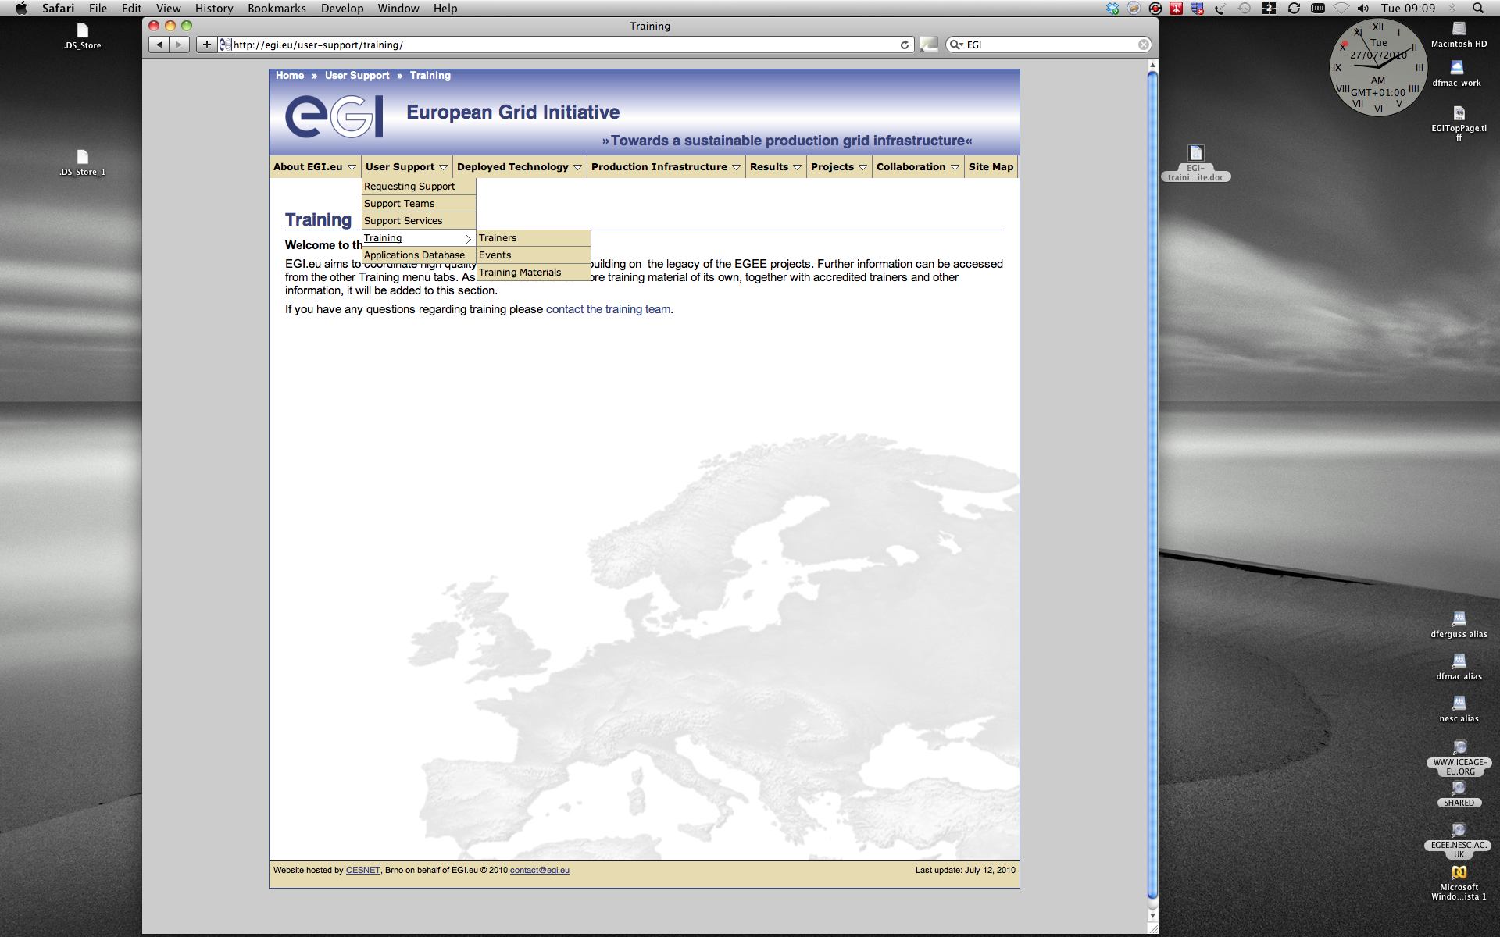

Training Events
The Training events service is accessible at: http://training.egi.eu/index.cfm
The event data is held in a SQLServer database and accessed through ColdFusion SQL queries. All events are moderated before being made visible to the public.
The events are presented as a reverse chronology (most recent first) browse-able list. A search facility allowing search by title or date is also available.
(see figure 2)

Figure 2 Training Event listing
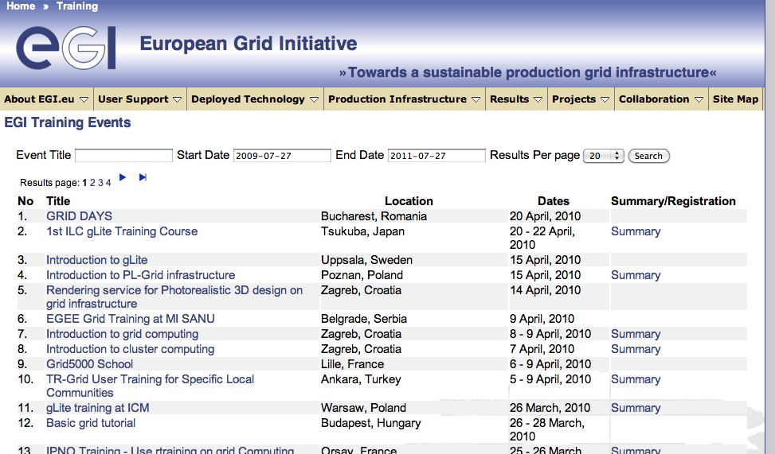

Training Materials
EGI Training materials site is available at: http://training.egi.eu/material/index.cfm
The training materials data is held in a Fedora (http://www.fedora-commons.org/) based digital library. Fedora is a well adopted open source standard digital library implementation.
Further details of the library structure and implementation can be found in EGEE and ICEAGE project deliverables.
The training materials in the EGI training web site are presented as a browse-able list with a free text search facility, which can search within all documents held, a tag cloud of the types of materials held (video, audio, slides, etc) and a tag cloud of the subjects of records in the library.
(see figure 3)

Figure 3 Training materials list


Trainers Information
The EGI Trainers information site is available at: http://training.egi.eu/trainers/index.cfm
The trainers data is held in a SQLServer database and accessed through ColdFusion SQL queries
The trainer information is derived from the trainer certification process of EGEE 3. The information is presented as a browse-able list with a free text search facility.
(see figure 4)

For each trainer there is also a drill-down facility to allow more information to be accessed.
(see figure 5)

Figure 4 Trainer information list
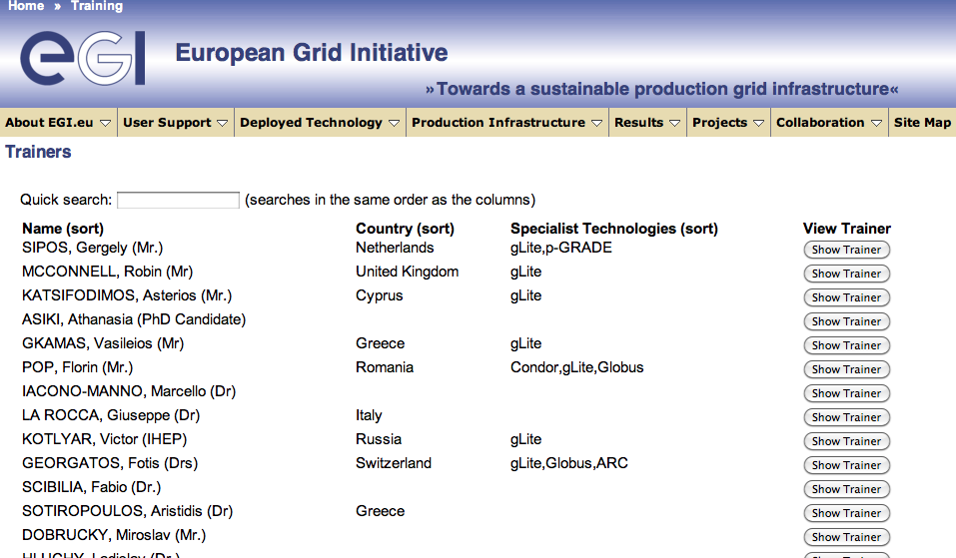

Figure 5 Example trainer information drill-down
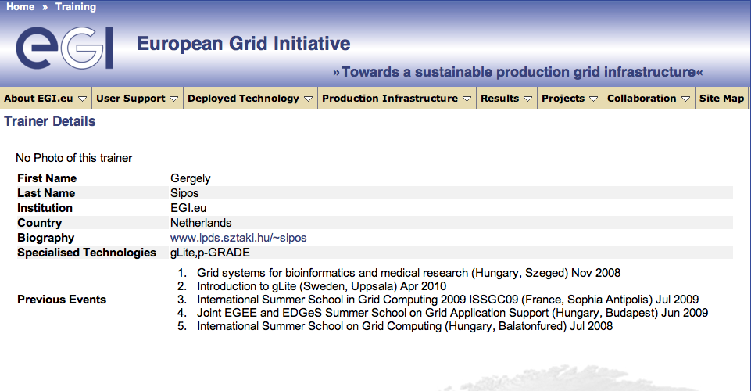

Contacts and Input forms
Contact and input forms are available at: http://training.egi.eu/contact.cfm

A web form providing an email facility to allow users to contact the EGI training activity has been provided (see figure 6).

Figure 6 Contact Form
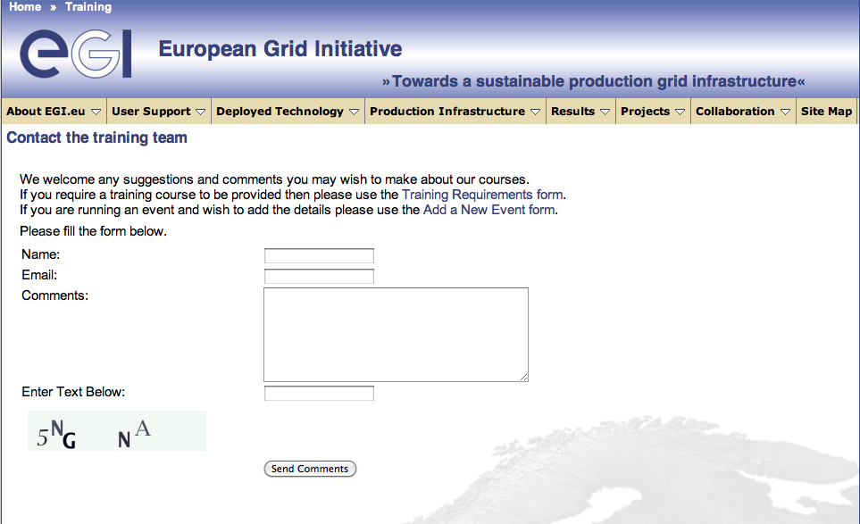

From this page forms to provide training requirements and to allow input of new training events can be accessed (see figure 6).

Figure 7 Training request form


Figure 7 shows the training request form. This form generates and email request to a generic email list (currently a EGEE training activity based list).

Figure 8 Training event input form
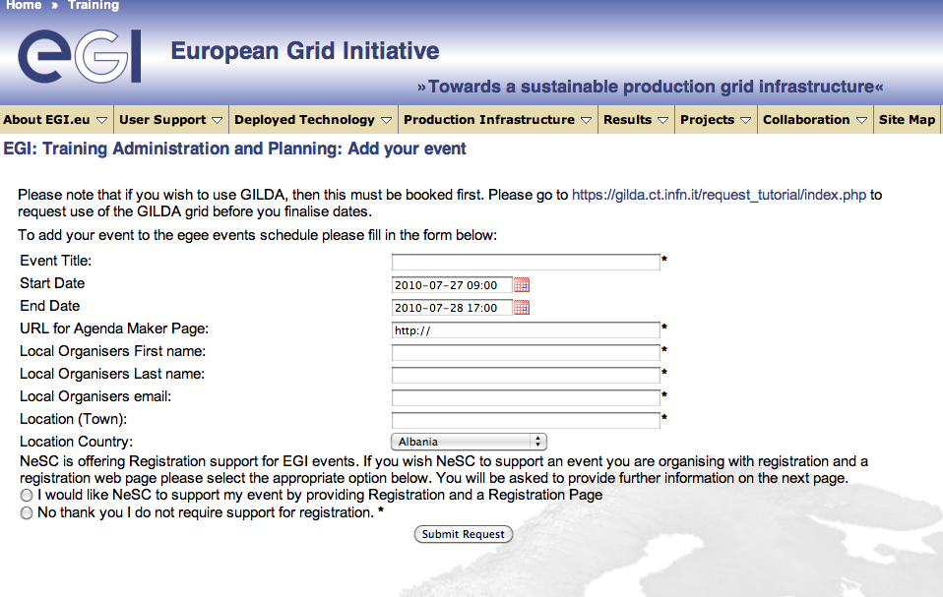

The training event input form (see figure 8) allows the input of new training events. These are immediately added to the SQLServer database but are not made visible in the training event list until they have been manually moderated, that is their status changed in the databse.

Conclusions
The EGEE training support services have been migrated from the EGEE web site to the EGI web site. In order to support this process, and to make the services robust to expected short term modifications to the EGI web site, the front-ends for the services have been minimally re-factored during the migration process.

