EGI-InSPIRE

Training Web site

EU MILESTONE: MS302

Document identifier: | EGI-M.302-V3WebSite-DF-revised-XXX2
Date: | 06/08/2010
Activity: | NA3
Lead Partner: | University of Edinburgh
Document Status: | DRAFT
Dissemination Level: | Confidential
Document Link:

Abstract
The EGEE training support services have been migrated from the EGEE web site to the EGI.eu web site. In order to support this process, and to make the services robust to expected short-term modifications to the EGI web site, the front-ends for the services have been minimally re-factored during the migration process.

Copyright notice:
Copyright © Members of the EGI-InSPIRE Collaboration, 2010. See www.egi.eu for details of the EGI-InSPIRE project and the collaboration.
EGI-InSPIRE (“European Grid Initiative: Integrated Sustainable Pan-European Infrastructure for Researchers in Europe”) is a project co-funded by the European Commission as an Integrated Infrastructure Initiative within the 7th Framework Programme. EGI-InSPIRE began in May 2010 and will run for 4 years.
This work is licensed under the Creative Commons Attribution-Noncommercial 3.0 License. To view a copy of this license, visit http://creativecommons.org/licenses/by-nc/3.0/ or send a letter to Creative Commons, 171 Second Street, Suite 300, San Francisco, California, 94105, USA. The work must be attributed by attaching the following reference to the copied elements: “Copyright © Members of the EGI-InSPIRE Collaboration, 2010. See www.egi.eu for details of the EGI-InSPIRE project and the collaboration”.
Using this document in a way and/or for purposes not foreseen in the license, requires the prior written permission of the copyright holders.
The information contained in this document represents the views of the copyright holders as of the date such views are published.

Delivery Slip
 | Name | Partner/Activity | Date
From | Dr David Fergusson | UEDIN NA3 | 27/7/10
Reviewed by | Moderator:  Reviewers:
Approved by | AMB & PMB

Document Log
Issue | Date | Comment | Author/Partner
1.0 | 27/7/10 | First draft | Dr David Fergusson/UEDIN
2.0 | 6/7/10 | 2nd draft in response to reviewers comments. | Dr David Fergusson/UEDIN
3.0
4.0

- Contents
2 Introduction 4
2.1 Purpose 4
2.2 Application area 4
2.3 References 4
2.4 Document amendment procedure 4
2.5 Terminology 4
3 Executive Summary 5
4 Forseen Work 6
4.1 Web site training services 6
4.2 Migration of user interfaces 6
4.3 Architecture Revisions 6
4.3.1 Modularisation 7
4.3.2 Implementation 7
4.3.3 ColdFusion 8 Application Server. 9
4.3.4 SQL Server Database. 9
5 Porting different sections of the website 10
5.1 Digital library / Training Materials: 10
5.2 Trainers Section 10
5.3 Events 10
6 EGI Training web site interface 12
6.1 Training Events 12
6.2 Training Materials 13
6.3 Trainers Information 14
6.4 Contacts and Input forms 15
7 Conclusions 19

Introduction

Purpose
This document describes the migration of training support services into the EGI.eu web site.

Application area
This document is a formal deliverable for the European Commission, applicable to all members of the EGI-InSPIRE project, beneficiaries and Joint Research Unit members, as well as its collaborating projects.

References
Table 1: Table of references

R 1
R 2
R 3
R 4
R 5

Document amendment procedure
Amendments, comments and suggestions should be sent to the authors. The procedures documented in the EGI-InSPIRE “Document Management Procedure” will be followed:
https://wiki.egi.eu/wiki/Procedures

Terminology
A complete project glossary is provided in the EGI-InSPIRE glossary:
http://www.egi.eu/results/glossary/.

Executive Summary
The EGEE training support services (a registry of training services, trainers’ registry, and calendar of training events) have been migrated from the EGEE web site to the EGI.eu web site. In order to support this process, and to make the services robust to the expected short term modifications needed to integrate them into the EGI.eu web site, the front-ends for the services have been minimally re-factored during the migration process.

Forseen Work

Web site training services
The EGEE web site hosted a number of services aimed at supporting cooperation between trainers in different localities these included:
1. Training events list: This allows trainers to advertise their training events and to be made aware of other training events being run within the community. It also provides potential attendees with information about events within their local area and globally.
2. Training Materials: This repository provides access to a digital library which holds all forms of training related materials. This acts as a resource allowing trainers to share, find and re-purpose materials
3. Trainers information: This holds information about trainers across the EGI area. Allowing trainers to contact each other and solicit expertise to help support their training activities.
At the start of the EGI-InSPIRE project these services were migrated to the EGI.eu web domain, providing the same functionality as they did under EGEE.

Migration of user interfaces
As these training services have been built as loosely coupled user interfaces (clients) and data sources (servers) the main work carried out was on migrating the user interfaces. The servers provide feeds in a number of formats and support a number of different searches. Some modification of the front-ends of the services was required in order to change branding from EGEE to EGI.eu and to integrate the services into the EGI.eu web site, as the site structure is slightly different.
As the services have grown organically over the 6 years of the three EGEE projects there was some build-up of legacy code and structures within the existing front-ends. In order to allow the migration to proceed some degree of re-factoring of the front-ends was required to streamline the code. This focussed on modularising the components (to improve re-use and consistency within the code) and concurrently separation of the data and presentation components of the code. This was necessary to avoid issues with the propagation of the re-branding within the site and to some degree resulted from the build-up of succeeding EGEE styling revisions (CSS sheets) in the past.
During the gathering of requirements for the migration it also became clear that the whole EGI.eu web site is likely to undergo further re-branding in the short term (3 – 6 months). It was therefore important to make sure that during the migration process the migrated code was modularised to allow a simplification of the expected future re-branding activity.

Architecture Revisions
The following architectural revisions were made resulting in the system architecture shown in Figure 1:
- Removal of the inline database queries and styling from the old site code.
- Removal of the table based layouts from the old site code
- The site still uses the existing database tables from previous projects to ensure there is no loss of data. Any updates to the old sites should filter through to the new EGI.eu site.

The internal structure of the web application was separated into:
- Theme folder: theme specific images and libraries (CSS, Javascript etc.).
- Global includes: config, default files: CSS, Javascipt, images, global library of reusable server side functions (components
- Sub folders to contain imported code or imported frameworks that can be upgraded independently, e.g. Trainer sections and Digital library front-end.

Modularisation
The migration has resulted in the following modularisation activities:
- A library of reusable server side functions (components) have been created that can return raw data, be it database queries, validation objects or web services without any formatting.
- Forms and other smaller web page components have been moved to a generic includes folder so they can be managed in a container that is not styled and can be reused across the site where needed.
- A single config file has been created to hold site wide variables such as contact emails, web developer email, site theme (skin) and references to relevant databases. This is included in ColdFusion’s Application.cfc file which is a global handler anyway but having this should make it easier for someone who is not a ColdFusion programmer to set or, more importantly, change simple global variables without in depth technical knowledge.

Implementation
The migration has resulted in the following implementation changes:
- A new front end has been created to browse training events. This is cleaner and quicker than the previous design and the validation and error handling has been greatly improved.
- Greater use of Ajax requests to both local server and remote objects to improve performance.
- Utilisation of the jQuery Javascript framework, extensions and UI’s such as a calendar to improve usability and reduce the size and complexity of the web forms.
- Ported relevant content from egee.nesc (events section and web forms), ICEAGE (trainer section) and Digital Library standalone front end module.
The user interfaces are all implemented as ColdFusion scripts and exported as HTML into the EGI.eu web site. The site can be accessed at: http://training.egi.eu/
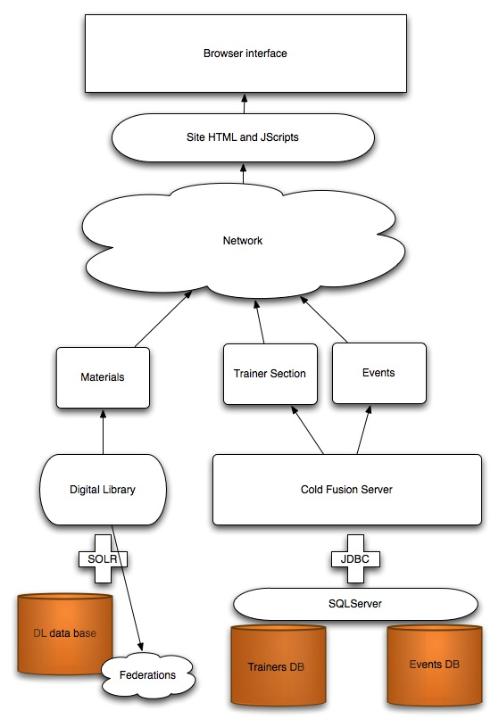
Figure 1: Training Services Architecture

ColdFusion 8 Application Server.
NESC invested in, and upgraded to, a new version of ColdFusion (to version 8 from 6.1) and has leveraged a number of new features of that service that improve both performance and security.
Security is improved due to form and URL validation by enhancing or rewriting existing code, and the abstraction of code to more reusable ColdFusion components (cfc’s). Inline database queries and other functions have been abstracted out to ColdFusion components (cfc’s) which afford an extra level of protection as they cannot be accessed directly in the browser. Reusing these components means that changes, validation and enhancements can now be affected site wide from single files. ColdFusion instantiates these components when the web Application starts and holds these in cache so there is a substantial increase in performance as well.

SQL Server Database.
No major change needed to the “model” in our MVC framework.

Porting different sections of the website

Digital library / Training Materials:
The digital library, located at http://library.nesc.ed.ac.uk:8080/ runs Apache SOLR on Fedora. There is an existing front end at the above URL but that is not styled for EGI “nor are there the resources to continually create new front ends for this service.”
The recently created reusable, “custom” integration uses a jQuery based, minimally styled Javascript façade that can be dropped into any existing web template whilst still, asynchronously, leveraging the powerful faceted search features of SOLR.
In this instance, the created search “module” lives in its own separate directory under the web root and leverages ColdFusion to provide a web template only.

Trainers Section
The trainers section also uses a JavaScript façade (Adobe Spry in this instance) but this relies on ColdFusion’s connection to the existing SQL Server database to provide the data.
It is worth mentioning here that this service was conceived and implemented in the last 12 months of the EGEE-III project has scope to be further developed and expanded as a resource to the community. Its initial implementation was under an ICEAGE URL but the database is held separately within a “Person Registry” with which is currently underutilised. With some minor tweaking could become a very valuable resource for the future as it contains not only information about existing trainers but also, almost 800, students who have applied for, and/or attended schools, workshops and grid computing related events under ICEAGE and EGEE projects.

Events
Of all the sections this has taken the most work to port over even though the resulting “façade” may “seem” very similar to previous incarnations. The main work was that inline database queries and functions be abstracted to, site wide, reusable components, e.g. a reusable, simple function like: getEvents (arguments).
The old mixture of table based and subsequent CSS based, page layouts has all been integrated and replaced with CSS based equivalents. This will allow easier, global restyling and separates the presentation layer and business layer to allow easier integration future projects.
As a result the web pages have been broken down into reusable components that do not require full page styling to exist. For example, web forms (including validation), menus/ site navigation, global variables (project ID, project name, contact details etc…) are all extracted into single, reusable instances. This has nothing against previous developers practices, merely a reflection of current trends, and continuing practice with any well maintained system, towards building and extending web applications with the most modular and reusable architecture available.
An example that highlights the above would be the “Add an Event Page” (addEvent.cfm) which on the previous EGEE site was spread across three different web pages and involved well over 1,500 lines of code. The current incarnation, employing the features outlined above namely:
- ColdFusion 8 enhancements,
- abstraction of functions,
- separating logic and
- separating presentation
has reduced this to a single page of only 260 lines of code which can easily be restyled or redeployed.

Finally, it would appear that Adobe seems to be actively moving ColdFusion more and more into the Service Layer of the web application tier making it a valuable resource for multiple front ends, both locally and remotely. As an ongoing resource and with such a valuable data source, the training section could benefit from further investment to support and enhance these features as an ongoing concern.

EGI Training web site interface
The various training support services are accessible through a menu structure from the top menu bar of the EGI.eu site See Figure 1 below.

Figure 1 Training Web site menu structure
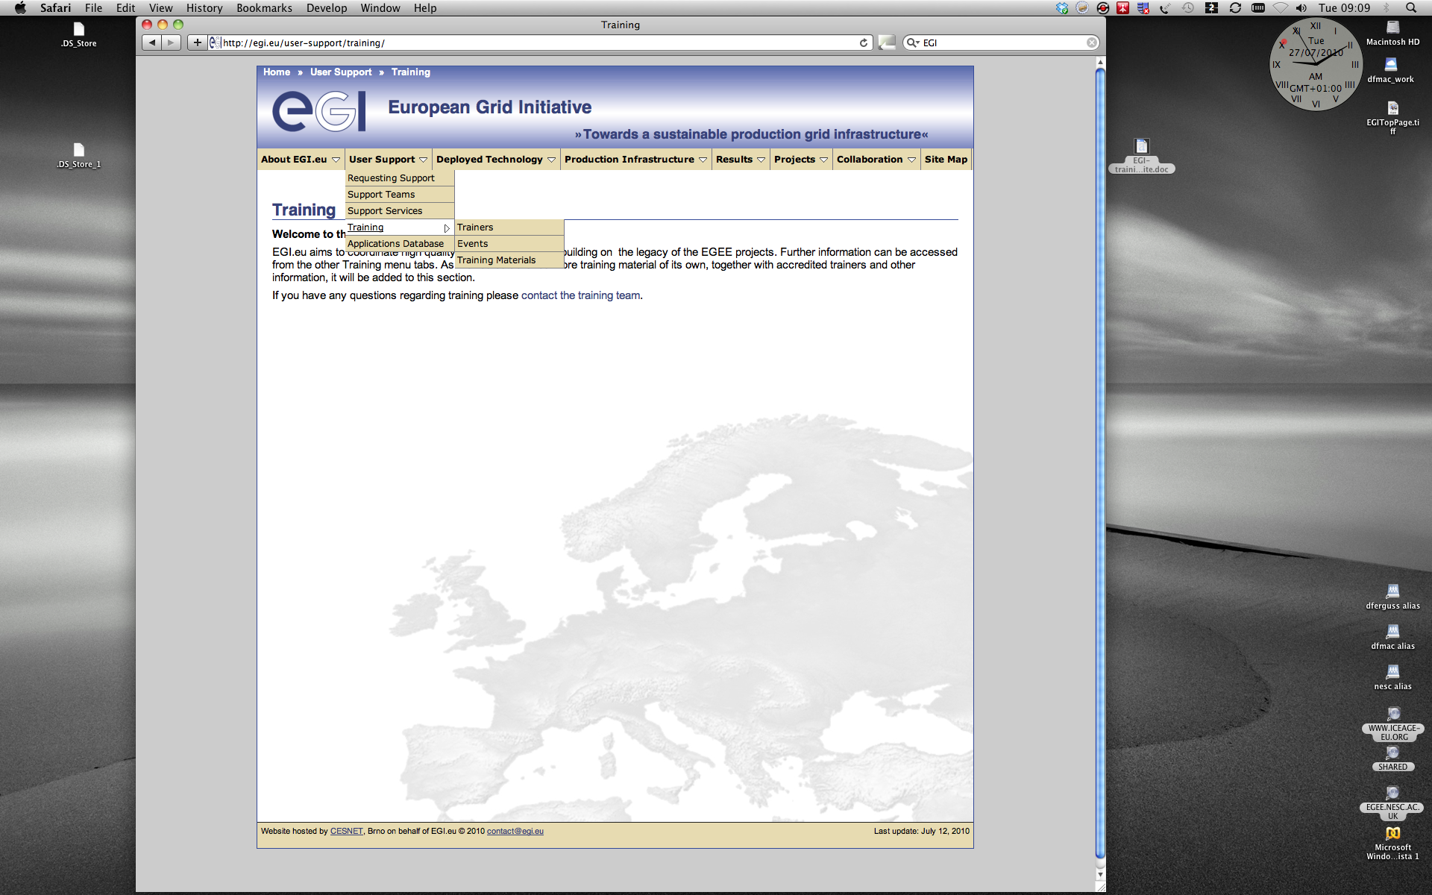

Training Events
The Training events service is accessible at: http://training.egi.eu/index.cfm
The event data is held in a SQLServer database and accessed through ColdFusion SQL queries. All events are moderated before being made visible to the public.
The events are presented as a reverse chronology (most recent first) browse-able list. A search facility allowing search by title or date is also available. See Figure 2.

Figure 2 Training Event listing
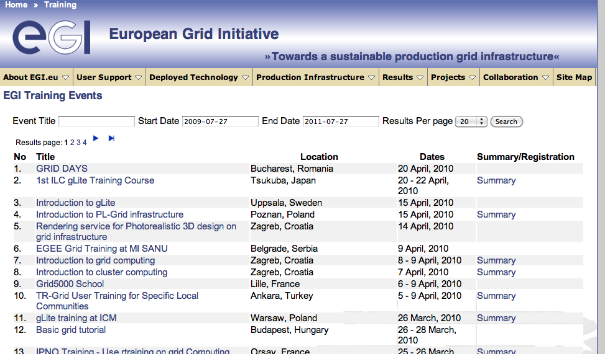

Training Materials
EGI Training materials site is available at: http://training.egi.eu/material/index.cfm. The training materials data is held in a Fedora (http://www.fedora-commons.org/) based digital library. Fedora is a well adopted open source standard digital library implementation. Further details of the library structure and implementation can be found in EGEE and ICEAGE project deliverables.
The training materials in the EGI training web site are presented as a browse-able list with a free text search facility, which can search within all documents held, a tag cloud of the types of materials held (video, audio, slides, etc.) and a tag cloud of the subjects of records in the library. See Figure 3.

Figure 3 Training materials list
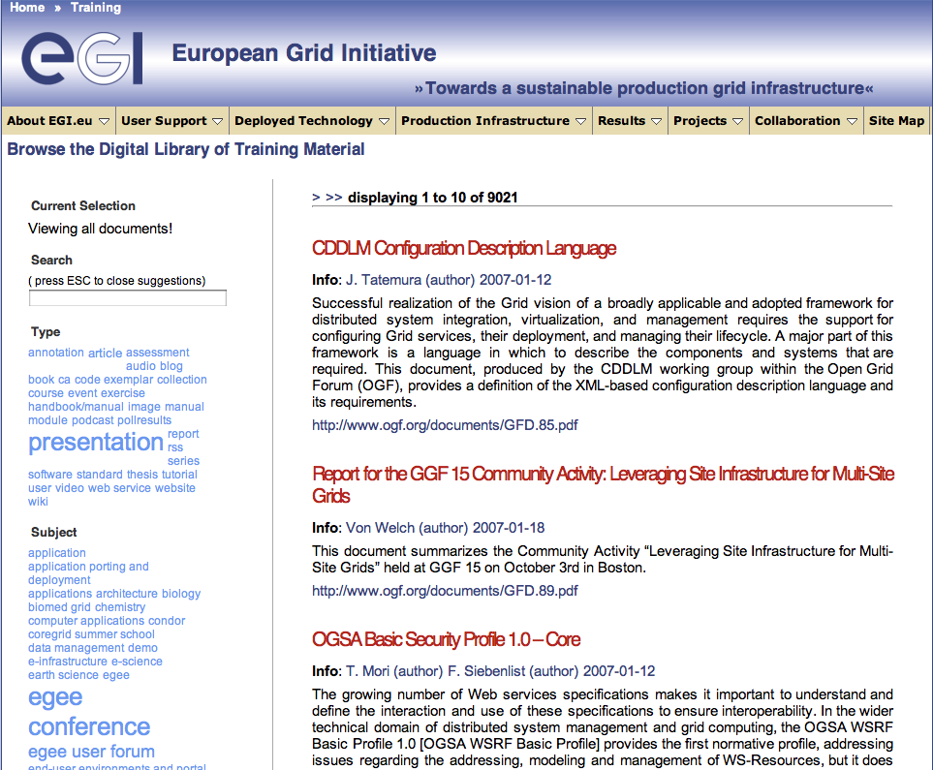

Trainers Information
The EGI Trainers information site is available at: http://training.egi.eu/trainers/index.cfm. The accreditation procedure is outlined in the EGI document at: https://documents.egi.eu/secure/ShowDocument?docid=116
The trainers data is held in a SQLServer database and accessed through ColdFusion SQL queries
The trainer information is derived from the trainer certification process of EGEE 3. The information is presented as a browse-able list with a free text search facility. See Figure 4. For each trainer there is also a drill-down facility to allow more information to be accessed. See Figure 5.

Figure 4 Trainer information list
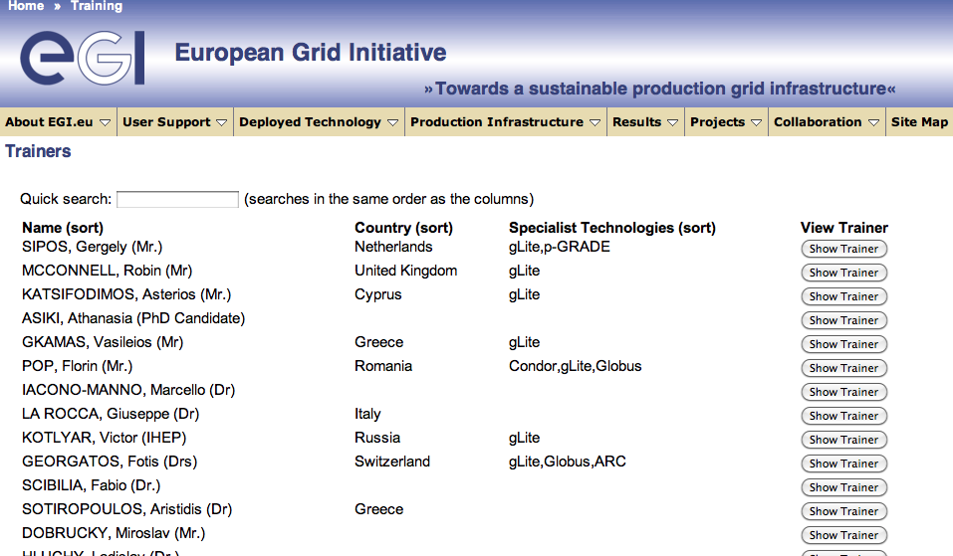

The list of trainers can be given in alphabetical order using the “(sort)” link. Additional work may be necessary for this option to be more obvious.

Figure 5 Example trainer information drill-down
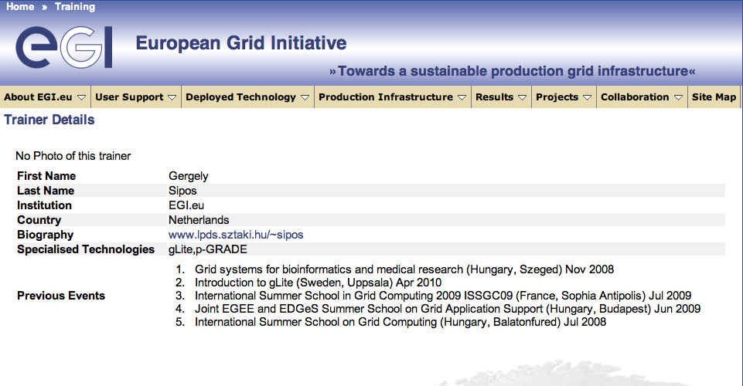

Contacts and Input forms
Contact and input forms are available at: http://training.egi.eu/contact.cfm A web form providing an email facility to allow users to contact the EGI training activity has been provided (see Figure 6).

Figure 6 Contact Form
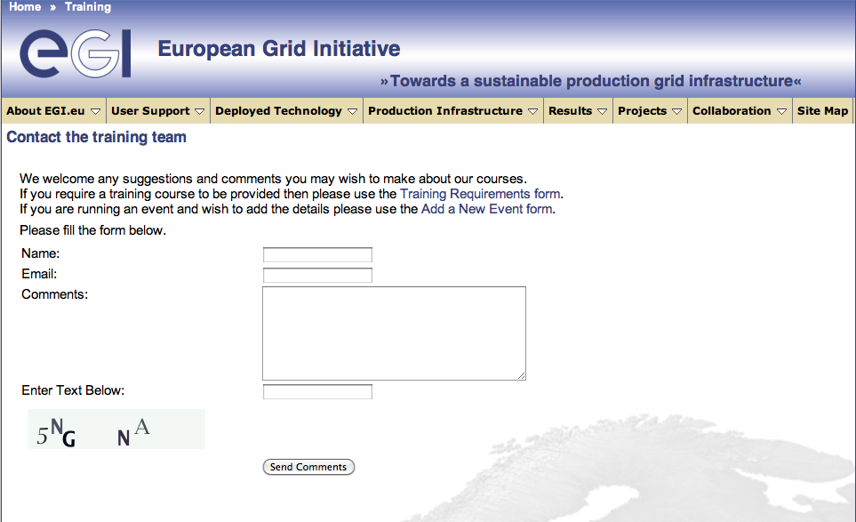

This page has links to forms allow the input of new training requirements and to allow input of new training events can be accessed (see Figure 6).

Figure 7 Training request form


Figure 7 shows the training request form. This form generates and email request to an EGI email list.

Figure 8 Training event input form
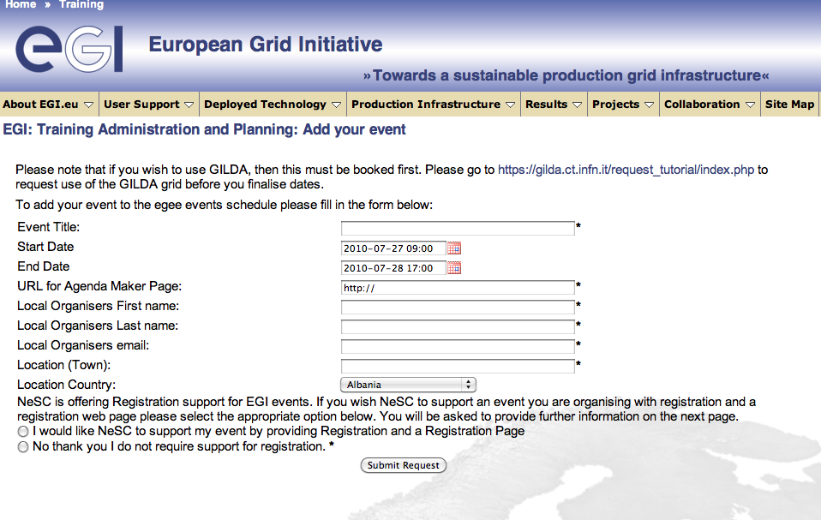

The training event input form (see figure 8) allows the input of new training events. These are immediately added to the SQLServer database but are not made visible in the training event list until they have been manually moderated, that is their status changed in the database.

Conclusions
The EGEE training support services (a registry of trainers, a calendar of training events, and a digital library of training materials) have been migrated from the EGEE web site to the EGI.eu web site. In order to support this process, and to make the services robust to expected short term modifications to the EGI.eu web site, the front-ends for the services have been minimally re-factored during the migration process.
This is the first step in establishing the training services within EGI. These services will need to be developed to meet the future requirements of the EGI user community. These developments will have to fit within the framework of the EGI User Support activity as a whole. With the EGI staff now in place and the community forming, potential developments can begin to be formulated. A key element in this process will be the gathering of requirements at the 1st EGI Technical Forum.
Immediate developments include a simple form to allow authorised personnel to moderate events, improvements in the interface to allow users to create and edit materials, and to update the look and feel of the EGI.eu web site when the design changes.

