EGI-InSPIRE

Work of the Asia-Pacific Region

EU MILESTONE: MS 117

Document identifier: | input.doc
Date: | 14/03/2012
Activity: | NA2
Lead Partner: | ASGC
Document Status: | FINAL
Dissemination Level: | PUBLIC
Document Link: | https://documents.egi.eu/document/1067

Abstract

The EGI-InSPIRE project has 9 unfunded partners from the Asia Pacific region that are organised into an informal Asia Pacific Grid Initiative (APGI). This report details their diverse activities over PY2.

- Copyright notice
Copyright © Members of the EGI-InSPIRE Collaboration, 2010-2014. See www.egi.eu for details of the EGI-InSPIRE project and the collaboration. EGI-InSPIRE (“European Grid Initiative: Integrated Sustainable Pan-European Infrastructure for Researchers in Europe”) is a project co-funded by the European Commission as an Integrated Infrastructure Initiative within the 7th Framework Programme. EGI-InSPIRE began in May 2010 and will run for 4 years. This work is licensed under the Creative Commons Attribution-Noncommercial 3.0 License. To view a copy of this license, visit http://creativecommons.org/licenses/by-nc/3.0/ or send a letter to Creative Commons, 171 Second Street, Suite 300, San Francisco, California, 94105, and USA. The work must be attributed by attaching the following reference to the copied elements: “Copyright © Members of the EGI-InSPIRE Collaboration, 2010-2014. See www.egi.eu for details of the EGI-InSPIRE project and the collaboration”. Using this document in a way and/or for purposes not foreseen in the license, requires the prior written permission of the copyright holders. The information contained in this document represents the views of the copyright holders as of the date such views are published.
- Delivery Slip
 | Name | Partner/Activity | Date
From | Simon C. Lin,  Stella Shen,  Vicky Huang | ASGC/NA2 | 14/03/2012
Reviewed by | Moderator: Richard McLennan  Reviewers: Ludek Matyska | EGI/NA2  CESNET/NA2 | 11/04/2012
Approved by | AMB & PMB |  | 27/4/2012
- Document Log
Issue | Date | Comment | Author/Partner
1 | 14/03/2012 | First draft | Simon C. Lin
2 | 21/03/2012 | Second draft | Steven Newhouse
3 | 24/04/2012 | Third edit | Simon Lin/ Eric Yen/ Stella Shen/ Vicky Huang
- Application area
This document is a formal deliverable for the European Commission, applicable to all members of the EGI-InSPIRE project, beneficiaries and Joint Research Unit members, as well as its collaborating projects.
- Document amendment procedure
Amendments, comments and suggestions should be sent to the authors. The procedures documented in the EGI-InSPIRE “Document Management Procedure” will be followed:
https://wiki.egi.eu/wiki/Procedures
- Terminology
A complete project glossary is provided at the following page: http://www.egi.eu/about/glossary/.

No. | Acronyms | Full Name
1 | APGI | The Asia Pacific Grid Initiative
2 | AP region | Asia Pacific region
3 | WRF | Weather Research and Forecasting Model
4 | iRODS | the integrated Rule-Oriented Data System
5 | iSGTW | International Science Grid This Week
6 | IGTF | The International Grid Trust Federation
7 | GVSS | Grid-enabled Virtual Screening Service
8 | SRM | The Storage Resource Manager
9 | GAP | Grid Application Platform
10 | NMR | Nuclear Magnetic Resonance Spectroscopy
11 | WeNMR | A Worldwide e-Infrastructure for NMR and structural biology
12 | NOAA | National Oceanic and Atmospheric Administration
13 | APROC | Asia Pacific Regional Operation Center
14 | IDGF | International Desktop Grid Federation
15 | NeCTAR | National eResearch Collaboration Tools and Resources

- PROJECT SUMMARY

To support science and innovation, a lasting operational model for e-Science is needed − both for coordinating the infrastructure and for delivering integrated services that cross national borders.

The EGI-InSPIRE project will support the transition from a project-based system to a sustainable pan-European e-Infrastructure, by supporting ‘grids’ of high-performance computing (HPC) and high-throughput computing (HTC) resources. EGI-InSPIRE will also be ideally placed to integrate new Distributed Computing Infrastructures (DCIs) such as clouds, supercomputing networks and desktop grids, to benefit user communities within the European Research Area.

EGI-InSPIRE will collect user requirements and provide support for the current and potential new user communities, for example within the ESFRI projects. Additional support will also be given to the current heavy users of the infrastructure, such as high energy physics, computational chemistry and life sciences, as they move their critical services and tools from a centralised support model to one driven by their own individual communities.

The objectives of the project are:

- The continued operation and expansion of today’s production infrastructure by transitioning to a governance model and operational infrastructure that can be increasingly sustained outside of specific project funding.
- The continued support of researchers within Europe and their international collaborators that are using the current production infrastructure.
- The support for current heavy users of the infrastructure in earth science, astronomy and astrophysics, fusion, computational chemistry and materials science technology, life sciences and high energy physics as they move to sustainable support models for their own communities.
- Interfaces that expand access to new user communities including new potential heavy users of the infrastructure from the ESFRI projects.
- Mechanisms to integrate existing infrastructure providers in Europe and around the world into the production infrastructure, so as to provide transparent access to all authorised users.
- Establish processes and procedures to allow the integration of new DCI technologies (e.g. clouds, volunteer desktop grids) and heterogeneous resources (e.g. HTC and HPC) into a seamless production infrastructure as they mature and demonstrate value to the EGI community.

The EGI community is a federation of independent national and community resource providers, whose resources support specific research communities and international collaborators both within Europe and worldwide. EGI.eu, coordinator of EGI-InSPIRE, brings together partner institutions established within the community to provide a set of essential human and technical services that enable secure integrated access to distributed resources on behalf of the community.

The production infrastructure supports Virtual Research Communities (VRCs) − structured international user communities − that are grouped into specific research domains. VRCs are formally represented within EGI at both a technical and strategic level.
- EXECUTIVE SUMMARY

The EGI-InSPIRE project has 9 unfunded partners from the Asia Pacific region that are organised into an informal Asia Pacific Grid Initiative (APGI). This report details their diverse activities over PY2.

The APGI is led by ASGC which serves as the liaison between the EGI-InSPIRE Project Office and APGI partners and represents them in the EGI-InSPIRE PMB. In PY2, ASGC established contact with the Mongolian Academy of Science and participated and organised a number of workshops and events including the 10th International Symposium on Grids and Clouds (ISGC 2012).

The ASTI continued with its activities on High Performance Computing. A major accomplishment was the virtualization of the clusters using the OpenNebula platform and continuing collaborations, both with local research institutions and regional/international communities through the Philippine e-Science Grid (PSciGrid) Program and activities pertaining to collaborations including the EGI-InSPIRE.

During PY2 of the EGI-InSPIRE project ITB has continued to provide computing and GPU clusters to support the Weather Forecast research group and Computational Chemistry research groups. The integration of these resources into EGI will continue alongside further activity in Desktop Grids.

KEK’s activity was severely disrupted during PY2 due to the large scale earthquake happened on March 11th in the northern area of Japan and related disasters. Operation was disrupted until mid-April and after that date continued at a reduced level due to insufficient electricity supply. This experience demonstrated the difference between regular disaster recovery planning and recovering from such a catastrophic event.

PY2 for EGI-InSPIRE has been a good year for KISTI especially in terms of providing a relatively stable and reliable Grid service and operation. For the last year, KISTI has provided an average of 131% of the CPU it was supposed to deliver in the WLCG MoU and an average of 93% in the service availability and reliability.

During PY2 NECTEC/NSTDA focused on contributing to the “Thailand National e-Science Infrastructure Consortium” project (http://www.e-science.in.th) which is a five year national e-Infrastructure for e-Science project, organised through a consortium of research institutes with a total budget of USD$3.7Million that will use virtual organisations to manage application areas by using the gLite middleware.

The KISTI Super Computer Center, CC-IN2P3 and KEK-CRC have federated their computing resources to provide a France-Asia virtual organization to share computing resources providing a total of 25,000 CPU cores and 8 TBytes of disk space to users. KISTI has also been actively involved in the user support activity as well by providing researchers with the support for application porting and large-scale deployment of the applications on production Grid infrastructures like Biomed VO and France-Asia VO. The NUS has no explicit funding and continues to contribute on a best effort basis.

The Australian EGI-InSPIRE activities saw the establishment of a Centre of Excellence for Particle Physics at the Terascale (CoEPP) that brings together theoretical and experimental physicists from across Australia’s leading universities and has assumed the management role of Australia’s contribution to the EGI-InSPIRE partnership. This includes running the Australian ATLAS Tier 2 centre for WLCG and their engagement in the National eResearch Collaboration Tools and Resources (NeCTAR) Research Cloud to move grid services onto cloud infrastructure and utilize the storage that will be provided by the nationally funded Research Data Storage Infrastructure (RDSI).

UPM continues to carry out tasks established in the EUAsiaGrid Project and has been working on the development of grid sites for all universities to be certified within EGI, while exploring the potential of cloud resources. The Malaysian Identity Management and Access Management (MyIFAM) has been formally accepted as a Member of APGridPMA and IGTF and thus approved to be Malaysia’s National CA.

TABLE OF CONTENTS
1 Introduction 9
2 Academia Sinica Grid Computing Centre (ASGC) 10
2.1 Introduction 10
2.2 Activity Summary 11
2.2.1 WP2 – NA2 External Relations (Total PM: 12) 11
2.2.2 WP3 – NA3 User Community Coordination (Total PM: 30) 12
2.2.3 WP4 – SA1 Operations (Total PM:48) 15
3 Advanced Science and Technology Institute (ASTI) 18
3.1 Introduction 18
3.2 Activity Summary 18
3.2.1 WP2 – NA2 External Relations (Total PM: 4) 18
3.2.2 WP3 – NA3 User Community Coordination (Total PM: 36.40) 18
3.2.3 WP4 – SA1 Operations (Total PM: 36) 19
4 Institut Teknologi Bandung (ITB) 21
4.1 Introduction 21
4.2 Activity Summary 21
4.2.1 WP2 – NA2 External Relations (Total PM: 0.5) 21
4.2.2 WP3 – NA3 User Community Coordination (Total PM: 1.7) 21
5 Inter-University Research Institute Corporation High Energy Accelerator Research Organization (KEK) 23
5.1 Introduction 23
5.2 Activity Summary 23
5.2.1 WP4 – SA1 Operations (Total PM: 0.5) 23
6 Korea Institute of Science and Technology Information (KISTI) 25
6.1 Introduction 25
6.2 Activity Summary 26
6.2.1 WP3 – NA3 User Community Coordination (Total PM: 12) 26
6.2.2 WP4 – SA1 Operations (Total PM: 24) 27
7 National Science and Technology Development Agency (NSTDA) 28
7.1 Introduction 28
7.2 Activity Summary 28
7.2.1 WP2 – NA2 External Relations (Total PM: 0.2) 28
7.2.2 WP3 – NA3 User Community Coordination (Total PM: 10) 29
8 National University of Singapore (NUS) 30
8.1 Introduction 30
8.2 Activity Summary 30
8.2.1 WP4 – SA1 Operations (Total PM: 1) 30
9 University of Melbourne (UNIMELB) 31
9.1 Introduction 31
9.2 Activity Summary 32
9.2.1 WP4 – SA1 Operations (Total PM: 15) 32
10 Universiti Putra Malaysia (UPM) 33
10.1 Introduction 33
10.2 Activity Summary 33
10.2.1 WP2 – NA2 External Relations (Total PM: 6) 33
10.2.2 WP4 – SA1 Operations (Total PM: 4) 34
11 Conclusions 35

Introduction
The unfunded contribution from the Asia-Pacific partners illustrates the breadth of activities taking place across the region through their various national initiatives and their links with on-going European activities. Although the EGI-InSPIRE project restructured its funded activities during PY2, the reporting from the Asia-Pacific partners remains on the original project structure (i.e. including an NA3 focused on user community support).

Academia Sinica Grid Computing Centre (ASGC)

Introduction
As the lead partner of APGI (Asia Pacific Grid Initiative), ASGC served as the liaison between the EGI-InSPIRE Project Office and APGI partners. ASGC provides the continued its coordination of the administration tasks amongst the APGI partners in the 2nd reporting period In addition ASGC represented the APGI partners on the EGI-InSPIRE PMB.

Besides WP1, ASGC also participated in WP2, WP3 and WP4. In WP2, dissemination of knowledge and expertise coming from EGI-InSPIRE was further extended to the AP region not directly included in the EGI-InSPIRE project. In PY2, ASGC established contact with the Mongolian Academy of Science. In total, ASGC participated in 9 national/international events and gave 11 talks. ASGC also organized 3 Applications Workshop, 1 International Conference and 5 Grid/Cloud related Workshops. Dissemination materials were translated and media releases were issued throughout the year. In WP3, ASGC facilitates communication between domain experts and helps building communities of e-Science applications (including HEP, Life Science, Earth Science, Environmental Changes and e-Social Sciences) in the AP region. Based on the requirements of the local user community participating in the WeNMR project, a new VO, ENMR, has been supported since May 2011.

In PY2, ASGC released two new user interfaces that enable Drug Discovery and the Weather Research Forecasting (WRF) model. Furthermore, ASGC continues to extend geographical coverage of its training events and to enhance the training quality with more flexibility. ASGC takes part in detailed event design, training partner coordination, logistics preparation, and training material preparation, delivery, reporting and analysis. In WP4, EUAsia Virtual Organization provides continuous access to the Asian-Pacific Distributed Computing Infrastructure (including computational and storage services) for academic researchers from the countries within the region through a catch-all approach. The primary aim of EUAsia VO is to support research activities through multidisciplinary, generic applications deployed and running within EUAsia VO environment. Detailed work on the NGI International Tasks is described in the following section.

In Asia, many grid-based collaborations are already in place. In terms of middleware, other than gLite, there is also the Pacific Rim Application and Grid Middleware Assembly (PRAGMA) in constructing collaborations and drive the development of technology by applications. NAREGI and two China Grid systems are mainly used in Japan and China respectively. See table below for the summary of the Grid deployment status in Asia. In APGI, we are only focus on the gLite-based distributed infrastructure.

Summary of Grid Deployment Status of Asia by Middleware:
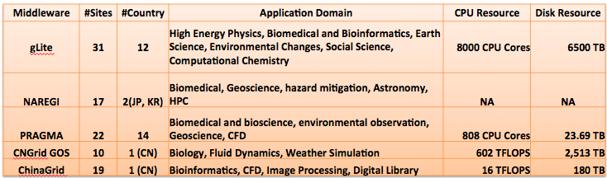

Activity Summary

WP2 – NA2 External Relations (Total PM: 12)

TNA2.2 Dissemination
In PY2, ASGC participated in both the EGI Technical Forum and Community Forums. In the Technical Forum, ASGC participated in all relevant committee meetings and workpackage meetings, as well as giving a talk on GSTAT. In the EGI Community Forum, ASGC gave 3 talks, they were: (1) e-Science on Weather Simulation Using the WRF Model, (2) Cloud Federation over the World Wide Grid, and (3) HIGH Throughput Interactive In-Silico Drug Discovery Platform: GVSS-2. ASGC also assisted the EGI-InSPIRE Project Office in promoting the EGI Community Forum among Asia Pacific partners, and coordinated with the PO regarding the communication and execution of financial supporting program to Asian Pacific partners. There are 4 partners (Australia, Korea, Malaysia and Taiwan) attending the Community Forum.

In addition to the EGI Technical/User Forums, ASGC has participated in 7 international events and gave 8 talks providing a general picture of the EGI-InSPIRE project, the dissemination of advanced e-Science knowledge to the potential user communities and give them the skills to deploy and use the e-Science infrastructure. Detailed list of international activities are as follows:

Date | Place | Conference | Presentation
February 2012 | India | AFAD Workshop | WLCG Tier-1 Center and e-Science Development in Taiwan
September 2011 | Japan | iRODS Workshop | iRODS Application & Development in Taiwan
July 2011 | India | GARUDA-NKN Partner Meeting | e-Science Development in Taiwan and Asia
July 2011 | Mongolia | 11th Science Council of Asia Conference | (Keynote Speech)  - Introduction to e-Scinece  - Why e-Science in Asia
June 2011 | Germany | ISC 2011 | HPC & e-Science Application in Taiwan
May 2011 | Italy | Role of e-Infrastructure on Climate Change Research | e-Infrastructure for Climate Change in Asia Pacific
April 2011 | Austria | European Geoscience Union General Assembly 2011 | e-Science Application on EUAsiaGrid: gLite based WRF simulation

During PY2, ASGC joined the iSGTW Board and will support an Asia-Pacific Editor. Working together with GridCast, ASGC conducted 13 video interviews during the ISGC 2012.

TNA 2.3 Policy Development
ASGC continued participating in the Security Policy Group meetings and IGTF activities. ASGC organized and hosted the Federated Identity Management Workshop (http://event.twgrid.org/isgc2012/idm.html) on 27 February 2012 in Taipei. Representatives from a variety of research communities, including photon/neutron facilities, social science & humanities, high-energy physics, atmospheric science, bioinformatics and fusion energy, have come together to discuss how to address these issues with the objective to define a common policy and trust framework for Identity Management based on existing structures, federations and technologies.

TNA 2.4 Event Management
In PY2, ASGC WP4 organized 3 Application Workshops, 1 international conference and 5 Grids/Clouds related Workshops. The three Application Workshops were: the Workshop on e-Science Applications & Technology in Mongolia and two WeNMR Workshop in Taiwan.

Collaborating with the Mongolia Academy of Science, the Workshop on e-Science Applications & Technology was held in Ulaanbaatar, Mongolia on 3-5 October 2011. This workshop was specifically designed for Mongolian scholars who are interested in learning on e-Science. In addition to the concept of e-Science, e-Science environment and tools, three applications including Drug Discovery, earthquake and climate change, were introduced. Around 50 participants attended the workshop.

Two WeNMR Workshops were held, one was held on 1 May 2011 and the other (http://event.twgrid.org/isgc2012/wenmr.html) was held on 27 February 2012 in conjunction with ISGC 2012. The workshop provides a general introduction to grid computing and the WeNMR services currently available through the WeNMR virtual research community portal (www.wenmr.eu), and then focus on one specific topic: the modelling of protein-nucleic acids interactions. A general introduction to HADDOCK and its application to the modelling of protein-nucleic acid systems were given. Participants gained experience in the use of the software through a guided hands-on HADDOCK tutorial. In total 48 participants from 14 countries registered at the workshop.

The International Symposium on Grids and Clouds (ISGC 2012) was held at Academia Sinica in Taipei from 26 February to 2 March 2012 with other co-located events including: iRODS Workshop (45 registrants from 16 countries), Asia@Home Workshop (40 registrants from 15 countries), WeNMR Workshop (48 registrants from 14 countries), Federated Identity Management Workshop (63 registrants from 23 countries), Cloud Interoperability Workshop (76 registrants from 25 countries), CHAIN Meeting (37 registrants from 15 countries) and APGridPMA Meeting (20 registrants from 15 countries). ISGC 2012 was celebrating its 10th anniversary this year and over the last decade has tracked the convergence, collaboration and innovation of individual researchers across the Asia Pacific region to a coherent community and as a result has helped drive the growth of regional e-Science activities and its collaborations around the world. This year there were 8 FP7 projects in attendance: EGI-InSPIRE, WeNMR, GISELA, EMI, DEGISCO, CHAIN, and e-ScienceTalk. A total of 12 Asia Pacific countries gave reports on their current status at the “Grids and Clouds Activities on Asia Pacific” Session. In addition, ASGC delivered eight talks, they were: (1) Overview of Current Activities in Asia Pacific, (2) e-Science Activities in Taiwan, (3) Peta-scale Data Management System Building Block for DCI, (4) WRF Weather Simulation on Grid, (5) Grid/Cloud the Resource Federation, (6) GVSS Portal: A Fully Functional High throughput Screening Web-based Service, (7) The Storage Application and Development Based on iRODS, (8) SRM - iRODS Interface Development. Detailed Conference Program could be found at http://event.twgrid.org/isgc2012/program.html.

WP3 – NA3 User Community Coordination (Total PM: 30)
ASGC coordinates the e-Science infrastructure support and user community engagement with all the APGI partners. With stable infrastructure contributed by distributed resource centres at partner sites, users are able to easily access resources and collaborate with partners and e-Science communities across the Asia Pacific region. With the driver of real user requirements, we target at problems with Asia Pacific concerns and demonstrate the value of collaboration by e-Science paradigm. Main activities are described as follows:

TNA3.2 User & Community Support Team
ASGC provided user support to the following applications:
High Energy Physics (HEP):
ASGC continued supporting ATLAS and CMS which are the largest user communities in terms of the resource consumption. In PY2 for ATLAS the inbound transfer data volume to ASGC reached 1,718 TB and outbound transfer volume from ASGC to other T1s/T2s reached 1,892TB. For CMS, the inbound transfer data size to ASGC reached 1,504TB and outbound transfer rate from ASGC to other T1s and T2s reached 1,524TB. Taiwan WLCG Tier-1 and Tier-2 Centres finished 8.9M jobs in the PY2 and provided 110.4.M normalised CPU time (HEPSPEC06.Hours).
Bioinformatics and Biomedics:
- Drug Discovery: ASGC helped local researcher from AS Genomics Research Center prepare the docking for transglycosylase (TG). The outbreaks of drug-resistant bacteria have caused difficulty in the treatment of bacterial infections. New antibacterial agents are in urgent demand to combat these hurtful antibiotic-resistant problems. This could be achieved by targeting a bacteria cell wall enzyme, TG that participates in the synthesis and furnish the formation of bacteria cell wall. It is expected to inhibit the function of TG, leading to interference with the replication of bacteria by hindering cell wall formation. Theoretically, TG is one outer-bound membrane protein, antibiotics targeting to TG do not need to penetrate into cell, which should have less cause to induce drug resistant. We screen more than 1.77M compounds and obtained 1150 representatives from top-affinity-ranked chemical structure families. In total, we have finished 1.8M ligand docking via EUAsia Grid resources and Taiwan Desktop Grid resources.
One of the major efforts in PY2 is to release GVSS-2 (http://gvss2.twgrid.org). To improve the accessibility of the distributing computing resources, service grid and desktop grid, ASGC developed the GVSS-2 empowered by GAP-2 with the new functions of automation of pre-requisite process and adding new protein structure database. The GVSS-2 has two new features: the automation of pre-requisite process and a new protein structure database. In order to run the AutoDock virtual screening application, the Biomedical scientists need to convert the ligand files from “mol2” to “pdbq/pdbqt” format before submitting the virtual screening job. Via GVSS-2, users only need to upload their “mol2” files and then the system will convert the “mol2” format into “pdbq/pdbqt” automatically. While extracting information in mol2 file, the system also pre-calculates ligand physicochemical descriptors such as Atom Count, Molecular Weight, Aromatic Ring Count, etc. With the pre-calculation descriptors, users would get the results back in clustered category. It is more efficient and easier for users to examine their results. Moreover, users could implement advanced ligand filter, such as similarity during library preparation and retrieve the results based on the physicochemical descriptors. GVSS-2 features a new function for classifying protein structure via its PDBID annotated in the PDB bank. The new protein structure database has been added into the GVSS-2. In addition, we provide online tools for users to decide the docking site and to generate energy map files of various atom types.
- NMR: ASGC worked with a local researcher from the Institute of Biomedicines, Academia Sinica to join the WeNMR project. Academia Sinica became a WeNMR project partner in December 2011. ASGC provides a stable infrastructure for WeNMR and helps WeNMR disseminate its application to our local NMR community. Two WeNMR workshops in Taiwan have been organized in PY2.
- Next Generation Sequencing: To resolve the large-scale computing and the analysis workflow requirements for the bioinformatics Virtual Research Communities, the Center for Systems and Synthetic Biology (CSB2) in National Yang-Ming University and ASGC collaborated on porting bioinformatics tools to the gLite grid environment. This work attempted to address the emerging need for timely annotation of new genomes fast accumulating in recent years. Two bioinformatics tools essential for genome annotation have been ported to the grid computing environment. Firstly, a grid-based BLAST database search service has been created to facilitate the similarity-based function annotation of genes. Secondly, a grid-based Pfam database search service is created to accelerate the protein-domain search. This service is particularly useful when annotating new eukaryotic genes, since protein domains in a gene may give us clues about its potential functions even when this gene does not have any homologous genes of known functions. Researchers can access and start using these services easily on the Internet.
Natural Disaster Mitigation:
- Earthquake: Seismogram-on-demand and shake movie are the two primary services on earthquake disaster mitigation based on the seismic wave propagation simulation. Generating Seismogram for any location can be generated on the fly for any earthquake event in Taiwan region. The intensity map in the form of shake movie is created in minutes based on the updated Strain Green’s Tensor (SGT) database. A cheap portal sensor network which is the Quake Catcher Network (QCN), has also been deployed in Taiwan. Working together, ASGC, the Institute of Earth Science and the National Taiwan Normal University has made use of QCN sensors to enhance the aftershock data collection and improve the quake event intensity resolution. So far, around 70 QCN sensors were deployed in schools of I-Lan area (in the Northeast part of Taiwan) to support earth science education in quake-prone area and to be used as volunteer computing resources as well as for e-Science experiments for younger generation and teachers. The use case of QCN providing complementary data to the current seismic network of Taiwan for analysis of rupture process and this mechanism has been demonstrated at the ISGC 2012. The future plan is to replicate this successful use case with the APGI partners. The QCN installation in Philippine would be implemented in late 2012.
(2) Tsunami Simulation: During PY2, ASGC continued coordinating with the National Central University on the Tsunami simulation. A useful tsunami hazard map should not only include the tsunami arrival time and wave height, but also the inundation map with the momentum flux which can be easily transferred into the force on the structures. To achieve this a more detailed coastal sea-bed map is needed to lead to more accurate simulations. NOAA’s open data set will be used to achieve this. Part of the simulation results have demonstrated in the ISGC 2012 to the Natural Disaster Mitigation Working Group including Asian partners from Indonesia (ITB and BMKG), Malaysia (UPM), Philippines (ASTI and AdMU), Taiwan (ASGC, AS Institute of Earth Science, National Taiwan University and National Central University), Vietnam (IFI and Vietnam Earthquake Information and Tsunami Warning Centre), Thailand (HAII), Pakistan as well as US partners including University of California at Riverside and California Institute of Technology.
(3) Climate Change: During PY2, ASGC has focused on developing the gWRF (gLite based WRF) portal (https://gwrf.twgrid.org). A new graphical user interface (GUI), gWRF uses the global e-Science infrastructure for WRF weather modelling. It allows users to access the system by using a standard web browser. It replaces the command-line interface with an intuitive and easy-to-use GUI. gWRF is a tool which allows the model to be deployed on the global distributed infrastructure that is capable of supporting parallel computing. The latest version is based on WRF v3.1.1 and is designed to mask the complexity of grid operations from end users. The new web-based GUI facilitates the submission, retrieval and monitoring of jobs and provides debug information.

e-Social Science:
ASGC has continued working with National Sun Yat-sen University and National Chung-Cheng University to conduct the social simulation on Taiwan’s voting behaviour. Predicting the voting tendency or the voting result is an essential research in social science. Based on the traditional "Voter Model", we add two new parameters into the model: the "Memory" and the "Transition Rate". The progress has been made on understanding some generic features of the voters such as the memory effect.

TNA3.3 NGI User Support Team
Besides the user support for the local researchers in the above-mentioned application areas, ASGC has provided consultancy and support to
(1) WeNMR: Academia Sinica successfully joined WeNMR project in December 2011. The Institute of Biomedical Sciences participated in Virtual Research Community and Joint Research Activities Whereas ASGC supported Operation/ Maintenance of the Grid as well as Dissemination/Outreach. In addition, ASGC is discussing with WeNMR on running Gromacs jobs with long time proxy.

WP4 – SA1 Operations (Total PM:48)
ASGC operates the Asia Pacific Regional Operation Centre (APROC) that extends EGI’s resources to the Asia Pacific region and maximise the e-Infrastructure reliability to support various e-Science user communities. At this moment, there are 31 sites from 13 countries (excluding China) supporting 20 VOs in EGI’s regional Asia Pacific infrastructure. Two new sites (Seoul University of Korea and Institute of Technology in Pakistan) were certified by APROC during PY2. Another two sites (Universiti Utara Malaysia and Institute for Research in Fundamental Sciences of Iran) are under certification. Around 10,696 cores, 8.1 PB disk space are available from the Asia Pacific resource centres. Currently, there are 1,579 registered users in total according to APGridPMA statistics in February 2012. In terms of normalised CPU time (HEPSPEC06), the monthly average resource utilisation in this region is 23.68M normalised CPU time (in HEPSPEC.hours). The daily average of completed jobs has greatly increased from 49,408 in PY1 to 73,896 in PY2.

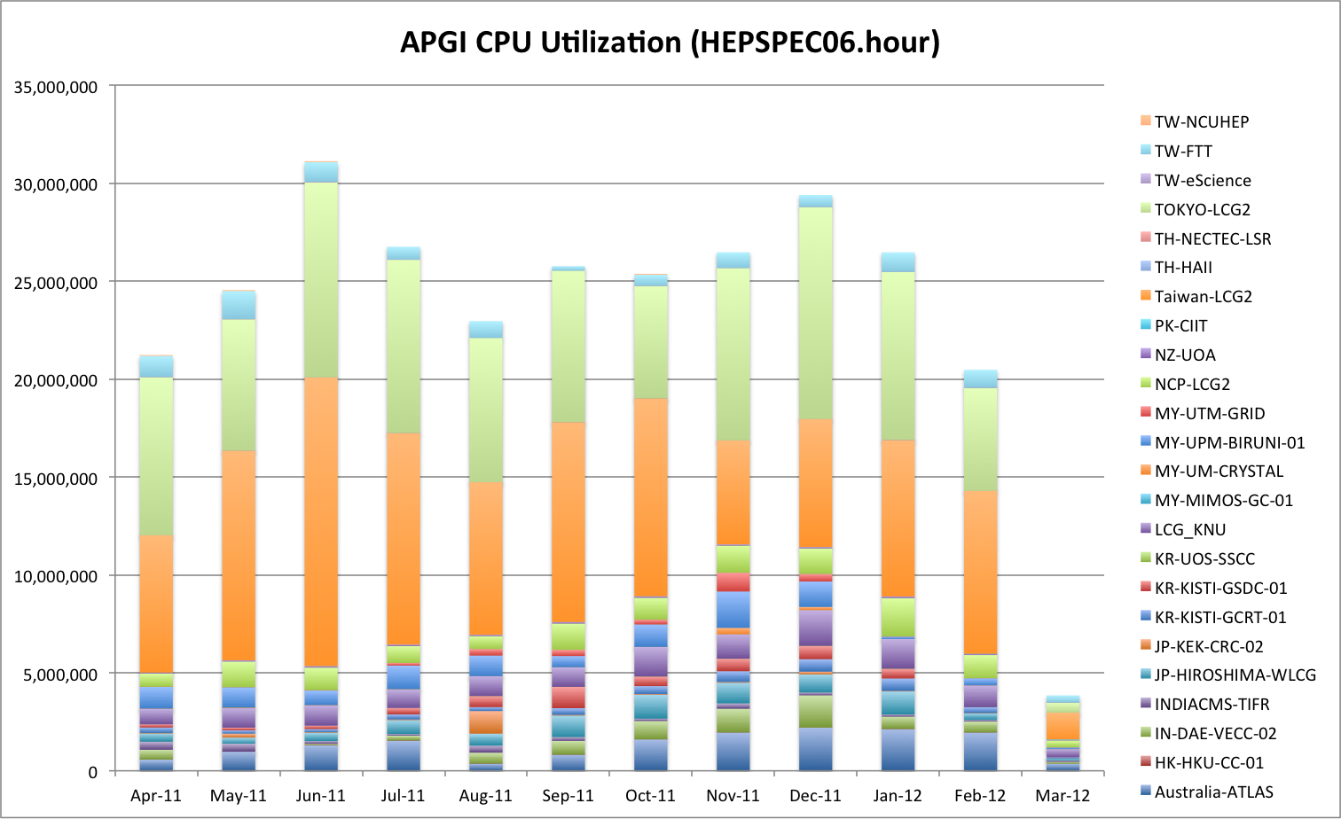

TSA1.2 A Secure Infrastructure
APROC coordinates and supports the infrastructure security issues in Asia Pacific region being a member and aligning activities with both EGI-CSIRT and EGI SPG teams. APROC serves as a consultant and follows up every security event in the Asia Pacific partners, including operating system and middleware vulnerability patching, verification and follow ups, as well as the rapid reporting channel. Once there is any incident or action required on security issues, APROC tracks the status everyday until the remedy is taken. Besides, APROC also enforces the accomplishment of security service challenge conducted by EGI-CSIRT.

For site level authentication and authorization, ASGCCA acts as regional ‘catch-all’ certificate authority (CA) to support any country without any production domestic CA and to help the establishment of a new country CAs. A Registration Authority of ASGCCA will be setup at a new user site if there is no available IGTF accredited CA in the country. Mongolia RA was setup by Mongolia Academy of Science in October 2011. During the reorganization of the APAC project of Australia, ASGCCA also supported New Zealand on the Grid authentication services in 2012.

TSA1.3 Service Deployment Validation
APROC is in charge of site certification and also application environment verification to maintain consistent APGI regional collaboration framework. The middleware support is now migrating from gLite to EMI in APGI. ASGC provides resources serving the EMI pre-production environment and shared with APGI members for testing, evaluation and training purposes. Operation and middleware practices workshop is held routinely in conjunction with the ISGC conferences when most sites representatives are getting together. ASGC also tracks and helps member sites on middleware and Grid services updates from EGI. In addition, APROC also coordinates and supports middleware layer interoperation among partner sites and user communities, such as VDT, Globus and Condor, etc.

At the application level, core services such as MPI environment, compiler, and specific application programs and packages from regional e-Science collaboration, are all deployed and supported by APROC. Currently, EUAsia VO is the primary and ‘catch-all’ VO for the regional collaborations of APGI. Once there is any individual domain application scales out, the linkage with EGI corresponding VO or a new VO will be created

TSA1.4 Infrastructure for Grid Management
To help regional sites understand the service quality, ASGC provides regional Nagios services for all production sites in its region. The service has been in operation from February 2011. GStat2 is also installed at ASGC as a regional Grid information system sanity check services for both Asia Pacific region and the European NGIs in EGI. GStat2 provides a complete solution for visualising grid infrastructure information and ensuring that the information content is accurate, and making sure that the infrastructure information system is healthy. The adoption of GLUE2 on GStat2 is under development and planned to be online in September 2012.

TSA1.5 Accounting
APROC checks the correctness and completeness of accounting information as well as the site reliability status at all APGI sites in a monthly basis. Services such as providing a stable accounting data publishing proxy are provided by APROC when site is not able to take care of accounting data process in time. A regional accounting portal and accounting repository is still under construction.

TSA1.7 Support Teams
ASGC provides first-line and second-line support to APGI member sites by the APROC framework. The first-line support works directly with site administrators until the problem is solved. In PY2 over 569 tickets from 21 regional sites were resolved by APROC support. Sites with monthly availability lower than 70% will be followed up by APROC every other day.

In this reporting period, ASGC supported the nationwide e-Science networking infrastructure as well as assisting Asia Pacific academic network backbone by direct peering with TEIN3 in Hong Kong.

TSA1.8 Providing a Reliable Grid Infrastructure
The reliable APGI infrastructure is enforced by Service Level Agreement of each site and APROC services. Besides the GGUS and tracking channels we have now, APROC is improving the online supporting system (e.g., Q&A and problem solving references by making use of EGI database) to shorten the problem solving time of APGI sites and increase the site reliability. In the past 5 month, the APGI average reliability from October 2011 to February 2012 is 98.52% which nearly reach the target 99%.

Advanced Science and Technology Institute (ASTI)

Introduction
The ASTI continued with its activities on High Performance Computing. A major accomplishment was the virtualization of the clusters using the OpenNebula platform and continuing its collaborations, both with local research institutions and regional/international communities such as PRAGMA, PandaGrid, and EGI-InSPIRE.

In terms of personnel, there are a total of four (4) full-time technical staff, and three (3) management personnel handling the Philippine e-Science Grid (PSciGrid) Program and activities pertaining to collaborations including the EGI-InSPIRE.

In summary, ASTI was able to carry out the following activities:
- Maintain and operate the ASTI HPC facility and PSciGrid;
- Maintain service availability of PSciGrid;
- Contribute computing resources to EGI and PRAGMA; and
- Provide technical support to partners and users.

Moreover, in the coming months/years, we intend to accomplish the following:
- Expand computing and storage resources
- Integrate computing and storage resources to a Government Data Center
- Continue to engage with and support our research communities.

Activity Summary

WP2 – NA2 External Relations (Total PM: 4)

TNA2.2 Dissemination
In terms of dissemination events, ASTI was able to carry out the 3rd Philippine Grid Computing Forum on June 23 2011 at the ASTI. With various institutions in attendance, the one-day event presented updates on the PSciGrid and the latest innovations on High-Performance Computing (HPC). Speakers from different partner institutions presented topics on weather forecasting, disaster mitigation, crop genetics, and energy. With the theme “From Grids to Clouds: Providing a Platform for Innovation and Collaboration”, the forum and workshop highlighted the impacts of grid computing throughout the years.

The following activities were also continued: (1) Maintenance of PSciGrid website http://www.pscigrid.gov.ph/index.php; (2) Reproduction and dissemination of brochures; and (3) Development of user case studies.

WP3 – NA3 User Community Coordination (Total PM: 36.40)

TNA3.2 User & Community Support Team
No formal training or capacity-building activities were carried out for the period.

TNA3.3 NGI User Support Team
The following activities were provided to users/collaborators/partners:
- Project Collaboration on “Integrative Bioinformatics: Data Warehousing of Microbial Information”: ASTI developed BIOTECH's Data Warehouse portal with the use of BioWarehouse, an open-source toolkit for constructing bioinformatics database warehouses. The portal enables BIOTECH researchers to easily access databases such as GenBank, Uniprot, BioCyc, etc., which they use for their work. During PY2, the following activities were completed: operational Data Warehouse portal; user training on accessing the Data Warehouse; and development of research paper on the UPLB-BIOTECH data warehouse.
- Project Collaboration on “Quantified Flood Forecasting through Rain Rate Estimation Using Satellite Imagery and Generalized Watershed Runoff Calculations”: This project is a collaboration between the University of the Philippines Diliman National Institute of Geological Sciences (UP NIGS), Philippine Atmospheric, Geophysical and Astronomical Services Administration (PAGASA), and Advanced Science and Technology Institute (ASTI). It aims to provide a more accurate flood forecasting for a better early warning system in the Philippines. ASTI provided access on its High Performance Computing (HPC) facility to run the rain rate software; data storage; as well as webhosting services for the project’s website.
- In the area of Physics, user support was given to graduate and undergraduate students from the National Institute of Physics who are using Enthought Python Distribution. Research topics include Transport Systems in Cells, 3D Numerical Model for Photopolymerization Dynamics, and Evolution of an Erdo-Renyi Network Driven by Agent Diversity among others.
- The Energy Development Corporation, a private company involved in the geothermal energy industry approached ASTI for assistance in the parallelization of iTOUGH2 application which is being used for their geothermal project sites.

WP4 – SA1 Operations (Total PM: 36)

TSA1.2 A Secure Infrastructure
ASTI’s high-performance computing facility was recently restructuring to make way for ASTI’s private cloud. The restructuring involved decommissioning of all physical clusters in order to form one huge cluster. This newly aggregated cluster now serves as physical host for the virtual machines running on ASTI’s OpenNebula-driven private cloud. The private cloud is also host to several virtual clusters.

Security updates are regularly applied to all machines, both physical and virtual. A remote server running Syslog-ng is used for reliable logging. System logs of virtual machines currently hosted on ASTI’s private cloud are copied through a secure channel to the remote logging server to ensure that logs always have backups that are required for troubleshooting and security audits.

TSA1.3 Service Deployment Validation
Due to the series of restructuring done in the HPC facility during the PY2, site availability for PH-ASTI-LIKNAYAN was greatly affected. Thus starting July 2011, PH-ASTI-LIKNAYAN was removed from the list of EGI-certified production clusters.
Recertification of PH-ASTI-LIKNAYAN is still on-going with the assistance of the support team of the Asia Pacific Regional Operations Center (APROC).

TSA1.4 Infrastructure for Grid Management
All grid services are being hosted on ASTI’s private cloud which relies on OpenNebula cloud. ASTI's private cloud is a physical cluster composed of 30 nodes with roughly around 200 cores. Expansion of the storage and computing power is still on-going. Figure 2 below shows an overview of ASTI’s private cloud.

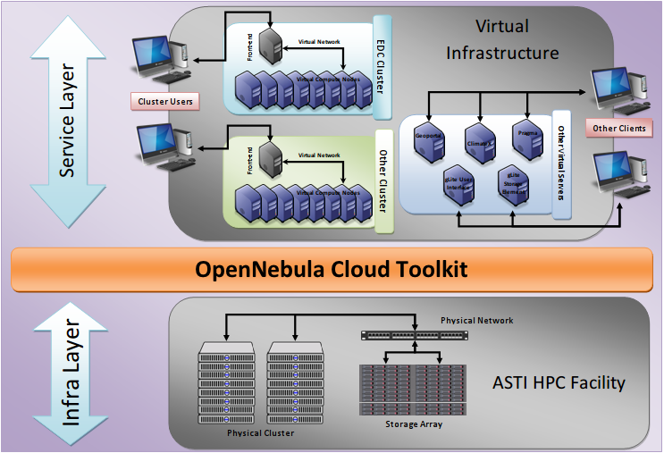
Fig. 2 ASTI private cloud overview

TSA1.8 Providing a Reliable Grid Infrastructure
Images of the virtual machines used for the PH-ASTI-LIKNAYAN site services are always backed up on a centralized storage server. Migrating the virtual machine to another physical server during hardware system failures keeps downtime at a minimum.
Also, ASTI has recently procured a new electrical generator set that is able to provide continuous power to the clusters and air-conditioning system during power failures.

Institut Teknologi Bandung (ITB)

Introduction
During PY2 of the EGI-InSPIRE project, more people are beginning to get involved in Grid Computing Development in ITB. The ID-ITB Grid Site also has been rebuilt and certified under USDI-ITB coordination. In addition, some GPU machines dedicated for the High Performance Computing Facility have a also been made available for use during this period. GPU machines are currently being used especially by Weather Forecast research group and Computational Chemistry research group to do their work and research. In the future, these GPU machines will be integrated to ITB’s Grid Infrastructure.

In this period also Desktop Grid introduced through an event with Dr. Robert Lovas from IDGF and M. Farhan S. from UPM as speaker.

Activity Summary

WP2 – NA2 External Relations (Total PM: 0.5)
External Relations activities continued in PY2 by disseminating information about EGI-InSPIRE to user communities in Indonesia during the Seminar on Desktop Grid in ITB.

TNA2.2 Dissemination
Dissemination activities in PY2 focused on Desktop Grid Computing. Speakers in this event are Dr. Robert Lovas from IDGF and M. Farhan S. from UPM. Participants at this event were mostly from ITB, but there were also participants from other institution such as from Ministry of Education, Ministry of Communication and Informatics, LIPI (Indonesian Institute of Sciences), BMKG (Meteorological, Climatologically and Geophysical Agency), and other universities from Java and Sumatera area.

Dissemination to a wider range of user communities will be performed in the following years in the form of conferences and training. In addition to socializing the use of e-infrastructure, dissemination activities are also aimed to promote collaboration between local and European user community.

TNA 2.3 Policy Development
PY2 activities do not yet include Policy Development.

TNA 2.4 Event Management
In Event Management, ITB will mainly spread the information about regional events to local user communities, for instance displaying event information on local Grid website and updating the content of the website.

WP3 – NA3 User Community Coordination (Total PM: 1.7)
For EGI-InSPIRE, besides continuing the coordination with user communities that have been involved with the EUAsiaGrid Project, ITB also looked for other user communities that can have benefit from the use of the e-Infrastructure. User communities from previous activities are those from Weather Forecast, Disaster Mitigation, and Computational Chemistry. Coordination with new area such as Volcanoes and Forestry (Firewatch) are less intensive than last year.

Support given to users is similar to that provided within the EUAsiaGrid Project such as ID-ITB site, website and wiki site that display some information in Bahasa Indonesia, and open communication channel such as e-mail and mailing list for grid users.

TNA3.1 Activity Management
During PY2, communication and coordination with the local user community is done through emails, phone calls, and informal meetings. To have a more organized communication channel we are currently updating information in a website that may also use for activity management purposes.

TNA3.2 User & Community Support Team
In order to facilitate user communities in Indonesia, ITB provides a grid site that is connected to the EUAsiaGrid Infrastructure and this site can be accessed by all registered users.

User communities that were involved in EUAsiaGrid Project are still active in EGI-InSPIRE. ITB is currently experimenting with the WRF weather forecasting application on a GPU cluster. There are also other experimental weather forecast extensions such as Quick Forecasting of Volcanic Ash Dispersion, Prediction for Tropical-belt Domain, and Radar Data Assimilation.

In PY2, the ID-ITB resource centre has been rebuilt and certified. However, the lack of a Grid System Administrator is the obstacle that still needs to be overcome. Therefore ITB plans to host a Grid System Administrator training especially for ITB communities. ITB is currently working on the training materials that will cope with the different level of understanding and needs from user communities. Moreover, the training must also accommodate users from local communities whose needs are not yet identified.

TNA3.3 NGI User Support Team
Support for the PY2 is mainly for Weather Forecast and Computational Chemistry research group.

In order to facilitate user communities in Indonesia, ITB has rebuilt its grid site that is connected to the EUAsiaGrid Infrastructure and this site can be accessed by all registered users. ITB Grid site is mainly provided for users, in this case the researchers, to experiment porting their application so it can be run on Grid Infrastructure.

TNA3.4 Technical Services
No specific activities related to Technical Services have been performed for local user communities in PY2. However, local user communities that needed support can reach user support staff especially through emails.

Other Activities
ITB has proposed to have a centralized High Performance Computing Facility through JICA Project. This facility will be maintained by USDI-ITB and can be used especially by all users in ITB.

Inter-University Research Institute Corporation High Energy Accelerator Research Organization (KEK)

Introduction
Due to the large scale earthquake happened on March 11th in the northern area of Japan and related disasters; operation of the centres major computing systems (including Grid access) was stopped until mid-April. Even after the period, the number of available computing nodes was reduced because of insufficient electricity supply. This continued until the end of September when the peak demand period of electricity finished. The sizes of computing nodes before and after the earthquake is shown below:
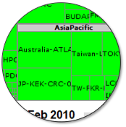  Feb 15th 2010 | 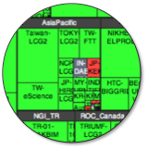  January 10th 2012

KEK had offers of support from institutions such as CC-IN2P3, PNNL, and ASGC and so on. In order to migrate our services backup copies of the images of hard disks or virtual machines had to be regularly taken and stored outside KEK. As the systems had to remain turned off for a long time many of these offers could not be used. This experience demonstrated the difference between regular disaster recovery planning and recovering from such a catastrophic event. Discussions are continuing with CC-IN2P3 and others as to how KEK can prepare for the next big earthquake expected to happen with 70% and 98% probabilities within 10 years and 30 years respectively.

Activity Summary

WP4 – SA1 Operations (Total PM: 0.5)
In addition to the disaster recovery activities KEK replaced its hardware in the Computing Research Center through competitive tendering. This procedure usually takes 18 months because of the government regulations. The previous three systems (two for data analysis and another super computer) have been replaced by a single data analysis system and a super computer. The tendering took place in the summer of 2011. The replacements of the systems are on-going and both systems start the full size operation in production on April 2nd, 2012.

The new data analysis system has more than 4000 Xeon cores, 3.5Peta Bytes disk space for users, 3Peta bytes HPSS disk cache independently; 16Peta bytes tape capacity with 60 IBM TS1140 tape drives and so on. It is planned that the whole resource will be made accessible through the NAREGI and UMD middlewares.

The new supercomputer system has two components, one is HITACH SR-16000 Model 2 and the other is IBM Blue Gene/Q with 55 Tflops and 1258Tflops expected performances respectively. They will not be part of the grid. The discussion on KEK’s relationship with the new government lead project HPCI (High Performance Computing Infrastructure) is ongoing. HPCI will be the new infrastructure for resource sharing among super computer centers in Japan. “K” is the central system of HPCI and Riken is coordinating the activities.

The research activities to develop UGI (Universal Grid Interface) have been carried out in RENKEI project. The project ended in the end of JFY2011 and we had fruitful achievements. KEK developed the SAGA modules for NAREGI, PBS, and Torque and so on. They have been contributed to the SAGA project and distributed the results freely. KEK developed UGI over the SAGA layer in Python to make the usage of multiple distributed computing infrastructures more easily. As a result an environment for particle therapy simulation was established with medical physicists.. The UGI can be used to make the web interface easily for multiple middleware, not only for Grid, but also cloud and local resources.

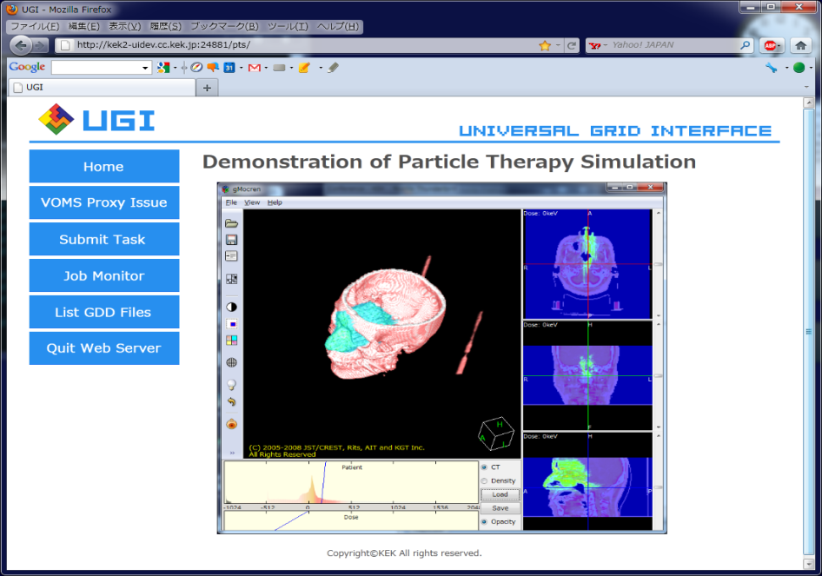

Korea Institute of Science and Technology Information (KISTI)

Introduction
PY2 for EGI-InSPIRE has been a good year for KISTI especially in terms of providing a relatively stable and reliable Grid service and operation. In 2007, KISTI signed a WLCG MoU Agreement with CERN to become an official Tier-2 for the ALICE experiment, pledging to provide a 150KSI2K in CPUs and 50TB of disk storage dedicated to ALICE computing. For the last year, KISTI has provided an average of 131% of the CPU it was supposed to deliver in the WLCG MoU (See the top blue line in Figure 1). KISTI provided an average of 93% in the service availability and reliability for the past one year. (See the red line in Figure 1). There was some drops in the reliability number in October and November due to some site reorganization where some services were set up to run on virtual machines.

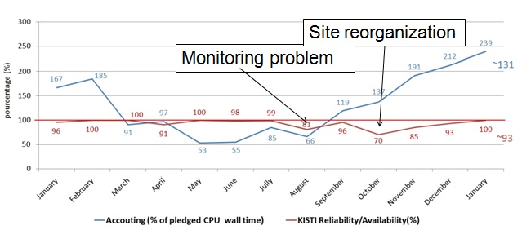
KISTI Tier2 Accounting and Reliability/Availability in 2011

The KISTI Super Computer Center, CC-IN2P3 and KEK-CRC have started federating their computing resources last year. A France-Asia virtual organization to share computing resources and to make them accessible to multidisciplinary scientific projects (primarily the ones which are part of the CNRS/IN2P3 Associated International Laboratories and Asian countries) has been established. Previously deployed virtual organization devoted to the France-Korea Particle Physics Laboratory have been migrated to this new VO and it is now prepared to host members of other Asian countries, not only users but also computing sites. The new France-Asia virtual organization was deployed and is now fully functional at three sites: KEK (Japan), KISTI (Korea) and CC-IN2P3 (France), providing a total of 25,000 CPU cores and 8 TBytes of disk space to users. The work performed during this year has allowed KEK to lay out clean foundations of the virtual organization central infrastructure that will allow KEK to focus on extending both its usage by the interested experiments and the number of computing sites joining the collaboration.

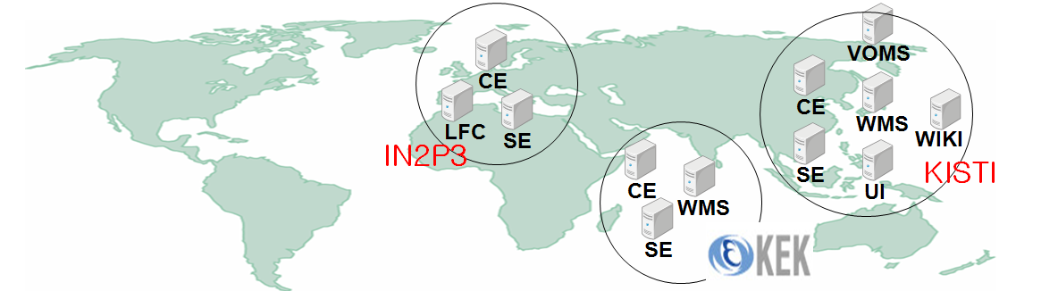
France-Asia VO Grid Infrastructure

IHEP-Beijing computing centre has expressed its interests to joining the virtual organization; and two Sino-French experiments want to evaluate this platform for their daily work. IHEP has a plan to contribute to the France-Asia VO by setting up a grid site at IHEP in the near future. IOIT-Vietnam has expressed its interest in having access to this collaboration for the deployment of in silico drug discovery. To this end they have been working on deploying a new grid service for this collaboration.
Training is an integral part of Grid infrastructure projects like France-Asia VO. In order to promote the adoption of Grid technology and infrastructure, we organized 2011 Geant4/GATE/Grid tutorial for medical applications in Seoul from October 31st to November 4th (See Figure 3). More than 40 students from over 10 institutes attended the tutorial and there are seven experts in the area of Geant4, GATE and Grid coming from France, the US, Japan and Korea contributed to the tutorial.

In summary, KISTI has joined the EGI-InSPIRE project with an interest in participating to Grid Operation and User Community Coordination activities. For the past year, KISTI has made its full commitment to the stable and reliable operation of ALICE Tier-2 and France-Asia VO. KISTI has also been actively involved in the user support activity as well by providing researchers with the support for application porting and large-scale deployment of the applications on production Grid infrastructures like Biomed VO and France-Asia VO.
In order to help users to have easier access to grid infrastructures that KISTI is participated in or involved in, we have a plan to deploy such easy-to use services such as the DIRAC service in the coming years that we expect to attract more users of non-grid experts to grid computing in developing and deploying much larger scale applications on the Grid.

Activity Summary

WP3 – NA3 User Community Coordination (Total PM: 12)

TNA3.3 NGI User Support Team
At the request of scientists in Chonnan National University, a large-scale deployment of in-silico docking on the Biomed VO and France-Asia VO Grid was conducted to find a potential drug against Human Collagenase MMP1 from a total of 1,100,000 chemical compounds (300,000 from Chembridge chemical database and 800,000 from ZINC database). KISTI mobilized up to 1,000 computers on both the Biomed VO and the France-Asia VO to screen the 1,100,000 compounds using Autodock.

KISTI also organized the 2011 Geant4, GATE and Grid tutorial for medical applications, where an in-depth lecture on Geant4 and Grid computing was provided and hands-on exercises on how to port users’ Geant4 and GATE applications on the Grid. Participants were also introduced to high-level tools such as Ganga during the tutorial to help them have an easier access to Grid computing resources.

Last year, KISTI contributed about 10 PM to the support for application porting and large-scale deployment activities. KISTI allocated at least 2 PM to the Grid-relating training events as well.

WP4 – SA1 Operations (Total PM: 24)

TSA1.8 Providing a Reliable Grid Infrastructure
Since the signing of the WLCG MoU with CERN in 2007, KISTI has been part of ALICE distributed computing grid as an official Tier-2, providing a reliable and stable node. KISTI has fulfilled its 2011 resource pledge of 600 HS (CPU) and 50 TB (DISK). According to the monthly reported Tier-2 accounting information, KISTI provided a 30% more in CPU than its pledge for 2012. Regarding the reliability and availability of KISTI Tier-2 site, KISTI offered a 93% in average for 2011, which is considered to be relatively good enough, even with some site reorganization involved in the introduction of some services on virtual machines taking place in 2011.

The France-Asia VO was set up as a grass-root collaboration of three computing centers of KISTI (Korea), CC-IN2P3 (France), KEK (Japan) last year, which is now fully functional. As of now, there are 106 users who have registered at the France-Asia VO.

Last year, KISTI contributed about 24 PM to the activities around the operation and management of ALICE Tier-2 and France-Asia VO.

National Science and Technology Development Agency (NSTDA)

Introduction
During PY2 NECTEC/NSTDA focused on contributing to the “Thailand National e-Science Infrastructure Consortium” project. The brief summary of the project development was presented in ISGC 2011. Its start up and progresses was presented in ISGC 2012 in “e-Science Activities in Asia-Pacific” session on 29 February 2012.

The description of the Thailand e-Science Infrastructure Consortium project (http://www.e-science.in.th):
- Five-year project to provide national infrastructure for e-Science in Thailand
- Run as a consortium (All members manage their own budget and Heads of all institutes are on the management committee)
- Total Budget: USD$3.7Million
- Use Virtual Organization (VO) to manage application areas
- Shared resource through Grid middleware, gLite

Formal Inauguration of the National e-Science Infrastructure Consortium MoU took place when the MoU was signed on 27 SEP 2011, at Chulalongkorn University. The founding members include Chulalongkorn University (CU), King Mongkut University of Technology Thonburi (KMUTT), Suranaree University of Technology (SUT), Hydro and Agro Informatics Institute (HAII) and National Science and Technology Development Agency (NSTDA by NECTEC + NanoTEC).

The Thailand e-Science Infrastructure Consortium has completed the procurement and configuration of Computing resource planned in 2011 with a total computing cores of 340 (vs. planned 300 cores) and a total storage of 300TB (vs. planned 210 TB). It supports the following VOs: Particle Physics, Climate Change, Water Resource, Energy, and Environment Management, Computational science and engineering as well as Computer science and engineering. In addition, it also provides NECTEC GOC CA services (member of APGrid-PMA). The PR activities include (1) Organizing “e-Science Infrastructure Consortium” Seminar, 13 OCT 2011, at Sofitel Centara Grand Bangkok; and (2) taking part in Press Conference and MoU signing among 13 institutions towards Thailand-CERN collaboration, 18 JAN 2012, hosted by Thailand Synchrotron Light Research Institute(SLRI), Ministry of Science and Technology.

Future plans include focusing on Thailand e-Science Infrastructure Consortium project, continuing Operation service of Grid CA, as a member of APGridPMA and report progress annually in ISGC.

Activity Summary

WP2 – NA2 External Relations (Total PM: 0.2)

TNA2.2 Dissemination
Participating and presenting in the ISGC 2012 and Presenting in “e-Science Activities in Asia Pacific (II)”.

WP3 – NA3 User Community Coordination (Total PM: 10)

TNA3.1 Activity Management
Activities include (1) system design, (2) information gathering for writing up proposal, (3) coordination and meetings, until reaching agreement and approval, (4) MoU development and legal procedures and (5) organizing event (MoU, seminar, Public Relation, training).

TNA3.4 Technical Services
Services include (1) NECTEC GOC CA services, (2) procuring and configuring the computing and storage infrastructure, (3) setup VO and services as well as (4) service operation.

National University of Singapore (NUS)

Introduction
We have no grant and are unable to execute other than on a best effort basis.

Activity Summary

WP4 – SA1 Operations (Total PM: 1)

TSA1.4 Infrastructure for Grid Management
We have tested large scale deployment of a Linux image on a cloud with over 100 instances and are now ready to consider making a gLite image to deploy over such a cloud. This will test the deployment of a grid infrastructure running over a virtualized hardware.

University of Melbourne (UNIMELB)

Introduction
PY2 has been one of new beginnings and growth for the Australian EGI-InSPIRE group. The Centre of Excellence for Particle Physics at the Terascale (CoEPP) was established in June 2011 bringing together theoretical and experimental physicists from across Australia’s leading universities and it has assumed the management role of Australia’s contribution to the EGI-InSPIRE partnership.

The CoEPP, recognising the importance of grid computing and advanced research computing for achieving its scientific research goals, formed the Research Computing (RC) team. The RC team in 2011 grew from a single position to three full time positions, two based at the University of Melbourne and the other at the University of Sydney. This growth in RC positions comes at a time of significant change in personnel including the departure of experienced Australian-ATLAS grid site manager Tim Dyce.

The Research Computing team now consists of:
- Lucien Boland - Research Computing Manager (UniMelb)
- Sean Crosby - Research Computing System Administrator and Developer (UniMelb)
- Sachin Wasnik – Scientific Computing Officer (USyd)

The computing resources available to the Australian ATLAS Tier 2 WLCG site also grew significantly during 2011 with the addition of 2500 HEPSPECs of compute and 200TB of storage resources. The procurement, installation and configuration were completed by Tim Dyce in May 2011, prior to the start of the CoEPP and the formation of the RC team. Additional resource growth opportunities will present themselves during the upcoming year through the NeCTAR Research Cloud and RDSI resource allocation application process.

On the development front the CoEPP successfully applied for NeCTAR (National eResearch Collaboration Tools and Resources) funding to develop the technology needed by the Australian research community to move grid services onto cloud infrastructure and utilize the storage that will be provided by the nationally funded Research Data Storage Infrastructure (RDSI). The project, entitled “High throughput computing for globally connected Science”, will employ three FTE developers for a period of two years.

In summary, the Australian EGI-InSPIRE group has managed to keep up its core operational contributions during a period of significant change to the personnel and research environment in Australia. The establishment of the CoEPP and specifically its Research Computing team provides the organisational framework for future management and expansion of grid activity within Australia.

As the Research Computing team becomes more experienced within the grid community it will be able to begin outreach activities promoting the EGI-InSPIRE project and its objectives within the broader Australian research community.

The past year has seen significant resource growth in Australian grid computing both in the hardware and in the personnel dedicated to the Australian WLCG Tier 2 site.

Activity Summary

WP4 – SA1 Operations (Total PM: 15)
The Australia-ATLAS Tier 2 WLCG site has continued to maintain excellent reliability and availability statistics throughout the reporting period despite the change in key personnel and the growth of both the computing resources and the support team.

The Australian site’s performance has seen continued growth due to the addition of new hardware and the improvements in fault monitoring over the last year. There were however two periods of sub-optimal performance during the new hardware commissioning phase and during the personnel handover phase. Improvements in site documentation and upgrade procedures will address both of these issues for future enhancement projects and team changes.
Associate Professor Martin Sevior, one of the CoEPP’s Chief Investigators, spearheaded the CoEPP’s funding application from NeCTAR for the development eResearch tools. CoEPP proposed to build two essential tools to capitalize on the investments made by NeCTAR and RDSI and to fully exploit existing eResearch tools and infrastructure. These are:
- A National Cloud-based, general purpose, high throughput, data processing, simulation and analysis facility. We plan to deploy these at co-located NeCTAR/RDSI nodes in Adelaide, Melbourne and Sydney. These will be tightly integrated with each other and also with the Australian Tier 2 LHC site in Melbourne.
- An international Cloud-based grid site that corresponds to a World Large Hadron Collider Computing Grid (WLCG) “Tier 2” site. This combines the flexibility of Cloud computing with the data transfer, access control, security and global reach of an international grid site.

These tools can be reused by other Australian groups to utilize NeCTAR and RDSI resources and to build their own high-throughput facilities for their respective disciplines.

The CoEPP also sponsored a two month student summer research project by James Kahn entitled “File System Solutions For Cloud Based Data Processing”.

Universiti Putra Malaysia (UPM)

Introduction
UPM continues to carry out tasks established in the EUAsiaGrid Project and putting effort behind the EGI agenda in the development of Grid/Cloud in Malaysia. UPM works closely with the coordinating ministry, Ministry of Science, Technology and Innovation (MOSTI) under the National Grid Computing Initiative (NGCI). One of the recommendations adopted by NGCI is to endorse the development of grid sites for all universities to build their own EGI certified infrastructure according to the minimum hardware requirements and using the approach at UPM. After the end of EUAsiaGrid Project, two (2) universities were connected and now there are 5 universities (an increase of 3 universities) and it is hoped that all 23 public/government-linked company universities will have EGI Grid Certified Site by the end of EGI-InSPIRE Project.

Engagement of universities on Grids and Clouds as championed by UPM under the workpackages pledged to EGI-InSPIRE is continuous and now working closely National Grid Secretariat as well as a new industrial partner, NVGScientific SDN BHD, a company incorporated in Malaysia specialising in grid and cloud technology development, training and support. The close and coordinated working relationship between UPM, NGCI and NVG which has just been initiated will hopefully be able to facilitate the adoption of all the best practices of EGI and its many facets of technology development and deployment. As the first phase of activities, five (5) public /government-linked company universities out of the 14 unengaged universities have been visited to introduce EGI technology and explore the state of readiness towards grid computing and to understand the needs.

As a direct consequence of the EGI collaboration, NGCI has mandated Malaysian Identity Management and Access Management (MyIFAM) championed by UPM due to the vast experience to establish National Grid Certification Authority (CA). On that basis, MyIFAM, UPM has been in close working relationship with APGridPMA and IGTF since two years ago for the establishment of Malaysia CA. During International Conference on Grids and Clouds (ISGC2012), MyIFAM was formally accepted as Member of APGridPMA and IGTF and thus approved to be Malaysia’s National CA. The next step is to appoint Registration Authority for every university and organizations to facilitate users in getting the certificates.

Activity Summary

WP2 – NA2 External Relations (Total PM: 6)
Workshop on Campus Grid usage for Biotechnologists: 13 OCTOBER 2011 (Thursday), Faculty of Computer Science and Information Technology, UPM.

Workshop and Seminar on Desktop Grid Computing, 27-30 September 2011, InfoComm Development Centre, Universiti Putra Malaysia (Malaysia)

Two-day Cloud Computing Seminar, 12-13 April 2011, Faculty of Computer Science, Universiti Sains Malaysia.

Websites:
DG@Putra – http://boinc.biruni.upm.my/putra
http://idec.upm.edu.my/DesktopGrid/
http://www.researchsea.com/html/article.php/aid/6084/cid/2

WP4 – SA1 Operations (Total PM: 4)
BIRUNI GRID Centre at UPM remained the largest resource contributor in Malaysia. From our efforts of continued encouragement to other universities, 3 additional certified sites are established with one in the process of certification. Now we have 6 EGI Certified sites and all are working together in one VO of Academic Grid VO. Academic Grid aspires to have all 22 public/government-linked company universities to have EGI certified site.

UPM is also embarking on desktop grid technology in close collaboration with MTA STAZKI’s researcher, Dr Robert Lovas and managed to establish a working desktop grid resource in one of our computer labs with 70 desktops. This desktop grid is now connected to the BIRUNI GRID Centre resource and hopefully resource from more desktops in other computer labs on campus can be tapped in the future and thus add to the growing EGI certified sites under Academic Grid initiative.

Conclusions
This report captures the breadth of activity and engagement across the Asia Pacific region that is contributed as unfunded effort into the EGI-InSPIRE project to complement the activity taking place within the funded European partners.

