EGI-InSPIRE

MS221 EGI technical Forum

EU MILESTONE: MS221

Document identifier: | input.doc
Date: | 25/04/2012
Activity: | NA2
Lead Partner: | EGI.eu
Document Status: | FINAL
Dissemination Level: | PUBLIC
Document Link: | https://documents.egi.eu/document/1106

Abstract
Event report from the EGI Technical Forum, held in Lyon, between 19-23 September 2011. The report contains the detailed information collected around the event. Detailed analysis of the event is recorded in the relevant Quarterly Report (https://documents.egi.eu/document/881) and Annual Report on EGI and its External Relations activity (https://documents.egi.eu/document/1069).

- Copyright notice
Copyright © Members of the EGI-InSPIRE Collaboration, 2010-2014. See www.egi.eu for details of the EGI-InSPIRE project and the collaboration. EGI-InSPIRE (“European Grid Initiative: Integrated Sustainable Pan-European Infrastructure for Researchers in Europe”) is a project co-funded by the European Commission as an Integrated Infrastructure Initiative within the 7th Framework Programme. EGI-InSPIRE began in May 2010 and will run for 4 years. This work is licensed under the Creative Commons Attribution-Noncommercial 3.0 License. To view a copy of this license, visit http://creativecommons.org/licenses/by-nc/3.0/ or send a letter to Creative Commons, 171 Second Street, Suite 300, San Francisco, California, 94105, and USA. The work must be attributed by attaching the following reference to the copied elements: “Copyright © Members of the EGI-InSPIRE Collaboration, 2010-2014. See www.egi.eu for details of the EGI-InSPIRE project and the collaboration”. Using this document in a way and/or for purposes not foreseen in the license, requires the prior written permission of the copyright holders. The information contained in this document represents the views of the copyright holders as of the date such views are published.
- Delivery Slip
 | Name | Partner/Activity | Date
From | Catherine Gater et al. | NA2 | 9 October 2011
Reviewed by | AMB & PMB |  | 9 October 2011
Approved by | AMB & PMB |  | 9 October 2011
- Document Log
Issue | Date | Comment | Author/Partner
1 | 30 September 2011 | First draft | C. Gater et al.
2 | 9 October 2011 | Final version | C. Gater et al.
- Application area
This document is a formal deliverable for the European Commission, applicable to all members of the EGI-InSPIRE project, beneficiaries and Joint Research Unit members, as well as its collaborating projects.
- Document amendment procedure
Amendments, comments and suggestions should be sent to the authors. The procedures documented in the EGI-InSPIRE “Document Management Procedure” will be followed:
https://wiki.egi.eu/wiki/Procedures
- Terminology
A complete project glossary is provided at the following page: http://www.egi.eu/about/glossary/.
- PROJECT SUMMARY

To support science and innovation, a lasting operational model for e-Science is needed − both for coordinating the infrastructure and for delivering integrated services that cross national borders.

The EGI-InSPIRE project will support the transition from a project-based system to a sustainable pan-European e-Infrastructure, by supporting ‘grids’ of high-performance computing (HPC) and high-throughput computing (HTC) resources. EGI-InSPIRE will also be ideally placed to integrate new Distributed Computing Infrastructures (DCIs) such as clouds, supercomputing networks and desktop grids, to benefit user communities within the European Research Area.

EGI-InSPIRE will collect user requirements and provide support for the current and potential new user communities, for example within the ESFRI projects. Additional support will also be given to the current heavy users of the infrastructure, such as high energy physics, computational chemistry and life sciences, as they move their critical services and tools from a centralised support model to one driven by their own individual communities.

The objectives of the project are:

- The continued operation and expansion of today’s production infrastructure by transitioning to a governance model and operational infrastructure that can be increasingly sustained outside of specific project funding.
- The continued support of researchers within Europe and their international collaborators that are using the current production infrastructure.
- The support for current heavy users of the infrastructure in earth science, astronomy and astrophysics, fusion, computational chemistry and materials science technology, life sciences and high energy physics as they move to sustainable support models for their own communities.
- Interfaces that expand access to new user communities including new potential heavy users of the infrastructure from the ESFRI projects.
- Mechanisms to integrate existing infrastructure providers in Europe and around the world into the production infrastructure, so as to provide transparent access to all authorised users.
- Establish processes and procedures to allow the integration of new DCI technologies (e.g. clouds, volunteer desktop grids) and heterogeneous resources (e.g. HTC and HPC) into a seamless production infrastructure as they mature and demonstrate value to the EGI community.

The EGI community is a federation of independent national and community resource providers, whose resources support specific research communities and international collaborators both within Europe and worldwide. EGI.eu, coordinator of EGI-InSPIRE, brings together partner institutions established within the community to provide a set of essential human and technical services that enable secure integrated access to distributed resources on behalf of the community.

The production infrastructure supports Virtual Research Communities (VRCs) − structured international user communities − that are grouped into specific research domains. VRCs are formally represented within EGI at both a technical and strategic level.

TABLE OF CONTENTS
1 Statistics 5
1.1 Overall 5
1.2 Registration Breakdown 5
1.3 Social Media 5
1.4 Website 8
2 Events and Launches 9
2.1 MoU signings 9
2.2 Publications 9
3 Surveys 10
4 Media Appearances 17
5 EGI press releases 18

Statistics

Overall
 | Number | Number/percentage of women
Registered participants | 660 | NA
Contributions | 132 | 16/12,12%
Speakers | 296 | 27/9,12%
Session conveners | 34 | 7/20,5%

Registration Breakdown
 | EARLY |  |  |  | NORMAL |  |  |  | LATE
 | fee | registrants | dinner | EC | fee | registrants | dinner | EC | fee | registrants | dinner | EC
full week | 499 | 235 | 235 | 9 | 599 | 92 | 92 | 2 | 699 | 10 | 10 | 1
three days | 400 | 21 |  | 3 | 490 | 26 |  |  | 580 | 7
two days | 270 | 16 |  |  | 330 | 44 |  | 2 | 390 | 12
one day | 140 | 29 |  | 3 | 170 | 41 |  | 1 | 200 | 35 |  | 1
EC | 150 | 87 |  | 87
extra  dinner | 95 |  | 18 |  |  |  | 16 |  |  |  | 3
TOTAL |  | 388 | 253 | 102 |  | 203 | 108 | 5 |  | 64 | 13 | 2

 | Registrants | dinner | EC
early | 388 | 253 | 102
normal | 203 | 108 | 5
late | 64 | 13 | 2
TOTAL | 655 | 374 | 109
In total there were 655 participants. Of those, 109 came for the eConcertation meeting and 87 for that meeting only. A total of 374 out of these went to the conference dinner.

Social Media
Twitter
27 twitterers
250 tweets
Some examples…..
it's always great to see a map of the world which has Africa in the centre of operations. #egitf11 #eumeduf
the eumed user forum is a real n-way discussion between infrastructure providers, support and users. So glad to be a part of it ! #egitf11
StratusLab and @VENUSCProject have signed a Memorandum of Understanding at #egitf in Lyon!
380 people, 95 euro, 12 waiters, 4 courses, 3 wine glasses, one boat ride, one michelin star. #egitf
The exclusive dinner is exclusive. Black and other caviar, big French abby, uber nice food. Wow. #egitf11
Had a great time at the agile #EGITF session. Thanks to Pau Minoves and all the participants.
Representatives of India, Australia and USA all confirm that they want to collaborate with EU Research Infra's #concertation #egitf11
*very* cool talk by Alex Szalay on #data computing architectures @ #egitf11
facial feature extraction from a 3-D head application now at #eumeduf #egitf11 breaking silence of the deaf in tunisia
Alex Szalaxy at #egitf11 says science in changing from hypothesis drive to data driven. I doubt that. Just depends on what you call "data"

Flickr
The number of photos uploaded in Flickr using the egitf11 tag, is 13

GridCast
27 posts – including 9 videos
Bloggers:
Sergio Andreozzi
Corentin Chevalier
Manisha Lalloo
Steve Brewer
Catherine Gater
Zara Qadir
Agnes Szeberenyi
Brusisceddu

Visits | 572
Unique visitors | 331
Pages viewed | 1066
Average number of pages viewed | 1,86
Time spent on the site | 3:49
New visits | 49,13%

Youtube (from http://www.youtube.com/user/gridtalkproject#p/u)
6 videos
http://www.youtube.com/watch?v=9V8ofiu8E_M
89 visits
http://www.youtube.com/watch?v=XapB5SXng5g
32 visits
http://www.youtube.com/watch?v=eWGShP40WEU
24 visits
http://www.youtube.com/watch?v=m7BDMocn2YY
9 visits
http://www.youtube.com/watch?v=3B2erGA_0rU
18 visits
http://www.youtube.com/watch?v=nR-RPaPKZic
11 visits

Website
Table 1. : Number of visitors between 15 April and 23 September, 2011
Metric | Value | UF11 Value [% difference]
Visits | 7,479 | 7,479 [+ 41.6]
Unique visitors | 3,068 | 2,646 [+ 15.9]
Pages viewed | 29,692 | 20,185 [+ 47.1]
Average number of pages viewed | 2.80 | 2,70 [+ 3.7]
Time spent on the site | 00:03:08 | 00:02:44 [+ 14.6]
New visits | 27.83 % | 38.27 % [- 27.3]
Highest number of visits in a day | 396 (19 September) | 319 (11 April) [+ 24.1]

Table 2. Number of visits on the week of the Technical Forum (19-23 September)
Metric | Value | UF11 Value [% difference]
Visits | 2,023 | 1,256 [+ 61.1]
Unique visitors | 980 | 580 [+ 69.0]
Pages viewed | 5,583 | 3,307 [+ 68.8]
Average number of pages viewed | 2.76 | 2.63 [+ 4.9]
Time spent on the site | 00:02:30 | 00:02:32 [- 1.3]
New visits | 25.61 % | 25.64 % [- 0.1]
Highest number of visits in a day | 396 (19 September) | 319 (11 April) [+ 24.1]

Events and Launches

MoU signings
- EGI & South Africa Grid
- EGI & SIENA
- EMI and EDGI

Publications
- Conference programme
- Mini programme for the badges

Surveys
Survey conducted on Zoomerang, issued on Friday 23 September, open for 2 weeks.
114 responses

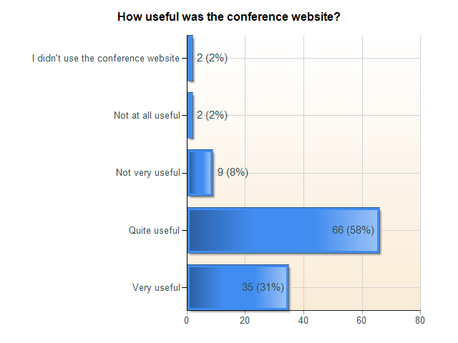

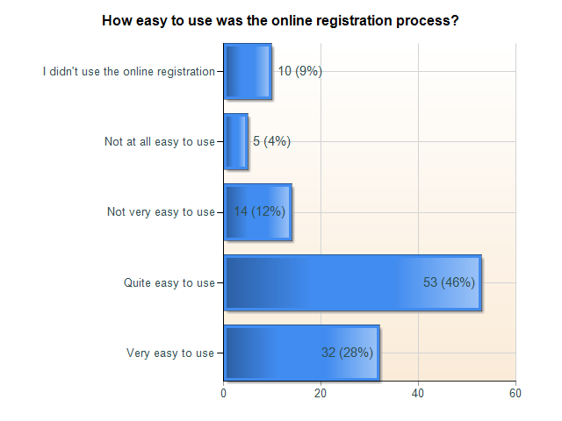

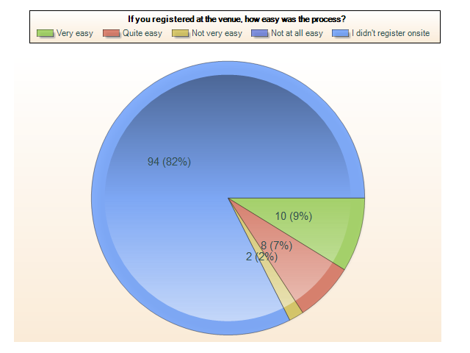

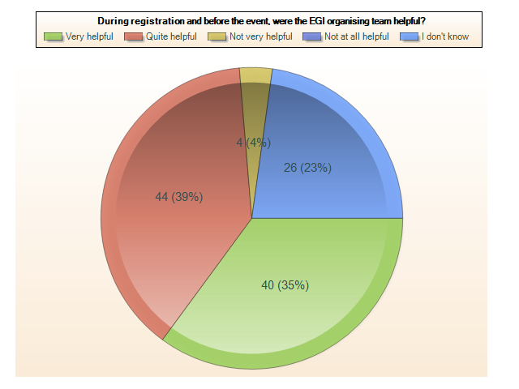

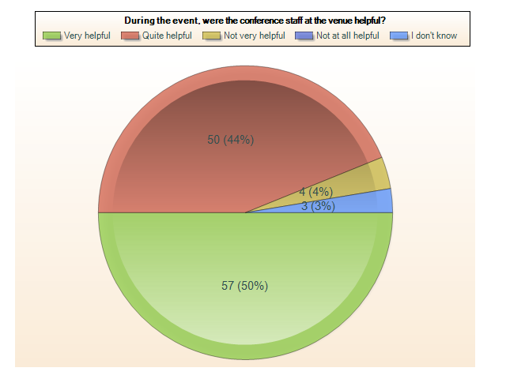

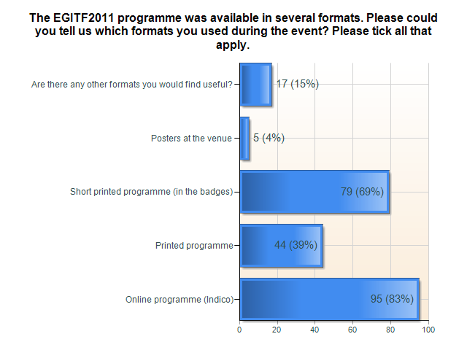

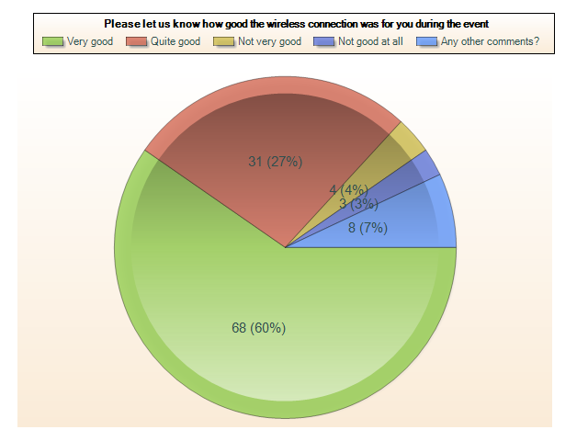

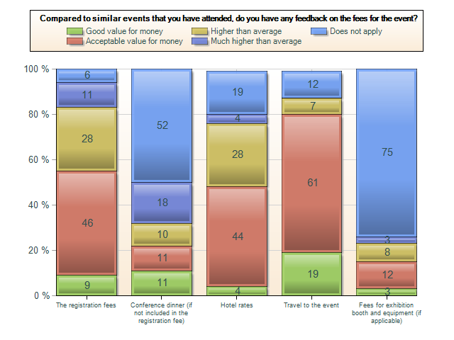

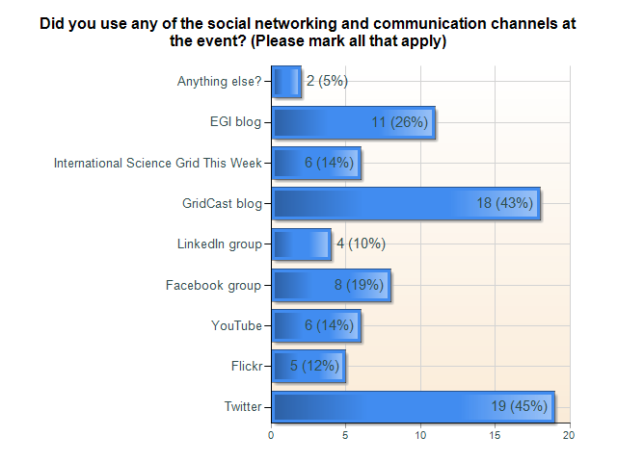

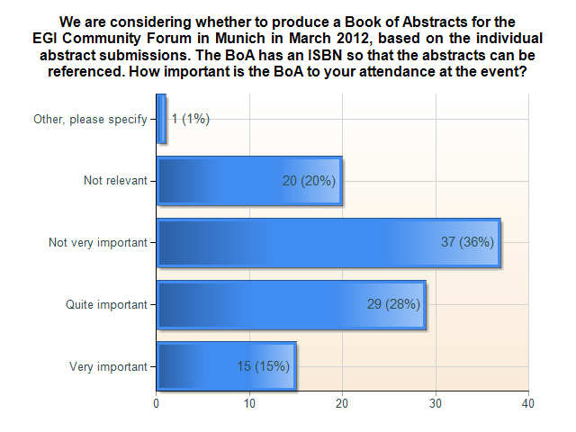

Media Appearances
- GRDI2020 Envisions New Science Paradigms, HPC in the Cloud, 22 September 2011
http://www.hpcinthecloud.com/hpccloud/2011-09-22/grdi2020_envisions_new_science_paradigms.html
- Laying the Foundation for National Grid Infrastructures, HPC in the Cloud, 21 September 2011
http://www.hpcinthecloud.com/hpccloud/2011-09-21/laying_the_foundation_for_national_grid_infrastructures.html
- European Clouds Take Center Stage in September, HPC in the Cloud, 20 September 2011
http://www.hpcinthecloud.com/hpccloud/2011-09-20/european_clouds_take_center_stage_in_september.html
- Gearing up for the EGI Technical Forum in Lyon
http://www.geant.net/Media_Centre/connect/Pages/july_2011_community_news.aspx

EGI press releases
A media release was issued:
Tabor Communications Inc. Announces Co‐Marketing Partnership for the European Grid Forum and the GlobusEUROPE Conferences
http://www.egi.eu/export/sites/egi/about/press/Press_Release_EGI_Technical_Forum_September2011.pdf

A separate media invitation was issued to 2,600 journalists through the AlphaGalileo press service, submitted to the Cordis press page and was also published on the EGI website and sent to the media contacts list and the dissemination mailing list.

