EGI-InSPIRE

MS226 EGI Community Forum

EU MILESTONE: MS226

Document identifier: | input.doc
Date: | 23/04/2012
Activity: | NA2
Lead Partner: | EGI.eu
Document Status: | FINAL
Dissemination Level: | PUBLIC
Document Link: | https://documents.egi.eu/document/1107

Abstract
Event report from the EGI Community Forum, held at the Leibniz Supercomputing Centre (LRZ) in Garching near Munich, Germany between 26-30 March 2012.

- Copyright notice
Copyright © Members of the EGI-InSPIRE Collaboration, 2010-2014. See www.egi.eu for details of the EGI-InSPIRE project and the collaboration. EGI-InSPIRE (“European Grid Initiative: Integrated Sustainable Pan-European Infrastructure for Researchers in Europe”) is a project co-funded by the European Commission as an Integrated Infrastructure Initiative within the 7th Framework Programme. EGI-InSPIRE began in May 2010 and will run for 4 years. This work is licensed under the Creative Commons Attribution-Noncommercial 3.0 License. To view a copy of this license, visit http://creativecommons.org/licenses/by-nc/3.0/ or send a letter to Creative Commons, 171 Second Street, Suite 300, San Francisco, California, 94105, and USA. The work must be attributed by attaching the following reference to the copied elements: “Copyright © Members of the EGI-InSPIRE Collaboration, 2010-2014. See www.egi.eu for details of the EGI-InSPIRE project and the collaboration”. Using this document in a way and/or for purposes not foreseen in the license, requires the prior written permission of the copyright holders. The information contained in this document represents the views of the copyright holders as of the date such views are published.
- Delivery Slip
 | Name | Partner/Activity | Date
From | Catherine Gater et al. | NA2 | 23-4-2012
Reviewed by | AMB & PMB |  | 23-4-2012
Approved by | AMB & PMB |  | 23-4-2012
- Document Log
Issue | Date | Comment | Author/Partner
1 | 20-4-2012 | First draft | C. Gater et al.
2 | 23-4-2012 | Second draft | C. Gater et al.
- Application area
This document is a formal deliverable for the European Commission, applicable to all members of the EGI-InSPIRE project, beneficiaries and Joint Research Unit members, as well as its collaborating projects.
- Document amendment procedure
Amendments, comments and suggestions should be sent to the authors. The procedures documented in the EGI-InSPIRE “Document Management Procedure” will be followed:
https://wiki.egi.eu/wiki/Procedures
- Terminology
A complete project glossary is provided at the following page: http://www.egi.eu/about/glossary/.
- PROJECT SUMMARY

To support science and innovation, a lasting operational model for e-Science is needed − both for coordinating the infrastructure and for delivering integrated services that cross national borders.

The EGI-InSPIRE project will support the transition from a project-based system to a sustainable pan-European e-Infrastructure, by supporting ‘grids’ of high-performance computing (HPC) and high-throughput computing (HTC) resources. EGI-InSPIRE will also be ideally placed to integrate new Distributed Computing Infrastructures (DCIs) such as clouds, supercomputing networks and desktop grids, to benefit user communities within the European Research Area.

EGI-InSPIRE will collect user requirements and provide support for the current and potential new user communities, for example within the ESFRI projects. Additional support will also be given to the current heavy users of the infrastructure, such as high energy physics, computational chemistry and life sciences, as they move their critical services and tools from a centralised support model to one driven by their own individual communities.

The objectives of the project are:

- The continued operation and expansion of today’s production infrastructure by transitioning to a governance model and operational infrastructure that can be increasingly sustained outside of specific project funding.
- The continued support of researchers within Europe and their international collaborators that are using the current production infrastructure.
- The support for current heavy users of the infrastructure in earth science, astronomy and astrophysics, fusion, computational chemistry and materials science technology, life sciences and high energy physics as they move to sustainable support models for their own communities.
- Interfaces that expand access to new user communities including new potential heavy users of the infrastructure from the ESFRI projects.
- Mechanisms to integrate existing infrastructure providers in Europe and around the world into the production infrastructure, so as to provide transparent access to all authorised users.
- Establish processes and procedures to allow the integration of new DCI technologies (e.g. clouds, volunteer desktop grids) and heterogeneous resources (e.g. HTC and HPC) into a seamless production infrastructure as they mature and demonstrate value to the EGI community.

The EGI community is a federation of independent national and community resource providers, whose resources support specific research communities and international collaborators both within Europe and worldwide. EGI.eu, coordinator of EGI-InSPIRE, brings together partner institutions established within the community to provide a set of essential human and technical services that enable secure integrated access to distributed resources on behalf of the community.

The production infrastructure supports Virtual Research Communities (VRCs) − structured international user communities − that are grouped into specific research domains. VRCs are formally represented within EGI at both a technical and strategic level.

TABLE OF CONTENTS
1 statistics 5
2 EVENTS/ LAUNCHES 11
2.1 MoU signings 11
2.2 Publications 11
3 Surveys 12
3.1 Zoomerang 12
3.2 General comments: 18
3.3 Feedback on Media Training 20
4 MEdia appearance 22

statistics
 |  |  |  | Number |  |  |  |  |  | Number/percentage of women
Registered participants |  |  |  | 421 |  |  |  |  |  | 80/ 19%
Contributions |  |  |  | 171 |  |  |  |  |  | 26
Speakers |  |  |  | 208 |  |  |  |  |  | 25/9%
Session conveners |  |  |  | 44 |  |  |  |  |  | 4/9%
 | EARLY |  |  |  |  | NORMAL |  |  |  |  | LATE
 | fee | registrants | dinner |  | EC | fee | registrants | dinner | EC |  | fee | registrants | dinner | EC
full week
three days
two days
one day
EC
extra
dinner
TOTAL

 | registrants | dinner | EC
early | 299
normal | 99
late | 23
TOTAL | 421 | 299
In total there were 421 participants. Of those, 120 registered for the 2nd Annual European Globus Community Forum. A total of 299 out of these went to the conference dinner.

Twitter
Total Number of Tweets 403

Tweets per day
Februray 2nd 1
Februray 17th 1
March 13th 2
March 16th 5
March 20th 2
March 23rd 1
March 24th 3
March 25th 7
March 26th 17
March 27th 125
March 28th 126
March 29th 72
March 30th 38
April 2nd 1
April 4th 2

Tweets by EGI 77
EuropeanGrid 49
EGITech 5
EGIUsers 6
EGIPolicy 17

Total Number of Twitter users - 60
e_scitalk 77
europeangrid 49
torstenreimer 31
primeurmagazine 23
Machar 22
EGIPolicy 17
gridpp 14
SergioDCI 11
CatherineGater 11
Contrailproject 10
ohjajog 10
isgtw 9
nimp0 7
SCIBUSproject 7
brusisceddu 6
candiello 6
EdwardKaravakis 6
naomiwv 6
EGIUsers 6
EGITech 5
gridfederation 5
richardnixonhed 4
sienainitiative 4
Woods90 4
TheSAGrid 5
hsucht 3
lezzidan 3
m3drano 3
neasan 3
alainvanhoof 2
simonl 2
Walisisch 2
writerinsw17 2
NetRicky 2
anniblu 1
BIFI_Instituto 1
BoincRussiaTeam 1
CESGA_ 1
ClaudineMoulin 1
CmsSage 1
CReATIVEB2 1
fmatorras 1
geekeconomist 1
Ibercivis 1
jgfanjul 1
josealivivas 1
martwine 1
mike_priddy 1
pavlozahozhenko 1
Promezium 1
REACCIUN 1
soilandreyes 1
SpaceKangaroo 1
tharandur 1
VENUSCProject 1
webcommunicatie 1
worlduniranking 1
ifttwow 1
ISChpc 1
okoeroo 1

Examples:
Steven Newhouse from EGI asks whether we can develop a 'human cloud' at #egicf12. - https://twitter.com/#!/naomiwv/status/184618998980284416
Richard McLennan from EGI asks Steve Tuecke: How does all this agility not become chaos? at #egicf12. A: Discipline + 'embrace the chaos'. - https://twitter.com/#!/naomiwv/status/184650985023606784
How many users are registered with EGI? Over 20.000 http://bit.ly/H7mvfO at #egicf12 - https://twitter.com/#!/primeurmagazine/status/184576843851116545
#EGICF12 Newhouse suggests EGI may have to operate in more flexible way, offering specific, shorter-term offerings to research communities. - https://twitter.com/#!/torstenreimer/status/184617584967159812
Setting up clouds with open source middleware appears to be competitive with giant commercial providers! http://bit.ly/GVHuS5 at #egicf12 - https://twitter.com/#!/candiello/status/184981199431802880
Nice responses from the room at #egicf12 for example interesting development taking place in Greece: https://cms.okeanos.grnet.gr/services/pithos - https://twitter.com/#!/ohjajog/status/184940255722487808
#EGICF12 Dutch BigGrid present BeeHub project for scientific data sharing: https://www.beehub.nl/ Will it lure people away from DropBox? - https://twitter.com/#!/torstenreimer/status/184935593745199105

Flickr
The number of photos uploaded in Flickr using the egitf11 tag, is 220

Conference4Me Downloads
Android: 106 users
iPhone: 48 users

Short links
Registration short link (http://go.egi.eu/registration-cf12): 1297 clicks

YouTube
14 videos

GridCast
31 posts –including 14 videos
Bloggers:
Beatrice Bressan, CERN
Elizabeth Leake, freelance journalist US
Agnes Szeberenyi, SZTAKI LPDS, Hungary
Sean Crosby, ATLAS, Australia
Martin Veichert, University of Copenhagen, Denmark
Oxana Smirnova, Lund University, Sweden
Stefan Janusz, e-ScienceTalk, UK
Zara Qadir, e-ScienceTalk, UK
Corentin Chevalier, e-ScienceTalk, UK
Adrian Giordani, iSGTW, CERN

Visits | 644
Unique visitors | 402
Pages viewed | 1189
Average number of pages viewed | 1.85
Average time spent on the site | 3:51
New visits | 58%

Website
Table 1. : Number of visitors between 1 January and 25 March, 2012. Compared with values from the User Forum website taken between 1 January 2011 and 10 April, 2011
Metric | Value | UF11 Value [% difference]
Visits | 5,385 | 6,246 [-13.8 %]
Unique visitors | 1,732 | 2,330 [-25.7 %]
Pages viewed | 15,679 | 16,920 [-7.3 %]
Average number of pages viewed | 2.91 | 2.71 [+7.4 %]
Time spent on the site | 03:01 | 02:46 [+9.0 %]
New visits | 27.65% | 37.30% [-25.9 %]
Highest number of visits in a day | 229 (23 March) | 221 (8 April) [+3.6 %]
Table 2. Number of visits on the week of the Community Forum (26-30 March)
Metric | Value | UF11 Value [% difference]
Visits | 1,537 | 1,178 [+30.5 %]
Unique visitors | 661 | 549 [+20.4 %]
Pages viewed | 3,746 | 3,141 [+19.3 %]
Average number of pages viewed | 2.44 | 2.67 [-8.61 %]
Time spent on the site | 02:13 | 02:37 [-15.3 %]
New visits | 22.32% | 26.15% [-14.7 %]
Highest number of visits in a day | 416 (27 March) | 451 (11 April) [-7.8 %]

EVENTS/ LAUNCHES

MoU signings
- EGI and SCI-BUS

Publications
- Combined conference programme / Book of Abstracts
- Mini programme for the badges

Surveys

Zoomerang
Event survey conducted on Zoomerang, issued on Friday 30 March, open until Monday 23 April.
122 responses

Summary of feedback:
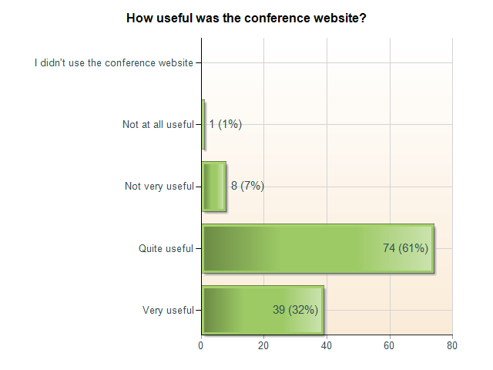

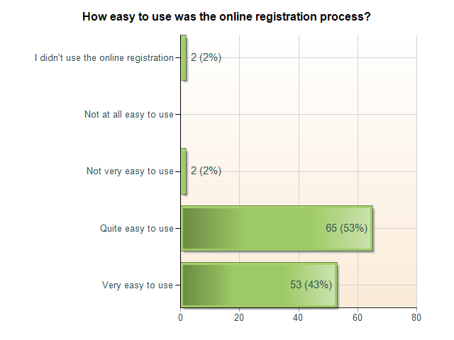

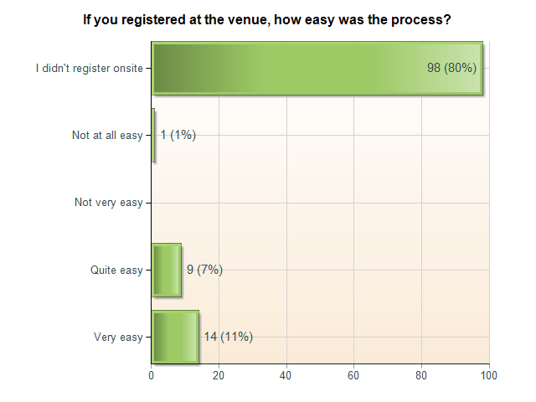
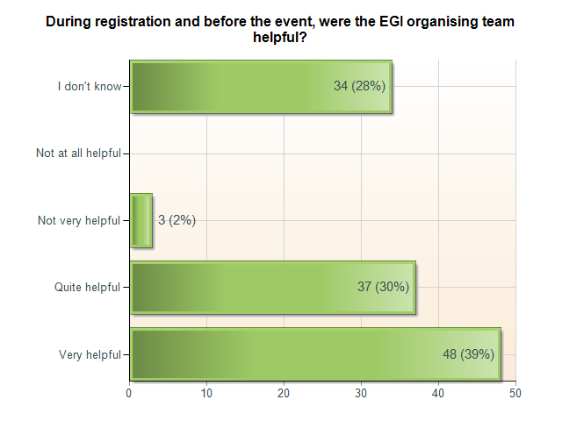

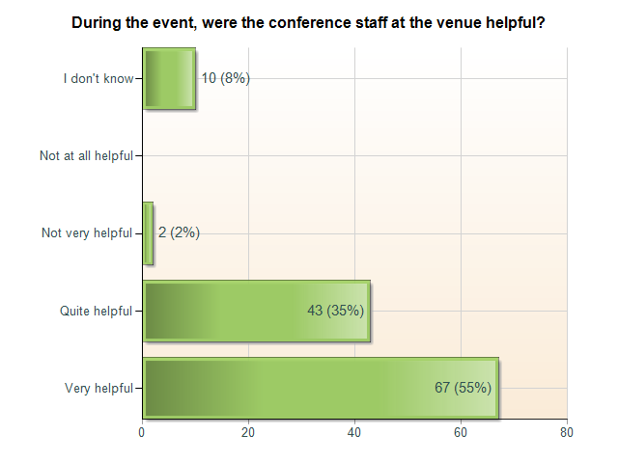

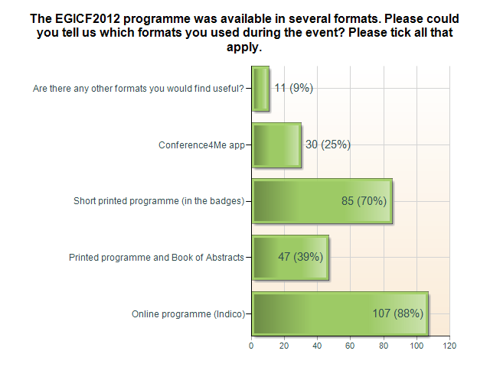

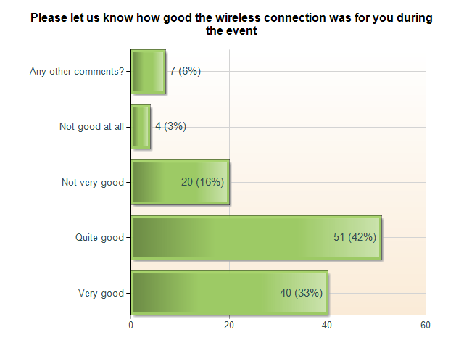

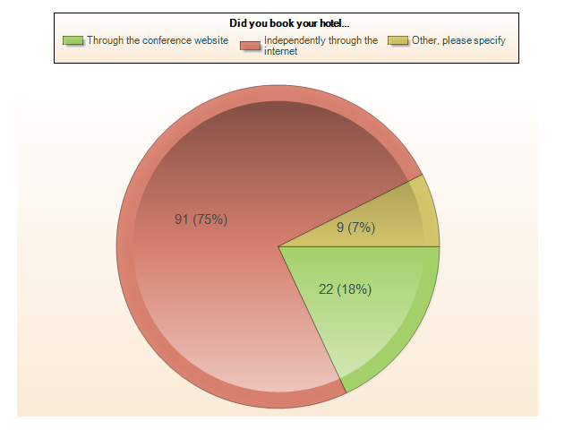
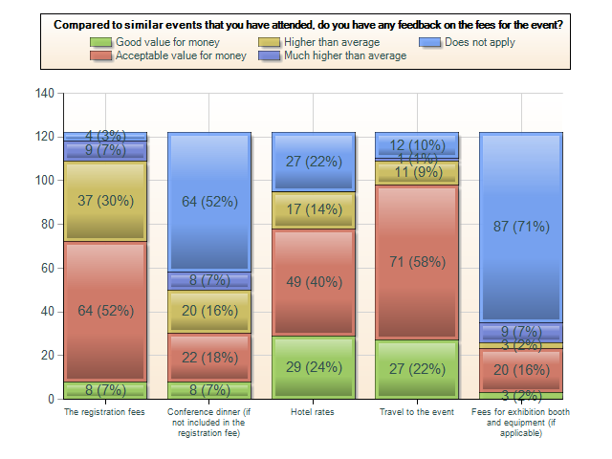

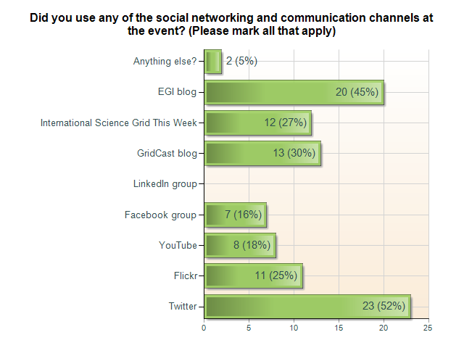

General comments:

- Catering
“Truly excellent catering services, delicious and well planned snacks during the breaks and fantastic, friendly and professional staff!”
“Best conference to date I thought.”
“Everything was very well organized, coffee breaks OK as well as lunchtime catering, well selected dishes”
“All good good idea to spread out the coffee/cake points as you did later in the week, to make sure people move around the stands and posters”
- Conference dinner
“It was excellent. Well organised, great food, good staff, and vitally the speeches etc were nice and short! I was skeptical a buffet would work but it was really effective.”
“good example of bavarian cuisine. Perhaps buffet caused a bit of a scrum to start!”
- Conference materials
“The conference bag was a really good size as it allowed me to carry my laptop in it easily; the programme booklet was very well produced.”
“Online program loaded quite slowly at times. Conference bag was good, one of the few conference gifts I may use again!”
“To be honest I don't see any need for paper materials.”
“The online program was very difficult to read if ones wanted to have all details about sessions - the printed program was great!”
“Less paper, more electronic would be preferrable and more fitting the community”
- Other formats for the programme?
“User-configurable iCal feed like http://tools.ietf.org/agenda/83/calendar”
- Wifi
“Good, but didnt like the fact that it was open wifi”
The wireless connection was not healthy at some points and rooms but it was reasonable in general.”
- Venue
“The building was beautiful and pleasant. the installations for the conference were good, however i missed some "bell" to announce the start of the sessions, as well as proper presenting materials (one laptop ran out of battery during a talk, there were no pointers..) moreover, the locations were too spread, and the room indications were not clear.”
“Venue was a bit far away from the city center, but it was really well connected via underground so it was OK. The rooms were very comfortable because the seats were very ergonomic. Plus points because the rooms had a lot sockets to plug laptops easily accessible. Sound was really good.”
“I am very positive (the access was easy, the conference rooms fine, and the large hall which accommodated all participants, posters and exhibition booth, with tables and benches, eased all kind of interactions).”
“Generally excellent. Power sockets were widely available in the "Halls". Travel to the venue was fine, although I think I missed clear instructions on getting from the airport to the venue and so travelled a long route into Munich city centre and back out to the venue. Also, please continue to host these conferences in cities that are well served by airports, have good public transport, etc. Resist the temptation to move them to more "exotic" locations outside major cities...”
- Demo booths
“Booth costs were high but this has been the case for the last few years. Booth positions were not great as some were very far away from the food. Would have been good if they had moved the food tables on Tuesday afternoon instead of Thurs morning. Finding out why delegates don't really visit the exhibition stands would be good as they don't seem to circulate round them - why? Are they completely uninterested, do they know it all already etc?”
“I liked very much the idea of the demo booth dedicated to a single demo for an entire day.”
“Cooperation worked really well both before and during the event, instructions were clear and all worked effortlessly and efficiently.”
- Feedback on the new EGI website
“Congratulations, well planned site, easy to navigate, not too packed with technical details, good and clean look&feel!”
“looks great!”
“governance and social media is a bit more difficult to find - at least for me.”
- General comments
“About the format: there were too many competing sessions (certainly on tuesday and wednesday). The audiences were small. Many topics and talks were overlapping. I believe it would be in the interest of all (presenters and audience) to have a more selective program and less parallel sessions in a more compact conference.”
“I booked in for only one day (the day I was due to present) because I was not sure whether the event would be for me/worthwhile. In fact, I was very pleasantly surprised and would happily have stayed longer. Next time!”
“Maybe it is good to have less parallel sessions. A few sessions that I wanted to attend were at the same time. The people were spread over many rooms, so sometimes the room/hall was a bit empty.”
“Conference was an excellent opportunity for interesting talks - and more importantly to network with people - it's a very efficient way to solve problems face to face. Make sure you keep the coffee breaks long - for networking and for when the talks run over time.”
“Overall good event, good speakers and good networking opportunities.”
“I love EGI conferences.”

Feedback on Media Training

1. What was the best bit about the course today?
it was useful to hear the voice of experts and to exchange opinions with colleagues facing the same problems and difficulties and having more or less the same goals.

2. What was the least useful element for you?
There were no "least" useful elements! The course was very interesting indeed!

3. Would you recommend similar training to colleagues and why (or why not)?
I would recommend it, for the same reason above and because I think it's useful to exchange opinion on the topic and do it in such a lively way.

4. What future training would you be interested in?
Some of us are asked to do dissemination, but aren't actually professional researchers. What/how we are suggested to do by professional communication people is not what researchers would like to see in press cuts (or similar). It's hard to convince researchers that their language needs to be "translated" into a simpler one. It would be nice to have a meeting where some research/disseminators could simultaneously interact. Many researchers do need to know more about communication, as well.
“I was very satisfied after the media training on Monday, I enjoyed it and I think was really useful to me. The part I liked most, and I think was most useful, are the 'hands-on' (interviews and press conference), because they put me on the 'other side', so giving me a different perspective allowing me to see which are the largest gaps that I should fill. I would recommend this training to everyone involved in scientific communication; for the future I would be interested on more specific trainings, for instance, given a subject, how to write a press release, or a dissemination article (though these parts could have been already covered, I could join the training only after lunch). I think that a training focused on social network communication could be useful as well.”
Further feedback at http://gridtalk-project.blogspot.de/2012/03/how-media-works-how-to-get-stories.html

MEdia appearance

http://www.1news.az/society/20120329093604633.html
www.isgtw.org/visualization/isgtw-gridcast-egi-community-forum-2012
http://cordis.europa.eu/wire/index.cfm?fuseaction=article.Detail&rcn=29615&rev=0
http://infteam.jiscinvolve.org/wp/2012/04/13/beyond-grid-vs-cloud-%E2%80%93-egi-community-forum-2012/

