EGI-InSPIRE

Deployed Middleware Support Unit Operations Procedures

EU MILESTONE: MS511

Document identifier: | input.doc
Date: | 19/06/2012
Activity: | SA2
Lead Partner: | EGI.eu
Document Status: | DRAFT
Dissemination Level: | PUBLIC
Document Link: | https://documents.egi.eu/document/1134

Abstract
This document is an extensive update of MS502 and MS507. It provides an overview of current DMSU operational procedures. Agreed changes in the relationship to technology providers, in particular the ticket follow-up are discussed. Metrics evaluating both DMSU and TP performance are presented. Finally, a proposal of reorganisation of the EGI software support is outlined.

- Copyright notice
Copyright © Members of the EGI-InSPIRE Collaboration, 2010-2014. See www.egi.eu for details of the EGI-InSPIRE project and the collaboration. EGI-InSPIRE (“European Grid Initiative: Integrated Sustainable Pan-European Infrastructure for Researchers in Europe”) is a project co-funded by the European Commission as an Integrated Infrastructure Initiative within the 7th Framework Programme. EGI-InSPIRE began in May 2010 and will run for 4 years. This work is licensed under the Creative Commons Attribution-Noncommercial 3.0 License. To view a copy of this license, visit http://creativecommons.org/licenses/by-nc/3.0/ or send a letter to Creative Commons, 171 Second Street, Suite 300, San Francisco, California, 94105, and USA. The work must be attributed by attaching the following reference to the copied elements: “Copyright © Members of the EGI-InSPIRE Collaboration, 2010-2014. See www.egi.eu for details of the EGI-InSPIRE project and the collaboration”. Using this document in a way and/or for purposes not foreseen in the license, requires the prior written permission of the copyright holders. The information contained in this document represents the views of the copyright holders as of the date such views are published.
- Delivery Slip
 | Name | Partner/Activity | Date
From | Aleš Křenek | CESNET/SA2
Reviewed by | Moderator:  Reviewers:  <<To be completed by project office on submission to AMB/PMB>>
Approved by | AMB & PMB  <<To be completed by project office on submission to EC>>
- Document Log
Issue | Date | Comment | Author/Partner
1 | June 12, 2012 | First draft | Aleš Křenek/CESNET
2 | June 19, 2012 | Reflected the first SA2 review comments and added missing sections. | Aleš Křenek/CESNET
3
- Application area
This document is a formal deliverable for the European Commission, applicable to all members of the EGI-InSPIRE project, beneficiaries and Joint Research Unit members, as well as its collaborating projects.
- Document amendment procedure
Amendments, comments and suggestions should be sent to the authors. The procedures documented in the EGI-InSPIRE “Document Management Procedure” will be followed:
https://wiki.egi.eu/wiki/Procedures
- Terminology
A complete project glossary is provided at the following page: http://www.egi.eu/about/glossary/.

- PROJECT SUMMARY

To support science and innovation, a lasting operational model for e-Science is needed − both for coordinating the infrastructure and for delivering integrated services that cross national borders.

The EGI-InSPIRE project will support the transition from a project-based system to a sustainable pan-European e-Infrastructure, by supporting ‘grids’ of high-performance computing (HPC) and high-throughput computing (HTC) resources. EGI-InSPIRE will also be ideally placed to integrate new Distributed Computing Infrastructures (DCIs) such as clouds, supercomputing networks and desktop grids, to benefit user communities within the European Research Area.

EGI-InSPIRE will collect user requirements and provide support for the current and potential new user communities, for example within the ESFRI projects. Additional support will also be given to the current heavy users of the infrastructure, such as high energy physics, computational chemistry and life sciences, as they move their critical services and tools from a centralised support model to one driven by their own individual communities.

The objectives of the project are:

- The continued operation and expansion of today’s production infrastructure by transitioning to a governance model and operational infrastructure that can be increasingly sustained outside of specific project funding.
- The continued support of researchers within Europe and their international collaborators that are using the current production infrastructure.
- The support for current heavy users of the infrastructure in earth science, astronomy and astrophysics, fusion, computational chemistry and materials science technology, life sciences and high energy physics as they move to sustainable support models for their own communities.
- Interfaces that expand access to new user communities including new potential heavy users of the infrastructure from the ESFRI projects.
- Mechanisms to integrate existing infrastructure providers in Europe and around the world into the production infrastructure, so as to provide transparent access to all authorised users.
- Establish processes and procedures to allow the integration of new DCI technologies (e.g. clouds, volunteer desktop grids) and heterogeneous resources (e.g. HTC and HPC) into a seamless production infrastructure as they mature and demonstrate value to the EGI community.

The EGI community is a federation of independent national and community resource providers, whose resources support specific research communities and international collaborators both within Europe and worldwide. EGI.eu, coordinator of EGI-InSPIRE, brings together partner institutions established within the community to provide a set of essential human and technical services that enable secure integrated access to distributed resources on behalf of the community.

The production infrastructure supports Virtual Research Communities (VRCs) − structured international user communities − that are grouped into specific research domains. VRCs are formally represented within EGI at both a technical and strategic level.

- EXECUTIVE SUMMARY
The document describes the operational procedures of the Deployed Middleware Support Unit (DMSU) in EGI. The daily work of reactive support on tickets coming in through GGUS is presented as well as other DMSU tasks like production of documentation, assessment of requirements, and monitoring of other user fora.
Revisions of the procedures with respect to the previous period are discussed, in particular the new procedures defined for handling high- and low-priority issues in a different manner.
Section 4 provides two sets of metrics – those related to DMSU performance and those covering behavior of technology providers. Phenomena revealed by collecting these metrics are discussed in detail, and some further metrics are suggested.
Finally, the proposal for changes in the EGI software support (merge of 1st line TPM with DMSU) is described.

TABLE OF CONTENTS
1 Introduction 7
2 DMSU Operation 8
2.1 Initial ticket analysis and assignment 8
2.2 Ticket resolution 9
2.3 Monitoring user fora 10
2.4 Requirement assessment 10
2.5 Production of FAQs and documentation 10
3 Relation to technology providers and Ticket Followup 12
3.1 Follow-up of high priority issues 12
3.2 Follow-up of lower priority issues 13
4 Metrics 14
4.1 DMSU workload and performance 14
4.2 Technology provider workload and performance 15
5 Proposed Changes in Software Support 17
5.1 Current situation 17
5.2 Proposed roles and responsibilities 17
6 Conclusion 19
7 References 20

Introduction

The Deployed Middleware Support Unit (DMSU) [R1] is a global task in the EGI infrastructure responsible for the second-line support of the middleware technology which is in current use on the EGI infrastructure. The main motivation of establishing DMSU emerged from the split of the EGEE series of projects. In the EGI model there is no single-project based control on the middleware development and support. Therefore EGI itself has to run a software support unit in order to achieve certain stability and control of the support task. DMSU initial organization was described in [R2], updates after the first project year were presented in [R3].
In PY2 DMSU procedures were revised in order to address issues identified in PY1, in particular the low ratio of tickets actually addressed by DMSU. The new procedures were discussed, documented at the extensively revised DMSU wiki [R1], and their current state is described in Sect. 2 of this document.
In final months of PY2 further reorganization of the software support in EGI, with the most visible consequence of merging TPM and DMSU, was discusses and approved by PMB. The detailed reasons for the reorganization as well as the proposed model are described in Sect. 5.

DMSU Operation
The principal task of DMSU is handling the tickets arriving to GGUS which are related to problems with middleware, suspect software defect, point at insufficient or unclear documentation etc. The current processes of this task are described in sections 2.1 and 2.2.
Further, DMSU members follow other fora where middleware problems are discussed (sect. 2.3), helps to assess software requirements coming to EGI (sect. 2.4). Finally, DMSU produces digests of the solved problems and other documentation on demand (sect. 2.5).
The rest of this section describes the current status and procedure of these tasks in more detail. Section 4 provides quantitative assessments of this work (numbers of tickets, timings etc.).

Initial ticket analysis and assignment
Initial DMSU process design [R1] assumed the first line support (TPM) to assess the incoming tickets and, according to the table of expertise (“DMSU cheat sheet”), assign them to DMSU individuals. Only minority of tickets would reach DMSU unqualified in this way. However, this foreseen process has never come true, for two reasons:
- assessment of many tickets is not trivial, even in the aspect of detecting in which of dozens middleware components is the problem suspected,
- internal schedule and load-balancing of the DMSU people can’t be easily achieved in this way.
Therefore alternate approach is currently followed. TPM assigns a middleware related ticket to DMSU as a whole. DMSU runs a weekly rotating duty of shift. The person on shift, drawn from the pool of people who have larger DMSU effort allocated (in [R2,R3] known as assigners) has much deeper middleware knowledge than the TPM staff, and he/she attempts to start solving the problem him-/herself, e.g. requesting the submitter for further information. If the problem turns not to be easy, the person on shift typically assigns the ticket to one of the DMSU experts. He/she is aware of the DMSU people specialised expertise as well as their current load, and he/she is able to assign the tickets in a meaningful way.
The individual work of the person on shift is complemented by regular jabber meeting of the assigners. Those meetings are organised weekly, and they may last for quite long time (several hours). The open tickets assigned to DMSU are revised one after another, and they are discussed. The experience proves this approach to be very efficient. Because typically more difficult issues remain in the DMSU queue to be discussed at the meeting, they are worth to be approached collectively, combining the expertise of the participating people. The meeting is not limited to the assigners, if there is specific need, further DMSU experts are invited. The jabber format of the meeting was chosen intentionally – people are brought together, they work on the same topic, and they keep exchanging ideas. However, the discussions are not extremely extensive, and they are complemented with e.g. 10-minutes periods of source code inspection, attempts to reproduce the problem etc. For this purpose tele- or video conference format is not suitable. On the contrary, running weekly teleconferences which last even for 3-4 hours would be extremely exhausting for the participants.
In fairly rare occasions (cf. metrics in Sect. 4.1) it is found out that a ticket should have not been assigned to DMSU because it reflects a pure operational problem etc. In this case the tickets are reassigned back to TPM with a comment on appropriate direction it should take.
Two years of experience show a strong imbalance among representation of different middleware stacks in the incoming tickets. Vast majority of the tickets (over 90%) are related to former gLite components. Therefore the rotating shift is run among people with gLite background. On the contrary, the weekly meetings are attended by the representatives of the other middleware stacks as well.

Ticket resolution
Ticket resolution is typically done under supervision of one of DMSU team members with appropriate expertise. Tickets are either assigned explicitly to a single person, or the assignment is apparent from the context. As only 10—20 tickets are open typically at the same time in DMSU, the informal approach is still feasible.
The first mandatory step of DMSU work on a ticket is understanding what is the reason of the reported problem. The outcome of the analysis is documented with the ticket, preferably as a response to the user. The analysis may or may not include thorough reproduction of the problem; it is left to common sense.
During the analysis DMSU also adjusts Type of problem and Ticket category fields eventually. Because ticket submitters may have subjective view on the problem severity, the ticket priority is assessed to match the following guidelines, which give unified view on the priority handling:
- Top Priority. Issues which affect the entire infrastructure, its significant portion, or a very large number of users, with paralyzing impact. Immediate reaction is required. DMSU work is restricted for the sake of speed, mostly to assessment whether the ticket really deserves Top-priority category. Once this is confirmed, the appropriate 3rd line support unit is involved (to get an early warning). In general, no thorough, time-consuming analysis is done, and the ticket is reassigned to the 3rd line support quickly.
- Very Urgent. Issues of broad impact, where no workaround is known or feasible. DMSU should react on the same day preferably. The ticket should not be delayed for more than 2 working days before reassignment to 3rd line, while preserving all the ticket handling guidelines described here.
- Urgent. Issues of impact on significant user community, however, affecting only some patterns of their work, and with a workaround generally available. DMSU should react in 2 working days preferably to assess the priority and to produce first results of the ticket analysis in 5 working days.
- Less Urgent. Less significant issues with either easy workaround or marginal impact. DMSU should produce first results of the ticket analysis within 2 weeks.
Typically, the analysis involves communication with the users. DMSU sets ticket state to Waiting-for-reply whenever expecting feedback by the user. It is foreseen GGUS will implement automatic switch to In-progress when the user answers.
DMSU expertise should cover most tickets. When necessary developers (i.e. the 3rd line support) can be involved for brief consultation informally (though they are not obliged to answer and they do so on their good will). As long as DMSU can make some progress, the control on the ticket is still kept within DMSU, i.e. the ticket is not reassigned to another support unit. On the other hand, tough issues when DMSU expertise runs out should be still reassigned.
The GGUS fieds Component name and Component version are assigned appropriate values. If the problem spans multiple compoments and 3rd support action is needed, the ticket is cloned (one new ticket per component), and the clones are linked appropriately with the original.
The principal criterion whether to assign the ticket to 3rd line support is the need to make changes in code, documentation, default configuration etc., i.e. release of anything by the technology provider. A ticket should not leave DMSU before there is strong evidence that such changes are or are not necessary to provide a clean solution (i.e. not a temporary workaround) to the reported problem. If there is no such need, DMSU describes solution to the ticket in the final comment, and the ticket is closed.
Otherwise, the ticket is reassigned to the appropriate 3rd line support unit. In this case, the most recent comment (i.e. on reassignment) should contain a brief summary of the DMSU analysis on the ticket, pointing to what is wrong exactly, how to reproduce the problem etc., so that 3rd line supporters don't have to gather all information from the ticket correspondence, which tends to be rather long.
A special case are tickets that were solved in DMSU but they require comment by th 3rd line, i.e. to confirm feasibility of the solution. Those tickets should be closed in DMSU just with a comment indicating the 3rd line was contacted, and the 3rd line approached by other means. The standard GGUS workflow must not be used for this communication, in order to keep the statistics clean, mostly.
When the user does not react on a raised question, she is typically reminded weekly, on the DMSU meetings. If there is no reaction for more than one month, the ticket is closed as unsolved.

Monitoring user fora

DMSU follows other user and system administrators fora and national mailning lists, where problems related to the same software are discussed. DMSU members contribute to discussions there, and bring issues with broader impact as new GGUS tickets. The following are the main ones:
- lcg-rollout@jiscmail.ac.uk – legacy named list used for discussing deployment problems at many EGI sites
- unicore-support@unicore.eu – main support channel for UNICORE middleware, installation and configuration questions as well as runtime problems and site specific UNICORE extensions are discussed there. Bug tracker http://sourceforge.net/tracker/?group_id=102081 is also regularly checked for these issues.
- unicore-devel@unicore.eu – UNICORE developer issues
- dpm-users-forum@cern.ch – active list for DPM specific issues
- user-forum@dcache.org – specific dCache mailing list
- nordugrid-discuss@nordugrid.org – operational issues of NorduGrid. ARC Bugzilla is also followed.

Requirement assessment
Some of tickets arriving to DMSU are classified (either initially or during their analysis) as requirements requesting additional functionality. In addition, resolving incident tickets may yield further requirements on functionality. DMSU assesses such requirements in terms of estimated effort to implement. If the effort is not large, the requirements are assigned to the 3rd line support as urgent or less urgent priority tickets. On the contrary, in the case of considerable estimated effort a ticket is spawned through the standard EGI requirements gathering channel – the requirements queue in EGI RT, linking the GGUS and RT ticket with each other in a bidirectional manner. Additionally, the countertickets in the RT requirements queue are marked with a “DMSU” tag for further tracking. However, the middleware functionality is quite stable, only very few such requests were generated.
On the other hand, the requirement evaluation team of EGI may need to request DMSU expertise to assess an arriving requirement. Technically, this is processed as a ticket submitted to GGUS which is analyzed and commented by DMSU and closed then. Again, such requests are quite rare, not more than 1—2 per month typically, not consuming large DMSU effort.

Production of FAQs and documentation
Some of issues identified during ticket resolution may not affect the individual submitter only but they have broader impact. In order to make the EGI operations and users aware of such issues in advance, DMSU provides digests of such problems. In particular, symptoms, impact, and possible workarounds are documented at the wiki [R4]. This process was introduced in PY2, getting quite positive feedback already.
DMSU expertise is also leveraged in preparation of specific documentation which targets specific middleware usage on the EGI infrastructure and which reaches beyond the standard documentation provided by technology providers. In PY2 three such manuals (BDII high availability, VOMS replication, and WMS best practices) were produced on request of EGI Operations, and they were made available as [R5].

Relation to technology providers and Ticket Followup
As outlined in Sect. 1 DMSU contributes to the EGI-side of interface between EGI and the external technology providers – software developers. Essentials of this relationship and the split of responsibilities were described in [R2] (in particular which type of problems falls to DMSU and the TP, cf. Sect. 2.1). Typically, there is a bilateral Memorandum of Understanding document defining the general terms, and a specific Service Level Agreement. With respect to handling software issues, SLA typically defines maximum reaction times the technology provider is obliged to provide a feedback to a reported issue.
The original model of [R1] and [R2] assumed that each ticket gets an Estimated Time of Arrival (ETA) of the fix individually. However, in PY2 it turned up that such an individual ticket handling both yields unnecessary bureaucratic load on both sides, and that it is rather unrealistic in many cases anyway. Therefore the process was revised extensively, ETA is managed for high-priority issues only. Details are given in Sect. 3.1 and 3.2.
In PY2 the problem of appropriate ticket follow-up was identified as well. The GGUS ticket submitters interact with EGI in the role of “customer”. Therefore, emerging from this relationship, EGI should be responsible for the resolution of the reported issue, at least from the point of view of the ticket submitter. However, as the ticket is reassigned in GGUS to another support unit handled by the TP, the direct control by EGI is lost. At this point, two risks are identified: an urgent issue may not be solved with appropriate priority in time, and the less urgent issues may cumulate, creating an ever-increasing backlog which is not cleaned up appropriately. In order to regain the control and to avoid the risks, while not imposing inappropriate routine load on the highly-qualified DMSU staff, the processes of the ticket follow-up were defined and agreed with major TPs. Details differ by ticket priority and they are described in the following sections again.

Follow-up of high priority issues
High priority issues include Top-priority and Very-urgent ticket priorities in GGUS. These issues were identified to have serious impact on the infrastructure operation and its users. On the other hand, experience shows that these priority levels are very rare, top priority occurs only once per several months, and there are only up to few dozens very urgent ones per year (see ticket statistics in Sect. 4.1). Therefore it is both desirable and feasible to give special care to these tickets, including manual one-by-one follow up.
When such ticket is assigned to 3rd line, the TP is obliged to response to it within the timeframe given by SLA. For these tickets ETA is also assigned subsequently by the TP. Assignment of ETA is essential for EGI Operation to plan accordingly (e.g. whether to deploy emergency workarounds).
The assignment of ETA is checked by DMSU, it is urged when it seems to be delayed, and it is checked whether it meets expectations. Eventual discrepancies are negotiated with the TP.
When the ETA time arrives, DMSU checks whether the fix was delivered. If not, TP is requested to provide a new estimate and an appropriate justification. If there are doubts, the tickets can be escalated to TCB.
Typically, SLA defines the reaction time to be 4 hours for Top-priority and 2 working days for Very-urgent (numbers taken from [R6]). The ETA is not strictly specified by the SLA, as a thorough solution even of an urgent issue may not be feasible in short time. However, there is an agreement at the TCB level that Top-priority issues have as short ETA as possible, typically triggering an unscheduled release of the affected component. Very-urgent issues are resolved to provide a fix in the next scheduled release, with an upper limit of 45 days (the default ETA).
In order to track the process properly, a new ETA field was added to GGUS.

Follow-up of lower priority issues
On the other hand, lower priority issues have rather limited impact, and they are far more frequent. Therefore a complementary approach to their follow-up is taken.
First, it is not feasible to assign a meaningful ETA to such tickets. Their fix cannot be reliably scheduled specifically because of the low priority while arrival of work of higher priorities is not known in advance to the TP. Therefore the tickets are queued and approached by the TP as the resources become available.
It's also agreed that solving all submitted tickets may even reach beyond the capabilities of TP. Therefore the “Fedora approach” of closing low-priority tickets after a timeout, regardless of the fix availability, is taken. This is a trade-off approach, avoiding the ever-increasing backlog of tickets. If the reported problems persist, and users are still affected, they are expected to submit new tickets.
More specifically, the following is expected from TP:
- When a fix is available in a revision or minor release, the ticket is closed as solved.
- Before a major release, the TP is expected to run a pre-release campaign on all open tickets.
- Issues that can be solved with feasible effort are fixed in this campaign and the fixes are scheduled for the upcoming major release.
- Tickets older than 6 months which are not being solved in the upcoming release are closed as unsolved.
Then, DMSU checks the open low priority tickets on UMD releases (typically every 6 weeks):
- All low-priority tickets older than 6 months (counting the date of assignment from DMSU to TP) for which there was a release of the affected component in-between, are identified.
- A summary report is generated and sent to the TPs so that forgotten tickets can be closed as solved first.
- After a grace period of 2 weeks all remaining tickets on the list are closed as unsolved.
Altogether, the process guarantees that:
- as the worst case, there are no issues older than 6 months left opened after a major release;
- if there are minor and revision releases more frequently, the number of old opened issues is reduced gradually, even between major releases.
The described process requires certain technical support in GGUS and the EGI software repository in order to generate the summary report of open tickets. For this purpose, new fields Affected component and Component version were added to GGUS, and their available values are populated from the software repository. Setting of those fields becomes mandatory when tickets are reassigned from DMSU to the TP support units. Then the required report can be generated by combining GGUS query with the information on the released components in the repository.

Metrics
The initial design of DMSU in [R1] proposed a rich set of tentative metrics. The set was revised consequently, mostly according to the revised process of ticket follow-up (Sect. 3). The rest of this section provides the metrics collected in PY2.

DMSU workload and performance
The principal metric which describes the amount of work done by DMSU is the “inflow” traffic, number of tickets assigned to it. The metric is complemented with the “outflow” traffic, i.e. numbers of tickets solved in DMSU, returned back to TPM, and reassigned to 3rd line support. summarizes these metrics per quarter:

Metric | PQ5 | PQ6 | PQ7 | PQ8
Assigned to DMSU | 218 | 183 | 173 | 212
Solved by DMSU | 37 | 27 | 53 | 53
Reassigned to TPM | 20 | 18 | 23 | 22
Assigned to 3rd level support | 175 | 137 | 118 | 139
Mean/median time to solve in days | 24/4.2 | 17/11 | 21.4/5.1 | 11/1.9
Table 1: Numbers of tickets processed by DMSU in PY2 and solution times for those solved by DMSU.
The number of tickets oscillates, however, it had reached a more or less stable level. It’s montly distribution is shown in Figure 1 where the peaks represent preparation of UMD-1 in June 2011, and release of WMS, a large and extensively used complex software component, in January 2012.

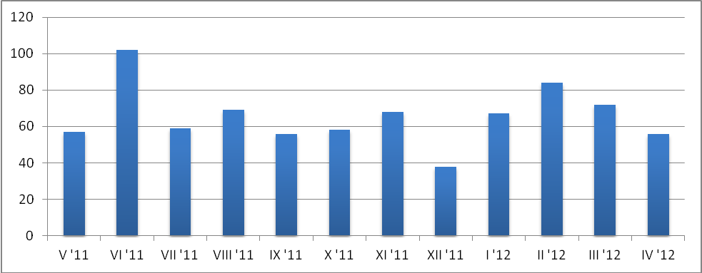
Figure 1: Monthly distribution of tickets assigned to DMSU.

The number of tickets reassigned back to TPM remains at approx. 10 %, half of it being tickets related to batch systems, which have to be routed to the appropriate support units through TPM again, and the remaining 5 % are tickets wrongly assigned to DMSU (i.e. indicating an operational issue only), which is an acceptable error ratio in general. Number as well as ratio of tickets solved by DMSU increased over PY2, as also witnessed by the weekly distribution graph in Figure 2:

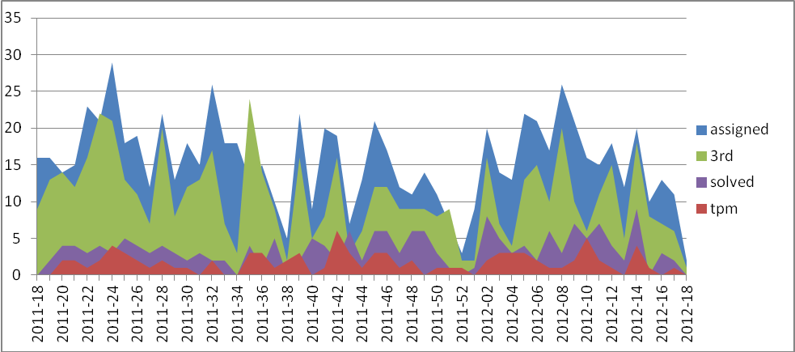
Figure 2: Weekly distribution of DMSU tickets

Despite of large oscillations and relatively low numbers that make statistical conclusions difficult, there is an apparent increasing trend in the number of solved tickets in PQ7 and PQ8. This is a consequence of more thorough deployment of the policies on ticket reassignment to 3rd line support (Sect. 2.2). The average ratio of solved with respect to assigned tickets is 22 % in PY2 which is a significant improvement to 10 % reported in PY1.
The number of tickets reassigned to the 3rd line support follows the distribution of the assigned tickets quite well, indicating there are no unnecessary delays once the tickets are proven to be defects to be solved by the 3rd line support.
The final metric to discuss is the time to solve a ticket in DMSU. The mean time, despite provided for completeness in the table above, is rather misleading. It is strongly affected by outliers, tickets which are put on hold because of being tracked elsewhere but not in any of the TPs’ support units in GGUS where they could have been reassigned, e.g. waiting for a release of an external component in the EPEL repository. Therefore the median time is more representative. With the exception of PQ6 which covered the top holiday season, the median solution time is less than one week.

Technology provider workload and performance
There are two metrics that reflect the TP performance in terms of ticket handling and management of the support load:
- SLA violations, i.e. number of failures to react to a reassigned ticket on time. Those numbers are regularly reported to TCB.
- ETA violations, i.e. failures to deliver a fix for a high-priority issue in the negotiated time. The ETA negotiation process has just been introduced, and the metric will start to be collected in the following period.
- Number of open tickets with a TP. Given the processes described in Sect. 3 it serves as a crosscheck how they are followed. The data gathered for EMI (the major TP, the only one with statistically significant number of tickets assigned) in production of [R7] are shown in :

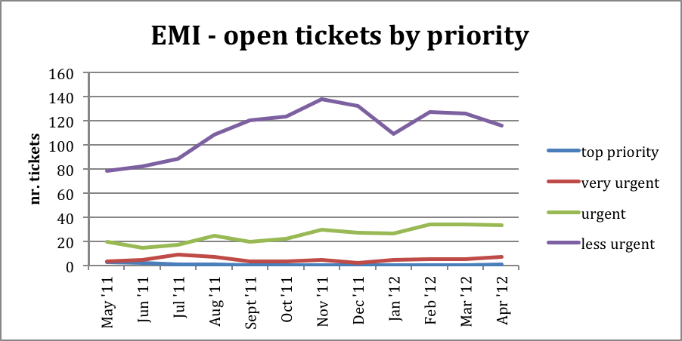
Figure 3: Nubers of open tickets in EMI support units

The chart shows that the number open of high priority tickets is kept nearly zero, indicating acceptable performance in their solution. On the other hand, the increasing backlog of low-priority categories is well justifies the introduced process, in particular closing unsolved low-priority issues also as unsolved after given timout. Also, the apparent drop of the ticket number between December and January corresponds to a ticket closing campaing during the code freeze of EMI-2 release, confirming the feasibility of the proposed process.
Related to this process, the metric of tickets closed as unsolved is also considered. Too high numbers are quite correlated to frustrated users, and they would indicate understaffing of the support with the TP.
Otherwise, it was agreed that gathering absolute numbers of tickets assigned to per-component support units individually cannot be used to derive any performance-related conclusions. Variances of both complexity of code and extent of deployment is too large among the componets, therefore the numbers of tickets are not indicative wrt. the software quality.

Proposed Changes in Software Support
Evaluation of the work of TPM and DMSU in the first two years of the project revealed that the initially assumed 1st line support role of TPM is not fully justified as well as that there is an apparent ovelap in the functions of the two teams Therefore a merge of the TPM and DMSU tasks was proposed. Details are given in [R8], a document approved by PMB. This section provides an essential summary of the model proposed for PY3.

Current situation
The support function is currently covered by two tasks in the project.
- TSA1.7 provides general ticket triaging, including classification to operational or software incident and provision of the 1st line support. The task also provides operations support as described in the DoW, which is left intact by this proposal.
- TSA2.5 provides common 2nd level software support, i.e. deeper investigation of the incident, and software and configuration analysis, in order to find a solution or workaround for the described incident. Where necessary, the ticket is forwarded to 3rd level expert support.
Howerver, it turns up that the traditional work of 1st line support of the end-users is mostly done by NGIs and VOs, their support structures are able to deal with the routine load of requests efficiently. The central team (TPM) receives tickets that are already filtered by these support layers. Hence TPM does not fulfil the role of the 1st line support in terms of solving significant fraction of the incoming requests. On the contrary, most of the tickets are forwarded to the 2nd line support units.
Similarly, significant overlaps in the work of TPM and DMSU were identified, e.g. both the teams run internal rotating shifts to handle incoming tickets, and both make decisions where to assign the individual tickets if they can’t be solved in place.
Moreover, it was identified that for certain set of components (SAM, APEL, ARGUS, LRMS) there is not sufficient expert coverage in DMSU, and there are further components which are likely to need support in the upcoming period (CANL, virtualization frameworks, EMIR, Hydra).

Proposed roles and responsibilities
The following functions are foreseen in the merged support unit.
- Ticket triage and assessment. Both TPM and DMSU followed a model where ticket assigners were on schedule for taking charge of tickets arriving at either TPM or DMSU, do an initial triaging, and assign them to the actual experts available in the respective team. This model has proven to be useful and will be re-used in the new support task.
This will be merged into one schedule of “ticket assigner on duty” with sufficient specialised expertise as required for 2nd level support duties. Ticket triage requires a rota structure to make sure that a service is provided during regular business days.
The assigner is responsible for initial analysis of the incoming ticket, requesting additional information from the submitter, and then either delivering a solution or assigning the ticket to a particular expert to resolve, or to NGIs in case of operational incidents.
Due to the prevailing number of tickets related to the former gLite components this role is foreseen to be taken by CESNET and INFN only.
- Support of deployed software. The software tickets undergo the analysis described in Sect. 2.2 until a solution is found or sufficient evidence of a defect is collected. This work requires deep expertise and it is distributed among all involved partners.
- Production of documentation. DMSU expertise can be leveraged to produce specific documentation as described in Sect. 2.5. This is a work not directly related to ticket processing, and is done on external demand typically. An exception is production of FAQs. They emerge from the processed tickets, and this task is foreseen to be done together with the assigner on duty shift.
- Ticket oversight and followup. This function implements the general operation of the support unit which is independent on the actual ticket content and it does not require specific software expertise. These tasks include:
  - Administrative and reporting functions of the helpdesk infrastructure, e.g.
    - Collecting ticket statistics and producing the defined metrics (Sect. 4),
    - Internal and external reporting of statistics for SLAs monitoring and other reporting duties.
  - Follow-up of tickets to oversee the operation of the support unit itself independently as well as to implement the process defined in Sect. 3. In particular, the following is done:
    - Notifying supporters when the reaction to high-priority tickets is not fast enough,
    - Requesting information from ticket submitters when they do not react,
    - Ensuring assigners/resolvers will react sufficiently fast when the submitter provides additional information
    - Checking whether TPs react according to the SLA and whether the ETA is assigned to high-priority tickets,
    - Triggering renegotiation of ETA once it is missed,
    - Checking old open low-priority tickets after UMD release and closing them eventually (Sect. 3.2).

Automated support for parts of these duties is expected to appear in GGUS over time.

Conclusion
The operational procedures, as defined in [R1] and [R2] were further adjusted according to the years of experience in the project. In particular, certain assumptions (i.e. possibility to assign a ticket to a specific person directly by TPM) were found not to be true and they were abandoned. On the other hand, internal DMSU rules introduced in PY2 make sure only tickets related to defects in software (or documentation, default configuration etc.) are passed to the 3rd line support. Consequently, the ratio of tickets solved by DMSU increased from 10 % in PY1 to 22 % in PY2.
The original procedure of ETA assignment to each ticket was revised, and it is kept with high-priority tickets only. For low-priority tickets alternative procedure was defined – under certain conditions they are closed as unsolved to avoid ever-increasing backlog of open tickets. These procedures were extensively discussed with TPs and they were agreed at the TCB level.
Finally, in PY2 a discussion on merging the TPM (1st line) and DMSU (2nd line) support was triggered. It emerged into a change proposal which was accepted by PMB and it will serve as a basis for reorganization of the support units work in the following period.

References
R 1 | EGI DMSU wiki, https://wiki.egi.eu/wiki/EGI_DMSU
R 2 | MS502: DMSU Operations Procedures, https://documents.egi.eu/document/69
R 3 | MS507: Deployed Middleware Support Unit Operations Procedures, https://documents.egi.eu/document/504
R 4 | Middleware issues and solutions wiki, https://wiki.egi.eu/wiki/Middleware_issues_and_solutions
R 5 | EGI Operations Manuals, https://wiki.egi.eu/wiki/Operations_Manuals
R 6 | SLA with EMI, https://documents.egi.eu/document/461
R 7 | Annual Report on the status of Software Provisioning activity and the work of DMSU, https://documents.egi.eu/document/1015
R 8 | Revision of TPM and DMSU activities, https://documents.egi.eu/document/1104

