EGI-InSPIRE

EU MILESTONE: MS201 EGI Website

Document identifier: | EGI-MS201-final
Date: | 04/11/2010
Activity: | NA2.2
Lead Partner: | EGI.eu
Document Status: | FINAL
Dissemination Level: | PUBLIC
Document Link: | https://documents.egi.eu/document/126

Abstract
This document gives a brief overview of the EGI website, which fulfils milestone MS201. The document outlines the technical details for the site, the roles and responsibilities for updating and maintaining the content and a brief overview of the content of the website.

- Copyright notice
Copyright © Members of the EGI-InSPIRE Collaboration, 2010. See www.egi.eu for details of the EGI-InSPIRE project and the collaboration. EGI-InSPIRE (“European Grid Initiative: Integrated Sustainable Pan-European Infrastructure for Researchers in Europe”) is a project co-funded by the European Commission as an Integrated Infrastructure Initiative within the 7th Framework Programme. EGI-InSPIRE began in May 2010 and will run for 4 years. This work is licensed under the Creative Commons Attribution-Noncommercial 3.0 License. To view a copy of this license, visit http://creativecommons.org/licenses/by-nc/3.0/ or send a letter to Creative Commons, 171 Second Street, Suite 300, San Francisco, California, 94105, and USA. The work must be attributed by attaching the following reference to the copied elements: “Copyright © Members of the EGI-InSPIRE Collaboration, 2010. See www.egi.eu for details of the EGI-InSPIRE project and the collaboration”. Using this document in a way and/or for purposes not foreseen in the license, requires the prior written permission of the copyright holders. The information contained in this document represents the views of the copyright holders as of the date such views are published.
- Delivery Slip
 | Name | Partner/Activity | Date
From | Catherine Gater | EGI.eu | 2/8/10
Reviewed by | Moderator: Steven Newhouse  Reviewers: Karolis Eigelis | EGI.eu | 9/8/10
Approved by | AMB & PMB |  | 19/8/10
- Document Log
Issue | Date | Comment | Author/Partner
1 | 1 August 2010 | First draft | C. Gater
2 | 9 August 2010 | External review | C. Gater
3 | 19 August 2010 | PMB Review | C. Gater
- Application area
This document is a formal deliverable for the European Commission, applicable to all members of the EGI-InSPIRE project, beneficiaries and Joint Research Unit members, as well as its collaborating projects.
- Document amendment procedure
Amendments, comments and suggestions should be sent to the authors. The procedures documented in the EGI-InSPIRE “Document Management Procedure” will be followed:
https://wiki.egi.eu/wiki/Procedures
- Terminology
A complete project glossary is provided at the following page: http://www.egi.eu/about/glossary/.
- PROJECT SUMMARY

To support science and innovation, a lasting operational model for e-Science is needed − both for coordinating the infrastructure and for delivering integrated services that cross national borders.

The EGI-InSPIRE project will support the transition from a project-based system to a sustainable pan-European e-Infrastructure, by supporting ‘grids’ of high-performance computing (HPC) and high-throughput computing (HTC) resources. EGI-InSPIRE will also be ideally placed to integrate new Distributed Computing Infrastructures (DCIs) such as clouds, supercomputing networks and desktop grids, to benefit user communities within the European Research Area.

EGI-InSPIRE will collect user requirements and provide support for the current and potential new user communities, for example within the ESFRI projects. Additional support will also be given to the current heavy users of the infrastructure, such as high energy physics, computational chemistry and life sciences, as they move their critical services and tools from a centralised support model to one driven by their own individual communities.

The objectives of the project are:

- The continued operation and expansion of today’s production infrastructure by transitioning to a governance model and operational infrastructure that can be increasingly sustained outside of specific project funding.
- The continued support of researchers within Europe and their international collaborators that are using the current production infrastructure.
- The support for current heavy users of the infrastructure in earth science, astronomy and astrophysics, fusion, computational chemistry and materials science technology, life sciences and high energy physics as they move to sustainable support models for their own communities.
- Interfaces that expand access to new user communities including new potential heavy users of the infrastructure from the ESFRI projects.
- Mechanisms to integrate existing infrastructure providers in Europe and around the world into the production infrastructure, so as to provide transparent access to all authorised users.
- Establish processes and procedures to allow the integration of new DCI technologies (e.g. clouds, volunteer desktop grids) and heterogeneous resources (e.g. HTC and HPC) into a seamless production infrastructure as they mature and demonstrate value to the EGI community.

The EGI community is a federation of independent national and community resource providers, whose resources support specific research communities and international collaborators both within Europe and worldwide. EGI.eu, coordinator of EGI-InSPIRE, brings together partner institutions established within the community to provide a set of essential human and technical services that enable secure integrated access to distributed resources on behalf of the community.

The production infrastructure supports Virtual Research Communities (VRCs) − structured international user communities − that are grouped into specific research domains. VRCs are formally represented within EGI at both a technical and strategic level.

- EXECUTIVE SUMMARY
This document summarises the details relating to the main website portal for the European Grid Infrastructure, including the roles and responsibilities for maintaining and updating the content, the topics covered by the site, the technical details regarding support and upkeep of the site, as well as future plans. The EGI website is available from www.egi.eu. The EGI website aims to provide a one stop shop for core information about EGI, EGI.eu, EGI-InSPIRE and the other projects that EGI.eu is involved in on behalf of the EGI Collaboration. The EGI website provides a broad overview and introduction to the infrastructure, the organisations involved in running it and the projects currently underway, with content that remains fairly static. A small number of areas on the main website will be frequently updated, such as the press area, news feed and events calendar.

The EGI website is maintained by a small team of administrators and content managers. The following roles have been established for the website:
- Site administrators
- Web support
- Web content administration
- Web content management
- Web content providers

The EGI website is hosted and supported by CESNET. This document includes details of the hardware, virtual hosts, network connectivity, back up and monitoring, the operating system and software environment, servers and hosted environment. Further details of these arrangements are covered by MS501 Establishment of the EGI software repository and associated tools. [R2]

An overview of the website is given, including the top level sections of the website: the home page, about EGI.eu, user support, deployed technology, production infrastructure, results, projects and collaborations. Also included are screenshots of the home page and a typical page, taken from the current version of the website.

In conclusion, the EGI website is a work in progress. The content covered will be balanced against the content available on other related EGI websites so that information is neither repeated, inconsistent or missing. The design, layout and content of the site will be evolved in the future in line with D2.2 Dissemination Plan, and in close collaboration with other activities. Roles and responsibilities will also evolve as the project progresses and as the project team expands.

TABLE OF CONTENTS
1 Introduction 6
2 ROLES AND responsibilities 7
3 Web InfrastruCture 8
3.1 Main Website 8
3.2 Document Server 8
3.3 Training Services 8
3.4 Application Database 9
3.5 Wiki 9
4 CONTENT Of the website 10
4.1 Screenshots 11
5 Conclusion and future plans 12
6 References 13

Introduction
This document summarises the details relating to the main website portal for the European Grid Infrastructure, including the roles and responsibilities for maintaining and updating the content, the topics covered by the site, the technical details regarding support and upkeep of the site, as well as future plans. The EGI website is available from www.egi.eu. Other EGI websites are also available, including the Wiki site at https://wiki.egi.eu/, the training website http://training.egi.eu, the applications database http://appdb.egi.eu and others, particularly sites run by the NGIs and EGI-InSPIRE project partners.

The EGI website aims to provide a one stop shop for core information about EGI, EGI.eu, EGI-InSPIRE and the other projects that EGI.eu is involved in. This information has to be balanced against the detailed, project specific and user related information contained on other websites. In general, the content on the EGI website provides a broad overview and introduction to the topics above, with content that remains fairly static. Information that needs to be updated on a regular basis will be added to wiki site. A small number of areas on the main website will be frequently updated, such as the press area, news feed and events calendar. Using the EGI website as a jumping off point, users, the public, press, project members and other stake holders should be able to gain access to the information that they need easily and transparently.

ROLES AND responsibilities

The EGI website is maintained by a small team of administrators and content managers. The following roles have been established for the website:

Site administrators
Site administration is provided by CESNET by the it-support@egi.eu team. Further details of technical support are given in the next section.

Web support
Day to day web support services are provided by CESNET, again by the it-support@egi.eu team. This consists of trouble shooting, management of the OpenCMS content management system and implementation of major updates or changes to the website structure, as well as administration of user access and web statistics packages. Further details are also given in the next section.

Web content administration
Overall content administration for the site is provided within NA1 by EGI.eu. All content is verified and checked before publication, by NA1. Major upgrades and changes to the site structure or content are also approved by EGI.eu, and any issues are escalated to the AMB, PMB or EB as appropriate. For example, issues relating to technical content or the structure of the website might be escalated to the AMB, issues relating to the EGI-InSPIRE website might be escalated to the PMB, or to the EGI.eu pages to the EB.

Web content management
Day-to-day content management of the website is provided by WP2 under dissemination task NA2.2. This role includes writing and publishing of content, images, news updates and events announcements across all sections of the website. The development strategy for the website, its main audiences and future direction is covered by D2.2 Dissemination Plan [R1].

Web content providers
Responsibility for keeping specialist content up to date is delegated by NA1 to other work packages as appropriate eg WP2 for policy and dissemination, WP3 for user support related content, WP4 for operations and production infrastructure, WP5 for software, WP6 for content aimed at heavy user communities and WP7 for operational tools. Delegation is effected by nominating a contact person for the various areas of the main website, which can then be updated or monitored by that person on behalf of the work package. Similarly, the day to day upkeep of the detailed information on the wiki is managed by the work package and task leaders, with NA1 taking a strategic overview.

Web InfrastruCture
The web infrastructure for the EGI-InSPIRE project is hosted and supported by CESNET within a virtualised environment. Further details regarding the technical set up of the website and its support services are available from MS501 Establishment of the EGI Software Repository and associated tools. [R2]

Main Website
The project web site provides a web front-end for all the services needed by project members. Apache2 from the Debian distribution is deployed on the server. The content of the web site is managed by a content management system, OpenCMS. Google Analytics gathers statistics on the website.

Document Server

The DocDB document server has been set up for large files and for official documents of the project, such as Deliverables and Milestones. All users with an EGI SSO account can log in to the DocDB server. Groups are used for restricting access to documents. The DocDB is available from the following sites:
http://documents.egi.eu (public access)
https://documents.egi.eu/secure (authenticated access)

Training Services

A number of websites are available to support the training services. The Digital Library contains links to online training materials, and is searchable by type of resource, subject, year and creator. The library can be accessed from http://training.egi.eu/material/index.cfm.

The training event calendar is available from http://training.egi.eu/ and lists the title, location and dates for each training event submitted to the calendar by the training team.

A registry of trainers is also available online from http://training.egi.eu/trainers/index.cfm. The site lists the names of trainers, their area of expertise, location and a link to a summary page for each trainer.

More information about these website is available from MS302 Training Website. [R3]

Application Database

The EGI Applications Database is available from http://appdb.egi.eu. This website will ultimately evolve to produce a full-fledged, community driven portal, which will act as a point-of-reference for the scientific software and tools that are available in the EGI infrastructure, as well as a registry of the people involved in developing them. The database helps to facilitate the reuse of applications and expertise that is available within the NGIs.

More information about the Ported Applications Database is available from MS303 Ported Applications Website. [R4]

Wiki
The EGI Wiki site is available at https://wiki.egi.eu/wiki. It is based on the MediaWiki system and is available for the EGI community. Write access is restricted - only users with account in the EGI.eu Single Sign On system can log in. Write access for certain namespaces is also limited to specific groups.

The Wiki site contains links to sites for the organisational groups within EGI.eu, the policy groups and projects such as the EGI-InSPIRE main page at https://wiki.egi.eu/wiki/EGI-InSPIRE:Main_Page. The site also includes links to the NGI websites. The information on the EGI-InSPIRE project wiki site is maintained by the work package leaders and task leaders for each area and contains detailed information that is expected to change on a frequent basis

CONTENT Of the website

The development plan for the layout, design and content of the EGI website is covered in more detail in D2.2 Dissemination Plan. [R1]

Currently the EGI website consists of the following elements:

Title of section | Description
Home page | Introduction to EGI.eu website, calendar and news feed
About EGI.eu | Overview of EGI.eu and links to the intranet services for project members
User Support | Information on training, support teams and services and a link to the applications database
Deployed technology | Technology roadmap and information about technology providers as well as assessment criteria
Production infrastructure | Covers the current status of the production infrastructure, usage figures and links to the NGI individual sites
Results | Links to articles about EGI, project newsletters, presentations press releases and reports
Projects | Links to the EGI-InSPIRE project website, the EGI-DS website and websites for the three phases of EGEE.
Collaborations | Links to collaborations with infrastructure, technology, community and other projects.

Screenshots
Below are listed screenshots of the home page and a typical page for the EGI website.
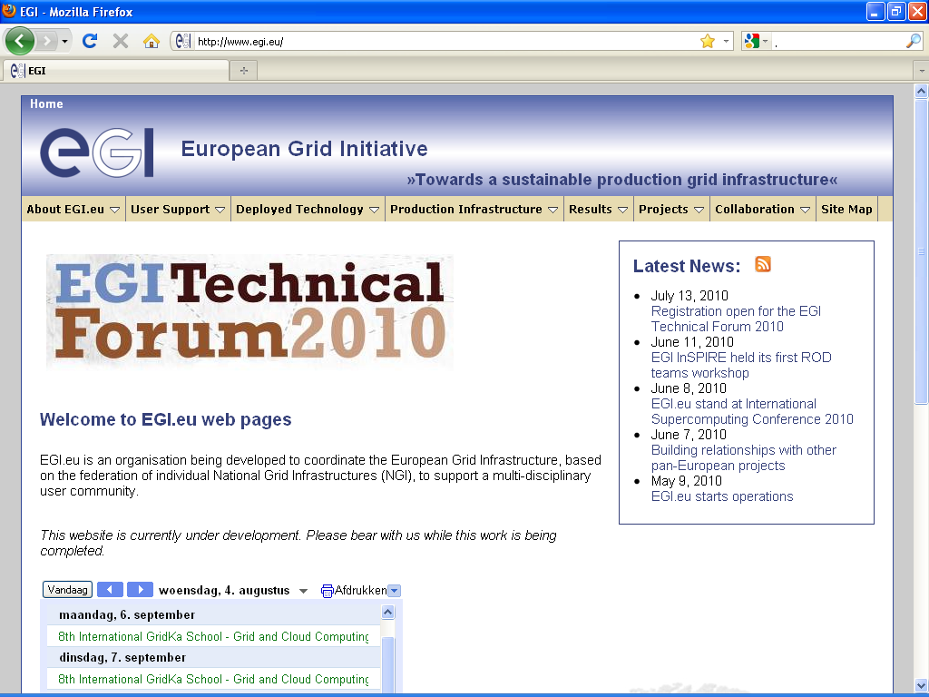

Figure 1: EGI website home page

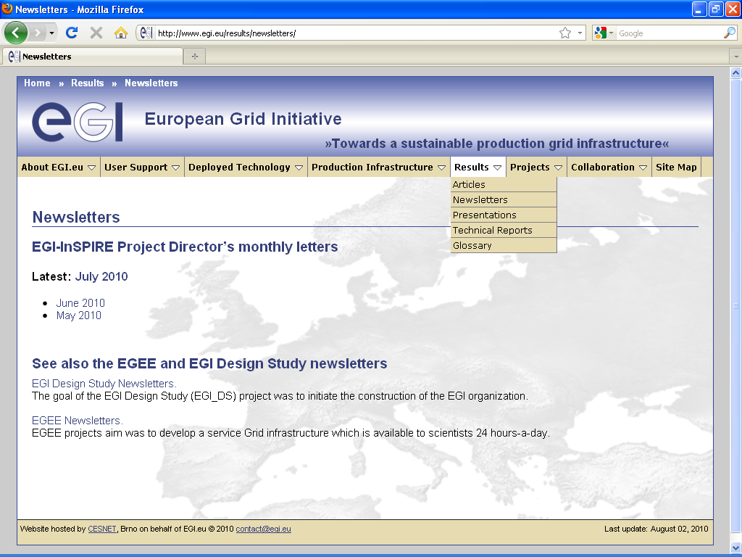

Figure 2: EGI website typical page

Conclusion and future plans

Currently the EGI website is a work in progress. The content covered needs to be balanced with the content available on other related EGI websites so that information is neither repeated, inconsistent or missing. The design, layout and content of the site will be evolved in the future in line with D2.2 Dissemination Plan, and in close collaboration with other activities. Roles and responsibilities will also evolve as the project progresses and as the project team expands, with responsibility for keeping content up to date increasingly being devolved from the central web team to the work packages and task leaders specialising in the relevant areas.

References
R 1 | D2.2 Dissemination Plan https://documents.egi.eu/document/56
R 2 | MS501 Establishment of the EGI software repository and associated tools https://documents.egi.eu/document/46
R 3 | MS203 Training Website https://documents.egi.eu/document/104
R 4 | MS303 Ported Applications Website https://documents.egi.eu/document/92

