EGI-InSPIRE

Integrating Resources into the EGI Production Infrastructure

EU MILESTONE: MS421

 | Document identifier: | input.doc
 | Date: | 25/09/2012
 | Activity: | SA1
 | Lead Partner: | SRCE
 | Document Status: | DRAFT
 | Dissemination Level: | PUBLIC
 | Document Link: | https://documents.egi.eu/document/1308
Abstract
This document describes and defines the operational interfaces that must be supported for resources to be integrated into EGI. This includes operational tools provided by the EGI-InSPIRE JRA1 activity and procedures and policies defined to ensure interoperability within EGI and in the interaction with other DCIs, the adoption of best practices and compliance with service level agreements.

- Copyright notice
Copyright © Members of the EGI-InSPIRE Collaboration, 2011-2014. See www.egi.eu for details of the EGI-InSPIRE project and the collaboration. EGI-InSPIRE (“European Grid Initiative: Integrated Sustainable Pan-European Infrastructure for Researchers in Europe”) is a project co-funded by the European Commission as an Integrated Infrastructure Initiative within the 7th Framework Programme. EGI-InSPIRE began in May 2010 and will run for 4 years. This work is licensed under the Creative Commons Attribution-Noncommercial 3.0 License. To view a copy of this license, visit http://creativecommons.org/licenses/by-nc/3.0/ or send a letter to Creative Commons, 171 Second Street, Suite 300, San Francisco, California, 94105, and USA. The work must be attributed by attaching the following reference to the copied elements: “Copyright © Members of the EGI-InSPIRE Collaboration, 2010. See www.egi.eu for details of the EGI-InSPIRE project and the collaboration”. Using this document in a way and/or for purposes not foreseen in the license, requires the prior written permission of the copyright holders. The information contained in this document represents the views of the copyright holders as of the date such views are published.
- Delivery Slip
 | Name | Partner/Activity | Date
From | Emir Imamagic | SRCE/SA1 | 1-8-2012
Reviewed by | Krzysztof Kurowski, Robert Lovas | PSNC, MTA SZTAKI | 12-9-2012
Approved by
- Document Log
Issue | Date | Comment | Author/Partner
1 | 01/08/2012 | Initial draft | Emir Imamagic/SRCE
2 | 29/08/2012 | First complete draft | Emir Imamagic/SRCE
3 | 04/09/2012 | Included comments from Tiziana Ferrari | Emir Imamagic/SRCE
4 | 25/09/2012 | Included comments from reviewers | Emir Imamagic/SRCE
- Application area
This document is a formal deliverable for the European Commission, applicable to all members of the EGI-InSPIRE project, beneficiaries and Joint Research Unit members, as well as its collaborating projects.
- Document amendment procedure
Amendments, comments and suggestions should be sent to the authors. The procedures documented in the EGI-InSPIRE “Document Management Procedure” will be followed:
https://wiki.egi.eu/wiki/Procedures
- Terminology
Various term definitions are available in the EGI Glossary at: https://wiki.egi.eu/wiki/Glossary; acronyms are defined at http://www.egi.eu/about/glossary/.
- PROJECT SUMMARY
To support science and innovation, a lasting operational model for e-Science is needed − both for coordinating the infrastructure and for delivering integrated services that cross national borders.
The EGI-InSPIRE project will support the transition from a project-based system to a sustainable pan-European e-Infrastructure, by supporting ‘grids’ of high-performance computing (HPC) and high-throughput computing (HTC) resources. EGI-InSPIRE will also be ideally placed to integrate new Distributed Computing Infrastructures (DCIs) such as clouds, supercomputing networks and desktop grids, to benefit user communities within the European Research Area.
EGI-InSPIRE will collect user requirements and provide support for the current and potential new user communities, for example within the ESFRI projects. Additional support will also be given to the current heavy users of the infrastructure, such as high energy physics, computational chemistry and life sciences, as they move their critical services and tools from a centralised support model to one driven by their own individual communities.
The objectives of the project are:
- The continued operation and expansion of today’s production infrastructure by transitioning to a governance model and operational infrastructure that can be increasingly sustained outside of specific project funding.
- The continued support of researchers within Europe and their international collaborators that are using the current production infrastructure.
- The support for current heavy users of the infrastructure in earth science, astronomy and astrophysics, fusion, computational chemistry and materials science technology, life sciences and high energy physics as they move to sustainable support models for their own communities.
- Interfaces that expand access to new user communities including new potential heavy users of the infrastructure from the ESFRI projects.
- Mechanisms to integrate existing infrastructure providers in Europe and around the world into the production infrastructure, so as to provide transparent access to all authorised users.
- Establish processes and procedures to allow the integration of new DCI technologies (e.g. clouds, volunteer desktop grids) and heterogeneous resources (e.g. HTC and HPC) into a seamless production infrastructure as they mature and demonstrate value to the EGI community.
The EGI community is a federation of independent national and community resource providers, whose resources support specific research communities and international collaborators both within Europe and worldwide. EGI.eu, coordinator of EGI-InSPIRE, brings together partner institutions established within the community to provide a set of essential human and technical services that enable secure integrated access to distributed resources on behalf of the community.
The production infrastructure supports Virtual Research Communities (VRCs) − structured international user communities − that are grouped into specific research domains. VRCs are formally represented within EGI at both a technical and strategic level.

- EXECUTIVE SUMMARY
This document describes the operational interfaces that must be supported for resources to be integrated into the European Grid Infrastructure (EGI), and is an updated version of milestone MS414. The basic operational interfaces that must be supported for resources to be integrated into EGI consist of a management interface, a monitoring interface, an accounting interface, a support interface and a dashboard interface.
During the first year of the project activities focussed on the integration of four middleware stacks: ARC, gLite, Globus and UNICORE. The integration of ARC was completed during the first project year. Two task forces for integration of UNICORE and Globus continued to steer integration tasks of Globus and UNICORE middleware stacks during the second year.
In the second year special focus was given to integration of Desktop Grids and MAPPER/QCG middleware stacks. Work on integrating Desktop Grids and QCG was defined by MoUs between EGI-InSPIRE, EDGI and MAPPER. As the MAPPER community uses resources both from EGI and PRACE infrastructures, a joint MAPPER/EGI/PRACE task force was constituted to foster progress of this integration activity. In addition a new EGI task force for was setup to track the integration of MAPPER resources into EGI operational tools. Discussions on how to integrate operational services deployed by EGI and EUDAT have started.
The EGI management system GOCDB was extended with a number of service types needed for new middleware stacks. Also, for the needs of UNICORE middleware definition of service URLs was implemented.
The following middleware stacks: ARC, gLite, Globus and UNICORE are fully integrated with the EGI monitoring system SAM. Monitoring tests became operational during the first two years of the project. Probes for Desktop Grids were provided in the latest SAM release Update-17. Probes have also been developed for MAPPER/QCG and they will be part of the next SAM release Update-19 scheduled for beginning of October 2012.
Middleware stacks ARC and gLite are now fully integrated into the current EGI accounting system. The APEL team is working on the definition and implementation of an accounting protocol based on messaging system to be adopted by other resource infrastructures. A new accounting task force has been created to collect EGI accounting requirements and ensure that technology providers fulfil them. EMI supported middleware stacks (ARC, gLite, UNICORE) will use software provided APEL, as will MAPPER/QCG middleware. The integrated accounting of Globus resources needs extensions to GridSAFE, which are scheduled to be released at the end of September 2012. Once deployed in production, mechanism for publishing data to central APEL repository will need to be deployed. Desktop Grids accounting implementation is still under development, the design plan was ready by August 2012.
In order to implement the support interface, EGI provided a Technology Helpdesk for ARC, gLite, UNICORE and Globus support. 3rd level support for Globus is provided by the EMI and IGE projects. The Technology Helpdesk contains a queue to forward 3rd level support tickets directly to the technology provider support teams. A new 2nd level support unit was requested for the needs of MAPPER/QCG middleware stack, but also an integrated MAPPER/EGI/PRACE helpdesk for internal and external MAPPER users is being investigated by the MAPPER/EGI/PRACE task force.
Middleware stacks ARC and gLite are fully integrated into dashboard system. Integration of Globus and UNICORE started in April 2012, but it is pending SAM release Update-17 which introduces fixes related to UNICORE probes. Integration of tests for Desktop Grids and MAPPER/QCG middleware stacks will start as soon as SAM releases Update-17 and Update-19 are deployed in production.
The integration of gLite and ARC can be now considered fully completed. Integration of UNICORE and Globus into management, support and monitoring systems has been finished, but integration into accounting and dashboard systems is still in progress. Integration of Desktop Grids and MAPPER/QCG into management and monitoring systems has been finished, but integration with support, accounting and dashboard still has to be completed. Table 1 summarizes the integration status of various deployed middleware stacks.

TABLE OF CONTENTS
1 Introduction 8
2 Operational Tools 9
2.1 Management Interface 9
2.1.1 Integration of new middleware 10
2.2 Monitoring Interface 10
2.2.1 Integration of new middleware 11
2.3 Accounting Interface 11
2.3.1 Integration with other infrastructures 12
2.4 Support Interface 13
2.4.1 Integration of new middleware 14
2.5 Dashboard Interface 14
2.5.1 Integration of new middleware 15
3 Middleware 17
3.1 Overall Middleware Integration Status 17
3.2 UNICORE 18
3.2.1 Management 18
3.2.2 Monitoring 19
3.2.3 Accounting 20
3.2.4 Support 20
3.2.5 Dashboard 20
3.3 Globus 20
3.3.1 Management 20
3.3.2 Monitoring 21
3.3.3 Accounting 21
3.3.4 Support 21
3.3.5 Dashboard 21
3.4 Desktop Grids 22
3.4.1 Management 22
3.4.2 Monitoring 22
3.4.3 Accounting 22
3.4.4 Support 23
3.4.5 Dashboard 23
3.5 MAPPER/QCG 23
3.5.1 Management 23
3.5.2 Monitoring 24
3.5.3 Accounting 24
3.5.4 Support 24
3.5.5 Dashboard 24
4 DCI Integration 25
5 Future Plans 26
6 References 27

Introduction
In order to add new resources to the EGI production infrastructure, a basic set of operational interfaces must be supported by those new resources. These interfaces are defined and described in terms of their basic functionality.
Different resources can use different middleware components. EGI-InSPIRE will support the Unified Middleware Distribution (UMD) for deployment on the production infrastructure, which integrates software from multiple technology providers.
Operational tools such as the GOCDB management system and the SAM monitoring system are key software components for the reliable and stable operation/monitoring of the infrastructure. Although the current operational tools may change in the future, they currently provide the starting point for comparing the operational interoperability of different middleware components.
Operational procedures and policies are needed to enforce the use of the agreed basic set of operational interfaces which should be supported by all resources. The EGI procedures and policies have been adapted and new requirements were identified. These have evolved into new procedures and policies that are relevant for the integration of new resources.
Section 2 describes the basic operational interfaces that must be supported for resource integration into the EGI. The next section continues with an overview of the status of those interfaces provided by each middleware stack. Section 4 provides an overview of the current status of integration activities for EGI, EUDAT and PRACE. Finally, section 5 concludes by providing plans for the third year of the project and beyond.

Operational Tools
Availability and reliability measurement, registration of services, information indexing, monitoring, accounting, user and operational support in EGI currently rely on operational tools which are developed in EGI-InSPIRE JRA1 [JRA1].
The basic operational interfaces that must be supported for resources to be integrated into EGI consist of a management interface, a monitoring interface, an accounting interface, and a support interface. Additionally, the basic operational interfaces provide a graphical dashboard interface that collects and presents the information provided by the others and ties them together in a meaningful way to facilitate daily oversight grid monitoring duties.

Management Interface
Grid Configuration Database (GOCDB) [GOCDB] contains general information about the sites participating to the production Grid. GOCDB allows resource centres to store, maintain and view the topology of the production infrastructure and the basic information about the respective resources within it, such as:
- Participating Resource Providers (National Grid Initiatives, European Intergovernmental Organizations), the respective Operations Centres and the related information (countries, contact information etc.).
- Resource Centres contributing resources to the infrastructure including management, technical and security related contact points.
- Resources and services, including scheduled intervention plans and service status information (e.g. certification, production and monitoring status).
- Participating people and their roles within EGI operations, where roles limit operations that particular group of people can perform.
Services registered in GOCDB are described with the following information:
- Service Type: a unique name that identifies the type of software component deployed on a Grid. The current list of service type definitions are given in [GOCDB_ST]
- Service Endpoint: is a deployed instance of a named service type
- Endpoint Location: a Service Endpoint may optionally define an Endpoint Location which locates the service (URL).
Besides providing a central management tool to view and define production state, downtimes and maintenance status and whether a resource needs monitoring, it shall in essence depict what services are running where and who to contact for certain type of issues. The presented information can be a combined view of different regionalized or otherwise separated instances with their own local inputs.
A management interface provides information about a resource through the certification process. The history and details of the certification status transitions and other state transitions like site decertification and suspension are desirable additional information.
GOCDB is referent database for all other operational tools, providing all the relevant data about NGIs, resource centres, services and administrators responsible for resources and services.

Integration of new middleware
Integration of new middleware stacks into GOCDB requires creation of a new service type. This step enables sites with new middleware to define their service endpoints. The appropriate procedure for adding new service type is defined here: [GOCDB_NEW_ST].
Requirements of new service types require documentation about the nature of the service requested. During PY2 GOCDB was made more versatile to allow the registration of any service type besides baseline grid middleware services, e.g. belonging to the user application framework, or for local Resource Centre management. In this case these new services are registered as CUSTOM. The feature allows for including software which scope may be limited to a specific organizational unit (e.g. NGI or VO), or software which has been customised so its not standards-compliant to any further extent.
The service type name reflects the usable scope of deployment.

Monitoring Interface
The Service Availability Monitoring (SAM) [SAM] system is used to monitor the resources within the production infrastructure. SAM monitoring data is used for calculation of availability and reliability of grid sites. It includes the following components:
- test execution framework based on the open source monitoring framework Nagios and the Nagios Configuration Generator (NCG)
- databases which contain topology (gathered from GOCDB and other sources), profiles (mapping between service types and tests), test results and availability and reliability of sites and services
- message bus infrastructure used for communication between distributed SAM instances
- visualization portal MyEGI/MyWLCG which enables users to access current status, history and availability of monitored sites and services
- programmatic interface which enables other tools (e.g. Operations Portal, VO dashboards) to access test results and availability and reliability of sites and services
- probes used to test monitored services which are provided by middleware developers and third parties (e.g. NGIs, Nagios community).
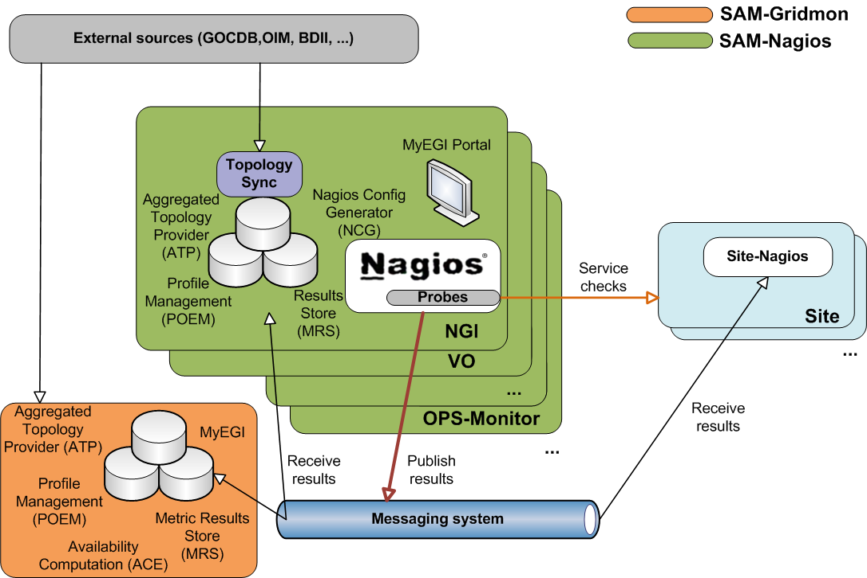
Figure 1 SAM architecture
SAM is deployed in a distributed manner (figure 1). Each NGI deploys its own SAM instance which is responsible for monitoring sites and services of that NGI. A central instance deployed at CERN consumes results from all NGI instances, calculates availability and reliability and provides central visualization portal. This architecture enables NGIs to extend their SAM instances with custom service types and tests for services deployed only on their resources.

Integration of new middleware
To integrate a new middleware stack with SAM, sensible tests for the service types defined in the management interface for this middleware have to be developed to cover the relevant functionality in the middleware stack. The probes are subsequently integrated into the SAM Release. Integration also requires from probe developer to provide naming and test configuration (e.g. probe parameters, execution frequency, timeout, etc). The list of currently supported Nagios SAM probes can be found in [SAM_PROBES]. Additional information about Nagios probe development and integration can be found in [NAGIOS_PROBES].
For the integration of new middleware two EGI procedures are relevant:
- Adding new probes to SAM [EGI_ADD_SAM] – a procedure for adding new OPS Nagios probes to the SAM release.
- Management of the EGI OPS Availability and Reliability Profile [EGI_AR] – a procedure for changing list of tests used for generating Availability and Reliability monthly statistics.

Accounting Interface
The EGI Accounting Infrastructure collects CPU accounting records from sites and/or grid infrastructures and summarizes the data by site, date (especially by month), VO, and user. This summary data can be displayed in a central Accounting Portal [EGI_ACCNT] by dynamic queries on the parameters above at any level of the hierarchical tree structure representing EGI and its partner grids. The core EGI Accounting Infrastructure is based on APEL [APEL]. Other accounting systems have to publish the data in the central repository via the APEL interface.
The bulk of existing Resource Centres collect data from their batch systems (e.g. LSF, Torque, SGE), which are joined with information about the job's user grid credentials and published to the central APEL repository. Other partner grids (e.g. Open Science Grid, IGI and NDGF), and a few additional Resource Centres with their own accounting services, currently publish summaries of data in the form described above directly into the APEL central repository. While participant Resource Infrastructures publish all of their VOs data, partner grids can publish information for a subset of VOs (e.g. OSG) according to the VO requirements.
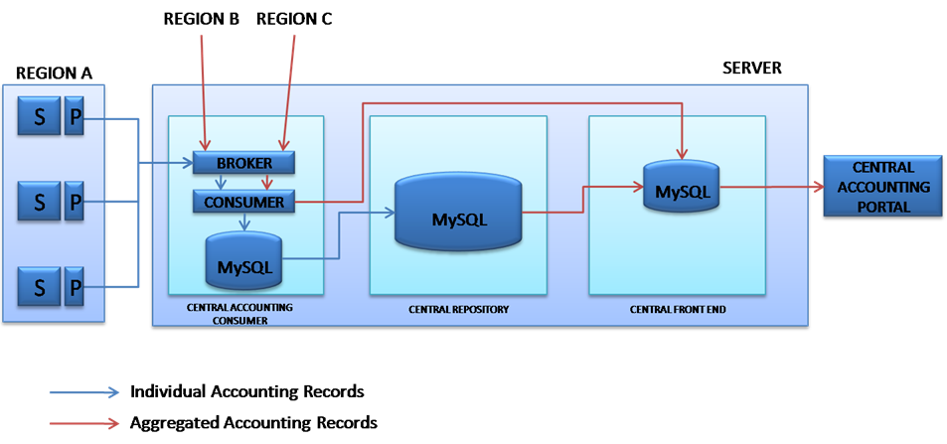
Figure 2 APEL repository architecture
The OGF UR Working Group (UR-WG) is considering a proposal from EMI for a UR for storage accounting. It is anticipated that this will be integrated into the same APEL infrastructure once implemented on the relevant storage products. EMI also has a group reviewing the implementations of the OGF UR for compute accounting to agree on the semantics of the existing UR and existing common extensions and possibly propose further extensions.
A new accounting task force [ACCNT_TF] has been created to track down EGI accounting requirements and ensure that technology providers fulfil requirements.

Integration with other infrastructures
When looking at the accounting interface as the interface between the accounting services of different interoperating infrastructures the main aim is to enable all the accounting data of a VO to be collected in one place for a unified view. This is assumed to be delivered by the exchange of accounting data at the appropriate level.
Other grid infrastructures, which wish to publish accounting data need to:
- Adopt an OGF standard Usage Record scheme and an EGI-compatible profile. A draft exist of the EGI Accounting Profile [EGI_ACCNT_PROF] for the new emerging OGF standards (Compute Accounting Record and STorage Accounting Record), which will be finalized by the end of 2012.
- Define a structure for their grid in GOCDB (or equivalent) that can be used by the accounting portal to display the data. The minimum requirement is a flat set of site names, used in the accounting records (e.g. for OSG these data are obtained from MyOSG). This is required only if the EGI Accounting Portal is the tool of choice for visualization of the data.
- Extract data from their accounting system grouped data by site/VO/User/FQAN/ month and create each group into a 'summary record' meeting the APEL definition. Experience shows that for accounting systems using the OGF-UR this is a simple transformation.
- Register the publisher with APEL as the APEL Repository only accepts accounting records from registered Resource Centres.
- Publish the records into EGI's ActiveMQ Message Bus using the agreed encryption framework and the Secure Stomp Messenger (SSM) [SSM] . The APEL repository will accept the records into a holding container from where they will be merged with the summaries from other grids and the summary produced by APEL from the job records it has received. Currently, the master summary is rebuilt from scratch several times per day. Each time it uses the last set of summaries received from each grid.
- From the master summary table, the data are then exported to the Accounting Portal where they can be viewed.

Support Interface
The user support infrastructure in use within EGI Helpdesk is distributed consisting of various topical and regional helpdesk systems that are linked together through a central integration platform, the GGUS helpdesk [GGUS]. This central helpdesk enables formalized communication between the submitter of the incident record and all partners involved in user support by providing an interface to which all other tools can connect and enabling central tracking of a problem, independent of the origin of the problem and the tool in which the work on the problem is done.
The interlinking of all ticket systems in place throughout the project enables to pass trouble tickets from one system to the other in a way that is transparent to the user. By exposing agreed interfaces, a hierarchical of tree of interworking helpdesk systems can be implemented allowing for transparently exchanging incident records across different resource infrastructures. It also enables the communication and ticket assignment between experts from different areas (e.g. middleware experts and application experts) while at the same time allowing them to work with the tools they are used to. A reference implementation was defined for the interface between ticket systems and also a template for a ticket layout exists to ensure the quality of service. These are documented in the GGUS documentation [GGUS_INTERFACE].
The regionalized implementation of GGUS is called xGUS. xGUS is a simplified regional helpdesk instance for NGIs. These instances are operated centrally but can be customized by the regions. In xGUS the tickets can have a local or global scope. All answers to a global ticket are redirected to the central GGUS.
Ticket processing management (TPM) is responsible of ticket triage and holds a global overview of the state of all tickets. TPM is responsible for those tickets that have to be assigned manually, i.e. so that they get forwarded to the correct support units. In this way, a problem submitted to GGUS can be quickly identified as either a grid problem or a VO specific problem and addressed to the appropriate second line specialized support units or the dedicated VO support teams whose members have specific VO knowledge.
Second-level support is formed by many support units. Each support unit is formed from members who are specialists in various areas of grid middleware, or regional supporters for operations problems, or VO specific supporters. The membership of the support units is maintained on mailing lists.
Regardless of the number of parties involved, the submitter of a trouble ticket should be able to transparently follow the chain of actions needed to solve the reported problem. This is especially important since the support interface is not only used for 3rd level support dedicated to the end user, but also for the relevant parts of internal trouble ticket communication fulfilling standard operational, grid oversight and partially also development functionalities.

Integration of new middleware
New middleware stack provider can request creation of support unit in GGUS Helpdesk and use it directly for support. The procedure for creation of new support unit is described here: [GGUS_NEW_SU].
In case when EGI decided to utilize software from a technology provider that has not so far involved with the project, an agreement has to be made with that technology provider on how to integrate its support infrastructure within the EGI Helpdesk. This process is already complete for the EMI and IGE projects. EGI has set up a Technology Helpdesk which is interfaced to GGUS for that purpose. No general description of the details of the integration of a new technology provider into the Technology Helpdesk can be given here, as this is highly dependent on the internal support structure of the respective technology provider. Nevertheless it is important that this is done in a way that enables EGI to have an overview of issues with the products provided by the technology provider and to gather statistics on the quality of the support given by the provider. For details on the Technology Helpdesk refer to [MS410].

Dashboard Interface
In order to operate a distributed infrastructure, management and monitoring information has to be collected and presented in a labour saving way to assist the operators of the infrastructure in their daily work. The dashboard interface combines and harmonizes different static and dynamic information and therewith enables the operators to react on alarms, to interact with the sites, to provide first-level support and/or to really operate the Resource Centres by creating and supervising problem tickets on regional as well as central level.
The dashboard allows predefined communication templates and is adaptable to different operational roles (first-level support, regional, central). Resource Centres in the dashboard scope can be regional, central or predefined out of a list and can be sorted and displayed according to numerous criteria to indicate actions needed for a single service, but also for a whole region or even the whole production infrastructure.

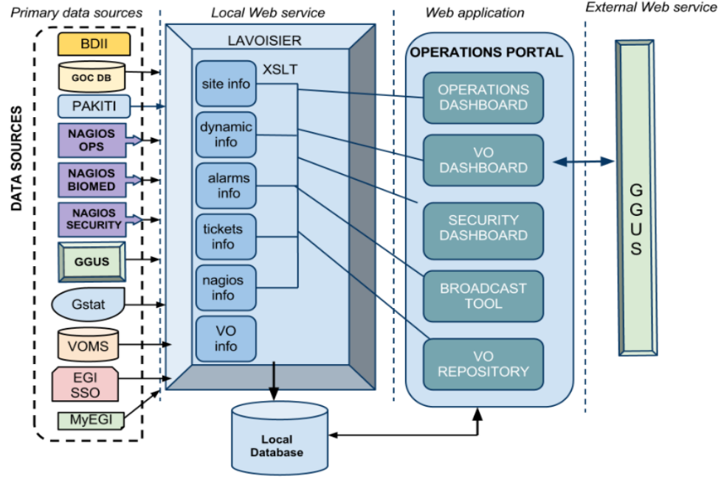
Figure 3 Operations Portal architecture
The Operations Portal [OPS_PORTAL] content is based on information which is retrieved from several different distributed static and dynamic sources – GOCDB, SAM monitoring system, EGI information system, GGUS, web services, etc. – and gathered into the portal. Interlacing this information has enabled us to display relevant views of static and dynamic information of the EGI production grid. Integrating different technologies and different resources creates high dependencies to the data provided. Consequently, the portal is organized around a web service Lavoisier that provides a transparent integration of each of these resources.

Integration of new middleware
The procedure “Setting a Nagios test status to OPERATIONS” [EGI_OPER_TEST] defines how to add new test to list of alarms raised in the Operations Portal’s Dashboard.
The architecture of the portal has been designed to propose a standard access to information from an extended number of data sources. The integration of new data sources is eased by the use of the Lavoisier web service. In the case of a known technology we will create and add a new view by using an existing plug-in out of the wide-range of plug-ins already available.
If a site and its resources are already integrated in all the other operational tools through existing information providers (e.g. registered in GOCDB, monitored by Nagios, publishing their information via BDII and having a tree in GGUS), existing plug-ins can be reused and no additional integration effort for the usage of the Operations Portal is needed. For new providers, new plug-ins can be developed as needed.
The modularity of Lavoisier allows the easy integration of almost any kind of information. Such integration is certainly needed and meaningful for the new resource types entering EGI, such as HPC systems, virtualized resources or desktop resources. As long as these resources are monitored, it is possible to integrate them via plug-ins inside Lavoisier. The integration will be done step-by-step during the whole project according to the identified priorities.

Middleware
While different middleware stacks are supported by EGI for deployment in the resource centres, the central and distributed instances of the operational tools are operated by a small number of partners committed to provide such services for National or Regional Grid Initiatives, or even for the whole EGI.
EGI will need to deploy several middleware stacks according to the requirements of users and site managers. Presently, gLite and ARC can be viewed as fully integrated into all the operational tools, whilst some smaller adaptations are still needed due to changed and more standardized interfaces of the operational tools enabling broader access to other types of middleware.
UNICORE, Globus, Desktop Grids and MAPPER/QCG operational integration is in full progress also thanks to the specialised integration task forces. The comprehensive integration is a short-term objective of the first phase of the project. The designing solutions used for the integration of the different middleware stacks with the operational tools have to be stable and reliable.
Sections below describe overall middleware integration status and work done on integrating UNICORE, Globus, Desktop Grids and MAPPER/QCG middleware stacks into each operational tool.

Overall Middleware Integration Status
Table 1. Status of integration of ARC, gLite, Globus and UNICORE
 | gLite | ARC | UNICORE | Globus | Desktop Grids | MAPPER/QCG
Management | Completed | Completed | Completed | Completed | Completed | Completed
Monitoring | Completed | Completed | Completed | Completed | Completed | Completed  (waiting SAM release Update-19)
Accounting | Completed | Completed | In progress (waiting for a new APEL client – EMI 3 release) | In progress (waiting for GridSAFE – IGE 3.0 release) | Under development  (design study is ready) | In progress (waiting for a new APEL client – EMI 3 release)
Support | Completed | Completed | Completed | Completed | Not started | In progress (requested new GGUS support unit for QCG). An independent xGUS instance will be provided for broader MAPPER support activities.
Dashboard | Completed | Completed | In progress (waiting deployment of SAM release Update-17) | In progress (waiting deployment of SAM release Update-17) | Not started  (waiting deployment of SAM release Update-17) | Not started  (waiting SAM release Update-19)

UNICORE
Uniform Interface to Computing Resources (UNICORE) [UNICORE] makes distributed computing and data resources available in a seamless and secure way in intranets and the internet. Currently UNICORE is one of products developed and maintained by EMI project.
In order to speed up integration of UNICORE resources task force [UNICORE] was created in the first year of the project. In the last year the task force has been providing the meeting place of UNICORE developers, operations tools developers and EGI resource providers.
Currently three NGIs have resource centres with UNICORE services:
- Belarus
- Germany (NGI_DE)
- Poland (NGI_PL).

Management
During the first year of project the following UNICORE service types were added to GOCDB:
- unicore6.Gateway: entry point to one or more UNICORE services; represents a gateway for UNICORE services to the internet
- unicore6.Registry: used for registration of all UNICORE services; clients ask the registry for available services in the Grid
- unicore6.ServiceOrchestrator: handles dispatching of a workflow's atomic jobs, and brokering
- unicore6.StorageFactory: creates StorageManagement instances, a user can create dynamic storage management services for own purposes with it
- unicore6.StorageManagement: provides an abstract file system-like view on a storage resource
- unicore6.TargetSystemFactory: used as an entry-point for submitting single jobs
- unicore6.UVOSAssertionQueryService: provides data and user information via the SAML standard as needed for authorization and environment customization
- unicore6.WorkflowFactory: creates workflow instances and can submit workflows to them.
In addition in PY2 GOCDB enabled the definition of a service URL. Since most of UNICORE services are accessible through the unicore6.Gateway, a URL is needed in order to provide monitoring probes with the exact addresses for monitoring.
The following additional service types were added in August 2012:
- org.ogf.bes.BESFactory: BES job submission entry point
- unicore6.Catalogue: service providing a unified view of files in multiple unicore6.StorageManagement instances
- unicore6.CISInfoProvider: provides data for CIS
- unicore6.CISRegistryPortType: provides a human friendly interface for browsing the UNICORE Grid status
- unicore6.GridBeanService: enables the download of GridBeans (modules providing an application-specific GUI).

Monitoring
UNICORE probes were initially provided by NGI_PL [PL_UNICORE]. Currently the probes area developed and maintained by the respective UNICORE EMI product teams.
The initial integration of UNICORE probes with the SAM was implemented in SAM Update-14, and eight new tests were included. The list of tests included in SAM:
- unicore6.Gateway
  - emi.unicore.Gateway
- unicore6.Registry
  - emi.unicore.Registry
- unicore6.ServiceOrchestrator
  - emi.unicore.ServiceOrchestrator
- unicore6.StorageManagement
  - emi.unicore.GlobalStorage
  - emi.unicore.GlobalStorage-FreeSpace
- unicore6.TargetSystemFactory
  - emi.unicore.TargetSystemFactory
- unicore6.UVOSAssertionQueryService
  - emi.unicore.UVOS
- unicore6.WorkflowFactory
  - emi.unicore.WorkflowService.
SAM administrators are required to perform additional steps [SAM_UNICORE] including manual installation of packages. In SAM release Update-17 UNICORE integration was improved by including all UNICORE probes packages into the SAM package repository.
Two new additional tests will be included in the next SAM release Update-19:
- unicore6.StorageFactory
  - emi.unicore.StorageFactory
- unicore6.TargetSystemFactory
  - emi.unicore.UNICORE-Job.

Accounting
Accounting services for UNICORE have been developed by NGI_PL and NGI_BY. These are being reviewed within the UNICORE community. D-Grid within the NGI_DE is also building a regional service to collect accounting data from UNICORE and other clients. For all these implementations the common interface to publish data onwards to the EGI central repository needs to be used.
UNICORE will use APEL software for publishing accounting information. Full integration with APEL is currently waiting for the final definition and implementation of APEL messaging protocol (SSM).

Support
UNICORE support is provided by the EMI teams through the EGI Technology Helpdesk.

Dashboard
Integration of UNICORE tests listed above into the Operations Portal started in April 2012, but it is waiting for SAM release Update-17 to be deployed across the infrastructure, which introduces various UNICORE probe fixes.

Globus
The Globus Toolkit [GLOBUS] is an open source software toolkit used for building grids. It is being developed by the Globus Alliance and Initiative for Globus in Europe (IGE) project [IGE]. IGE is especially focusing on providing packaged version of various Globus Toolkit components (e.g. MyProxy, GRAM, GridFTP).
In order to speed up the integration of Globus resources, a task force [GLOBUS_TF] was created in the first year of the project. In the last year the task force has been providing the meeting place of Globus developers, operations tools developers and EGI resource providers.
Currently the following NGIs have or are planning to deploy resource centres with Globus services:
- Croatia (NGI_HR)
- Germany (NGI_DE)
- Netherlands (NGI_NL)
- UK (NGI_UK).

Management
During the first year of project the following Globus service types were added to GOCDB:
- globus-GRIDFTP: storage endpoint and data transfer service for the Globus middleware stack
- globus-RLS: the globus Replica Location Service
- globus-GSISSHD: certificate based interactive login service (sshd) for the Globus middleware stack
- GRAM5: job submission service for Globus version 5.x.

Monitoring
The initial integration of Globus probes with the SAM was implemented in release Update-12, and six GLOBUS tests were added. The current list of tests included in SAM:
- globus-GRIDFTP
  - hr.srce.GridFTP-Transfer
  - org.nagios.GridFTP-Check
- globus-GSISSHD
  - org.nagios.gsissh-Check
- GRAM5
  - hr.srce.GRAM-Auth
  - hr.srce.GRAM-Command
  - hr.srce.GRAM-CertLifetime
  - hr.srce.GridFTP-Transfer
  - org.nagios.GridFTP-Check.
Maintenance of Globus probes is now a responsibility of the IGE project. It was agreed to repackage all the probes and release them to the EPEL package repository.

Accounting
IGE has adopted GridSAFE [GRIDSAFE] as its accounting solution. GridSAFE was designed as a site accounting repository to collect data locally but it has the interfaces to accept data from other Resource Centres too, so it can act as a regional repository receiving data from a number of Resource Centres.
From the specification GridSAFE does not have the ability to publish data on to higher levels in a hierarchy of repositories. It relies on others pulling data from it through an OGF RUS interface rather than the EGI push model. Additional work is needed in order to implement accounting data pushing to central APEL repository by using the SSM client.
IGE is currently working on packaging GridSAFE and the first release is scheduled for end of September 2012.

Support
Globus support is provided by the EMI and IGE teams through the EGI Technology Helpdesk.

Dashboard
Integration of Globus tests listed above into the Operations Portal started in April 2012. At the beginning of September 2012 regional operations team (ROD) in Germany confirmed that they are satisfied with the results of Globus tests in SAM. Full integration with Operations Portal will be finalized by October 2012.

Desktop Grids
The European Desktop Grid Initiative (EDGI) [EDGI] develops middleware that consolidates the results achieved in the EDGeS project concerning the extension of Service Grids with Desktop Grids (DGs) in order to support EGI and NGI user communities that are heavy users of Distributed Computing Infrastructures (DCIs) and require an extremely large number of CPUs and cores.
In order to speed up the integration of Desktop Grids into the EGI infrastructure, a Memorandum of Understanding (MoU) between EGI-InSPIRE and EDGI [MOU_EGI_EDGI] was signed on November 22 2011. The main activities defined in MoU were:
- the integration of Desktop Grids into EGI monitoring and accounting systems
- dissemination of the results of Desktop Grids integration.

Management
The following Desktop Grids service types were added to GOCDB on November 8th 2011:
- dg.ARC-CE: ARC gateway to Desktop Grid
- dg.CREAM-CE: CREAM gateway to Desktop Grid
- dg.TargetSystemFactory: UNICORE gateway to Desktop Grid.

Monitoring
Desktop Grids probes were provided by the EDGI project. The EDGI project will also maintain and develop probes in the long-term future.
The initial integration of Desktop Grids probes with the SAM was implemented in release Update-17 with the integration of one probe. The current list of tests included in SAM is the following:
- dg.ARC-CE
  - dg.FinishedJobs
- dg.CREAM-CE
  - dg.FinishedJobs
- dg.TargetSystemFactory
  - dg.FinishedJobs.

Accounting
Design study for integrated accounting was planned as part of the MoU. Initial meeting between APEL and EDGI teams was held in February 2012, where details about APEL client and messaging protocol were presented. The accounting design study was completed by the end of August 2012. Timeline for implementation of proposed accounting system was not provided at the time of preparation of this document.

Support
Technical support for Desktop Grids is provided by the EDGI project in Europe (and by the DEGISCO project for partners from ICPCs). At the time of writing this document, support unit has still not been integrated with the EGI helpdesk system. Precise timeline for integration has not been provided yet. The new follow-up project IDGF-SP [IDGF-SP] is to provide support and further integration with EGI services from Q4/2012.

Dashboard
Integration of tests for Desktop Grids will start as soon as SAM release Update-17 is deployed in production on all NGIs.

MAPPER/QCG
The Multiscale APPlications on EuRopean e-infrastructures (MAPPER) project [MAPPER] aims to deploy a computational science environment for distributed multiscale computing, on and across European e-infrastructures. In order to further the project’s aim, MAPPER initiated a collaboration with EGI InSPIRE and PRACE (PaRtnership for Advanced Computing in Europe) in May 2011, when MAPPER-PRACE-EGI Task Force (MTF) [MTF] was created. The main goal was to integrate two applications that perform distributed multiscale computing by using a set of core middleware services from the QosCosGrid (QCG) middleware stack [QCG].
At the end of 2011the task force was finished and in January 2012 a new task force [MAPPER_TF] was created with the main goal of integrating QCG middleware used by MAPPER with EGI operational tools.
In addition, in order to enable MAPPER users to have integrated operational tools over EGI and PRACE, a series of meetings between three parties were organized in order to define a broader operations integration plan across MAPPER, EGI and PRACE.
Currently the following NGIs are involved in MAPPER/QCG:
- Netherlands
- Poland – 5 sites with deployed QCG and configured advance reservation functionality
- UK – 3 sites interested in deploying, but no timelines for deployment are currently provided.

Management
The following QCG service types were added to GOCDB:
- QCG.Broker: QosCosGrid resource management, co-allocation and brokering service
- QCG.Computing: a compute component based on the OGF Basic Execution Service (BES) standard with advanced reservation support
- QCG.Notification: a notification middleware component using a brokered version of the OASIS WS-Notification standard.

Monitoring
MAPPER/QCG probes were provided by the QCG project. The QCG project will also maintain and develop probes in the long-term future. The initial integration of MAPPER/QCG probes with the SAM was implemented with release Update-19, with five tests included:
- QCG.Broker
  - pl.plgrid.QCG-Broker
  - hr.srce.QCG-Broker-CertLifetime
- QCG.Computing
  - pl.plgrid.QCG-Computing
  - hr.srce.QCG-Computing-CertLifetime
- QCG.Notification
  - pl.plgrid.QCG-Notification.

Accounting
QCG services deployed in the PL-Grid infrastructure report usage records to the national accounting system called BAT. QCG Accounting solution [QCG_ACCNT] development based on APEL component was planned for the end of June 2012 and finally completed in August 2012.

Support
Support for QCG middleware is planned to be provided through GGUS support unit. Request for creation of new 2nd level support unit was submitted on July 26th 2012. At the time of the writing this document, support unit creation is still in progress.

Dashboard
Integration of tests for MAPPER/QCG will start as soon as SAM release Update-19 is deployed in production by all NGIs.

DCI Integration
EGI is currently investigating the operations integration with two different infrastructures: EUDAT and PRACE.
Requirements of users in need of coupled usage of EGI and PRACE resources were collected, investigated and prioritized in May 2012. MAPPER requirements are:
- Need for a streamlined access to e-Infrastructure services and resources through common mechanisms for resource allocation reducing the bureaucratic overhead.
- Advance reservation and co-allocation mechanisms across EGI and PRACE to support novel use-cases.
- Availability of monitoring information across EGI and PRACE.
- Availability of accounting information through a single portal.
- User authentication through X.509 certificates.
- Harmonized user support in case of problems concerning different infrastructures at the same time: end users should have a single point of contact for both EGI and PRACE infrastructures.
The integration of helpdesk and accounting infrastructures were identified as the first two steps of the EGI-PRACE integration roadmap, and meetings took place during the summer to technically investigate this.
The user requirements mentioned above need common policies for secure access to confidential information. EGI and PRACE already collaborate on security matters by sharing security policies and communication channels to support integrated security incident response activities.
The development of standard security policies runs under the coordination of the Security for Collaborating Infrastructures initiative (SCI) [SCI], led by EGI. SCI is a collaborative activity of security staff from several large-scale distributed computing infrastructures including EGI, OSG, PRACE, WLCG, and XSEDE. SCI is developing a framework to enable interoperation of collaborating Grids with the aim of managing cross-Grid operational security risks. This work includes building trust via developing security policy standards for collaboration especially in cases where we cannot just share identical security policy documents
An EGI-PRACE integration plan will be finalized and EGI-EUDAT integration strategies will be discussed.
The EDGI project related Desktop Grid integration efforts will continue in the new IDGF-SP project from Q4/2012. A new MoU is planned by the project.

Future Plans
The functionality and the requirements of the different operational tool interfaces will evolve over time. Operational requirements will continue to be collected from Resource Providers that are interested in integrating novel resource types into their e-Infrastructure as required. Input from infrastructure providers planning to operate different middleware stacks will also be gathered. In parallel to this, the integration with other Distributed Computing Infrastructures will likely bring new requirements for the extension of the operational interfaces currently deployed in EGI for monitoring, accounting, communication, management and support, as well.
The following year of the project will be focused on the completion of the integration of all middleware stacks. Also, further integration with EUDAT and PRACE will be driven by requirements of the MAPPER community and new emerging communities interested in coupled access to data hosted across different research infrastructures. An EGI-EUDAT-PRACE workshop will take place during the Technical Forum 2012 [EGI_EUDAT_PRACE] to investigate HTC-HPC data management use cases.
A EGI-PRACE integration plan will be finalized and EGI-EUDAT integration strategies will be discussed.

References

ACCNT_PROTO | Accounting Messaging Protocol https://wiki.egi.eu/wiki/APEL/MessagingProtocol
ACCNT_TF | Accounting Task Force https://wiki.egi.eu/wiki/TCB:Accounting_Task_Force
APEL | APEL https://wiki.egi.eu/wiki/APEL
EGI_ACCNT | EGI Accounting Portal https://wiki.egi.eu/wiki/Accounting
EGI_ACCNT_PROF | EGI Accounting Profile https://indico.egi.eu/indico/conferenceDisplay.py?confId=723
EGI_ADD_SAM | EGI Procedure – Adding new probes to SAM https://wiki.egi.eu/wiki/PROC07
EGI_AR | EGI Procedure – Management of the EGI OPS Availability and Reliability Profile https://wiki.egi.eu/wiki/PROC08
EGI_OPER_TEST | EGI Procedure – Procedure for setting Nagios test status to operations https://wiki.egi.eu/wiki/PROC06
EGI_EUDAT_PRACE | EGI/EUDAT/PRACE workshop https://indico.egi.eu/indico/sessionDisplay.py?sessionId=10&confId=1019#20120918
EDGI | European Desktop Grind Initiative (EDGI) Project http://edgi-project.eu/
GGUS | GGUS https://wiki.egi.eu/wiki/GGUS
GGUS_INTERFACE | GGUS Documentation on interfaces  https://ggus.eu/pages/ggus-docs/interfaces/docu_ggus_interfaces.php
GGUS_NEW_SU | GGUS – New Support Unit https://wiki.egi.eu/wiki/FAQ_GGUS-New-Support-Unit
GLOBUS | Globus Toolkit http://www.globus.org/toolkit/
GLOBUS_TF | GLOBUS Integration Task Force https://www.egi.eu/indico/categoryDisplay.py?categId=53
GOCDB | GOCDB https://wiki.egi.eu/wiki/GOCDB
GOCDB_NEW_ST | GOCDB Documentation – Adding new service types https://wiki.egi.eu/wiki/GOCDB/Input_System_User_Documentation#Adding_new_services_types
GOCDB_ST | GOCDB Documentation – Service Types https://wiki.egi.eu/wiki/GOCDB/Input_System_User_Documentation#Service_types
GRIDSAFE | GridSAFE project http://www.jisc.ac.uk/whatwedo/programmes/eresearch/gridsafe.aspx
IDGF-SP | International Desktop Grid Federation – Support project http://idgf-sp.eu
IGE | IGE Project http://www.ige-project.eu
JRA1 | JRA1 WP7: Operational Tools Description of Work summary https://wiki.egi.eu/wiki/WP7:_Operational_Tools_DoW_summary
MAPPER | MAPPER Project http://www.mapper-project.eu/web/guest
MAPPER_TF | MAPPER Integration Task Force https://wiki.egi.eu/wiki/MAPPER-PRACE-EGI_Task_Force_%28MTF%29-II
MOU_EGI_EDGI | MoU between EGI-InSPIRE and EDGI https://documents.egi.eu/document/496
MS410 | MS410 EGI Helpdesk and the NGI Support Units https://documents.egi.eu/document/522
MTF | MAPPER-PRACE-EGI Task Force (MTF)  https://wiki.egi.eu/wiki/MAPPER-PRACE-EGI_Task_Force_(MTF)
NAGIOS_PROBES | Nagios Probe Development  https://tomtools.cern.ch/confluence/display/SAMDOC/Probes+Development
OPS_PORTAL | Operations Portal https://wiki.egi.eu/wiki/Operations_Portal
OTAG | OTAG https://wiki.egi.eu/wiki/OTAG
PL_UNICORE | PL-Grid UNICORE Monitoring System http://www.unicore.eu/summit/2010/presentations/18_Bala_Monitoring.pdf
QCG | QosCosGrid http://www.qoscosgrid.org
QCG_ACCNT | QCG Accounting http://www.qoscosgrid.org/trac/qcg-computing/wiki/QCG-Accounting
SAM | SAM https://wiki.egi.eu/wiki/SAM
SAM_PROBES | SAM Probes https://wiki.egi.eu/wiki/SAM#Tests_and_probes
SAM_UNICORE | SAM setup for UNICORE probes https://tomtools.cern.ch/confluence/display/SAM/SAM+setup+for+UNICORE+services
SCI | Security for Collaborating Infrastructures (SCI) https://indico.cern.ch/conferenceDisplay.py?confId=183229
SSM | Secure Stomp Messenger https://wiki.egi.eu/wiki/APEL/SSM
UNICORE | UNICORE http://www.unicore.eu/
UNICORE_TF | UNICORE Integration Task Force https://www.egi.eu/indico/categoryDisplay.py?categId=49

