EGI-InSPIRE
MS232 EGI technical Forum

EU MILESTONE: MS232

Document identifier: | input.doc
Date: | 15/10/2012
Activity: | NA2
Lead Partner: | EGI.eu
Document Status: | FINAL
Dissemination Level: | PUBLIC
Document Link: | https://documents.egi.eu/document/1381

Abstract
Event report from the EGI Technical Forum, held in Prague, between 17-21 September 2012. The report contains the detailed information collected around the event.

- Copyright notice
Copyright © Members of the EGI-InSPIRE Collaboration, 2010-2014. See www.egi.eu for details of the EGI-InSPIRE project and the collaboration. EGI-InSPIRE (“European Grid Initiative: Integrated Sustainable Pan-European Infrastructure for Researchers in Europe”) is a project co-funded by the European Commission as an Integrated Infrastructure Initiative within the 7th Framework Programme. EGI-InSPIRE began in May 2010 and will run for 4 years. This work is licensed under the Creative Commons Attribution-Noncommercial 3.0 License. To view a copy of this license, visit http://creativecommons.org/licenses/by-nc/3.0/ or send a letter to Creative Commons, 171 Second Street, Suite 300, San Francisco, California, 94105, and USA. The work must be attributed by attaching the following reference to the copied elements: “Copyright © Members of the EGI-InSPIRE Collaboration, 2010-2014. See www.egi.eu for details of the EGI-InSPIRE project and the collaboration”. Using this document in a way and/or for purposes not foreseen in the license, requires the prior written permission of the copyright holders. The information contained in this document represents the views of the copyright holders as of the date such views are published.
- Delivery Slip
 | Name | Partner/Activity | Date
From | Catherine Gater et al. | NA2 | 12 October 2012
Reviewed by | AMB & PMB
Approved by | AMB & PMB
- Document Log
Issue | Date | Comment | Author/Partner
1 | 12 October 2012 | First draft | C. Gater et al.
2 | 15 October 2012 | Second draft | C. Gater et al.
- Application area
This document is a formal deliverable for the European Commission, applicable to all members of the EGI-InSPIRE project, beneficiaries and Joint Research Unit members, as well as its collaborating projects.
- Document amendment procedure
Amendments, comments and suggestions should be sent to the authors. The procedures documented in the EGI-InSPIRE “Document Management Procedure” will be followed:
https://wiki.egi.eu/wiki/Procedures
- Terminology
A complete project glossary is provided at the following page: http://www.egi.eu/about/glossary/.
- PROJECT SUMMARY

To support science and innovation, a lasting operational model for e-Science is needed − both for coordinating the infrastructure and for delivering integrated services that cross national borders.

The EGI-InSPIRE project will support the transition from a project-based system to a sustainable pan-European e-Infrastructure, by supporting ‘grids’ of high-performance computing (HPC) and high-throughput computing (HTC) resources. EGI-InSPIRE will also be ideally placed to integrate new Distributed Computing Infrastructures (DCIs) such as clouds, supercomputing networks and desktop grids, to benefit user communities within the European Research Area.

EGI-InSPIRE will collect user requirements and provide support for the current and potential new user communities, for example within the ESFRI projects. Additional support will also be given to the current heavy users of the infrastructure, such as high energy physics, computational chemistry and life sciences, as they move their critical services and tools from a centralised support model to one driven by their own individual communities.

The objectives of the project are:

- The continued operation and expansion of today’s production infrastructure by transitioning to a governance model and operational infrastructure that can be increasingly sustained outside of specific project funding.
- The continued support of researchers within Europe and their international collaborators that are using the current production infrastructure.
- The support for current heavy users of the infrastructure in earth science, astronomy and astrophysics, fusion, computational chemistry and materials science technology, life sciences and high energy physics as they move to sustainable support models for their own communities.
- Interfaces that expand access to new user communities including new potential heavy users of the infrastructure from the ESFRI projects.
- Mechanisms to integrate existing infrastructure providers in Europe and around the world into the production infrastructure, so as to provide transparent access to all authorised users.
- Establish processes and procedures to allow the integration of new DCI technologies (e.g. clouds, volunteer desktop grids) and heterogeneous resources (e.g. HTC and HPC) into a seamless production infrastructure as they mature and demonstrate value to the EGI community.

The EGI community is a federation of independent national and community resource providers, whose resources support specific research communities and international collaborators both within Europe and worldwide. EGI.eu, coordinator of EGI-InSPIRE, brings together partner institutions established within the community to provide a set of essential human and technical services that enable secure integrated access to distributed resources on behalf of the community.

The production infrastructure supports Virtual Research Communities (VRCs) − structured international user communities − that are grouped into specific research domains. VRCs are formally represented within EGI at both a technical and strategic level.

TABLE OF CONTENTS
1 Statistics 6
1.1 Overall 6
1.2 Registration Breakdown 6
1.3 Social Media 6
2 Events and Launches 10
3 PUBLICATIONS 11
4 Surveys 11
5 Media Appearances 18
6 EGI press releases 18

Statistics

Overall
 | Number | Number/percentage of women
Registered participants | 415 (+5 cancelled) | 65 / 15.66%
Contributions | 305 | 45 / 14.75%
Speakers | 203 | 29 / 14,28%
Session conveners | 42 | 9 / 21,42%

Registration Breakdown
 | EARLY |  |  | LATE |  |  | ON-SITE |  |  | GROUP (early)
 | Fee | registrants |  | Fee | registrants |  | fee | registrants |  | fee | registrants
full week | 499 | 178 |  | 599 | 30 |  | 699 | 2 |  | 0 | 42
three days | 420 | 28 |  | 515 | 13 |  | 610 | 1 |  | 0 | 1
two days | 290 | 22 |  | 350 | 21 |  | 410 | 3 |  | 0 | 3
one day | 150 | 20 |  | 180 | 23 |  | 210 | 8 |  | 0 | 3
TOTAL | 248 |  |  | 87 |  |  | 14 |  |  | 49
Sponsors | 10
Speakers | 7
GRAND TOTAL | 415

In total there were 413 participants. A total of 280 out of these went to the conference dinner.
2 EC members were registered to and attended the conference.

Social Media

Twitter
Total number of tweets - 509
Dates - 13th to 20th
Number of tweeters - 60
Tweets by the 4 EGI accounts - 153
Tweets by non-EGI accounts – 356

Top 7 (excluding EGI accounts):
geekeconomist - 71
gera_p - 69
e_scitalk - 33
isgtw - 32
CatherineGater - 21
GolemPraha - 12
fkarayan - 11

Tweets by Day:
12th - 3
13th - 4
14th - 7
16th - 1
17th - 94
18th - 186
19th - 134
20th - 80

Example tweets:
e_scitalk - Erwin Laure: Users don't care whether they use grid or
cloud, or the fashion of the day, they just want to get their work done.
#egitf12

gera_p - Quiet honest and reflective question from the #egitf12
audience: are we succesful? Yes: our community is educated, No: we have
lost momentum

gera_p - Scientist in the audience is asking for a predictable (grid)
roadmap - Steven Newhouse replies that he wants a predictable user -
#egitf12

isgtw- Helmut Heller of #IGE giving welcome speech. "Let us know your
grid success stories" #egitf12

okoeroo - Always cool to see a commercial company using our software.
#GridWiseTech #egitf12 #Nikhef #GlobusEurope

andreabiancini - Whant to expand EGI to new communities? Become an EGI
champion at http://t.co/sezmrcpY #EGITF12

catherinegater - EC meeting: What's an ok level of job failure for
business and researchers? Is this different and is over-engineering the
key? #egitf12

ccbuhr - Indeed RT @geekeconomist: Perez Busquets: By funding Helix
Nebula the @EU_Commission is already implementing the EU Cloud strategy
#egitf12

e_scitalk - Press are interested in what e-infrastructures do (e.g.
#Higgs) not how they work #egitf12

fkarayan - At EC H2020 consultation workshop: From A.Lyall's: I
interpret that probably EBI-EMBL has both big and small science
requirements...#egitf12

rogerofcern - Listening to work on 'cloud' solutions for computing. It's
basically the Grid with an improved interface #egitf12

misurelized - RC forum at #egitf12, @europeangrid needs common processes
to match offer with demand to support international collaborations (T.
Ferrari)

sergiodci - GEANT can connect to commercial cloud providers as along as
it is for research-related traffic #hnws1 #egitf12 http://t.co/PXhrgyz3

woords90 - Pelino (ICT Lawyer): Personal Data Protection legislation is
a general framework applies to ALL areas handling personal data #hnws1
#egitf12

wvengen - "Civilization advances by extending the number of important
operations which we can perform without thinking about them." Whitehead
#egitf12

SZTAKI_LPDS - Who are the members of an e-science community? #egitf12
http://t.co/p0EFxCrj

Flickr
http://www.flickr.com/photos/europeangrid
The number of photos uploaded in Flickr using the egitf12 tag, is 19

GridCast
http://gridtalk-project.blogspot.ch/
There were actually 17 posts
9 webcasts (Wibke Sudholt was added last week)
Number of bloggers + names = 5 + 2 (Sean Crosby, Zara Qadir, Beatrice Bressans, Carmela Asero, Stefan Janusz, Golem, Adrian Giordani)

 | Gridcast blog | Gridcast.org
Visits | 330 | 118
Unique visitors | 238 | 75
Pages viewed | 555 | 156
Pages/ visit | 1,68 | 1,32
Average time spent on the site | 00:02:09 | 00:01:24
New visits | 67.58% | 55.93%
Bounce rate | 66.06% | 77.12%

Youtube
Two video demos uploaded:
- OpenNaaS software community: http://www.youtube.com/watch?v=ARFE2f-jauM
- Monitoring National Infrastructure with Logging and Bookkeeping: http://www.youtube.com/watch?v=tI5m45jbxmU&list=PL8MrRo-3u8huT3_wq3lPiTkOutgGVEX-Y&feature=mh_lolz
Website
Metric | Value | TF11 Value [% difference]
Visits | 7,931 | 10,650 [-34.3 %]
Unique visitors | 2,417 | 3,092 [-27.9 %]
Pages viewed | 21,027 | 29,798 [-41.7 %]
Average number of pages viewed | 2.65 | 2.80 [-5.7 %]
Time spent on the site | 02:44 | 03:07 [-14.0 %]
New visits | 28.66% | 27.91% [+2.6 %]
Highest number of visits in a day | 338  (18 September) | 523 [-54.7 %]  (19 September)
Number of visitors between 31 March, 2012 (end of Community Forum) and 23 September 2012. Compared with values from the Technical Forum 2012 website taken between 15 April 2011 and 25 September, 2011

Short links
Technical Forum Indico page (http://go.egi.eu/tf12): 3981 clicks
Registration short link (http://go.egi.eu/registration-tf12): 562 clicks
Timetable short link (http://go.egi.eu/tf12-timetable): 245 clicks

Conference4Me Downloads
190 users, app. 170-180 updates

Events and Launches
a) Globus Online launch (20 September)
Press release issue jointly with Globus and the Initiative for Globus in Europe.
http://www.egi.eu/news-and-media/newsfeed/news_0165_GlobusOnline_goes_live.html
b) EC Workshop: Distributed Computing Infrastructures for e-Science: Future Perspectives (18 September)

PUBLICATIONS
- Conference programme
- Mini programme for the badges

Surveys
Event survey conducted on Zoomerang, issued on open for 2 weeks.
126 responses

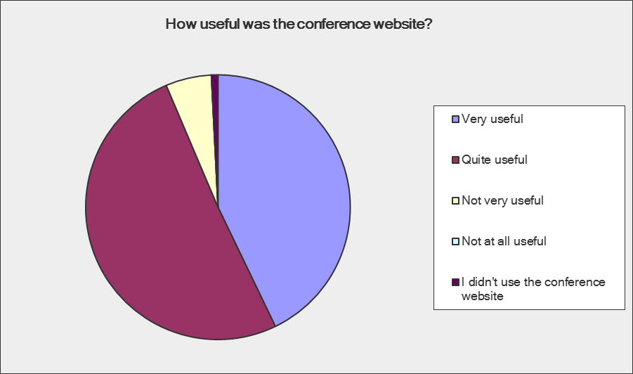
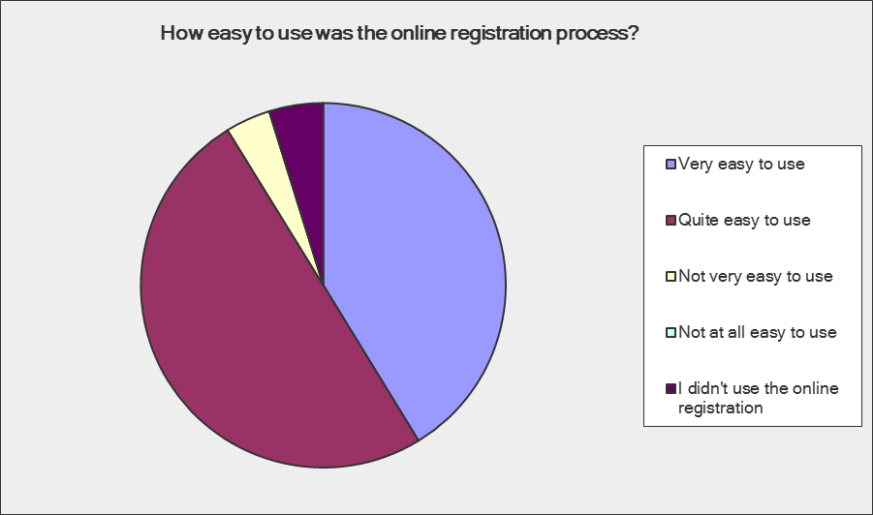
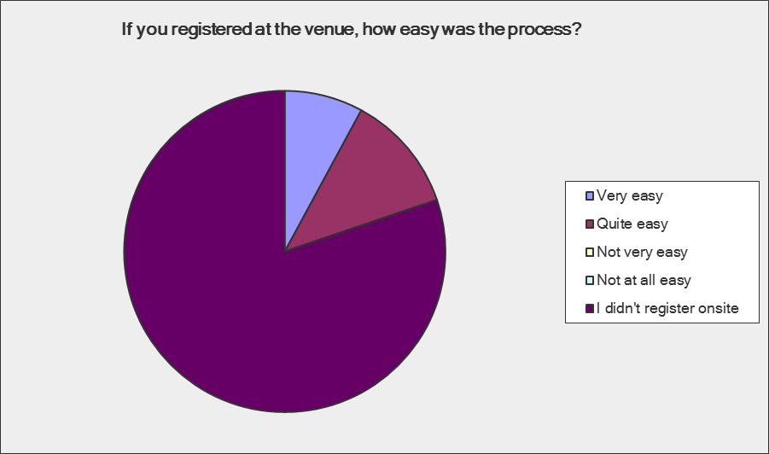
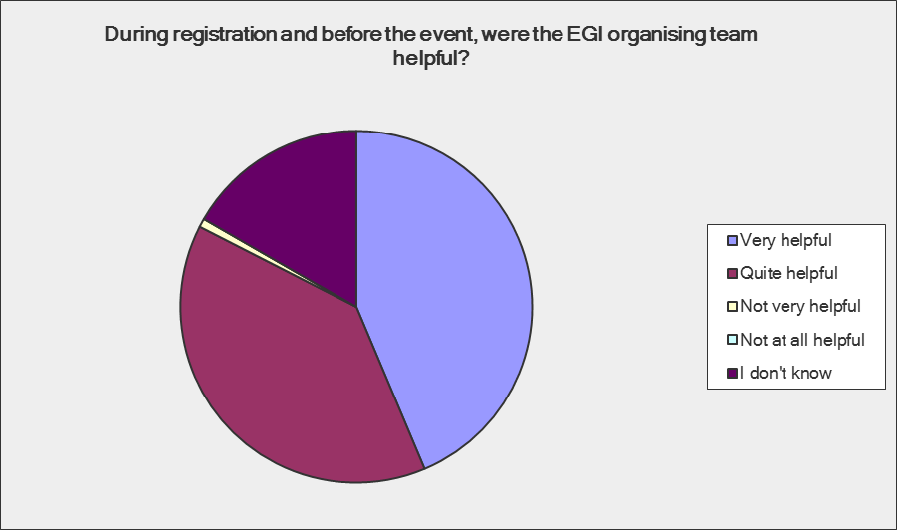
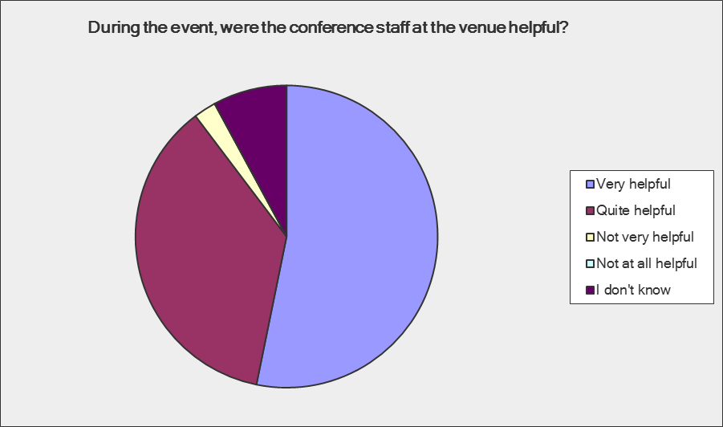
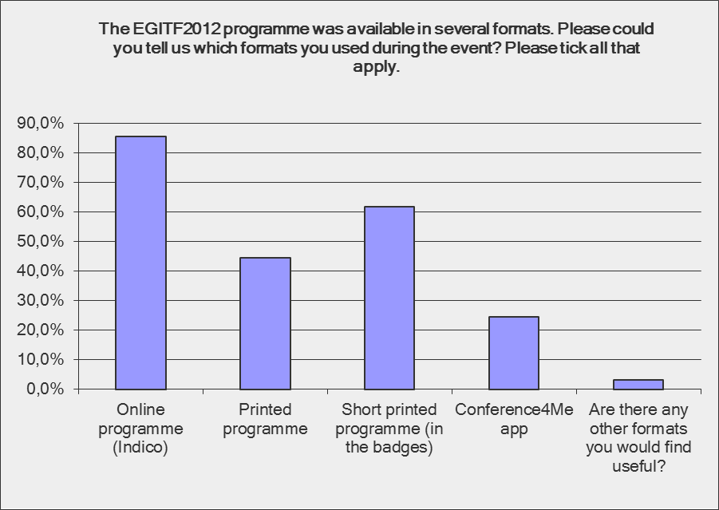
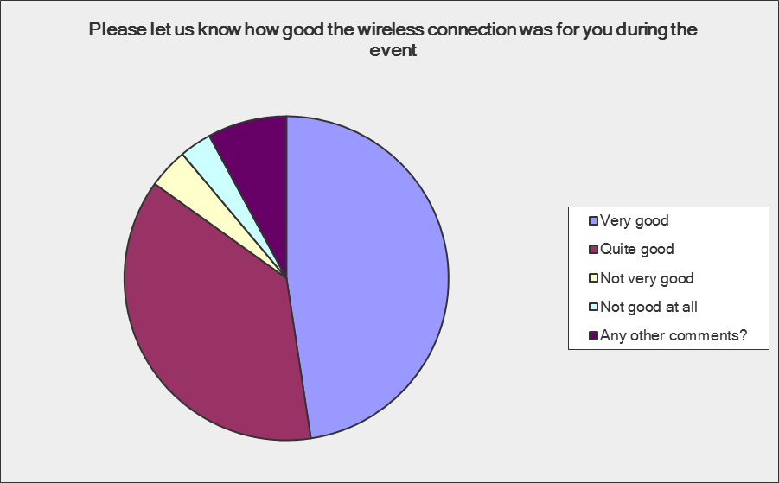
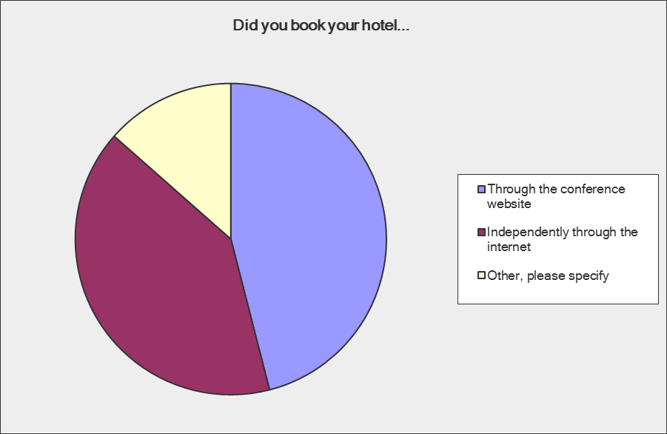

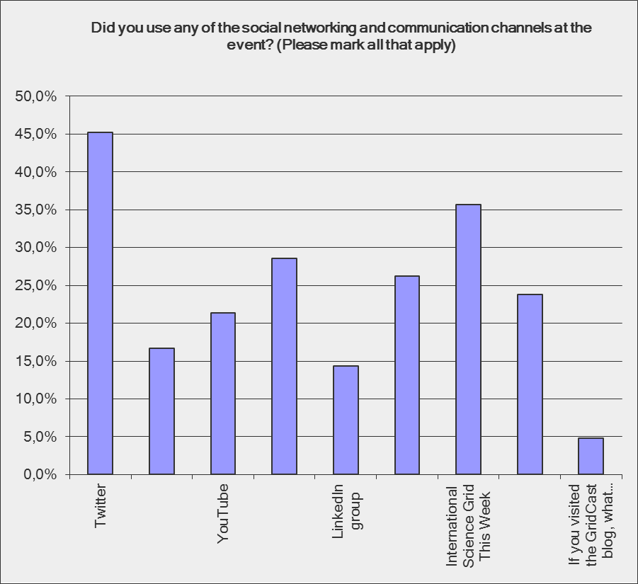

Did you use any of the social networking and communication channels at the event? (Please mark all that apply)
Answer Options | Response Percent | Response Count
Twitter | 45,2% | 19
Flickr | 16,7% | 7
YouTube | 21,4% | 9
Facebook group | 28,6% | 12
LinkedIn group | 14,3% | 6
EGI blog | 26,2% | 11
International Science Grid This Week | 35,7% | 15
GridCast blog | 23,8% | 10
If you visited the GridCast blog, what was your main reason for visiting? Would you be interested in contributing to the blog yourself? | 4,8% | 2
answered question |  | 42
skipped question |  | 84

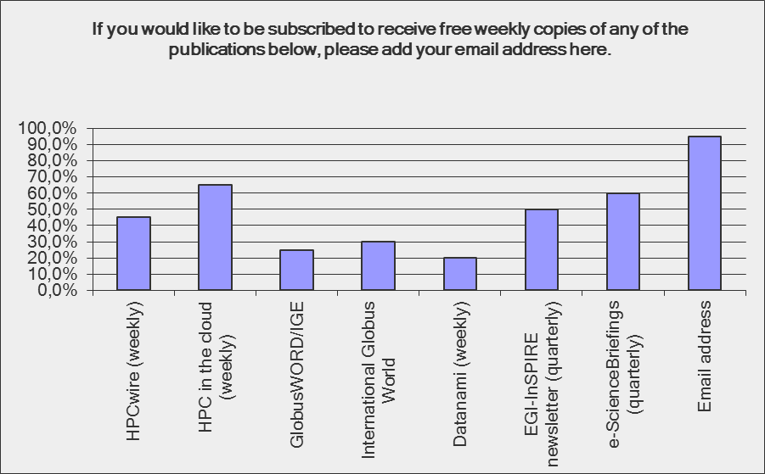

Compared to similar events that you have attended, do you have any feedback on the fees for the event?
Answer Options | Good value for money | Acceptable value for money | Higher than average | Much higher than average | Does not apply | Rating Average | Response Count
The registration fees | 14 | 60 | 37 | 10 | 5 | 2,36 | 126
Conference dinner | 10 | 18 | 24 | 12 | 62 | 2,59 | 126
Hotel rates | 29 | 57 | 9 | 6 | 25 | 1,92 | 126
Travel to the event | 33 | 67 | 11 | 1 | 14 | 1,82 | 126
Fees for booth | 2 | 21 | 6 | 2 | 95 | 2,26 | 126
answered question |  |  |  |  |  |  | 126
skipped question |  |  |  |  |  |  | 0

Selected comments
On food
“Good catering, but coffee machines out of service during session time.”
“Coffee and water could be continuously available.”
“Vegetarian options limited. Coffee supply sub-optimal.”
“Very positive, except Monday lunch”
“All fine - personally I would have liked something sweet also in the afternoon coffee break.”
“Very good! Some fruits and other healthy alternatives would have been appreciated in lunches or coffee breaks”
“quality of the coffee was below par, but this seems to be a prague-wide issue”

Venue
“Hotel Clarion was really selected in the best way - it's suitable for such events.”
“Very easy to get to the venue.”
“Layout was good with good acoustics and equipment”
“Excellent venue and it was fantastically convenient that it was inside a hotel.”
“A bit outside the centrum”

In general
“Keep up the good conferences!”
“Preparation of the community forum should involve NILs very actively”
“The grid users did not show up again :(
“EGI keeps organizing these expensive "internal events" that don't bring any new user groups.”
“booking the hotel via the conference site was more expensive than on the internet, this is unacceptable!”
“very well prepared conference in general”

Media Appearances
Globus and Grid: Blazing Trails for Future Discovery (Elizabeth Leake)
http://www.hpcinthecloud.com/hpccloud/2012-09-13/globus_and_grid:_blazing_trails_for_future_discovery.html

Grid Community Gathers in Prague (Tiffany Trader)
http://www.hpcinthecloud.com/hpccloud/2012-09-18/grid_community_gathers_in_prague.html?featured=top

Greetings from Prague
http://www.isgtw.org/spotlight/greetings-prague

EGI press releases
Globus Online launch (20 September)
Press release issue jointly with Globus and the Initiative for Globus in Europe.
http://www.egi.eu/news-and-media/newsfeed/news_0165_GlobusOnline_goes_live.html

