EGI-InSPIRE

MS101 EGI Quality Assurance Wiki site

EU MILESTONE: MS101

Document identifier: | input.doc
Date: | 04/11/2010
Activity: | NA1
Lead Partner: | EGI.eu
Document Status: | FINAL
Dissemination Level: | PUBLIC
Document Link: | https://documents.egi.eu/document/144

Abstract
This document gives a brief overview of the EGI Quality Assurance Wiki Site, which fulfils milestone MS101. The document outlines the technical details for the site, the roles and responsibilities for updating and maintaining the content and a brief overview of the content.

- Copyright notice
Copyright © Members of the EGI-InSPIRE Collaboration, 2010. See www.egi.eu for details of the EGI-InSPIRE project and the collaboration. EGI-InSPIRE (“European Grid Initiative: Integrated Sustainable Pan-European Infrastructure for Researchers in Europe”) is a project co-funded by the European Commission as an Integrated Infrastructure Initiative within the 7th Framework Programme. EGI-InSPIRE began in May 2010 and will run for 4 years. This work is licensed under the Creative Commons Attribution-Noncommercial 3.0 License. To view a copy of this license, visit http://creativecommons.org/licenses/by-nc/3.0/ or send a letter to Creative Commons, 171 Second Street, Suite 300, San Francisco, California, 94105, and USA. The work must be attributed by attaching the following reference to the copied elements: “Copyright © Members of the EGI-InSPIRE Collaboration, 2010. See www.egi.eu for details of the EGI-InSPIRE project and the collaboration”. Using this document in a way and/or for purposes not foreseen in the license, requires the prior written permission of the copyright holders. The information contained in this document represents the views of the copyright holders as of the date such views are published.
- Delivery Slip
 | Name | Partner/Activity | Date
From | Catherine Gater | EGI.eu | 24/8/10
Reviewed by | Moderator: Steven Newhouse  Reviewers: Steve Brewer | EGI.eu | 7/7/10
Approved by | AMB & PMB |  | 11/10/10
- Document Log
Issue | Date | Comment | Author/Partner
1 | 2/7/10 | First draft | Catherine Gater
2 | 23/9/10 | Second draft | Catherine Gater
3 | 11/10/10 | Final | Catherine Gater
- Application area
This document is a formal deliverable for the European Commission, applicable to all members of the EGI-InSPIRE project, beneficiaries and Joint Research Unit members, as well as its collaborating projects.
- Document amendment procedure
Amendments, comments and suggestions should be sent to the authors. The procedures documented in the EGI-InSPIRE “Document Management Procedure” will be followed:
https://wiki.egi.eu/wiki/Procedures
- Terminology
A complete project glossary is provided at the following page: http://www.egi.eu/about/glossary/.
- PROJECT SUMMARY

To support science and innovation, a lasting operational model for e-Science is needed − both for coordinating the infrastructure and for delivering integrated services that cross national borders.

The EGI-InSPIRE project will support the transition from a project-based system to a sustainable pan-European e-Infrastructure, by supporting ‘grids’ of high-performance computing (HPC) and high-throughput computing (HTC) resources. EGI-InSPIRE will also be ideally placed to integrate new Distributed Computing Infrastructures (DCIs) such as clouds, supercomputing networks and desktop grids, to benefit user communities within the European Research Area.

EGI-InSPIRE will collect user requirements and provide support for the current and potential new user communities, for example within the ESFRI projects. Additional support will also be given to the current heavy users of the infrastructure, such as high energy physics, computational chemistry and life sciences, as they move their critical services and tools from a centralised support model to one driven by their own individual communities.

The objectives of the project are:

- The continued operation and expansion of today’s production infrastructure by transitioning to a governance model and operational infrastructure that can be increasingly sustained outside of specific project funding.
- The continued support of researchers within Europe and their international collaborators that are using the current production infrastructure.
- The support for current heavy users of the infrastructure in earth science, astronomy and astrophysics, fusion, computational chemistry and materials science technology, life sciences and high energy physics as they move to sustainable support models for their own communities.
- Interfaces that expand access to new user communities including new potential heavy users of the infrastructure from the ESFRI projects.
- Mechanisms to integrate existing infrastructure providers in Europe and around the world into the production infrastructure, so as to provide transparent access to all authorised users.
- Establish processes and procedures to allow the integration of new DCI technologies (e.g. clouds, volunteer desktop grids) and heterogeneous resources (e.g. HTC and HPC) into a seamless production infrastructure as they mature and demonstrate value to the EGI community.

The EGI community is a federation of independent national and community resource providers, whose resources support specific research communities and international collaborators both within Europe and worldwide. EGI.eu, coordinator of EGI-InSPIRE, brings together partner institutions established within the community to provide a set of essential human and technical services that enable secure integrated access to distributed resources on behalf of the community.

The production infrastructure supports Virtual Research Communities (VRCs) − structured international user communities − that are grouped into specific research domains. VRCs are formally represented within EGI at both a technical and strategic level.

- EXECUTIVE SUMMARY
This document summarises the details relating to the Quality Assurance Wiki site for the European Grid Infrastructure, including the roles and responsibilities for maintaining and updating the content, the topics covered by the site, the technical details regarding support and upkeep of the site, as well as future plans. The Wiki site is available at https://wiki.egi.eu/.

The EGI Wiki site is maintained by a small team of administrators and content managers. The following roles have been established for the website:
- Site administrators
- Web support
- Content update

The EGI Wiki site is available at https://wiki.egi.eu/wiki. It is based on the MediaWiki system and is available for the EGI community. Write access is restricted - only users with account in the EGI.eu Single Sign On system can log in. Write access for certain namespaces is also limited to specific groups.

The Quality pages contain a number of sections, including an outline of the procedures used in project management, document management and for recording project outputs. Links to templates for project presentations, deliverables and milestones, review documents and the quarterly reports are also included. A summary of the deliverables and milestones review process is included, as well as an overview of the metrics used to track the project’s progress.

Currently the EGI Wiki is a work in progress. The content covered needs to be balanced with the content available on other related EGI websites so that information is neither repeated, inconsistent or missing. The design, layout and content of the site will be evolved in the future in line with D2.2 Dissemination Plan, and in close collaboration with other activities.

TABLE OF CONTENTS
1 Introduction 6
2 ROLES AND responsibilities 7
3 InfrastruCture 8
4 CONTENTs 9
4.1 Screenshots 10
5 Conclusion and future plans 11
6 References 12

Introduction

This document summarises the details relating to the Quality Assurance Wiki site for the European Grid Infrastructure, including the roles and responsibilities for maintaining and updating the content, the topics covered by the site, the technical details regarding support and upkeep of the site, as well as future plans. The Wiki site is available at https://wiki.egi.eu/.

ROLES AND responsibilities

The EGI Wiki site is maintained by a small team of administrators and content managers. The following roles have been established for the website:
Site administrators
Permission to edit contents is given to the Dissemination Manager, the Administrative Support and the Project Office.
Web support
Day to day web support services are provided by CESNET, again by the it-support@egi.eu team. This consists of trouble shooting, management of the OpenCMS content management system and implementation of major updates or changes to the website structure, as well as administration of user access and web statistics packages. Further details are also given in the next section.
Content update
The content is updated exclusively by the Quality Assurance Officer .
A Quality Assurance Officer (QAO) is a key member of the NA1 team and is responsible for ensuring the high quality of the output of the project – the services, deliverables and processes. The QAO is also involved in defining; implementing and collecting the metrics through the various EGI functions – the operations, software and user support – and the project as a whole. These metrics are established, reviewed annually for their relevance, and used to monitor progress within these areas of the project. They QAO also leads the production of project wide reports, i.e. the Gender Action Plan (GAP), quarterly reports, annual reports, etc.

InfrastruCture
The EGI Wiki site is available at https://wiki.egi.eu/wiki. It is based on the MediaWiki system and is available for the EGI community. Write access is restricted - only users with account in the EGI.eu Single Sign On system can log in. Write access for certain namespaces is also limited to specific groups.

The Wiki site contains links to sites for the organisational groups within EGI.eu, the policy groups and projects such as the EGI-InSPIRE main page at https://wiki.egi.eu/wiki/EGI-InSPIRE:Main_Page. The site also includes links to the NGI websites. The information on the EGI-InSPIRE project wiki site is maintained by the work package leaders and task leaders for each area and contains detailed information that is expected to change on a frequent basis.

The Quality Assurance pages are available at https://wiki.egi.eu/wiki/Quality_Assurance:Main_Page.

CONTENTs

Title of section | Description
Procedures
- Project Management | Explanation of Project Progress Tracking tool which is being used to track the staff efforts committed to EGI InSPIRE.
- Document Management | Guidelines to how the documents produced during the project should be treated from appropriate content formatting to where the formal outputs must be located.
- Recording Project Outputs | List of tools that must be used when recording procedures during project.
Templates | Linked to the official templates of the most important project documents.
Deliverables and Milestones Monitoring
Metrics Monitoring | List and explanation of metrics that must be applied to each group in order to evaluate performance (under progress)

Screenshots
Figure 1: EGI Wiki site home page

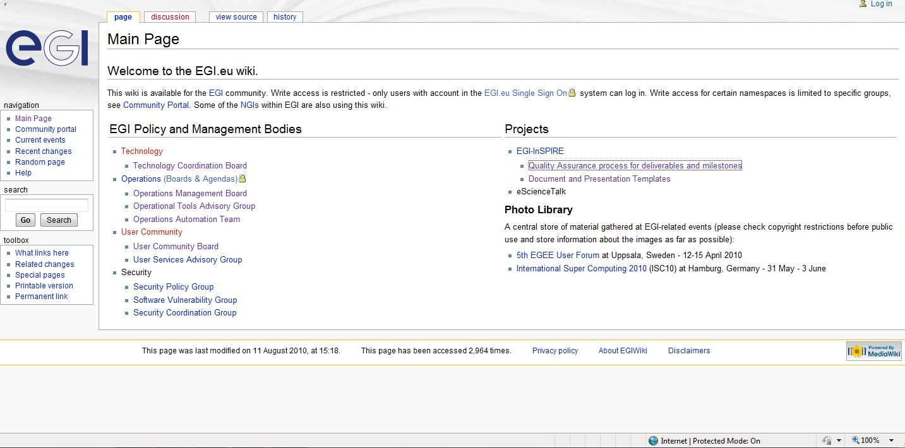

Figure 2: Quality Assurance main page

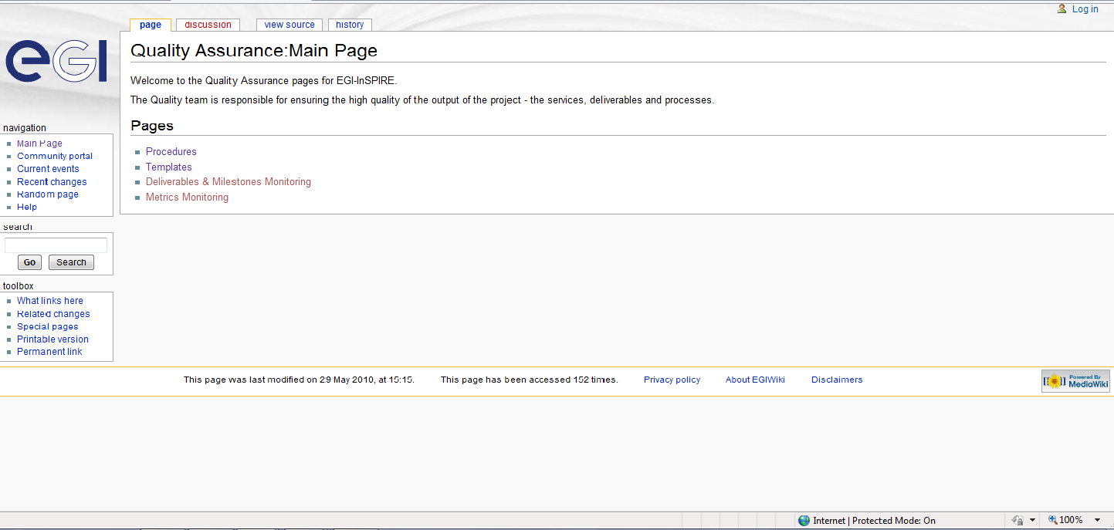

Conclusion and future plans

Currently the EGI Wiki is a work in progress. The content covered needs to be balanced with the content available on other related EGI websites so that information is neither repeated, inconsistent or missing. The design, layout and content of the site will be evolved in the future in line with D2.2 Dissemination Plan, and in close collaboration with other activities.

References
R 1 | EGI D2.2 Dissemination Plan  https://documents.egi.eu/document/56
R 2 | EGI InSPIRE- Description of Work  https://documents.egi.eu/document/10

