EGI-InSPIRE

DISSEMINATION HANDBOOK

EU MILESTONE: MS203

Document identifier: | input.doc
Date: | 04/11/2010
Activity: | NA2
Lead Partner: | EGI.eu
Document Status: | FINAL
Dissemination Level: | PUBLIC
Document Link: | https://documents.egi.eu/document/26

Abstract
This document gives an overview of the dissemination guide for EGI-InSPIRE, including mailing lists, logos, branding, EC attribution and links to resources.

- Copyright notice
Copyright © Members of the EGI-InSPIRE Collaboration, 2010. See www.egi.eu for details of the EGI-InSPIRE project and the collaboration. EGI-InSPIRE (“European Grid Initiative: Integrated Sustainable Pan-European Infrastructure for Researchers in Europe”) is a project co-funded by the European Commission as an Integrated Infrastructure Initiative within the 7th Framework Programme. EGI-InSPIRE began in May 2010 and will run for 4 years. This work is licensed under the Creative Commons Attribution-Noncommercial 3.0 License. To view a copy of this license, visit http://creativecommons.org/licenses/by-nc/3.0/ or send a letter to Creative Commons, 171 Second Street, Suite 300, San Francisco, California, 94105, and USA. The work must be attributed by attaching the following reference to the copied elements: “Copyright © Members of the EGI-InSPIRE Collaboration, 2010. See www.egi.eu for details of the EGI-InSPIRE project and the collaboration”. Using this document in a way and/or for purposes not foreseen in the license, requires the prior written permission of the copyright holders. The information contained in this document represents the views of the copyright holders as of the date such views are published.
- Delivery Slip
 | Name | Partner/Activity | Date
From | Catherine Gater | EGI.eu/NA2.2 | 23/8/10
Reviewed by | Moderator: Steven Newhouse  Reviewers: Claire Devereux | NA2 | 21/9/10
Approved by | AMB & PMB |  | 14/10/10
- Document Log
Issue | Date | Comment | Author/Partner
1 | 23 August 2010 | First draft | C.Gater/EGI.eu
2 | 21 September 2010 | Second draft | C.Gater/EGI.eu
3 | 14 October 2010 | Third draft | C.Gater/EGI.eu
- Application area
This document is a formal deliverable for the European Commission, applicable to all members of the EGI-InSPIRE project, beneficiaries and Joint Research Unit members, as well as its collaborating projects.
- Document amendment procedure
Amendments, comments and suggestions should be sent to the authors. The procedures documented in the EGI-InSPIRE “Document Management Procedure” will be followed:
https://wiki.egi.eu/wiki/Procedures
- Terminology
A complete project glossary is provided at the following page: http://www.egi.eu/about/glossary/.
- PROJECT SUMMARY

To support science and innovation, a lasting operational model for e-Science is needed − both for coordinating the infrastructure and for delivering integrated services that cross national borders.

The EGI-InSPIRE project will support the transition from a project-based system to a sustainable pan-European e-Infrastructure, by supporting ‘grids’ of high-performance computing (HPC) and high-throughput computing (HTC) resources. EGI-InSPIRE will also be ideally placed to integrate new Distributed Computing Infrastructures (DCIs) such as clouds, supercomputing networks and desktop grids, to benefit user communities within the European Research Area.

EGI-InSPIRE will collect user requirements and provide support for the current and potential new user communities, for example within the ESFRI projects. Additional support will also be given to the current heavy users of the infrastructure, such as high energy physics, computational chemistry and life sciences, as they move their critical services and tools from a centralised support model to one driven by their own individual communities.

The objectives of the project are:

- The continued operation and expansion of today’s production infrastructure by transitioning to a governance model and operational infrastructure that can be increasingly sustained outside of specific project funding.
- The continued support of researchers within Europe and their international collaborators that are using the current production infrastructure.
- The support for current heavy users of the infrastructure in earth science, astronomy and astrophysics, fusion, computational chemistry and materials science technology, life sciences and high energy physics as they move to sustainable support models for their own communities.
- Interfaces that expand access to new user communities including new potential heavy users of the infrastructure from the ESFRI projects.
- Mechanisms to integrate existing infrastructure providers in Europe and around the world into the production infrastructure, so as to provide transparent access to all authorised users.
- Establish processes and procedures to allow the integration of new DCI technologies (e.g. clouds, volunteer desktop grids) and heterogeneous resources (e.g. HTC and HPC) into a seamless production infrastructure as they mature and demonstrate value to the EGI community.

The EGI community is a federation of independent national and community resource providers, whose resources support specific research communities and international collaborators both within Europe and worldwide. EGI.eu, coordinator of EGI-InSPIRE, brings together partner institutions established within the community to provide a set of essential human and technical services that enable secure integrated access to distributed resources on behalf of the community.

The production infrastructure supports Virtual Research Communities (VRCs) − structured international user communities − that are grouped into specific research domains. VRCs are formally represented within EGI at both a technical and strategic level.

- EXECUTIVE SUMMARY
This document gives an overview of the practical elements relating to dissemination, design and branding for the EGI-InSPIRE project. Targeted at the central dissemination team, coordinated by EGI.eu under task TNA2.2, it is also aimed at the partners providing effort to the dissemination task within WP2. The dissemination task within EGI-InSPIRE falls into WP2, NA2-External relations. This activity supports the development of policy, the coordination of standards and the dissemination and community building activity appropriate for the role that EGI.eu will play in coordinating the European e-Infrastructure. For task NA2.2, the aim is to disseminate the work of the EGI and its user communities both within the project and worldwide.

The document refers to the contributors to the EGI Global and EGI National Tasks and lists the participating partners. Also discussed is the branding for EGI-InSPIRE, which was refreshed during the first quarter, including new logos and colour palettes. Appropriate usage of these logos, colours, fonts and additional logos, such as the EC logos is discussed.

The document also covers how internal communication will be handled within the project, including the details of project mailing lists, an outline of the dissemination sections of the project wiki and the publication of deliverables and milestones on the Document Server. A number of resources are also available on the main project website. The expected use of social media channels such as Twitter and Flickr is also discussed. The document also covers the basic procedures for events, press releases and publicity and how these will be updated. Also covered are guidelines for the working relationships and mutual expectations between the central EGI.eu dissemination team and the local dissemination teams within the NGIs and EIROs.

TABLE OF CONTENTS
1 Introduction 6
2 Dissemination in EGI-inspire 7
2.1 EGI Global Task 7
2.2 NGI International Task 7
3 Branding In EGI-InSPIRE 11
3.1 Logos 11
3.2 Colour palettes 12
3.3 Fonts 13
3.4 EC logo usage 13
4 Internal Communication 14
4.1 Mailing lists 14
4.2 Wiki 14
4.3 Document sharing 14
4.4 Website 14
4.5 Social media 14
4.6 Press releases 15
5 Guides to Dissemination 16
5.1 Deliverables and Milestones 16
5.2 Templates and “how to” guides 17
5.3 Copyright and Creative Commons 17
5.4 Events 17
5.5 NGI and partner websites 18
6 working with national grid initiatives and eiros 19
6.1 Dissemination as a resource 19
6.2 NA2.2’s relationships and expectations 20
6.3 Local dissemination 20
6.4 User support 20
7 Conclusions 22
8 References 23

Introduction
This document gives an overview of the practical elements relating to dissemination, design and branding for the EGI-InSPIRE project. The document is targeted at the central dissemination team, coordinated by EGI.eu under task TNA2.2. It is also targeted at the partners providing effort to the dissemination task within WP2 (NA2). The document refers to the contributors to the EGI Global and EGI National Tasks, discusses branding in EGI-InSPIRE, including logos and colour palettes and EC logo use.

The document also covers how internal communication will be handled within the project, including mailing lists, the project wiki, document server and social media. The document also covers the basic procedures for events, press releases and publicity and how these will be updated, as well as how the EGI.eu team will work with the NGIs and EIROs.

The branding for the EGI-InSPIRE project was refreshed during the first quarter of the project, including new logos for EGI-InSPIRE, EGI and EGI.eu and a new colour palette.

The document will be updated in PM14 through the MS217 milestone, and again in PM26 and PM38.

Dissemination in EGI-inspire
The dissemination task within EGI-InSPIRE falls into WP2, NA2-External relations. This activity supports the development of policy, the coordination of standards and the dissemination and community building activity appropriate for the role that EGI.eu will play in coordinating the European e-Infrastructure. For task NA2.2, the aim is to disseminate the work of the EGI and its user communities both within the project and worldwide.

The task will work with contacts within the NGIs and related EC proposed projects, for example e-ScienceTalk and SIENA. It will maintain and develop content for the project website (www.egi.eu), the monthly Project Director’s letter, a quarterly newsletter and develop case studies and success stories based on the applications and communities within the applications database (http://appdb.egi.eu/).

The dissemination task of EGI-InSPIRE is covered in further detail in D2.1 Dissemination Plan [R1].

EGI Global Task
The EGI Global task is coordinated by EGI.eu in Amsterdam, and contributes 96PM to task TNA2.2. A Dissemination Manager manages the task through the coordination of the staff within EGI.eu and those located in the NGIs, assisted by professional science writers and an NGI Dissemination Coordinator. The EGI Global Task also administers a dissemination budget for stands at major exhibitions, design and printing of posters, leaflets, booklets and other promotional materials and website design.

NGI International Task

The NGI International Task includes contributions from 37 partners across Europe and beyond, including 31 funded European partners, and 6 unfunded non-European partners in Taiwan, Australia, Singapore, Indonesia, Malaysia and the Philippines. These partners will all promote the EGI and the work of the project to their local national audiences.

Participant Number | Participant Short name  / Lead Beneficiary | WP 2 (NA2): External Relations  Person Months per Task | Total NA2 Person Months per Effort Type |  | Total NA2 Person Months
Participant Number | Participant Short name  / Lead Beneficiary | TNA2.2 | EGI | NGI
1 | EGI.EU | 96 | 308 | 0 | 308
2 | UPT | 5 |  | 12 | 12
5 | IPP-BAS | 8 |  | 8 | 8
 | IPP-BAS | 8 |  | 8 | 8
7 | SWITCH |  |  | 7 | 7
 | SWITCH |  |  | 7 | 7
8 | UCY | 3 |  | 8 | 8
9 | CESNET | 4 |  | 8 | 8
10 | KIT-G | 10 |  | 17 | 17
 | KIT-G | 10 |  | 14 | 14
 | BADW-LRZ |  |  | 3 | 3
12 | CSIC | 23 |  | 35 | 35
 | CSIC | 11 |  | 23 | 23
 | UPVLC | 12 |  | 12 | 12
13 | CSC | 8 |  | 17 | 17
14 | CNRS | 7 |  | 21 | 21
 | CNRS | 2 |  | 16 | 16
 | HealthGrid | 5 |  | 5 | 5
18 | MTA KFKI | 4 |  | 4 | 4
 | BME | 2 |  | 2 | 2
 | MTA SZTAKI | 2 |  | 2 | 2
19 | TCD | 3 |  | 6 | 6
20 | IUCC | 1 |  | 4 | 4
21 | INFN | 12 |  | 20 | 20
 | INFN | 12 |  | 20 | 20
22 | VU | 11 |  | 21 | 21
26 | NCF |  | 5 | 7 | 12
 | FOM |  | 5 | 3 | 8
 | SARA |  |  | 4 | 4
27 | SIGMA | 3 |  | 6 | 6
 | SIGMA | 3 |  | 6 | 6
28 | CYFRONET | 6 |  | 16 | 16
 | CYFRONET | 6 |  | 16 | 16
29 | LIP | 6 |  | 12 | 12
30 | IPB | 8 |  | 12 | 12
31 | ARNES | 24 |  | 28 | 28
32 | UI SAV | 4 |  | 8 | 8
33 | TUBITAK ULAKBIM | 8 |  | 16 | 16
34 | STFC | 12 | 19 | 24 | 43
 | STFC | 12 | 19 | 24 | 43
36 | UCPH | 5 |  | 12 | 12
38 | VR-SNIC | 4 |  | 8 | 8
 | KTH | 4 |  | 8 | 8
39 | IMCS-UL | 22 |  | 22 | 22
40 | E-ARENA | 4 |  | 14 | 14
 | E-ARENA | 4 |  | 14 | 14
42 | ASGC | 16 |  | 48 | 48
43 | ASTI | 8 |  | 20 | 20
44 | ITB | 1 |  | 3 | 3
47 | UNIMELB | 4 |  | 4 | 4
48 | NUS | 8 |  | 20 | 20
49 | UPM | 8 |  | 12 | 12
 | TOTALS | 346 | 332 | 480 | 812

The current list of project participants is as follows:

Vicky Huang ASGC
Mariusz Sterzel CYFRONET
Klemens Noga CYFRONET
Péter Dóbé BME
Richárd Kápolnai BME
Jana Hrdličková CESNET
Suvi Alanko CSC
Tatiana Strizh E-ARENA
Baiba Kaskina IMCS UL
Kristiāna
Mūze-Feldberga IMCS UL
Aleksandar Belic IPB
Aleksandar Bogojevic IPB
Slobodan Vrhovac IPB
Arad Alper IUCC
Nadav Grossaug IUCC
Wilhelm Bühler KIT-G
Lilit Axner KTH
Michael Hammill KTH
David Horat LIP
Goncalo Borges LIP
Hugo Miguel da Silva
Gomes LIP
Jorge Gomes LIP
Miklos Kozlovszky MTA SZTAKI
Robert Lovas MTA SZTAKI
Stuart Kenny TCD
Burcu Ortakaya TUBITAK ULAKBIM
Hakan Bayındır TUBITAK ULAKBIM
Maria Poveda UCY
Marios Dikaiakos UCY
Peter Kurdel UI SAV
Tim Dyce UNIMELB
Vicente Hernández UPVLC

Branding In EGI-InSPIRE
The branding for the EGI-InSPIRE project was refreshed during the first quarter of the project, including new logos for EGI-InSPIRE, EGI and EGI.eu and a new colour palette. The website was also reviewed for milestone MS207 Review of website content [R2]. Further details of the website redesign are included in this document.

The entire logo is designed to work as a whole on all primary communications, however the individual elements can be used as design elements supporting the full logo e.g. watermark (tint) of just the icon.

Logos
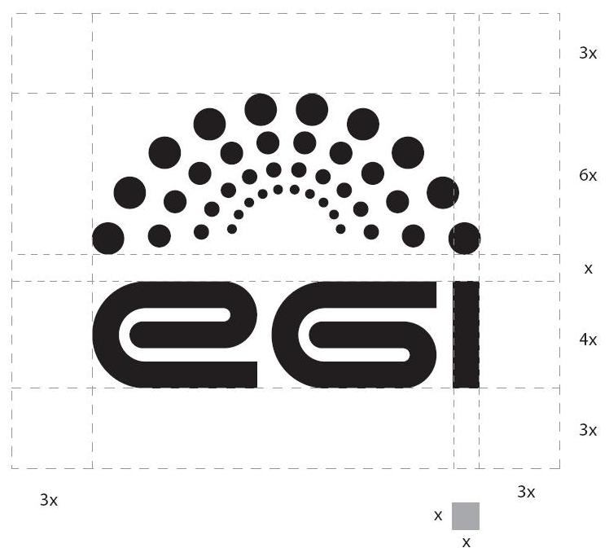
The spaces around the various logo elements and the entire logo itself play a part in ensuring its communication effectiveness. The clear space shown here represents the preferred proportional distance between the logo and any other design or graphic elements.

The EGI logo has been designed for use in two colours (discussed later). It is most effective
when used in these two colours against a white background.

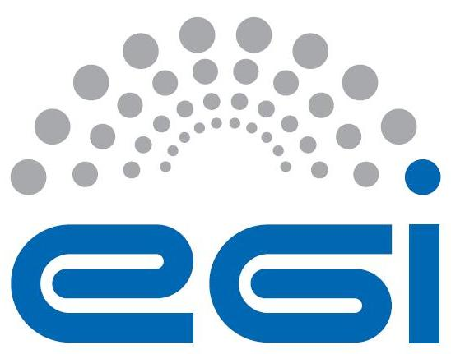

The brand is completed by two other versions of the logo: EGI-European Grid Infrastructure and EGI-InSPIRE



Colour palettes
The corporate colours are listed below for pantone, CMYK and RGB values.
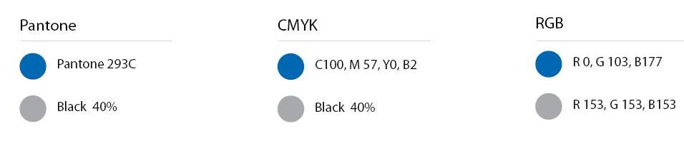

Fonts
The font used for the EGI logo is an adapted version of Helvetica Condensed Bold. The typography in the logo for the EGI-European Grid Infrastructure and EGI-InSPIRE version should not be recreated.
The fonts to be used with the logo (main title...) should be of the same family: Helvetica condensed (medium, roman, light, italic...).

For body text a standard Helvetica (roman, bold, italic) can be used. In the case of internet page Arial can also be used.

EC logo usage
Unless the Commission requests otherwise, any publicity, including at a conference or seminar or any type of information or promotional material (brochure, leaflet, poster, presentation etc), must specify that the project has received Community research funding, quote the contract number RI 261323 and display the European emblem. When displayed in association with a logo, the European emblem should be given appropriate prominence.

The following logos must be used with appropriate prominence together with the project logo:
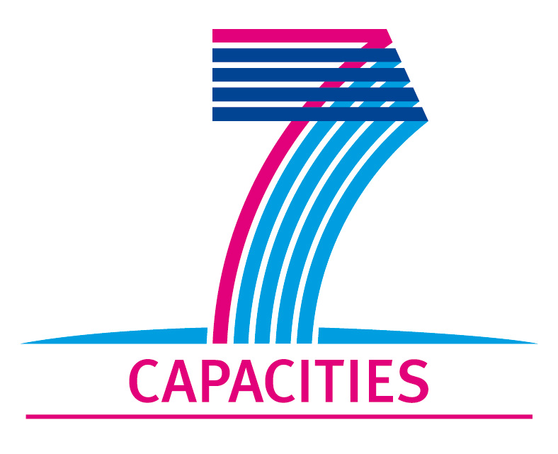

The e-Infrastructures Unit logo may also be used:



Internal Communication
For effective dissemination, it is important that internal communication channels are established early in the project and are used for maximum impact. Dissemination relies on clear communication of success stories from other activities to the dissemination staff, so that these can be communicated more widely outside the project to the user communities and beyond. Similarly, the work packages outside the dissemination activities should be kept up to date with current dissemination activities and the dissemination materials that are available for download, for distribution at events and so on. As TNA2.2 is also a widely dispersed task geographically speaking, well supported central sources of information and means for sharing information are essential.

Mailing lists
A dedicated mailing list has been set up for all members of the TNA2.2 task at https://mailman.egi.eu/mailman/listinfo/inspire-na2-dissemination.

A second mailing list for the whole of WP2 is also available at https://mailman.egi.eu/mailman/listinfo/inspire-na2, which complements the dissemination list.

Project members and also the general public and media can also contact the dissemination team at press@egi.eu.

Wiki
A task-specific wiki site is available at https://wiki.egi.eu/wiki/TNA2.2_Dissemination. The wiki site includes information for project members about the objectives for the task, the description of work, the team and involved partners, the deliverables and milestones and also the links to the social media sites and partner dissemination projects, such as e-ScienceTalk.

Document sharing
The key deliverables and milestones relating to dissemination are published in the EGI Document Server at http://documents.egi.eu. Once fully reviewed by the AMB, PMB and EC, the documents are made publically available to all project members, including the dissemination team.

Website
The EGI website at www.egi.eu contains a Results section that is dedicated to dissemination products, that are available to all project partners as well as the general public. Included in the section are recent articles about EGI and EGI-InSPIRE, project newsletters, the monthly Director’s Letters and press releases. These are available for download by all dissemination partners. As the website develops, further publically available dissemination materials will be added here, such as logos, presentation templates and poster templates. The dissemination team also maintains the RSS news feed of the website, and posts events to the calendar.

Social media
EGI is setting up a series of social media sites including a Twitter feed at www.twitter.com/egi_inspire. This feed will pull in the RSS news feed from the EGI website as well as providing a channel for live reports on EGI events and meetings. By following feeds from participating partners, this will help to build a dissemination community around EGI’s online presence.

EGI is also setting up a Flickr photostream at www.flickr.com/photos/european-grid-initiative for images and photos and will also investigate setting up further social media sites, such as Vimeo and YouTube.

Press releases
Press releases will be issued by the central dissemination team at EGI.eu on a regular basis, in the run up to events and in response to key achievements by the project, such as the publication of high impact scientific papers. These press releases issued on behalf of EGI-InSPIRE will be approved through the PMB of the EGI-InSPIRE project, and will also be sent for information to the Executive Board of EGI.eu.

Once approved, press releases will be issued on behalf of EGI-InSPIRE by the central team to the EGI media mailing list, media@egi.eu. Press releases will also be issued to the inspire-na2-disseminate list so that NGIs can translate them, redistribute them to their own mailing lists, and post them on local websites. The press releases will be published in English on the EGI website at https://www.egi.eu/about/press/ along with any translated press releases provided by partners.

EGI-InSPIRE partners are encouraged to issue press releases about the project and the EGI-InSPIRE template is available for use. Any press releases using the official template should be approved by the EGI central dissemination team and the PMB. Press releases by partners issued on behalf of the local institution should use the approved Notes for Editors about EGI, EGI.eu and EGI-InSPIRE. Local press releases can be sent to the central team for input on the text and can also be added to the press office website.

Guides to Dissemination
A number of guides for dissemination will be available to project partners, both those participating directly in the dissemination task, but also partners and collaborating projects beyond the TNA2.2 task.

Deliverables and Milestones
A series of deliverables and milestones are planned throughout the project to keep project partners informed of progress in dissemination:

D2.1, D2.10, D2.16 EGI-InSPIRE presentation [R3]
Using the project’s presentation template provide a public presentation on the website that describes EGI-InSPIRE’s past, present and future planned activities. This will also include details on the consortium and infrastructure. The presentation will be updated each year.

D2.2, D2.9 Dissemination plan [R1]
Plan to disseminate EGI.eu and EGI-InSPIRE’s activities to the DCI community in Europe and Worldwide.

D2.3, D2.17 EGI-InSPIRE paper [R4]
A public white paper that describes in more depth the activities and plans taking place within EGI-InSPIRE. The paper will provide a reference that will be used by the community to describe the organisational structure, technical architecture and support model within the project. The paper will be updated after two years.

D2.9, D2.15, D2.22 Dissemination plan [R1]
Plan to disseminate EGI.eu and EGI-InSPIRE’s activities to the DCI community in Europe and Worldwide.

The deliverables will be supplemented by a number of milestones:

MS201 Basic website with key collaborative tools [R5]
MS202 Project presentation template [R6]
MS203, 217, 228, 238 Dissemination handbook
MS204, 211, 213, 215, 218, 222, 223, 225, 229, 233, 234, 236, 239, 244, 245, 247 EGI newsletter [R7]
MS207, 220, 231, 242 Review of website content [R2]

All deliverables and milestones will be published in the Document Server. In addition, the project presentations, project paper and newsletters will be published on the EGI website.

Templates and “how to” guides
Project templates are available from the EGI Quality Assurance wiki site at https://wiki.egi.eu/wiki/Templates. These templates include the project presentation template, the quarterly report template, the deliverable and milestone template and the document review template.
All these templates are also available from adirect link on the Wiki homepage at wiki.egi.eu.

As the dissemination areas of the website and wiki expand, further templates and ‘how to’ guides, such as advice for dealing with the media and tips for preparing dissemination materials will be available online.

Copyright and Creative Commons
In all EGI-InSPIRE official documents, such as Deliverables and Milestones, the following copyright notice should be added:

@Copyright © Members of the EGI-InSPIRE Collaboration, 2010. See www.egi.eu for details of the EGI-InSPIRE project and the collaboration. EGI-InSPIRE (“European Grid Initiative: Integrated Sustainable Pan-European Infrastructure for Researchers in Europe”) is a project co-funded by the European Commission as an Integrated Infrastructure Initiative within the 7th Framework Programme. EGI-InSPIRE began in May 2010 and will run for 4 years. This work is licensed under the Creative Commons Attribution-Noncommercial 3.0 License. To view a copy of this license, visit http://creativecommons.org/licenses/by-nc/3.0/ or send a letter to Creative Commons, 171 Second Street, Suite 300, San Francisco, California, 94105, and USA. The work must be attributed by attaching the following reference to the copied elements: “Copyright © Members of the EGI-InSPIRE Collaboration, 2010. See www.egi.eu for details of the EGI-InSPIRE project and the collaboration”. Using this document in a way and/or for purposes not foreseen in the license, requires the prior written permission of the copyright holders. The information contained in this document represents the views of the copyright holders as of the date such views are published.@

The guidelines regarding copyright and attribution should be followed by all EGI-InSPIRE partners producing materials related to the project, printed or online, and when using elements of the project’s branding, such as logos, graphics and colours.

Events
EGI-InSPIRE will run two major events per year, through the TNA2.4 task. These events will be key opportunities to communicate directly with the distributed dissemination team, to keep them updated on progress within the project and provide opportunities for the team to share best practice.

The central dissemination team will aim to host a face-to-face TNA2.2 meeting at each of these events, in order to facilitate these discussions. In addition, the team will aim to provide a more general dissemination session aimed at the wider project membership to communicate advice on dissemination, drawing on external speakers such as journalists and communications specialists.

The first of these sessions are planned for the EGI Technical Forum 2010 in Amsterdam, 13-17 September. A dissemination plan including an event website, the launch of EGI’s social media channels, including an iPhone app, and a series of press releases has also been developed to maximise the media impact of EGI’s first major event. A report from this event focussing on the dissemination and outreach activities will be produced and uploaded to the dissemination area of the wiki site.

NGI and partner websites

The refreshed branding and format of the website is covered in MS207 Review of the website [R2]. This includes a new template and page layout for the site, including the new logos.

Websites that are affiliated to EGI-InSPIRE should use elements of the new website design, depending on the closeness of the affiliation to the project.

Affiliation of the website | Branding elements requested
Websites loosely affiliated eg websites for collaborating projects | - EGI logo  - Link back to the main EGI site
Websites run independently by EGI-InSPIRE partners, that include pages about the project | - EGI-InSPIRE logo  - Link back to the main EGI site
NGI websites | - EGI logo  - EC logos  - Link back to the main EGI site
Websites run as part of a Global Task eg training site, applications database | - EGI style sheets ie colours, fonts  - EGI website top banner and logo  - EC logos  - Link back to the main EGI site  - Only reproduce the left hand menu bar if it is synchronised automatically with the main site (to avoid the links becoming out of date)
Website directly affiliated to EGI-InSPIRE eg the main project website, the project intranet sites eg DocDB, SSO | - Use the EGI template in full ie top menu, logos, style sheets and side navigation bar.

working with national grid initiatives and eiros
All activities performed by the NA2.2 group will aim to assist the EGI core goal to expand and improve the European grid infrastructure by increasing both the number of end users and public awareness of the infrastructure. This will require the team to work closely with various groups and in many different ways. Dissemination of EGI’s activities, by increasing awareness, will feed into a cycle which will ultimately create new user communities (see Fig 1).

Fig. 1 Dissemination’s role in creating new user communities

To do this the dissemination team will provide two services:
- A first point of contact
The dissemination team will provide a lot of the manpower to allow EGI to be present at a wide range of events to attract new users
- Creation of content/materials
Leaflets, news stories etc, will support the first contact but also in some cases be the first encounter with the grid for potential users

Dissemination as a resource

The team at EGI.eu would like to be viewed as a resource which is free at point of use for anyone in the community. The team can help the community in various ways:
- Publicising local success stories in suitable media
- Creating materials for various audiences; from politicians to scientists
- Providing speakers/presence at events
- Helping write up success stories
- Pointing potential users in the right direction
The team is happy to hear from anyone in the community from individual researchers to project heads who would like help in any of these areas, either by email to press@egi.eu or through the inspire-na2-dissemination mailing list.

NA2.2’s relationships and expectations

The NA2.2 team will need to form relationships with particular areas of expertise within EGI, in particular local dissemination activities and the user support community. To achieve this aim the team at EGI.eu will need to develop a network of contacts across Europe from both these groups that are pro-active or at the very least responsive to requests for information.

It is hoped that these areas will provide the success stories and some of the expert effort for EGI-InSPIRE’s presence at events. Both of these relationships will also be important when initiating contact with a particular community. When the dissemination team is either attending a community event or creating materials aimed at a community the following need to be taken into account:
- Is this community on the grid already?
- What similar kind of work is being done?
- Who is the local or scientific contact best placed to help that community?
It is local dissemination teams and the user support activity which are best placed to answer these questions.

Local dissemination

One thing that was learned from the EGEE series of projects is that there is no replacement for local knowledge and contacts. It is very difficult for the team at EGI to monitor events and activities across more than 30 countries covered the infrastructure. It is hoped that both the funded and unfunded partners within EGI will flag news stories and interesting user community events in their local area to the EGI team. This allows the team to both publicise success stories from across the grid but also to make strategic decisions on which events EGI should have a presence at. Partners can also get involved by providing people to be at these events, as the relatively small team based at EGI.eu is not able to cover every event in person, but can provide materials that locals can use at an event.

User support

Another lesson learned during EGEE was that it is best to use professionals. While the dissemination team can produce materials, attend events and initiate first contact, it is the user support team who will be able to start them on the road to being actual users. The user support community both at EGI and locally will hopefully, like the local dissemination team, provide news stories, events and effort. This will mainly be done through NA3 at EGI,eu but will expand to cover other personal contacts in countries and communities where possible.

Combining these two areas of expertise means that the users learn as much as they can about the potential the grid has for their community. It also means that they are being passed on to the best person possible to assist them. Once that community has established itself the dissemination team can use their story in various ways to again, increase awareness and attract new users.

Conclusions
This Dissemination Handbook is a work in progress and will be updated annually through the project in order to provide an up-to-date resource for project partners. The development of the Handbook will coupled to the milestones relating to the review of the website, and also the annual updates to the Dissemination Plan, D2.1 [R1].

References
R 1 | D2.2 Dissemination plan https://documents.egi.eu/document/56
R 2 | MS207 Review of the website https://documents.egi.eu/document/179
R 3 | D2.1 EGI-InSPIRE presentation https://documents.egi.eu/document/43
R 4 | D2.3 EGI-InSPIRE paper
R 5 | MS201 Basic website with key collaborative tools https://documents.egi.eu/document/126
R 6 | MS202 Project presentation template https://documents.egi.eu/document/35
R 7 | MS204 EGI-InSPIRE newsletter https://documents.egi.eu/document/146

