EGI-InSPIRE

Capabilities offered by Heavy User Communities

EU DELIVERABLE: D6.1

Document identifier: | input.doc
Date: | 28/08/2010
Activity: | SA3
Lead Partner: | CERN
Document Status: | Draft
Dissemination Level: | PUBLIC
Document Link: | https://documents.egi.eu/document/??

Abstract
This document describes the capabilities offered by the Heavy User Communities (HUCs) to other communities: This public report illustrates how the functional capabilities being supported by this activity can be re-used by other communities using European Distributed Computing Infrastructures (DCIs). Sufficient technical depth is provided for potential adopters of DCI platforms to make an initial assessment of how they could work with the offered technologies.

Copyright notice:
Copyright © Members of the EGI-InSPIRE Collaboration, 2010. See www.egi.eu for details of the EGI-InSPIRE project and the collaboration.
EGI-InSPIRE (“European Grid Initiative: Integrated Sustainable Pan-European Infrastructure for Researchers in Europe”) is a project co-funded by the European Commission as an Integrated Infrastructure Initiative within the 7th Framework Programme. EGI-InSPIRE began in May 2010 and will run for 4 years.
This work is licensed under the Creative Commons Attribution-Noncommercial 3.0 License. To view a copy of this license, visit http://creativecommons.org/licenses/by-nc/3.0/ or send a letter to Creative Commons, 171 Second Street, Suite 300, San Francisco, California, 94105, USA. The work must be attributed by attaching the following reference to the copied elements: “Copyright © Members of the EGI-InSPIRE Collaboration, 2010. See www.egi.eu for details of the EGI-InSPIRE project and the collaboration”.
Using this document in a way and/or for purposes not foreseen in the license, requires the prior written permission of the copyright holders.
The information contained in this document represents the views of the copyright holders as of the date such views are published.

Delivery Slip
 | Name | Partner/Activity | Date
From
Reviewed by | Moderator:  Reviewers:
Approved by | AMB & PMB

Document Log
Issue | Date | Comment | Author/Partner
1.0 | July 2010 | First draft | IT-ES group, CERN
2.0 | August 2010 | Case studies received from partners | SA3
3.0 | August 24, 2010 | Merged document with new input, obvious formatting errors fixed. | SA3
4.0 | August 28, 2010 | Final input, slight reorganisation, consistent spelling for names / acronyms | SA3

PROJECT SUMMARY

To support science and innovation, a lasting operational model for e-Science is needed − both for coordinating the infrastructure and for delivering integrated services that cross national borders.

The EGI-InSPIRE project will support the transition from a project-based system to a sustainable pan-European e-Infrastructure, by supporting ‘grids’ of high-performance computing (HPC) and high-throughput computing (HTC) resources. EGI-InSPIRE will also be ideally placed to integrate new Distributed Computing Infrastructures (DCIs) such as clouds, supercomputing networks and desktop grids, to benefit the user communities within the European Research Area.

EGI-InSPIRE will collect user requirements and provide support for the current and potential new user communities, for example the ESFRI projects. Support will also be given to the current heavy users of the infrastructure, such as high energy physics, computational chemistry and life sciences, as they move their critical services and tools from a centralised support model to one driven by their own individual communities.

The objectives of the project are:

- The continued operation and expansion of today’s production infrastructure by transitioning to a governance model and operational infrastructure that can be increasingly sustained outside of specific project funding.
- The continued support of researchers within Europe and their international collaborators that are using the current production infrastructure.
- The support for current heavy users of the infrastructure in earth science, astronomy and astrophysics, fusion, computational chemistry and materials science technology, life sciences and high energy physics as they move to sustainable support models for their own communities.
- Interfaces that expand access to new user communities including new potential heavy users of the infrastructure from the ESFRI projects.
- Mechanisms to integrate existing infrastructure providers in Europe and around the world into the production infrastructure, so as to provide transparent access to all authorised users.
- Establish processes and procedures to allow the integration of new DCI technologies (e.g. clouds, volunteer desktop grids) and heterogeneous resources (e.g. HTC and HPC) into a seamless production infrastructure as they mature and demonstrate value to the EGI community.

The EGI community is a federation of independent national and community resource providers, whose resources support specific research communities and international collaborators both within Europe and worldwide. EGI.eu, coordinator of EGI-InSPIRE, brings together partner institutions established within the community to provide a set of essential human and technical services that enable secure integrated access to distributed resources on behalf of the community.

The production infrastructure supports Virtual Research Communities − structured international user communities − that are grouped into specific research domains. VRCs are formally represented within EGI at both a technical and strategic level.

Table of Contents
1. Introduction 6
1.1. Purpose 6
1.2. Application area 6
1.3. References 6
1.4. Document amendment procedure 6
1.5. Terminology 6
2. EXECUTIVE SUMMARY 7
3. An Overview of Grid Computing 8
3.1. What is the Grid? 8
3.2. “The Knowledge” 8
3.3. Motivation 9
3.4. First Steps in the grid 9
3.4.1. General remarks 9
3.4.2. VO managers 9
3.4.3. VO users 10
3.5. Case Study: EnviroGRIDS 10
3.5.1. Introduction 10
3.5.2. SWAT 11
3.5.3. Gridification of SWAT 11
3.6. Case Study: PARTNER and ULICE 12
3.7. Case Study: Support for a new VO 12
3.7.1. Enabling a VO without access to resources (EnviroGRIDS) 13
3.7.2. Case Study: Enabling a VO with compute / storage requirements (LCD) 15
3.7.3. Grid Support Issues 16
3.8. Fusion Case Studies 16
3.9. Earth Sciences and Environmental Case Studies 17
3.10. The Chemistry and Molecular Science and Technology community 17
3.10.1. The present situation 17
3.10.2. The work plan for the project 19
3.10.3. Services for other communities 20
3.11. Technology 23
3.11.1. Inter-VO Benefits 23
3.11.2. Dashboards 23
3.11.3. Ganga & DIANE 26
3.11.4. Grid Relational Catalog – GRelC 28
3.11.5. Kepler 28
3.11.6. Hammercloud 29
3.11.7. MOTEUR 29
3.12. Data Management 30
3.12.1. DPM 30
3.12.2. LFC 30
3.12.3. FTS 30
3.12.4. Future Data Management Developments 31
3.13. Capabilities of the WLCG Service 31
4. Conclusions 35

Introduction

Purpose
The purpose of this document is to describe the capabilities offered by the Heavy User Communities (HUCs) to other communities. This public report illustrates how the functional capabilities being supported by this activity can be re-used by other communities using European DCIs. Sufficient technical depth is provided for potential adopters of DCI platforms to make an initial assessment of how they could work with the offered technologies.
The strategy adopted is to present a number of case studies that cover a range of areas and disciplines, including initial “gridification” investigations (the porting of an application to the grid environment) to full production support for a new virtual organisation, with a specific focus on the services supported by this work package.

Application area
This document is a formal deliverable for the European Commission, applicable to all members of the EGI-InSPIRE project, beneficiaries and Joint Research Unit members, as well as its collaborating projects.

References
Table 1: Table of references
R 1 | EGI-InSPIRE Description of Work (DOW)
R 2 | MS601 – HUC Contact points and the support model
R 3 | MS602 – HUC Software Roadmap
R 4 | MS603 – Services for High Energy Physics
R 5 | MS604 – Services for the Life Science Community
R 6 | EnviroGRIDS project home page: http://www.envirogrids.net/
R 7 | PARTNER project home page: http://partner.web.cern.ch/
R 8 | ULICE project home page: http://ulice.web.cern.ch/
R 9 | Linear collider detector home page: http://lcd.web.cern.ch/lcd/

Document amendment procedure
Amendments, comments and suggestions should be sent to the authors. The procedures documented in the EGI-InSPIRE “Document Management Procedure” will be followed:
https://wiki.egi.eu/wiki/Procedures

Terminology
A complete project glossary is provided in the EGI-InSPIRE glossary:
http://www.egi.eu/results/glossary/.

EXECUTIVE SUMMARY
Through a series of case studies covering the full range of disciplines currently supported by the Heavy User Communities, this document explains in concrete terms what is required in order to exploit the grid for a variety of applications. It covers the full lifecycle from first “test-drives” to petascale production use (typically defined as 10⁵ cores but in this case also in terms of data volume stored and transferred).

Although the case studies in this document underline the applicability of grid computing (and the services for the Heavy User Communities in particular) to a wide and diverse range of application areas, concrete steps in the grid require close collaboration between application-specific experts and those of grid technology.

This is an annual report that will be updated or rewritten to reflect the then-current status in one and two years from the date of this document.

An Overview of Grid Computing
After one decade of grid computing there are now many demonstrations and realisations of production usage, ranging from scavenging of spare cycles on desk-top PCs to “petascale computing”, as shown most clearly by the Worldwide LHC Computing Grid (WLCG). Grids have thereby been shown to be suitable for applications ranging from quasi-“single user” cases – for example, when a well-defined application has to be run for a short period, but for which turn-around is critical – to decade-long, multi-VO environments, supporting thousands of users, up to one million jobs per day, data rates of multi-GB per second and multiple petabytes of data and for which the application development cycle is a continuous process. Clearly, the requirements in these cases differ widely and hence a “one-size-fits-all” approach is unlikely to be applicable. In order to make this document as useful as possible, a variety of case studies are presented, covering all the disciplines supported by this activity as well as the full dynamic range of usage. It covers areas that are “linked by the discipline” – e.g. showing re-use amongst various High Energy Physics collaborations – as well as those “linked by the technology” – where sometimes widely different application domains can benefit from the same tools, applications, or even basic concepts.
The case studies are presented in order of increasing complexity – from first steps through full production to advanced use and optimisation.

What is the Grid?
In 2002 Ian Foster – often referred to as one of the founders of grid computing – wrote a definitive article: What is the Grid? A Three Point Checklist. This short document can still be considered valid and highlights the following three points:
- (A grid) coordinates resources that are not subject to centralized control…
- … using standard, open, general-purpose protocols and interfaces…
- …to deliver non-trivial qualities of service.
Thus, a grid is more than a distributed system: it is one with which a well-defined and measurable level of service is associated, resources are coordinated as opposed to centrally managed and it is based on interfaces and standards rather than strictly defined (and typically limited) implementations. These attributes offer a great deal of flexibility that comes at the price of a certain degree of complexity. Despite constant efforts to keep the costs of entry and ownership as low as possible, there are non-negligible start-up and on-going support issues that need to be well understood. For applications that do not require significant computational or storage resources, nor for which the aggregation of resources across multiple sites is a significant advantage, a simpler approach, e.g. based on a localised farm, maybe more appropriate. On the other hand, where one or both of these is a requirement – as typified by the needs of large High Energy Physics experiments – grid computing offers a proven solution. Even if this is not the case, some of the basic concepts that are fundamental to grid computing – such as the virtual organisation – may well be of interest. More details are given in the case studies below.

“The Knowledge”
Aside from specific details about the services and tools for the Heavy User Communities and how they could be applied elsewhere, perhaps the most tangible benefit that the HUCs can offer is a huge wealth of knowledge and experience. Whilst this work has been extensively documented through EGEE milestones, deliverables and reports, there is much to be gained by a short session of informal consultancy that can address many of the issues described in detail below. Having read this document, communities interested in going further would be well advised to contact an appropriate member of the HUCs, based on the contact points detailed in MS601 (HUC Contact points and the support model), as well as on the wiki pages at https://wiki.egi.eu/wiki/WP6:_Services_for_the_Heavy_User_Community.

Motivation
There is a wide range of applications that require significant computational and storage resources – often beyond what can conveniently be provided at a single site. These applications can be broadly categorized as provisioned – meaning that the resources are needed more or less continuously for a period similar to, or exceeding, the usable lifetime of the necessary hardware; scheduled – where the resources are required for shorter periods of time and the results are not necessarily time critical (but higher than for the following category); opportunistic – where there is no urgent time pressure, but any available resources can be readily soaked up. Reasons why the resources cannot easily be provided at a single site include those of funding, where international communities are under pressure to spend funds locally to institutes that are part of the collaboration, as well as those of power and cooling – increasingly a problem with high energy prices and concerns over greenhouse gases. To give an explicit example, the WLCG requirement has always been for the order of 100,000 of the fastest commodity PCs on the market (now interpreted as 100K cores) – far above what can realistically be provided by an individual research laboratory today.
Currently, adapting an existing application to the Grid environment is a non-trivial exercise that requires an in-depth understanding not only of the Grid computing paradigm but also of the computing model of the application in question. This requires that experts in both the application domain as well as grid technology need to work closely together to assess the suitability of grid technology and perform the necessary porting and infrastructure setup. More details are given below.

First Steps in the grid

General remarks
The current HUC Grid infrastructure is primarily developed and supported for the SL(C) – Scientific Linux (CERN) – operating system. Usage with other systems is possible but may result in much more difficult and time-consuming deployment issues. The choice of the operating system has an impact on VO management (deployment of grid services) as well as on the applications (which should be able to run on a chosen OS). This report refers to gLite middleware that is widely used in WLCG and EGEE.
Several of the sections below contain hyperlinks to more detailed documentation. These are clearly identified using the standard notation (blue underlined text).

VO managers
In general you want to make the life of your users as easy as possible, not exposing them to the unneeded underlying complexity of grid infrastructure. This requires documentation to be provided in the early phases of your project and simplification of the procedures of interest to your users.
Before you go on, check if your activity may be hosted by one of the existing VOs. This will save you the considerable effort of creating your own VO – described below.
Otherwise, the online registration form for a new VO is available here. The procedure is fully described in this document and includes security certificates and acceptable use policy to be defined for your VO.
New VOs have been provided with minimal set of resources just for basic testing – typically in opportunistic or occasionally (for specific production-like purposes) scheduled fashion. As a VO manager you should find existing Grid sites that are willing to contribute the resources to your activity. The procedure how to setup a WLCG site is described here.
N.B. production grid usage – other than at the level of first test-drives or low-level purely opportunistic usage – implies the contribution of the corresponding resources.
Job submission requires an installation of Grid middleware called the User Interface on a computer where users have interactive login access. Re-locatable tarfiles are probably the easiest installation method, which is described here. General gLite installation instructions can be found at this address. The UI installation is nonetheless quite difficult - don't ask your users to do it themselves.
For applications that require large and complex installation, you should probably provide pre-installed application code in the grid sites that support your VO (for simple/smaller applications users may just send all required files with every job). This may be achieved using your VO manager credentials and so-called software tags and software areas. The software area is simply a local directory in each site, typically mounted on a network file system and shared with the worker nodes (where the jobs execute) such that jobs may access application files installed there. (N.B. for larger VOs, instabilities or configuration issues with the software area continues to be one of the major reasons for tickets to be opened against sites, with corresponding impact on production activities. Careful design and management of the software area is essential and should not be overlooked!) The software tag is a way of marking a site to have a certain version of application installed, such that users may send jobs to those sites only.
An example of how this works is provided here.

VO users
Make sure you understand basic security concepts: digital certificates and public-private keys and follow the registration procedure that is described here.
Grid computing revolves around two key concepts: jobs (computational tasks) and data (access to distributed storage systems). The gLite manual provides an in-depth introduction to these concepts. The gLite middleware supports different types of jobs including job arrays (collections) for parameter sweep applications. User may provide job requirements, which specify desirable resource parameters such as memory and CPU time limits, installed application software tags, etc. The system automatically finds the most appropriate resources for job execution. The system allows the specification of so-called sandbox files, which are transferred from the end-user environment (user interface) to the worker nodes and back. This transfer method is suitable for small files, where a typical limit for all files in a sandbox is of the order of 10 MB. Data management tools support the distribution and transfer of larger files. The key concepts include: Storage Elements (SEs) which are typically mass-storage systems distributed in the grid and File Catalogs (FCs) which allow one to keep track of files and metadata lookup.
Raw gLite commands may be difficult to use. Job management may be greatly simplified by using higher-level tools, such as Ganga, which allow also easy switching between various middleware flavours and local job processing systems. Other tools of interest are listed in the RESPECT programme.

Useful references and in-depth reading: the LCG User Guide.

Case Study: EnviroGRIDS

Introduction
The Black Sea catchment is internationally known as an area of ecologically unsustainable development and inadequate resource management. This has led to severe environmental, social and economic problems. The EnviroGRIDS @ Black Sea catchment project addresses these issues by bringing together several emerging information technologies that are revolutionizing the way we are able to observe our planet. The project is developing a system that aims to assist governments and communities to track and respond to environmental trends in the Black Sea catchment.
The Group on Earth Observation Systems of Systems (GEOSS) is building a data-driven view of our planet that feeds into models and scenarios to explore our past, present and future. EnviroGRIDS aims at building the capacity of scientist to assemble such a system in the Black Sea catchment, the capacity of decision-makers to use it, and the capacity of the general public to understand the important environmental, social and economic issues at stake. EnviroGRIDS will particularly target the needs of the Black Sea Commission (BSC) and the International Commission for the Protection of the Danube River (ICPDR) in order to help in bridging the gap between science and policy.
CERN is a partner in this project, providing grid expertise and specific support for porting the “SWAT” (see below) application to the grid environment. Recently, the project has asked to have its own VO created by the CERN team and supported by the CERN VOMS infrastructure.
By partnering with a member of the Heavy User Communities, this project benefits from:
- Access to consultancy and expertise that represents many hundreds of years of combined grid and data management knowledge;
- Access to infrastructure services – e.g. the VOMS services at CERN – at a marginal cost with respect to dedicated services for the project;
- Specific support for tools such as Ganga and Dashboards – again available at a marginal cost with respect to bespoke applications for a single community or project.

SWAT
SWAT is the acronym for Soil and Water Assessment Tool, a river basin, or watershed, scale model. It was developed to predict the impact of land management practices on water, sediment and agricultural chemical yields in large complex watersheds with varying soils, land use and management conditions over long periods of time.

Gridification of SWAT
Gridification of SWAT in EnviroGrids means creating the possibility for parallel execution on grid nodes. The key points are integration with existing tools and users habits and to control grid instabilities (execution errors due to the infrastructure and minimize/make dependable the latency as seen by scientists. Here we list the main use cases:
- Single SWAT run – we can gridify a single SWAT run by splitting the SWAT model based on sub-basins and followed by routing and running each sub-model separately on the grid.
- LH-OAT sensitivity analysis – parameter sweep; requires hundreds of iterations; in this use-case we provide SWAT model with a different parameter sets and find out which parameters are the “relevant” for the model under study. This is achieved by observing the effect of parameter variation on the quality of the simulation (e.g. nitrogen transport and transformation in soil). In this case we run on the grid the same SWAT model using different parameter sets.
- SWAT-CUP calibration and uncertainty analysis tool – SWAT-CUP is a computer program (ran on scientists' desktop) for calibration of SWAT models. Calibration and uncertainty analysis also requires running SWAT model simulations hundreds of times (parameter sweep). Gridification here is focused on sufi2 algorithm (the only SWAT-CUP algorithm that can be parallelized). The overall gridification operating principle is the same as in LH-OAT algorithm but it is required that
Ganga and DIANE software were used to run SWAT and SWAT related software in parallel mode, which greatly reduced the effort needed to port SWAT into the GRID. In addition Ganga and DIANE allow to achieve the two main goals already mentioned, namely to have a dependable behaviour of large simulation in terms of execution time and of error control (automatic error recovery and dynamic task distribution to minimize completion waiting time).

Case Study: PARTNER and ULICE
These “physics for health” projects – in which CERN is also a partner – are linked to the core business of the laboratory primarily through the use of particle accelerators as hadron sources. As is the case with EnviroGRIDS, what is of much more value to them is access to the considerable knowledge base through the WLCG project and the Experiment Support group in CERN’s IT department. Whereas data management is an important issue for these projects, the concept of Virtual Organisations as a means of tying together multiple medical facilities into one logical whole is also of key value. Once again, partnering with a member of the Heavy User Communities results in huge resource savings together with access to a large amount of expertise and services at small incremental cost.
The PARTNER project has performed a requirements analysis based on a small number of specific Use Cases. These are described in detail in the following project deliverable document and are briefly summarized below:

General requirements from the healthgrid perspective:

USER requirements
- The software stack should be easy to deploy, to use and to maintain and be robust and fault tolerant

TECHNICAL requirements
- Compatibility with existing hospital data and image archiving systems (standards like DICOM, HL7)
- Security should enforce legal policies (and ethical guidelines) without overhead on end-users
- Framework for negotiating agreements
- Framework for ensuring data interoperability

Domain specific requirements
- Data interoperability for the hadron therapy field

Although the project is not currently “running in the grid” (the project is evaluating grid services for eventual production usage in a later stage), the above gives a good example of the sort of application specific analysis that needs to be done in evaluating grid services and tools. It once again underlines the need for close cooperation between people expert in the application domain as well as those versed in grid technology – only by close collaboration between the two can a success story be built.

Case Study: Support for a new VO
Establishing support for a new Virtual Organisation includes a variety of steps, starting with a request that is currently made using the CIC portal.
This, however, is just a first step that needs to be performed, after which (or preferably in parallel, or beforehand) the more complex issue of resource allocation must be addressed. This is a point that is often overlooked – whilst there may be resources available “on loan” for pilot activities, the bulk of grid resources are provisioned for specific purposes, such as the Resource Pledges made for the WLCG project.
The information listed below is based on the following CERN wiki pages: https://twiki.cern.ch/twiki/bin/view/LCG/EnablingNewVOATCern and has been applied to a number of VOs, including the International Linear Detector project – a recognised High Energy Physics project CERN – as well as the EnviroGRIDS Earth Science project.
Enabling support for a new VO at other grid sites may well differ in detail – what is important to retain is that it is a non-trivial operation that typically has both resource (computer and storage hardware) and support issues.

Enabling a VO without access to resources (EnviroGRIDS)
This boils down to registering the VO and then configuring the agreed Virtual Organization Membership Service (VOMS) infrastructure as required. The following example is for the EnviroGRIDS VO, created in the Earth Science category.
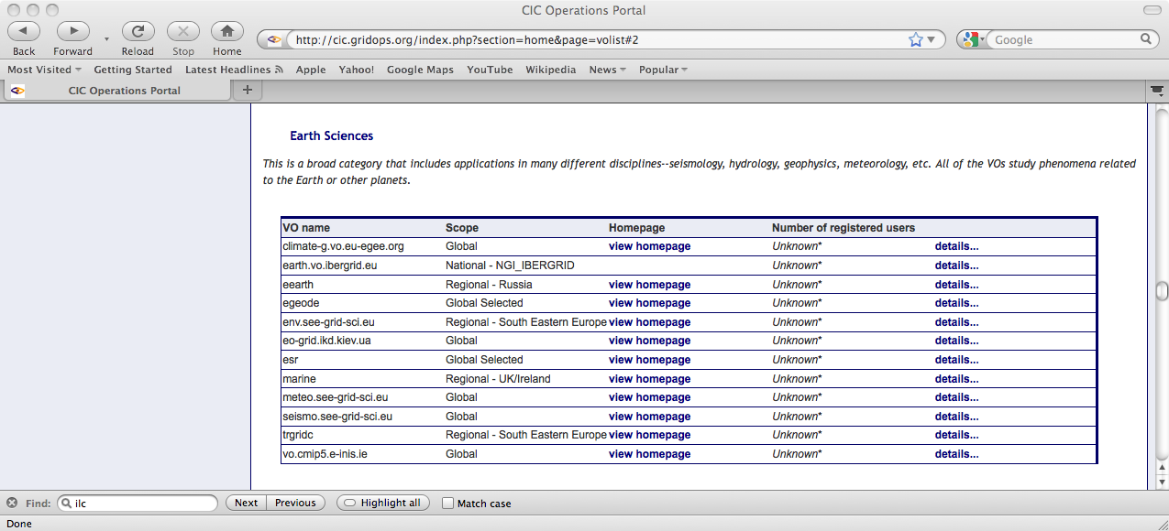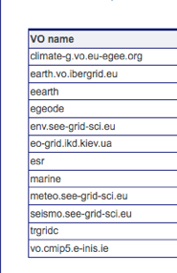
Figure 1 - Starting Point: without EnviroGRIDS VO
Having complete the registration form for new VOs on the CIC portal, the new VO shortly appears as below:
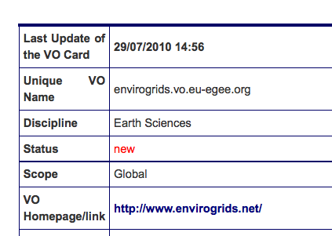
Once this request has been made it has to be validated by the “RAG” – Resource Allocation Group.

As part of the validation process, the VO Manager has to complete the Acceptable Use Policy (AUP) duly compiled in all its parts. In the case of EnviroGRIDs the [owner body] must be clearly put to "enviroGRIDS @ Black Sea Catchment collaboration" or one of the institutes from the collaboration. An extract is given below.

This Acceptable Use Policy applies to all members of envirogrids.vo.eu-egee.org Virtual Organisation, hereafter referred to as the VO, with reference to use of the LCG/EGEE Grid infrastructure, hereafter referred to as the Grid.
The [owner body] owns and gives authority to this policy.

Goal and description of the VO:
The Black Sea Catchment is internationally known as one of ecologically unsustainable development and inadequate resource management, which has led to severe environmental, social and economic problems. The EnviroGRIDS @ Black Sea Catchment project addresses these issues by bringing several emerging information technologies that are revolutionizing the way we are able to observe our planet. The Group on Earth Observation Systems of Systems (GEOSS) is building a data-driven view of our planet that feeds into models and scenarios to explore our past, present and future. EnviroGRIDS aims at building the capacity of scientist to assemble such a system in the Black Sea Catchment, the capacity of decision-makers to use it, and the capacity of the general public to understand the important environmental, social and economic issues at stake. EnviroGRIDS will particularly target the needs of the Black Sea Commission (BSC) and the International Commission for the Protection of the Danube River (ICPDR) in order to help bridging the gap between science and policy.

Members and Managers of the VO agree to be bound by the Grid Acceptable Usage Rules, VO Security Policy and other relevant Grid Policies, and to use the Grid only in the furtherance of the stated goal of the VO.

When the validation process has been completed a broadcast message is issued as shown below.

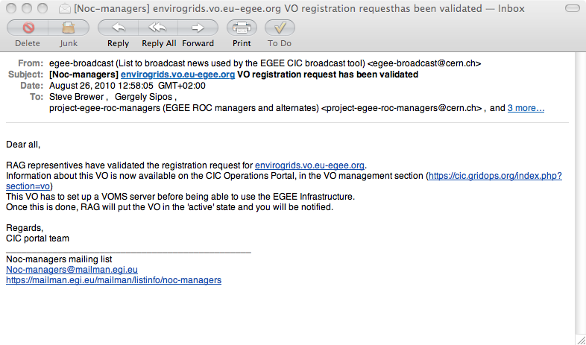

Case Study: Enabling a VO with compute / storage requirements (LCD)
The Linear Collider Detector project at CERN focuses on physics and detector issues for a future e⁺e⁻ collider at the TeV-scale. The work is carried out in collaboration with several study groups from across the globe, addressing physics and detectors at either the International Linear Collider (ILC) or the Compact Linear Collider (CLIC). ILD, the international large detector concept, is one of several detector concepts that are being studied for the International Linear Collider (ILC). The primary grid-related application for this community is detector studies, based on the DIRAC framework of the LHCb experiment. Their motivation for access to grid resources stems from the need to seamless run simulations at a number of (grid) sites, together with time pressure to produce reports, based on conference schedules, plus the schedule for the production of the related ILC technical design report.
Within WLCG, there is a dedicated body to handle computing resources across the different sites (Tier0, Tier1, Tier2) – the Computing Resources Review Board. At a specific site – in this case CERN – resource management is the responsibility of the WLCG Resource Manager. Once a given project or experiment is approved by the Scientific Management of the laboratory, it is the Resource Manager’s task to ensure that the request fits in the overall resource envelope of the site.
In the case of a new approved VO, some initial discussions between the VO representative(s) and the Resource Manager are required to determine whether the use of grid resources is indeed appropriate (as opposed to simply local batch), as well as the overall requirements in terms of cpu, disk, tape, network, services, etc. Should the green light be given, tickets are issued to the services concerned (batch, storage services) and a detailed checklist is followed to ensure that all of the necessary setup and configuration is performed. This list is somewhat extensive and clearly only makes sense for projects of a certain size and duration.

Some specific details of the project’s resource requests are given below for sizing purposes.

- 51 * 10⁹ kSI2K seconds of CPU time
- 67.5 TB of mass storage, 1.0 TB of Disk and 6 TB of Disk cache
- Enabling the ILC VO to use the CERN resources
- VO box server for the LCD project
  - This machine shall have the typical LHCb VO box profile.
  - Special accounts on this machine required for MySQL and for a DIRAC account.

For the year 2011, similar needs of CPU time and data storage are expected.

[ To be compared with the resource requests for the LHC experiments, where CPU is specified according to the HEP-SPEC06 benchmark results. ]

In this specific case, one can expect that support for this project piggy-back on that for LHCb. This is clearly a big potential saving and such re-use of technology between projects is clearly to be encouraged. The project also uses an existing VO – ILC – but one that was not previously enabled to use CERN resources, nor for which resources were provisioned.

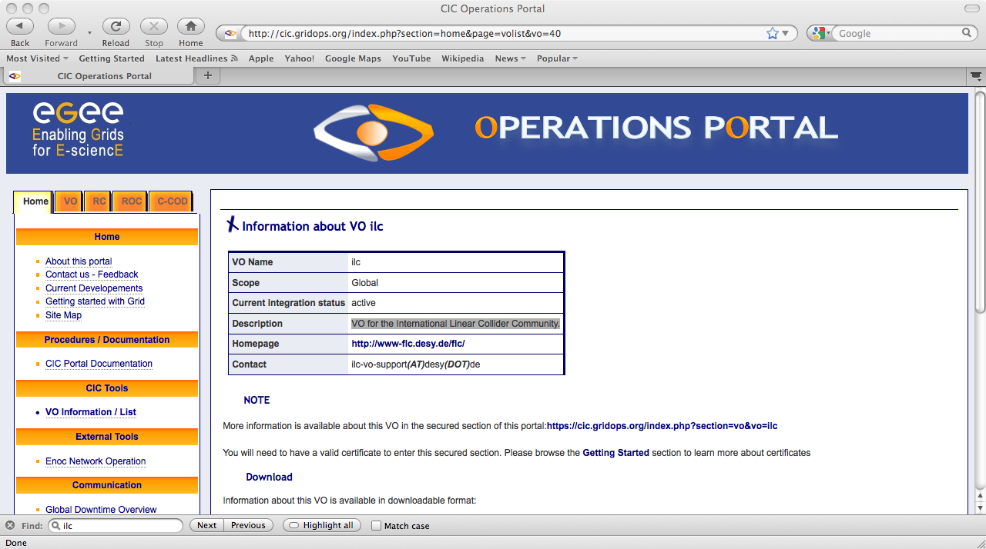
Figure 2 - ILC VO Information, the VO used also by the LCD project
It is not the purpose of this document to act as a guide to system administrators / service managers on the steps that need to be taken in order to support a new VO with access to computational and storage resources at a large grid site such as CERN, however the number of steps that need to be followed to configure and verify the setup are based on being followed by a dedicated contact person on the experiment / grid support side, who works in close contact with other groups in IT together with the experiment / project in question.
For smaller / shorter projects and / or for test activities, the use of an existing VO might be more appropriate, as explained above.

Grid Support Issues
Historically, all new applications that have been ported to the grid have required both initial as well as on-going support. Much of this was provided via the EGEE NA4 work-package, together with corresponding infrastructure (neither funded nor matching funding) in a number of key sites, such as CERN. The continuation of this activity was expected to be via the ROSCOE/SAFE/TAPAS projects, which have not been funded. Some limited effort for such activities is available through this work-package, e.g. for official CERN-recognised experiments and projects, but this effort of necessity competes with the mainstream activities of this work package. Full support for a new VO – as witnessed by the above checklist – is a non-trivial operation and requires the involvement of a number of groups and services, plus preferably a dedicated contact person on both the CERN and VO sides, at least during the duration of the setup and initial testing. On-going support, for both integration and operations purposes, is clearly needed by the larger VOs, such as the LHC experiments.

Fusion Case Studies
The fusion community makes use of the top computational environment with a wide range of applications, tools and developments. Several different studies and use cases can be established by means of these applications and tools. These studies can be focused on various aspects of fusion research, like NBI heating, transport, turbulences or MHD equilibrium. Considering these different areas and the possible relations among them, some application workflows could be also considered in order to carry out more complex simulations. Thus, the impact of the heating in the evolution of the trajectories of particles in the confined plasma arises as an important use case.
As stated, there is a wide range of applications. Several of them are Monte Carlo codes that are perfectly suitable for the grid. There are also Message Passing Interface (MPI) applications that can be used. In order to perform these studies, these different applications must be coupled. In this coupling Kepler (see below) plays an important role in order to assure this procedure is carried out transparently to the user. This tool allows the exchange of data among the applications involved in the study, the management of the execution of the different components and a user-friendly environment to use the computational resources.

Earth Sciences and Environmental Case Studies
In the Earth Science and Environmental domains, the Climate-G testbed represents an important case study. The Climate-G testbed provides an experimental large-scale data environment for climate change addressing challenging data and metadata management issues. The main scope of Climate-G is to allow scientists to carry out geographical and cross-institutional climate data search & discovery, access, visualization and sharing. The GRelC software is exploited in this use case to perform metadata management, harvesting functionalities, data search & discovery. From the metadata management point of view, the testbed involves relational and non-relational (XML-based) data sources hosting Climate-G projects and experiments metadata information.
Climate-G is a multidisciplinary collaboration involving both climate and computer scientists and it currently involves several partners such as: Centro Euro-Mediterraneo per i Cambiamenti Climatici (CMCC), Institut Pierre-Simon Laplace (IPSL), Fraunhofer Institut fur Algorithmen und Wissenschaftliches Rechnen (SCAI), National Center for Atmospheric Research (NCAR), University of Reading, University of Salento and at the Italian Southern Partnership for Advanced Computational Infrastructures (SPACI). A new version of the GRelC service is now tested to manage climate metadata. A new version of the Climate-G portal has been deployed (http://grelc.unile.it:8080/ClimateG-DDC-v2.0/) and tested in July. The new version fixes some bugs related to the search and discovery functionalities as well as to the metadata extraction and presentation. New requirements and scenarios will be gathered and defined by talking with the Earth Sciences representatives involved in the EGI-InSPIRE project. A virtual organization (named climate-g.vo.eu-egee.org and defined with global scope during the EGEE-III Project) will support distributed testing activities on the Climate-G testbed.

The Chemistry and Molecular Science and Technology community

The present situation
The Computational chemistry and Molecular Science community is presently composed of two pan-European grid VOs constituted during the final years of the EGEE project (UNIPG and CYFRONET) as can be seen at http://cic.gridops.org/index.php?section=home&page=volist. GAUSSIAN was mainly devoted to implement and maintain codes and to provide also support on the Grid to computational chemists carrying out their research using commercial software (as is the popular Gaussian package) for predicting in an ab initio fashion the structure and the electronic properties of molecules and molecular aggregates (related calculations are of invaluable help in applicative fields as spectroscopy, chemical analysis, materials, biochemistry, drug design, energy conversion and storage, etc.). COMPCHEM was mainly devoted to implement codes and provide support on the Grid to computational chemists carrying out their research by combining structural, dynamical and kinetics studies of chemical processes using componente of ad hoc workflows linking ab initio calculations to the experimental signal. The process was accompanied by the cooperation activities of some working groups of the Actions D23 and D37 funded by the European initiative COST. To the same Computational Chemistry (CC) cluster of EGEE III belong three national VOs, whose work in EGEE III are shown in figure 3, taken from the EGI-InSPIRE proposal. The two most important of them are those associated with the computational chemistry and the molecular science communities of Turkey. The researchers who belong to these VOs are mainly running the chemistry and molecular dynamic packages such as VASP, NAMD, Espresso, Gaussian'03, Gaussian'09, Charmm, CPMD, Gamess, Gromos, Gromacs and Amber. They consist of more than 150 national researchers. At the same time intention to join the grid activities of the community has been expressed by other geographically dispersed minor groups though they were not active in EGEE. Altogether this makes a block of more than 500 people that refer to EGI as a coordination body for distributed computing. Progress of this community in grid computing was relying on three different proposals (ROSCOE, HIPEG, SCHEMA respectively presented by C. Loomis, A. Laganà and E. Rossi) that failed to succeed at the INFRA 2010 call.

However, despite the failure in getting funded, some basic activities of the community are being carried out albeit at slower pace and on a best effort regime. In particular:
- the activities of the VOs are being continued
- the hardware patrimony has been saved and consolidated
- the program library has been kept alive and updated
- the support to the users has been continued
- some tools facilitating the use of the Grid by the members of the community were further developed.
The intention of the mentioned CC VOs is therefore to act at present as a hub for its community, coordinating computing activities on heterogeneous platforms, providing support for its members, safeguarding its knowledge as well as preserving and maintaining a set of services on the best effort basis. The activities of the VOs of the community have already produced in the final period of EGEE III a significant volume of activity (see the graph below) that would be a pity to disperse (and that has to be added up to the traditional high share of computing resources traditionally used by the community on large scale facilities that is usually allocated by research projects).
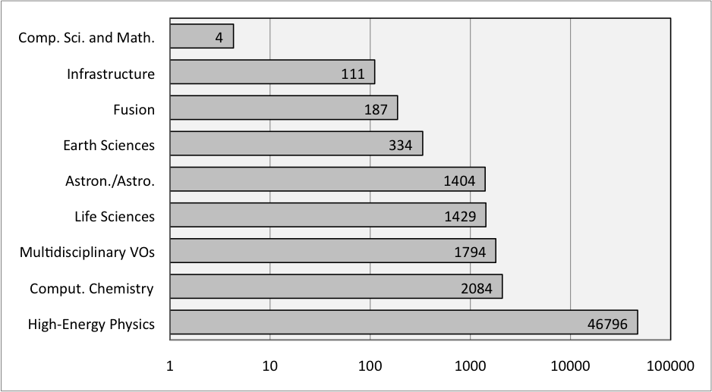
Figure 3: Approximate number of CPUs used by different communities on EGEE (9/2008-8/2009) (from EGI-InSPIRE proposal)

The target of the community is the study of properties of the matter referable to the characteristics of the nuclei considered as stable (though structured) entities and as (from weak to strong) aggregates of atoms and molecules. The purpose of such study is to invest the knowledge developed in this way to build new science, innovation, technologies and services for social and economics growth. Accordingly, the engagement of the community in computation is addressed to a series of research activities, computer codes (either commercial or in-house designed and implemented), development, database construction and management, data rendering and virtual reality handling fragmented into a large number of laboratories that concur to carry out advanced modelling and simulations based on multi-scale and multi-physics approaches to reality starting, whenever is appropriate, from the nano-scale level. This means that there are several important applications (yet not a dominant one as in other scientific domains) and a large number of in-house developed methods and software packages with a high innovative potential that benefit from the efforts of a large number of researchers and may serve an even larger number of users.
The success of the community is visible in the implementation of highly successful quantum chemistry packages (like Gamess, Gaussian, etc.), which are at present solid foundations of any determination of molecular structures and properties. Their application ranges from materials design to photo-assisted processes rationalization and spectroscopic analytic studies. With the advent of the grid more and more of these studies are becoming "flagship applications" although the natural computational platforms are supercomputers.
Molecular dynamics codes are also another popular pillar of innovative research in science and technology. Some of the relevant codes have been implemented on the grid both out of the family of programs treating the atoms in a classical fashion (like Venus, DL_Poly, Gromacs, etc.) and out of the family of programs treating the atoms as waves. However, the exact calculations of the quantum scattering equations is a more difficult task to handle on the grid because of the higher request of node memory and is most often implemented on supercomputers. Nonetheless this has been successfully achieved for some quantum atom diatom programs using either time dependent approaches (like Rwavepr, MCTDH, FLUSS, etc.). or the time independent one (like ABC). Also the corresponding semi-classical program has been considered for porting on the Grid (SC-IVR, etc.). Scattering efficiency of chemical reactions, however, is only one of the important chemical properties. To characterise most of the chemical processes of interest in practical applications thermal reactivity (the so-called rate coefficients) is the input needed (like in kinetics simulations of reactive systems).
Most of the realistic modelling applications, however, take these calculations as building blocks of a multi-scale treatment. For this reason the prospect is to incorporated them into universal-like molecular simulators (like the so called Grid Empowered Molecular Simulator based on a grid workflow linking grid version of ab initio, quantum dynamics and statistical averaging) that can be used as a molecular properties computational engine to be assembled with other computational packages in more complex applications.
The combination of above described molecular level studies with different scale and statistical treatments generates theoretical predictions of structure-property relationships, size of molecules effects, chain of molecular processes, inter-phase phenomena, interaction with light are all properties of interest among for chemists, materials technologists, engineers, biologists that can be evaluated in reasonable amounts of elapsed time only using distributed computing. Several examples of advanced scientific achievements obtainable in this way can be given.

The work plan for the project
The originally proposed contribution of the CC community is given in the footnote where the community (the was intended to be structured as a Specialized Support Centre (SSC)) is identified as CMST (Chemistry and Molecular Science and Technology). The final effort assigned to the community within EGI-InSPIRE, is the support to the use of MPI within its members. This is part of the effort made in porting to the Grid the above-mentioned packages and inhouse developed programs. Detailed report of this activity will be given as part of the progress report. The plans are to test the use of MPI and develop MPI versions of examples belonging to three categories of products: linear algebra routines, inhouse developed codes and licensed packages.
However, as a best effort voluntary contribution of the community to EGI progress will be made to deploy the InsilicoLab portal developed by CYFRONET as an example of user centric work environment etc.. The Gaussian VO is going to become the standard testbed for the InsilicoLab environment. All the work for Gaussian VO is done on best effort basis. The main engagement of recent times has been the updating of the package Gaussian to version 09. Work will also be spent to enrich the offer of products by enabling the use of Turbomole, NWChem (freely available) and ADF packages. A rescue operation of the users of Turbomole (due to the planned closure of the Turbomole VO) is being designed by incorporating them into the Gaussian VO. The best effort contribution of the COMPCHEM VO will consist in extending and consolidating the library of programs implemented on the Grid. In particular efforts will be devoted to implement a grid version of some of the programs on the GPUs (typically the bench program used for that is either ABC or RWAVEPR) in order to enrich the articulation of the GEMS simulator. A second important line of best effort commitment of the COMPCHEM VO will be that of developing a facilitator for the gridification of the programs on the grid that, moving along the line of evaluating QoS and QoU, does not need any knowledge of the grid to submit jobs on the grid.

Services for other communities
Currently computational chemistry VOs are open for all communities looking for access to molecular dynamics and ab initio/first principle methods. Available software portfolio, workflow engines and tools are accessible for any person with valid certificate on a standard basis via our VOs. Also, it is highly recommended for beginners looking for vast amount of computational power in a grid environment to start with InsilicoLab portal. Currently aside from chemists our resources are mainly utilized by users from biology and related fields as well as the earth science community.

Footnote
CMST contribution to EGI proposal (Version 0.2 August 14)
Antonio Lagana, Mariusz Sterzel
The table contains services and tasks to be implemented or procured for the benefit of CMST

Services | Specific tasks | Resources required in FTE | Project providing resources | Type of activity
Coordination and management | Regime Management of the SSC  Preparation of an implementation roadmap of the SSC  Preparation of the SSC sustainability plan  Relationships with EGI (User Forum representative)  Relationships with NGIs  Relationships with ESFRIs  Relationship with major CMST research institutes  Realtionships with third bodies  Quality evaluation | 2.0 | SSC | NA1
Dissemination and knowledge base | Contact potential users, stakeholders and third bodies  Implementation of appropriate dissemination tools and services  Coordination with other dissemination bodies  Maintenance of the related knowledge base | 1.0 | SSC | NA2
User training | Coordination with other training bodies  Hands on training school for CMST grid applications  Identification of CMST pilot applications to be used for training and dissemination | 2.0 | SSC | SA1
Operation of data and access services | Science gateway operation Maintenance of data repositories Collaboration with ESFRIs for service provision | 2.0 | SSC | SA2
User support | User support and front desk  Application porting  Coordination with EGI User Support and other Application Porting bodies  Coordination of the CMST related VOs | 2.0 | SSC | SA3
Scientific gateways and middleware | Scientific gateways – Design of template and development | 2.0 | SSC | JRA1
Middleware | Interaction with middleware bodies  Find solutions for CMST applications | 1.0 | SSC | JRA2
Service hosting and support | Hosting CMST specific services (portals, interVO services, interapplication workflows). An analysis of different workflows (DIANE, TAVERNA, TRIANA, GEMMSTONE, …) and different portals (g-Eclipse, EnginFrame, P-GRADE, …) will be made | 2.0 | 1.2.1.2 | Ref 1
Service hosting and support | Hosting VO specific services (like handling licensed software for GAUSSIAN and handling a credit system for COMPCHEM) | 2.0 | 1.2.1.2 | Ref 2
Service hosting and support | Hosting Framework services (like Dashboards) | 0.5 | 1.2.1.2 | Ref 3
Service hosting and support | Hosting tools useful for Scientific Gateways (like for the standardization of data formats, for the offering of applications as web services, for CMST oriented graphical libraries, for MPI applications) | 2.0 | 1.2.1.2 | Ref 4
Service hosting and support | Support interoperability among CMST applications operating on different middleware and/or needing platforms of different level | 0.5 | 1.2.1.2 | Ref 5
Service hosting and support | Support for the transition of services of the Chemistry cluster of EGEE to the CMST EGI services | 1.0 | 1.2.1.2 | Ref 6
TOTAL |  | 20.0 FTE

WP 8 Specific Comments:
The main goal of the CMST SSC is to move a large fraction of the present CMST usage of large scale computing facilities (about 50% of their overall usage) to the grid. For this reason, in addition to the general services the CMST SSC shall provide the following specific services:
• Ref 1 – Support the activities of the CMST and other communities by means of grid tools and services useful for that purpose like portals, inter-VO services, inter-application workflows, etc.. In particular various workflows (DIANE, TAVERNA, TRIANA, GEMMSTONE, ..) and portals (g-Eclipse, EnginFrame, P-GRADE, …) will be considered in order to meet the complexity of several CMST applications showing articulated branches among various suites of codes which often combine nested features of high performance and high throughput computing. The considered tools are meant to allow a friendly use of the Grid and to run on a large variety of platforms.
• Ref 2- Host and support VO specific services (like handling licensed software for GAUSSIAN and handling a credit system for COMPCHEM). As to the licensed software handling although some solutions have been experimented in the final period of EGEE III the problem still needs to be systematically investigated and a general solution to be implemented. As to the support for the development of a credit system aimed at fostering the collaborative implementation of CMST complex applications a scheme of objective and subjective evaluation of providers and users activities will be adopted. This will focus on the (objective and subjective) evaluation of the quality of the services provided and of the suitability of the resources used (as well as of the analysis of the users attitudes) to constitute a base for managing a credit system. Specific training and support activities will be implemented for the members of the CMST community in order to enable them to efficiently implement related grid applications by lowering the barriers introduced by the continuous and rapid evolution of distributed computer technologies (which remain hard to master for researchers of other fields). This implies also to train CMST scientists to design and implement new approaches to the solution of molecular and material problems as well as to develop even more complex (and at the same time more realistic) grid enabled simulations. Finally support fort he use of a variety of visualization tools will be offered to exploit the grid capability of providing increasingly realistic means for graphical representations of molecules and nanostructures.
• Ref 3 - Hosting Framework services (like Dashboards) for an efficient management of the community. This support will be aimed at facilitating an integration of the activities of the different theoretical, computational and experimental laboratories. Support will be also given to the assemblage of collaborative tools for scientific investigation like the so called Grid Empowered Molecular Simulator (GEMS) designed to support the collaborative execution of realistic simulations relevant to either technological or environmental simulations and relevant as well to the integration on the Grid platform of a set of distributed chemical instrumentations and experiments. Such an integration is meant to support the institution of a Europe wide virtual chemical laboratory for either educational or experimental purposes.
• Ref 4 – Hosting services for the scientific gateways (in particular, though not solely, for the CMST community) focused on the implementation of standardized data formats, the offer of computer applications as web services, the exploitation of CMST application oriented graphical and MPI libraries. The support to the implementation of de facto standards for molecular structural data calculation and representation will be based on ab initio electronic structure outputs generated by different Quantum Chemistry (QC) packages. This will make the assemblage of repositories, tools and workflows more friendly to CMST users and will encourage, as well, efforts in predicting, designing and analysing Molecular and Materials structures and properties using multiple codes, across multiple disciplines, and for an open user base. Due to the fact that QC databases (especially those concerned with drugs and life science) are spread worldwide and often private, facilitating their access on the Grid is of paramount importance and the use of appropriate Grid tools for handling them necessary. This is for example the case of G-DSE (Grid-Data Source Engine), one of the first tools aimed at integrating database resources and the Grid. Support will also be given to other tools like OGSA-DAI, AMGA, GRElC and G-DSE. Another important support will be the one given to MPI, MPICH and other instruments of this type. Several CMST applications do in fact get significant benefit from being parallelized (especially if executed on HPC platforms) and therefore represent suitable candidates for exploiting the use of parallelization tools. Support will be given, therefore, to the efforts of building a suitable environment in which libraries of grid enabled CMST computer codes (possibly offered as web services) can be made available since they represent the most valuable asset of the CMST community.
• Ref 5 - Support interoperability among CMST applications operating on different middleware and/or needing platforms of different level. This support will be provided for both developed in-house and licensed software. For licensed software, again, no general policy has yet been developed despite the fact that a large fraction of commonly used QC applications are not open source. The problem is of concern not only for the gLite middleware but also for the ARC and UNICORE ones. The fact that also other disciplines depend in some way from commercial and/or licensed software makes developed solutions of benefit also for other communities.
• Ref 6 - Support for the transition of services of the Chemistry cluster of EGEE to the CMST EGI services. This support will be vital in the first part of the project and will require a substantial communication effort not to loose part of the community. Actually, however, the transition period will be taken as an opportunity for structuring the community along the guidelines of the project.
The CMST SSC will provide other more general support to the grid user in close contact with other EGI instances. These are: general coordination of the activities, validation of the proposed middleware services, fostering of the interoperability of the interdisciplinary codes on various platforms, support inter-domains application development and porting, maintain a front desk, ensure documentation, training and dissemination for the related science gateways. More in detail this implies fort the SSC to:
- support with its own services the current activities of the existing CC VOs
- establish and operate Grid Software Sharing (GriSS), a database of grid ports of software packages together with tools and documentation
- help VOs in managing registered users and shared resources
- gather, maintain, consolidate and further develop other VOs
- spread to other domains the knowledge produced by the members of the CMST community
- foster interactions, relationships and resource sharing with other VOs and SSCs
- increase the number of people and entities using the CMST SSC services
- promote the use of computer resources and Grid technologies by the CMST community
- collaborate with EGI operations and middleware development groups to tailor a design and an implementation of grid tools and services best suited to the necessity of the CMST community
- support for and help in the design of scientific projects and funding applications through a valorization of the services provided efficiently.
- Support its members with training, documentation and maintenance procedures (including the proper handling of trademark and commercial obligations for commercial packages).

Technology
In the following sections we consider some of the shared technologies that are available today, followed by an explicit discussion of data management. This list is not exhaustive but covers some of the main tools and services that are supported through this activity.

Inter-VO Benefits
The HUCs can offer benefits not only to new adopters of grid technology but also to each other. This continues to be demonstrated, both by the adoption of tools initially developed for one community spreading to others, as well as at the conceptual level: less optimal but offering a more pragmatic solution for existing communities. These inter-VO benefits typically not only result in more powerful solutions but also save significant amounts of manpower in the long run – such benefits would be unlikely to be achieved with some generic support structures, both for individual large communities such as HEP (which could otherwise develop multiple similar solutions to basically common problems), as well across disciplines (e.g. the usage of Dashboards, Ganga and Hammercloud across communities, described in more details below).

Dashboards
In order to perform production and analysis tasks across a highly distributed system crossing multiple management domains, powerful and flexible monitoring systems are clearly needed. The Experiment Dashboard monitoring system was originally developed to support the four main LHC experiments (LHCb, CMS, ATLAS, ALICE). This framework not only supports multiple grids / middleware stacks, including gLite (EGEE), VDT (OSG) and ARC (NDGF), but is also sufficiently generic to address the needs of multiple user communities including, but not limited to HUCs. Furthermore, the system covers the full range of the experiments’ computing activities: job monitoring, data transfer and site commissioning. It also addresses the needs of different categories of users, including:

- Computing teams of the LHC VOs;
- VO and WLCG management;
- Site administrators and VO support at the sites;
- Users running their computational tasks on the grid infrastructure.

All Experiment Dashboard applications are developed using the Dashboard framework which is implemented in Python. The Dashboard framework defines the structure of Dashboard modules. It provides the build system and a common implementation of the main components of monitoring applications and services. The typical structure of a Dashboard application consists of information collectors, a data repository, normally implemented using Oracle database technology, and user interfaces. Information from data sources can be transmitted to the Dashboard application via various protocols. In most cases, the Dashboard application uses asynchronous communication between the data sources and data repository. Dashboard agents are the components that have to perform regular tasks. Examples of such tasks are: collecting monitoring data, aggregating statistics, analyzing statistics, sending alarms, etc.... The framework provides all necessary tools to manage and monitor Dashboard agents.

Experiment Dashboard applications are widely used by the LHC experiments for their everyday work. Over a thousand unique visitors use Dashboard applications every day and this number is steadily growing. An example of the usage statistics for the CMS Dashboard server is shown in figure 3. Figure 3 demonstrates that during the first half of 2010 the number of unique visitors of the CMS
Dashboard increased by more than 50 percent, and the number of accessed pages over the same period of time more than doubled.

Figure 4 – Web statistics showing usage of the CMS Dashboard service for the first half of 2010.

LHC virtual organizations represent one of the main user communities of the Grid infrastructure. Therefore monitoring LHC computing activities provides the best estimation of Grid reliability and performance. Constant improvement of the quality of the Grid infrastructure is achieved due to LHC site commissioning activity and LHC computing shifts. One of the most important functions of the Experiment Dashboard is to provide necessary information for LHC computing shifts and LHC site commissioning. LHC computing shifts follow up the status of the distributed sites and services and their capability to perform the tasks of the LHC virtual organizations. The result of the visible improvement of the quality of the distributed sites as measured and shown in the Dashboard Site usability monitor is shown in figure 4.

Figure 5 Shows monthly availability of the sites used by CMS. Every bar corresponds to a particular site – availability is in the range 0–100%. Green color corresponds to high availability, red one to the low availability

The Site Status Board (SSB) is another example of a Dashboard application that was developed for monitoring the distributed sites and services from the perspective of a particular virtual organization. SSB provides a very flexible framework enabling a customizable metric store and user interface exposing runtime and historical monitoring data. The tool is used by several LHC virtual organizations, namely ATLAS, LHCb and CMS.

The importance of flexible monitoring tools focusing on applications has been demonstrated to be essential not only for power-users, but also for single users. For power users (such as managers of key activities such as large simulation campaigns in HEP or drug searches in LS communities) a very important feature is to be able to monitor resource behaviour to detect the origin of failures and optimize their system. They also benefit from the possibility to measure efficiency and evaluate the quality of the service provided by the infrastructure. Single users are typically scientists using the Grid for data analysis, and verifying hypotheses on data sets that could not be achieved on other computing platforms. In this case, monitoring, provided by Experiment Dashboards, is a guide to understanding the progress of their activity, and identifying and solving problems connected to their application.

It is essential to allow efficient user support by empowering the user in such a way that only non-trivial issues are escalated to support teams (for example, jobs on hold due to scheduled site maintenance can be identified as such and the user can decide to wait or to resubmit). As shown in figure 6, up to 350 physicists in the CMS VO use the Task monitoring application daily. This application was developed in order to facilitate user analysis on the distributed infrastructure by providing necessary monitoring information to analysis users and to analysis support teams.

The Experiment Dashboard applications obtaining information from sources that are not VO-specific can be used by VOs outside the LHC and HEP scope. Among those applications are Site Status Board and Site Usability interface. A generic job monitoring application that will use job status information from the Messaging System for the Grids (MSG) is now being prototyped. Job status information can be reported to MSG either from the new version of the Logging and Bookkeeping system or from VO-specific frameworks. The Dashboard team provides generic methods enabling instrumentation of VO-specific frameworks for MSG reporting.

Figure 6 – Daily number of unique visitors of the CMS Dashboard Task monitoring application for the first half of 2010. The decrease in the number of users in August is due to vacations.

Future work will concentrate effort on common applications which are shared by multiple LHC VOs, but which could also be used outside the scope of LHC and HEP.

References:
Experiment Dashboard for monitoring computing activities of the LHC virtual organizations
Journal of Grid Computing, Volume 8, Number 2, 323-339, DOI: 10.1007/s10723-010-9148-

Ganga & DIANE
Ganga is an easy-to-use frontend for job definition and management that provides a uniform interface across multiple distributed computing systems. DIANE is a lightweight task processing framework which allows for more efficient and robust execution of large numbers of computational tasks in unreliable and heterogeneous computing infrastructures. Both tools are part of EGEE RESPECT - Recommended External Software for User Communities.

Ganga has been developed to meet the needs of the ATLAS and LHCb user communities, and includes built-in support for configuring and running applications based on the Gaudi / Athena framework which is common to the two experiments. Ganga is supported and heavily used by the ATLAS and LHCb users. However, it also provides functionalities for running of a wider range of applications, including arbitrary executables. Ganga is implemented in Python and it was designed in a way that makes it very easy to use for parameter-sweep applications and to realize more complex application use cases. Ganga allows trivial switching between testing on a local batch system and large-scale processing on Grid resources and effectively provides a simple but powerful abstraction layer for distributed computing environments. As it is based on a plugin system it is readily extended and customised to meet the needs of different user communities. Ganga is included in the EGEE RESPECT Programme (Recommended External Software Packages for EGEE Communities). It has also been used in EGEE tutorials to introduce new users to the Grid.

Functionality provided by Ganga includes a command line interface for job configuration, submission ans management; automatic configuration of complex applications; automatic handling of large datasets as job inputs and outputs; splitting of jobs for parallel processing and subsequent merging of outputs. Ganga currently supports the following backends for general use: Portable Batch System (PBS), Load Sharing Facility (LSF), Sun Grid Engine (SGE), Condor, gLite WMS/CREAM-CE, ARC, Globus/GRAM, GridWay and the SAGA API standard.

The usage of Ganga has been increasing in the last years and is presented in the figure 7.

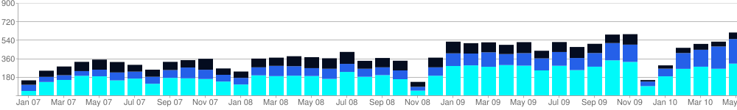
Figure 7. Monthly number of GANGA users in 2007-2010

On average, there are 500 users every month using the tool for their everyday work. Some 75% of the usage comes from the HEP VOs and the rest from other user communities.

DIANE is a task coordination overlay framework that exploits the late-binding method (also known as pilot jobs or worker agents). DIANE provides an application-aware scheduler that may be extended by a system of plugins to support master/worker workloads such as task farms and bag of tasks. Plugins for Direct Acyclic Graph (DAG) and data-oriented workflows have been implemented as third-party contributions by a number of interested user communities. The framework also supports customized, application-specific processing methods and failure-management strategies. DIANE worker agents are often submitted using Ganga. This integration of the tools allows for a dynamic combination of resources across several distributed computing infrastructures, including High Performance Computing (HPC) resources.

As an example, a Ganga/DIANE overlay was interface to the MOTEUR workflow engine and is run as a service for the biomed community in the context of GATE medical imaging applications. Between July 2009 and August 2010 more than 360 DIANE master instances were activated in the service backbone that handled 58000 worker agent jobs completing more than 113000 simulation tasks.

Both Ganga and DIANE include Dashboard plugins that provide the user communities with on-line monitoring of executed tasks.

Besides the LHC communities, the use of Ganga/DIANE tools has been reported for UNOSAT applications, Geant4 medical and space simulations and grid-enabled regression testing, AvianFlu Drug Search, ITU digital broadcasting planning, LatticeQCD simulations, Fusion, Image Processing and Classification, EnviroGrids and Simulation of Gaseous Detectors (GARFIELD).

References:
- Ganga: a tool for computational-task management and easy access to Grid resources;
Computer Physics Communications, Volume 180, Issue 11, (2009)
- Lattice QCD Thermodynamics on the Grid;
Computer Physics Communications 181 (2010), pp. 1715-1726
- Grid-Enabled High-Throughput Screening Against Influenza A Neuraminidase;
IEEE Trans. Nanobioscience, Volume 5 (2006)
- Dynamic partitioning of GATE Monte-Carlo simulations on EGEE;
J. Grid Computing, Volume 8 (2):241-259, 2010.
- Scheduling for responsive Grids;
J. Grid Computing, Volume 6 (15-27), 2008.

Grid Relational Catalog – GRelC
The Grid Relational Catalog Project (GRelC) aims at providing a set of advanced data grid services to transparently, efficiently and securely manage Databases on the Grid. The GRelC software has been exploited in several grid research projects to support bioinformatics experiments on distributed data banks as well as metadata management in the Earth Sciences and Environmental domains.
At the moment the GRelC Data Access and Integration Service (GRelC DAIS) allows users to access and interact with different DBMSs both relational (PostgreSQL, MySQL, SQLite, etc) and non-relational (eXist, XIndice, XML flat files). It provides an uniform access interface to heterogeneous data sources. The GRelC DAIS is now part of the IGI (Italian Grid Infastructure) release.
Since 2008, the GRelC middleware has been included in the EGEE RESPECT Program (Recommended External Software Packages for EGEE CommuniTies) since it works well in concert with the gLite software by expanding the functionality of the grid infrastructure (with respect to database management in the grid).
The GRelC service is currently adopted as the grid metadata management service in the Climate-G testbed to enable geographical data sharing, search and discovery activities. Moreover it is currently used at the Euro-Mediterranean Centre for Climate Change to manage climate metadata across the CMCC data grid infrastructure through the CMCC Data Distribution Centre portal.
It is important to remark that, the GRelC software provides 2 different kinds of clients: the Command Line Interface (CLI) and the GRelC Portal. The CLI is available as a single rpm for the gLite platform.
On the other hand, the GRelC Portal (available from the “GRelC Portal” link on the GRelC website – www.grelc.unile.it) offers a direct way to submit queries, manage the enterprise grid, manage users and their privileges, define virtual spaces and their properties, manage VOs, manage several GRelC DASs at the same time, view metadata information concerning the schema of your database/tables. It offers all of the functionalities provided by the Command Line Interface. It is able to provide user-friendly and easy access to GRelC DAS functionalities simplifying the interaction between the users and the data grid environment.
Finally, a wide set of tutorials are available for end users to learn more about the GRelC Portal, the CLI and the JDK. Useful links can be found here:
https://grid.ct.infn.it/twiki/bin/view/GILDA/ GrelCProject.

Kepler
Kepler is a free and open source, scientific workflow application. Kepler is designed to help scientists and developers create, execute, and share models and analyses across a broad range of scientific and engineering disciplines. Kepler ships with a searchable library containing over 350 ready-to-use processing components ('actors') that can be easily customized, connected and then run from a desktop environment to perform an analysis, automate data management, and integrate applications efficiently. Kepler workflows can be nested, allowing complex tasks to be composed from simpler components, and enabling workflow designers to build re-usable, modular sub-workflows that can be saved and used for many different applications.
Kepler is the official platform for constructing scientific workflows by the fusion community associated with EFDA Integreted Tokamak Modelling Task Force. Euforia (EU Fusion for ITER applications) project has extended the Kepler components repository with the actors enabling support for multiple grids / middleware stacks, including gLite (EGEE), UNICORE(access to HPC resources) and i2g (int.eu.grid). The extension covers the activities like: job submission, monitoring, data handling and interactive access to running jobs. All actors are generic and could be reused by multiple other communities. There are also a number of different predefined use cases that could be easily customized and reused by different applications. As an example use case in terms of the Euforia project there are a number of mixed workflows running fusion codes, using grid (EGEE/EUFORIA) and HPC (DEISA/EUFORIA) resources in the same time.

Hammercloud
HammerCloud is a distributed analysis stress testing system built around Ganga. It was motivated by a requirement from the ATLAS collaboration for site- and central-managers to easily test a set of grid sites with an arbitrarily large number of real analysis jobs. These tests are useful during site commissioning to validate and tune site configurations, and also during normal site operations to periodically benchmark the site performance. HammerCloud generates a test report including metrics such as the event processing rate, the mean CPU utilization, and timings related to various stages of the user analysis jobs. The report is presented in a web-interface that makes it simple to compare sites and observe trends over time. The system has been used by the ATLAS experiment to run greater than
200,000 CPU-days of test analyses. HammerCloud is implemented as a Django web application, with state maintained in a MySQL database and job management built around Ganga in python. Jobs can be submitted to WLCG sites using the gLite UI and to all ATLAS sites using PanDA.
Prototype plugins for the CMS and LHCb experiments are in development.
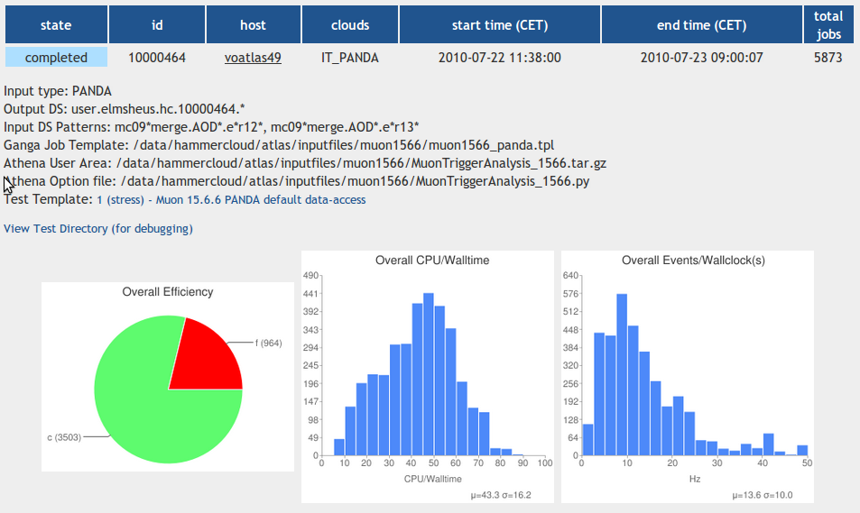
Figure 8 – The HammerCloud web-interface to the results of distributed analysis stress tests.

MOTEUR
Grid-enabled workflow designers and workflow enactment engines are application production environments delivering an abstract framework for the description of application logics and shielding the non-expert users from direct interaction with the grid environment. The MOTEUR workflow manager was developed to cope with the needs for describing and enacting data-intensive medical image analysis pipelines on the EGEE Grid infrastructure. This tool is not specific to this application area though and may be reused in a broad category of applications covering the needs for many scientific areas using the grid for its High Throughput Computing capability.
MOTEUR workflows are described through a graphical editor. Their internal representation is a workflow-specific language based on array programming principles that makes it well adapted to represent parallel data flows and complex data manipulation constructs which are common in data-driven scientific applications. This language is particularly compact and it makes representation parallelism implicit and is well suited for non-expert users. In addition, it has more expressive power than the Scufl language underlying the Taverna workbench and is backward compatible with it. It can represent all forms of data parallel constructs such as parameter sweep studies, map-reduce operations and much more complex use cases.
The MOTEUR workflow enactor is an independent fully asynchronous gLite-interfaced engine capable of exploiting maximum data and service parallelism while exploiting grid resources to harness the computation load. It was designed for performance in a grid execution context. It can accommodate the heavy loads required for large-scale grid applications. Furthermore, it includes a command line application wrapper tool that makes easy the process of packaging and interfacing a command line interface-based tool to the gLite middleware.
MOTEUR is an open-source workflow engine available from: http://modalis.i3s.unice.fr/softwares/moteur/start.

Data Management

DPM
The WLCG Disk Pool Manager (DPM) – based on the CERN CASTOR storage system – is a light-weight but fully functional Storage Resource Management (SRM)-enabled storage element (SE) that is currently used by the LHC VOs and some 60 others. As mentioned DPM offers SRMv2 as management interface, while files can be access both via the GridFTP (ideal for wide are network transfers) and RFIO (for local access) protocols. Both protocols support GSI authentication via X509 certificates. The DPM namespace offers flexible and configurable authentication and authorization capabilities, such as support for VOMS groups and roles, mappings to virtual IDs and ACLs at the directory and file level. Whilst DPM has been initially developed for storages on the order of 100TBs, we have examples of successful deployments at large sites at the PB scale, while one should remember its primary advantages as ease of deployment and management.

LFC
The LCG File Catalog (LFC) is the replacement for previously existing European Data Grid file (pre-EGEE) catalogues, providing more features and improving the performance and scalability. Sharing a common code base with the DPM, it also offers ease of deployment and management.
Some of the features it provides are the use of hierarchical namespace and namespace operations, built-in security and the possibility to use bulk methods to avoid long round-trip times. LFCs are used in over 60 grid sites and by some tens of VOs, including two of the LHC experiments, ATLAS and LHCb. In the case of ATLAS, as of today, over 118 million files are registered between 11 LFC instances. The deployment model between these two experiments is somewhat different: ATLAS currently deploys LFCs at Tier1 sites to catalog data at the Tier1 and associated Tier2s, whereas LHCb deploy a global catalog with readonly replicas at the Tier0 and Tier1s. Synchronisation is maintained using the Oracle Streams product.

FTS
The gLite File Transfer Service (FTS) is a point-to-point scheduler for data transfers over the wide area network. The Grid Storage Element endpoints are paired in channels, resembling the network topology between the sites and ensuring balancing and throttling of data movement requests over the infrastructure. FTS channels can be configured in order to guarantee a minimal share of bandwidth to each Virtual Organization enabled in the channel. The FTS service can negotiate with the storage endpoints via the SRM protocol, while it utilizes gridFTP in third party mode for the actual byte streaming. A web service frontend allows the user to submit transfer jobs (consisting of many files), to poll their status and cancel jobs. The states of all transfers (both the current ones and the history) are stored in an oracle database, together with the monitoring information. In WLCG, the deployment of FTS is distributed across many sites (the Tier0 and the Tier1s). The FTS server at CERN regulates the traffic from CERN to all Tier1s (and vice-versa), while each FTS server at a given Tier1 regulates the incoming traffic to that Tier1 (apart from the one coming from the Tier0) and to all Tier2s associated to the Tier1.

Future Data Management Developments
Following first experience with real LHC data taking, production and analysis it has become clear that some of the assumptions behind the current model are not strictly valid. For example, the “pre-placement” of data from Tier1 sites to Tier2s for analysis has shown that a large fraction of the data is never accessed. Alternative models, such as dynamic caching of data and / or remote access, have recently been proposed for evaluation. As with most developments in this area, such strategies could be equally beneficial to other communities and could result in better resource utilization (potentially lower network traffic as only the needed data is transferred and improved storage management through smaller numbers of data copies). Other issues currently being studied include the potential use of industry-standard components for storage management and / or data access – again of likely interest to all communities.

Capabilities of the WLCG Service
The WLCG service can be considered the “high end” of grid computing. In terms of number of unique users, number of jobs per day, data volumes and access rates, number of cores provisioned, volume and growth of data it well exceeds any other community in its use of – as well as commitment to – grid computing. WLCG chose to align itself as closely as possible with EGEE from the very early days and this commitment continues with EGI with the use of key operations and support tools, together with a middleware stack that is primarily based on gLite (WLCG sites also exist in the Nordic region, running ARC plus some gLite components such as the LFC and FTS, and the US – based on OSG but again with selected gLite components).
Although subject to a Memorandum of Understanding, WLCG works primarily as a collaborative effort (between sites, service providers and the experiments) – much in the way that the experiments themselves do. WLCG has developed a small number of operational procedures, some of which have already been adopted by EGEE (and hence by default also EGI). Other procedures are fully generic and can be easily be adopted by different communities, as and when their production needs grow. This includes strategies for deploying and running robust and resilient services, as well as policies for dealing with prolonged site or infrastructure (e.g. GGUS) outages.
Large new communities may wish to adopt some of these strategies from the beginning – all are extensively documented and further details can be obtained from the MS601 contact points.
The goal of the WLCG project is to enable the exploitation of the physics potential of the LHC machine itself. This has born fruit, as witnessed at the 2010 International Conference on High Energy Physics (ICHEP), as witnessed by the following slides from the ATLAS and CMS status reports.
In particular, Fig 10 shows the daily average throughput rate (in MB/s) for worldwide ATLAS data transfers over the last seven months.

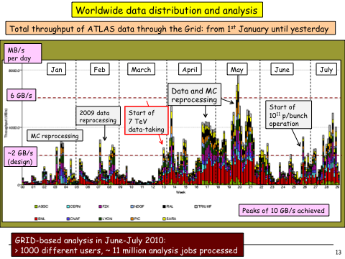
Figure 9. ATLAS Grid Status at ICHEP 2010

One can notice that while the mean throughput is consistent with the design value of 2GB/s, there are large fluctuations in order to deliver promptly newly reprocessed data to the physicists. Such fluctuations, peaking at 10GB/s are properly absorbed by the system that on no occasion has been seen to suffer of high load. At the same time, the infrastructure demonstrated to be able to cope with multiple experiment activities at the same time: in Fig 10 one can see how an increase of ATLAS activity (in the period from April to June) largely above the design model has no implication on the CMS data transfer capability with no evidence of saturation, up to the point where more than 700TB have been dispatched worldwide in a single day by the two experiments.
Figure 10. Daily transfer volume of ATLAS and CMS virtual organizations

Figure 11 shows the increase of CMS analysis jobs over the last many months, in conjunction with events like important conferences.

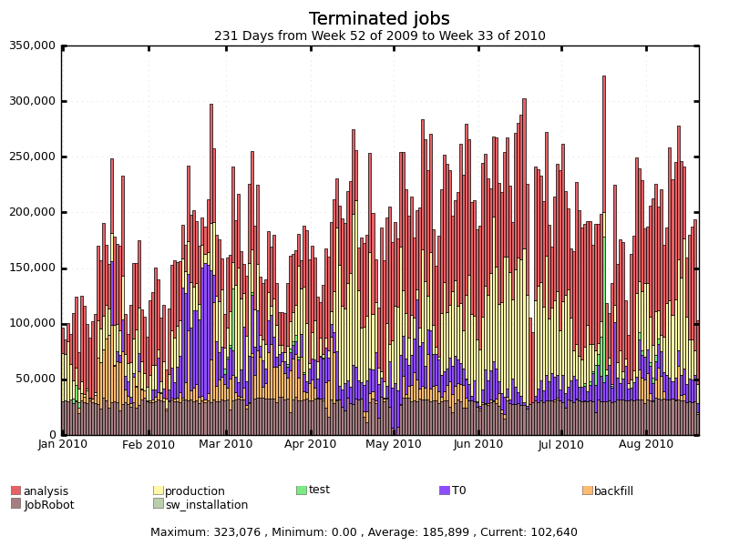
Figure 11. Number of jobs processed per day by the CMS VO worldwide.
Again, while routinely the CMS system runs the order of about 200K jobs per day, it is capable to absorb peaks of activity up to 1.5 times larger than the steady rate. The load comes of course both from scheduled productions and single user analysis. In Figure 12 one should notice how the number of single users submitting jobs to the Grid in CMS has exceeded 500 within the same week, while the same number was approximately 100 before the beginning of data taking in 2010.

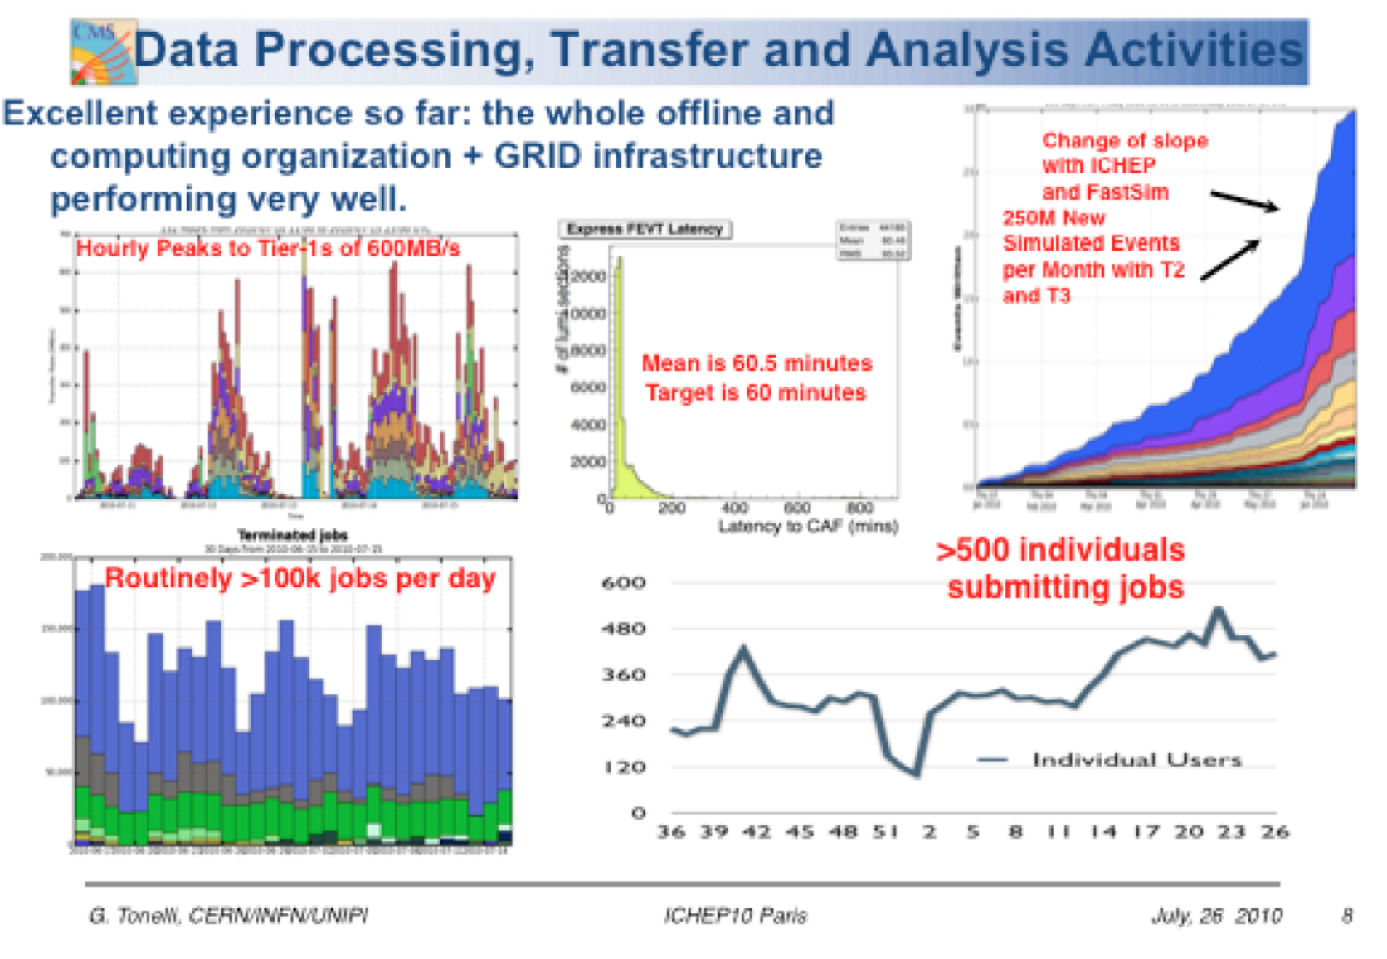
Figure 12. CMS Grid Status at ICHEP 2010

The increase of analysis activity is even more visible in Fig 13 (right), showing the number of analysis ATLAS jobs running simultaneously over the WLCG infrastructure on a daily basis. While this number progressively increases over the last 7 months, one can easily see a burst of activity in the middle of March after the first 7TeV LHC run, in May after the major Monte Carlo and Detector Data reprocessing campaign and in July, prior to ICHEP 2010. To this, one should add the continuous (and more regular load) of the production activity in Fig. 13 (left), adding up to a maximum of more that 60K jobs running concurrently over the Grid computing resources

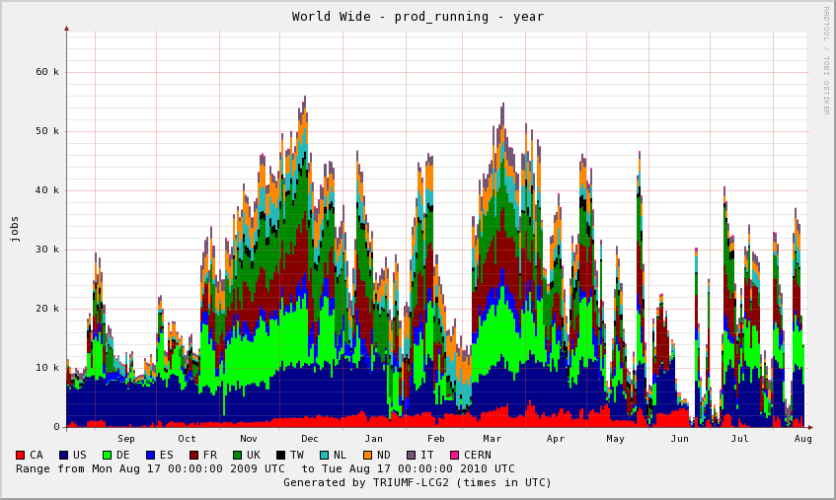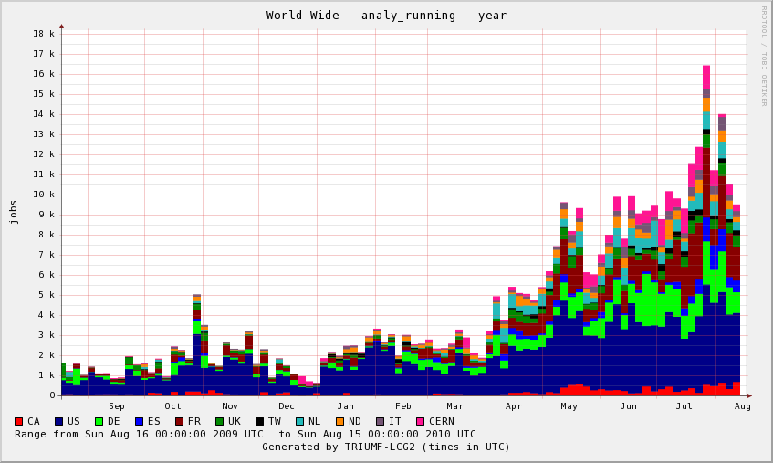
Figure 13. Number of ATLAS production (left) and analysis (right) jobs running in parallel

The screenshot of the WLCG Google Earth display in Figure 14 shows a runtime picture of the LHC jobs processing and data transfer activities on the worldwide distributed infrastructure.

Figure 14. WLCG Google Earth display shows the LHC computing activity on the distributed infrastructure

Conclusions
Through a series of case studies we have described a variety of application domains and the concrete steps required to use grid services and resources from first steps to petascale production. Grid computing is not a panacea: for suitable computing models – such as those that can be readily decomposed into a set of parallel tasks – it offers a number of well documented advantages over alternative solutions. In particular, it is significantly cheaper in terms of hardware and support costs than super-computer based solutions – especially in the case of long-lived projects where the application development cycle is quasi-continuous. It also allows funding to be invested locally, potentially breathing life into local economies and societies via a vibrant local research and education infrastructure, something that would be less obvious (at least in the former case) than current commercial cloud-based solutions. Most importantly, it has been proven to work. Until alternative models have been demonstrated on the production scale required by a project such as the LHC, this is an undeniable advantage.

See Economist article on the LHC: http://www.economist.com/realarticleid.cfm?redirect_id=16690695.

