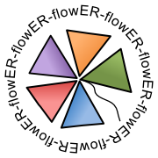

Project Number: RI-312579
Project Acronym: ER-flow
Project Full Title:
Building an European Research Community through Interoperable Workflows and Data

Theme: Research Infrastructures
Call Identifier: FP7-Infrastructures-2012-1
Funding Scheme: Coordination and Support Action
Deliverable D2.1
ER-flow dissemination and communication tools
Due date of deliverable: 30/11/2012 Actual submission date: 30/11/2012
Start date of project: 01/09/2012 Duration: 24 months
Lead Contractor: University of Westminster
Dissemination Level: PU
Version: 1.0
Table of Contents
Contents
Table of Contents 2
1 List of Figures and Tables 3
2 Status and Change History 4
3 Glossary 5
4 Introduction 6
5 Goals of dissemination and communication 7
6 Websites 10
6.1 ER-flow website 10
6.2 SHIWA Website 12
7 Social Media 14
8 Dissemination and Training Events 16
8.1 Community and international events 16
8.2 Training courses 17
9 Graphic and printed materials 18
10 Presence in the media 19

List of Figures and Tables
Figures:
Figure 1 First version of the ER-flow website 11
Figure 2 SHIWA User Forum message board 13
Figure 3 Facebook page 14
Figure 4. ER-flow logo 18
Figure 5 Powered by SHIWA logo 18
Tables
Table 1. Deliverable Status 4
Table 2. Deliverable Change History 4
Table 3. Glossary 5

Status and Change History
Status: | Name: | Date: | Signature:
Draft: | Kitti Varga | 20/10/12 | n.n. electronically
Reviewed: | Gergely Sipos | 28/11/12 | n.n. electronically
Approved: | Gabor Terstyanszky | 30/11/12 | n.n. electronically
Table 1: Deliverable Status

Version | Date | Pages | Author | Modification
1.0 | 20/10/12 | all | KV | Creation
1.1 | 12/11/12 | All | KV | First version created
1.2 | 29/11/12 | Chapter 5, 6, 7, 8 | KV | Corrections after the review
Table 2: Deliverable Change History

Glossary
CO | Confidential
DoW | Description of Work
INDICO | Integrated Digital Conference
PDF | Portable Document Format
PU | Public
QR | Quality Reviewer
SMB | Support Management Board
SSO | Single Sign On
SSP | SHIWA Simulation Platform
SVN | Subversion version control system
WP | Work package
Table 3. Glossary

Introduction
This document introduces the dissemination and communication tools that will be used by the ER-flow project. These tools will help ER-flow implement its dissemination strategy, namely to disseminate the achievements of the FP7 SHIWA project, particularly the coarse-grained workflow interoperability based on the SHIWA Simulation Platform, and to promote workflow development, sharing and integration within various scientific communities. The ER-flow project is building its strategy based on the SHIWA developments, using the SHIWA technology as a brand. The ER-flow website and the SHIWA User Forum are planned to evolve dynamically during the project, so this document covers only the initial version of these sites and outlines the processes by which these will be updated.

Goals of dissemination and communication
The ER-flow project will build a European Research Community to promote workflow sharing and to investigate interoperability of the scientific data in workflow sharing. The project will disseminate the achievements of the FP7 SHIWA project, particularly the coarse-grained workflow interoperability based on the SHIWA Simulation Platform. It will target major research communities that use workflows to run their experiments on a regular basis.
The project includes four major research communities: Astrophysics, Computation Chemistry, Heliophysics and Life Sciences. They will be supported to run experiments on the simulation platform. Beyond these communities the project will identify additional research communities who could benefit from the services of the SHIWA Simulation Platform.
ER-flow is a support action project, it does not develop technologies, it reuses the SHIWA Simulation Platform technology that has been developed by the FP7 SHIWA project and it is now maintained by the SHIWA consortium. The SHIWA Simulation Platform (SSP) is a package that includes the following services:
- SHIWA Repository: A database where workflows and meta-data about workflows can be stored. The database is a central repository to discover and share workflows within and among communities.

- SHIWA Portal: A web portal that is integrated with the SHIWA Repository and includes a workflow executor engine that can orchestrate various types of workflows on various grid and cloud platforms. Workflow execution is orchestrated by the workflow systems that are interfaced with the portal.

- SHIWA Desktop: A desktop environment that provides similar access capabilities than the SHIWA Portal, however it runs on the users’ desktops/laptops instead of a portal server.
The SHIWA Simulation Platform can support various scenarios that involve development, execution, integration and sharing of workflows, or workflow systems. The core set of use cases underpinning such scenarios have been collected by the WP2 activity and are available in Table 1.

USER PROFILE | USER GOAL | TASKS | TASK GUIDANCE
Principal investigator, demonstrator, research student, research fellow | Run a pre-defined scientific calculation, for example, to repeat an experiment or to demonstrate a scientific method during a training event. | Execute a workflow | Select a workflow that encapsulates the simulation. Import the workflow into the execution environment, then run it with the default, or with an updated set of input parameters.
Research fellow, scientific programmer | Capture a scientific calculation into a process that can be repeated at a later stage in an unmodified, or in some customised form. | Develop a workflow | Use a workflow editor system to define the steps of the calculation, input data for the calculation, and data dependencies among the computational steps.
Research fellow, scientific programmer | Integrate multiple scientific calculations into a single computation, for example to compare different approaches or to achieve results that can be delivered only with an integrated system. | Integrate workflows | Use a workflow editor that can encapsulate workflows that are written in different workflow languages with different tools.
Research fellow, scientific programmer | Share scientific calculation with research collaborators or with the general public, so they can repeat and reuse these on demand. | Share a workflow | Use the Repository to store and share a workflow with colleagues or with the general public. Provide a description and other meta-data for the workflow so others can find and use it effectively.
Project/community representative, scientific programmer | Support scientific communities to define, execute and share novel types of data processing workflows. | Integrate a workflow system | Integrate your workflow system with the SHIWA platform to make your system compatible with other workflow environments, and with various cloud and computing grid infrastructures.
Project/community representative, scientific programmer | Enrich a community specific portal with workflow development, sharing and execution capabilities. | Integrate a community portal | Interface your portal environment with SHIWA services. The Repository provides storage for workflows and their meta-data.
Table 1: Use cases supported by ER-flow through the SHIWA Simulation Platform.
The use cases include various types of actors ranging from principal investigators, to research fellows, trainers, scientific programmers and software operators. The goals of the ER-flow dissemination and communication activities are
- to reach those actors within European scientific communities who could benefit from SHIWA technology and ER-flow services through the use cases, and
- to communicate/explain to them the benefits and usage of SHIWA - ER-flow services to implement the use cases.
Besides reaching out to the direct beneficiaries, the ER-flow dissemination and communication activity also needs to ensure the proper communication within the consortium – especially between the WP5 activity (Application support for the four scientific communities) and the other WPs that deliver/provide solutions for applications.
The WP2 activity will use the following tools to reach these goals. The tools are explained in the subsequent sections:
- Websites (ER-flow and SHIWA)
- Social media (blogs, networking sites, RSS feeds, etc.)
- Events (presentations, demos, workshops, trainings)
- Graphic and printed materials (logos, leaflets, flyers, posters)
- Presence in the media

Websites
The project will maintain two websites: the ER-flow website at http://www.erflow.eu/, and the SHIWA website at http://www.shiwa-workflow.eu. Both websites will use similar design elements to strengthen the image that they belong together. The SHIWA website is based on the Liferay portal technology that is a fully functioning content management system. Since it was used without any major problem in the last two years, the ER-flow website will be developed based on Liferay technology as well. The Liferay technology allows the providing of keywords for search optimization and the creation of statistics using Google Analytics. Both websites will be updated on a regular basis to disseminate the results and services of the WP3, WP4 and WP5 activities.

ER-flow website
The goals and feature requirements of the ER-flow website are the following:
- Provide basic information (facts and numbers) about the ER-flow project (project goals, partners, background, etc.)
- Provide contact information to the project consortium
- Provide information about dissemination and training events (calendar, list of events, trainings’ page, publications, etc.)
- Provide ER-flow project related information announcement and news (news section, Facebook feed, etc.)
- Provide links to the SHIWA technology website based on the available user scenarios
- Support project management (Internal pages, Wiki, etc.)
- Support the download of documents and software (Document storage, links to external materials, etc.)
- Provide information about the workflow use case that ER-flow supports by using the SHIWA technology.
Events will be added to the already existing, but re-named SHIWA calendar. By merging the SHIWA and ER-flow calendars the past events will be kept and by following links in the calendar can browse the materials related to these events. Also the new events will become available on both website without the need of duplicating them. The calendar is created by using Google Calendar, so it is easy to share it among the project partners and everyone can easily have access to it.
Considering the experience of the SHIWA project the ER-flow project will use the Integrated Digital Conference (INDICO) tool along with the Doodle poll tool to organise meetings and events. INDICO pages can be easily integrated into the website.
Project documents will be stored in the EGI Document Database (DocDB) provided by EGI.eu. The solution was chosen because it is accessible through a web browser, and allows role based access control, and it provides good visibility of the ER-flow public documents for the European Grid Infrastructure community, who is one of the key potential consumer of the ER-flow services. This service will be integrated into the website’s private part for easier access to the consortium members.
The first version of the ER-flow website was created in September 2012, when the project started, using the information that was already available by that time. Based on the partners’ feedback the website will be improved significantly in the next few months.
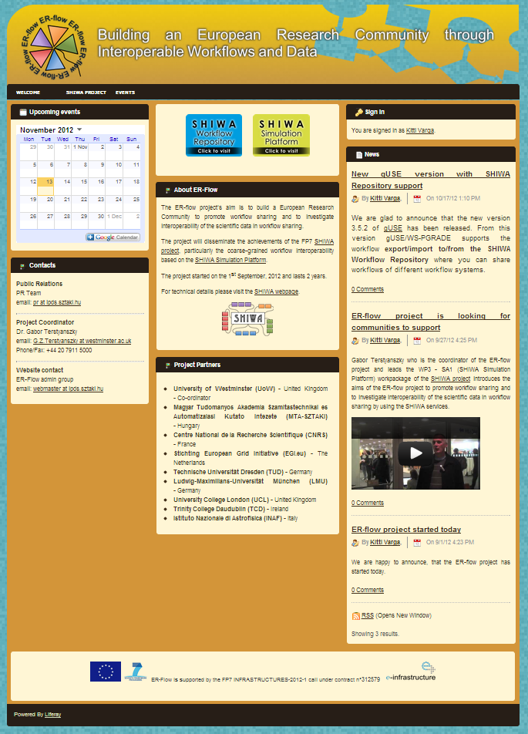
Figure 1 First version of the ER-flow website
The web site incorporates public and protected (or private) sections. The protected sections can be accessed after login on the website. The password protected private section will provide sensitive information for project members. The Liferay portal motor enables a wide range of authorisation possibilities, for example the creation of groups with different roles and accessibility options.
The website authentication is planned to be integrated with EGI Single Sign On account (SSO) system so people need to register only once to access both the private section of the website and the EGI Document Database where the project documents are stored. Currently the consortium investigates this possibility with the EGI SSO technical experts.

SHIWA Website
Although the SHIWA project has ended in the end of September 2012, the technologies delivered by SHIWA, especially the SHIWA Simulation Platform, and other components such as the SHIWA web site, are central components of the ER-flow project. The SHIWA website (http://www.shiwa-workflow.eu) will be used by the ER-flow project and will be converted into a technological website by the SHIWA community to contain the details of each component used in the SHIWA technology. The ER-flow website will contain detailed information about the events organised and will function as a project website.
The SHIWA website includes a section called SHIWA User Forum (http://www.shiwa-workflow.eu/shiwa-user-forum). This forum was established in the first year of the SHIWA project to serve a better communication with the users of the SHIWA technology products, such as the SHIWA Simulation Platform. It will be further improved and used in the ER-flow project to serve as channel forum where SHIWA developers and users can meet and help each other in technical questions. The forum therefore has paramount importance in building workflow communities in Europe.
To provide continuous service, the SHIWA User Forum will stay on the SHIWA website and will keep its current user base, about 55 people. The topics on the Message Board will be re-organised by the ER-flow consortium members to better facilitate the needs of the User Forum members.
All the topics are public, so registration is needed only for posting messages. However the project consortium always encourages the interested parties to register, so they can subscribe to a number of topics they would like to receive updates from. The registration to the SHIWA User Forum has been made easier by setting up Facebook authentication.
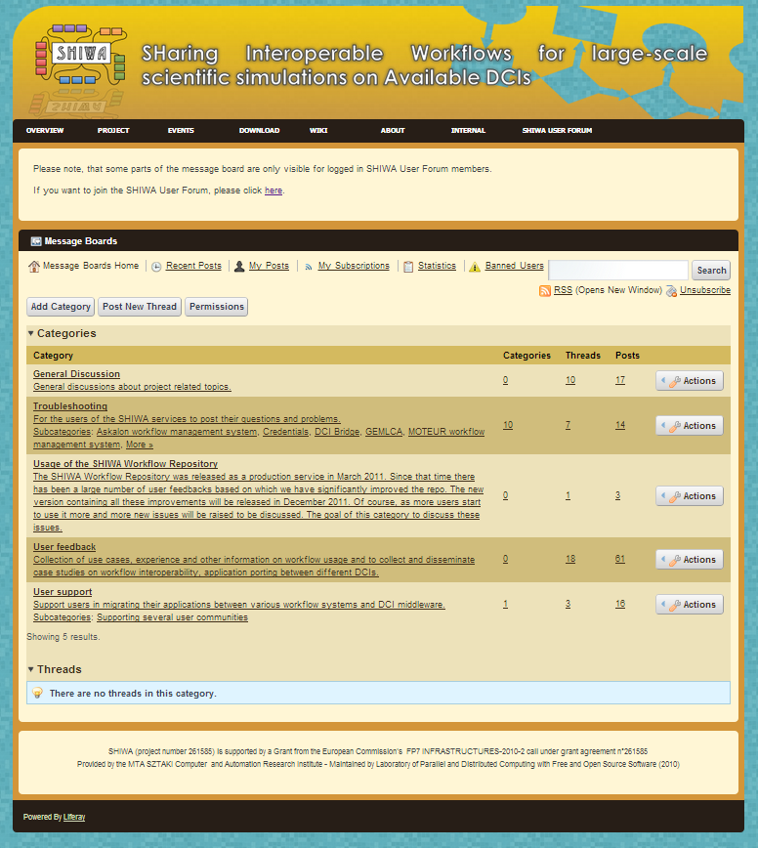
Figure 2 SHIWA User Forum message board

Social Media
The SHIWA Facebook page (http://www.facebook.com/SHIWA.technology) was created during the second year of the SHIWA. As social networking became very popular, the SHIWA Facebook page worked as a secondary interface to provide information for those who are interested in the SHIWA project without the need to visit the SHIWA webpage every day. Usually smaller status reports and photos were posted about the SHIWA related events. Similar to the website, the Facebook page will be converted to become the SHIWA technology page, as a brand, instead of being the SHIWA project’s page.
The other aim of the Facebook page is to disseminate the SHIWA technology to a wider audience through those people who “Like”-d the Facebook page. The SHIWA Facebook page has 48 Like-s at the moment and those people who are following SHIWA’s updates have more than 19 000 friends. So when they “Like” an article on the SHIWA Facebook page, their friends will see it on their Timeline and this way SHIWA can reach a large number of people through Facebook.
To avoid losing followers, the SHIWA Facebook page will be kept and re-organised to promote the SHIWA technology instead of the SHIWA project.
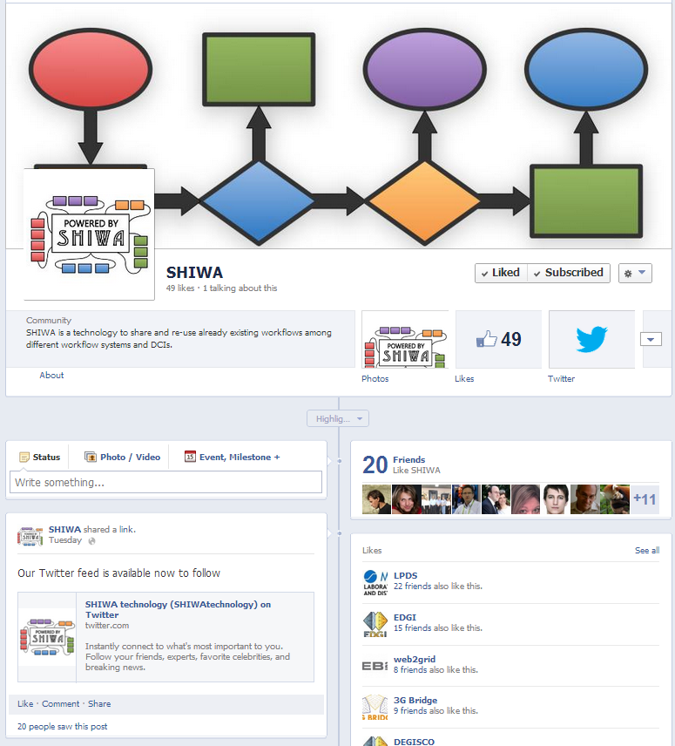
Figure 3 Facebook page
A Twitter account (http://twitter.com/SHIWAtechnology) was set up and connected to the Facebook feed to attract those who are more comfortable reading news on Twitter. A news blog with RSS feed will available on the ER-flow and SHIWA websites (same content) to promote the newest achievements for the visitors on the main page. The most important news will be forwarded to other widely read media sources.

Dissemination and Training Events

Community and international events
The ER-flow project is planning to organise events for the existing partner communities and to attract new ones to use the SHIWA technology. Events both in national and international level will be held.
All four communities that are involved in the ER-flow project declared about their already known or planned events for the first project year. This list will be extended and most likely changed during the next few weeks. These events are:
Life Science community:
The main event for the Life Science community will be the Healthgrid conference that has no date yet. They will have presentation of talks about the ER-flow project at the Dutch bio-assist meetings that is a monthly meeting of bioinformaticians and scientific programmers. They also submitted a partially ER-flow related poster to the IWBBIO 2013 (International Work-Conference on Bioinformatics and Biomedical Engineering). They are also looking into the technological tracks of some events such as the Annual International conference on Intelligent Systems for Molecular Biology (ISMB) and the European Conference on Computational Biology (ECCB).
MoSGrid community:
The chemist community is organising three meetings:
- 10th April 2013 in Cologne at RRZK
- 17th April 2013 at LMU Munich, Department of Chemistry
- 16th October 2013 at LMU Munich, Department of Chemistry
These three meetings will include information on the progress in MoSGrid, hands-on training on MoSGrid, introduction to Workflows, introduction to the ER-flow project and the SHIWA technology, hands-on training on the SHIWA technology and a discussion session for actual questions and desires from the community. The meetings will be organised in the MoSGrid centres to reach a great number of interested chemist.
Astrophysics community:
The Astrophysics community is planning to hold face-to-face workshops at several institutes of the community. During these meetings people directly involved in the ER-flow project will introduce the aims of the ER-flow project and the SHIWA technology. The groups can show the list of workflow(s) that with the specific group is already contributing or could contribute to ER-flow. The detailed information can be gathered for each of the contributed workflows and the approach to be adopted and to be ported to the SHIWA technology can be discussed.
- Face-to-face ER-flow Astrophysics meetings in different institutes (with fixed dates):
  - 25 - 29 November 2012 - University of Portsmouth, UK
  - 12 - 13 December 2012 - Solvak Academy of Sciences, Bratislava, SK
  - 8 - 9 January 2013 - Astronomical Observatory of Teramo, IT
- Planned face-to-face ER-flow Astrophysics meetings in different institutes for 2013
  - The Astronomical Institute of Andalucia (IAA), Granada, ES
  - The Insitituto del Fisica de Cantabria, Santander, ES
  - The Asronomical Observatory of Meudon, Paris, FR
  - The CDS Institute, Strasbourg, FR
  - The ASTRON Institute, Amsterdam, NL
  - The AIP Institute, Potsdam, DE
Heliophysics community:
The heliophysics community is planning to participate at two large events (no exact dates have been confirmed yet): European Geosciences Union - normally held in Vienna in April and the American Geophysical Union - held in San Francisco in December. Both meeting have sessions relevant to heliophysics and both also have a block of informatics sessions covering topics relevant to data management.
For them there are other two meetings that could be taken into consideration, but no exact information about them is available at the moment: The European Solar Physics and COSPAR.
To reach out to new user communities the project consortium is considering submitting a proposal to organise a workshop during the EGI Community Forum in March 2013.

Training courses
Training courses play a key role in the dissemination strategy as the user communities need to learn the usage of the SHIWA technology tools to be able to successfully use them. The satisfaction of the users is very important for spreading the technology among the communities. The project consortium is considering the option of holding smaller training events for the communities itself, instead of investing resources into large events where not all of the users can be present. This way more real users can be reached and more time can be spent on solving individual problems.
As it can be seen in Chapter 8.1, the communities already started to plan their events, some including hands-on session. The project is encouraging the communities to follow this road and organise their own training courses in order to reach out to great number of interested community members.

Graphic and printed materials
The ER-flow logo was created using the key attributes of the SHIWA logo. The colouring scheme is the same, but the logo is connecting the separate shapes to form one whole to symbolise that the main aim of the project is to connect the parts of different communities together in order to create one large community.
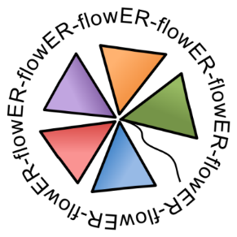
Figure 4. ER-flow logo
Introducing the SHIWA technology as a brand requires a logo that is based on the previous SHIWA logo but expresses that it is not a project any more but a technological solution to be used. For this reason the ‘Powered by SHIWA’ logo was created.
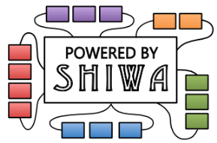
Figure 5 Powered by SHIWA logo
A general dissemination poster and flyer will be designed for the project focusing on the SHIWA technology and its advantages, describing the use cases where SHIWA technology could be useful for workflow user communities with the need of large computation power. For larger international events, such as the EGI Technical and Community Forums, where ER-flow is planning to organise its own workshops and trainings, special flyers will be created to contain the location and the schedule of these events.
The first version of the poster is scheduled during mid-December, the final version will be made around February, 2013.
Give-aways are always very welcomed at dissemination events, hence it is planned to design and order gadgets that the project consortium decides would fit the goal of ER-flow project best. The options contain T-shirts, pens, badge holders and many more.

Presence in the media
The ER-flow project will also focus on external media entries beside its own resources. To achieve this goal it is planned to sign ‘Memorandum of Understandings’ (MoU) with partner projects and communities. During the SHIWA project a successful collaboration was started with the e-ScienceTalk project. They published several posts about the SHIWA technology and events on their widely read blog, called GridCast. The ER-flow project is planning to continue this collaboration in the form of a new MoU.
Many partner institutes and communities have their own news feeds and newsletters, such as the MoSGrid and EGI newsletters to inform their members about the recent developments and about upcoming events. The ER-flow project is counting on these sources to publish news and facts about the SHIWA technology and about the ER-flow events regularly.

https://doodle.com/

