WP5: Tool tests for scenario 1.3

Authors:

Eva Toller (National Archives of Sweden, RA)
……

Project co-funded by the European Commission within the ICT Policy Support Programme
Dissemination Level
P | Public | P
C | Confidential, only for members of the consortium and the Commission Services

Revision History

Revision | Date | Author | Organisation | Description
0.1 | 20130503 | Eva Toller | RA | First draft
0.2 | 20130506 | Eva Toller | RA | Added tests results for ROND (Riksarkivet Open Data).

TOOL Testing for scenario 1.3

Scenario description
“A little museum in Malta has a historical library and a digitised personal archive collection. The museum has staff of only 9 and only voluntary IT support. The director of the museum is aware of the need to organise digital preservation for the digitised documents, but is not sure how to do it. He receives periodically offers for long-term storage of digital content, but finds it difficult to select or to make a decision. He has practically no IT competence to rely on for decision-making, but is convinced that the decision should be forward-looking and accommodate the needs of the museum for the next 5 years.”
General comment: if this scenario is reused in Proof of Concept #2, we could try to find a real organisation that has this problem (although it does not have to be a museum).
Suggested test data: see document DCH-RP_WP5_Scen-1-3_ID-51.doc

General comments

Chapter 2 is structured in the following way:

In sections X.1, a short description is given of the tool and how it works.

In sections X.2, the data set(s) that the tool will be tested on is described. If there are several data sets, they are described in sub sections: X.2.1, X.2.2, X.2.3 … X.2.n.

In sections X.3, the results of the tests are given. If there are several data sets and the results differ significantly between them, they are described in sub-sections: X.3.1, X.3.2, X.3.3 … X.3.n.

In sections X.4, general comments are given about the tool and its usability for digital cultural heritage preservation, dissemination et c.

TEST and evaluation of tools

ROND
ROND (Riksarkivet OpeN Data) is a tool for de-identifying data sets. It is written in C#. It is dependent on Riksarkivet's chosen meta data format for structured text files, ADDML : http://xml.ra.se/addml/ (in Swedish). ROND was developed at Riksarkivet in 2012, using a grant from Vinnova; see http://www.vinnova.se/sv/Resultat/Projekt/Effekta/Riksarkivet-Open-data-pilot---RONDp/ (in Swedish).
ROND works in the following way. You choose a meta data file (currently, an Excel spreadsheet) and a directory where the corresponding raw data files are situated. Then you give a directory where the de-identified files should be written.
The data is loaded, and now you can choose a record type corresponding to a specific file (“Posttyper att hantera”) and choose what columns that should be de-identified (“Kolumner att hantera”). The default character for subsitution of the de-identification candidates is 0 (zero), but you can choose any other suitable character (“Inställningar för varje kolumn”, “Censureringstecken”). You can also choose to either substitute all characters in the field (“Censurera alla tecken I fältet”), or only some of them. The latter is feasible when you, for example, have social security numbers where you want to keep the birth year and birth month only.
The output files that are changed are named <old filename>_konverterad.<file extension>
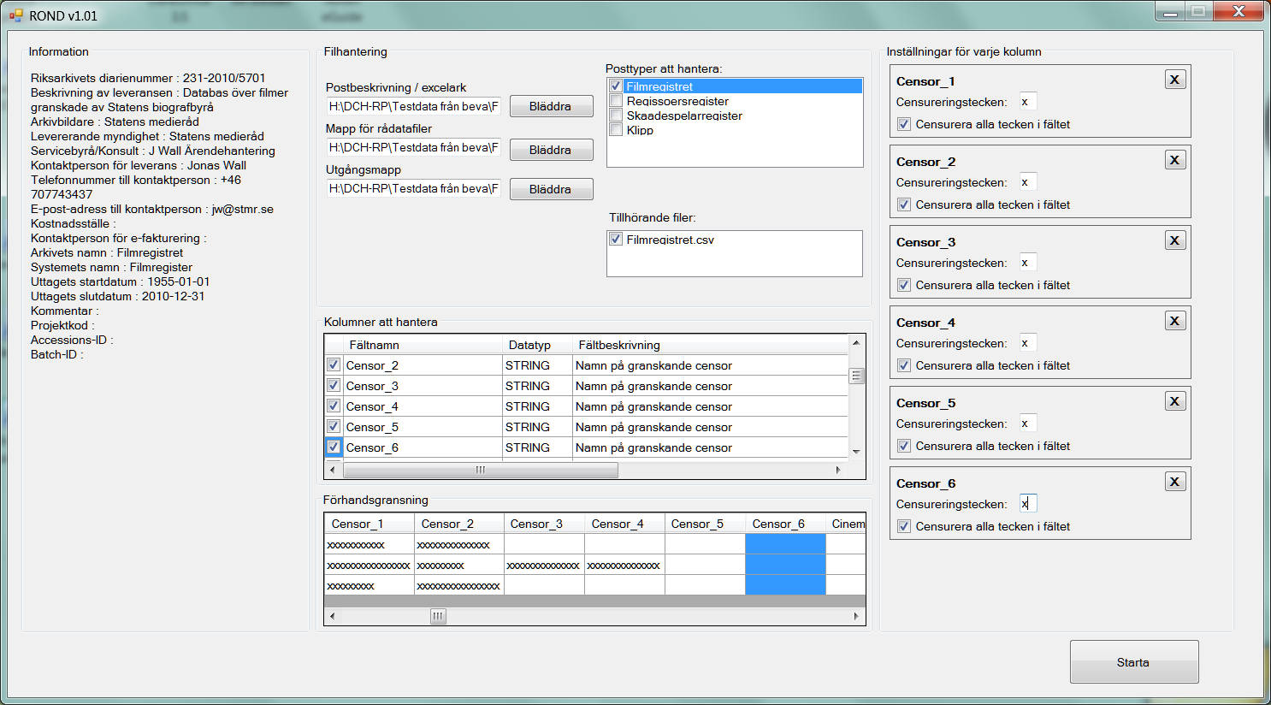
Figure 1: An example of de-identification in ROND
ROND does the following changes to the files:
- In the meta data file (Excel spreadsheet), comments are inserted about the columns that have been de-identified. If the size of the file has been changed as a direct consequence of the de-identification, this is noted. The new names of the de-identified raw data file are written instead of the original file names.
- Besides from de-identifying the chosen columns, ROND also inserts row numbering after the rightmost column in the changed raw data files (consecutive numbering 1,2,3, … , n). This is done to later make it possible to identify the changed data when needful, by comparing the <old filename>_konverterad.<file extension> file with the original file.

Data set
The data set that was used to test ROND is called “Filmregistret” (the Film Records Collection). These are not records of films per se, but of the censorship that has been performed for some films containing scenes that are violent or offensive in other ways. The actual cuts are not included in this data set.
There are four separate files in “Filmregistret”:
Filmregistret.csv: contains general and administrative information about the films and the censoring process (including the name of the censors and the technicians). All in all, there are 109 columns in this data set. The number of record instances (rows) is 59785.
Regissoer.csv: contains the names of the directors and IDs for the censorships for that director's films. There are only these 2 columns in this data set. The number of record instances (rows) is 30405.
Skaadespelare.csv: contains the names of the actors and IDs for the censorships for that actor's films. There are only these 2 columns in this data set. The number of record instances (rows) is 139301.
Klipp.csv: contains detailed information about the cuts that have been made (description of the scenes, lengths of cuts, sections of law that are referred to, and so on). There are 14 columns in this data set. The number of record instances (rows) is 8330.

test results
Although “Filmregistret” does not, “by the letter of the law”, contain any confidental information, it was considered prudent to de-identify the names of the censors and the technicians. The names of the directors and actors were not de-identified; firstly, they are widely known, and secondly, to remove them would greatly decrease the usability of the data set.
Names of censors and technicians are columns in Filmregistret.csv:
Censor_1, Censor_2, Censor_3, Censor_4, Censor_5, Censor_6
Tekniker, Teniker2
All letters in the names were replaced with x's (see Figure 1 in section 2.1 for an example).
The program behaved as expected and gave the correct results. However, there may be a problem with this program concerning usability.

usability
There is no manual and no other help for the user, since it was deemed to be relatively easy to use by the developers. However, some of the text that is used in labels is quite misleading, and it is also unnecessarily cumbersome to choose the files you want to work with.
It would be rather easy to fix these problems, and then the program would be (even more) easy to use, also for a non-technician. It is also recommended that some in-built help is added, for example “tool tips” that contain short explanations about the different things you must do in order to get the de-identification running.
ROND is easy to install; it is a C# program that is compiled to an .exe file that can be easily distributed and/or downloaded.
Recommendation
If ROND should be recommended as a tool for de-identification of archive information in the DCH sector, the improvements mentioned above should be made first. It should also be pointed out that ROND has a major limitation in that it requires a certain metadata model (ADDML), which is currently only used by Sweden and Norway.
However, tools of this type could be very useful for publishing huge amounts of archival information as open data; information that otherwise would be locked up in the archives, and much harder to find and obtain for interested parties.
Grade
On a scale from 1 (very bad) to 5 (very good). X is “Not applicable”.
Simplicity of installation: 5
Simplicity of management: X
Ease of use: 2 - 3
Generality of solution: 1

