EGI-InSPIRE

Technology Provider Service Model

Document identifier: | input.doc
Date: | 29/05/2013
Activity: | NA2
Lead Partner: | EGI.eu
Document Status: | DRAFT
Dissemination Level: | PUBLIC
Document Link: | https://documents.egi.eu/document/1778

Abstract
This document provides a description of the business and service model that EGI is developing and planning to implement in order to formalise EGI's technology support for research communities in the EGI ecosystem.

- Copyright notice
Copyright © Members of the EGI-InSPIRE Collaboration, 2010. See www.egi.eu for details of the EGI-InSPIRE project and the collaboration. EGI-InSPIRE (“European Grid Initiative: Integrated Sustainable Pan-European Infrastructure for Researchers in Europe”) is a project co-funded by the European Commission as an Integrated Infrastructure Initiative within the 7th Framework Programme. EGI-InSPIRE began in May 2010 and will run for 4 years. This work is licensed under the Creative Commons Attribution-Noncommercial 3.0 License. To view a copy of this license, visit http://creativecommons.org/licenses/by-nc/3.0/ or send a letter to Creative Commons, 171 Second Street, Suite 300, San Francisco, California, 94105, and USA. The work must be attributed by attaching the following reference to the copied elements: “Copyright © Members of the EGI-InSPIRE Collaboration, 2010. See www.egi.eu for details of the EGI-InSPIRE project and the collaboration”. Using this document in a way and/or for purposes not foreseen in the license, requires the prior written permission of the copyright holders. The information contained in this document represents the views of the copyright holders as of the date such views are published.
- Delivery Slip
 | Name | Partner/Activity | Date
From | <<The lead author/editor>>
Reviewed by | Moderator:  Reviewers:  <<To be completed by project office on submission to AMB/PMB>>
Approved by | AMB & PMB  <<To be completed by project office on submission to EC>>
- Document Log
Issue | Date | Comment | Author/Partner
1 |  | First draft
2
3
- Application area
This document is a formal deliverable for the European Commission, applicable to all members of the EGI-InSPIRE project, beneficiaries and Joint Research Unit members, as well as its collaborating projects.
- Document amendment procedure
Amendments, comments and suggestions should be sent to the authors. The procedures documented in the EGI-InSPIRE “Document Management Procedure” will be followed:
https://wiki.egi.eu/wiki/Procedures
- Terminology
A complete project glossary is provided at the following page: http://www.egi.eu/about/glossary/.
<<The authors should check if the acronyms are covered by the glossary page and if the definition is still correct; all the amendments should be communicated to glossary@egi.eu>>
- PROJECT SUMMARY

To support science and innovation, a lasting operational model for e-Science is needed − both for coordinating the infrastructure and for delivering integrated services that cross national borders.

The EGI-InSPIRE project will support the transition from a project-based system to a sustainable pan-European e-Infrastructure, by supporting ‘grids’ of high-performance computing (HPC) and high-throughput computing (HTC) resources. EGI-InSPIRE will also be ideally placed to integrate new Distributed Computing Infrastructures (DCIs) such as clouds, supercomputing networks and desktop grids, to benefit user communities within the European Research Area.

EGI-InSPIRE will collect user requirements and provide support for the current and potential new user communities, for example within the ESFRI projects. Additional support will also be given to the current heavy users of the infrastructure, such as high energy physics, computational chemistry and life sciences, as they move their critical services and tools from a centralised support model to one driven by their own individual communities.

The objectives of the project are:

- The continued operation and expansion of today’s production infrastructure by transitioning to a governance model and operational infrastructure that can be increasingly sustained outside of specific project funding.
- The continued support of researchers within Europe and their international collaborators that are using the current production infrastructure.
- The support for current heavy users of the infrastructure in earth science, astronomy and astrophysics, fusion, computational chemistry and materials science technology, life sciences and high energy physics as they move to sustainable support models for their own communities.
- Interfaces that expand access to new user communities including new potential heavy users of the infrastructure from the ESFRI projects.
- Mechanisms to integrate existing infrastructure providers in Europe and around the world into the production infrastructure, so as to provide transparent access to all authorised users.
- Establish processes and procedures to allow the integration of new DCI technologies (e.g. clouds, volunteer desktop grids) and heterogeneous resources (e.g. HTC and HPC) into a seamless production infrastructure as they mature and demonstrate value to the EGI community.

The EGI community is a federation of independent national and community resource providers, whose resources support specific research communities and international collaborators both within Europe and worldwide. EGI.eu, coordinator of EGI-InSPIRE, brings together partner institutions established within the community to provide a set of essential human and technical services that enable secure integrated access to distributed resources on behalf of the community.

The production infrastructure supports Virtual Research Communities (VRCs) − structured international user communities − that are grouped into specific research domains. VRCs are formally represented within EGI at both a technical and strategic level.

- EXECUTIVE SUMMARY
<< The text should provide a summary of the full report so that the reader can ‘in a page’ understand the problem it has been written to cover. This includes an overview of the background material and motivation for the report, a summary of the analysis, and the report’s main conclusions.>>

TABLE OF CONTENTS
1 Introduction 4
2 XXXX 4
2.1 YYYYYYYYYY 4
2.1.1 ZZZZZZZZ 4
3 Conclusion 4
4 References 4

Introduction
This document illustrates the EGI Service model for Technology Providers to support the EGI ecosystem at large, and the research communities in particular.
TBC

EGI Platform Architecture: Recap
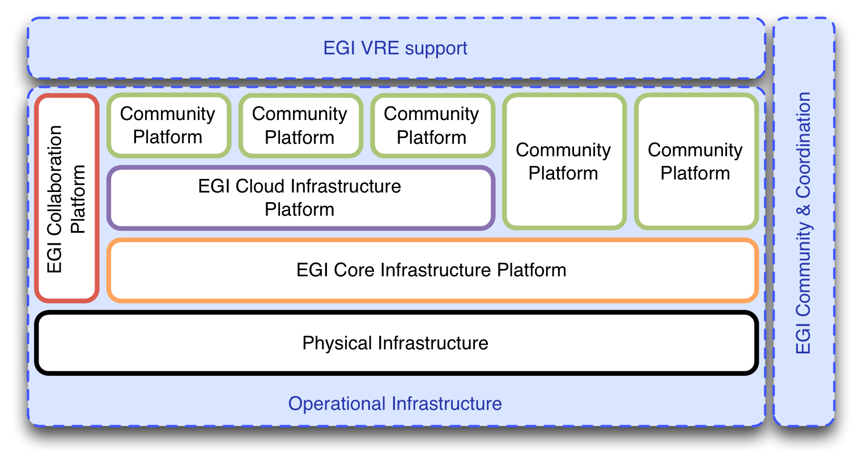
EGI is moving towards a platform-oriented model with clear roles and responsibilities for the involved stakeholders. Much of this is described in great detail in MS514, but for purpose of this document, it is recaptured in a much more compressed form as a starting point for subsequent sections.
Figure 1: The EGI Platform Architecture embedded in the EGI Strategy
The EGI Strategy encompasses three pillars:
- Operational Infrastructure
- Community & Coordination
- Virtual Research Environments

The Operational Infrastructures comprises of a number of technology platforms. Some of them EGI owns, some are owned by the respective Research Community that uses them.
EGI’s members, the Resource Centres and NGIs, own the physical infrastructure; on top of these, the following EGI-owned platforms are deployed:
- EGI Core Infrastructure Platform
- EGI Cloud Infrastructure Platform
- EGI Collaboration Platform

On top of these, any number of Community Platforms may be deployed. Community Platforms that are deployed on top of the Core Infrastructure Platform are in reality actually deployed directly on physical resources, while being integrated with the EGI Core Infrastructure Platform. Community Platforms that integrate with EGI’s Cloud Infrastructure comprise of any number of Virtual Machine Images.

EGI Core Infrastructure Platform
The EGI Core Infrastructure Platform consists of a number of subsystems that are necessary to operate federated, distributed Community Platforms. Note that this definition does not include any software that implements business logic directed at any particular user or research community. It includes software that is often part of the management infrastructure in data centres.

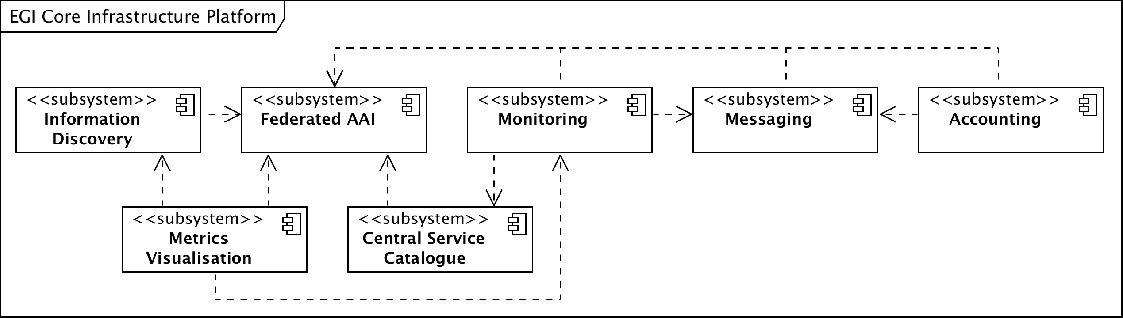
Figure 2: The subsystems of the EGI Core Infrastructure

As illustrated in Figure 2 the EGI Core Infrastructure Platform provides services that are required to provide a federation layer atop a set of resources exposed through a Community Platform.
The implied definition of a resources in this architecture on this level is very close to the actual physical infrastructure: Servers, blades, clusters (including batch systems), SANs, networks up to and including layer 4 are considered resources while RDBMS, Web Servers, and other similar solutions are not considered resources on this level.
Note that the EGI Core Infrastructure is not federating the resources themselves, but the Community Platforms that expose these resources.
Since the Community Platforms – at least the current ones – are difficult to contain and use resources that are generally shared in a collaborative mode, a number of support activities are part of the Core Infrastructure Platform that are not shown here. For example, operational security is a pervasive activity that monitors the patchlevel of specific components of Community Platforms in order to eliminate software vulnerabilities in EGI’s production infrastructure and prevend security incidents.

EGI Cloud Infrastructure Platform
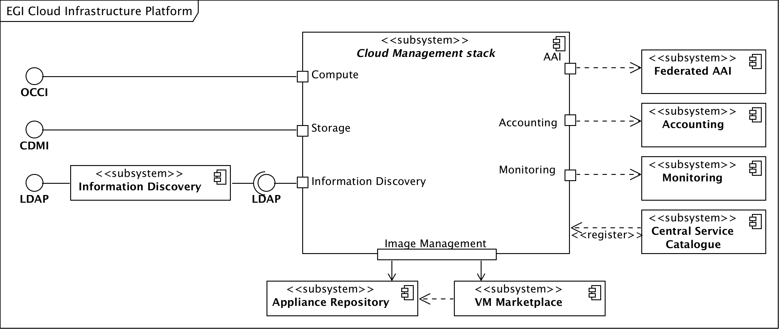
The EGI Cloud Infrastructure Platform aims to provide a federation of institutional private IaaS Clouds. The architectural model uses Virtual Machine Images (VMIs) as the abstraction and integration layer: The EGI Federated Clouds Platform provides consistent management interfaces for Cloud Computing and Cloud Storage services; additional management interfaces for other Cloud services may be added when required and sufficiently abstracted and standardised.
Figure 3: The EGI Cloud Infrastructure Platform
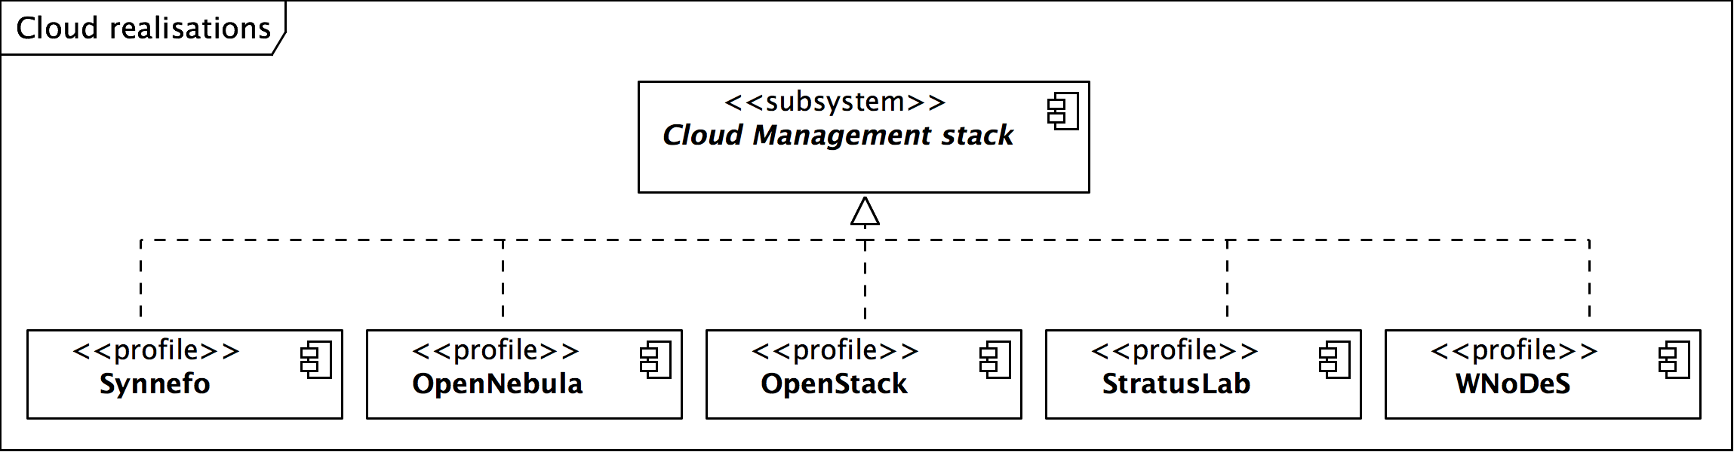
Central to the architecture of the Cloud Infrastructure Platform is the model of an abstract Cloud management stack: Participating Resource Providers are free to choose the Cloud management stack they wish to deploy, for as long as they ensure that they expose service management endpoints that comply with the federation requirements and are interoperable to all other federated Cloud resources. The members of the EGI Federated Clouds task are providing each other the necessary integration tools.
Figure 4: Existing realisations of the abstract Cloud management stack in EGI

The currently participating 14 Resource Centres in EGI are using a number of different Cloud management stacks as illustrated in Figure 4. The EGI Cloud Infrastructure Platform is integrating with the EGI Core Infrastructure Platform as illustrated in Figure 3, more specifically with the Federated AAI, Monitoring, Accounting and Information Discovery subsystems.
This architecture results in “pockets of support” around the various Cloud management frameworks that are organised in a community effort and a lean federation layer with a thin veneer of policy around it.

EGI Collaboration Platform
The EGI Collaboration Platform is currently in flux in terms of its content. It is defined as a set of services that allow Research Communities to collaborate within and across community boundaries. It includes collaboration tools and services for both social and technical collaboration, such as Wikis, DocDB, Indico, Requirements/Issue tracker, GlobusOnline and many more.
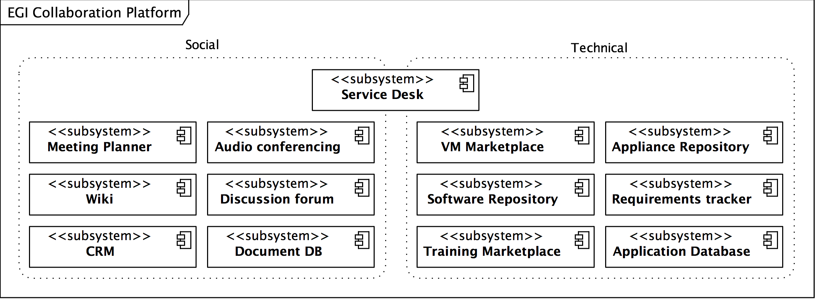
Figure 5: The Collaboration Plaform provides a wide variety of services

Note that this definition also includes prominent services of EGI, such as the Application Database, EGI Software Repository, the service desk (based on GGUS), and others.

Community Platforms
Community Platforms in EGI are a pivotal element in the EGI technical architecture since it is the components and services that are included in these that provide the targeted researchers with suitable and domain-specific access to the resources exposed through the EGI Platforms.
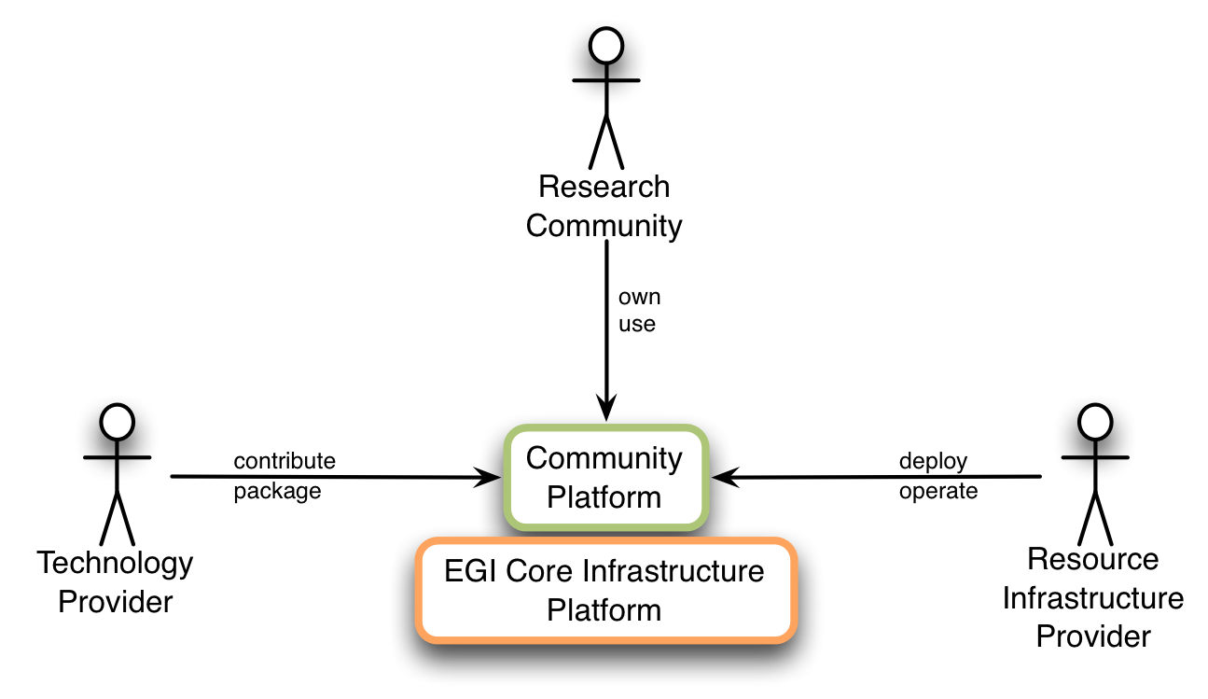
Fundamental to Community Platforms are the involved stakeholder and actors as illustrated below.
Figure 6: Stakeholders of classic Community Platforms

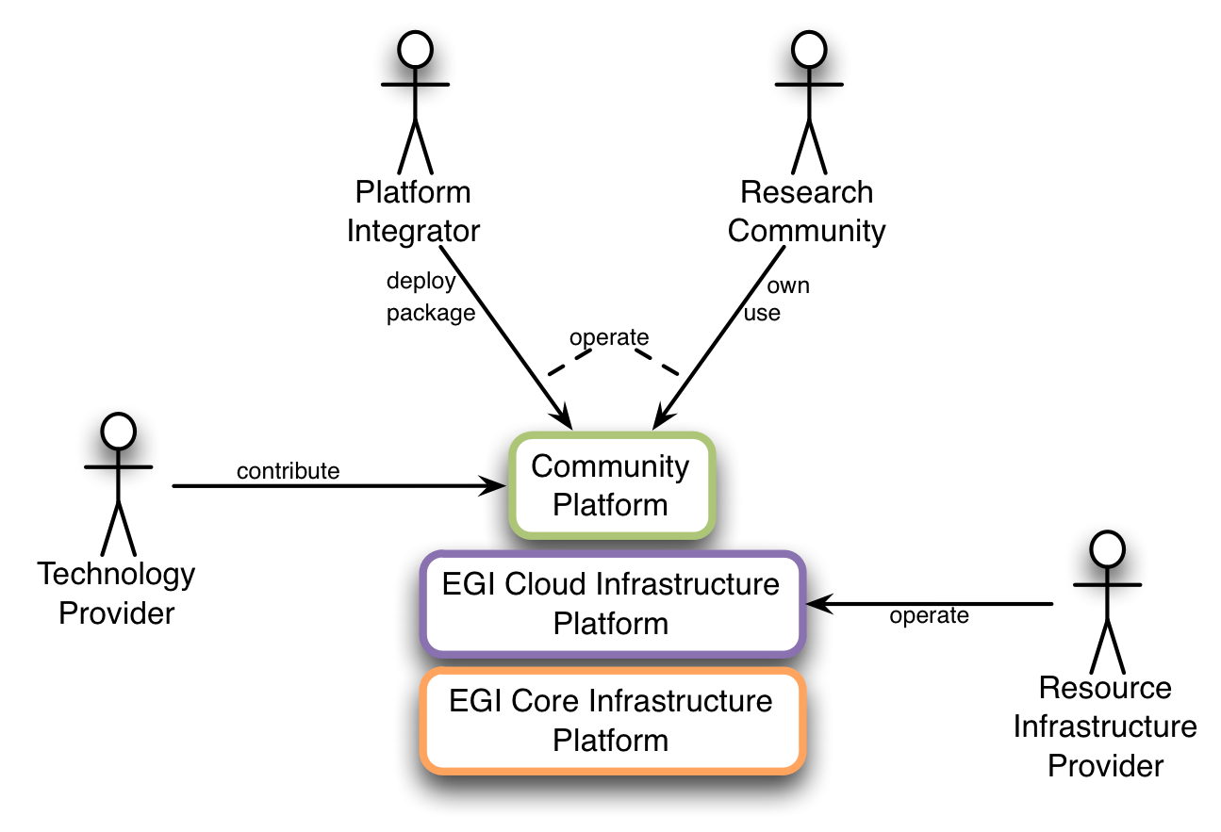
Figure 7: Stakeholders of Cloud-based Community Platforms

The components of the EGI Core Infrastructure Platform provide services and capabilities around AuthN & AuthZ, Monitoring of se

are owned by EGI, some are owned and m
Technology Providers with which EGI wishes to enter a contractual, committed relationship need to know the context within which the services are expected. This document focuses on relationships with Technology Providers who provide Community Platforms directly deployed on top of the EGI Core Infrastructure Platform. (See figure below)

A Community Platform is defined as a complete set of software services, libraries, configuration files, etc. that are necessary to deploy this platform out of a single source, for example a repository. This document presumes that Community Platforms
This is meant from an architectural point of view. In reality, the deployment will happen on the physical infrastructure.

a deployment model for such Community Platforms that require

XXXX

YYYYYYYYYY

ZZZZZZZZ

Conclusion

References
R 1
R 2
R 3
R 4
R 5

