EGI-InSPIRE

Technology Provider Service Model

Document identifier: | input.doc
Date: | 31/05/2013
Activity: | NA2
Lead Partner: | EGI.eu
Document Status: | DRAFT
Dissemination Level: | PUBLIC
Document Link: | https://documents.egi.eu/document/1778

Abstract
This document provides a description of the business and service model that EGI is developing and planning to implement in order to formalise EGI's technology support for research communities in the EGI ecosystem.

- Copyright notice
Copyright © Members of the EGI-InSPIRE Collaboration, 2010. See www.egi.eu for details of the EGI-InSPIRE project and the collaboration. EGI-InSPIRE (“European Grid Initiative: Integrated Sustainable Pan-European Infrastructure for Researchers in Europe”) is a project co-funded by the European Commission as an Integrated Infrastructure Initiative within the 7th Framework Programme. EGI-InSPIRE began in May 2010 and will run for 4 years. This work is licensed under the Creative Commons Attribution-Noncommercial 3.0 License. To view a copy of this license, visit http://creativecommons.org/licenses/by-nc/3.0/ or send a letter to Creative Commons, 171 Second Street, Suite 300, San Francisco, California, 94105, and USA. The work must be attributed by attaching the following reference to the copied elements: “Copyright © Members of the EGI-InSPIRE Collaboration, 2010. See www.egi.eu for details of the EGI-InSPIRE project and the collaboration”. Using this document in a way and/or for purposes not foreseen in the license, requires the prior written permission of the copyright holders. The information contained in this document represents the views of the copyright holders as of the date such views are published.
- Delivery Slip
 | Name | Partner/Activity | Date
From | <<The lead author/editor>>
Reviewed by | Moderator:  Reviewers:  <<To be completed by project office on submission to AMB/PMB>>
Approved by | AMB & PMB  <<To be completed by project office on submission to EC>>
- Document Log
Issue | Date | Comment | Author/Partner
1 |  | First draft
2
3
- Application area
This document is a formal deliverable for the European Commission, applicable to all members of the EGI-InSPIRE project, beneficiaries and Joint Research Unit members, as well as its collaborating projects.
- Document amendment procedure
Amendments, comments and suggestions should be sent to the authors. The procedures documented in the EGI-InSPIRE “Document Management Procedure” will be followed:
https://wiki.egi.eu/wiki/Procedures
- Terminology
A complete project glossary is provided at the following page: http://www.egi.eu/about/glossary/.
<<The authors should check if the acronyms are covered by the glossary page and if the definition is still correct; all the amendments should be communicated to glossary@egi.eu>>
- PROJECT SUMMARY

To support science and innovation, a lasting operational model for e-Science is needed − both for coordinating the infrastructure and for delivering integrated services that cross national borders.

The EGI-InSPIRE project will support the transition from a project-based system to a sustainable pan-European e-Infrastructure, by supporting ‘grids’ of high-performance computing (HPC) and high-throughput computing (HTC) resources. EGI-InSPIRE will also be ideally placed to integrate new Distributed Computing Infrastructures (DCIs) such as clouds, supercomputing networks and desktop grids, to benefit user communities within the European Research Area.

EGI-InSPIRE will collect user requirements and provide support for the current and potential new user communities, for example within the ESFRI projects. Additional support will also be given to the current heavy users of the infrastructure, such as high energy physics, computational chemistry and life sciences, as they move their critical services and tools from a centralised support model to one driven by their own individual communities.

The objectives of the project are:

- The continued operation and expansion of today’s production infrastructure by transitioning to a governance model and operational infrastructure that can be increasingly sustained outside of specific project funding.
- The continued support of researchers within Europe and their international collaborators that are using the current production infrastructure.
- The support for current heavy users of the infrastructure in earth science, astronomy and astrophysics, fusion, computational chemistry and materials science technology, life sciences and high energy physics as they move to sustainable support models for their own communities.
- Interfaces that expand access to new user communities including new potential heavy users of the infrastructure from the ESFRI projects.
- Mechanisms to integrate existing infrastructure providers in Europe and around the world into the production infrastructure, so as to provide transparent access to all authorised users.
- Establish processes and procedures to allow the integration of new DCI technologies (e.g. clouds, volunteer desktop grids) and heterogeneous resources (e.g. HTC and HPC) into a seamless production infrastructure as they mature and demonstrate value to the EGI community.

The EGI community is a federation of independent national and community resource providers, whose resources support specific research communities and international collaborators both within Europe and worldwide. EGI.eu, coordinator of EGI-InSPIRE, brings together partner institutions established within the community to provide a set of essential human and technical services that enable secure integrated access to distributed resources on behalf of the community.

The production infrastructure supports Virtual Research Communities (VRCs) − structured international user communities − that are grouped into specific research domains. VRCs are formally represented within EGI at both a technical and strategic level.

- EXECUTIVE SUMMARY
<< The text should provide a summary of the full report so that the reader can ‘in a page’ understand the problem it has been written to cover. This includes an overview of the background material and motivation for the report, a summary of the analysis, and the report’s main conclusions.>>

TABLE OF CONTENTS
1 Introduction 7
2 EGI Platform Architecture: Recap 8
2.1 EGI Core Infrastructure Platform 8
2.2 EGI Cloud Infrastructure Platform 9
2.3 EGI Collaboration Platform 10
2.4 Community Platforms 11
3 XXXX 13
3.1 YYYYYYYYYY 13
3.1.1 ZZZZZZZZ 13
4 Conclusion 14
5 References 15

Introduction
This document illustrates the EGI Service model for Technology Providers to support the EGI ecosystem at large, and the research communities in particular.
TBC

Principles of Technology Provider service models
The principal quality of the relationship between EGI and any Technology Providers is based on mutual trust. However, no matter how much partners trust each other, it is the agreement on a common shared goal and with that, the commitment towards reaching this goal.
This relationship is that of two partners that meet at eye-level, with mutual appreciation of the different set of services and capabilities that complement each other and together will provide the means of reaching this shared goal.

A shared common Goal
It may be obvious; nonetheless it is worth reiterating on the shared common goal in the EGI ecosystem, for as far as Technology Provider and EGI are concerned:
“The overarching shared goal of EGI and its affiliated Technology Providers is to work together to provide a common, versatile, scalable and flexible infrastructure at a European level for consumption and integration by research communities coming from the academic and publicly funded sector.”
To reach this common goal, everyone involved contributes their expertise and skills on appropriate levels: Not everyone involved is capable or interested in contributing as much or as little as everyone else.
For example, small product teams may be capable of providing a small, but popular libraries (e.g. common authentication libraries): The size of the contribution by no means correlates with the importance of it – since such a library may be very popular and used in many different platforms in EGI.

What EGI needs from Technology Providers
On the background of the EGI ecosystem, three principal stakeholders are involved:
- EGI as an infrastructure provider
- Research Communities as infrastructure consumer
- Technology Providers as suppliers of software, solutions and services.
As a whole, the EGI ecosystem is user driven or user orientated, meaning that one principal rule of conduct in EGI is to attract user communities and deliver an infrastructure that satisfies their needs (as opposed to the reverse, i.e. first delivering an infrastructure and then hunt for users that we want to use it).
The main architectural building block in the EGI Platform architecture that satisfies the shared goal described above in a user-driven ecosystem is the concept of Community Platforms.
The collaboration with Technology providers is built around delivering Community Platforms that are domain-specific to the targeted research community.
In a nutshell, EGI needs Technology Providers to provide software maintenance and support services around the components they contribute into the EGI production infrastructure.
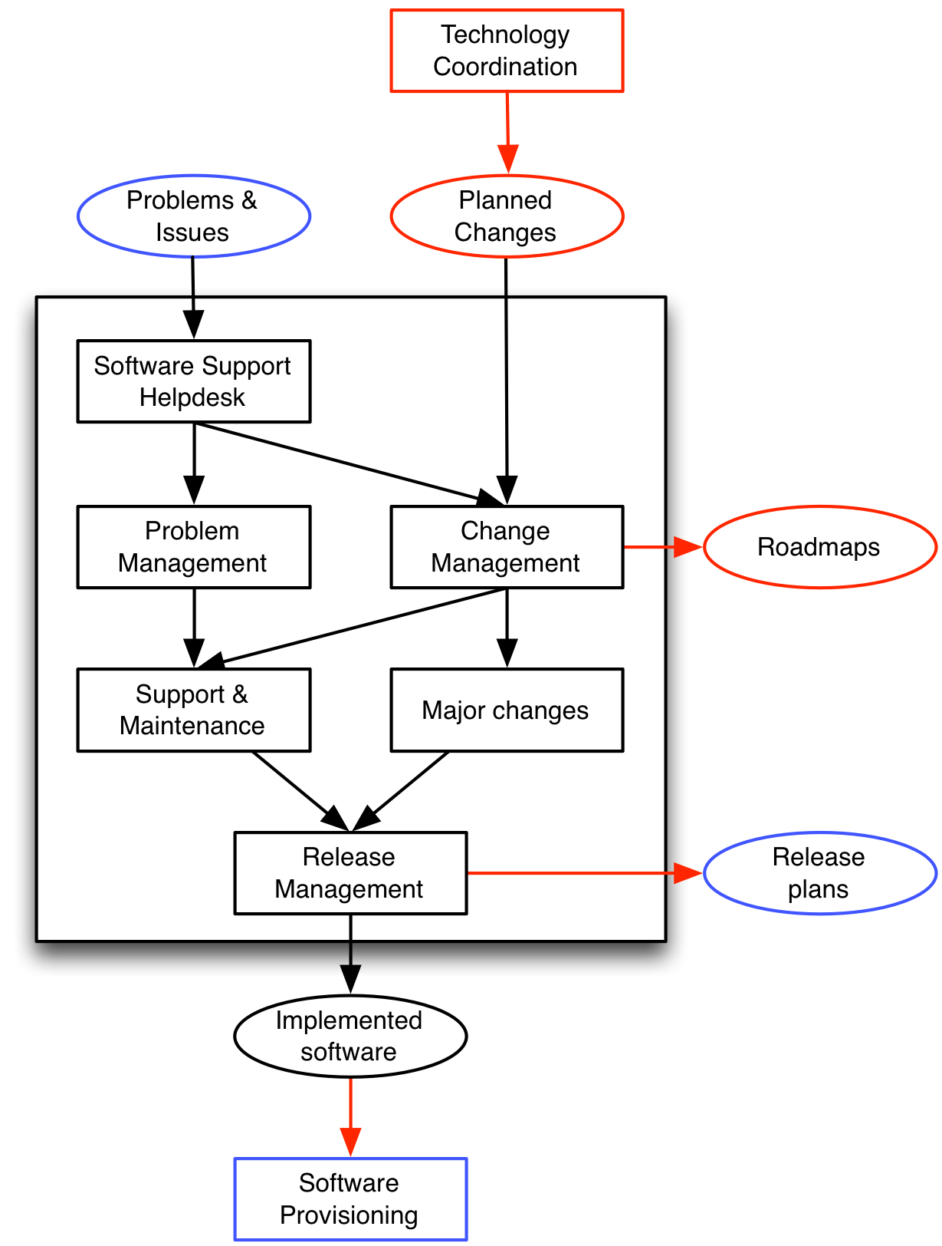
Figure 1: Overview of the Software Maintenance and Support service in EGI

Figure 1 illustrates the activities around the software that Technology Providers may contribute; in principle this process is assumed to be the same for any Technology Provider. The level of commitment of each Technology Provider makes the difference in how this process/service will play out. Nonetheless, to be able to provide a versatile production infrastructure, this process should be principally applied whether the target is a whole Community Platform, or a commonly shared library.

So, EGI needs to know from each Technology Provider the following:
- What is the product you are maintaining?
What is the value proposal of this component, what are the benefits for others to make use of it?
- On which commitment level would your Product Team be willing to collaborate with EGI?
Does your team prefer to work very independently or are you interested in intensive collaboration and coordination? On which terms, and which type of services from EGI would you need or being intererested in?
- Which service levels are you willing to commit to on for which service targets?
Looking at the indicated software maintenance services, a number of service targets (e.g. service request response time, solution time, etc.) come to mind, and different service levels agreements for the same targets can make the difference between similar or comparable components.

These three aspects may be interrelated at times depending on the individual Technology Provider. For example, EGI expects a number of Technology Providers to combine a high level of independence in terms of collaboration commitment with low or non-existent service levels. At the same time however, it is not unthinkable that some Product Teams may choose independence in collaboration, but commit to high service levels nonetheless.

What EGI can offer to Technology Providers
There are a number of services that EGI can offer that are needed by Technology Providers. Some of these are directly related to service levels and the necessary infrastructure to provide these.
Other services are sought by Technology Providers in which EGI has matching or exceeding expertise or capabilities to satisfy Technology Provider needs.
The following provides an initial list of EGI services for Technology Providers:

- Technical release coordination: The UMD Release Team is currently being established to coordinate the release of a number of individual software components with the UMD as a target, i.e. the release of implemented software is taken through the Software Provisioning Process and eventually published in the UMD.
This activity is provided in close coordination with the Technology Coordination Board (see below).
- Strategic technical coordination: Coordinated by the Technology Coordination Board, strategic decisions are being made that affect the EGI Operational Infrastructure. Driven by requirements and scenarios coming from the research communities through the UCB and the operations network (through the OMB), participating Technology Providers get access to information about future needs of the stakeholders of their software in EGI, and thus the chance of proactively aligning their own strategic goals based on that information.
- Precinded placement in the EGI Software Repository Portal: Software components for which EGI has backing from committed Technology Providers may be presented in an eye-catching manner. Graded by overall commitment level the presentation will attract attention to the component in question over other elements without Technology Provider commitment.
- Access to partnering programmes: Committed and proven Technology Providers may get access to EGI partnering programmes. This may be as little as “EGI partner” branding or much more.
- Priority access to booth space: A number of priority options are possible for EGI’s technology partners. For example, partners may get priority access to renting booths at EGI-organised conventions. Alternatively, priority access to more popular booths over less popular booths may be granted.
- Priority in allocating sessions and workshops: In support to EGI’s partners, priority in providing session slots graded by commitment may be granted to EGI’s partners.
- Inclusion in project proposals: To support innovation and evolution of the production infrastructure, EGI will initiate and contribute to project proposals for EC framework programmes and other funding schemes. EGI partners, where applicable, may be included in consortium discussions and project proposals.

Conclusion

References
R 1
R 2
R 3
R 4
R 5

EGI Platform Architecture: Recap
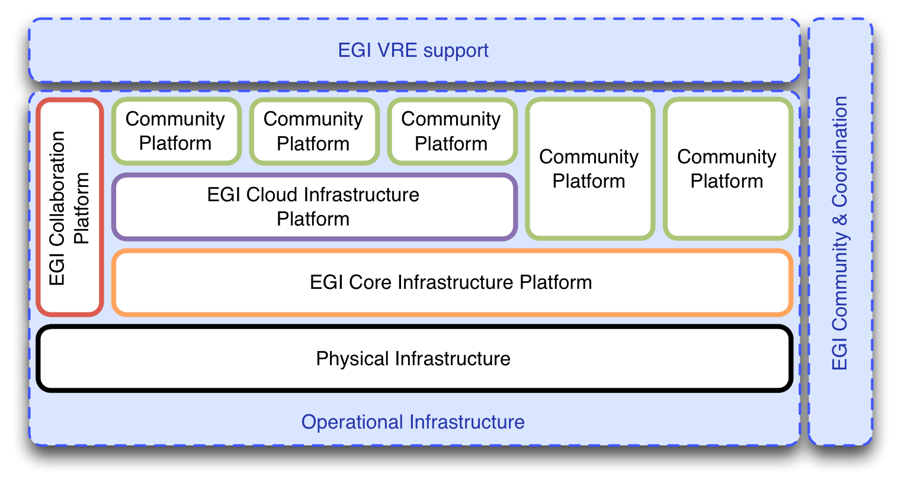
EGI is moving towards a platform-oriented model with clear roles and responsibilities for the involved stakeholders. Much of this is described in great detail in MS514, but for purpose of this document, it is recaptured in a much more compressed form as a starting point for subsequent sections.
Figure 2: The EGI Platform Architecture embedded in the EGI Strategy
The EGI Strategy encompasses three pillars:
- Operational Infrastructure
- Community & Coordination
- Virtual Research Environments

The Operational Infrastructures comprises of a number of technology platforms. Some of them EGI owns, some are owned by the respective Research Community that uses them.
EGI’s members, the Resource Centres and NGIs, own the physical infrastructure; on top of these, the following EGI-owned platforms are deployed:
- EGI Core Infrastructure Platform
- EGI Cloud Infrastructure Platform
- EGI Collaboration Platform

On top of these, any number of Community Platforms may be deployed. Community Platforms that are deployed on top of the Core Infrastructure Platform are in reality actually deployed directly on physical resources, while being integrated with the EGI Core Infrastructure Platform. Community Platforms that integrate with EGI’s Cloud Infrastructure comprise of any number of Virtual Machine Images.

EGI Core Infrastructure Platform
The EGI Core Infrastructure Platform consists of a number of subsystems that are necessary to operate federated, distributed Community Platforms. Note that this definition does not include any software that implements business logic directed at any particular user or research community. It includes software that is often part of the management infrastructure in data centres.

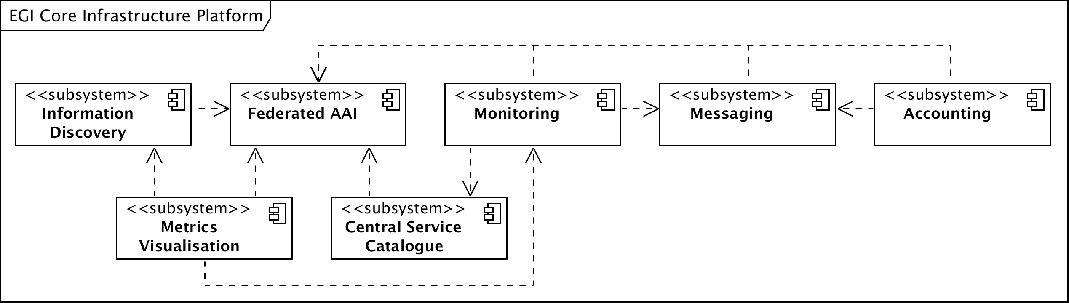
Figure 3: The subsystems of the EGI Core Infrastructure

As illustrated in Figure 3 the EGI Core Infrastructure Platform provides services that are required to provide a federation layer atop a set of resources exposed through a Community Platform.
The implied definition of a resources in this architecture on this level is very close to the actual physical infrastructure: Servers, blades, clusters (including batch systems), SANs, networks up to and including layer 4 are considered resources while RDBMS, Web Servers, and other similar solutions are not considered resources on this level.
Note that the EGI Core Infrastructure is not federating the resources themselves, but the Community Platforms that expose these resources.
Since the Community Platforms – at least the current ones – are difficult to contain and use resources that are generally shared in a collaborative mode, a number of support activities are part of the Core Infrastructure Platform that are not shown here. For example, operational security is a pervasive activity that monitors the patchlevel of specific components of Community Platforms in order to eliminate software vulnerabilities in EGI’s production infrastructure and prevend security incidents.

EGI Cloud Infrastructure Platform
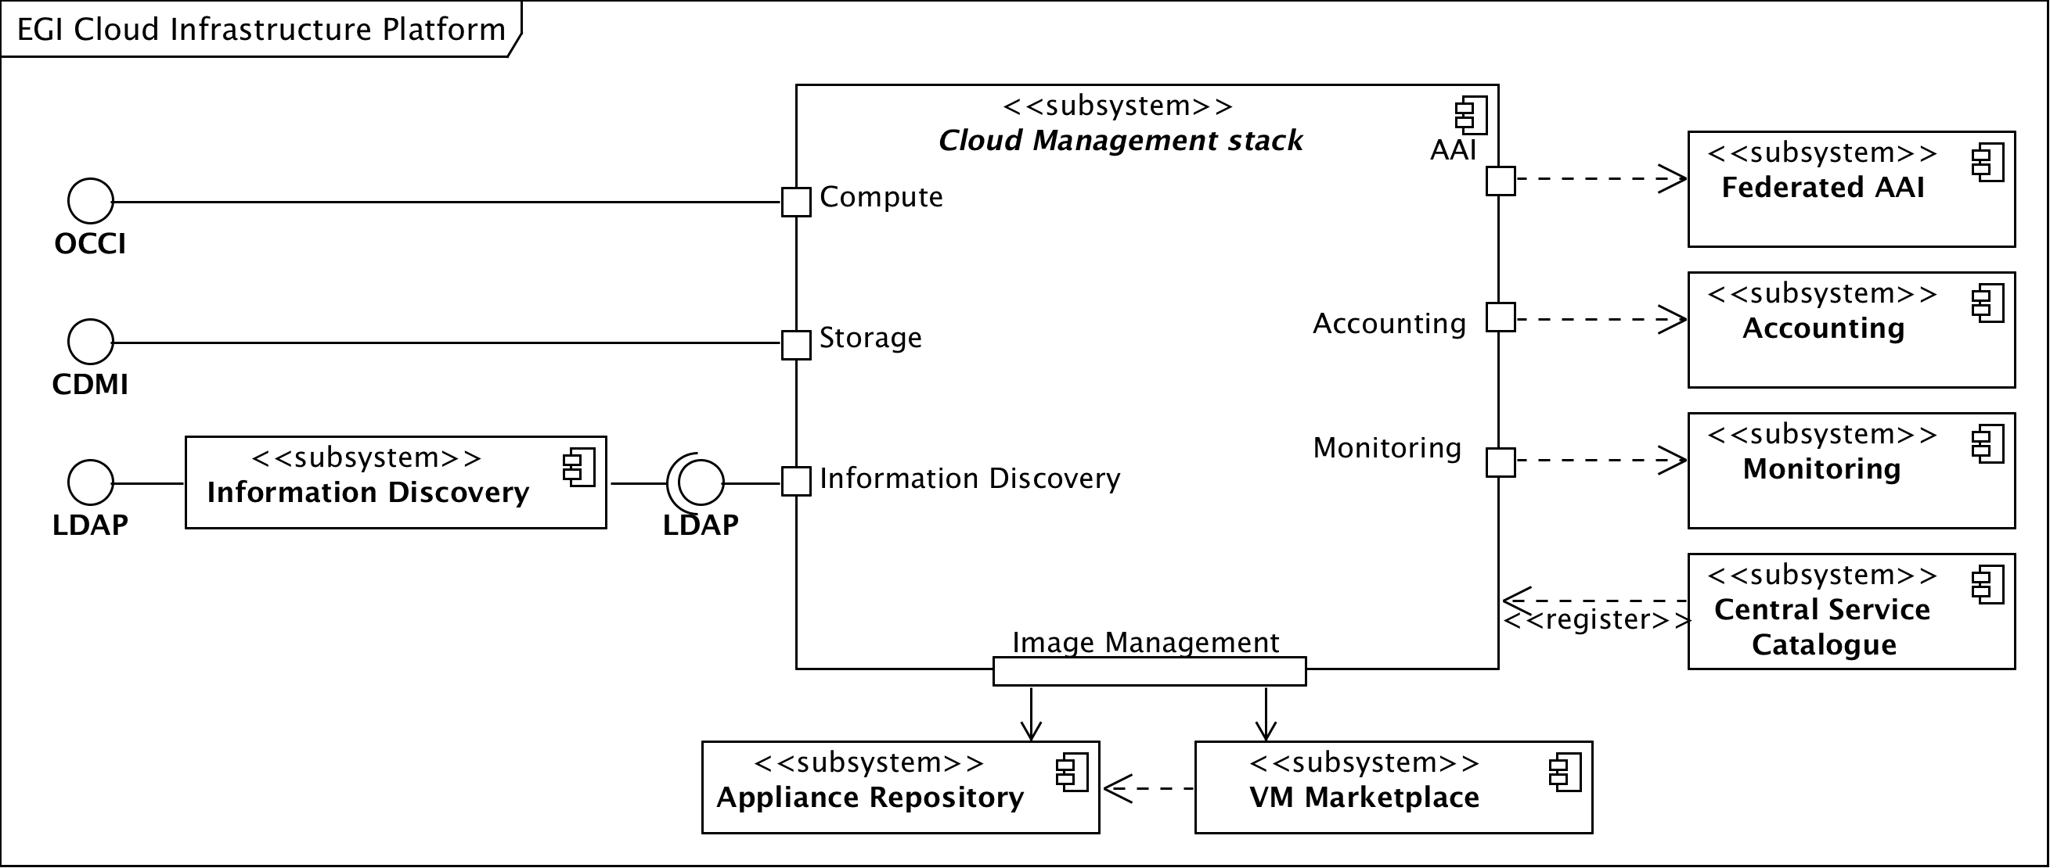
The EGI Cloud Infrastructure Platform aims to provide a federation of institutional private IaaS Clouds. The architectural model uses Virtual Machine Images (VMIs) as the abstraction and integration layer: The EGI Federated Clouds Platform provides consistent management interfaces for Cloud Computing and Cloud Storage services; additional management interfaces for other Cloud services may be added when required and sufficiently abstracted and standardised.
Figure 4: The EGI Cloud Infrastructure Platform
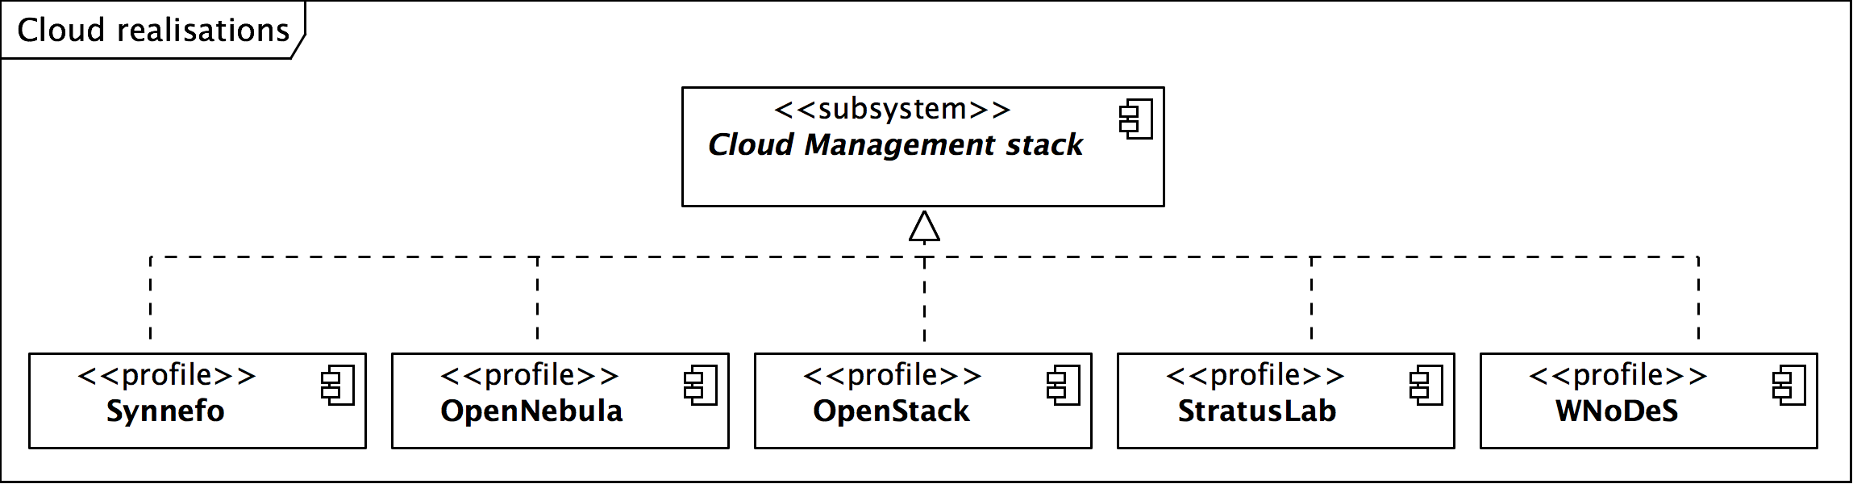
Central to the architecture of the Cloud Infrastructure Platform is the model of an abstract Cloud management stack: Participating Resource Providers are free to choose the Cloud management stack they wish to deploy, for as long as they ensure that they expose service management endpoints that comply with the federation requirements and are interoperable to all other federated Cloud resources. The members of the EGI Federated Clouds task are providing each other the necessary integration tools.
Figure 5: Existing realisations of the abstract Cloud management stack in EGI

The currently participating 14 Resource Centres in EGI are using a number of different Cloud management stacks as illustrated in Figure 5. The EGI Cloud Infrastructure Platform is integrating with the EGI Core Infrastructure Platform as illustrated in Figure 4, more specifically with the Federated AAI, Monitoring, Accounting and Information Discovery subsystems.
This architecture results in “pockets of support” around the various Cloud management frameworks that are organised in a community effort and a lean federation layer with a thin veneer of policy around it.

EGI Collaboration Platform
The EGI Collaboration Platform is currently in flux in terms of its content. It is defined as a set of services that allow Research Communities to collaborate within and across community boundaries. It includes collaboration tools and services for both social and technical collaboration, such as Wikis, DocDB, Indico, Requirements/Issue tracker, GlobusOnline and many more.
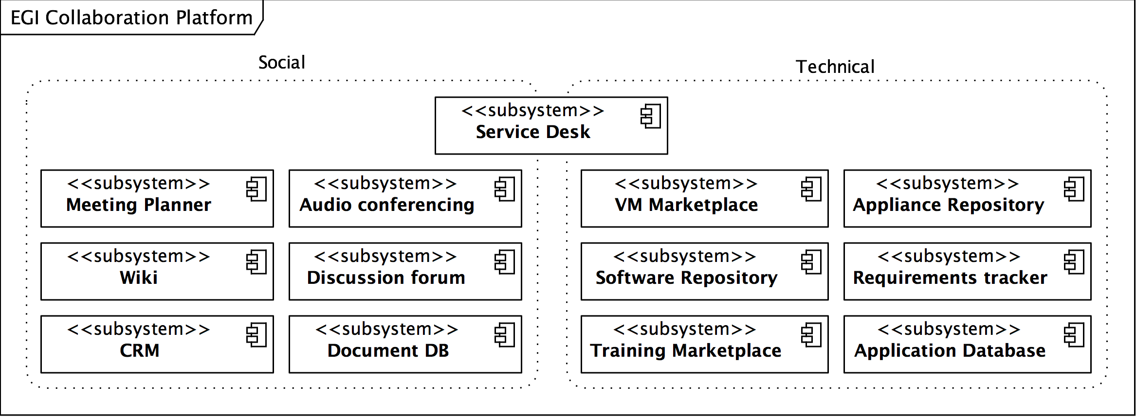
Figure 6: The Collaboration Plaform provides a wide variety of services

Note that this definition also includes prominent services of EGI, such as the Application Database, EGI Software Repository, the service desk (based on GGUS), and others.

Community Platforms
Community Platforms in EGI are a pivotal element in the EGI technical architecture since it is the components and services that are included in these that provide the targeted researchers with suitable and domain-specific access to the resources exposed through the EGI Platforms.
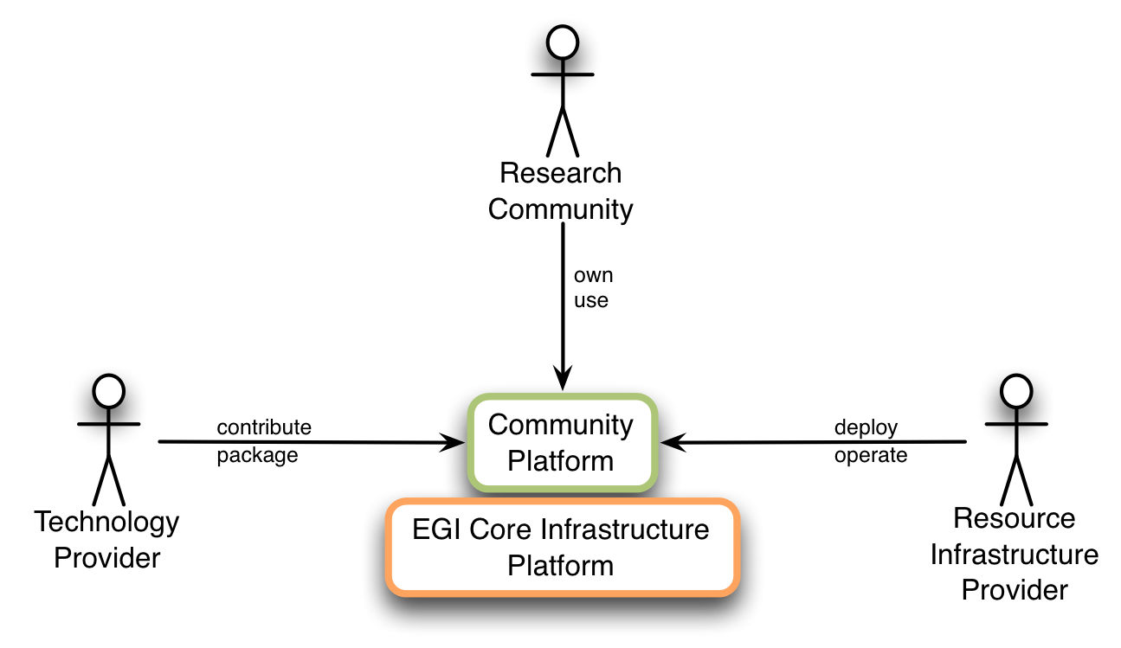
Fundamental to Community Platforms are the involved stakeholder and actors as illustrated below.
Figure 7: Stakeholders of classic Community Platforms

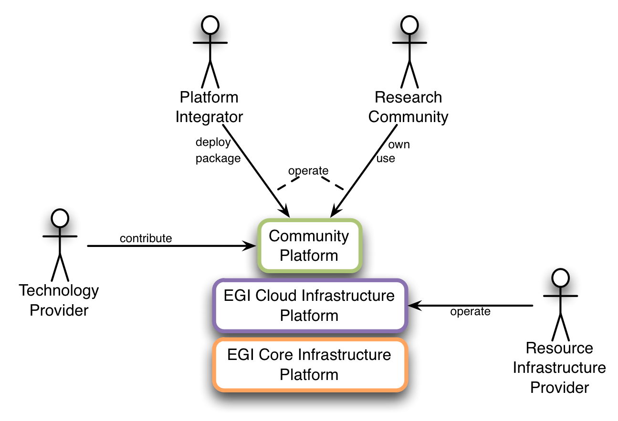
Figure 8: Stakeholders of Cloud-based Community Platforms

The components of the EGI Core Infrastructure Platform provide services and capabilities around AuthN & AuthZ, Monitoring of se

are owned by EGI, some are owned and m
Technology Providers with which EGI wishes to enter a contractual, committed relationship need to know the context within which the services are expected. This document focuses on relationships with Technology Providers who provide Community Platforms directly deployed on top of the EGI Core Infrastructure Platform. (See figure below)

A Community Platform is defined as a complete set of software services, libraries, configuration files, etc. that are necessary to deploy this platform out of a single source, for example a repository. This document presumes that Community Platforms
This is meant from an architectural point of view. In reality, the deployment will happen on the physical infrastructure.

a deployment model for such Community Platforms that require

