EGI-InSPIRE

Collaborative Software Provisioning in EGI

Document identifier: | input.doc
Date: | 10/06/2013
Activity: | NA2
Lead Partner: | EGI.eu
Document Status: | DRAFT
Dissemination Level: | PUBLIC
Document Link: | https://documents.egi.eu/document/1778

Abstract
This document provides a description of the business and service model that EGI is developing and planning to implement in order to formalise EGI's technology support for research communities in the EGI ecosystem.

- Copyright notice
Copyright © Members of the EGI-InSPIRE Collaboration, 2010. See www.egi.eu for details of the EGI-InSPIRE project and the collaboration. EGI-InSPIRE (“European Grid Initiative: Integrated Sustainable Pan-European Infrastructure for Researchers in Europe”) is a project co-funded by the European Commission as an Integrated Infrastructure Initiative within the 7th Framework Programme. EGI-InSPIRE began in May 2010 and will run for 4 years. This work is licensed under the Creative Commons Attribution-Noncommercial 3.0 License. To view a copy of this license, visit http://creativecommons.org/licenses/by-nc/3.0/ or send a letter to Creative Commons, 171 Second Street, Suite 300, San Francisco, California, 94105, and USA. The work must be attributed by attaching the following reference to the copied elements: “Copyright © Members of the EGI-InSPIRE Collaboration, 2010. See www.egi.eu for details of the EGI-InSPIRE project and the collaboration”. Using this document in a way and/or for purposes not foreseen in the license, requires the prior written permission of the copyright holders. The information contained in this document represents the views of the copyright holders as of the date such views are published.
- Delivery Slip
 | Name | Partner/Activity | Date
From | <<The lead author/editor>>
Reviewed by | Moderator:  Reviewers:  <<To be completed by project office on submission to AMB/PMB>>
Approved by | AMB & PMB  <<To be completed by project office on submission to EC>>
- Document Log
Issue | Date | Comment | Author/Partner
1 |  | First draft
2
3
- Application area
This document is a formal deliverable for the European Commission, applicable to all members of the EGI-InSPIRE project, beneficiaries and Joint Research Unit members, as well as its collaborating projects.
- Document amendment procedure
Amendments, comments and suggestions should be sent to the authors. The procedures documented in the EGI-InSPIRE “Document Management Procedure” will be followed:
https://wiki.egi.eu/wiki/Procedures
- Terminology
A complete project glossary is provided at the following page: http://www.egi.eu/about/glossary/.
<<The authors should check if the acronyms are covered by the glossary page and if the definition is still correct; all the amendments should be communicated to glossary@egi.eu>>
- PROJECT SUMMARY
To support science and innovation, a lasting operational model for e-Science is needed − both for coordinating the infrastructure and for delivering integrated services that cross national borders.
The EGI-InSPIRE project will support the transition from a project-based system to a sustainable pan-European e-Infrastructure, by supporting ‘grids’ of high-performance computing (HPC) and high-throughput computing (HTC) resources. EGI-InSPIRE will also be ideally placed to integrate new Distributed Computing Infrastructures (DCIs) such as clouds, supercomputing networks and desktop grids, to benefit user communities within the European Research Area.
EGI-InSPIRE will collect user requirements and provide support for the current and potential new user communities, for example within the ESFRI projects. Additional support will also be given to the current heavy users of the infrastructure, such as high energy physics, computational chemistry and life sciences, as they move their critical services and tools from a centralised support model to one driven by their own individual communities.
The objectives of the project are:
- The continued operation and expansion of today’s production infrastructure by transitioning to a governance model and operational infrastructure that can be increasingly sustained outside of specific project funding.
- The continued support of researchers within Europe and their international collaborators that are using the current production infrastructure.
- The support for current heavy users of the infrastructure in earth science, astronomy and astrophysics, fusion, computational chemistry and materials science technology, life sciences and high energy physics as they move to sustainable support models for their own communities.
- Interfaces that expand access to new user communities including new potential heavy users of the infrastructure from the ESFRI projects.
- Mechanisms to integrate existing infrastructure providers in Europe and around the world into the production infrastructure, so as to provide transparent access to all authorised users.
- Establish processes and procedures to allow the integration of new DCI technologies (e.g. clouds, volunteer desktop grids) and heterogeneous resources (e.g. HTC and HPC) into a seamless production infrastructure as they mature and demonstrate value to the EGI community.
The EGI community is a federation of independent national and community resource providers, whose resources support specific research communities and international collaborators both within Europe and worldwide. EGI.eu, coordinator of EGI-InSPIRE, brings together partner institutions established within the community to provide a set of essential human and technical services that enable secure integrated access to distributed resources on behalf of the community.
The production infrastructure supports Virtual Research Communities (VRCs) − structured international user communities − that are grouped into specific research domains. VRCs are formally represented within EGI at both a technical and strategic level.

- EXECUTIVE SUMMARY
<< The text should provide a summary of the full report so that the reader can ‘in a page’ understand the problem it has been written to cover. This includes an overview of the background material and motivation for the report, a summary of the analysis, and the report’s main conclusions.>>

TABLE OF CONTENTS
1 Introduction 7
2 A shared common goal 8
3 Working together on different levels 9
3.1 Technical/architectural aspect 9
3.2 Procedural/collaborative aspect 10
3.3 Formal/contractual aspect 11
4 What EGI needs from Product Teams 12
5 What EGI can offer to Product Teams 13
6 Conclusion 14
7 References 15
8 EGI Platform Architecture: Recap 16
8.1 EGI Core Infrastructure Platform 16
8.2 EGI Cloud Infrastructure Platform 17
8.3 EGI Collaboration Platform 18
8.4 Community Platforms 19

Introduction
This document illustrates the EGI Service model for Technology Providers to support the EGI ecosystem at large, and the research communities in particular.
TBC

A shared common goal
EGI is dependent on the software products coming from both large and small product teams and their associated communities around the world. This software is critical in supporting the production infrastructure and enabling access to the distributed computing and data resources needed for its research communities. Some of the open source software that EGI uses is generic in its nature (e.g. Operating System distribution) while some of it is specific to the use cases coming from EGI and its research communities. With the current end of centrally funded Technology Providers providing support and coordination to their affiliated product teams, the EGI community is moving to a model where individual product teams will need to establish direct technical and managerial relationships to develop and promote their activities.
There remains a shared common goal in the EGI ecosystem, for as far as the product teams and the Technology Provider they may be part of and EGI are concerned:
“The overarching shared goal of EGI and its affiliated Technology Providers is to work together to provide a common, versatile, scalable and flexible infrastructure at a European level for consumption and integration by research communities coming from the academic and publicly funded sector.”
So, while EGI is not currently in a position to provide direct financial support to the product teams that produce this software, it is able to offer some ‘in-kind’ benefits to the developers as part of a collaboration within the EGI ecosystem between three principal stakeholders:
- EGI as an infrastructure provider
- Research Communities as infrastructure consumer
- Product Teams as suppliers of software, solutions and services.
As a whole, the EGI ecosystem is user driven or user orientated, meaning that one principal rule of conduct in EGI is to attract research communities to use EGI and to deliver a production infrastructure that satisfies their needs.
The main architectural building block in the EGI Platform architecture that satisfies this shared goal in a user-driven ecosystem is the concept of Community Platforms. The collaboration that EGI provides with individual product teams is built around the delivery of high-quality software that can be integrated into Community Platforms that are tuned to the specific needs of the targeted research community.

Working together on different levels
In an ecosystem as rich as EGI’s it is necessary to balance each stakeholder’s needs and capabilities in order to provide a maximum benefit to the users in the ecosystem.
For EGI, this means that a number of Technology providers are needed that provide software ranging from low-level components to high-level services, or complete platforms. The union of all provided technology combined will provide the operational infrastructure in EGI. The EGI Operational Infrastructure comprises of the EGI Production Infrastructure, and a number of Community Platforms that are deployed on top of it. The EGI Production Infrastructure is a composition of three software platforms, the EGI Core Infrastructure Platform, the EGI Cloud Infrastructure Platform, and the EGI Collaboration Platform; all three are owned and operated by EGI. The Community Platforms however are owned by the Research Communities that use them.
Software is needed for all platforms, whether as part of EGI’s production infrastructure, or as part of Community Platforms. Also, a significant part of the software portfolio in the EGI ecosystem originates from Open Source projects or are in preparation for further being conducted as Open Source Projects.
Still, running a software maintenance project as an Open Source project does not mean that proponents of the project will not be able per se to provide more collaboration and service commitment beyond best effort. To manage this complexity, EGI.eu proposes to classify the collaboration with Technology Providers on three different aspects:
- Technical / Architectural
- Procedural / Collaborative
- Formal / Contractual

The following sections will dive into more details of these aspects; while these are defined in this document, they are meant to provide a discussion basis for the future, and as such will remain in flux for some time. Clearly, not all combinations of the cooperation aspects are meaningful. Also, the current definitions are not entirely free of interdependencies (which is mostly linked to meaningful distinctions between cooperation levels): For example, one element of added value of contributing Technology Providers is – from EGI’s point of view – a level of support for the contributed software that is more than just best effort without any guarantees.

Technical/architectural aspect
The software produced and maintained by Technology Providers comes in a wide spectrum of complexity, and covering different use cases and targets. Usually, different targets in the architecture are associated with different roles and responsibilities. For example, a team developing a crucial library that is re-used in a number of Community Platforms does not need to spend time worrying about delivering a certain service target for a service integrated into the EGI Operational Infrastructure (e.g. the Accounting database service). Likewise, a Platform Integrator most likely focuses on configuration and deployment aspects of software that is maintained and developed by a different Technology Provider.

To better indicate the type of contributions a Technology Provider is offering, EGI proposes to use the following terminology:

Technology Provider
Product Team | Provides a software component that requires bundling/integration with other components to provide purpose and functionality. This includes re-usable libraries, (command-line) tools, plug-ins, etc. – any software that cannot be invoked or configured as a software service, or provided in a Software as a Service model.
Platform Integrator | Assembles software that is partially developed and/or maintained by others into a self-sufficient well-behaving collection of software services. Includes producing integration code to achieve this goal. Frequently uses software in a specific configuration that is different from a configuration of the same software in a different context (i.e. Community Platform).
Software Service Provider | Provides software services as part of a specific platform, for example the EGI Core Infrastructure Platform. Software Service Providers are themselves responsible for the maintenance of the used software – the difference to Resource Providers is that the latter employ a certain set of software solely to expose physical resources for shared access and use, not the functionality of the software itself.

Procedural/collaborative aspect
This aspect of the collaboration between Technology Providers and EGI captures the level of cooperative coordination, or relative independence of decision-making: Ranging from high independence to close cooperation and coordinated decision making, this activity includes a good amount of knowledge sharing and process integration between Technology Providers and EGI:

Collaboration
Community | Community collaboration maintains a strict focus on the direct research community for which the pertinent software items are developed and maintained for. Coordination is very loose between the respective Technology Provider and EGI (and likely also other Technology Providers), and decisions taken on this basis bear chances of unforeseen disruptions when the software us re-used outside the direct focus of the Technology Provider.
Contributing | Contributing collaboration includes close communication between EGI and the Technology Provider with regular exchange of reliable roadmaps and release schedules. The atmosphere of the collaboration is generally constructive and implies accepting certain mutual influence on decisions for the benefit of the shared goal. This includes the Technology Provider’s willingness and commitment to constructively participate in discussions either remote of face-to-face, and in meetings in general.
Integrated | Integrated Technology Providers maintain the closest collaborative relationship with EGI. The software produced by such a Technology Provider will adhere to EGI’s quality criteria, and will undergo EGI’s Software Provisioning process. Fully integrating with EGI also implies the Technology Provider accepting that EGI may exert much larger influence on the technical and procedural cooperation.

Formal/contractual aspect
In some circumstances, both EGI and a Technology Provider may see benefit in formalising their relationship in contract-like agreements that incorporate mutual agreement on the quality of the service delivery. This frequently includes defining service levels for certain software maintenance services, such as 3rd level expert support, service desk support, etc.
The challenge in defining the details of this aspect lies in the fact that Technology Providers are likely to diverge in the extent of committed service, let alone agree to commit to the same level of support for individual targets.

Service commitment
Best effort | The Technology Provider cannot guarantee any minimum level of support, other than providing as much and as best as is possible in any given circumstance.
Basic | A minimum level of support is guaranteed for the most common service targets.
Extended | Technology Providers commit to significant and measurable support for the software and services they are responsible for.
Premium | Premium support indicates the highest level of support which may include specialised and personal assistance, customised service levels, etc.

What EGI needs from Product Teams
EGI needs a range of product teams within the EGI ecosystem ranging from low-level infrastructure components to high-level software environments to provide usable, reliable, stable and scalable software with defined maintenance and support services around the components they make available to the EGI community. These components may be software services, complete fully assembled virtual machine images ready for operation, or individual libraries that serve no purpose on their own but form a critical foundation for building other services. Those components that EGI uses within its production infrastructure will be expected to have a higher quality level and higher-level of support. Individual research communities can use their own quality criteria in assembling their Community Platforms for deployment within EGI’s production infrastructure.
Therefore, for the purpose of being able to inform the EGI ecosystem about the products coming from an individual product team, EGI.eu would like to collect and maintain the following data about your product team’s activities:
- What is the product you are maintaining?
What does the software do? What is the value proposition that it provides? What are the benefits for others to make use of it?
- What are your future plans for the product?
Tell us about your roadmap and future plans and release dates. This will help us and others know what you are doing and when to expect it.
- What support (and how) are you willing to provide to those that use your products?
Is there a helpdesk that people can use? Should users join a discussion email list to resolve support issues?
- Do you want to find out about new requirements from the EGI community?
EGI is always receiving input from its users? Do you want to be involved in requirement’s workshops and help us improve the service we offer to our users?
- Do you want to place your software (or links to it) as part of the EGI Software Repository?
The software repository provides a well-known location for the EGI community to contribute and consume software that can be linked to other EGI services such as the Applications Database, Training Marketplace and Virtual Machine Images.
- How would your product team be willing to collaborate with EGI.eu?
Does your team prefer to work very independently or are you interested in more intensive relationship with closer collaboration and coordination? Referring to section 4, would your team classify as, for example, an Integrated Product Team providing Extended support – or rather a Community Platform Integrator able to give best effort support?

On which terms, and which type of services from EGI would you need or being interested in?
- Would your team be interested in looking into formalising the support relationship with EGI?
If so, which would be the details and extent of the support? And what would your team expect in return?

NB: A product team’s commitment to collaborate with EGI and its service levels are separate issues. For example, EGI.eu expects some product teams to combine a high-level of independence in terms of collaboration commitment with low or non-existent service levels. At the same time however, it is not unthinkable that some product teams may choose independence in collaboration, but commit to high service levels nonetheless.

What EGI can offer to Product Teams
There are a number of services that EGI can offer that could be very useful to individual product teams as they lose some of the coordination activities they had access to when previously part of larger Technology Providers. Some of these are directly related to service levels and the necessary infrastructure to provide these.
The following provides an initial list of EGI services for individual product teams:

- Technical release coordination: The UMD Release Team is currently being established to coordinate the release of a number of individual software components with the UMD as a target, i.e. the release of implemented software is taken through the Software Provisioning Process and eventually published in the UMD.
This activity is provided in close coordination with the Technology Coordination Board (see below).
- Strategic technical coordination: Coordinated by the Technology Coordination Board, strategic decisions are being made that affect the EGI Operational Infrastructure. Driven by requirements and scenarios coming from the research communities through the UCB and the operations network (through the OMB), participating Technology Providers get access to information about future needs of the stakeholders of their software in EGI, and thus the chance of proactively aligning their own strategic goals based on that information.
- Priority placement in the EGI Software Repository Portal: Software components for which EGI has backing from committed product teams will be presented more visibly. Graded by overall commitment level the presentation will attract attention to the component in question over other elements without Technology Provider commitment.
- Access to partnering programmes: Committed and proven product teams may get access to EGI partnering programmes. This may be as little as “EGI partner” branding or much more.
- Priority access to booth space: A number of priority options are possible for EGI’s technology partners. For example, partners may get priority access to renting booths at EGI-organised conventions. Alternatively, priority access to more popular booths over less popular booths may be granted.
- Priority in allocating sessions and workshops: In support to EGI’s partners, priority in providing session slots graded by commitment may be granted to EGI’s partners.
- Inclusion in project proposals: To support innovation and evolution of the production infrastructure, EGI will initiate and contribute to project proposals for EC framework programmes and other funding schemes. EGI partners, where applicable, may be included in consortium discussions and project proposals.

Conclusion
As the EGI Community moves from the monolithic integrated project model in EGEE, to the separate projects in EMI/IGE to now a more decoupled community driven collaboration, the role played by the infrastructure coordinator continues to change. Presented here is a model for establishing a bi-directional non-exclusive relationship between product teams, EGI and the research communities the both wish to support.

References
R 1
R 2
R 3
R 4
R 5

EGI Platform Architecture: Recap
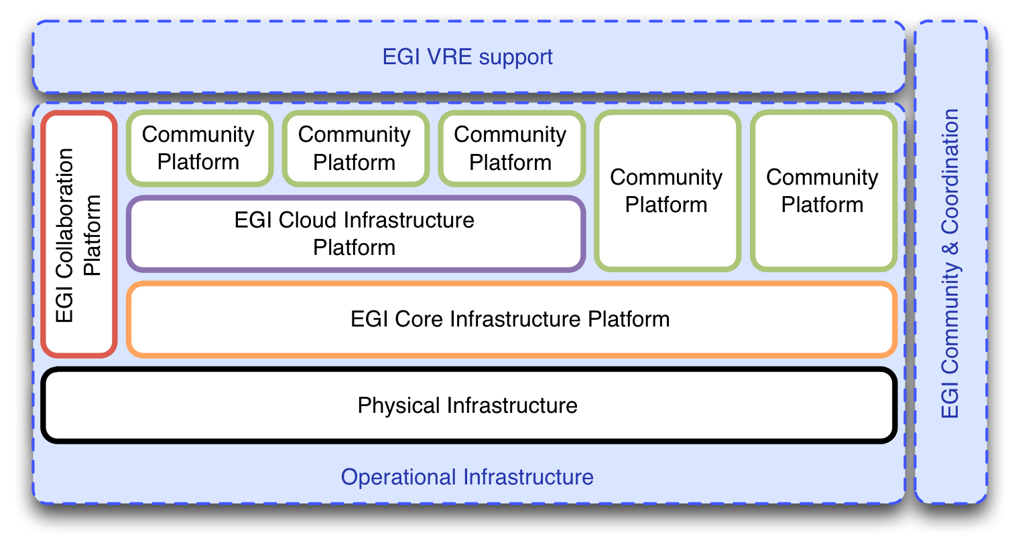
EGI is moving towards a platform-oriented model with clear roles and responsibilities for the involved stakeholders. Much of this is described in great detail in MS514, but for purpose of this document, it is recaptured in a much more compressed form as a starting point for subsequent sections.
Figure 1: The EGI Platform Architecture embedded in the EGI Strategy
The EGI Strategy encompasses three pillars:
- Operational Infrastructure
- Community & Coordination
- Virtual Research Environments

The Operational Infrastructures comprises of a number of technology platforms. Some of them EGI owns, some are owned by the respective Research Community that uses them.
EGI’s members, the Resource Centres and NGIs, own the physical infrastructure; on top of these, the following EGI-owned platforms are deployed:
- EGI Core Infrastructure Platform
- EGI Cloud Infrastructure Platform
- EGI Collaboration Platform

On top of these, any number of Community Platforms may be deployed. Community Platforms that are deployed on top of the Core Infrastructure Platform are in reality actually deployed directly on physical resources, while being integrated with the EGI Core Infrastructure Platform. Community Platforms that integrate with EGI’s Cloud Infrastructure comprise of any number of Virtual Machine Images.

EGI Core Infrastructure Platform
The EGI Core Infrastructure Platform consists of a number of subsystems that are necessary to operate federated, distributed Community Platforms. Note that this definition does not include any software that implements business logic directed at any particular user or research community. It includes software that is often part of the management infrastructure in data centres.

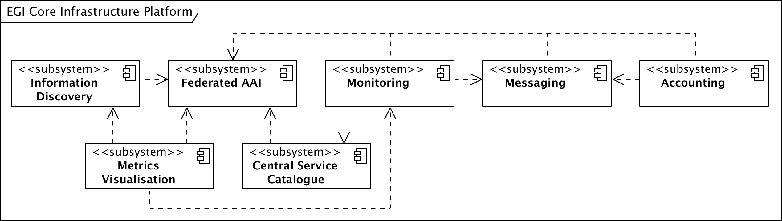
Figure 2: The subsystems of the EGI Core Infrastructure

As illustrated in Figure 2 the EGI Core Infrastructure Platform provides services that are required to provide a federation layer atop a set of resources exposed through a Community Platform.
The implied definition of a resources in this architecture on this level is very close to the actual physical infrastructure: Servers, blades, clusters (including batch systems), SANs, networks up to and including layer 4 are considered resources while RDBMS, Web Servers, and other similar solutions are not considered resources on this level.
Note that the EGI Core Infrastructure is not federating the resources themselves, but the Community Platforms that expose these resources.
Since the Community Platforms – at least the current ones – are difficult to contain and use resources that are generally shared in a collaborative mode, a number of support activities are part of the Core Infrastructure Platform that are not shown here. For example, operational security is a pervasive activity that monitors the patchlevel of specific components of Community Platforms in order to eliminate software vulnerabilities in EGI’s production infrastructure and prevend security incidents.

EGI Cloud Infrastructure Platform
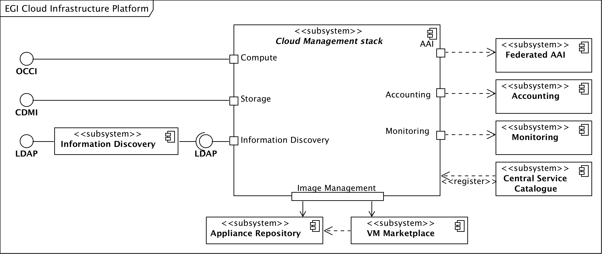
The EGI Cloud Infrastructure Platform aims to provide a federation of institutional private IaaS Clouds. The architectural model uses Virtual Machine Images (VMIs) as the abstraction and integration layer: The EGI Federated Clouds Platform provides consistent management interfaces for Cloud Computing and Cloud Storage services; additional management interfaces for other Cloud services may be added when required and sufficiently abstracted and standardised.
Figure 3: The EGI Cloud Infrastructure Platform
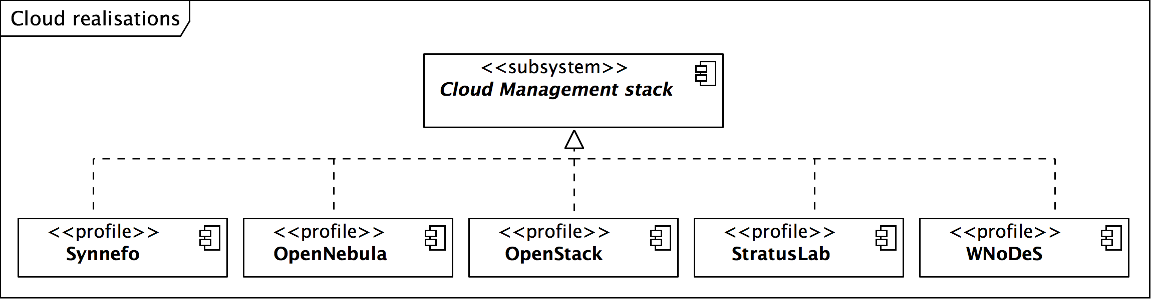
Central to the architecture of the Cloud Infrastructure Platform is the model of an abstract Cloud management stack: Participating Resource Providers are free to choose the Cloud management stack they wish to deploy, for as long as they ensure that they expose service management endpoints that comply with the federation requirements and are interoperable to all other federated Cloud resources. The members of the EGI Federated Clouds task are providing each other the necessary integration tools.
Figure 4: Existing realisations of the abstract Cloud management stack in EGI

The currently participating 14 Resource Centres in EGI are using a number of different Cloud management stacks as illustrated in Figure 4. The EGI Cloud Infrastructure Platform is integrating with the EGI Core Infrastructure Platform as illustrated in Figure 3, more specifically with the Federated AAI, Monitoring, Accounting and Information Discovery subsystems.
This architecture results in “pockets of support” around the various Cloud management frameworks that are organised in a community effort and a lean federation layer with a thin veneer of policy around it.

EGI Collaboration Platform
The EGI Collaboration Platform is currently in flux in terms of its content. It is defined as a set of services that allow Research Communities to collaborate within and across community boundaries. It includes collaboration tools and services for both social and technical collaboration, such as Wikis, DocDB, Indico, Requirements/Issue tracker, GlobusOnline and many more.
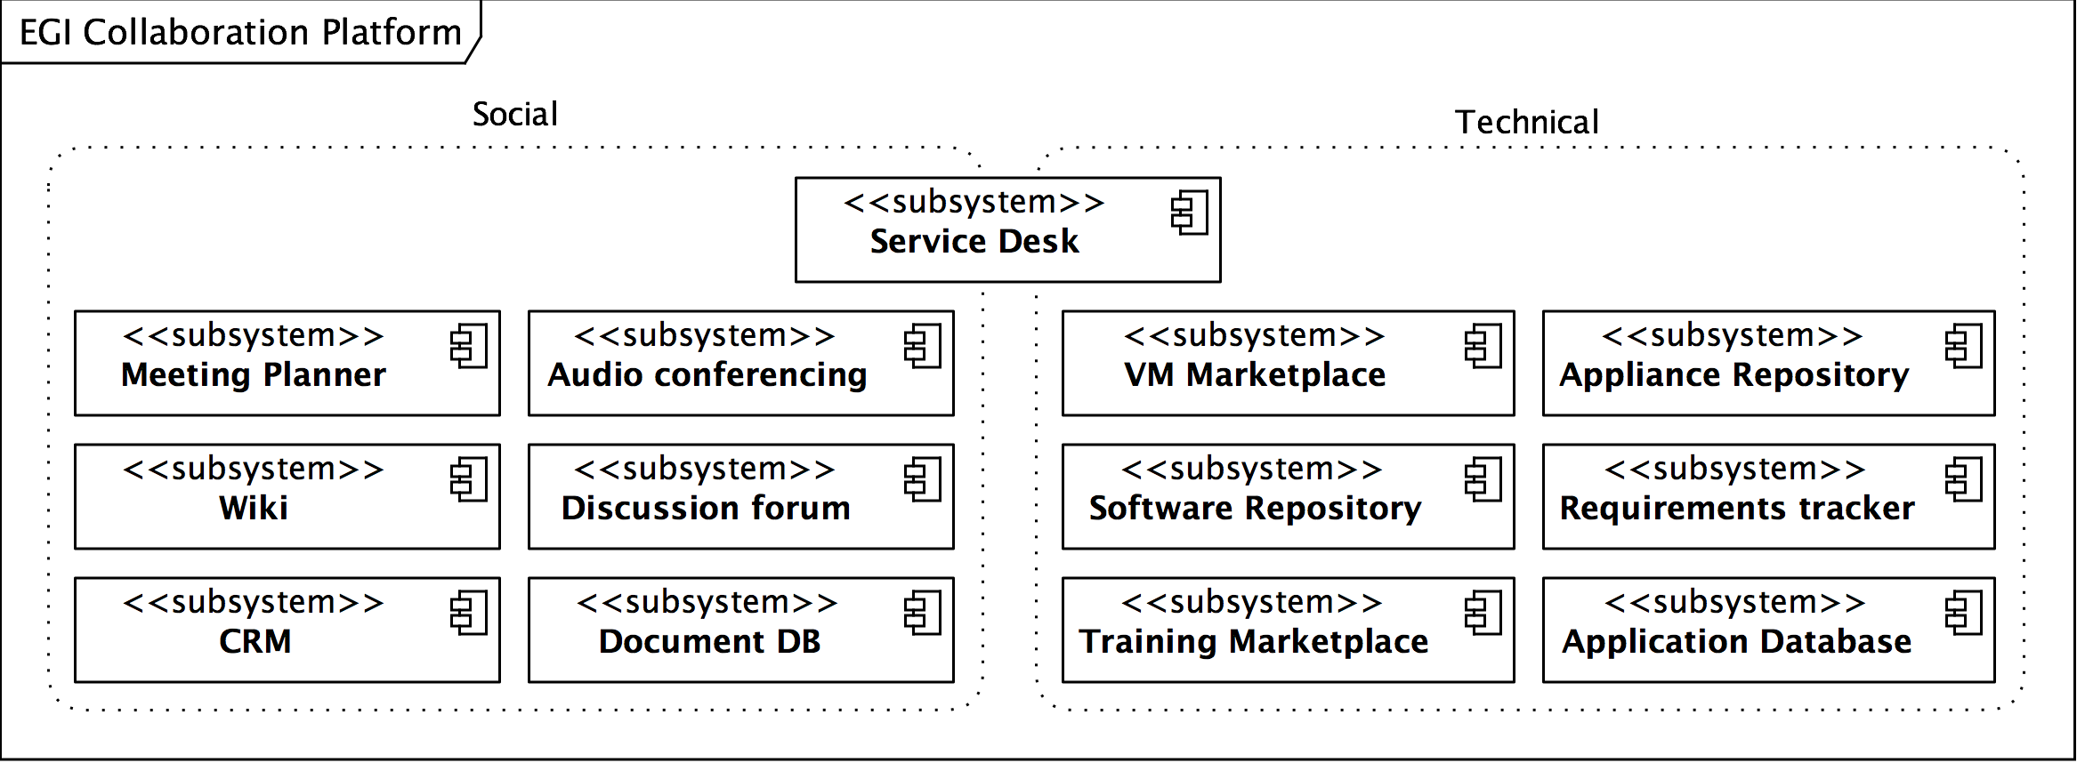
Figure 5: The Collaboration Plaform provides a wide variety of services

Note that this definition also includes prominent services of EGI, such as the Application Database, EGI Software Repository, the service desk (based on GGUS), and others.

Community Platforms
Community Platforms in EGI are a pivotal element in the EGI technical architecture since it is the components and services that are included in these that provide the targeted researchers with suitable and domain-specific access to the resources exposed through the EGI Platforms.
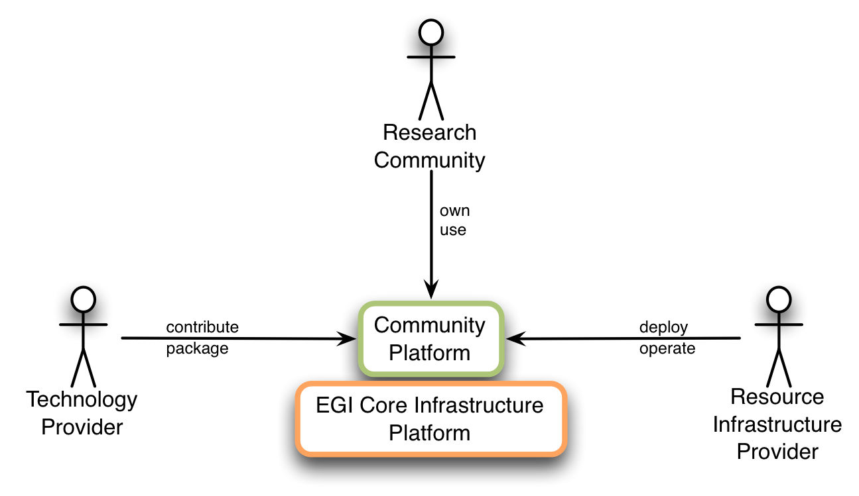
Fundamental to Community Platforms are the involved stakeholder and actors as illustrated below.
Figure 6: Stakeholders of classic Community Platforms

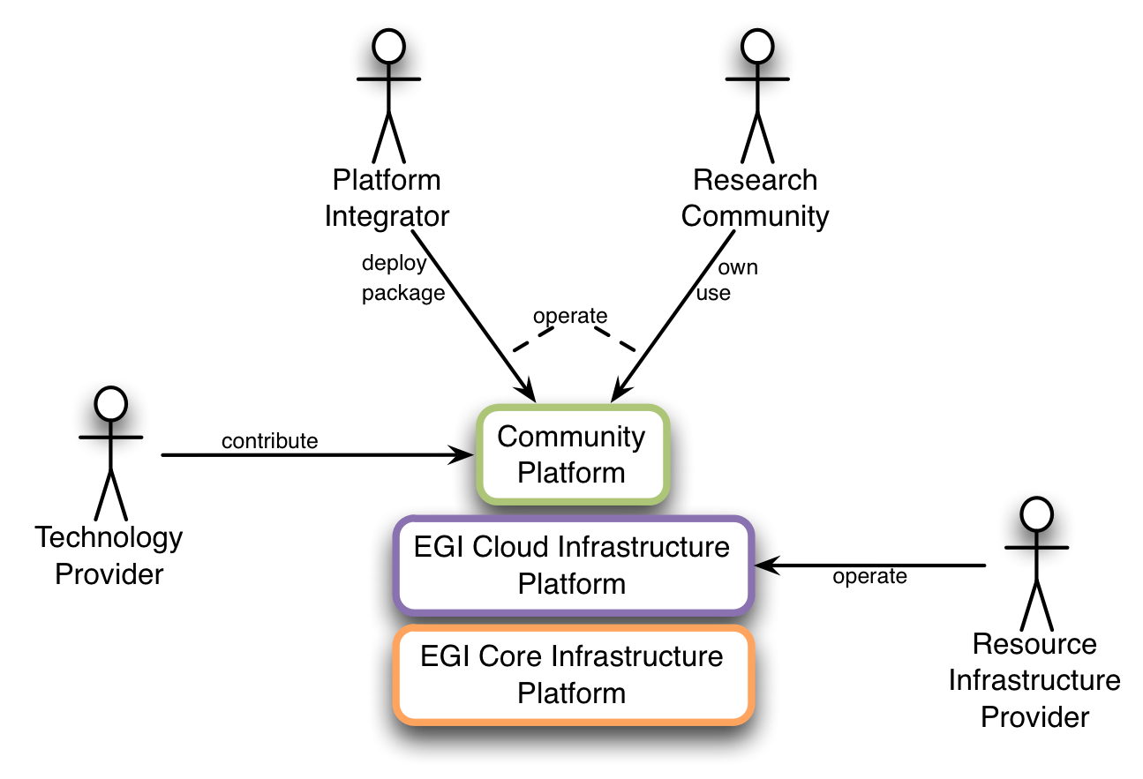
Figure 7: Stakeholders of Cloud-based Community Platforms

The components of the EGI Core Infrastructure Platform provide services and capabilities around AuthN & AuthZ, Monitoring of se

are owned by EGI, some are owned and m
Technology Providers with which EGI wishes to enter a contractual, committed relationship need to know the context within which the services are expected. This document focuses on relationships with Technology Providers who provide Community Platforms directly deployed on top of the EGI Core Infrastructure Platform. (See figure below)

A Community Platform is defined as a complete set of software services, libraries, configuration files, etc. that are necessary to deploy this platform out of a single source, for example a repository. This document presumes that Community Platforms
This is meant from an architectural point of view. In reality, the deployment will happen on the physical infrastructure.

a deployment model for such Community Platforms that require

Ownership in this context means primarily the authority over the requirements and usage of the respective Community Platform, for as long as financial compensation is not involved. Concrete manifestation of ownership in financial terms may emerge in the future, when Research Communities are fully prepared for such relationships.

