Staged Rollout Report
The Early Adopter team should fill the “grey” areas
NGI | NGI_IBERGRID
Site Name | IFIC-LCG2
EA team names | Álvaro Fernández, Pablo Briongos
EA team contacts | Alvaro.Fernandez@ific.uv.es, Pablo.Briongos@ific.uv.es
Product | EMI3 LB | Version | 4.0.11-sl6.x86_64 | RT ticket ID | 5799
The “outcome” is one of: OK, WARN, FAIL, NA (Not Aplicable), Nver (Not verified/Not tested).
Copy/paste any results from your commands where you see fit.
Metric | <OK|WARN|FAIL  |NA|NVer> | WEB URLs, Command used, other comments  (please always fill this table with as much information as possible, and as you see fit)
Release notes and other  documentation | OK | http://www.eu-emi.eu/releases/emi-3-monte-bianco/updates/-/asset_publisher/5Na8/content/update-6-08-07-2013-v-3-4-0-1#LB_v_4_0_11
Installation or upgrading (specify which) | OK | Upgrade from a previous EMI-3 LB 4.0.9 was successful in a clean Scientific Linux 6.4 (carbon) node, collocated with EMI-3 WMS 3.5.1 SL6 release
(RE-)configuration (if using yaim, specify command used) | OK | /opt/glite/yaim/bin/yaim -c -s site-info-stagerollout-ific.def -n LB -n WMS
Functionality (including start stop of deamons, and which) | OK | /etc/init.d/gLite start | stop | restart | status | version  No errors reported
SAM/Nagios/Gstat or any other monitoring framework  (specify the name of the machine) | OK | cg08.ific.uv.es tested by Nagios. Current Ibergrid Nagios ( rnagios.ibergrid.cesga.es) includes 1 probe for certificate lifetime.  [root@cg08~]# /usr/libexec/grid-monitoring/probes/emi.lb/LB-probe cg08.ific.uv.es  OK|time=2s
Interaction integration with other components (specify which) | OK | It works correctly with the collocated EMI-3 WMS 3.5.1 release.
Behaviour in production environment (after a few days). Specify VO’s using the service when applicable | WARN | *There's a known issue with Gridsite 2.1.0, that is part of this LB release and affects to WMS+LB nodes:  https://github.com/CESNET/gridsite/issues/5  https://ggus.eu/ws/ticket_info.php?ticket=95882  To avoid it, you have to downgrade gridsite to 2.0.4 version. Gridsite team is working on a new bug-free release.  *The product works as expected and the functionality is correct.  *1 week chart WMS+LB:  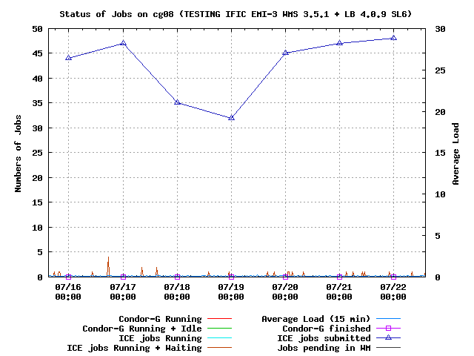
GGUS tickets opened: please insert the URLs of the tickets
Log files: usefulness, clarity, etc., any other comments on where/how to improve them. | OK
Error messages: please specify or comment any issues with error messages, if they are not correct, not clear, useful, etc. . | NA

