Quality Criteria Verification
Executive Summary
For QCV, Stage Rollout, DMSU and EGI internal

Name of the component | EMIR – server: emi-emir & client: emir-serp
Release | EMI 3.0.0-2 |  | RT Ticket
Software Provider
Release Contact | Name: |  | E-Mail
Validator | Name: Peter Tylka |  | E-Mail tylka@fzu.cz
V. Hours Worked | 1
Component status | OK | Date |  | 31.7.2013
Verification start date | 31.7.2013 | Verification end date |  | 31.7.2013

Summary:
I did:
upgrade repository EMI2 to EMI3
yum update
service emi-emir restart
service emir-serp restart

Update was flawless.
Both components works, but in emi-emir I see new warning, so I created ggus ticket 96269.

GGUS Tickets:
https://ggus.eu/ws/ticket_info.php?ticket=96269

Summary of Quality Criteria verification:
 | Generic Quality Criteria Total (Critical/Non critical)
 | Passed | Not passed | Not Applicable | Total
TP
VLD | 10 |  |  | 10
 | Specific Quality Criteria
TP |  |  |  | 0
VLD | 0 |  |  | 0

Quality Criteria verification cheatsheet:
<Insert filled excel cheatsheet>

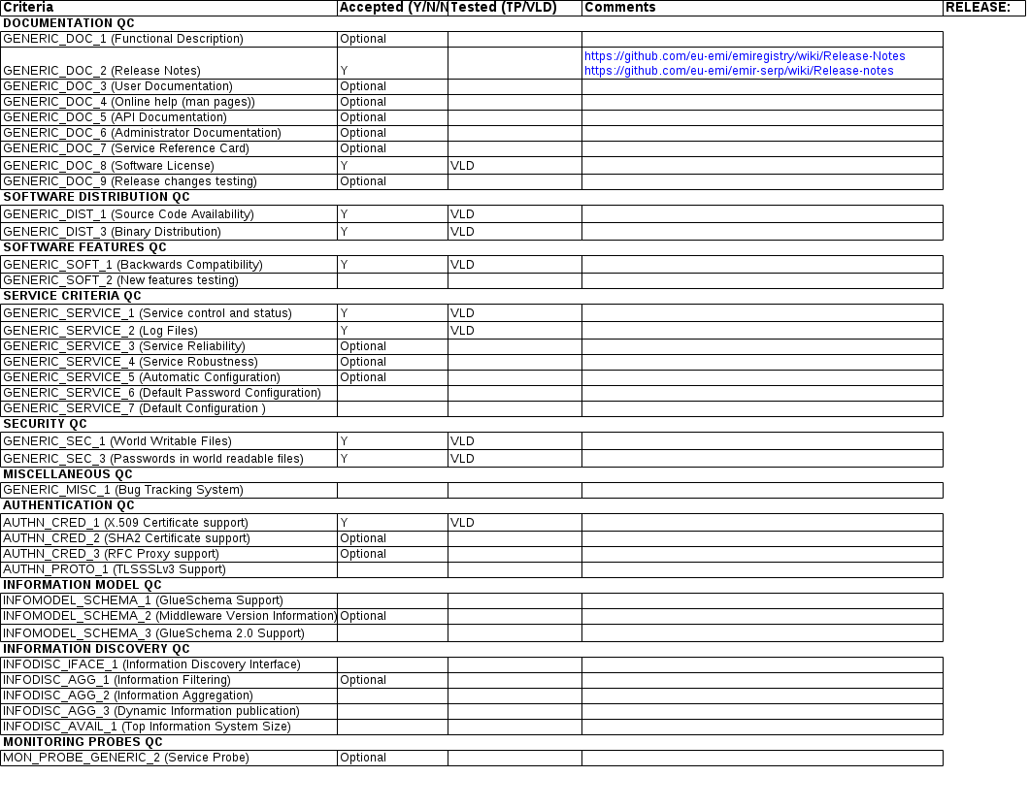

Validator comments:

Not applicable Quality Criteria

Specific Functional Tests to be repeated in SR:

Test number | Description | Motivation

Specific Non-functional tests (Scalability, etc…) to be repeated in SR:

Test number | Description | Motivation

Comments for UMD QC definition (TSA2.2):
- Review criteria xxxx
- Add criteria xxxx

Comments for SR (TSA1.3):

Comments for DMSU (TSA2.5):

Comments for TP:

