Quality Criteria Verification
Executive Summary
For QCV, Stage Rollout, DMSU and EGI internal

Name of the component | emi.bdii-site.sl6.x86_64-1.2.0
Release | UMD 3.0 |  | RT Ticket |  | 5868
Software Provider
Release Contact | Name: Cristina Aiftimei |  | E-Mail: cristina.aiftimiei@pd.infn.it
Validator | Name:Joao Pina |  | E-Mail: jpina@lip.pt
V. Hours Worked
Component status | ACCEPTED | Date |  | 07/08/2013
Verification start date | 07/08/2013 | Verification end date |  | 07/08/2013

Summary:
The emi-bdii-site was update from a previous UMD-3 machine. Configuration used also without any problem found.

Repositories used:

# EGI Software Repository - REPO META (releaseId,repositoryId,repofileId) - (5868,1197,1124)

[EMI.bdii-core.sl6.x86_64]
name=EMI.bdii-core.sl6.x86_64
baseurl=http://admin-repo.egi.eu/sw/unverified/umd-3.emi.bdii-core.sl6.x86_64/1/5/2/
enabled=1
protect=1
priority=1
gpgcheck=1
gpgkey=http://emisoft.web.cern.ch/emisoft/dist/EMI/3/RPM-GPG-KEY-emi

# EGI Software Repository - REPO META (releaseId,repositoryId,repofileId) - (5864,1193,1120)

[EMI.bdii-site.sl6.x86_64]
name=EMI.bdii-site.sl6.x86_64
baseurl=http://admin-repo.egi.eu/sw/unverified/umd-3.emi.bdii-site.sl6.x86_64/1/2/1/
enabled=1
protect=1
priority=1
gpgcheck=1
gpgkey=http://emisoft.web.cern.ch/emisoft/dist/EMI/3/RPM-GPG-KEY-emi

Installation:

[root@sbdii02 yum.localrepos.d]# yum update
Loaded plugins: fastestmirror, priorities, protectbase, security
Loading mirror speeds from cached hostfile
* base: ftp.dei.uc.pt
* epel: ftp.cica.es
* extras: ftp.dei.uc.pt
* updates: ftp.dei.uc.pt
EMI.bdii-core.sl6.x86_64 | 1.9 kB 00:00
EMI.bdii-core.sl6.x86_64/primary_db | 5.3 kB 00:00
2 packages excluded due to repository priority protections
76 packages excluded due to repository protections
Setting up Update Process
Resolving Dependencies
--> Running transaction check
---> Package bdii.noarch 0:5.2.20-1.el6 will be updated
---> Package bdii.noarch 0:5.2.21-1.el6 will be an update
---> Package glite-info-provider-ldap.noarch 0:1.4.4-1.el6 will be updated
---> Package glite-info-provider-ldap.noarch 0:1.4.5-1.el6 will be an update
---> Package glite-info-provider-service.noarch 0:1.12.0-1.el6 will be updated
---> Package glite-info-provider-service.noarch 0:1.13.1-1.el6 will be an update
---> Package glite-yaim-bdii.noarch 0:4.3.13-1.el6 will be updated
---> Package glite-yaim-bdii.noarch 0:4.3.14-1.el6 will be an update
--> Finished Dependency Resolution

Dependencies Resolved

========================================================================================================================================================
Package Arch Version Repository Size
========================================================================================================================================================
Updating:
bdii noarch 5.2.21-1.el6 EMI.bdii-core.sl6.x86_64 25 k
glite-info-provider-ldap noarch 1.4.5-1.el6 EMI.bdii-site.sl6.x86_64 9.0 k
glite-info-provider-service noarch 1.13.1-1.el6 EMI.bdii-core.sl6.x86_64 63 k
glite-yaim-bdii noarch 4.3.14-1.el6 EMI.bdii-core.sl6.x86_64 11 k

Transaction Summary
========================================================================================================================================================
Upgrade 4 Package(s)

Total download size: 108 k
Is this ok [y/N]:
Downloading Packages:
(1/4): bdii-5.2.21-1.el6.noarch.rpm | 25 kB 00:00
(2/4): glite-info-provider-ldap-1.4.5-1.el6.noarch.rpm | 9.0 kB 00:00
(3/4): glite-info-provider-service-1.13.1-1.el6.noarch.rpm | 63 kB 00:00
(4/4): glite-yaim-bdii-4.3.14-1.el6.noarch.rpm | 11 kB 00:00
--------------------------------------------------------------------------------------------------------------------------------------------------------
Total 85 kB/s | 108 kB 00:01
Running rpm_check_debug
Running Transaction Test
Transaction Test Succeeded
Running Transaction
Updating : bdii-5.2.21-1.el6.noarch 1/8
Updating : glite-yaim-bdii-4.3.14-1.el6.noarch 2/8
Updating : glite-info-provider-ldap-1.4.5-1.el6.noarch 3/8
Updating : glite-info-provider-service-1.13.1-1.el6.noarch 4/8
Cleanup : bdii-5.2.20-1.el6.noarch 5/8
Cleanup : glite-yaim-bdii-4.3.13-1.el6.noarch 6/8
Cleanup : glite-info-provider-ldap-1.4.4-1.el6.noarch 7/8
Cleanup : glite-info-provider-service-1.12.0-1.el6.noarch 8/8
Verifying : glite-info-provider-service-1.13.1-1.el6.noarch 1/8
Verifying : glite-info-provider-ldap-1.4.5-1.el6.noarch 2/8
Verifying : glite-yaim-bdii-4.3.14-1.el6.noarch 3/8
Verifying : bdii-5.2.21-1.el6.noarch 4/8
Verifying : glite-info-provider-ldap-1.4.4-1.el6.noarch 5/8
Verifying : bdii-5.2.20-1.el6.noarch 6/8
Verifying : glite-yaim-bdii-4.3.13-1.el6.noarch 7/8
Verifying : glite-info-provider-service-1.12.0-1.el6.noarch 8/8

Updated:
bdii.noarch 0:5.2.21-1.el6 glite-info-provider-ldap.noarch 0:1.4.5-1.el6 glite-info-provider-service.noarch 0:1.13.1-1.el6
glite-yaim-bdii.noarch 0:4.3.14-1.el6

Complete!

[root@sbdii02 yum.localrepos.d]# /etc/init.d/bdii restart
Stopping BDII update process: [ OK ]
Stopping BDII slapd: [ OK ]
Starting BDII slapd: [ OK ]
Starting BDII update process: [ OK ]
[root@sbdii02 yum.localrepos.d]#

GGUS Tickets:

Summary of Quality Criteria verification:
 | Generic Quality Criteria Total (Critical/Non critical)
 | Passed | Not passed | Not Applicable | Total
TP
VLD | 23 | 0 | 3 | 23
 | Specific Quality Criteria
TP
VLD

Quality Criteria verification cheatsheet:

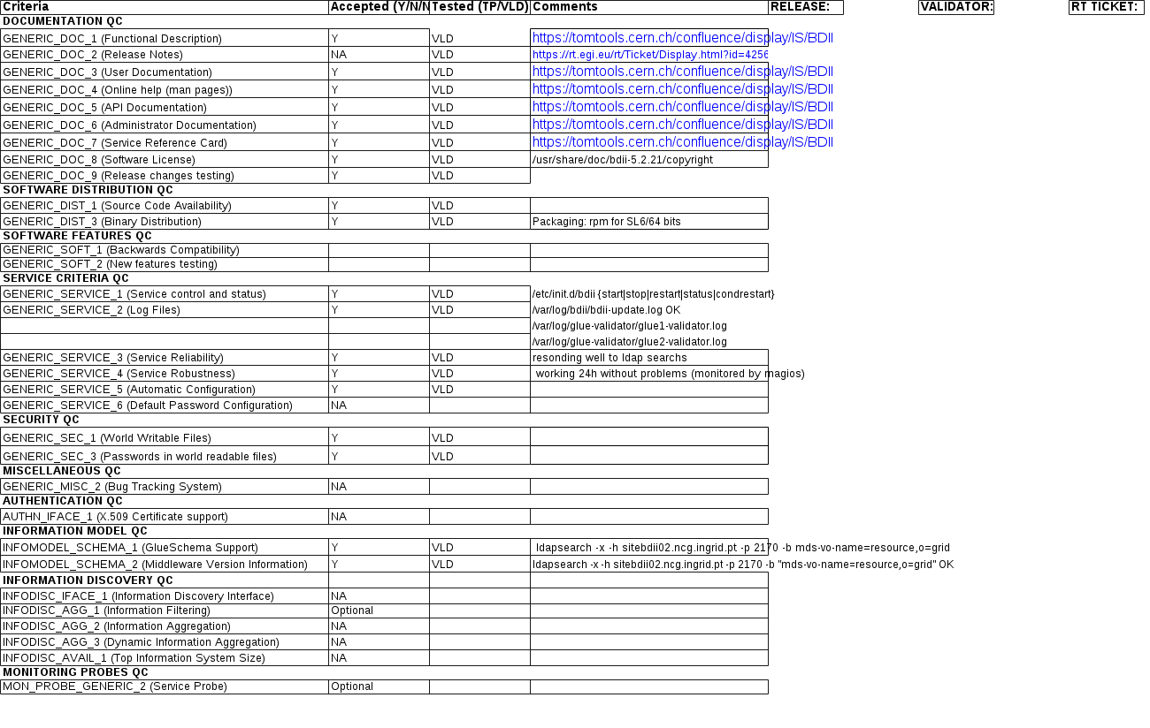

Validator comments:
No issues found during installation nor configuration

Not applicable Quality Criteria

Specific Functional Tests to be repeated in SR:

Test number | Description | Motivation

Specific Non-functional tests (Scalability, etc…) to be repeated in SR:

Test number | Description | Motivation

Comments for UMD QC definition (TSA2.2):
- Review criteria xxxx
- Add criteria xxxx

Comments for SR (TSA1.3):

Comments for DMSU (TSA2.5):

Comments for TP:

