EGI-InSPIRE

Integrating Resources into the EGI Production Infrastructure

MS427

 | Document identifier: | input.doc
 | Date: | 26/08/2013
 | Activity: | SA1
 | Lead Partner: | EGI.eu
 | Document Status: | FINAL
 | Dissemination Level: | PUBLIC
 | Document Link: | https://documents.egi.eu/document/xxx
Abstract
This document describes and defines the operational interfaces that must be supported for resources to be integrated into EGI. This includes operational tools provided by the EGI-InSPIRE JRA1 activity and procedures and policies defined to ensure interoperability within EGI and in the interaction with other DCIs, the adoption of best practices and compliance with service level agreements.

- Copyright notice
Copyright © Members of the EGI-InSPIRE Collaboration, 2011-2014. See www.egi.eu for details of the EGI-InSPIRE project and the collaboration. EGI-InSPIRE (“European Grid Initiative: Integrated Sustainable Pan-European Infrastructure for Researchers in Europe”) is a project co-funded by the European Commission as an Integrated Infrastructure Initiative within the 7th Framework Programme. EGI-InSPIRE began in May 2010 and will run for 4 years. This work is licensed under the Creative Commons Attribution-Non-commercial 3.0 License. To view a copy of this license, visit http://creativecommons.org/licenses/by-nc/3.0/ or send a letter to Creative Commons, 171 Second Street, Suite 300, San Francisco, California, 94105, and USA. The work must be attributed by attaching the following reference to the copied elements: “Copyright © Members of the EGI-InSPIRE Collaboration, 2010. See www.egi.eu for details of the EGI-InSPIRE project and the collaboration”. Using this document in a way and/or for purposes not foreseen in the license, requires the prior written permission of the copyright holders. The information contained in this document represents the views of the copyright holders as of the date such views are published.
- Delivery Slip
 | Name | Partner/Activity | Date
From | Małgorzata Krakowian | EGI.eu/SA1
Reviewed by
Approved by
- Document Log
Issue | Date | Comment | Author/Partner
1 |  | Initial draft | Małgorzata Krakowian/EGI.eu
2
3
4
- Application area
This document is a formal deliverable for the European Commission, applicable to all members of the EGI-InSPIRE project, beneficiaries and Joint Research Unit members, as well as its collaborating projects.
- Document amendment procedure
Amendments, comments and suggestions should be sent to the authors. The procedures documented in the EGI-InSPIRE “Document Management Procedure” will be followed:
https://wiki.egi.eu/wiki/Procedures
- Terminology
Various term definitions are available in the EGI Glossary at: https://wiki.egi.eu/wiki/Glossary; acronyms are defined at http://www.egi.eu/about/glossary/.
- PROJECT SUMMARY
To support science and innovation, a lasting operational model for e-Science is needed − both for coordinating the infrastructure and for delivering integrated services that cross national borders.
The EGI-InSPIRE project will support the transition from a project-based system to a sustainable pan-European e-Infrastructure, by supporting ‘grids’ of high-performance computing (HPC) and high-throughput computing (HTC) resources. EGI-InSPIRE will also be ideally placed to integrate new Distributed Computing Infrastructures (DCIs) such as clouds, supercomputing networks and desktop grids, to benefit user communities within the European Research Area.
EGI-InSPIRE will collect user requirements and provide support for the current and potential new user communities, for example within the ESFRI projects. Additional support will also be given to the current heavy users of the infrastructure, such as high energy physics, computational chemistry and life sciences, as they move their critical services and tools from a centralised support model to one driven by their own individual communities.
The objectives of the project are:
- The continued operation and expansion of today’s production infrastructure by transitioning to a governance model and operational infrastructure that can be increasingly sustained outside of specific project funding.
- The continued support of researchers within Europe and their international collaborators that are using the current production infrastructure.
- The support for current heavy users of the infrastructure in earth science, astronomy and astrophysics, fusion, computational chemistry and materials science technology, life sciences and high energy physics as they move to sustainable support models for their own communities.
- Interfaces that expand access to new user communities including new potential heavy users of the infrastructure from the ESFRI projects.
- Mechanisms to integrate existing infrastructure providers in Europe and around the world into the production infrastructure, so as to provide transparent access to all authorised users.
- Establish processes and procedures to allow the integration of new DCI technologies (e.g. clouds, volunteer desktop grids) and heterogeneous resources (e.g. HTC and HPC) into a seamless production infrastructure as they mature and demonstrate value to the EGI community.
The EGI community is a federation of independent national and community resource providers, whose resources support specific research communities and international collaborators both within Europe and worldwide. EGI.eu, coordinator of EGI-InSPIRE, brings together partner institutions established within the community to provide a set of essential human and technical services that enable secure integrated access to distributed resources on behalf of the community.
The production infrastructure supports Virtual Research Communities (VRCs) − structured international user communities − that are grouped into specific research domains. VRCs are formally represented within EGI at both a technical and strategic level.

- EXECUTIVE SUMMARY
This document describes the operational interfaces that must be supported for resources to be integrated into the European Grid Infrastructure (EGI), and is an updated version of milestone MS421. The basic operational interfaces that must be supported for resource providers and their resources to be integrated into EGI consist of a management interface, a monitoring interface, an accounting interface, a support interface and a dashboard interface.
During the first year of the project activities focussed on the integration of four middleware stacks: ARC, gLite, Globus and UNICORE. The integration of ARC was completed during the first project year. Two task forces for integration of UNICORE and Globus continued to steer integration tasks of Globus and UNICORE middleware stacks during the second year.
In the second year a special focus was given to integration of Desktop Grids and MAPPER/QCG middleware stacks. Work on integrating Desktop Grids and QCG was defined by MoUs between EGI-InSPIRE, EDGI and MAPPER. As the MAPPER community uses resources both from EGI and PRACE infrastructures, a joint MAPPER/EGI/PRACE task force was constituted to foster progress of this integration activity. In addition a new EGI task force for was setup to track the integration of MAPPER resources into EGI operational tools. Discussions on how to integrate operational services deployed by EGI and EUDAT have started.
In the third year integration activites were concentrated mainly on e-Infrasttuctures integration (PRACE, EUDAT, XSEDE, OSG and EGI Cloud Infrastructure) and the final integration of middlewares (UNICORE, Globus, QCG, Desktop Grid) will mainly focus on the remainingintegration aspect - accounting.
The management system GOCDB is already extended with a number of service types needed for all middleware stacks. With GOCDB version 5 it will be possible to integrate other e-infrastructures.

The following middleware stacks: ARC, gLite, Globus, Desktop Grid, QCG and UNICORE are all integrated with the EGI monitoring system SAM. Except for Desktop Grids, all middlewares are fully operational. QCG and Desktop Grid tests are still not part of EGIs OPS Availability and Reliability Profile and is therefore not yet fully integrated operationally into EGI.

Middleware stacks ARC, gLite, QCG and UNICORE are now fully integrated into the current EGI accounting system. The APEL team is working on the definition and implementation of an accounting protocol based on a messaging system that can be adopted by other resource infrastructures. The integrated accounting of Globus resources needs work to summarise the accounting data that needs to be published. The Desktop Grids accounting implementation is still under development.
In order to implement the support interface, EGI provides a Helpdesk for ARC, gLite, UNICORE, QCG and Globus support. The Suport Unit for Desktop Grid has been requested and will be part of the next release of the GGUS system.
Middleware stacks ARC, gLite, Globus and UNICORE are fully integrated into dashboard system. Integration of tests for Desktop Grids and MAPPER/QCG middleware stacks will start in second half of 2013.

TABLE OF CONTENTS
1 Introduction 7
2 Operational Tools 8
2.1 Management Interface 8
2.1.1 Integration of new middleware and E-Infrastructure 9
2.2 Monitoring Interface 9
2.2.1 Integration of new middleware and E-Infrastructure 10
2.3 Accounting Interface 10
2.3.1 Integration with other infrastructures 11
2.4 Support Interface 12
2.4.1 Integration of new middleware and E-Infrastructure 13
2.5 Dashboard Interface 13
2.5.1 Integration of new middleware and E-Infrastructure 14
3 Middleware 16
3.1 UNICORE 16
3.1.1 Management 16
3.1.2 Monitoring 17
3.1.3 Accounting 18
3.1.4 Support 18
3.1.5 Dashboard 18
3.2 Globus 18
3.2.1 Management 19
3.2.2 Monitoring 19
3.2.3 Accounting 20
3.2.4 Support 20
3.2.5 Dashboard 20
3.3 Desktop Grids 20
3.3.1 Management 21
3.3.2 Monitoring 21
3.3.3 Accounting 21
3.3.4 Support 21
3.3.5 Dashboard 22
3.4 MAPPER/QCG 22
3.4.1 Management 22
3.4.2 Monitoring 22
3.4.3 Accounting 23
3.4.4 Support 23
3.4.5 Dashboard 23
4 E-Infrastructure Integration 24
4.1 PRACE 24
4.1.1 Management 24
4.1.2 Monitoring 24
4.1.3 Accounting 24
4.1.4 Support 24
4.2 OSG 24
4.2.1 Management 24
4.2.2 Monitoring 24
4.2.3 Accounting 24
4.2.4 Support 24
4.3 XSEDE 25
4.4 EUDAT 25
4.4.1 Management 25
4.4.2 Monitoring 25
4.4.3 Accounting 25
4.4.4 Support 25
4.5 EGI Cloud 25
4.5.1 Management 25
4.5.2 Monitoring 26
4.5.3 Accounting 26
4.5.4 Support 26
4.5.5 Dashboard 26
5 Future Plans 27
6 References 28

Introduction
In order to add new resources to the EGI production infrastructure, those new resources must support a basic set of operational interfaces. These interfaces are defined and described in terms of their basic functionality.

Different resources can use different middleware components. EGI-InSPIRE will support the Unified Middleware Distribution (UMD) for deployment on the production infrastructure, which integrates software from multiple technology providers.

Operational tools such as the GOCDB management system and the SAM monitoring system are key software components for the reliable and stable operation/monitoring of the infrastructure. Operational procedures and policies are needed to enforce the use of the agreed basic set of operational interfaces that should be supported by all resources. The EGI procedures and policies have been adapted as new requirements were identified from the integration work. These requirements have evolved into new procedures and policies that are relevant for the integration of new resources.
Section 2 describes the basic operational interfaces that must be supported for resource integration into EGI. The following section provides an overview of the status of those interfaces provided by each middleware stack. Section 4 provides an overview of the current status of integration activities for PRACE, OSG, EUDAT, XSEDE and EGI Cloud infrastructure. Finally, section 5 concludes by providing plans for the fourth year of the project.

Operational Tools
Availability and reliability measurement, registration of services, information indexing, monitoring, accounting, user and operational support in EGI currently rely on operational tools which are developed in EGI-InSPIRE JRA1 [JRA1].
The basic operational interfaces that must be supported for resources to be integrated into EGI consist of a management interface, a monitoring interface, an accounting interface, and a support interface. Additionally, the basic operational interfaces provide a graphical dashboard interface that collects and presents the information provided by the others and ties them together in a meaningful way to facilitate daily oversight grid monitoring duties.

Management Interface
Grid Configuration Database (GOCDB) [GOCDB] contains general information about the sites participating to the production Grid. GOCDB allows resource centres to store, maintain and view the topology of the production infrastructure and the basic information about the respective resources within it, such as:
- Participating Resource Providers (National Grid Initiatives, European Intergovernmental Research Organizations), the respective Operations Centres and the related information (countries, contact information etc.).
- Resource Centres contributing resources to the infrastructure including management, technical and security related contact points.
- Resources and services, including scheduled intervention plans and service status information (e.g. certification, production and monitoring status).
- Participating staff and their roles within EGI operations, where roles limit operations that particular group of people can perform.

Services registered in GOCDB are described with the following information:
- Service Type: a unique name that identifies the type of software component deployed on a Grid. The current list of service type definitions are given in [GOCDB_ST]
- Service Endpoint: is a deployed instance of a named service type
- Endpoint Location: a Service Endpoint may optionally define an Endpoint Location which locates the service (URL).

Besides providing a central management tool to view and define production state, downtimes and maintenance status and whether a resource needs monitoring, GOCDB in essence depicts what services are running where and who to contact for certain type of issues. The presented information can be a combined view of different regionalized or otherwise separated instances with their own local inputs.
A management interface provides information about a resource through the certification process. The history and details of the certification status transitions and other state transitions, such as site decertification and suspension are desirable additional information.
GOCDB is referent database for all other operational tools, providing all the relevant data about NGIs, resource centres, services and administrators responsible for resources and services.

Integration of new middleware and E-Infrastructure
Integration of new middleware stacks into GOCDB requires creation of a new service type. This step enables sites with new middleware to define their service endpoints. The appropriate procedure for adding new service type is defined here: [GOCDB_NEW_ST].
Requirements of new service types require documentation about the nature of the service requested. It is also allowed to register any service type besides baseline grid middleware services, e.g. belonging to the user application framework, or for local Resource Centre management. In this case these new services are registered as CUSTOM. The feature allows for including software whose scope may be limited to a specific organizational unit (e.g. NGI or VO), or software which has been customised so its not standards-compliant to any further extent.
The service type name reflects the usable scope of deployment.

Monitoring Interface
The Service Availability Monitoring (SAM) [SAM] system is used to monitor the resources within the production infrastructure. SAM monitoring data is used for calculation of availability and reliability of grid sites. It includes the following components:
- Test execution framework based on the open source monitoring framework Nagios and the Nagios Configuration Generator (NCG)
- Databases which contain topology (gathered from GOCDB and other sources), profiles (mapping between service types and tests), test results and availability and reliability of sites and services
- Message bus infrastructure used for communication between distributed SAM instances
- Visualization portal MyEGI/MyWLCG which enables users to access current status, history and availability of monitored sites and services
- Programmatic interface which enables other tools (e.g. Operations Portal, VO dashboards) to access test results and availability and reliability of sites and services
- Probes used to test monitored services which are provided by middleware developers and third parties (e.g. NGIs, Nagios community).

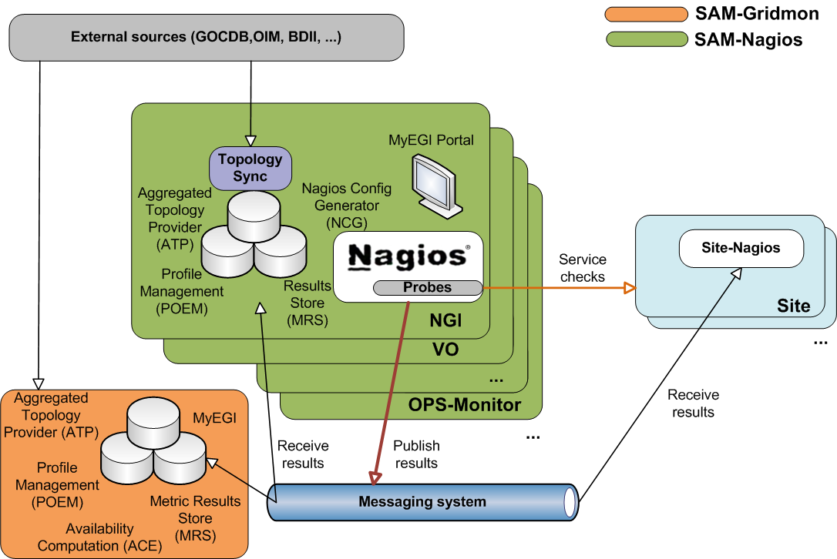
Figure 1 SAM architecture
SAM is deployed in a distributed manner (Figure 1). Each NGI deploys its own SAM instance which is responsible for monitoring sites and services of that NGI. A central instance deployed at CERN consumes results from all NGI instances, calculates availability and reliability and provides central visualization portal. This architecture enables NGIs to extend their SAM instances with custom service types and tests for services deployed only on their resources.

Integration of new middleware and E-Infrastructure
To integrate a new middleware stack with SAM, sensible tests for the service types defined in the management interface for this middleware have to be developed to cover the relevant functionality in the middleware stack. The probes are subsequently integrated into the SAM Release. Integration also requires from probe developer to provide naming and test configuration (e.g. probe parameters, execution frequency, timeout, etc.). The list of currently supported Nagios SAM probes can be found in [SAM_PROBES]. Additional information about Nagios probe development and integration can be found in [NAGIOS_PROBES].
For the integration of new middleware two EGI procedures are relevant:
- Adding new probes to SAM [EGI_ADD_SAM] – a procedure for adding new OPS Nagios probes to the SAM release.
- Management of the EGI OPS Availability and Reliability Profile [EGI_AR] – a procedure for changing list of tests used for generating Availability and Reliability monthly statistics.

Accounting Interface
The EGI Accounting Infrastructure collects CPU accounting records from sites and/or grid infrastructures and summarizes the data by site, date (especially by month), VO, and user. This summary data can be displayed in a central Accounting Portal [EGI_ACCNT] by dynamic queries on the parameters above at any level of the hierarchical tree structure representing EGI and its partner
grids. The core EGI Accounting Infrastructure is based on APEL [APEL]. Other accounting systems have to publish the data in the central repository via the APEL interface.
The bulk of existing Resource Centres collect data from their batch systems (e.g. LSF, Torque, SGE), which are joined with information about the job's user grid credentials and published to the central APEL repository. Other partner grids (e.g. Open Science Grid, IGI and NDGF), and a few additional Resource Centres with their own accounting services, currently publish summaries of data in the form described above directly into the APEL central repository. While participant Resource Infrastructures publish all of their VOs data, partner grids can publish information for a subset of VOs (e.g. OSG) according to the VO requirements.

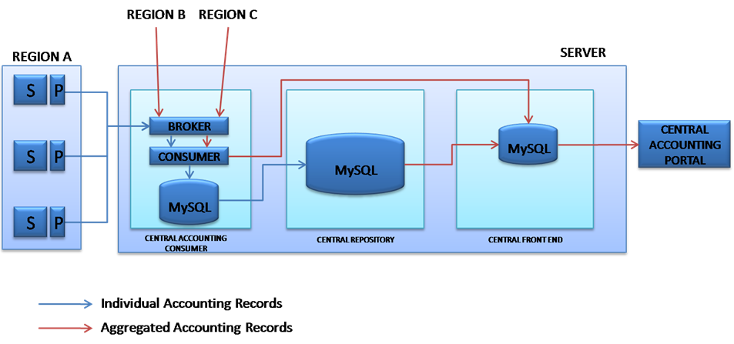
Figure 2 APEL repository architecture

Integration with other E-Infrastructures
When looking at the accounting interface as the interface between the accounting services of different interoperating infrastructures the main aim is to enable all the accounting data of a VO to be collected in one place for a unified view. This is assumed to be delivered by the exchange of accounting data at the appropriate level.
Other grid infrastructures, which wish to publish accounting data need to:
- Adopt an OGF standard Usage Record scheme and an EGI-compatible profile.
- Define a structure for their grid in GOCDB (or equivalent) that can be used by the accounting portal to display the data. The minimum requirement is a flat set of site names, used in the accounting records (e.g. for OSG these data are obtained from MyOSG). This is required only if the EGI Accounting Portal is the tool of choice for visualization of the data.
- Extract data from their accounting system grouped data by site/VO/User/FQAN/ month and create each group into a 'summary record' meeting the APEL definition. Experience shows that for accounting systems using the OGF-UR this is a simple transformation.
- Register the publisher with APEL as the APEL Repository only accepts accounting records from registered Resource Centres.
- Publish the records into EGI's ActiveMQ Message Bus using the agreed encryption framework and the Secure Stomp Messenger (SSM) [SSM]. The APEL repository will accept the records into a holding container from where they will be merged with the summaries from other grids and the summary produced by APEL from the job records it has received. Currently, the master summary is rebuilt from scratch several times per day. Each time it uses the last set of summaries received from each grid.
- From the master summary table, the data are then exported to the Accounting Portal where they can be viewed.

Support Interface
The user support infrastructure in use within EGI Helpdesk is distributed consisting of various topical and regional helpdesk systems that are linked together through a central integration platform, the GGUS helpdesk [GGUS]. This central helpdesk enables formalized communication between the submitter of the incident record and all partners involved in user support by providing an interface to which all other tools can connect and enabling central tracking of a problem, independent of the origin of the problem and the tool in which the work on the problem is done.
The interlinking of all ticket systems in place throughout EGI and related activities enables trouble tickets to be passed from one system to the other in a way that is transparent to the user. By exposing agreed interfaces, a hierarchical tree of interworking helpdesk systems can be implemented allowing for transparently exchanging incident records across different resource infrastructures. It also enables the communication and ticket assignment between experts from different areas (e.g. middleware experts and application experts) while at the same time allowing them to work with the tools they are used to. A reference implementation was defined for the interface between ticket systems and also a template for a ticket layout exists to ensure the quality of service. These are documented in the GGUS documentation [GGUS_INTERFACE].
The regionalized implementation of GGUS is called xGUS. xGUS is a simplified regional helpdesk instance for NGIs. These instances are operated centrally but can be customized by the regions. In xGUS the tickets can have a local or global scope. All answers to a global ticket are redirected to the central GGUS.
Ticket processing management (TPM) is responsible of ticket triage and holds a global overview of the state of all tickets. TPM is responsible for those tickets that have to be assigned manually, i.e. so that they get forwarded to the correct support units. In this way, a problem submitted to GGUS can be quickly identified as either a grid problem or a VO specific problem and addressed to the appropriate second line specialized support units or the dedicated VO support teams whose members have specific VO knowledge.
Second-level support is formed by many support units. Each support unit is formed from members who are specialists in various areas of grid middleware, or regional supporters for operations problems, or VO specific supporters. The membership of the support units is maintained on mailing lists.
Regardless of the number of parties involved, the submitter of a trouble ticket should be able to transparently follow the chain of actions needed to solve the reported problem. This is especially important since the support interface is not only used for 3rd level support dedicated to the end user, but also for the relevant parts of internal trouble ticket communication fulfilling standard operational, grid oversight and also some development functionalities.

Integration of new middleware and E-Infrastructure
New middleware stack provider can request creation of support unit in GGUS Helpdesk and use it directly for support. The procedure for creation of new support unit is described here: [GGUS_NEW_SU].
In cases when EGI decides to utilize software from a technology provider that has not so far involved with the project, an agreement has to be made with that technology provider on how to integrate its support infrastructure within the EGI Helpdesk.
It is important that this integration is done in a way that enables EGI to have an overview of issues with the products provided by the technology provider and to gather statistics on the quality of the support given by the provider.

Dashboard Interface
In order to operate a distributed infrastructure, management and monitoring information has to be collected and presented in a labour saving way to assist the operators of the infrastructure in their daily work. The dashboard interface combines and harmonizes different static and dynamic information and therewith enables the operators to react on alarms, to interact with the sites, to provide first-level support and/or to really operate the Resource Centres by creating and supervising problem tickets on regional as well as central level.
The dashboard allows predefined communication templates and is adaptable to different operational roles (first-level support, regional, central). Resource Centres in the dashboard scope can be regional, central or predefined out of a list and can be sorted and displayed according to numerous criteria to indicate actions needed for a single service, but also for a whole region or even the whole production infrastructure.

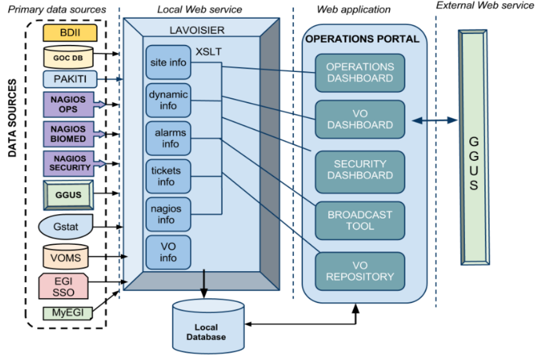
Figure 3 Operations Portal architecture

The Operations Portal [OPS_PORTAL] content is based on information which is retrieved from several different distributed static and dynamic sources – GOCDB, SAM monitoring system, EGI information system, GGUS, web services, etc. – and gathered into the portal. Interlacing this information has enabled us to display relevant views of static and dynamic information of the EGI production grid. Integrating different technologies and different resources creates high dependencies to the data provided. Consequently, the portal is organized around a web service Lavoisier that provides a transparent integration of each of these resources.

Integration of new middleware and E-Infrastructure
The procedure “Setting a Nagios test status to OPERATIONS” [EGI_OPER_TEST] defines how to add new test to list of alarms raised in the Operations Portal’s Dashboard.
The architecture of the portal has been designed to propose a standard access to information from an extended number of data sources. The integration of new data sources is eased by the use of the Lavoisier web service. In the case of a known technology we will create and add a new view by using an existing plug-in out of the wide-range of plug-ins already available.
If a site and its resources are already integrated in all the other operational tools through existing information providers (e.g. registered in GOCDB, monitored by Nagios, publishing their information via BDII and having a tree in GGUS), existing plug-ins can be reused and no additional integration effort for the usage of the Operations Portal is needed. For new providers, new plug-ins can be developed as needed.
The modularity of Lavoisier allows the easy integration of almost any kind of information. Such integration is certainly needed and meaningful for the new resource types entering EGI, such as HPC systems, virtualized resources or desktop resources. As long as these resources are monitored, it is possible to integrate them via plug-ins inside Lavoisier. The integration will be done step-by-step during the whole project according to the identified priorities.

Middleware
While different middleware stacks are supported by EGI for deployment in the resource centres, the central and distributed instances of the operational tools are operated by a small number of partners committed to provide such services for National or Regional Grid Initiatives, or even for the whole EGI.
EGI will need to deploy several middleware stacks according to the requirements of users and site managers. Presently, gLite and ARC can be viewed as fully integrated into all the operational tools, whilst some smaller adaptations are still needed due to changed and more standardized interfaces of the operational tools enabling broader access to other types of middleware.
UNICORE, Globus, Desktop Grids and MAPPER/QCG operational integration is in full progress. The designing solutions used for the integration of the different middleware stacks with the operational tools have to be stable and reliable.

UNICORE
Uniform Interface to Computing Resources (UNICORE) [UNICORE] makes distributed computing and data resources available in a seamless and secure way in intranets and the internet.
In order to speed up integration of UNICORE resources task force [UNICORE] was created in the first year of the project.
Currently two NGIs have resource centres with UNICORE services:
- Germany (NGI_DE)
- Poland (NGI_PL)

Management
During the first and second year of project the following UNICORE service types were added to GOCDB:
- unicore6.Gateway: entry point to one or more UNICORE services; represents a gateway for UNICORE services to the internet
- unicore6.Registry: used for registration of all UNICORE services; clients ask the registry for available services in the Grid
- unicore6.ServiceOrchestrator: handles dispatching of a workflow's atomic jobs, and brokering
- unicore6.StorageFactory: creates Storage Management instances, a user can create dynamic storage management services for own purposes with it
- unicore6.StorageManagement: provides an abstract file system-like view on a storage resource
- unicore6.TargetSystemFactory: used as an entry-point for submitting single jobs
- unicore6.UVOSAssertionQueryService: provides data and user information via the SAML standard as needed for authorization and environment customization
- unicore6.WorkflowFactory: creates workflow instances and can submit workflows to them.
- unicore6.Catalogue: service providing a unified view of files in multiple unicore6.StorageManagement instances
- unicore6.CISInfoProvider: provides data for CIS
- unicore6.CISRegistryPortType: provides a human friendly interface for browsing the UNICORE Grid status
- unicore6.GridBeanService: enables the download of GridBeans (modules providing an application-specific GUI).

Monitoring
The probes are developed and maintained by the respective UNICORE product teams.
The initial integration of UNICORE probes with the SAM was implemented in SAM Update-14, and eight new tests were included. The list of tests included in SAM:
- unicore6.Gateway
  - emi.unicore.Gateway
- unicore6.Registry
  - emi.unicore.Registry
- unicore6.ServiceOrchestrator
  - emi.unicore.ServiceOrchestrator
- unicore6.StorageManagement
  - emi.unicore.GlobalStorage
  - emi.unicore.GlobalStorage-FreeSpace
- unicore6.TargetSystemFactory
  - emi.unicore.TargetSystemFactory
  - emi.unicore.UNICORE-Job
- unicore6.UVOSAssertionQueryService
  - emi.unicore.UVOS
- unicore6.WorkflowFactory
  - emi.unicore.WorkflowService
- unicore6.StorageFactory
  - emi.unicore.StorageFactory

Starting from July 2013 following UNICORE tests were integrated with EGI OPS Availability and Reliability Profile:
- unicore6.TargetSystemFactory
  - emi.unicore.TargetSystemFactory
  - emi.unicore.UNICORE-Job

Accounting
Accounting services for UNICORE have been developed by NGI_PL and NGI_BY. UNICORE resource centers can publish accounting information through RUS server.

Support
Globus support is provided by the UNICORE product team through the EGI Helpdesk with medium level of service support [QoS].

Dashboard
Integration of following UNICORE tests into the Operations Portal took place in November 2012:
- unicore6.Gateway
  - emi.unicore.Gateway
- unicore6.Registry
  - emi.unicore.Registry
- unicore6.ServiceOrchestrator
  - emi.unicore.ServiceOrchestrator
- unicore6.UVOSAssertionQueryService
  - emi.unicore.UVOS
- unicore6.TargetSystemFactory
  - emi.unicore.TargetSystemFactory
- unicore6.StorageManagement
  - emi.unicore.GlobalStorag
  - emi.unicore.GlobalStorage-FreeSpace
- unicore6.WorkflowFactory
  - emi.unicore.WorkflowService

Globus
The Globus Toolkit [GLOBUS] is an open source software toolkit used for building grids. It was developed by the Globus Alliance and Initiative for Globus in Europe (IGE) project [IGE]. IGE was especially focused on providing packaged version of various Globus Toolkit components (e.g. MyProxy, GRAM, GridFTP). With the end of IGE project product is supported by the European Globus Community Forum (EGCF) established by IGE as its post-project sustainability initiative. The EGCF is the body of the Globus community in Europe that brings together administrators, users, and developers into one organisation.
Currently the following NGIs have resource centres with Globus services:
- Croatia (NGI_HR)
- Germany (NGI_DE)
- The Netherlands (NGI_NL)
- UK (NGI_UK)
- Finland (NGI_FI)

Management
During the first year of project the following Globus service types were added to GOCDB:
- globus-GRIDFTP: storage endpoint and data transfer service for the Globus middleware stack
- globus-RLS: the globus Replica Location Service
- globus-GSISSHD: certificate based interactive login service (sshd) for the Globus middleware stack
- GRAM5: job submission service for Globus version 5.x.

Monitoring
The current list of tests included in SAM:

- globus-GRIDFTP
  - hr.srce.GridFTP-Transfer
  - org.nagios.GridFTP-Check
- globus-GSISSHD
  - org.nagios.gsissh-Check
- GRAM5
  - hr.srce.GRAM-Auth
  - hr.srce.GRAM-Command
  - hr.srce.GRAM-CertLifetime
  - hr.srce.GridFTP-Transfer
  - org.nagios.GridFTP-Check.

Maintenance of Globus probes is now a responsibility of the EGCF.

Starting from July 2013 following Globus tests were integrated with EGI OPS Availability and Reliability Profile:
- GRAM
  - hr.srce.GRAM-CertLifetime
  - hr.srce.GRAM-Auth
  - hr.srce.GRAM-Command

Accounting
GridSAFE [GRIDSAFE] was adopted as an accounting solution. GridSAFE was designed as a site accounting repository to collect data locally but it has the interfaces to accept data from other Resource Centres too, so it can act as a regional repository receiving data from a number of Resource Centres.
From the specification GridSAFE does not have the ability to publish data on to higher levels in a hierarchy of repositories. It relies on others pulling data from it through an OGF RUS interface rather than the EGI push model.
Currently single accounting data publishing is fully integrated with EGI accounting system. There are still problems with summary data publishing which are plan to be solved during the second part of 2013.

Support
Globus support is provided by the EGCF product team through the EGI Helpdesk with base level of service support [QoS].

Dashboard
Integration of following Globus tests into the Operations Portal took place in November 2012:
- GRAM5
  - hr.srce.GRAM-Auth
  - hr.srce.GRAM-CertLifetime
  - hr.srce.GRAM-Command
- globus-GRIDFTP
  - hr.srce.GridFTP-Transfer
  - org.nagios.GridFTP-Check
- globus-GSISSHD
  - org.nagios.gsissh-Check

Desktop Grids
The European Desktop Grid Initiative (EDGI) [EDGI] develops middleware that consolidates the results achieved in the EDGeS project concerning the extension of Service Grids with Desktop Grids (DGs) in order to support EGI and NGI user communities that are heavy users of Distributed Computing Infrastructures (DCIs) and require an extremely large number of CPUs and cores.
In order to speed up the integration of Desktop Grids into the EGI infrastructure, a Memorandum of Understanding (MoU) between EGI-InSPIRE and EDGI [MOU_EGI_EDGI] was signed on November 22 2011.
The main activities defined in MoU were:
- the integration of Desktop Grids into EGI monitoring and accounting systems
- dissemination of the results of Desktop Grids integration.

Management
The following Desktop Grids service types were added to GOCDB on November 8th 2011:
- dg.ARC-CE: ARC gateway to Desktop Grid
- dg.CREAM-CE: CREAM gateway to Desktop Grid
- dg.TargetSystemFactory: UNICORE gateway to Desktop Grid.

Monitoring
Desktop Grids probes were provided by the EDGI project. The EDGI project will also maintain and develop probes in the long-term future.
The initial integration of Desktop Grids probes with the SAM was implemented in release Update-17 with the integration of one probe. The current list of tests included in SAM is the following:
- dg.ARC-CE
  - dg.FinishedJobs
- dg.CREAM-CE
  - dg.FinishedJobs
- dg.TargetSystemFactory
  - dg.FinishedJobs

Accounting
Accounting integration was started in May 2013 and is almost completed. Currently Desktop Grids accounting data are gathered and some sample records are successfully published. To be fully integrated visualization of accounting data on Accounting Portal needs to be discussed.

Support
Technical support for Desktop Grids is provided by the EDGI project in Europe (and by the DEGISCO project for partners from ICPCs). At the time of writing this document, EDGI submit a request for support unit in EGI helpdesk with medium level of service support [QoS].

Dashboard
Integration of tests for Desktop Grids will start in the second part of 2013.

MAPPER/QCG
The Multiscale APPlications on EuRopean e-infrastructures (MAPPER) project [MAPPER] aims to deploy a computational science environment for distributed multiscale computing, on and across European e-infrastructures. In order to further the project’s aim, MAPPER initiated a collaboration with EGI InSPIRE and PRACE (PaRtnership for Advanced Computing in Europe) in May 2011, when MAPPER-PRACE-EGI Task Force (MTF) [MTF] was created. The main goal was to integrate two applications that perform distributed multiscale computing by using a set of core middleware services from the QosCosGrid (QCG) middleware stack [QCG].
At the end of 2011the task force completed its work and in January 2012 a new task force [MAPPER_TF] was created with the main goal of integrating QCG middleware used by MAPPER with EGI operational tools.
In addition, in order to enable MAPPER users to have integrated operational tools over EGI and PRACE, a series of meetings between three parties were organized in order to define a broader operations integration plan across MAPPER, EGI and PRACE.
Currently one NGI has resource centres with QCG services:
- Poland – 5 sites with deployed QCG and configured advance reservation functionality

Management
The following QCG service types were added to GOCDB:
- QCG.Broker: QosCosGrid resource management, co-allocation and brokering service

- QCG.Computing: a compute component based on the OGF Basic Execution Service (BES) standard with advanced reservation support
- QCG.Notification: a notification middleware component using a brokered version of the OASIS WS-Notification standard.

Monitoring
MAPPER/QCG probes were provided by the QCG project. The QCG project will also maintain and develop probes in the long-term future. The initial integration of MAPPER/QCG probes with the SAM was implemented with release Update-19, with five tests included:
- QCG.Broker
  - pl.plgrid.QCG-Broker
  - hr.srce.QCG-Broker-CertLifetime
- QCG.Computing
  - pl.plgrid.QCG-Computing
  - hr.srce.QCG-Computing-CertLifetime
- QCG.Notification
  - pl.plgrid.QCG-Notification.

Integration of QCG tests with EGI OPS Availability and Reliability Profile is planned in second part of 2013.

Accounting
QCG services deployed in the PL-Grid infrastructure report usage records to the national accounting system called BAT. QCG Accounting solution [QCG_ACCNT] development based on APEL component was finally completed in July 2013. To be fully integrated visualization of accounting data on Accounting Portal needs to be discussed.

Support
Support for QCG middleware is provided through QosCosGrid GGUS support unit with medium level of service support [QoS].
An independent xGUS instance is currently being set up for broader MAPPER support activities.

Dashboard
Integration of tests for MAPPER/QCG will start in second part of 2013.

E-Infrastructure Integration
EGI is currently investigating the operations integration with the following e-infrastructures: EUDAT, PRACE, XSEDE, OSG and EGI’s Federated Cloud.

PRACE

Management
With GOC DB version 5 scoping functionality will be introduced which will allow to host different projects on one GOC DB instance. During the EGI Technical Forum 2013 in Madrid PRACE will presents its requirements and future plans will be discussed.

Monitoring
Preliminary information about usage of SAM to monitor PRACE resources was gathered in May 2012. At this point of time no integration planed.

Accounting
In terms of accounting integration between EGI and PRACE, GridSAFE can be adopted as an accounting solution. Integration plan still needs to be discussed between projects.

Support
The integration of PRACE helpdesk system with GGUS was postponed and currently there are no plans for the integration.

OSG

Management
Currently there are no plans for integration OSG with EGI management system.

Monitoring
Monitoring results of OSG resource centers are populated to EGI central database. In addition VO SAM is configured in a way that by default works with OSG sites and thus synchronizes with OSG management system.

Accounting
The accounting integration with OSG is in place. Future work is needed in terms of SSM 2 migration and is planned for year four.

Support
Support infrastructure is fully synchronized since 2006 with the OSG Footprints system.

XSEDE
During XSEDE 13 conference in July 2013 EGI and XSEDE project decided to collaborate to identify and exchange best practices and solutions between the e-infrastructures so they can operate more efficiently to serve scientists in the U.S. and Europe. One of the areas the collaboration is focussed is operation of e-infrastructure services which goal is to integration of helpdesk and accounting to support communities that in the future will jointly use XSEDE and EGI resources.

EUDAT

Management
Currently EUDAT project is using separate production instance of GOC DB. With GOC DB version 5 scoping functionality will be introduced which will allow to host different projects on one GOC DB instance. After its release EGI and EUDAT will discuss integration of EUDAT into EGI instance.

Monitoring
At this point EUDAT project is investigation usage of VO SAM instance as solution to monitor its resources. During the EGI Technical Forum 2013 in Madrid EUDAT requirements will be presented and discussed.

Accounting
Currently there are no plans for accounting integration between EUDAT and EGI.

Support
EUDAT project is providing support through helpdesk based on Request Tracker system which can be easily integrated with GGUS system. Potential plans concerning helpdesk integration still needs to be discussed between projects.

EGI’s Federated Cloud
EGI’s Federated Cloud Infrastructure reached its maturity where integration with Operations tools is necessary to provide production quality of services.

Management

Currently EGI’s Federated Cloud is fully integrated with Management system. The following service types are available in GOCDB:
- eu.egi.cloud.accounting
- eu.egi.cloud.information.bdii
- eu.egi.cloud.storage-management.cdmi
- eu.egi.cloud.vm-management.occi
- eu.egi.cloud.vm-metadata.marketplace

Monitoring
Central SAM instance is deployed for monitoring cloud resources. Once the set of probes is fully defined probes will be included to official SAM release and with official release central instance will be switched off.
The current list of is the following:
- eu.egi.cloud.accounting
  - eu.egi.cloud.APEL-Pub
- eu.egi.cloud.information.bdii
  - org.nagios.CloudBDII-Check
- eu.egi.cloud.storage-management.cdmi
  - org.nagios.CDMI-TCP
- eu.egi.cloud.vm-management.occi
  - eu.egi.cloud.OCCI-VM
  - org.nagios.OCCI-TCP

Accounting

Accounting integration is still in progress. Currently cloud accounting data are gathered in separate cloud accounting database and twice a day published Accounting Portal. Next integration step will be to verify data and decide on visualization in Accounting Portal.

Support

Support for resource centers which want to deploy Cloud resources is provided by Federated Cloud Task Force. Currently, the EGI Federated Cloud support unit exists in EGI helpdesk but its role needs to be redefined.

Dashboard
Integration of tests for the Federated Cloud is planned in second part of 2013.

Future Plans

The functionality and the requirements of the different operational tool interfaces will evolve over time. Operational requirements will continue to be collected from Resource Providers that are interested in integrating novel resource types into their e-Infrastructure as required. Input from infrastructure providers planning to operate different middleware stacks will also be gathered.

The main focus during the fourth year of the project will be put on the integration with other E-Infrastructures which will likely bring new requirements for the extension of the operational interfaces currently deployed in EGI for monitoring, accounting, communication, management and support.

The following year of the project will be focused on final integration of all middleware stacks. Further integration with EUDAT and PRACE will be driven by requirements of the MAPPER community and new emerging communities interested in coupled access to data hosted across different research infrastructures. Integration with OSG and XSEDE will be driven by such communities as WeNMR and CompChem.

References

ACCNT_PROTO | Accounting Messaging Protocol https://wiki.egi.eu/wiki/APEL/MessagingProtocol
ACCNT_TF | Accounting Task Force https://wiki.egi.eu/wiki/TCB:Accounting_Task_Force
APEL | APEL https://wiki.egi.eu/wiki/APEL
EGI_ACCNT | EGI Accounting Portal https://wiki.egi.eu/wiki/Accounting
EGI_ACCNT_PROF | EGI Accounting Profile https://indico.egi.eu/indico/conferenceDisplay.py?confId=723
EGI_ADD_SAM | EGI Procedure – Adding new probes to SAM https://wiki.egi.eu/wiki/PROC07
EGI_AR | EGI Procedure – Management of the EGI OPS Availability and Reliability Profile https://wiki.egi.eu/wiki/PROC08
EGI_OPER_TEST | EGI Procedure – Procedure for setting Nagios test status to operations https://wiki.egi.eu/wiki/PROC06
EGI_EUDAT_PRACE | EGI/EUDAT/PRACE workshop https://indico.egi.eu/indico/sessionDisplay.py?sessionId=10&confId=1019#20120918
EDGI | European Desktop Grind Initiative (EDGI) Project http://edgi-project.eu/
GGUS | GGUS https://wiki.egi.eu/wiki/GGUS
GGUS_INTERFACE | GGUS Documentation on interfaces  https://ggus.eu/pages/ggus-docs/interfaces/docu_ggus_interfaces.php
GGUS_NEW_SU | GGUS – New Support Unit https://wiki.egi.eu/wiki/FAQ_GGUS-New-Support-Unit
GLOBUS | Globus Toolkit http://www.globus.org/toolkit/
GLOBUS_TF | GLOBUS Integration Task Force https://www.egi.eu/indico/categoryDisplay.py?categId=53
GOCDB | GOCDB https://wiki.egi.eu/wiki/GOCDB
GOCDB_NEW_ST | GOCDB Documentation – Adding new service types https://wiki.egi.eu/wiki/GOCDB/Input_System_User_Documentation#Adding_new_services_types
GOCDB_ST | GOCDB Documentation – Service Types https://wiki.egi.eu/wiki/GOCDB/Input_System_User_Documentation#Service_types
GRIDSAFE | GridSAFE project http://www.jisc.ac.uk/whatwedo/programmes/eresearch/gridsafe.aspx
IDGF-SP | International Desktop Grid Federation – Support project http://idgf-sp.eu
IGE | IGE Project http://www.ige-project.eu
JRA1 | JRA1 WP7: Operational Tools Description of Work summary https://wiki.egi.eu/wiki/WP7:_Operational_Tools_DoW_summary
MAPPER | MAPPER Project http://www.mapper-project.eu/web/guest
MAPPER_TF | MAPPER Integration Task Force https://wiki.egi.eu/wiki/MAPPER-PRACE-EGI_Task_Force_%28MTF%29-II
MOU_EGI_EDGI | MoU between EGI-InSPIRE and EDGI https://documents.egi.eu/document/496
MS410 | MS410 EGI Helpdesk and the NGI Support Units https://documents.egi.eu/document/522
MTF | MAPPER-PRACE-EGI Task Force (MTF)  https://wiki.egi.eu/wiki/MAPPER-PRACE-EGI_Task_Force_(MTF)
NAGIOS_PROBES | Nagios Probe Development  https://tomtools.cern.ch/confluence/display/SAMDOC/Probes+Development
OPS_PORTAL | Operations Portal https://wiki.egi.eu/wiki/Operations_Portal
OTAG | OTAG https://wiki.egi.eu/wiki/OTAG
PL_UNICORE | PL-Grid UNICORE Monitoring System http://www.unicore.eu/summit/2010/presentations/18_Bala_Monitoring.pdf
QCG | QosCosGrid http://www.qoscosgrid.org
QCG_ACCNT | QCG Accounting http://www.qoscosgrid.org/trac/qcg-computing/wiki/QCG-Accounting
QoS | GGUS Quality of Service https://wiki.egi.eu/wiki/FAQ_GGUS-QoS-Levels
SAM | SAM https://wiki.egi.eu/wiki/SAM
SAM_PROBES | SAM Probes https://wiki.egi.eu/wiki/SAM#Tests_and_probes
SAM_UNICORE | SAM setup for UNICORE probes https://tomtools.cern.ch/confluence/display/SAM/SAM+setup+for+UNICORE+services
SCI | Security for Collaborating Infrastructures (SCI) https://indico.cern.ch/conferenceDisplay.py?confId=183229
SSM | Secure Stomp Messenger https://wiki.egi.eu/wiki/APEL/SSM
UNICORE | UNICORE http://www.unicore.eu/
UNICORE_TF | UNICORE Integration Task Force https://www.egi.eu/indico/categoryDisplay.py?categId=49

