Quality Criteria Verification
Executive Summary
For QCV, Stage Rollout, DMSU and EGI internal

Name of the component | Dcache
Release | 2.6.5-2 |  | RT-Ticket-Id:
Software Provider | EMI
Release Contact | Name: Cristina Aiftimiei |  | E-Mail |  | cristina.aiftimiei@pd.infn.it
Validator | Name: Ulf Tigerstedt |  | E-Mail | ulf.tigerstedt@csc.fi
Component status | ACCEPTED | Date
Verification start date | 10 August 2013 | Verification end date |  |  |  | 18 August 2013

Summary of Quality Criteria verification:
 | Generic Quality Criteria Total (Critical/Non critical)
 | Passed | Not passed | Not Applicable | Total
TP
VLD | 23 | 0 | 1 | 24
 | Specific Quality Criteria
TP
VLD | 18 | 0 | 0 | 18

Summary:
This is an upgrade from a previous dcache 2.2 version

Validator comments:
Instalation Ok

We found one bug last week, which is fatal for some users:
If a pool has permanent migration jobs, and these are saved with the
"save" command, the next time the pool is restarted and "save" issued again the migration is now stored as "null" which makes the next restart fail.

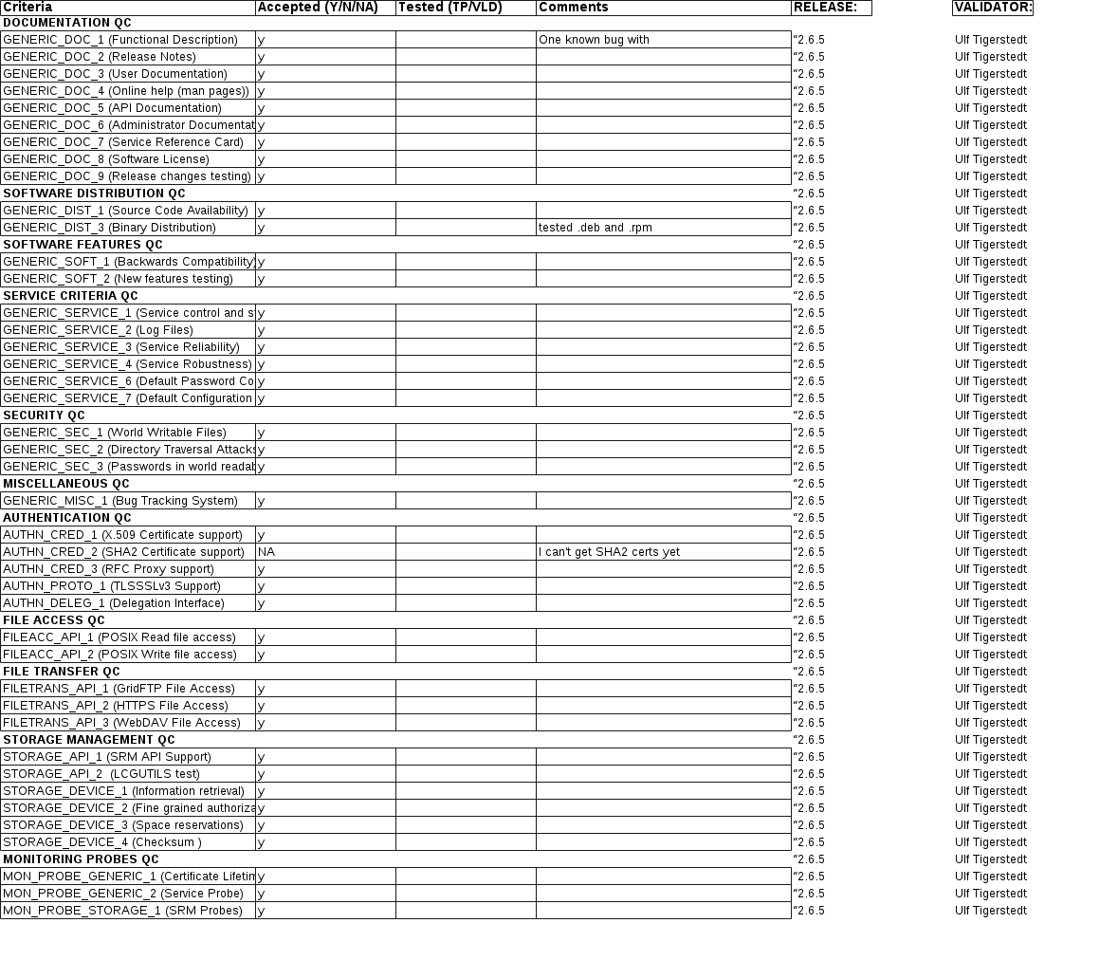
Not applicable Quality Criteria

Specific Functional Tests to be repeated in SR:

Test number | Description | Motivation

Specific Non-functional tests (Scalability, etc…) to be repeated in SR:

Test number | Description | Motivation

Comments for UMD QC definition (TSA2.2):
- Review criteria xxxx
- Add criteria xxxx

Comments for SR (TSA1.3):

Comments for DMSU (TSA2.5):

Comments for TP:

