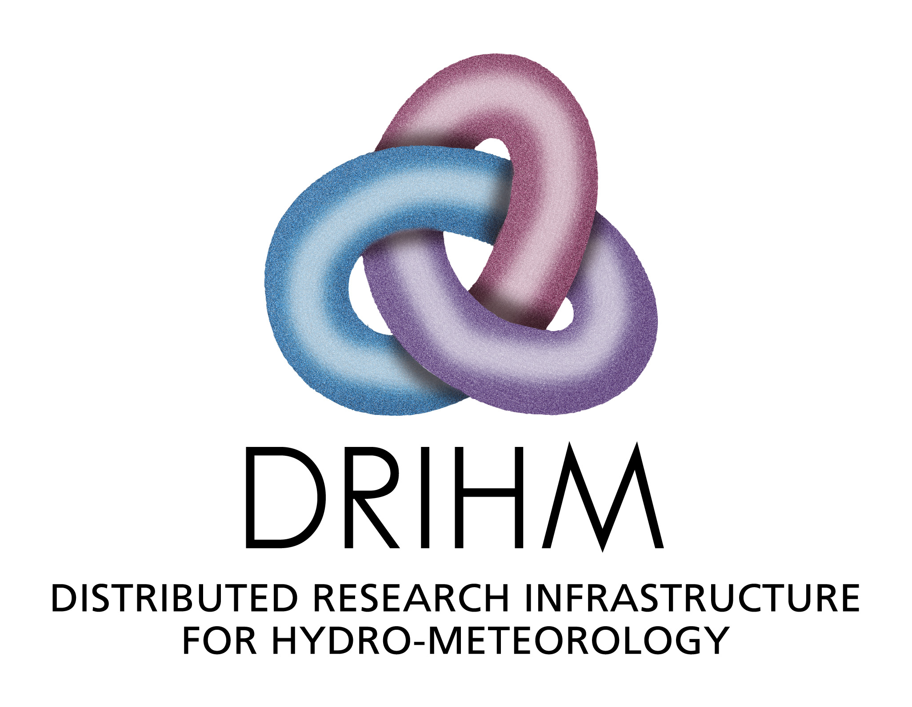
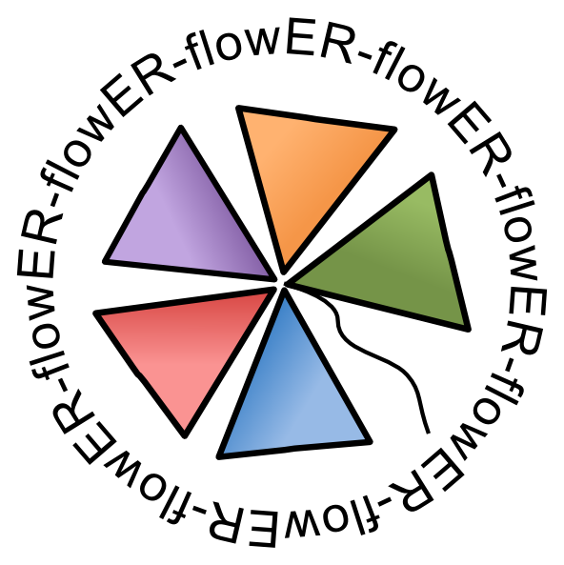

MEMORANDUM OF UNDERSTANDING

BETWEEN

ER-flow and DRIHM

The purpose of this Memorandum of Understanding (MoU) is to define a framework of collaboration between ER-flow, a European Project supported by the FP7 Capacities Programme under contract n°312579, with address: Centre for Parallel Computing, University of Westminster, School of Informatics, 115 New Cavendish Street, London W1W 6UW, and DRIHM (Distributed Research Infrastructure for Hydro-Meteorology), a European project supported by the FP7 Capacities Programme under contract n°RI-283568, with address: CIMA Foundation, Armando Magliotto 2, 17100, Savona, Italy (hereafter also referred to as “the Party”). Hereafter ER-flow and DRIHM are referred to as “the Parties”.

The Parties recognise, by this MoU, the opening of a wider and longer-term cooperation in activities, which will bring visible benefits.

The Parties are desirous of entering into this Memorandum of Understanding to declare their respective intentions and to establish a basis of cooperation and collaboration between the Parties upon the terms as contained herein. This MoU is a counterpart to an existing MoU between SCI-BUS and DRIHM. They are intended to support one another in contributing to the same overall outcomes.

AREAS OF COOPERATION

The main goals of the activities developed in the context of this MoU as support to the activities under the ER-flow / DRIHM MoU are:

- To explore the workflow interoperability through understanding of the SHIWA Simulation Platform and any other relevant technologies developed under ER-flow and how to use it in the DRIHM community.

- To support workflow development on the SHIWA Simulation Platform to enable workflow sharing in the DRIHM community.

- To enhance the potential of the scientific gateway under construction for the DRIHM community by extending it with workflow interoperability support to enable execution of workflows.

- Promote and disseminate the joint outcomes of the ER-flow and DRIHM projects.

Commitments of ER-flow:

- Give training on the ER-flow workflow interoperability approach explaining how to use the SHIWA Simulation Platform.

- Give application support for developing DRIHM applications on the SHIWA Simulation Platform and for running them on the WS-PGRADE based DRIHM science gateway. This may include access to the SHIWA Simulation Platform to aid prototyping of solutions and training.

- Register DRIHM researchers on the SHIWA Simulation Platform and provide application porting and technical support them to run workflows.

- Inform the DRIHM community about all the material, guides, training courses that may be interesting for this collaboration.

- Disseminate the collaboration and promote the DRIHM community and its science gateway as appropriate.

- Promote DRIHM as an associated partner on the ER-flow web page and at events organized by ER-flow.

- Enable DRIHM participation at ER-flow workshops and meetings as appropriate.

- Register as an interested party on the DRIHM portal.

- Coordinate the collaboration between the Parties.

Commitments of DRIHM:

- To explore the development of a science gateway based on WS-PGRADE/gUSE, building on the potential from SCI-BUS through understanding of the SHIWA Portal and any other relevant technologies developed under ER-flow.

- Encourage the DRIHM user community to use the SHIWA Simulation Platform to develop, publish and share workflows.

- Define a roadmap for the planned work alongside the SCI-BUS / DRIHM MoU.

- Promote the SHIWA User Forum in the DRIHM community to be involved in the discussions on the SHIWA Simulation Platform and to communicate their needs.

- Promote the collaboration with the ER-flow project on the DRIHM webpages.

- Disseminate and promote the gateway for all relevant DRIHM user communities.

- Should the technology be successful and finally adopted, set up the DRIHM science gateway as a production service for its user community.

- Ensure that usage of the DRIHM workflow service will not relate to an area under ethical compromise or biosecurity such us military research or bioethical studies.

- Participate in at least one ER-flow workshop.

- Register the necessary individuals on the SHIWA Portal.

FINANCIAL ARRANGEMENTS

This Memorandum of Understanding will not give rise to any financial obligation between the Parties. Both DRIHM and ER-flow will bear its own cost and expenses in relation to this Memorandum of Understanding.

COMMUNICATION

The Parties shall keep each other informed on all their respective activities and on their progress and shall consult regularly in areas offering potential for cooperation. Each of the parties shall designate a “point of contact” that shall be responsible for monitoring the implementation of this MoU and for taking measures to assist in the further development.

EFFECT AND DURATION

This Memorandum of Understanding will come into effect on the date of signing and will remain in effect for the combined period of the two projects. DRIHM is currently scheduled to conclude in January 2015 and ER-flow in September 2014. As such, this Memorandum of Understanding will conclude in September 2014. This Memorandum of Understanding may be extended for a further period as may be agreed in writing by the Parties.

Signed in duplicate by, for and on behalf of ER-Flow on ………………………………

Dr Gabor Terstyanszky,
ER-Flow Project Coordinator

Signed in duplicate by, for and on behalf of DRIHM on ………………………………

Dr Antonio Parodi,
DRIHM Project Coordinator

