e-ScienceTalk

PROJECT PERIODIC REPORT

Grant Agreement number: 260733
Project acronym: e-ScienceTalk
Project title: e-ScienceTalk : Supporting Grid and High Performance Computing reporting
across Europe
Funding Scheme: CSA
Date of latest version of Annex I against which the assessment will be made: 2013-03-01
(NEF version 2013-04-10)
Periodic report: 1st □ 2nd □ 3rd 
Period covered: from 1st Sept 2012 to 31st July 2013
Name, title and organisation of the scientific representative of the project's coordinator: EGI.eu, Catherine Gater. Deputy Director
Tel: + 31 (0)6 30372738
E-mail: catherine.gater@egi.eu
Project website address: http://www.e-sciencetalk.eu/

Table of Contents
Declaration by the scientific representative of the project coordinator 3
1.1 Publishable summary 4
1.1.1 Project context and objectives 4
1.1.2 Work performed in Project Year Three 6
WP1: Policy, impact and sustainability 6
WP2: GridCafé, GridGuide, GridCast 7
WP3: iSGTW 8
WP4: Management and International Collaboration 9
1.1.3 Expected final results and impact 9
1.1.4 Project web addresses 11
1.2 Core of the report for the period: Project objectives, work progress and achievements, project management 12
1.2.1 Project objectives for the period 12
1.2.1.1 Objectives for work package 1 – Policy, impact and sustainability 12
1.2.1.2 Objectives for work package 2 – GridCafé, GridCast and GridGuide 14
1.2.1.3 Objectives for work package 3 – International Science Grid This Week 18
1.2.1.4 Objectives for work package 4 – Management 20
1.2.1.5 Objectives summary table 21
1.2.2 Work progress and achievements during the period 24
1.2.2.1 WP1: Policy, impact and sustainability 24
1.2.2.2 WP2: GridCafé, GridGuide, GridCast 27
1.2.2.3 WP3: iSGTW 31
1.2.3 Project management during the period 34
1.2.3.1 Project management 34
1.3 Deliverables and milestones tables 38
Part I Explanation of the use of the resources 43
1. PARTNER short name EGI.eu 45
2. PARTNER short name QMUL 46
3. PARTNER short name APO 47
4. PARTNER short name Imperial 48
5. PARTNER short name CERN 49
Part II Form C and Summary financial report (draft version 30-08-2013) 50
FORM C for the other JRUs MEMBERS (3rd party listed in GA) – N/A 51

Declaration by the scientific representative of the project coordinator

I, as scientific representative of the coordinator of this project and in line with the obligations as stated in Article II.2.3 of the Grant Agreement declare that:

- The attached periodic report represents an accurate description of the work carried out in this project for this reporting period;
- The project (tick as appropriate) :
 has fully achieved its objectives and technical goals for the period;
  - has achieved most of its objectives and technical goals for the period with relatively minor deviations.
  - has failed to achieve critical objectives and/or is not at all on schedule.

- The public website, if applicable
 is up to date
  - is not up to date
- To my best knowledge, the financial statements which are being submitted as part of this report are in line with the actual work carried out and are consistent with the report on the resources used for the project (section 3.4) and if applicable with the certificate on financial statement.
- All beneficiaries, in particular non-profit public bodies, secondary and higher education establishments, research organisations and SMEs, have declared to have verified their legal status. Any changes have been reported under section 3.2.3 (Project Management) in accordance with Article II.3.f of the Grant Agreement.

Name of scientific representative of the Coordinator: Catherine Gater..................

Date: ......30../ ..08....../ ..2013.. 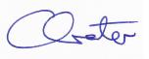

For most of the projects, the signature of this declaration could be done directly via the IT reporting tool through an adapted IT mechanism.

1.1 Publishable summary

1.1.1 Project context and objectives

Over the last 10 years, the European Commission and governments have invested substantial funds in distributed computing infrastructures. Scientists have access to state-of-the-art computational and data resources located around the world, putting European research into a leading position to address the greatest challenges facing us today, such as climate change, pandemics and sustainable energy. The advent of the European Grid Infrastructure, combined with the blurring of boundaries between grids, clouds, supercomputing networks and volunteer grids, means that a clear consistent source of information aimed at non-experts is now more important than ever, through dissemination projects that cross national boundaries.

The objectives for e-ScienceTalk are:

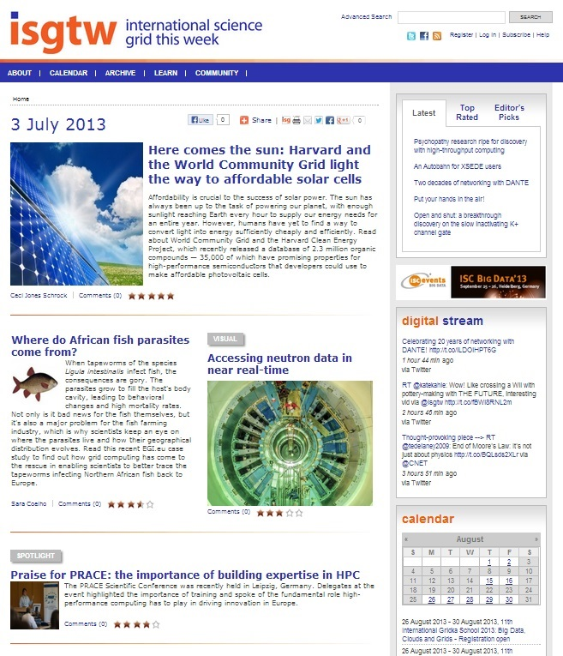
- e-ScienceTalk will build on the achievements of the GridTalk project in bringing the success stories of Europe’s e-Infrastructure to policy makers in government and business, to the scientific community and to the general public.
- e-ScienceTalk will work with EGI-InSPIRE and other collaborating projects to expand the scope of the existing GridTalk outputs, and to report on the interactions of grids with e-Infrastructures such as cloud computing and supercomputing.
- The project will explore options for the sustainability of e-ScienceTalk’s products.
- e-ScienceTalk will produce a series of reports aimed at policy makers to disseminate key policy issues underpinning grid and e-Infrastructure development in Europe. The project will also coordinate e-concertation activities.
- The GridCafé, GridCast and GridGuide suite of websites will cover new topics and explore novel web technologies; they will integrate closely with the Real Time Monitor, combining live views of grid activity with the human aspects of computing.
- The growing weekly publication, International Science Grid This Week (iSGTW) will bring news and events to the existing and potential e-Science community.

e-ScienceTalk disseminates the success stories and impact of grid computing and e-Infrastructures. These stories come from the e-Infrastructure’s flagship pan-European projects but also from a whole host of smaller and emerging projects. By giving these projects access to e-ScienceTalk’s wide variety of dissemination channels, including websites, blogs, social media sites, weekly publications, events, conference booths and printed materials, their results can be disseminated far more widely and to a greater range of audiences than would otherwise be possible. This audience reaches beyond Europe to the US, to Asia and to Latin America.
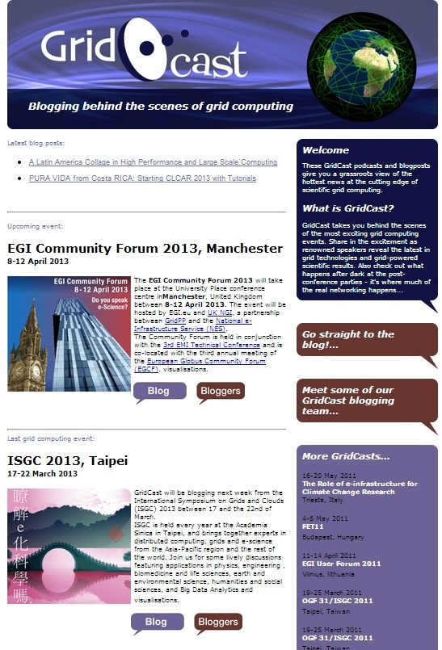
e-ScienceTalk forms a key element in a network of dissemination hubs serving the user communities, including the dissemination teams of EGI.eu, ESFRI projects, the National Grid Initiatives and others. Each of these hubs target different audiences, whether users from a virtual research community, users located in a particular country or region, middleware developers or owners and managers of the grid resources. As a dissemination project with international scope, e-ScienceTalk is well placed to distribute its products via the hubs for these specialist networks and hence reach a much wider audience. In turn, e-ScienceTalk is able to offer its well-established channels for success stories from the various communities, including its networks of media contacts, policy makers and its general public-focused products. For example, the GridCafé website provides an authoritative and unbiased introduction to grids for the general public, while iSGTW reaches 8700 subscribers from across a wide range of science communities. The community contributions encouraged during GridTalk have been extended during e-ScienceTalk to include blogging through the GridCast and iSGTW websites, and coordination of e-concertation activities in the e-Infrastructure area.

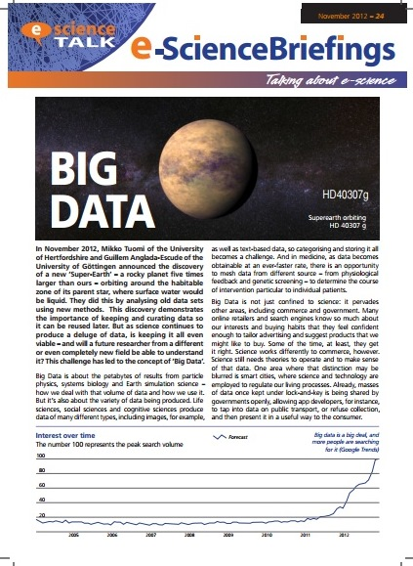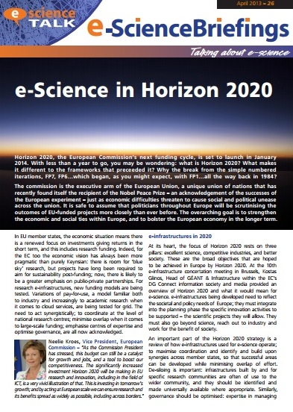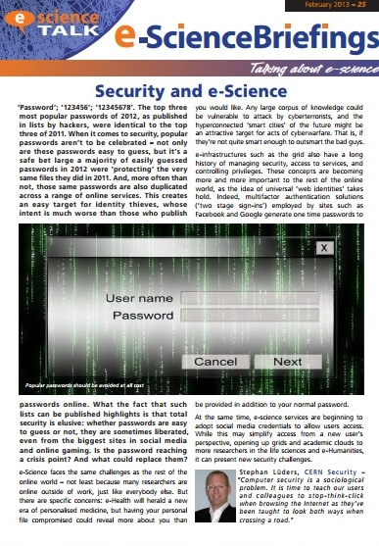
e-ScienceTalk is working with other projects such as GÉANT, DANTE and PRACE to disseminate the interdependencies of Europe’s e-Infrastructures through the e-ScienceBriefings, articles in iSGTW and by expanding the content of the GridCafé. e-ScienceTalk is also working closely with e-IRG and the European Strategy Forum on Research Infrastructures (ESFRI) projects who are involved in building a united roadmap for the development of e-Infrastructures in Europe. e-ScienceTalk aims to bring the progress of this roadmap to all its audiences in Europe and beyond. The e-ScienceBriefings are circulated to a wider audience beyond Europe, the GridGuide features an increasing number of sites outside Europe and GridCast blogs from at least one non-European event per year. As a joint EU-US initiative, iSGTW is by nature an international publication, covering projects from Europe and the US, as well as increasingly from Asia, Latin America and Africa.

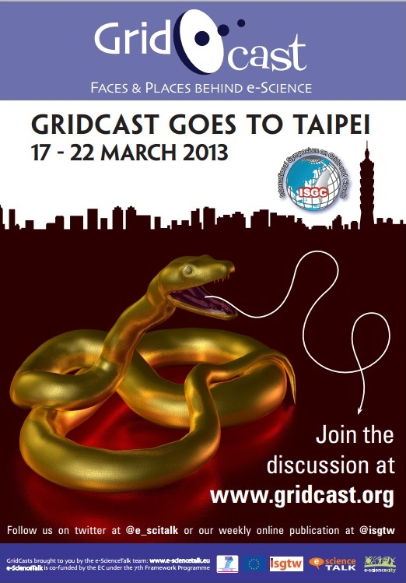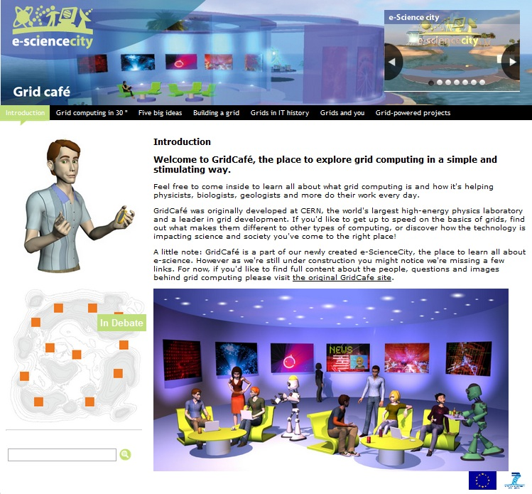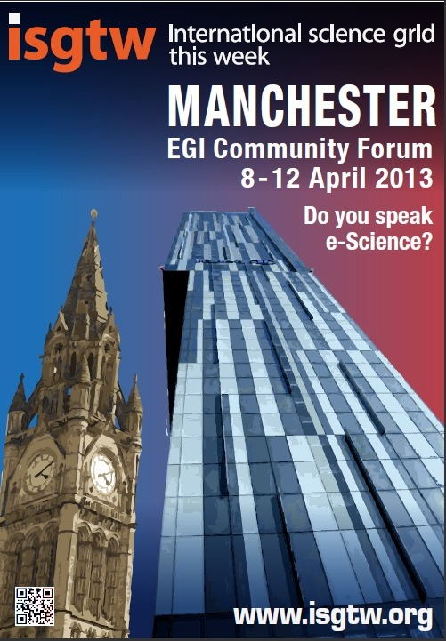

1.1.2 Work performed in Project Year Three

WP1: Policy, impact and sustainability

The main outputs from the policy, impact and sustainability work package have been in the areas of events, e-ScienceBriefings and policy-related GridCasts. The framework for consultation has also been working well through the policy advisory group.

The briefings produced this year are:

- Transferring Technology and Knowledge – Oct 2012
- Big Data – Nov 2012
- The Security Issue – Feb 2013
- Horizon2020 – April 2013

The briefings are available online from the e-ScienceTalk website and have been distributed through mailing lists and at events such as the EGI Technical Forum 2012, ISGC 2013, Cloudscape V, and the EGI Community Forum 2013.

In March 2013, WP1 and WP4 coordinated the 10th e-Infrastructure Concertation meeting, which took place in Brussels, Belgium. The event attracted 130 delegates, including representatives of all the major Distributed Computing Infrastructure projects. e-ScienceTalk’s WP2 created a supporting website for the event.

The WP1 team also attended several policy oriented events to report on them for the GridCast blog, to research information for the briefings and to distribute the briefings themselves, including the EGI Technical Forum in Prague, eChallenges, EUDAT, e-IRG, CloudScape V, the 10th e-Infrastructure Concertation meeting, the CRISP annual event, ISGC2013 and the EGI Community Forum among others.

In response to the reviewers’ comments at the 2nd Periodic Review, e-ScienceTalk reviewed the impact of its products and explored options for sustainability through the annual reports. WP1 led on producing the annual impact, feedback and sustainability reports in collaboration with WP4. The report concludes that the impact of each ScienceTalk product is encouraging in most cases and each product is reaching its intended audiences, with various options for sustainability beyond e-ScienceTalk for the majority of the activities.

WP2: GridCafé, GridGuide, GridCast

WP2 is responsible for e-ScienceTalk’s suite of interactive websites, Gridcafé, GridCast and GridGuide, as well as the main project website and the Real Time Monitor.

GridCafé and e-ScienceCity

When the GridCafé website was first developed, it was a novel form of science communication that was nominated for awards. However, in order to fulfill the objective of keeping the GridCafé at the cutting edge WP2 needed to explore interactive environments and new web tools. A second aim for was to develop new content areas of the website that covered other areas of e-infrastructures and distributed computing. The GridCafé website main content areas were migrated to the e-ScienceCity template at the end of PY1. The formal launch of the e-ScienceCity and the CloudLounge was in PM13. Areas on volunteer computing (Volunteer Garage), supercomputing (HPC Tower) and data (Data Park) have also been published live during PY3. Central areas are also now available, including the Communications Centre for news and briefings, People Bay which includes profiles of people working in grid, and GridPort which includes the GridGuide sites. A marketing plan has been followed to drive traffic to the new site including the use of wikipedia, social media, iSGTW links, internal linking, an offline schools pack, and promotion at conferences. Web statistics for the e-ScienceCity are gradually improving, particularly for sites that were launched first, such as Cloud Lounge. To develop the pilot 3D site, e-ScienceTalk partnered with Virtus, a non-profit association and New World Grid. The growing virtual e-ScienceCity is available to New World Grid users.

GridCast

A number of GridCasts have been held during the second year. At most GridCasts, one or more members of the e-ScienceTalk team attended the event, blogging and in some cases recording video interviews. GridCasts were held at the EGI Technical Forum 2012, Prague, eChallenges 2012, Lisbon, EUDAT and the 5th CAPRI meeting among others.

In PY3, we now have the maximum number of bloggers on the Blogger platform, over 100. This year, e-ScienceTalk published a total of 115 blog entries, 31 podcasts on GridCast from 20 bloggers. On average, there have been 6 bloggers at each major GridCast. The number of unique visitors has increased by 78% in PY3. The videos produced at GridCasts over the years have now been viewed nearly 250,000 times in YouTube.

GridGuide / Real Time Monitor

The RTM is a real time visualisation of activity on the grid computing infrastructure. The RTM overlays site activity and job transfers onto the 3D globe, giving users the ability to see the current state of the grid infrastructure. RTM development has focused on four areas; the website, maintenance, user support and extending the application’s functionality. In PY3, 54 countries are included in the RTM and the team has visited events where the RTM has been demonstrated to over 10,000 delegates. During the project lifetime, around 30,000 people may have seen the RTM at an event. GridGuide gives a human face to the grid, showing the sites and sights of grid computing. Users can listen to podcasts from grid sites worldwide, read about the ongoing work and watch interviews with researchers. There are currently 102 sites on the GridGuide, including 53 EU sites and 49 non-EU in the Americas, Africa and the Asia-Pacific region.

The aim for PY3 has been to complete the transfer to the latest version of WorldWind, fully integrate the CMS data transfers, continue to ensure that the application displays up-to-date and accurate information and investigate displaying data from new sources and infrastructures. These aims have been achieved by the end of July 2013.

The RTM developer has worked in collaboration with the London Science Museum to design an RTM demo as part of their LHC exhibit, Collider, which will run from November 2013 to April 2014. According to their 2011–2012 report, the Science Museum Group welcomed 2.95 million people over the year to its London museum, indicating that for its six-month run, the RTM could receive ten times’ its former audience.

WP3: iSGTW

International Science Grid This Week (iSGTW) is produced on a weekly basis by WP3 and is sent to over 8700 subscribers by email. ISGTW published 45 issues in PY3. During PY3 the trend for more rapid social media growth and more modest growth in weekly subscriptions that had begun in PY2 continued, reflecting a change in the habits of our readership largely in line with trends reported by other online news sources. While the number of subscriptions has levelled off in the last year, growth has resumed in the final months of the project. The promotional focus for iSGTW has been on social media followers. The number of twitter followers has increased by 530% (341 to 1,796). Up to 179 countries and territories accessed the website on average during PY3. The total number of unique visitors to the website has increased by one third. The number of page views has also more than doubled and the number of user accounts stands at more than 1,000. The media form an increasing proportion of iSGTW’s readers, as shown by the annual readership survey. As a result, iSGTW’s stories are increasing being ‘picked up’ by other media including Symmetry, HPCwire, Discovery News and Wired, increasing traffic to the publication.

The 2013 iSGTW readership survey was launched in March 2013 and 113 readers completed a multiple choice survey and provided comments. This is equivalent to 1.3% of the 8770 subscribers, a slight decrease on previous years. The results from the survey showed that iSGTW is still highly reliant on the weekly newsletter for driving the majority of traffic to the site. The survey results also suggested that readers are fairly dedicated, with most respondents reading at least 3 out of every 4 issues. The feedback on user preferences will be used to shape editorial policy in the future and ensure that the topics covered reflect the interests of the readership. At the same time, the editorial team and board will seek to address those areas in which the publication scored less well and will seek to increase readership from under-represented demographics, such as young people.

WP4: Management and International Collaboration

The management team produced a report on feedback and metrics with WP1, including additional training materials for training events at the EPN site in Grenoble, and at EUDAT and CRISP events. In total, an additional three Memoranda of Understanding have been signed with collaborating projects in PY3, outlining how the projects and the e-ScienceTalk collaboration will work together to maximise mutual dissemination activities and ensure sustainability, including iMENTORs, Blog4Ever and Ubuntunet. E-ScienceTalk also chairs the iSGTW Advisory Board and is part of the Programme Committee for the 12th International Symposium on Grids and Clouds 2014 in Taipei.

1.1.3 Expected final results and impact

The important scientific and social impacts of dissemination projects that span national and international borders were outlined by Kostas Glinos, Head of Unit “GÉANT & e-Infrastructures, Directorate General for Information Society and Media, European Commission” in the GridBriefing Annual Report 2008-2009, produced by GridTalk:

“Today, grid e-Infrastructures are facing significant challenges such as sustainability and the transition to a more user-driven and service-centric model. Grid computing has already engaged in the process of transitioning to a sustainable model of operation that would integrate at European level the corresponding national operations. This new pan-European organisation model will open grid e-Infrastructures to all scientific disciplines and complement national funding strategies in support of e-Science. Thanks to grid computing many prominent results have been achieved that directly affect people’s lives.

It is essential to show the world and especially European citizens how European-funded research e-Infrastructures are working for them. Responsible and open communication plays an important role in ensuring public support of the European grid e-Infrastructures activities. This is where projects like GridTalk, disseminating the benefits, success stories and challenges of grid computing to a wider audience, play an important role. The effective communication of complex technical or scientific matters to a wider audience not only increases the public appreciation and support to scientific progress but also inspires the younger generations to get involved in the research process.”

The need for dissemination projects to communicate the success stories and societal impact of grid computing and other EC funded e-Infrastructures has not diminished since GridTalk started in April 2008. In fact with the transition to a new model for distributed computing in Europe expected under Horizon2020, this is more important than ever. Thierry van der Pyl, Director European Commission, DG Communications Networks, wrote in the e-ScienceBriefings Compendium, 2010-2013:

“The opportunities and challenges associated with e-infrastructures are now very much aligned with those of mainsteam research, as more and more research disciplines employ extensive computational methods to cope with the data deluge. Digital science has grown well beyond its origins in the high energy physics domain. Now the astronomical, life- and environmental-sciences communities have established a firm foothold in the world of e-infrastructures and increasingly find themselves working alongside researchers from the social sciences and humanities.”

“Together these e-science briefings show that e-Science in Europe is reaching a real maturity and delivering tangible results, which are in turn promoted and disseminated by projects such as e-ScienceTalk. We can look forward to a bright future on the horizon for European science and society.”

e-ScienceTalk is ideally placed to communicate this overview and its global context to the wide-ranging audiences already established for its products through the GridTalk project, and earlier in the case of the GridCafé and iSGTW, which have built up a loyal following over a number of years. The ability to reach out to these audiences has been enhanced during e-ScienceTalk by co-development with the Real Time Monitor of Imperial College, London, which has proved to be an essential tool for communicating the global spread and complexity of the grid computing network to the general public and to key policy makers.

As mentioned by Kostas Glinos, it is not only important to increase public appreciation and support for scientific progress but also to inspire the younger generations to get involved. Communicating to university students and final year high school students has been an objective for e-ScienceTalk, which is again ideally placed to reach out to scientists and the consumers and providers of e-Infrastructures of the future. eScienceCity is already seen as an important source of information for educators. Adding more information about the human face of grid computing to the global GridGuide offers useful careers-based information to students thinking of a career in science, using profiles of people already working in grid computing and e-Infrastructures to answer questions such as: what qualifications do you need, what sort of careers are possible and where are the best places to work? Similarly, by marketing the e-ScienceTalk products on specialist and social media sites such as Slashdot, Facebook, Nature Networks, Twitter and BoingBoing, e-ScienceTalk reaches a younger audience, who are significant users of these technologies. The development of the 3D e-ScienceCity in collaboration with NewWorldGrid is also an ideal way to bring e-science to a new and younger audience

1.1.4 Project web addresses

The web addresses for the e-ScienceTalk project are:

www.e-sciencetalk.eu – project website
www.gridcafe.org – the GridCafé website
www.e-sciencecity.org – the e-ScienceCity website
www.gridcast.org – the GridCast blog
www.gridguide.org – the GridGuide website
www.isgtw.org – the International Science Grid This Week website
http://rtm.hep.ph.ic.ac.uk/ - the Real Time Monitor website

1.2 Core of the report for the period: Project objectives, work progress and achievements, project management

1.2.1 Project objectives for the period

This section is taken from FP7-INFRASTRUCTURES-2010-CSA-SA_eScienceTalk_DoW Part B Section B1.1.1-B1.1.5.

1.2.1.1 Objectives for work package 1 – Policy, impact and sustainability
Governments across Europe have committed substantial funds to scientific grid computing, both through national projects and European initiatives. Scientists are reaping the benefits of this forward-looking investment, as there is an extensive production infrastructure in place, which is relied on by tens of thousands of researchers in many disciplines to produce results, including life sciences, social sciences, astronomy and high energy physics – work that is now being published in prestigious journals such as Nature. However, this message needs to be reinforced with policy makers who influence the political decision-making process for science at the national and European levels.

GridBriefings

While projects such as Grid Computing Now! in the UK produced case studies and briefings aimed at UK businesses, there is still a need for reporting at a European and international level that is targeted at policy makers in science and business. In the past, this has represented a substantial gap in grid dissemination, and significant inroads have been made into this area by the GridTalk project’s series of GridBriefings. These short, full-colour policy articles illustrate the scientific results and impacts arising from grid computing, interpreting EC policy documents and reports in an accessible and attractive format. GridBriefings have covered standardisation, the European Grid Initiative Design Study, grids and clouds and women in ICT among other topics and have been distributed to all contributing organisations, the Enabling Grids for E-sciencE dissemination lists and non-European projects including OSG, ThaiGrid and the E-science grid facility for Europe and Latin America (EELA-2). The GridBriefings are timed to coincide with relevant events, such as conferences or the launch of reports. In the first year, more than 40 projects contributed to the production of the briefings, including global projects and initiatives such as the Open Grid Forum, the Worldwide LHC Computing Grid, the Green Grid and the fusion project, ITER. The reviewers noted that the project “has made appropriate efforts on issues of importance to the European Commission, such as gender, through eg its GridBriefing on ‘Women in ICT’.”

Examples of e-ScienceBriefings

With the transition from the EGEE project to EGI and the rise in publicity surrounding cloud computing, it is now more important than ever to keep the achievements supported by European funded e-Infrastructures at the forefront of policy makers’ minds. E-ScienceTalk will continue the successful series of GridBriefings as e-ScienceBriefings, aimed at policy makers in all layers of government and industry, describing for a non-technical audience how long-term investments in grid technology have led to concrete results. The reporting will provide useful policy metrics, in terms of investment, manpower and spin-offs in science and industry, and will also put results into the context of the overarching research themes supported by the EC. E-ScienceTalk will expand the audience and distribution lists for these targeted reports to regions outside Europe including the US, for example through the collaboration with OSG, Asia in partnership with ASGC and EUAsiaGrid, South America together with REUNA and ALICE2, and Africa. The content of the GridBriefings will also broaden, to discuss how grid computing is interacting with and influencing other forms of computing, including supercomputing, clouds and volunteer grids in order to offer policy makers a full picture of the development of e-Infrastructures in Europe.

A final summary of the e-ScienceBriefings will be published bringing together all the e-ScienceBriefings issued during the project, together with a foreword by a key official. A previous summary included a foreword by Kostas Glinos, Head of Unit “GÉANT & e-Infrastructures, Directorate General for Information Society and Media, European Commission” and was distributed to 100 decision makers in 47 countries. Recipients included leaders of EU projects such as GLOBAL and PRACE as well as members of the EGI policy board and policy makers in relevant governmental departments, for example the Chief Scientific Adviser of the Government Office for Science in the UK. Around an additional 100 copies of the annual report were also printed and distributed at events such as EGEE'09, the British Science Festival and eChallenges 2009 and a similar distribution plan will be followed for e-ScienceTalk.

The work package will synergise with other policy oriented e-Infrastructure projects, including the e-Infrastructure Reflection Group (e-IRG), the European Grid Initiative, the SIENA project (Standards and Interoperability for e-Infrastructure Implementation Initiative), the European Institute of Innovation and Technology and the ESFRI projects. It will also aim to work with science policy bodies, learned societies and with funding councils to raise the profile of grid computing and e-Infrastructure in parliaments and governments. It will cooperate with networking and coordination projects such as GÉANT, DANTE, DEISA and PRACE.

Impact and sustainability

Additionally, this work package will assess the impact of longer running products such as iSGTW and GridCafé and explore possibilities for their sustainability beyond e-ScienceTalk. Assessment of the long term impact of these products was recommended by the first year reviewers of the GridTalk project. This work package will analyse the metrics and feedback gathered during both GridTalk and e-ScienceTalk, in order to formulate reports that will make recommendations on future direction, highlight lessons learnt that can benefit other EC-funded projects and explore options for sustainability beyond e-ScienceTalk. Explorations of self-sustaining funding models during GridTalk to date have found that the timing is not right for commercial support for iSGTW or GridCafé due to the financial climate, but this assessment could well change in the future and new opportunities may arise. Sustainability of the e-ScienceTalk products such as iSGTW, e-ScienceBriefings, GridCafé, multimedia outputs, digital library contents, images and publications will be a principal aim for this work package.

This work package will also assume a key leading and coordinating role in the concertation activities and meetings related to the e-Infrastructure area. The objective will be to optimise synergies between projects by providing input and receiving feedback from working groups addressing activities of common interest (e.g. from clusters and projects). Projects may offer advice and guidance, and receive information relating to the 7th Framework programme implementation, standardisation, policy and regulatory, EU Member States initiatives or relevant international initiatives. These annual events will seek to build on the LHC GridFest event in October 2008, which generated 160 international press clippings from TV, radio and press and significantly raised the profile of grid computing in the minds of the general public and policy makers. The work package will also identify and attend events focused on policy makers, similar to the eChallenges event in Istanbul attended by GridTalk in October 2009, in order to distribute briefings and communicate the issues directly. Similarly, the work package will target media meetings such as the International Science Journalism conference to build a network of media contacts, since reaching out through the media is an effective way to communicate with policy makers, as well as the general public.

The work package will be led by QMUL with contributions from APO and CERN, and will be tied closely to the GridCafé and iSGTW work packages. Policy articles will be published in iSGTW, helping to disseminate them to a wider audience including the grid community and e-ScienceBriefings will fuel the ‘In Debate’ section of the GridCafé and the Nature Networks forum of iSGTW.

1.2.1.2 Objectives for work package 2 – GridCafé, GridCast and GridGuide
This work package covers a suite of three high quality interactive websites: GridCafé, GridCast and GridGuide. GridCafé was created by CERN and the design company APO prior to the start of GridTalk and further developed during the project. All three web sites target slightly different sectors of the GridTalk and e-ScienceTalk audiences. Common to all three sites, as well as all GridTalk’s printed materials, is the outstanding design input from APO, a factor that is considered by the consortium to be a major contributor to the success of GridTalk. The reviewers also commended the extremely high standards attained stating: “The reviewers note the consistent high quality of the dissemination materials, both content (writing and subjects covered) and graphics.”

GridCafé

The GridCafé website (www.gridcafe.org) was launched by CERN in 2003, with the aim of explaining to non-experts in a simple and stimulating fashion “what grid computing is and what it could soon be.” It was nominated for both Pirelli International and Webby awards. GridCafé has been translated into several languages, including Spanish and French and it is widely cited as a primary web-based introduction and source of information about the grid.

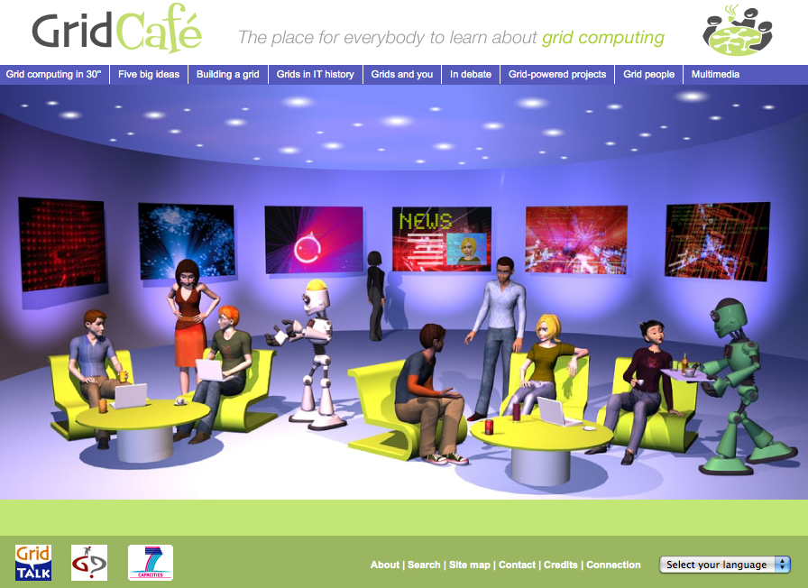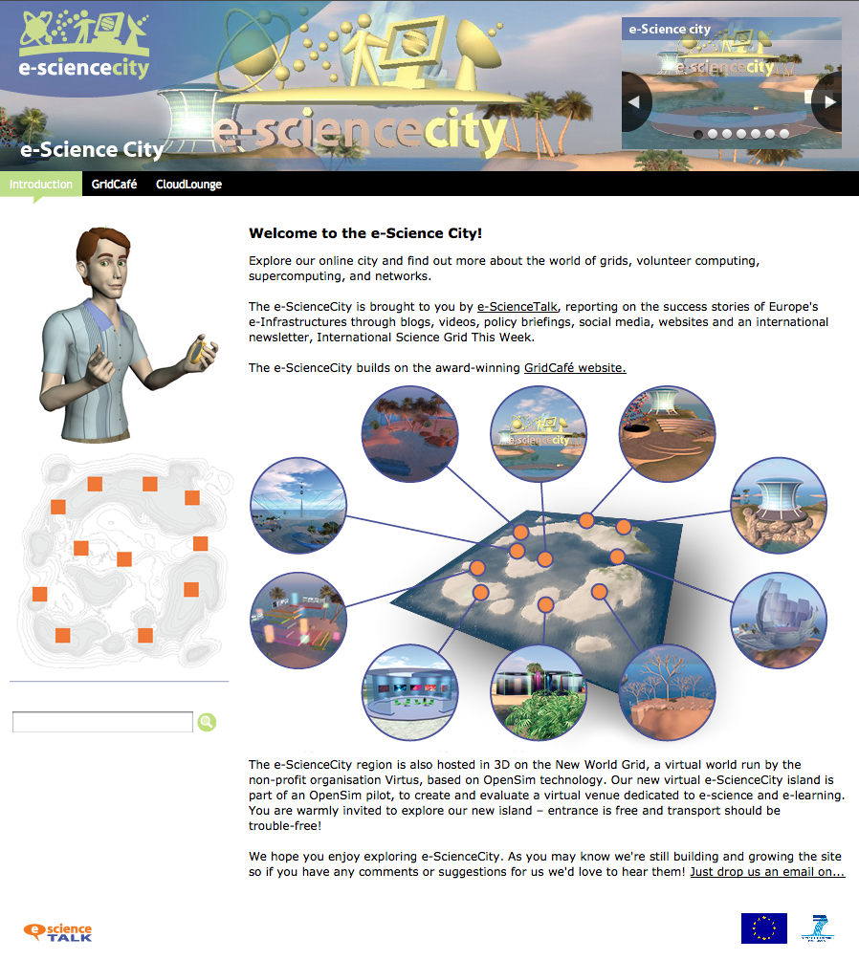

Screenshots of the home pages for the GridCafé and e-ScienceCity websites

As one of the few places where grid computing is presented without bias to a specific grid or project, the GridCafé website is already widely used as a reference by many grid project websites, including the Open Grid Forum (OGF), a standards body for grids and the Enabling Grids for E-sciencE project. GridCafé also featured prominently in the coverage of grid computing during CERN’s publicity campaign surrounding the start up of the Large Hadron Collider in September 2008. Grids were covered in the mainstream press, including on the BBC News website, in the London Times and the Telegraph.

In its first phase, GridTalk redesigned the GridCafé website, keeping the friendly and welcoming feel of the original but introducing 3-D elements, new characters and a simpler navigation system to ensure easy access to all the site’s pages. A new administrative system was developed, which enabled contributors to add materials in a range of languages, and the content of the site was completely revised. The new site has 65 new pages and has attracted more than 320,000 visits from nearly 100,000 visitors since its launch in November 2008, averaging over 5500 visitors per month.

In e-ScienceTalk, this work package will maintain and extend the GridCafé website, keeping it at the cutting edge of grid and science communication. The work package will add further links to demos, videos, games and online interactive tools and will also evaluate the possibilities for extending GridCafé into an interactive environment, such as Second Life, based on the success achieved during pilots conducted in GridTalk. The content of the site will be expanded to cover the interactions between grid computing and other forms of e-Infrastructure, including clouds, supercomputing and networks. Further translations of the site will be launched, including a Chinese version, in collaboration with the iSGTW contributor in Asia.

GridCast

This work package will also continue the GridCast blog site (www.gridcast.org) which enables scientists at grid events to blog about their experiences. The site was initially created before the start of GridTalk, and was redesigned and relaunched in September 2009. In its first year, GridTalk held six GridCast events, filming more than 70 podcasts with over 7300 views on YouTube alone. These events included the Open Grid Forum 23 in June 2008 in Spain, Supercomputing 2008 in the US, Cloudscape in Belgium and Enabling Grids for E-science 2009 in Barcelona. The GridCast blog attracted over 10,000 visitors by October 2009 from up to 80 countries. To promote GridCast’s content to a wider audience, all posts are featured in Google News and Google Alerts. For e-ScienceTalk, the work package will continue to refine the blogging team, providing guidelines for bloggers and advertising the blogs widely in advance, featuring high profile guest bloggers and breaking more news via the blog. The work package will aim to run GridCasts from key grid events, including EGI conferences, the DEISA/PRACE Symposia and TERENA conference and will also aim to broadcast from at least one event in a developing country.

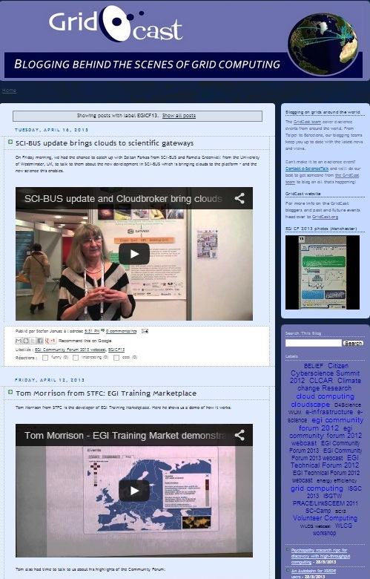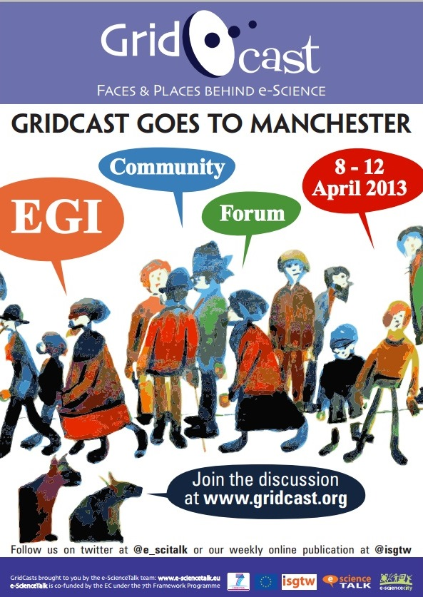

Screenshots and promotional poster for the GridCast blog site

GridGuide and the Real Time Monitor

The GridGuide (www.gridguide.org) gives a human face to the grid, showing the sites and sights of grid computing. Users can listen to podcasts from grid sites worldwide, read about the ongoing work and watch interviews with researchers. GridGuide is the youngest of the GridTalk products, officially launched at the 4th EGEE User Forum in Sicily in March 2009. Individual sites are able to upload content themselves, allowing the GridGuide to grow independently but within the control of e-ScienceTalk. In its first months, the site has gathered together 31 site guides, 52 people profiles, 19 slideshows, 27 videos plus much more, adding up to a total of 250 items on more than 240 pages, and it is still growing. To date, the site has attracted more than 10,000 visitors, representing nearly 20,000 visits. The real impact of the site comes into its own when combined with the 3-D interactive Real Time Monitor (RTM) of GridPP.

The RTM is a 3-D virtual globe that shows live information about the jobs the grid is processing. The Imperial College developers worked with GridTalk to produce a version of the RTM that integrates GridGuide information. By clicking on a site that is also in GridGuide, a site information box opens that includes a feed from the GridGuide pages. At a click, the visitor can see a full picture of information from the site, on a technical and human level. The RTM is widely used for demonstrating the grid at conferences and events across Europe and beyond and is an accessible and engaging way to understand more about the grid. This work package will aim to integrate the recent developments of the RTM with the GridGuide to continue to foster this partnership, with the aim of making the RTM available on a wider range of platforms including as a web application, and ultimately on smart phones. E-ScienceTalk will also aim to increase the number of sites featured in the GridGuide including a higher proportion located outside Europe, representing work both in the grid arena, but also in related areas such as the network layer, supercomputing, volunteer and cloud computing. All the NGIs will be invited to participate, making GridGuide a definitive guide to the institutions that will create the backbone of the new European Grid Infrastructure. This work package will also investigate ensuring continued access to the existing contents of the Digital Library assembled by the BELIEF-II project.

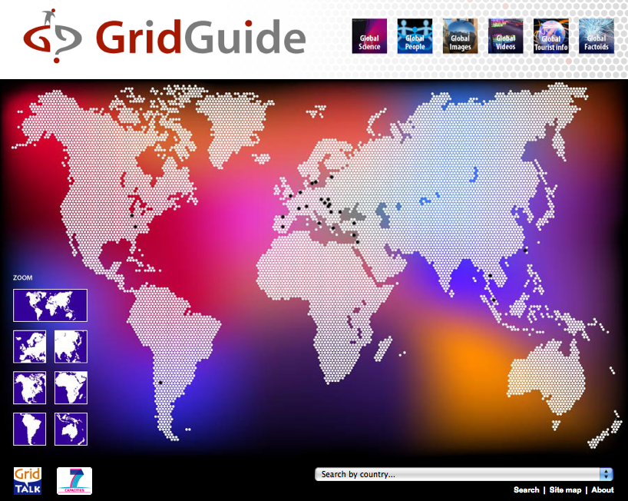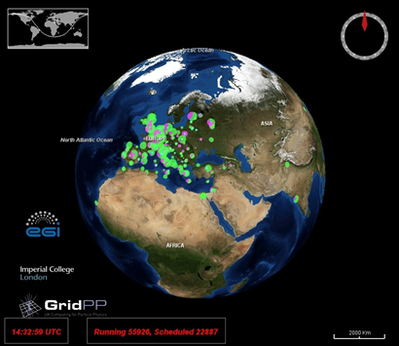

Screenshots of the GridGuide (left) and the Real Time Monitor (right)

This work package will drive the overall branding for e-ScienceTalk, updating the logos and templates for posters and promotional materials such as leaflets and branded giveaway items. WP2 will also refresh the e-ScienceTalk project website, updating the look and feel for the start of the new project, providing information about the project and the project team, links to the e-ScienceTalk websites, downloads and press materials, as well as displaying news feeds from the other e-ScienceTalk websites such as iSGTW. The work package may also investigate updating the names of e-ScienceTalk products to reflect their expansion in scope, such as iSGTW and the GridBriefings. In addition, a full acknowledgement of the source funding (for example, the FP7 logo and the EU flag, EC/e-Infrastructures etc) will be given in all dissemination activities.

For this work package, led by APO with input from Imperial, QMUL and CERN, integration and collaboration with iSGTW will be of particular mutual benefit. The shared resources section will be further developed, exchanging materials and producing collaborative multi-media content. The GridGuide and Real Time Monitor are outstanding tools for communicating the scope and usage of the grid to policy makers, the media and the general public, and will be of significant use to WP1, particularly for the e-concertation events. GridCafé will also include a selection of grid and e-Infrastructure success stories based on the GridBriefings.

1.2.1.3 Objectives for work package 3 – International Science Grid This Week
International Science Grid This Week (www.isgtw.org) is a free weekly online newsletter that promotes grid computing around the world by sharing stories of grid-empowered science and scientific discoveries. ISGTW was launched in November 2006, and is now produced through a collaboration between GridTalk and Open Science Grid (OSG) in the US. During the first year of GridTalk, 50 weekly issues of iSGTW were produced and after 18 months there are now over 5800 subscribers, a 65% increase since the start of GridTalk. Over the same period, the iSGTW website saw 235,300 page views, with its readership coming from a total of 196 countries. In total 62 separate European projects were covered during the first year, and 46 American projects. The first year reviewers noted the increase in subscribers, and commended the project team’s ‘flexibility and creativity’ in surpassing the original goal of increasing iSGTW subscriptions by 25% in year one “through proactive marketing linked to conference registrations.” Some examples of these marketing materials − posters displayed at events − are shown below.

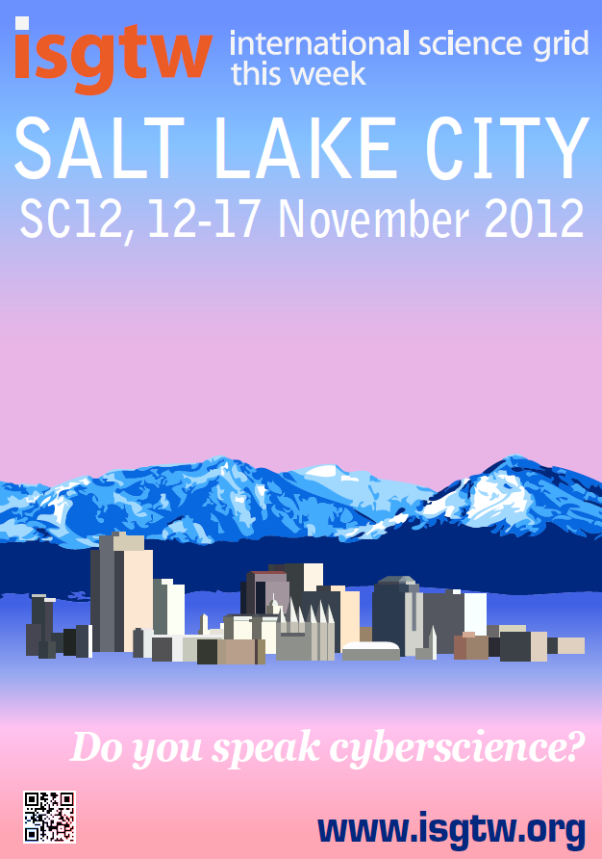

Publicity materials produced for iSGTW for events
Although iSGTW is a successful dissemination tool for the multi-science grid projects EGEE and OSG, it is apparent from readership feedback that the appeal of this newsletter lies in its much wider scope and selection of subject matter. The newsletter covers a broad range of national and regional grid projects, as well as related developments in the wider world of distributed computing and supercomputing. During the first year of GridTalk, iSGTW ran two month-long themed series, one on particle physics and the LHC and a second on women in information technology. In an effort to attract and retain readers, iSGTW also covered stories on more unusual topics such as combating real-life, modern day pirates, earthquake prediction in Asia and innovative European art repositories. These stories often prove to be popular with other media outlets, and several have been reprinted in other online publications such as SupercomputingOnline and PhysOrg. Short readership surveys were conducted every six months, confirming that the iSGTW readership is happy with the publication and is keen to see a variety of topics covered, including the applications supported by the grid.

To enhance the online profile of iSGTW and to expand its readership, iSGTW set up a Facebook site to act as a community discussion area for beginners to the grid, and launched a forum on the prestigious Nature Networks site, a development that was strongly endorsed by the first year reviewers. Nature Networks is an online scientific community, hosted by the journal Nature, where scientists can keep in touch with colleagues and discuss research and scientific issues. The iSGTW forum was featured on the home page of the Nature Networks site, a page that attracts millions of hits per year. ISGTW also tags articles so that items relevant to particular topics can be extracted from the archives and compiled into themed publications, such as the “EGEE in the iSGTW headlines” publications, produced by EGEE in April 2008, 2009 and 2010.

ISGTW is currently produced by a full-time European editor working in close collaboration with a US editor, based at Fermilab. Each editor publishes iSGTW on alternate weeks and reports to an Advisory Board that comprises members of EGEE, CERN, Fermilab and OSG. This has proved to be a highly productive partnership and OSG through TeraGrid has committed to a future phase of GridTalk and iSGTW via a formal Letter of Support accompanying this document. All technical support and maintenance for the iSGTW website is provided by Xenomedia, and all costs for this support are covered by OSG, an arrangement that will continue for the second phase. E-ScienceTalk will continue to fund the iSGTW European editor based at CERN, who will be jointly responsible (with the US editor) for locating stories, researching, interviewing, writing original content, fact-checking, locating illustrations, editing and proofreading each issue of iSGTW, as well as acting as day-to-day webmaster.

An important new development for e-ScienceTalk will be a new name for the publication and this will go hand-in-hand with a major redesign and relaunch of the publication. The relaunch will be enabled by a comprehensive upgrade to the underlying web content management system powering the publication, an essential replacement for the current older system. The upgrade will allow for significantly increased functionality, such as the ability to comment on stories and rate them, share stories through social media sites, run surveys and polls of the week and incorporate multimedia content more easily, effectively future-proofing the publication for the duration of e-ScienceTalk. The upgrade will be implemented by Xenomedia, and the one-off costs of this upgrade will be funded equally by OSG and e-ScienceTalk. The relaunch will allow the readers to engage more deeply with iSGTW, building up an active community around the publication. This interactivity will be enhanced by the Nature Network forums, which if successful during GridTalk, will be expanded in the second phase of the project to become a key resource for working scientists to find out more about grid computing and e-Infrastructures and to discuss the issues of the day.

A second key advance for iSGTW during e-ScienceTalk, which will be reflected in its new name, will be an expansion of the variety of topics covered. While grid computing will remain at the publication’s core, the impact of technologies such as supercomputing, the network layer, data and cloud computing on grid development and on e-Science will also be covered. This will reflect the current readers’ interest in new and varied topics, a greater proportion of whom are now describing themselves as researchers rather than IT developers. Covering new areas will also help to make the publication appealing to readers from new fields, enabling iSGTW to grow its readership further during e-ScienceTalk by at least 30%. While this expansion in topics is driven by the readers’ feedback, it also seen to be essential by the Advisory Board in order to allow the publication to grow and develop as grid computing and e-Infrastructures themselves develop and become more integrated.

This expansion will be supported by additional writing resource that will become available through a collaboration with a new contributor based in Asia, which will be available to e-ScienceTalk as unfunded effort. E-ScienceTalk will also fund an additional post for a Science Writer and Dissemination Officer at CERN who will write for iSGTW, while also making significant contributions to WP1 and WP2. As well as increasing the scope of the topics covered, these additional resources will allow for more exclusive stories and longer, more in-depth, multi-source stories to be produced – something that iSGTW’s readers have consistently asked for in the readership surveys. ISGTW will also seek to recruit a student intern to work on the publication for up to 3 months, based either at CERN, Imperial or QMUL in collaboration with Science Communication degree courses. An internship was completed successfully during GridTalk by a student from the MSc in Science Communication at Imperial College, who advanced the marketing plan and contributed several articles at minimal cost to the project.

WP3, led by CERN with input from QMUL and APO, will integrate very closely with the other work packages in e-ScienceTalk. Articles for iSGTW can readily be adapted for use in the e-ScienceBriefings produced by WP1, and case studies discussed in the e-ScienceBriefings may also lead to full articles in iSGTW. The shared resources area between iSGTW and the GridCafé will continue to expand during e-ScienceTalk, and features and articles written for iSGTW can be included as web content in the GridCafé, GridCast and GridGuide sites.

1.2.1.4 Objectives for work package 4 – Management

The objectives for the management work package are to ensure that the e-ScienceTalk project is run effectively and achieves its overall objectives in reaching out to its key audiences of policy makers, the scientific community, students and the general public. The work package will coordinate all the various activities for e-ScienceTalk and will also monitor progress. This will be achieved by recording a range of metrics, but also through surveys of the iSGTW readers, conducting interviews and questionnaires at conferences attended by the grid and e-Infrastructure community, through the impact and sustainability reports of WP1 and also by acting on the feedback from the Project Management Board. This work package will also assist the EC in the organisation of information days, concertation meetings and brainstorming activities including access to videconferencing facilities. WP4 will also draw on the outputs of the final reports from each of the work packages to produce an overall guide to dissemination for EU-funded projects, based on the experience gained and lessons learnt from both the GridTalk and e-ScienceTalk projects. In this way, a strong synergy between the four work packages exists and can be exploited very effectively by this support action.

1.2.1.5 Objectives summary table

Key objectives of the Capacities Research Infrastructures Work Programme call  INFRA-2010-3.3 | E-ScienceTalk’s relevance to these objectives
Proposals will aim at providing support for e-Infrastructures, including the coordination between national and pan-European e-Infrastructure initiatives and programmes… | E-ScienceTalk will act as a key communication channel between the National Grid Initiatives, EGI.eu and dissemination teams in other e-Infrastructure projects, helping to coordinate their dissemination activities to deliver a clear message about the evolution of Europe’s grid computing and e-Infrastructure services during the transition to EGI. GridTalk established a wide range of contacts across more than 60 European projects and will bring this high level of collaboration to e-ScienceTalk. The project has received Letters of Support from a number of European projects covering countries across Europe and beyond, and this document sets out concrete plans for how e-ScienceTalk will work particularly closely with EGI, DEISA, PRACE, GÉANT, OpenAIRE, OSG and others.  E-ScienceTalk will form a key element in a network of dissemination hubs, including the dissemination teams of EGI.eu, EMI, the NGIs and others. Each of these hubs will target different audiences, whether users from a particular scientific community, users located in a particular country or region, middleware developers or owners and managers of the grid resources. As a dissemination project with international scope, e-ScienceTalk will be well placed to distribute its products via the hubs for these specialist networks and hence reach a much wider audience. In turn, e-ScienceTalk will be able to offer its well established networks of media contacts, policy makers and its general public-focused products as channels for success stories from the various communities. E-ScienceTalk will focus on collaboration with the dissemination teams of EGI.eu and DANTE. According to the EGI Blueprint, the dissemination team for EGI.eu will “focus on content production and coordinating activities” and “support and coordinate the publication work of EGI”. E-ScienceTalk’s products will provide ideal channels for disseminating the outputs from these teams.  For example, the GridCafé website is a standard resource for an authoritative and unbiased introduction to grids for the general public. ISGTW reaches over 5800 subscribers from across a wide range science communities, and e-ScienceTalk aims to increase this by at least a further 30%. This anticipated growth in readership will be coupled to an increasingly community-based dimension to iSGTW. This will be achieved through its contributions on grid computing and e-Infrastructures to the Nature Networks forum, the introduction of a reader comment facility on articles that will be available in the relaunched iSGTW, as well as reader polls and the ability to share stories through social media sites. The community contributions encouraged during GridTalk will be extended during e-ScienceTalk to include blogging through the GridCast website, and coordination of e-concertation activities in the e-Infrastructure area.
..specific studies on e-Infrastructure related topics, in particular to evaluate the impact of the e-Infrastructure programme including the establishment of appropriate indicators… | Responding to the review comments for GridTalk, the e-ScienceTalk project will seek to evaluate more closely the impact of long running products such as GridCafé and iSGTW on their audiences, as well as the impact of the younger products. In turn, this will shed light on the impact of the e-Infrastructure programme itself on policy makers, innovators, the e-Science community and the general public. E-ScienceTalk will gather and analyse metrics relating to the GridTalk products, such as the readership figures for iSGTW and the profile of this readership by conducting annual readership surveys. Through web statistics, it is also possible to assess which types of stories gain the most attention from the community and to follow this up with more in-depth one-to-one interviews. The general and trade press also pick up certain iSGTW stories and redistribute them to their own readership, for example a feature on tracking down pirates off the Horn of Africa, and another on resurrecting an ancient Greek musical instrument using the grid. By evaluating which stories gain a wider a readership, it will also be possible to understand the impact the research has had on the general public.  By monitoring which areas of GridCafé website are most frequented, this will also add to our knowledge of where gaps in understanding still exist among the general public regarding e-Infrastructures and build up a fuller picture of where future dissemination projects should focus their efforts. Tracking the usage of the GridTalk products through readership surveys, questionnaires and interviews with delegates at key conferences will all help to extend our insight. By making the results of these studies available to other EC-funded projects through open access channels such as the BELIEF Digital Library and OpenAIRE, e-ScienceTalk will also contribute to the sustainability of the e-ScienceTalk products. E-ScienceTalk will also draw together the final deliverables from each of the work packages to produce an overall guide to dissemination for EC-funded projects, based on the experience gained and lessons learnt during both phases of the project.
...support actions for the dissemination of information on the e-Infrastructure programme and project results as well as for project concertation. | The principle aim of e-ScienceTalk’s work packages will be to disseminate the success stories and impact of grid computing and e-Infrastructures. These stories will come from the e-Infrastructure’s flagship pan-European projects but also from a whole host of smaller and emerging projects, who have limited effort available for dissemination and limited networks of contacts and collaborating partners. By giving these projects access to e-ScienceTalk’s wide variety of dissemination channels, including websites, blogs, social media sites, weekly publications, events, conference booths and printed materials, their results can be disseminated far more widely and to a greater range of audiences than would otherwise be possible. This audience reaches beyond Europe to the US through the US editor for iSGTW and the collaboration with OSG, to Asia through partnership with ASGC and EUAsiaGrid and to Latin America through REUNA. Collaborating with projects with an international scope such as SIENA and others opens up an even wider global audience for the European e-Infrastructure programme project results.
…international cooperation including promotion of the interoperation between similar infrastructures on the global scale with the aim of reinforcing global relevance and impact of European e-Infrastructures. | E-ScienceTalk will work with the other projects such as GÉANT, DANTE and DEISA/PRACE to disseminate the interdependencies of Europe’s e-Infrastructures through the eScienceBriefings, articles in iSGTW and by expanding the content of the GridCafé. Through the policy impact work package, e-ScienceTalk will also work closely with e-IRG and the European Strategy Forum on Research Infrastructures (ESFRI) projects who are currently involved in building a united roadmap for the development of e-Infrastructures in Europe that are user relevant and appeal to a wide variety of disciplines including social science and the humanities. E-ScienceTalk will aim to bring the progress of this roadmap to all its audiences in Europe and beyond. For example, the e-ScienceBriefings produced by WP1 will be circulated to a wider audience beyond Europe, including the US, Asia and Latin America. The GridCafé will feature success stories from beyond Europe contributed by collaborating projects such as ASGC, REUNA and EUAsiaGrid. The GridGuide will also feature an increasing number of sites outside Europe, and GridCast will blog from at least one non-European event. ISGTW is by nature an international publication as it is a joint EU-US initiative, covering projects from Europe and the US, as well as increasingly from Asia, Latin America and Africa.

1.2.2 Work progress and achievements during the period

1.2.2.1 WP1: Policy, impact and sustainability

The main outputs from the policy, impact and sustainability work package have been in the areas of events, e-ScienceBriefings and policy related GridCasts. The work package leader also worked to consolidate the framework within which policy consultation takes place, liaising with the policy advisory group. This consists of the e-IRG Board, with additional advisors, for example from the EGI-InSPIRE project, from the European Middleware Initiative and others. The collaboration with e-IRG is formalised in a Memorandum of Understanding signed between e-ScienceTalk and e-IRGSP2/3 during PY1.

Distribution of the briefings

The e-ScienceBriefings are mostly available in both printable pdf and html format, which improves the likelihood of them being indexed by search engines and facilitates the addition of additional links and multimedia resources. The briefings are disseminated through iSGTW, GridCast, Twitter, selected briefings in GridCafé and e-IRG newsletters. They are also distributed by email to all contributing organisation and the EGI mailing lists. Printed versions of the reports have also been distributed through booths at several events during the year, including the EGI Technical Forum 2012, ISGC 2013, Cloudscape V, EGI Community Forum 2013, 5th CAPRI meeting, eChallenges 2012 and e-IRG workshops. An RSS feed has been set up to allow readers to subscribe to e-ScienceBriefings. This feed is now displayed on the EGI.eu website and the release of the briefings is announced on the news feed. In PM13, a self-subscription mailing list was set up to allow people to sign up to receive the latest briefings and now has 164 subscribers, an increase of 22% since last year.

The briefings produced this year are:

- October 2012: Transferring Technology and Knowledge
Transfer of people, of ideas and of technologies continues to feed into and out of the e-science ecosystem. There are sometimes challenges in commercialising ideas coming out of academia, but scientists are becoming more adept at doing so as larger cultural changes take hold. Commercial models like cloud equally finding a place in public research settings.
.
- November 2012: Big Data
Big Data in science is a challenge requiring input across and between disciplines, and even outside the realms of academic science towards the citizen scientist. But there are tremendous benefits to having so much data available to science: for one, it allows us to test and modify theories as never before, with greater accuracy.

- February 2013: The Security Issue
E-Science faces the same challenges of authentication, universal identity management, and authorisation as many other web services. But with the number of researchers using such services in light of the growing importance placed on Big Data for life sciences and e-Health, for example, it is important that access to them is properly and securely controlled.

- April 2013: Horizon2020
How Horizon 2020 affects e-infrastructures, virtual research environments and coordinating activities, and the opportunities it brings in allowing science to work more closely with industry and wider society.

In PY3, e-ScienceBriefings have included case studies, quotes and information from 59 projects. On 31st August 2013, the number of total downloads stood at 17,300. Although maintaining a wide circulation of printed briefings is important, many more people download copies, and feedback from surveys reveals that people often forward the PDFs to colleagues. Data from the D1.5 Annual Impact and Sustainability Report revealed that the briefings are shared on regular basis through a variety of ways. Unfortunately, if a briefing is forwarded via email, it cannot be tracked. Since implementing AddThis Share information on the e-ScienceBriefings page in April 2012, 26 people have tweeted the main e-ScienceBriefings page and 10 people have shared the page with others, with 550 views via v.gd link shortening.

Events organisation and attendance

The team has organised one policy event in PY3, the 10th e-Infrastructure Concertation meeting, which attracted 130 delegates from a number of countries. WP1 and WP4 coordinated the logistics for the meeting, which took place in Brussels in March 2013. The two-day event attracted 130 delegates including representatives from the e-Infrastructure landscape, policy makers and funding agencies, representing 80 projects. Over the course of the two days, there were 51 visits to the e-ScienceTalk page, and 212 visits to the GridCast blog. Andrew Purcell’s spotlight in iSGTW (E-infrastructure success stories) received 5 ‘Likes’ on Facebook, and 201 page views (147 unique pageviews) with an average time of four minutes and thirteen seconds spent reading the content.

The WP1 team have also attended several policy oriented events in PY3, to report on them for the GridCast blog, to research information for the briefings and to distribute the briefings.

- EGI Community Forum 2013, Manchester
- e-IRG workshop, Amsterdam
- EGI Technical Forum 2012, Prague
- CloudScape V, Brussels
- XSEDE’13, San Diego

Impact and sustainability

In response to the reviewers’ comments at the PY1 and PY2 Reviews for e-ScienceTalk, WP1 has investigated the impact of its products and explored options for sustainability through a series of annual reports. WP1 led on producing D1.5 Annual Impact and Sustainability Report and had a significant input into D4.5 Annual Report on Feedback and Metrics together with WP4. The report concludes that the impact of most ScienceTalk products is significant and each product is reaching its intended audiences.

E-ScienceTalk’s impact has been measured by quantitative analyses using key metrics set out during the project’s initiation in September 2010, then updated at the end of PY1 in response to the reviewers comments at the 1st Periodic Review. Qualitative assessment of the project’s impact and reach has also been collected from surveys, focus groups, expert advisory panels and from anecdotal reports from individuals working in scientific research and science policy. Quantitative research has been carried out using surveys, web analytics, webometric tools and social media measurement tools.

The project has been successful in reaching a wide audience through its social media channels (@isgtw and @e_scitalk. It has amassed 4,000 followers, and the quality of followers is also high with a large number of influential followers with wide spheres of influence. e-ScienceTalk has signed a Memoranda of Understanding with 19 projects. The project team has also developed spin-off training and consultancy in a number of different areas, which was beyond the scope of the original project (e.g. blogging, science writing, event logistics, media outreach and newsletters). The project has also successfully coordinated three e-concertation meetings. The team has developed a Guide to Dissemination for the EC, and has also written a peer-reviewed academic paper on measuring the impact of e-science/e-infrastructure outreach.

E-ScienceBriefings continue their expanding coverage of e-infrastructure and e-science policy-related issues for policy makers in industry and governments throughout Europe. Although more of a niche publication, they are well-known within the community and highly regarded as a quick reference guide to topics. In the last year and a half, there have been 17,281 downloads.

The GridCafé has been expanded by integrating it within a larger ‘e-Science City’. The new website is gradually attracting more interest and several e-science topics are fully covered (e.g. HPC, volunteer computing, data and cloud technologies). GridCast continues to support the sense of community for participants in e-infrastructure and distributed computing across the globe, with traffic increasing year on year. It has attracted many more readers with highest views taking place in May 2013. To maintain visibility in the next year, five Star Bloggers have been recruited to keep GridCast active with the European Grid Infrastructure (EGI) dissemination team taking over responsibility for coordinating major GridCasts. There is evidence to show that the blog is also regularly read by the mainstream computer science press. GridGuide has seen an increase in the number of sites covered in line with targets, and has now been integrated into e-ScienceCity as GridPort. The Real Time Monitor is increasingly being used as a visual tool for educators explaining the potential of the grid. During e-ScienceTalk, approximately 30,000 people have viewed the RTM at conferences. Towards the end of 2013, the RTM will be adopted by the London Science Museum for its LHC Collider exhibition, which means it could be potentially seen by 1.5 million people — 50 times the number that have seen it at e-science conferences.

Identified by e-ScienceTalk team members as one of the most successful products, International Science Grid This Week has seen its readership increase to over 3,000 followers on social media and 8,770 subscribers. Traffic to the site has quadrupled during the project. The project has also successfully negotiated funding for the iSGTW Editor at CERN in Geneva and a US Desk Editor at Indiana University to continue after the close of e-ScienceTalk.

Strategies for sustainability rely heavily on the success the project has experienced in establishing individual product brands and the ongoing commitment of the project consortium, in addition to the network of support partners with whom MoUs have been established (BlogForever, CHAIN, CRISP, EDGI, EGI, e-IRGSP3, EMI, ERINA+, EU-IndiaGrid, EUDAT, GISELA, Global Excursion, iMENTORS, LINKSCEEM, N4U, SHIWA, Ubuntunet, Virtus and WeNMR). For the e-ScienceBriefings, time and effort is needed to curate future issues and a sponsor would need to have overarching policy aims in a European context. The GridCast site requires some funded effort for moderation and coordination of the volunteer blogger contributions, plus the video posts are a major draw and again require professional production. Contributions could be funded on a per event basis, perhaps through media partnerships. Maintenance of e-ScienceCity now all areas are complete is expected to be low – however new partners would be needed to develop content for new sections. For the RTM, development work is needed to sustain and update the underlying WorldWind platform, and to introduce new datasets. GridGuide is now sustained through incorporation into the e-ScienceCity. ISGTW continues to nurture a network of unfunded contributors from a wide range of projects in all its contributing regions. Work has continued during PY3 to position iSGTW as a preferred channel for the research community and major e-Infrastructures in Europe. US funds have now been secured for the US Editor for the next 3 years and funding is needed to support the EU Editor role beyond e-ScienceTalk.

1.2.2.2 WP2: GridCafé, GridGuide, GridCast

WP2 is responsible for e-ScienceTalk’s suite of interactive websites, Gridcafé, GridCast and GridGuide, as well as the main project website and the Real Time Monitor. During PY3, the work package also produced promotional materials, such as posters to advertise the e-ScienceCity, GridCasts and iSGTW at a number of events, as described below. A summary of web statistics for PY3 for each site is listed below:

e-ScienceTalk | e-ScienceCity | GridCafe | GridGuide | GridCast blog | Cloud Lounge
1372 unique visitors  3656 pages viewed  00:01:20 duration  68% bounce rate  65% new visits | 3703 unique visitors  13,122 pages viewed  00:04:22 duration  65% bounce rate  77% new visits | 3387 unique visitors  6566 pages viewed  00:01:09 duration  73% bounce rate  80% new visits | 645 unique visitors  1082 pages viewed  00:00:54 duration  84% bounce rate  77% new visits | 8925 unique visitors  16,943 pages viewed  00:01:18 duration  74% bounce rate  79% new visits | 9222 unique visitors  17,834 pages viewed  00:01:30 duration  79% bounce rate  89% new visits

e-ScienceCity and GridCafé

When the GridCafé website was first developed, it was a novel form of science communication that was nominated for awards. However, in order to fulfill the objective of keeping the GridCafé at the cutting edge WP2 needed to explore interactive environments and new web tools. The aim at the start of the project was to create a simple virtual 3D on the OpenSim platform. Standard 3D tools would be used to create the content, so that it could be transferred to a different platform if OpenSim proved not to be a sustainable solution.

A second aim was to develop new content areas of the website that covered other areas of e-infrastructures and distributed computing. Development of parallel GridCafé and other websites, such as CloudLounge proved to be impractical and went counter to the feedback from the audiences who prefer integrated websites, so a home website called the e-ScienceCity was developed in PY1. This involved the creation of a new concept of website, with new ways to navigate through the different zones of the virtual city. The structure and navigation for the 2D website ties in closely with the structure of the associated 3D virtual world and uses a hybrid technology: a unique dynamic menu, with static html content, in order to be able to update content with standard tools, avoid technologic problems like the use of Cyrillic alphabet and allow simple maintenance for the future.

The GridCafé website main content areas were migrated to the e-ScienceCity template at the end of PY1. The formal launch of the e-ScienceCity and the CloudLounge was in PM13. Areas on volunteer computing (Volunteer Garage), supercomputing (HPC Tower) and data (Data Park) have also been published live. Central areas are also now available, including the Communications Centre for news and briefings, People Bay which includes profiles from people working in grid, and GridPort which includes the GridGuide sites. A marketing plan has been followed to drive traffic to the new site including the use of wikipedia, social media, iSGTW links, internal linking, an offline schools pack, and promotion at conference. Web statistics for the e-ScienceCity are gradually improving, particularly for longer running sites such as Cloud Lounge.

Virtual worlds are increasingly popular for social networking, gaming and learning. In developing a pilot 3D site, e-ScienceTalk has partnered with Virtus, a non-profit association and New World Grid. The e-ScienceTalk team is benefiting from technical help from the NWG team, and from the team and community spirit of the users and has signed an MoU with the umbrella Virtus organization. The virtual world version of the site was launched in early PY2, and experienced good levels of visits throughout PY3.

GridCast

A number of GridCasts have been held during the third year. At most GridCasts, one or more members of the e-ScienceTalk team attended the event, blogging and in some cases recording video at the event. Some of the GridCasts have been organised remotely, such as the ENVRI and Helix-Nebula meetings. At most events, the e-ScienceTalk team was supplemented bloggers from other projects and organisations, such as EGI-InSPIRE, the Oxford e-Research Centre, the Software Sustainability Institute, CERN and the University of Melbourne. The details of some of the GridCasts are listed below.

- EGI Technical Forum 2012, Prague
- eChallenges 2012, Lisbon
- EUDAT Annual meeting, Barcelona
- eIRG meeting, Amsterdam
- CloudScape V, Brusssels
- 10th e-Infrastructure Concertation meeting, Brussels
- International Symposium on Grids and Cloud 2013, Taipei
- EGI Community Forum 2013, Manchester
- 5th CAPRI Evaluation Meeting, Utrecht
- e-IRG workshop, Dublin
- ISC’13, Leipzig
- XSEDE’13, San Diego
In PY3, we have the maximum number of bloggers on the Blogger platform, over 100. This year, e-ScienceTalk has a total of 115 blog entries, 31 podcasts and 20 bloggers. On average, there have been 6 bloggers for all major GridCasts. The number of unique visitors has increased by 78%. The videos produced at GridCasts over the years have now been viewed nearly 250,000 times in YouTube.

The aim for GridCast during e-ScienceTalk, in comparison to GridTalk, has been to develop new types of blog post, such as editorial-style posts and feature guest bloggers from outside the usual community, such as from industry. Longer videos, such as conference overviews and on-camera face-to-face interviews, in a change to the more common off camera demo style videos have also been continued during PY3.

GridGuide / Real Time Monitor

The current version of the GridGuide is available at http://www.gridguide.org and the Real Time Monitor can be downloaded as a standalone application from http://rtm.hep.ph.ic.ac.uk/ or launched as a Java Webstart version.

In PY3, 54 countries are included in the RTM and the team has visited six events where the RTM has been demonstrated. These included Supercomputing ‘12, EGI Technical Forum 2012 and EGI Community Forum 2013, ISC 2013, the European Conference on Computational Biology and the 9th European Biophysics Congress. Additionally, the RTM was shown at multiple locations for the UK Particle Physics Masterclass series of events.

In the third project year, the team worked to increase the number of sites within the GridGuide to the target of 100. In Q11, a number of new sites were added from both grid-only and grid/e-science resource providers from around the world, bringing the total to 102.

The total includes 21 in North America, 5 in South America, 53 in Europe, 7 in Africa, 9 in Asia and 7 in Oceania. This represents an additional 72 sites since the start of the project. Of these, 59 of the biggest grid sites (in terms of number grid jobs sent, received and processed) are also currently included in the Real Time Monitor, ensuring that the system focuses on those sites that are most involved in the global grid community.

Prior to the start of the e-ScienceTalk project the RTM was upgraded to the latest version of the WorldWind software. Since the start of e-ScienceTalk the RTM has kept abreast of developments of WorldWind and the move to the next full version has been completed during PY3. In PY3 efforts have been made to develop better communications channels with system admins at grid Sites, to ensure that new and existing sites on the RTM have the correct data and to prevent sites disappearing.

The aim for PY3 has been to complete the transfer to the latest version of WorldWind, fully integrate the CMS data transfers, continue to ensure that the application displays up-to-date and accurate information and investigate displaying data from new sources and infrastructures.

During PY3, the UK Science Museum expressed an interest in including the Real Time Monitor in their LHC exhibition, Collider. Collider will open on 13 of November 2013 and run for six months. The developer has worked on a number of features that will make the RTM more accessible and visually appealing to the tens of thousands of visitors that will visit the exhibition.

1.2.2.3 WP3: iSGTW

During PY3 the trend for more rapid social media growth and more modest growth in weekly subscriptions that had begun in PY2 continued, reflecting a change in the habits of our readership largely in line with trends reported by other online news sources. A greater proportion of the audience arrives at iSGTW articles through links from Twitter and blog posts. While readers are reaching iSGTW in a more piecemeal fashion, therefore, the audience is very likely broader and more diverse.

Despite WP3 having lost effort in PM29, the publication has continued to send out a high quality issues with a spread of articles from across the globe. In PM27, a new US Desk Editor was hired and funded through the National Science Foundation, based at the University of Indiana. iSGTW has managed both of these changes to deliver a consistently high-quality publication. Q11 saw peak unique visitor numbers, page views and visit duration for the entire project. iSGTW’s audience is not only much larger than at the start of the project, but readers are also more engaged (spending longer on visits, and reading more pages per visit).

ISGTW published slightly fewer issues than last year (48 in PY2 vs. 47 in PY2). While the number of subscriptions has levelled off in the last year, the promotional focus has been on social media followers. The number of twitter followers has increased by 530% (341 to 1,796). Up to 179 countries and territories accessed the website on average during PY3. The number of unique visitors to the website has increased by one third and the number of page views has also more than doubled.

From 29th May 2013, iSGTW produced issues with 2 rather than 3 feature articles, together with a spotlight article and a ‘visual’, and article focusing on an image or video. The total number of articles published has therefore decreased in PY3 compared to PY2. This however places the magazine at a sustainable level of content at the reduced effort levels, meaning that the magazine will continue to be issued weekly by the EU and US editors after the end of July 2013. The magazine has continued to include a wide geographical spread of articles, covering 71 European articles and 85 US articles..

The iSGTW Advisory Board has continued to meet and includes representatives from CERN, Fermilab, EGI.eu, OSG and QMUL and a representative from ASGC in Taiwan.

The media form an increasing proportion of iSGTW’s readers, as shown by the annual readership survey. As a result, iSGTW’s stories are increasing being ‘picked up’ by other media including Symmetry, HPCwire, Discovery News and Wired, increasing traffic to the publication and widening the audience.

iSGTW and social media

There have been 440,164 unique visitors visiting the iSGTW website and 1,038,455 page views since the start of the e-Science talk project. This is considerably more traffic than during the previous project, GridTalk. Generally, the website attracts between round 10,000 and 18,000 unique visitors a month, and numbers have climbed further towards the end of the project.

The publication has also significantly increased its proportion of female readers over the last few years to around one quarter but has struggled to achieve similar increases in the number of young readers who come to the site.

During the e-ScienceTalk project, iSGTW has been effective in achieving its aims of driving up its subscriptions and social media activity. Thanks to a proactive marketing strategy implemented in May 2011, iSGTW has been able to increase subscriber numbers by 30% during the project, as well as significantly increasing the number of number of social media followers (1,726 Twitter followers, 68 Google pluses and 1,167 Facebook). This marketing strategy comprised five methods for increasing iSGTW’s impact: (1) conferences and events; (2) media partnerships; (3) collaborating projects; (4) online promotion, including the newsletter, search engines and social media; and (5) setting up iSGTW as a social media site itself. While the rate of increase in subscriber numbers has slowed during PY3, with a slight upturn towards the end of the project, this has been compensated for by a rapid increase in the number of people who follow the publication through its social media channels.

As well as being a highly valuable source of article leads, conferences have proved an effective way to increase exposure and reach out to new communities. The Twitter hashtag from events can be used to promote stories and to respond to news and developments at the conference. Media partnerships give iSGTW a chance to offer delegates at the events the opportunity to sign up to the newsletter. Partnerships with other projects have helped us to increase our subscriber numbers further.

Finally, with regards to our social media strategy, the editorial team have found this to be a vital tool in promoting the site and expanding the audience. The key to a successful social media strategy has been an increased regularity and frequency of posting. For this, as well as tracking the reach of posts, there are various useful online tools available. As well as well-known social media outlets, such as Twitter, Facebook, and Google+, academic and professional social networks have been of use, such as LinkedIn, MyScienceWork, and ResearchGate. Other blogging and content aggregator sites, such as Reddit, StumbleUpon, Slashdot, Nature Networks, and Digg, have also been key tools in enabling us to successfully expand our audience..

Annual readership survey

iSGTW has surveyed its readership using an online tool called Zoomerang . The PY3 survey had 17 questions in total and was completed by 113 respondents. As with previous years, many of the questions are identical to the year before in order to help compare the results. This year, however, a number of the questions are also directly related to short and long-term impacts.

The results suggest that iSGTW has quite a dedicated audience, with a comfortable majority of respondents reporting that they read at least three out of every four issues. Meanwhile, a further third report that they read at least half of the issues.

The survey gives us the impression of a highly engaged readership, with 80 per cent of respondents saying that they have ‘discussed or forwarded an article or issue’. Well over half of respondents also reported that they had saved or bookmarked an article or issue. Significant numbers of respondents report that they have attended an event based on information they have found on our site, or have themselves submitted an event or job announcement to our site. 15% of respondents also said that they had themselves contributed in some way to the newsletter at some point and 17% said they had used iSGTW to source an image. In addition, 13% of respondents reported that they had either cited or linked to iSGTW in a blog, paper, poster or talk.

Respondents reported that iSGTW is pitched at roughly the right technical level, is relatively easy to navigate, covers a good spread of topics and regions, and is a useful and informative resource for readers. Readers were also asked to tell us which topics they most like to read about. The most popular topics were broadly the same ones as in recent years. As far as academic subjects are concerned, ‘physics and astronomy’ once more proved to be the most popular choice and ‘future computing technology’ came out on top in terms of the infrastructure related topics. The consistency of the responses to this survey question over the last three years suggests that these results accurately reflect our readers’ tastes.

Over two thirds of people felt that iSGTW has raised awareness of particular e-science tools, services, resources, projects, initiatives, and/or potential collaborators. Over a third of respondents reported that iSGTW has helped them with their research work and others reported that iSGTW had helped improve the exposure of their work and that iSGTW is a useful resource in terms of establishing new research collaborations. However, as with last year, only around half of respondents reported that they ‘agree’ or ‘strongly agree’ with the statement and “I use iSGTW to keep informed about events and announcements”.

Again, as for PY2, around 10% of respondents have reported that they work in the media. This suggests that we have significant ‘second order impact’ through the articles which are inspired as a result of journalists and other communications workers reading iSGTW. Despite a reasonably high number of people reporting that they are involved in grid computing, only around half reported that they like to read about this topic. This suggests that the decision to broaden the range of computing topics we cover at iSGTW was a good one. Volunteer and cloud computing came out on top as the subjects respondents most like to read about. Despite the large number of respondents reporting that they like to read about volunteer computing, only one fifth reported that they are currently involved with such projects. As such, our coverage of volunteer computing has the potential to act as a way of mobilising people to become involved with these projects themselves.

In terms of the age demographic of our readership, the results are almost identical to those attained the last two years. Yet again, 31-40 is the largest category and the growth in readers aged 51-60 has continued. However, we still seem to be struggling to target younger, typical university-aged students, with just 10% of respondents saying that they are under 30.

Also, while the vast majority of our audience is male, the proportion of our audience which is female has held steady (at just under a quarter) from last year. This is up from just 15% in 2008 and 18% in 2011. We have been publishing articles which are specifically targeted at women in science and we also have a special section on women in the grid on our site, which we have promoted on suitable occasions using our social media accounts.

Finally, almost 90% of respondents say that they would recommend iSGTW. This suggests that the vast majority of our readers believe iSGTW to be a good quality publication.

1.2.3 Project management during the period

1.2.3.1 Project management

During PY3, the PY2 costs were approved and remaining project finances were distributed to the partners in the consortium. An amendment to the Description of Work was approved on 40 April 2013, covering a no cost extension to the project to 31 July 2013.

Project governance

The Project Management Board for the project continued to meet under the Chairmanship of Prof Steve Lloyd of QMUL. The PMB has met four times in PM26, PM29, PM31 and PM34 to review the progress of the project and to monitor the risk register. These meetings acheived milestones MS10.9, MS10.10, MS10.11 and MS10.12. The PMB has also reviewed and approved all the Deliverables and Milestones produced during the third year, after an internal review by the rest of the project team. The timetable for the review process is as follows:

- Internal draft ready by day 1 of the PM the report is due
- Document internally reviewed by the e-ScienceTalk team – 2 weeks
- Document reviewed by the PMB – 1 week
- Document submitted at the end of the PM the report is due

Most Deliverables and Milestones have been submitted to the EC on time or in advance of the deadline.

The Project Coordinator has continued managing the team through weekly project meetings by telcon, which include all members of the project team. During these meetings, the Work Package Leaders present the progress achieved during that week by their team, actions are reviewed and discussed, and further actions agreed.

One management deliverable, D4.5 Annual Report on Feedback and Metrics was produced by WP4 in collaboration with WP1 in Q12, which included a summary of the project and work package metrics. In addition to the agreed Deliverables and Milestones for the project, WP4 also produced quarterly reports for Q9, Q10 and Q11, which included progress updates for each work package, the Deliverables and Milestones issued, an estimate of resources consumed and the project and work package metrics. WP4 coordinated training sessions in communications at the EPN campus, and at EUDAT and CRISP events.

During PY3, effort reporting was completed by each project team member through an online tool called EasyTimeSheet, hosted by ERCIM. Tracking of project related travels, and also unfunded effort has been achieved using this tool throughout the year and the estimated expenditure for each work package and partner can also be derived from the online timesheets.

Events attendance and organisation

Presentations about the project have been given by the Project Coordinator or by e-ScienceTalk team members at the eChallenges event, at the 10th e-Infrastructure Concertation Meeting in Brussels and at ISGC’13 in Taipei. A paper on e-ScienceTalk’s impact measurement activities was published as a result of the eChallenges event in Lisbon in October 2012.

In addition, WP4 assisted with logistics for the 10th e-Infrastructure Concertation event in Brussels in March, including preparation of event budgets, set up of registration and running an FP7 Success Story competition. The event was attended by over 130 participants who focussed on the issues related to the completion of the FP7 programme, and the start of an e-Infrastructure activity during Horizon2020.

International Collaborations

In total, 3 additional Memoranda of Understanding have been signed with collaborating projects, outlining how the projects and e-ScienceTalk will work together to maximise mutual dissemination activities, bringing the total to 19.

MoUs signed in PY3 are:

- Outreach: iMENTORS
- Regional infrastructures: Ubuntunet
- Policy: BlogForever

In addition, the Project Coordinator is the current Chair of the joint EU/US/Asia iSGTW Advisory Board that drives the editorial strategy of the publication. The Project Coordinator is also a member of the Programme Committee for the 12th International Symposium on Grids and Clouds 2014, Taipei.

1.2.3.2 Project issues

In PY3, e-ScienceTalk has encountered project issues that have required ongoing action throughout the year. Work package level issues resolved during the year have also been reported in the quarterly reports for Q9, Q10 and Q11. Issues that are to be followed up by the consortium after the end of the project include:

- Identification of funding for the costs of day to day maintenance of the iSGTW website by Xenomedia, once Fermilab funding ceases.
- Relationship management within the iSGTW team across the US and EU Editorial desks
- Adding Russian, Chinese and other non-Roman languages to the GridCafé database.
- Displaying jobs from other, non-gLite sources in the RTM.

1.2.3.3 Consumption of resources overview

Workpackage | Total plan (PM) | Achieved PY3 (PM) | Linear PY3 plan (PM) | YEAR 3 % achieved | YEAR 2 % achieved | YEAR 1 % achieved
WP1 | 46 | 15.5 | 16.7 | 93% | 92% | 92%
WP2 | 64 | 18.7 | 23.3 | 80% | 89% | 75%
WP3 | 52 | 17.5 | 18.9 | 92% | 93% | 121%
WP4-M | 17 | 5.1 | 6.2 | 82% | 85% | 113%
WP2-UNF | 8 | 0 | 2.9 | 0% | 0% | 0%
WP4-UNF | 5 | 0.6 | 1.8 | 31% | 39% | 18%
Total | 192 | 57.3 | 69.8 | 82% | 86% | 90%

Table 1: Overall effort achieved in Q9-12 in PMs: per work package (based on EasyTS)

Overall effort consumption is at 82% of the planned effort for WP1-4, slightly lower than in PY2 at 90%. For funded effort, consumption is at 86.8% of planned effort compared to 90.8% in PY1. However, overall the unfunded effort has been under reported in PY3, especially in WP2. The majority of unfunded effort for WP2 has been committed by Imperial in terms of general dissemination activity for the project, a total of 8PM over the project duration. The dissemination activities have been ongoing by Imperial but this has not been formally reported through the EasyTimeSheet tool. In PY1, there was under reporting in WP2 at 75% overall, and over reporting in WP3 at 121%. This was due to the overlap in staff and partners between WP2 and WP3 – many activities such as attending events and reporting for iSGTW and GridCast were done by the same staff at the same events and there can be ambiguity over which work package to report these activities in. For PY3, this effort has been rebalanced, and all work packages are reporting at similar levels, at 7-18% lower than planned for PY3. Two partners, Imperial and CERN have been affected by recruitment issues, with one staff member falling ill, and one staff member leaving before the end of the contract. This has not impacted heavily on the delivery of project goals overall, but has led to reduced effort reporting in some work packages.

Partner | Total plan (PM) | Achieved PY3 (PM) | Linear PY3 plan (PM) | YEAR 3 % achieved | YEAR 2 % achieved | YEAR 1 % achieved
CERN | 67 | 15.6 | 24.4 | 64% | 82% | 90%
APO | 34 | 10.7 | 12.3 | 86% | 86% | 110%
QMUL | 47 | 20.9 | 17.1 | 122% | 100% | 80%
IMPERIAL | 26 | 5.0 | 9.5 | 53% | 69% | 80%
EGI.eu | 18 | 5.2 | 6.5 | 79% | 84% | 110%
Total | 192 | 57.3 | 69.8 | 82% | 86% | 90%

Table 2: Overall effort achieved in Q9-12 in PMs: per partner (based on EasyTS)

As reported above, overall e-ScienceTalk is at 82% of planned effort for WP1-4. On a partner level, there is over reporting of effort by QMUL to compensate for effort needed in WP3, and to balance previous under-reporting in PY1. As coordinating partner, EGI.eu was heavily involved in the start-up of the project and effort was slightly front loaded during PY1. This was corrected in PY2, giving an average of 97% at the end of PY2. Reporting for PY3 is at 79% with further effort reporting expected to close the project in August and September 2013 . Similarly, for APO as leader of WP2, setting up the project website and project branding caused a peak in effort consumption in the opening months of PY1. This has been offset in PY2 and PY3, giving 94% overall. CERN slightly under reported effort in PY2 and PY1 due the Science Writer joining the project in PM2 and a gap in recruitment for the EU iSGTW Editor in summer 2012. Effort is also underreported for PY3 due to a member of staff leaving in January 2013. Imperial has under-reported in each year, with staff illness affecting the effort reported in PY3, although all project milestones have been achieved.

1.3 Deliverables and milestones tables

Deliverables

Table 1. Deliverables

Del. no. | Deliverable name | Version | WP no. | Lead beneficiary | Nature | Dissemination  level | Delivery date from Annex I (proj month) | Actual / Forecast delivery date  Dd/mm/yyyy | Status  No submitted/  Submitted | Contractual  Yes/No | Comments
D3.1 | Weekly issues of iSGTW |  | 3 | CERN | R | PU | 1-35 | 25-35 | Submitted | Yes
D1.2.9 | e-ScienceBriefings |  | 1, 2 | QMUL | R | PU | 25 | 25 | Submitted | Yes
D1.2.10 | e-ScienceBriefings |  | 1, 2 | QMUL | R | PU | 28 | 28 | Submitted | Yes
D1.2.11 | e-ScienceBriefings |  | 1, 2 | QMUL | R | PU | 30 | 30 | Submitted | Yes
D1.2.12 | e-ScienceBriefings |  | 1, 2 | QMUL | R | PU | 32 | 32 | Submitted | Yes
D3.6 | Report on survey of iSGTW readers and annual metrics |  | 3 | CERN | R | PU | 33 | 33 | Submitted | Yes
D1.6 | Briefing final summary |  | 1,2 | QMUL | R | PU | 34 | 34 | Submitted | Yes
D2.4 | Annual upgraded version of the RTM |  | 2 | APO | O | PU | 34 | 34 | Submitted | Yes
D2.5 | Final dissemination report on GridCafe, GridGuide and GridCast |  | 2 | APO | R | PU | 34 | 34 | Submitted | Yes
D2.6 | Schools pack based on e-ScienceCity |  | 1,2 | QMUL | R | PU | 34 | 34 | Submitted | Yes
D3.7 | Final report on iSGTW marketing |  | 3 | CERN | R | PU | 34 | 34 | Submitted | Yes
D4.5 | Final report on feedback and metrics |  | 4 | EGI.eu | R | PU | 34 | 36 | Submitted | Yes | Included material from final WP reports
D1.5 | Final report on impact and sustainability |  | 1 | QMUL | R | PU | 35 | 36 | Submitted | Yes | Final report
D4.6 | Guide to dissemination for EU projects |  | 4 | EGI.eu | R | PU | 35 | 36 | Submitted | Yes | Final report

Milestones
Table 2. Milestones

Milestone  no. | Milestone name | Work package no | Lead beneficiary | Delivery date from Annex I  dd/mm/yyyy | Achieved  Yes/No | Actual / Forecast achievement date  dd/mm/yyyy | Comments
MS10.7 | PMB meetings | 4 | EGI.eu | 25 | Yes | 26
MS4 | GridCast | 2 | APO | 26 | Yes | 26
MS7 | Posters and marketing materials | 3, 2 | APO | 27 | Yes | 27
MS10.10 | PMB meetings | 4 | EGI.eu | 28 | Yes | 29 | Diary constraints
MS4 | GridCasts | 2 | APO | 29 | Yes | 30 | Event calendar
MS15 | Dissemination materials | 4 | EGI.eu | 30 | Yes | 30
MS3 | 10th e-Concertation meeting | 1,2,3 | EGI.eu | 31 | Yes | 31
MS7 | Posters and marketing materials | 3,2 | APO | 31 | Yes | 31
MS10.11 | PMB meeting | 4 | EGI.eu | 31 | Yes | 31
MS4 | GridCasts | 2 | APO | 32 | Yes | 32
MS6 | GridGuide expanded to 100 sites | 2 | APO | 33 | Yes | 33
MS10.12 | PMB meeting | 4 | EGI.eu | 34 | Yes | 34
MS4 | GridCasts | 2 | APO | 35 | Yes | 35
MS7 | Posters and marketing materials | 3,2 | APO | 35 | Yes | 35
MS9 | Increase iSGTW readership by 15% | 3 | CERN | 35 | Yes | 35

Part I Explanation of the use of the resources
The following tables summarize the explanation of personnel costs, subcontracting and any major costs incurred by each beneficiary, such as the purchase of important equipment, travel costs, large consumable items, etc., linking them to work packages.

The partners QMUL, Imperial and CERN use the ‘Special transitional flat rate’ Cost model at 60%. However the initial tables into NEF record a flat rate @ 20%.
Table 3: Overall effort achieved in YEAR3 (view 1)

Work package | Total | Project plan | Linear Y3 plan | YEAR 3 % achieved
WP1 | 15.5 | 46 | 16.7 | 93%
WP2 | 18.7 | 64 | 23.3 | 80%
WP3 | 17.5 | 52 | 18.9 | 92%
WP4-M | 5.1 | 17 | 6.2 | 82%
WP2-UNF | 0.0 | 8 | 2.9 | 0%
WP4-UNF | 0.6 | 5 | 1.8 | 31%
Total | 57.3 | 192.0 | 69.8 | 82%
Table 4: Overall effort achieved in YEAR3 (view 2)
Partner | Total | Year plan | Linear Y3 plan | YEAR 3 % achieved
CERN | 15.6 | 67 | 24.4 | 64%
APO | 10.7 | 34 | 12.4 | 86%
QMUL | 20.9 | 47 | 17.1 | 122%
IMPERIAL | 5.0 | 26 | 9.5 | 53%
EGI.eu | 5.2 | 18 | 6.5 | 79%
Total | 57.3 | 192.0 | 69.8 | 82%
There are few deviations (1-2%) of the PMs declared through EGI.eu portal for the purpose of the quarterly reports, against the PMs declared in the Justification of resource. This is due either to the number of annual hours used by EGI.eu system to convert the days declared by the partners into PMs and/or because some hours have been omitted into EGI.eu portal at the time of the preparation of the quarterly reports.

Table 5: Actual Estimated expenditure PY3 (based on From C recorded in NEF)

 | Funding planned Y3 | Costs claimed Direct | Costs claimed Indirect | Costs claimed Eligible | Funding requested | Used Y3 %
EGI.eu | 92,212 | 77,687 | 15,237 | 92,924 | 82,534 | 90%
QMUL | 130,548 | 101,088 | 19,034 | 120,122 | 107,201 | 82%
APO | 78,344 | 61,723 | 12,344 | 74,067 | 63,921 | 82%
Imperial | 46,089 | 28,787 | 5,757 | 34,544 | 30,802 | 67%
CERN | 105,725 | 116,114 | 69,409 | 185,523 | 125,008 | 118%
 | 452,918 | 385,399 | 121,781 | 507,180 | 409,466 | 90%

Table 6: Project Total Expenditure
Based on From C recorded in NEF and on accepted funding in RP1 and RP2 and funding claimed in RP3

 | Total Funding Amendment N2 | Used Y1 | Used Y2 | Funding requested Y3 | Used Total Funding %
EGI.eu | 230,494 | 66,167 | 72,115 | 82,534 | 96%
QMUL | 285,688 | 64,185 | 90,955 | 107,201 | 92%
APO | 211,057 | 71,887 | 60,826 | 63,921 | 93%
Imperial | 108,831 | 27,492 | 35,250 | 30,802 | 86%
CERN | 463,930 | 249,763 | 108,442 | 125,008 | 104%
 | 1,300,000 | 479,494 | 367,588 | 409,466 | 97%

The costs recorded in NEF are subject to change after the audit in preparation for CERN and EGI.eu. In addition partners will submit a final version of the costs including the travel costs incurred for the participation in the final EC review 12-13 September.

PARTNER short name EGI.eu

Table 3.1 Personnel, subcontracting and other major cost items for the period

Work Package | Item description | Amount in € | Explanations
WP1 - Grid policy | Personnel effort
WP2 - GridCafe | Personnel effort
WP3 - iSGTW | Personnel effort
WP4- Mgmt | Personnel effort | 52,366 € | C Gater-Newhouse Coordinator: 4.33PMs; C Bitoune Project Finance  Assistant: 1.42 PMs;S Andreozzi and C Asero Policy team: 0.22 PMs  Unfunded PMs for S Newhouse: 0.06
 | Subcontracting | 1,500 € | Freelancer writing for iSGTW articles
WP1 - Grid policy | Travel costs
WP2 - GridCafe | Travel costs
WP3 - iSGTW | Travel costs
WP4- Mgmt | Travel costs | 5,296 € | 2012: EUDAT 21-24 Oct Barcelona; EC review 14-15 Oct Brussels; e-Challenge 16-19 Oct Lisbon PT  2013: TNC 3-6 June Maastricht, NL; CAPRI 17-18 Apr 2013, Utrecht, NL; XSEDE 20-25 July 2013 USA; C. Asero and S Andreozzi: e-infra Concertation meeting 6-7 March 2013 in Brussels
 | e-Concertation Meeting | 16,086 € | Organisation of 10th e-Concertation 6-14 March 2013 in Brussels
 | Remaining direct costs | 2,439 € | 2012-2013 OC: subscription, publications articles, printing slides, bank  costs
 | Indirect costs | 15,237 € | flat rate @ 20% or 60%. No overhead applies on subcontracting costs
TOTAL COSTS |  | 92,924 €

Situation of eligible budget and PM plan: 6.03 PMs used in Y3
Audit in preparation

PARTNER short name QMUL

Table 3.1 Personnel, subcontracting and other major cost items for the period

Work Package | Item description | Amount in € | Explanations
ALL | Personnel direct costs | 82,709 €
WP1 - Grid policy | Personnel effort |  | Personnel Zara Qadir 6.30 person months WP1  Personnel Stefan Janusz 6.85 man months WP1
WP2 - GridCafe | Personnel effort |  | Personnel Zara Qadir 3.30 person months WP2  Personnel Stefan Janusz 1.85 man month WP2
WP3 - iSGTW | Personnel effort |  | Personnel Stefan Janusz 2.84 man months WP3
WP4- Mgmt | Personnel effort
 | Subcontracting | 0 | n/a
ALL | Travel costs | 11,331 €
WP1 - Grid policy |  |  | list date and place of Travels related to the project activities
WP2 - GridCafe |  |  | list date and place of Travels related to the project activities
WP3 - iSGTW |  |  | list date and place of Travels related to the project activities
WP4- Mgmt |  |  | list date and place of Travels related to the project activities
 | Equipment | 0 | n/a
 | Remaining direct costs | 6,148 € | consumables
 | Indirect costs | 19,934 € | 60%. No overhead applies on subcontracting costs
TOTAL COSTS |  | 120,122 €

Situation of eligible budget and PM plan: 21.14 PMs used in Year 3
Draft version dated 28-08-2013

PARTNER short name APO

Table 3.1 Personnel, subcontracting and other major cost items for the period

Work Package | Item description | Amount in € | Explanations
WP1 - Grid policy | Personnel effort | 5,749 € | 1.36 PM Andre-Pierre Olivier
WP2 - GridCafe | Personnel effort | 39,221 € | 7,45 PMs; Andre-Pierre Olivier 0.64 and Corentin Chevalier 6.81
WP3 - iSGTW | Personnel effort | 6,581 € | 1.4 PMs: Andre-Pierre Olivier 0.75; Corentin Chevalier 0.64
WP4- Mgmt | Personnel effort | 1,983 € | Unfunded 0.5 PMs Andre-Pierre
 | Subcontracting | 0 € | n/a
WP1 - Grid policy | Travel costs |  | n/a
WP2 - GridCafe | Travel costs | 5,775 € | list date and place of Travels related to the project activities
WP3 - iSGTW | Travel costs |  | n/a
WP4- Mgmt | Travel costs |  | n/a
 | Equipment | 0 € | n/a
 | Remaining direct costs | 2,414 € | Web and virtual  world;images 3D
 | Indirect costs | 12,344 € | 60%. No overhead applies on subcontracting costs
TOTAL COSTS |  | 74,067 €

Situation of eligible budget and PM plan: 10.7 used in Year 3
Final version dated 30-08-2013

PARTNER short name Imperial

Table 3.1 Personnel, subcontracting and other major cost items for the period

Work Package | Item description | Amount in € | Explanations
WP1 - Grid policy | Personnel effort
WP2 - GridCafe | Personnel effort | 26,659 € | Dr. Janusz Martyniak; Total months for the period = 5.5
WP3 - iSGTW | Personnel effort
WP4- Mgmt | Personnel effort
 | Subcontracting | 0 | n/a
WP1 - Grid policy | Travel costs |  | n/a
WP2 - GridCafe | Travel costs | 2,128 € | EGI Technical Forum - Prague - September '12; e-ScienceTalk meeting - CERN - November '12; e-ScienceTalk review meeting -  Brussels - October '12; e-ScienceTalk review meeting - Brussels - October '12
WP3 - iSGTW | Travel costs |  | n/a
WP4- Mgmt | Travel costs |  | n/a
 | Equipment | 0 | n/a
 | Remaining direct costs | 0 | n/a
 | Indirect costs | 5,757 € | 60%. No overhead applies on subcontracting costs
TOTAL COSTS |  | 34,544 €

- Situation of eligible budget and PM plan: 5.5 PMs used in Year 3

Draft version dated 23-08-2013

PARTNER short name CERN

Table 3.1 Personnel, subcontracting and other major cost items for the period

Work Package | Item description | Amount in € | Explanations
WP1 - Grid policy | Personnel direct costs | 12,973 € | 1.83 PM - Fellow
WP2 - GridCafe | Personnel direct costs | 7.010 € | 1.05 PM - Fellow
WP3 - iSGTW | Personnel direct costs | 85,664 € | 13.12 PM - Fellow
WP4- Mgmt | Personnel direct costs
 | Subcontracting | 1,137 € | Audit costs
WP1 - Grid policy | Travel costs | 787 € | 2 person travelling to: eScience talk review Brussels 15/10/2012
WP2 - GridCafe | Travel costs | 664 € | 1 person travelling to: 10th e-Infrastructure Concertation meeting Brussels 06/03 - 07/03/2013
WP3 - iSGTW | Travel costs | 8,780 € | 2 persons travelling to: EGI Technical Forum Prague 17/09 - 21/09/2012 / 1 person traveling to: ISC Cloud '12 Frankfurt 23/09 - 25/09/2012 / 1 person travelling to: SC12 Salt Lake City 9/11 - 17/11/2012 / 1 person travelling to: EMI Community Forum Manchester 2013 08/04 - 12/04/2013 / 1 person travelling to: ISC 13 & Prace Scientific Conference Leipzig 16/06 - 20/06/2013 / 1 person travelling to: CRISP annual meeting Villigen 18/03/2013 - 19/03/2013
WP4- Mgmt | Travel costs |  | n/a
 | Equipment | 0 | n/a
 | Remaining direct costs | 0 | n/a
 | Indirect costs | 69,527 € | 60%. No overhead applies on subcontracting costs
TOTAL COSTS[1] |  | 186,541
Summary explanation if major deviation cost budget and from person-month budget
- Situation of eligible budget and PM plan: Total PMs 16 used in Year 3
Audit in preparation

Part II Form C and Summary financial report (draft version 30-08-2013)
The participants FORM C, from each beneficiary and from each third party are submitted via the NEF portal. The summary financial report is accessible on the portal. The current session is not submitted. Partners participating to the review on 12-13 September will claim their travel costs and then submit their Financial Statement for PY3. Partners EGI.eu and CERN are currently audited and will submit once their costs are cleared by the auditor.

FORM C for the other JRUs MEMBERS (3rd party listed in GA) – N/A

The following table is required only for the funding schemes for Research for the benefit of SMEs – N/A

THE TRANSACTION
Please provide a list of the actual cost incurred by the RTD performers during the performance of the work subcontracted to them. These costs refer only to the agreed 'Transaction'.

Name of RTD Performer | Number of person months | Personnel Costs (€) | Durable equipment | Consumables | Computing | Overhead Costs (€) | Other Costs (€) | Total by RTD performer
TOTAL

Usually the contact person of the coordinator as specified in Art. 8.1. of the Grant Agreement .
The home page of the website should contain the generic European flag and the FP7 logo which are available in electronic format at the Europa website (logo of the European flag: http://europa.eu/abc/symbols/emblem/index_en.htm logo of the 7th FP: http://ec.europa.eu/research/fp7/index_en.cfm?pg=logos). The area of activity of the project should also be mentioned.
If either of these boxes below is ticked, the report should reflect these and any remedial actions taken.
http://www.e-sciencetalk.org/briefings.php
http://www.e-sciencetalk.org/e-concertation/
www.e-sciencetalk.eu
http://www.e-sciencecity.org/
http://www.cloud-lounge.org/
http://www.volunteer-computing.org/
http://www.e-sciencecity.org/HPC-tower
http://www.e-sciencecity.org/data-park
http://www.e-sciencecity.org/communication-centre
http://www.e-sciencecity.org/people-bay
http://www.e-sciencecity.org/gridport
http://www.youtube.com/user/gridtalkproject
GridBriefing Annual Report 2008-2009, GridTalk
http://www.e-sciencetalk.org/download.php?ch=./briefings/&f=eScienceBriefings_compendium_web.pdf
Nature Genetics 41, 283 - 285 (2009), "Genome-wide haplotype association study identifies the SLC22A3-LPAL2-LPA gene cluster as a risk locus for coronary artery disease"
BBC News; 8 September 2008: "Large Hadron Collider: The Grid"
The Times, London, UK; 29 September 2008: "Grid of 100,000 computers heralds new internet dawn"
The Telegraph, London, UK; 9 September 2008: "The Grid' will see 80,000 computer network processing data from LHC"
EGI Blueprint, EU Deliverable: D5.3, 22 December 2008
http://www.e-sciencetalk.org/rss/briefings.xml
http://www.egi.eu/results/articles/
http://www.egi.eu/about/news/news.rss
https://documents.egi.eu/document/1874
https://documents.egi.eu/document/1875
http://www.e-sciencecity.org/
http://www.cloud-lounge.org/
http://www.volunteer-computing.org/
http://www.e-sciencecity.org/HPC-tower
http://www.e-sciencecity.org/data-park
http://www.e-sciencecity.org/communication-centre
http://www.e-sciencecity.org/people-bay
http://www.e-sciencecity.org/gridport
https://documents.egi.eu/document/1515
https://documents.egi.eu/document/1923
https://documents.egi.eu/document/1924
http://www.echallenges.org/e2012/default.asp?page=paper-repository
PU = Public PP = Restricted to other programme participants (including the Commission Services). RE = Restricted to a group specified by the consortium (including the Commission Services). CO = Confidential, only for members of the consortium (including the Commission Services). Make sure that you are using the correct following label when your project has classified deliverables. EU restricted = Classified with the mention of the classification level restricted "EU Restricted" EU confidential = Classified with the mention of the classification level confidential " EU Confidential " EU secret = Classified with the mention of the classification level secret "EU Secret "

