EGI-InSPIRE
EGI Technical Forum 2013

EU MILESTONE: MS243

Document identifier: | EGI-InSPIRE-MS243
Date: | 22/10/2013
Activity: | NA2
Lead Partner: | EGI.eu
Document Status: | DRAFT
Dissemination Level: | PUBLIC
Document Link: | https://documents.egi.eu/document/1981

Abstract
This document is an event report for the EGI Technical Forum 2013, held in Madrid, Spain, from 16 to 20 September 2013.
The event was hosted by EGI.eu and IBERGRID, a partnership between the Spanish and Portuguese National Grid Initiatives that represents the Iberian Peninsula in EGI.

- Copyright notice
Copyright © Members of the EGI-InSPIRE Collaboration, 2010-2014. See www.egi.eu for details of the EGI-InSPIRE project and the collaboration. EGI-InSPIRE (“European Grid Initiative: Integrated Sustainable Pan-European Infrastructure for Researchers in Europe”) is a project co-funded by the European Commission as an Integrated Infrastructure Initiative within the 7th Framework Programme. EGI-InSPIRE began in May 2010 and will run for 4 years. This work is licensed under the Creative Commons Attribution-Noncommercial 3.0 License. To view a copy of this license, visit http://creativecommons.org/licenses/by-nc/3.0/ or send a letter to Creative Commons, 171 Second Street, Suite 300, San Francisco, California, 94105, and USA. The work must be attributed by attaching the following reference to the copied elements: “Copyright © Members of the EGI-InSPIRE Collaboration, 2010-2014. See www.egi.eu for details of the EGI-InSPIRE project and the collaboration”. Using this document in a way and/or for purposes not foreseen in the license, requires the prior written permission of the copyright holders. The information contained in this document represents the views of the copyright holders as of the date such views are published.
- Delivery Slip
 | Name | Partner/Activity | Date
From | EGI Communications Team | NA2 | 10/10/13
Reviewed by: | Per Öster | EGI.eu EB | 18/10/13
Moderator by: | Catherine Gater | NA1 | 17/10/13
Approved by | AMB & PMB
- Document Log
Issue | Date | Comment | Author/Partner
1 | 9 October 2013 | First draft | Sara Coelho
2 | 21 October 2013 | Updated after comments | Neasan ONeill
- Application area
This document is a formal deliverable for the European Commission, applicable to all members of the EGI-InSPIRE project, beneficiaries and Joint Research Unit members, as well as its collaborating projects.

- Document amendment procedure
Amendments, comments and suggestions should be sent to the authors. The procedures documented in the EGI-InSPIRE “Document Management Procedure” will be followed:
https://wiki.egi.eu/wiki/Procedures

- Terminology
A complete project glossary is provided at the following page: http://www.egi.eu/about/glossary/.
- PROJECT SUMMARY

To support science and innovation, a lasting operational model for e-Science is needed − both for coordinating the infrastructure and for delivering integrated services that cross national borders.

The EGI-InSPIRE project will support the transition from a project-based system to a sustainable pan-European e-Infrastructure, by supporting ‘grids’ of high-performance computing (HPC) and high-throughput computing (HTC) resources. EGI-InSPIRE will also be ideally placed to integrate new Distributed Computing Infrastructures (DCIs) such as clouds, supercomputing networks and desktop grids, to benefit user communities within the European Research Area.

EGI-InSPIRE will collect user requirements and provide support for the current and potential new user communities, for example within the ESFRI projects. Additional support will also be given to the current heavy users of the infrastructure, such as high energy physics, computational chemistry and life sciences, as they move their critical services and tools from a centralised support model to one driven by their own individual communities.

The objectives of the project are:

- The continued operation and expansion of today’s production infrastructure by transitioning to a governance model and operational infrastructure that can be increasingly sustained outside of specific project funding.
- The continued support of researchers within Europe and their international collaborators that are using the current production infrastructure.
- The support for current heavy users of the infrastructure in earth science, astronomy and astrophysics, fusion, computational chemistry and materials science technology, life sciences and high energy physics as they move to sustainable support models for their own communities.
- Interfaces that expand access to new user communities including new potential heavy users of the infrastructure from the ESFRI projects.
- Mechanisms to integrate existing infrastructure providers in Europe and around the world into the production infrastructure, so as to provide transparent access to all authorised users.
- Establish processes and procedures to allow the integration of new DCI technologies (e.g. clouds, volunteer desktop grids) and heterogeneous resources (e.g. HTC and HPC) into a seamless production infrastructure as they mature and demonstrate value to the EGI community.

The EGI community is a federation of independent national and community resource providers, whose resources support specific research communities and international collaborators both within Europe and worldwide. EGI.eu, coordinator of EGI-InSPIRE, brings together partner institutions established within the community to provide a set of essential human and technical services that enable secure integrated access to distributed resources on behalf of the community.

The production infrastructure supports Virtual Research Communities (VRCs) − structured international user communities − that are grouped into specific research domains. VRCs are formally represented within EGI at both a technical and strategic level.
TABLE OF CONTENTS
1 Introduction 5
2 GENERAL INFORMATION 6
3 Statistics 8
3.1 Overall 8
3.2 Registration Breakdown 8
3.3 Outreach 9
4 Surveys 12
5 Conclusions 22

Introduction

The EGI Technical Forum 2013 took place at the Meliá-Castilla Hotel conference centre in Madrid, Spain, between 16-20 September 2013. The event was hosted by EGI.eu and IBERGRID, a partnership between the Portuguese and Spanish National Grid Infrastructures.

The Community Forum was held in conjunction with IBERGRID 2013, Cloud PlugFest #10, Open Grid Forum 39, GlobusEUROPE2013 and EU-Brazil OpenBIO.

GENERAL INFORMATION

The Technical Forum was held between 16-20 September 2013. The key dates in the run-up for the event were:
- 26 May 2013 - Deadline to submit technical, training and workshop proposals (call for proposals)
- 3 June 2013 - Online registration opens
- 15 July 2013 - Deadline to submit abstracts for posters and demonstrations
- 31 July 2013 - Close of early bird registration
- 6 September 2013 - Deadline to register a booth for the exhibition
- 9 September 2013 - Close of online registration

The detailed timeline of the event can be found online at the Technical Forum 2013 Indico pages: http://go.egi.eu/TF2013

Co-located events

IBERGRID 2013 (19-20 September)
The 2013 edition of the Iberian Grid Computing Conference is part of a series of events organised since 2007 in the context of the bi-lateral agreements between Portugal and Spain in matter of grid computing, super-computing, and scientific data repositories. http://www.ibergrid.eu/2013/

Cloud PlugFest (18-20 September)
The Cloud PlugFest #10 was part of the first Cloud Interoperability Week. The event continued the series of Cloud Plugfests aimed at promoting interoperability efforts on cloud standards-based software, services, frameworks, products and projects. http://www.cloudplugfest.org/events/next-event-september-18-20-2013

Other events
- Open Grid Forum 39 (16-18 September)
- GlobusEUROPE2013 (19 September)
- EU-Brazil OpenBIO (18-19 September)

News & blog mentions

The Technical Forum was mentioned in the following pages by external partners:
- SlipStream – a new web interface for the EGI Federated Cloud, iSGTW Spotlight, 25 September (http://www.isgtw.org/spotlight/slipstream-%E2%80%93-new-web-interface-egi-federated-cloud)
- SlipStream – a new web interface for the EGI Federated Cloud, SixSq news, 16 September (http://sixsq.com/news/2013/09/16/news-slipstream-egi-fedcloud.html)
- EGI Technical Forum 2013, Digitalmeetsculture (http://www.digitalmeetsculture.net/article/egi-technical-forum-2013/)
- BioVeL at EGI Technical Forum, BioVel news, 9 September (https://www.biovel.eu/index.php/news-and-updates/139-biovel-at-egi-technical-forum)
- CHAIN REDS at VRC Project Cases Workshop of EGI Technical Forum, CHAIN-REDS news, 24 July 2013 (http://www.chain-project.eu/news/-/asset_publisher/Y0St/content/id/4586161)
- ICCLab presents Interoperability and APIs in OpenStack @ EGI Technical Forum, Cloud Interoperability Week, ICCLAB blog, 2 October 2013 (http://www.cloudcomp.ch/2013/10/icclab-presents-interoperability-and-apis-in-openstack-egi-technical-forum-cloud-interoperability-week/)
- Lightning talk on OpenNaaS at EGI Technical Forum 2013 has been very well welcomed!, i2CAT blog, 19 September (http://dana.i2cat.net/lightning-talk-on-opennaas-at-egi-technical-forum-2013-has-been-very-well-welcomed/uncategorized/)
- PLGrid Plus at the EGI Technical Forum 2013 in Madrid, PL-Grid news, 23 September http://www.plgrid.pl/en/news/egitf13
- RedIRIS colabora en el EGI Technical Forum 2013, RedIRIS website (http://www.rediris.es/difusion/publicaciones/e-boletin/1/eventos/ev2.html)

Statistics

Overall
Number of... | TF2013 | CF2013 | TF2012 | CF2012 | TF2011
Registered participants | 471 | 380 | 415 | 421 | 660
Scheduled contributions | 238 | 287 | 305 | 171 | 132
Speakers | 142 | 199 | 203 | 208 | 296
Session conveners | 47 | 43 | 42 | 44 | 34

Number of sessions per day
Day | TF 2013 | OGF | IBERGRID | PlugFest | Globus | Total
Monday | 13 | 4 | - | - | - | 17
Tuesday | 20 | 9 | - | - | - | 29
Wednesday | 18 | 3 | - | 3 | - | 24
Thursday | 3 | - | 6 | 3 | 3 | 15
Friday | 2 | - | 5 | 4 | - | 11
Total | 56 | 16 | 11 | 10 | 3 | 96

Registration Breakdown
 | EARLY |  | LATE |  | ON-SITE
 | fee (€) | registrants | fee (€) | registrants | fee (€) | registrants
full week | 495 | 246 | 550 | 52 | 600 | 7
one day | 170 | 165 | 200 | 31 | 220 | 14
Total | 411 |  | 83 |  | 21

In total there were 471 participants, and a total of 515 registered days. Some participants registered for multiple days, which explains the discrepancy between registrations and participants. 318 delegates attended the conference dinner at the Santiago Bernabéu Football Stadium.

Registrations per parallel event
- CloudPlugFest 120
- GlobusEUROPE 58
- OFG 39 104
- Ibergrid 2013 85
- OpenBIO 41

Outreach

Twitter
The stats below were collected between 9-23 September 2013.

Total Number of Tweets - 454

Tweets by EGI - 112
EuropeanGrid - 41
EGITech - 29
EGIUsers - 21
EGIPolicy - 21

Unique Users – 79

Number of tweets by day
Monday, September 23 - 6
Sunday, September 22 - 1
Satday, September 21 - 1
Friday, September 20 - 15
Thuday, September 19 - 32
Wedday, September 18 - 75
Tueday, September 17 - 149
Monday, September 16 - 103
Sunday, September 15 - 4
Satday, September 14 - 3
Friday, September 13 - 25
Thuday, September 12 - 18
Wedday, September 11 - 10
Tueday, September 10 - 7
Monday, September 09 – 5

Top 10 tweeters
CloudWatchHub - 57
geekeconomist - 53
europeangrid - 41
EGITech - 29
OGFStandards - 25
EGIPolicy - 21
EGIUsers - 21
TheSAGrid - 19
primeurmagazine - 18
CloudPlugfest – 13

EGI Blog

The EGI Blog invited two delegates to contribute to the blog during the conference: Volodymyr Pelykh and Oksana Shadura, who published four stories each.
In total there were 10 blog posts during the week of the forum.

Google analytics | EGI Blog
Google analytics | 13 April-15 September  average per day [total] | 16-20 September  average per day [total]
Pages viewed | 22.1 [2,736] | 112.6 [563]
Unique pageviews | 18.2 [2,260] | 81.4 [407]
Average time spent on the site | n.a. [01:57] | n.a. [01:41]

Google Analytic data suggests that the EGI Blog received a five-fold increase in traffic during the forum.

Facebook
The stats below refer to the period: 16-20 September 2013.
- The EGI Facebook page acquired three new 'likes'.
- The most popular day on Facebook was Monday (16 September), with 168 unique viewers and 1515 page impressions/hits
- The lowest daily reach was 125 (on Thursday)
Popular posts:
- The most popular post during the week of the event was one the Slipstream demo news item (https://www.facebook.com/europeangrid/posts/657368240948725) - reach of 118
- Three other posts crossed the 2,000 hits: the announcement of the demo winner (https://www.facebook.com/europeangrid/posts/658280420857507), the news item on the event's highlights (https://www.facebook.com/europeangrid/posts/656923774326505) and the post about the co-located events (https://www.facebook.com/europeangrid/posts/658327364186146).

Website
Metric | Value | TF2012 Value [% difference]
Visits | 6,764 | 7,888 [-14.3 %]
Unique visitors | 2,264 | 2,401 [-5.7 %]
Highest number of visitors in a day | 391  (18 September) | 338 [+15.7 %]  (18 September)
Pages viewed | 19,087 | 20,954 [-8.9 %]
Unique page views | 15,425 | 16,305 [-5.4 %]
Time spent on the page | 01:15 | 01:40
Highest number of page views in a day | 1,071  (16 September) | 893 [+19.9 %]  (17 September)
This table represents the number of visitors from 13 April-20 September 2013 (end of event), compared with values from the Technical Forum 2012 (17-21 September) website taken between 31 March–21 September 2012.

Short links
Registration pages: http://go.egi.eu/reg-tf13 - 1325 clicks
Posters and demos (Indico pages): http://go.egi.eu/TF13-posters-demos - 352 clicks
Indico homepage: http://go.egi.eu/TF2013 - 3709 clicks

Conference4Me Downloads
http://conference4me.psnc.pl/
The conference app was downloaded by 161 unique users, of which 92 are Android and 69 are iOS (for iPhone). This represents a decrease from the last conference: the Conference4Me app was downloaded by 223 unique users at the Community Forum in Manchester (April 2013).

Surveys

A Zoomerang survey of the event was sent to 371 participants, of which 98 replied with answers. Below is a summary of the survey responses.

1) Do you have any comments about the programme for the event, for example the plenary speakers, parallel sessions or workshops?
29 participants commented on the conference, 69 skipped the question.

Overall found the programme adequate. Not many comments about the plenary speakers. The main complaint was the amount of parallel sessions and the inevitable clashes.

Selected comments:
- "It was very dense - effectively the main sessions were only 3 days. I think it would have been better to use the full week. As it was, many things clashed."
- "1) concerning // sessions: some rooms were too small others were empty ... 2) some of the information screen were not correct for the // sessions."
- "... do you need 3 (poor) plenary speakers a day? Would one really good one each day not be better?"

2) How useful was the conference website?
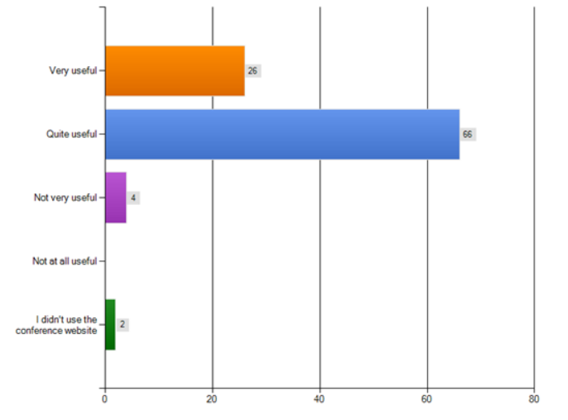
3) During registration and before the event, were the EGI organising team helpful?
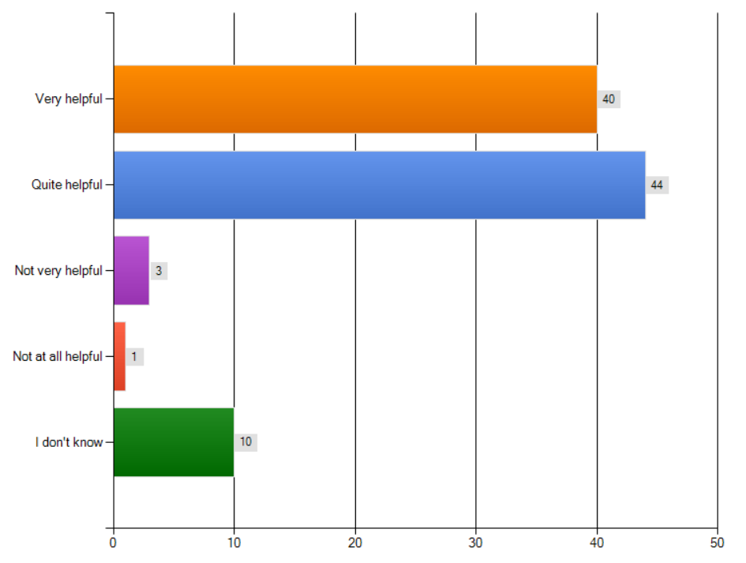

4) During the event, were the conference staff at the venue helpful?
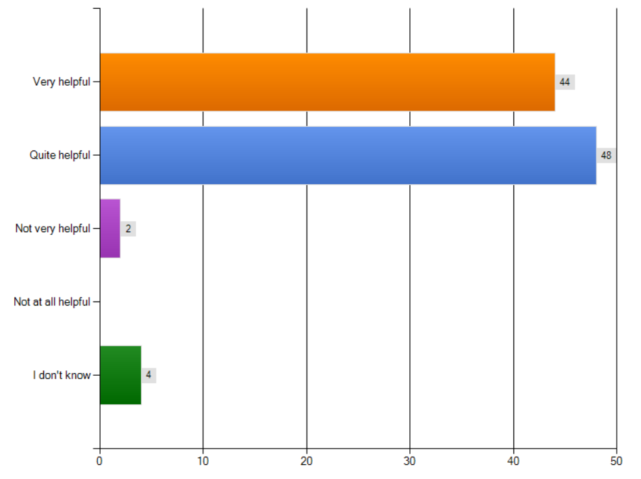
5) Please let us know your feedback on the conference catering i.e. the coffee breaks, the welcome reception on Tuesday 9th and the lunchtime catering.
77 participants commented on the catering, 21 skipped the question.

Summary:
Overall, participants seemed to find the catering acceptable and several respondents were very enthusiastic about the quality, despite repetition. Less fried snacks and more vegetables / fruit were recurring suggestions.
One major complaint was the lack of vegetarian options during lunch breaks.

Selected comments:
- "One of the better conference caterings on EGEE and EGI events."
- "Well, almost everyday paella it is not my dream... but quality and service was good"
- "Lunch was rather inconvenient due to the absence of tables."
- "Whilst the lunches and breaks offered tasty food, it became somewhat repetitive by the end of the week when every refreshment break and lunch offered the same options. They were also very oily and lacking vegetables."
- "catering very poor, in particular for vegetarians (= people who don't eat meat AND fish)"
- " [...] Despite of the "only vegetarians" table, it was often void and the catering staff brought on it meat and fish.. Every time you ate something you have to pray it was vegetables."

6) Do you have any comments on the conference dinner on Wednesday 18th, for example about the menu, the service or the venue?
64 participants commented on the conference dinner, 34 skipped the question.

Summary:
The majority of the respondents were happy with the venue (the stadium Santiago Bernabéu) and praised the originality of the choice and closeness to the hotel. The menu was praised and criticised in equal amounts (mainly for 'boringness' and lack of vegetarian option).

Selected comments:
- "The venue was beatiful. The menu was quite poor."
- " It was very nice that the location was near the conference hotel. The food and drinks before the dinner were distributed very chaotic. During the dinner the food was nothing special. Most of the people I talk with even didn't like it."
- " Very original Venue and good food. The group picture at Santiago Bernabeu was a really nice idea."

7) Do you have any comments on the conference materials eg online programme, materials, brochures, conference folder?
42 participants commented on the conference materials, 56 skipped the question.

Selected comments:
- "Indico is clumsy and requires far too many clicks to get what you want; navigation is difficult. C4Me is very nice but information was not kept up to date."
- "On line programme well arranged and detailed. The conference folder was ... almost empty, not so useful in the end."
- "Conference folder was great! Much better idea than one more material bag."
- "Missed not having a bag There were almost no sign at all. I spent 20 minutes to understand where the registration desk was."
- "I think it would be more useful if the presentation slides where online durint hte presentations or at least minutes after the presentation ends."

8) The EGITF2013 programme was available in several formats. Please could you tell us which formats you used during the event? Please tick all that apply.
98 participants commented on the conference materials, 0 skipped the question.
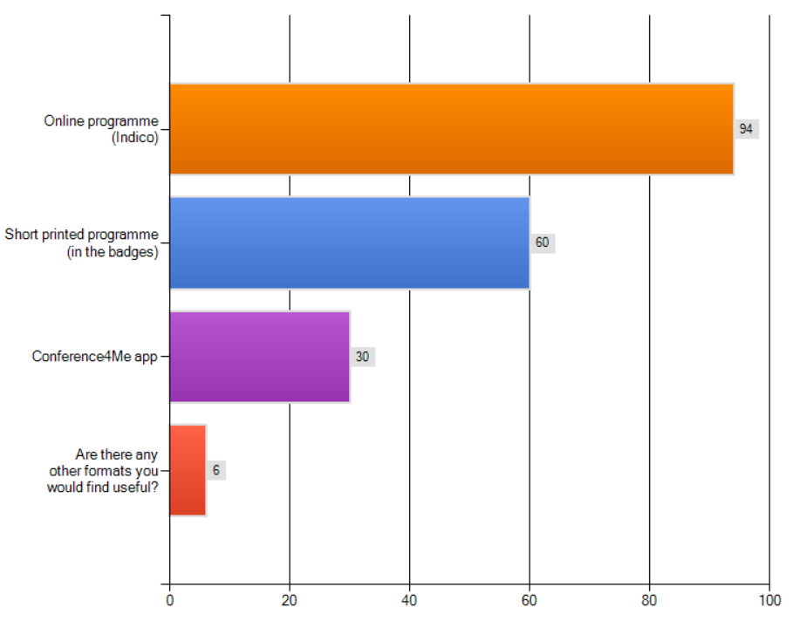

9) Do you have any feedback on the Conf4Me app? Was it useful, how well did it work, was there any information missing from the app?
40 participants commented on the conference materials, 58 skipped the question.

Summary:
Most participants seem to find the App useful. Recurring suggestions/complains refer to: 1) counter-intuitive interface, and 2) not up to date information during the week.

Selected comments:
- "I like it, but sometimes some information are missing or not updated."
- " good, not the first time i'm using it"
- " The informatation was not complete, and didnt use it much because of that."
- " Quite useful, would have liked a better layout of overlapping talks"
- " It was good. It could be improved to be more intuitive and easier to navigate."

10) Please let us know how good the wireless connection was for you during the event
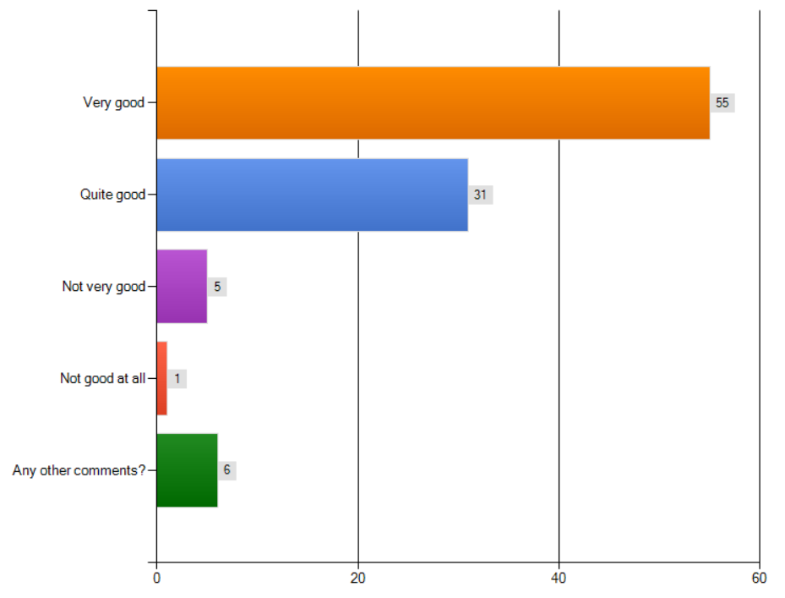

11) Do you have any comments on the conference venue, for example the size and layout of the rooms, how easy it was to get to the venue, acoustics or equipment?
47 participants commented on the conference materials, 51 skipped the question.

Summary:
The majority of the delegates considered the conference venue good. The most common negative points was the strength of the Air Conditioning system (which left some rooms too cold), and the somewhat confusing layout of the rooms.

Selected comments:
- "Always good to have the venue and hotel combined, and overall it was very efficient. The room facilities were a bit confusing - I chaired one session and nothing was set up, we had to get a technician to figure out how to project slides. The rooms were otherwise good and the water was welcome. However apart from the auditorium there weren't many power connections."
- "The Auditorium was great, because it was very confortable and had power plugs in each seat. The rest of the rooms were also very confortable, because having table and chair is a plus. Also having bottles of water available was nice. The only drawback was that the air conditioning in the Auditorium was sometimes too cold."
- "Once at the hotel, it was difficult to find the conference rooms and the registration desk for the first time. Air conditionning was too cold."

12) Did you book your hotel...
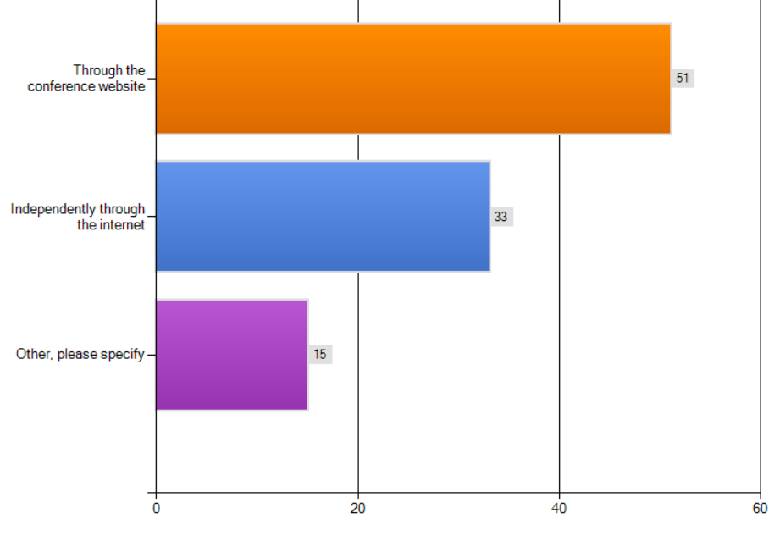

13) If you were an exhibitor or a demonstrator, do you have any comments on your experiences at the event eg the instructions, the space allocated, the facilities, the wifi, the booth costs, the exhibition and demo hall?
14 participants commented on the venue, 84 skipped the question.

Summary:
The exhibitors who commented were overall disappointed with lack of traffic to the booths.

Selected comments:
- "I think that the Exhibition and the Demo room should be near and at the same level of the main auditorium, otherwise many people don't go to see the demos and the posters."
- "It is a pity there is no designated poster/demo session anymore -- a time slot for everyone to gather in the exhibition area."
- "No complaints, all the facilities required for my presentation were present."

14) Compared to similar events that you have attended, do you have any feedback on the fees for the event?

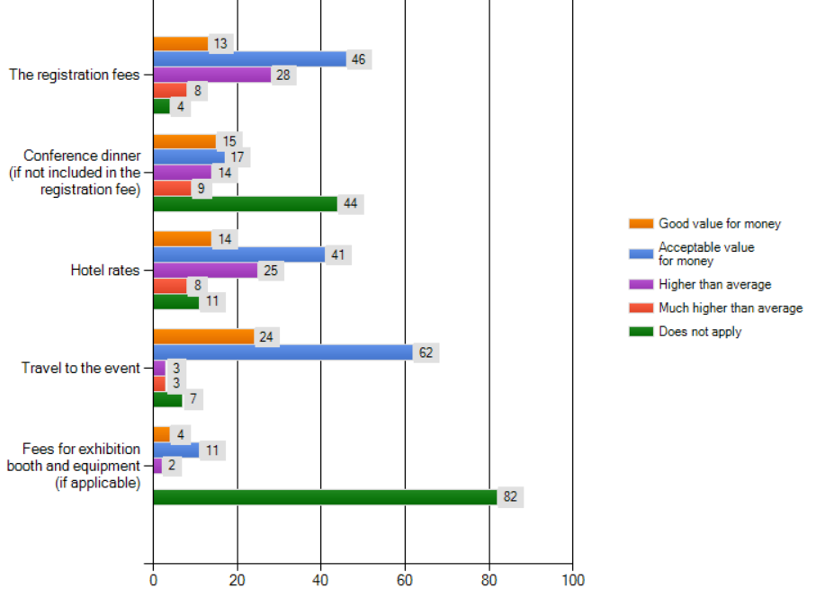

15) Did you use any of the social networking and communication channels at the event? (Please mark all that apply)
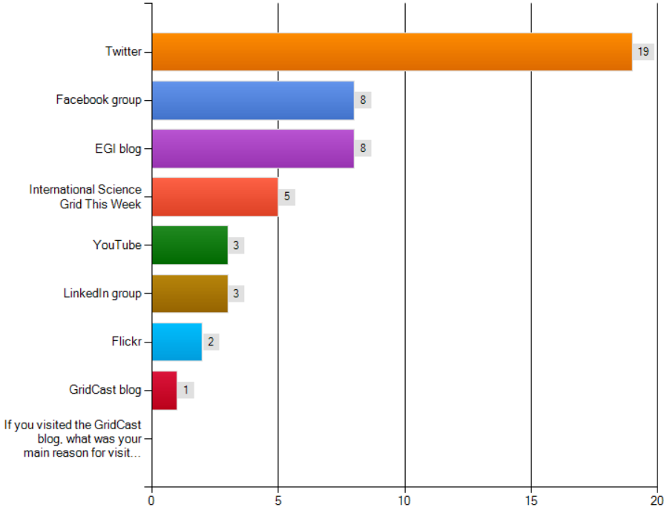

16) If you would like to be subscribed to receive free copies of any of the publications below, please add your email address here.
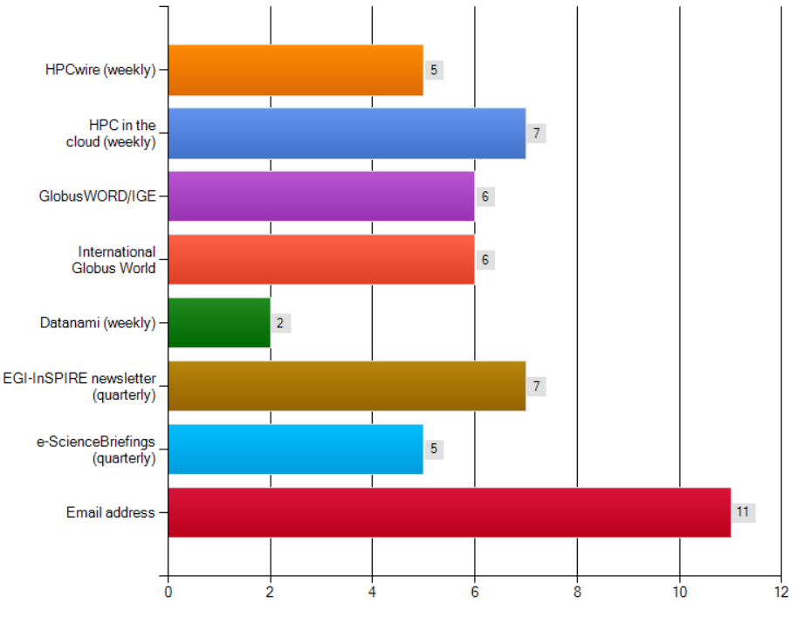
17) We are collecting case studies to illustrate how the infrastructure is being used at http://www.egi.eu/case-studies/. Please tell us below about any interesting research you would like us to highlight.
8 participants provided feedback.

18) Do you plan to attend other EGI events, such as the EGI Community Forum in May in Helsinki?
95 participants answered the question, 3 did not.

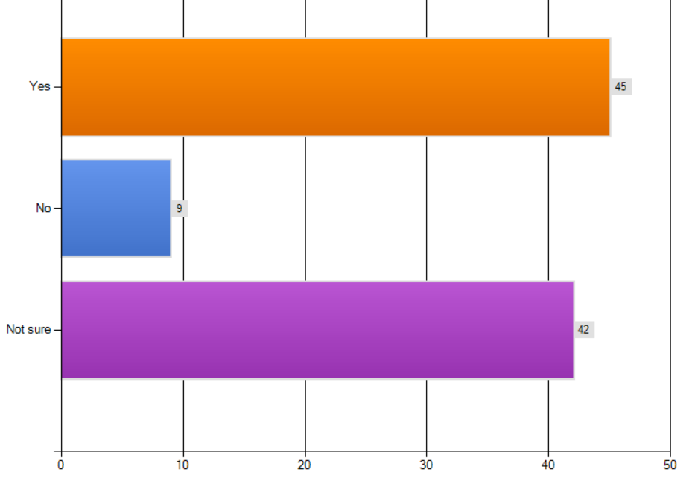
Please let us know your ideas for a conference theme, tracks or sessions.

Selected feedback:
- "On TF, in the grid middleware development field, more info about ARC, SLURM, and in Federated Cloud, more infor on direct integration of ARC + SLURM + OpenSTACK + CernVMFS (used by more projects now) with federated or PKI-based authentication/authorization."
- "In this turning point in EU funding I think a session (or at least more than just one person from the EU commission) would be important to see what we as a community can apply for the H2020 in smaller projects than the EGI. smaller projects that can came out of such sessions can indeed fuel EGI in the future"
- "I would like to have technical sessions where users can meet the technology providers to understand how to make (better) use of EGI services; more user orientated tracks; how are young researchers making use of the infrastructure; how big research infrastructures can make use of EGI?"
- "I would appreciate a program and content more focus on the users, it's a user forum"
- "We need more technical day-to-day sessions and less cloud politics."

19) Finally, is there any other feedback you would like to give us?
18 participants provided feedback

Selected comments:
- "Generally it was a bit above average for EGEE/EGI conferences."
- "Be more selective with the talks, only accept really good ones, have fewer parallel sessions instead."
- "Good conference. Very useful and very well organised. Well done!!"
- "for the hotels on the website, you should have a broader range of prices. it seems that hotels were cheaper booked outside the website of the conference ..."
- "It was very bad all 2/10 the puntuation"
- "I liked the more transparent process of creating the program of earlier events, with a CfP, etc."
- "Could you please put the timetable online at least one month before the end of early-bird fees, so that we can book cheap planes and hotels ?"
- "OGF sessions were planned far too late - programme needs to be finalised earlier. In fact clarifications of EGI sessions messed up OGF ones even after they had been set."

Conclusions
The Technical Forum 2013 brought together 238 scheduled contributions, organised in 96 sessions, and was attended by 471 participants. OGF, IBERGRID, CloudPlugFest and Globus organised parallel sessions.

Overall, the event was judged to be a success by the delegates who have answered the post-forum survey. The most relevant feedback collected from the attendees regards the large number of parallel sessions, with the delegates expressing preference for a 'lighter' programme that reduces the possibility of overlapping meetings.

