EGI-InSPIRE

D7.4 Annual Report on Operational Tool Maintenance and Development Activity

EU DELIVERABLE: D7.4

Document identifier: | input.doc
Date: | 01/04/2014
Activity: | JRA1
Lead Partner: | INFN
Document Status: | Draft
Dissemination Level: | PUBLIC
Document Link: | https://documents.egi.eu/document/2121

Abstract
The activity that has taken place during the 4th year of the EGI-InSPIRE’s work package 7 is reported in this document together with an assessment of the effort spent on all of the tools. The future development roadmap of each tool is also reviewed but not elaborated in details since it was the focus of a recent project milestone.

- Copyright notice
Copyright © Members of the EGI-InSPIRE Collaboration, 2010-2014. See www.egi.eu for details of the EGI-InSPIRE project and the collaboration. EGI-InSPIRE (“European Grid Initiative: Integrated Sustainable Pan-European Infrastructure for Researchers in Europe”) is a project co-funded by the European Commission as an Integrated Infrastructure Initiative within the 7th Framework Programme. EGI-InSPIRE began in May 2010 and will run for 4 years. This work is licensed under the Creative Commons Attribution-Noncommercial 3.0 License. To view a copy of this license, visit http://creativecommons.org/licenses/by-nc/3.0/ or send a letter to Creative Commons, 171 Second Street, Suite 300, San Francisco, California, 94105, and USA. The work must be attributed by attaching the following reference to the copied elements: “Copyright © Members of the EGI-InSPIRE Collaboration, 2010-2014. See www.egi.eu for details of the EGI-InSPIRE project and the collaboration”. Using this document in a way and/or for purposes not foreseen in the license, requires the prior written permission of the copyright holders. The information contained in this document represents the views of the copyright holders as of the date such views are published.
- Delivery Slip
 | Name | Partner/Activity | Date
From | <<The lead author/editor>>
Reviewed by | Moderator:  Reviewers:  <<To be completed by project office on submission to AMB/PMB>>
Approved by | AMB & PMB  <<To be completed by project office on submission to EC>>
- Document Log
Issue | Date | Comment | Author/Partner
1 | 21/03/2014 | First draft | D. Scardaci/INFN
2 | 25/03/2014 | Internal review | D. Scardaci/INFN
3
4 | 02/05/2014 | External review | G. Borges/LIP,  M. Radesky/CYFRONET, C. Aiftimiei/EGI.eu
- Application area
This document is a formal deliverable for the European Commission, applicable to all members of the EGI-InSPIRE project, beneficiaries and Joint Research Unit members, as well as its collaborating projects.
- Document amendment procedure
Amendments, comments and suggestions should be sent to the authors. The procedures documented in the EGI-InSPIRE “Document Management Procedure” will be followed:
https://wiki.egi.eu/wiki/Procedures
- Terminology
A complete project glossary is provided at the following page: http://www.egi.eu/about/glossary/.
<<The authors should check if the acronyms are covered by the glossary page and if the definition is still correct; all the amendments should be communicated to glossary@egi.eu>>
- PROJECT SUMMARY

To support science and innovation, a lasting operational model for e-Science is needed − both for coordinating the infrastructure and for delivering integrated services that cross national borders.

The EGI-InSPIRE project will support the transition from a project-based system to a sustainable pan-European e-Infrastructure, by supporting ‘grids’ of high-performance computing (HPC) and high-throughput computing (HTC) resources. EGI-InSPIRE will also be ideally placed to integrate new Distributed Computing Infrastructures (DCIs) such as clouds, supercomputing networks and desktop grids, to benefit user communities within the European Research Area.

EGI-InSPIRE will collect user requirements and provide support for the current and potential new user communities, for example within the ESFRI projects. Additional support will also be given to the current heavy users of the infrastructure, such as high energy physics, computational chemistry and life sciences, as they move their critical services and tools from a centralised support model to one driven by their own individual communities.

The objectives of the project are:

- The continued operation and expansion of today’s production infrastructure by transitioning to a governance model and operational infrastructure that can be increasingly sustained outside of specific project funding.
- The continued support of researchers within Europe and their international collaborators that are using the current production infrastructure.
- The support for current heavy users of the infrastructure in earth science, astronomy and astrophysics, fusion, computational chemistry and materials science technology, life sciences and high energy physics as they move to sustainable support models for their own communities.
- Interfaces that expand access to new user communities including new potential heavy users of the infrastructure from the ESFRI projects.
- Mechanisms to integrate existing infrastructure providers in Europe and around the world into the production infrastructure, so as to provide transparent access to all authorised users.
- Establish processes and procedures to allow the integration of new DCI technologies (e.g. clouds, volunteer desktop grids) and heterogeneous resources (e.g. HTC and HPC) into a seamless production infrastructure as they mature and demonstrate value to the EGI community.

The EGI community is a federation of independent national and community resource providers, whose resources support specific research communities and international collaborators both within Europe and worldwide. EGI.eu, coordinator of EGI-InSPIRE, brings together partner institutions established within the community to provide a set of essential human and technical services that enable secure integrated access to distributed resources on behalf of the community.

The production infrastructure supports Virtual Research Communities (VRCs) − structured international user communities − that are grouped into specific research domains. VRCs are formally represented within EGI at both a technical and strategic level.

- EXECUTIVE SUMMARY
This document reports the fourth and last year activity in work package 7 (JRA1) of the EGI-InSPIRE project, which deals with the maintenance and development of operational tools.
The routine maintenance and development of the operation tools proceeded regularly during the year with the introduction of many new features to all the operational tools. Among them we can mention a complete review of the Operations Portal to improve the look and feel, the ergonomics and the efficiency; the new GOCDB v5.X series which is now independent from the underlying RDBMS and offers many new capabilities such as the extensibility mechanism and new scoping extensions; and the integration of the EMI probes in SAM.
The regionalisation activities were successfully completed in the first months of PY4 with the release in production of the regional Accounting Repository and Portal. Currently, each tool has its working regionalisation solution or as independent instance or view inside the central instance.
The developments with respect to the accounting for different resource types, which started in PY3 and continued in PY4, are close to be completed. Cloud, Storage and Parallel Jobs resource types can be accounted in the EGI Accounting Repository based on Secure Stomp Messenger protocol and new views were developed in the portal to show this data. The remaining step to complete this activity is the deployment of an automatic system to dispatch this accounting data from the repository to the portal, and is foreseen for the end of April 2014.
Another important result achieved in PY4 is the integration in the Accounting Portal of a module able to get site charging attributes from the GOCDB, and use them, in association to the accounting data, as input parameters of a billing function. The charging attributes can be stored in the GOCDB through the new extensibility mechanism provided by the v5.2. Two provisional billing functions, one for grid resources and the other for cloud, are now available in the Accounting Portal. It is important to note that the modularity of the Accounting Portal functionality allows to easily and quickly introduce any kind of function, requiring as input parameters values associated to the GOCDB entities and data accounting to exploit the above described mechanism.
The document provides an analysis of the overall effort consumption for each operational tool and the distribution made between maintenance and development work. The maintenance effort has grown for almost all tools during the project’s lifetime. This reflects the decrease in the number of new features being developed once most user requirements have already been fulfilled, and the increase of the effort needed to refine the already delivered capabilities (e.g. bug fixing). Exceptions to this trend are the GOCDB and the Accounting Portal: the development of GOCDB v5 and the integration of the new resources types in the Accounting Portal increased the development load with respect to maintenance. This shift may indicate that the operational tools are now entering a phase of consolidation rather than new developments. This estimation has been the base to identify the effort needed to proactive maintain the EGI operational tools after the end of the JRA1 activity. Indeed, the resources allocated to the EGI Core Activities, which will start in May 2014 with the aim to guarantee the maintenance of the operational tools, have been assessed taking into account this evaluation.
The future roadmap for the tools is not described in detail in this document. However, it was briefly outlined in section 5 as it was the focus of a recent project milestone (MS711).
TABLE OF CONTENTS
1 Introduction 7
2 Development and maintenance 8
2.1 Operations Portal 8
2.2 EGI Helpdesk (GGUS) 9
2.3 Grid Configuration Database (GOCDB) 11
2.4 Accounting Repository 12
2.5 Accounting Portal 13
2.6 Service Availability monitoring (SAM) 14
2.7 Metrics Portal 15
2.8 Broker network configuration and infrastructure 16
2.9 Integration of new middleware types 16
3 Accounting for different resource types 19
3.1 Billing 19
3.2 Clouds 20
3.3 Parallel Jobs 21
3.4 Storage 22
3.5 Others 23
4 Effort assessment and main issues 24
4.1 Effort overview 24
4.1.1 Development vs Maintenance Effort 25
4.2 Major issues 27
5 Roadmap 29
6 Participation in conferences and project task forces 33
7 Conclusions 34
8 References 36
9 appendix a: jra1 effort tables 41

Introduction
This document reports the fourth project year activity of the work package 7 (JRA1). WP7 deals with the maintenance and development of operational tools. JRA1 is composed of five tasks:
- TJRA1.1 is the management task: the activity manager coordinates the seven product teams involved in the activity, define the software development roadmap in collaboration with the Operations Tools Advisory Group (OTAG), supervise the software testing and release before the installation in the production infrastructure and represent the WP7 in the project Activity Management Board.
- TJRA1.2 deals with the maintenance and the developments of all the tools
- TJRA1.3 devoted to the development of regionalised tools
- TJRA1.4 regards the extension of the accounting system to encompass new resource types (other than CPU)
- TJRA1.5 deals with the extension of the Operations Portal and its harmonization with other portal frameworks
TJRA1.5 completed its activities at the end of the third year, while TJRA1.3 ended in PY2 after one year extension.
In this deliverable there is also an effort assessment for each tool, in attempt to distinguish the effort spent in maintaining the tools and the effort used to develop new features. This exercise provides guidelines for funding of future activities/projects that will maintain the operational tools. The future roadmap for the tools is not described in details in this document; it’s just briefly outlined since it was the focus of a recent project milestone (MS711). A series of issues have arisen during the year and are also reported.
The document is organised into the following main sections:
- section 2 refers to task TJRA1.2 and describes the maintenance activity and the development needed to address the main user requirements for all the tools. Regionalisation activities are also reported in this section;
- section 3 provides details about TJRA1.4 and the accounting for new resource types;
- section 4 reports an assessment of the effort spent as well as the main issues encountered during the year;
- section 5 is a quick overview of the next year roadmap for all the tools;
- section 6 reports the participation of the JRA1 staff to the main project conferences, working groups and task forces.
The document finishes with conclusions discussed in section 7.

Development and maintenance
This section gives a summary of the development and maintenance activity performed for each of the JRA1 tools during PY4. A very short description of each tool is also provided at the beginning of each section together with references to outline tool architecture, documentation, deployment scenarios and future developments.
The general entry point to get information about the JRA1 activity and its tools is hosted by the EGI wiki at [R 1].

Operations Portal
The Operations Portal provides information to various actors (NGI Operations Center managers, VO managers, etc.) along with related facilities, such as the VO administration tool, the broadcast and downtime system and the access to the different specific dashboards (e.g. Operations dashboard, security dashboard). The Operations Portal is available as a central service that can host regional views. A detailed description of the whole system and of its modules can be found in [R 2].

The development of the Operations Portal during the entire PY4 focused on the following activities:
- Refactoring of the whole portal: a complete review of the portal to improve the look and feel, the ergonomics and the efficiency;
- Migration to Lavoisier 2.0: in parallel with the refactoring of the portal, the Lavoisier framework [R 3] has been upgraded to a more flexible and powerful new version;
- Enhancement of the VO security contact list functionality: new features to make easier the management of the security contacts;
- Introduction of the VO users listing functionality: new features to get the list of all the EGI users.

The portal refactoring has been done to homogenize and enhance the look and feel of the interfaces by exploiting the capabilities of the most recent technologies (see Figure 1) Due to these recent developments, an important improvement of the portal efficiency, reactivity and visibility has been achieved. Moreover, different new features have been developed allowing a more transparent and easy access to the information (e.g. filters on the long table, possibility to export information as json/csv files, auto completion on large list), as well as the introduction of new technology supports such as mobile smartphones and tablets. The new version of the dashboard is completely flexible and new sources of information can be easily added. A new Operations portal release (3.0) is now in pre-production since February 2014, and its production deployment is expected in April 2014.

The framework Lavoisier has been upgraded to the version 2.0. This new version provides many new functionalities such as the complete support of path and xpath, many different rendering formats (csv, json, txt, xml, yml, gzip, html, chart, etc) and the support of java scripts libraries and css framework.

In response to new requirements of the EGI CSIRT community [R 4], the management of the VO security contacts has been improved. A new page summarizing the list of VO security contacts has been created and, furthermore, EGI CSIRT members can now (1) export the VO security contact list and (2) send broadcast messages to these contacts in just one click.

Regarding the VO users listing, now it is possible to export the list of users and robot certificates registered in the portal user's database extracted from the different VOMS servers:
- to get the list of users use:
  - https://operations-portal.egi.eu/vo/downloadVoUsers
- to get the list of robot certificates:
  - https://operations-portal.egi.eu/vo/downloadVoUsers?robot=true

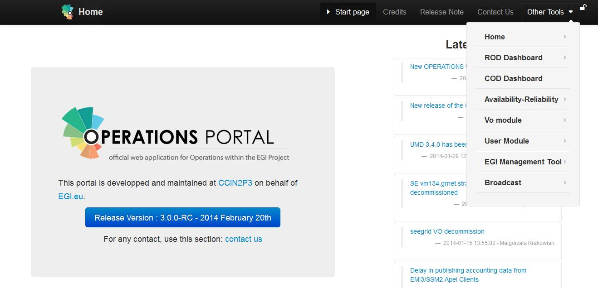
Figure 1: Operations Portal 3.0 - New look & feel.

As announced at the end of PY3, regionalization is supported by providing central customized views for each Operations Centre of the Operations Portal. Different views in the portal were created depending on the role of the users registered into GOC DB and associated to their certificates, so that access to information is restricted to the authorized operators only.

An unique major Operations Portal release (3.0) will be completed by the team in PY4. Currently, its deployment in production is expected for April 2014.

EGI Helpdesk (GGUS)
GGUS is the EGI helpdesk [R5] and the single point of contact for EGI users to report service requests and problems. It hosts all project-wide support units and acts as the central integration platform in the distributed support infrastructure consisting of regional and topical helpdesk systems (see Figure 2). GGUS is linked into various operational processes through interfaces to other operations tools.

There have been several important enhancements during the fourth year:
- Introduction of a new GGUS Report Generator functionality: the development of the new report generator has been completed in PY4;
- Implementation of high availability mechanisms for GGUS components (switching between stacks): the whole GGUS infrastructure was moved to two independent stacks of virtual machines in different locations and the manual switching mechanisms was implemented [R 79];
- Restructure VOMS GGUS synchronization: a complete refactoring of the VOMS synchronization for user authentication has been accomplished to improve its reliability;
- New interfaces to MAPPER [R 6]: a dedicated xGUS instance was set up [R 7]
- Several minor achievements have been completed such as the improvement of the interface to the CERN Service Now ticketing system, the change on the ticket workflow, the introduction of the quality of service levels and the upgrade of the interface towards GOCDB to support the new v5.

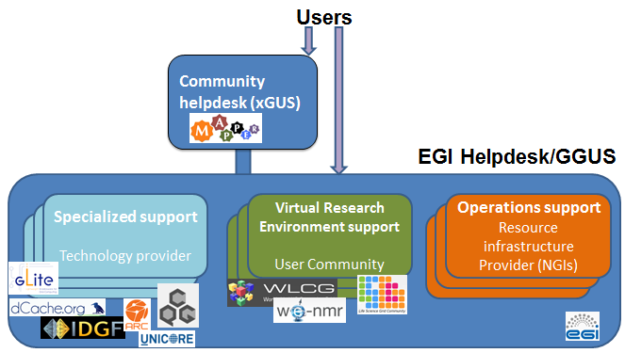
Figure 2: GGUS architecture.

The new GGUS authentication system based on AAI infrastructure and Shibboleth technology [R 8] is now completed and was released in April 2014. This new feature simplifies the usage of GGUS, indeed users don’t need any more an X.509 certificate to access GGUS. They can login on GGUS with their EGI SSO account.

The GGUS advisory board, created in PY3 to discuss the new GGUS requirements, has been fully operative during last year [R 9].

The xGUS helpdesk [R 10] covers the regionalisation needs of the NGIs that do not have a custom solution for their own local ticketing system. The xGUS helpdesk template has been developed for NGIs and user communities who want to build up their own user support infrastructure. It contains all basic helpdesk functionalities including user administration and certificate access, and allows the creation of customisable views. Currently, there are 6 NGIs using an xGUS instance (NGI_AEGIS, NGI_AFRICA, NGI_CH, NGI_CHINA, NGI_DE and NGI_SI)

The GGUS product team published a total of 8 releases during PY4.

Grid Configuration Database (GOCDB)
The GOCDB is the main source of topological information for the EGI e-infrastructure. It hosts general and semi-static information about the sites participating in the production infrastructure (covering data such as available services, service endpoints, service downtimes, site manager contact details, security contacts, virtual sites etc).

During PY4 the product team focused on the development of the GOCDB v5 [R 11]. This was a major release and the product team achieved a complete re-design of the tool’s business logic. This was necessary to accommodate requirements and emerging use-cases. The GOCDB v5 supports multiple projects and is used to manage the relationships between different entities (Grid, Cloud, etc.) using a well constrained relational schema It includes a comprehensive role-based permissions model and can be easily extended for project specific business rules and roles. After the v5, other two minor releases were released, v5.1 and 5.2.

The main features developed for the GOCDB v5 series during PY4 include:
- Support for different RDMBS: GOCDB v5 is now based on a well-established/de-facto Object Relational Mapping library (Doctrine ORM) [R 12]. Out of the box, this library supports a number of different RDBM systems. Support for Oracle and MySQL is already available and other DBs could be supported with few changes. This development replaces the previous proprietary ORM package (PROM; pseudo object relational model);
- Extensions to the scoping mechanism: this feature allows different operational entities (Sites, Services, ServiceGroups) to be tagged by one or more scope-tags (see Figure 3). The scope extensions allow the creation of flexible resource categories akin to a tag-cloud. Scope tags can be created to address any grouping requirement such as different projects and infrastructures. Importantly, this allows resources and their data to be defined only once which is essential to maintain the integrity of data across different groupings;
- Admin Interface: developed to simplify and speed-up daily operational tasks for GOCDB administrators. This feature was developed in the context of the mini project TSA4.11 -GOCDB Scoping Extensions and Management Interface [R 13];
- Extensibility mechanism: allows users to associate custom key-value pairs to Sites, Services, and ServiceGroups. Programmatic interface (PI) support is provided with a newly added ‘extensions’ parameter. This allows queries to perform fine-grained resource filtering based on custom properties. This new feature is crucial to implement the Pay-for-Use proof of concept [R 14] and can be exploited to satisfy other user requirements. This extension mechanism is based upon the primary GLUE2 extension mechanism;
- Support for multiple projects: a single GOCDB instance can now host more projects.

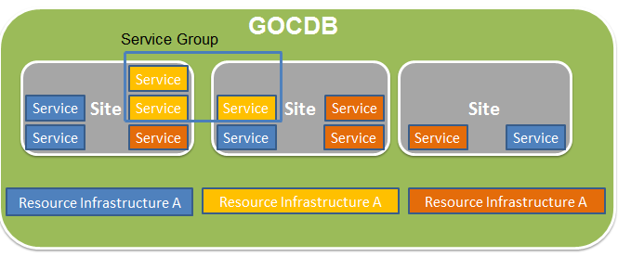
Figure 3: GOCDB - New scoping mechanism.

A further improvement that is scheduled in addition is GLUE2 support, i.e. to publish the GOCDB data in GLUE2 XML format. The OGF GLUE2 XML rendering specification [R 15] was published in May 2013 and was led by the GOCDB team. Following publication, the team has started on the development of new PI methods that are scheduled for release in 2014 (Q2/3).

A general improvement of the GOCDB failover mechanisms was achieved. To date, two failover instances are available:
- the primary failover instance is hosted at Daresbury Labs, Cheshire, UK: https://goc.dl.ac.uk/portal;
- the secondary one is hosted in Fraunhofer, Germany at: https://goc.itwm.fraunhofer.de/portal/.
An automatic monitoring/failover script that re-points the ‘goc.egi.eu’ domain from the main GOCDB instance to a failover instance has been deployed.

The GOCDB team continued to provide technical and operational support to EUDAT to manage their GOCDB instance. The EUDAT GOCDB instance has been updated to the latest GOCDB release.

Since the start of PY3 regionalisation of GOCDB is implemented through scoping and the implementation of scoped views of the data. See D7.3 [R 16] for details.

The GOCDB product team published three releases during PY4 whilst also continuously deploying a number of functional enhancements throughout the period.

Accounting Repository
The EGI accounting repository [R17] stores information related to the usage of resources within EGI’s production infrastructure. It receives data on individual jobs and job summaries records from resource centres and other infrastructure components, which joined with data collected by the information and messaging system, allows to produce accounting information that are consumed by clients as the accounting portal for visualization (see Figure 4). The control of which sites publish to the APEL repository is defined by the information pulled from GOCDB. Monitoring of whether sites actually publish their data is carried out centrally by APEL and the results are published to SAM.

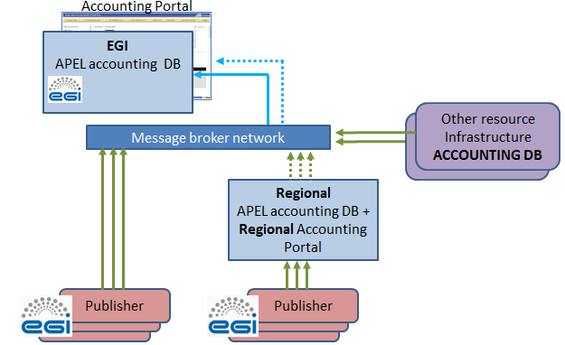
Figure 4: Accounting Repository system architecture including regionalisation.

In March 2013 EMI-3 [R 18] was released. It includes the new EMI-APEL client, completely rewritten, which uses the Secure Stomp Messenger (SSM) protocol v2 [R 19] for communication between clients and the APEL Accounting Repository and includes support for local jobs and MPI accounting. During PY4 the APEL team supported EGI sites to upgrade their APEL client from EMI-2 to EMI-3. In the meanwhile the two systems properly worked in parallel with one set of daily summaries retrieved by the Accounting Portal.

Moreover, the APEL team has worked with sites and developers running alternative accounting clients to use SSM to send their records to the Accounting Repository. There are now sites in production sending accounting data from ARC [R 20], QCG [R 21] and EDGI Desktop Grid [R 22]. Globus [R 23] and Unicore [R 24] have successfully tested but have not started publishing accounting data in production.

The Regional Accounting Repository has been released in May 2013. It was successfully tested by the South-African (NGI-ZA) and Greek NGI (NGI-GRNET). The South-African NGI showed interest in the deployment of the regional accounting repository in its production infrastructure.

Accounting Portal
The data recorded in the Accounting Repository (section 2.4) are processed, summarized and pulled to the Accounting Portal [R 17], which acts as a common interface to the different accounting record providers and presents a homogeneous view of the data gathered, and a user-friendly access to understand resource utilisation.

During PY4 the Accounting Portal team continued to improve the product with code refactoring and several enhancements and optimizations mostly driven by user requirements. The most important improvements are the following:
- Improved UserDN country classiﬁcation patterns
- Support for new RFC 2253 UserDNs
- UserDN NGI attribution
- Support for local jobs. There are three options, selectable on most views:
  - Only Grid jobs (default)
  - Grid and local jobs (In case there is a corresponding global VO, both are aggregated)
  - Only local jobs
- Moved InterNGI views to production: these views show how the users of each NGI use the resources of the other NGIs. They are very useful to highlight the collaborations between NGIs and the benefit that each NGI obtain thanks to his participation to the EGI.eu collaboration.
- New code for UserDN SAM probe that detects if sites have published CPU/UserDN records on the last 7 days and honours some NGI non publishing policy
- Installation of new SSM software

The Regional Accounting Portal has been released in May 2013. It was successfully tested by the Greek NGI. The South-African NGI (NGI-ZA) showed interest in the deployment of the regional accounting portal in its production infrastructure.

Service Availability monitoring (SAM)
The Service Availability Monitor (SAM) [R 25] is the system that is used to monitor EGI resources within the production infrastructure. It consists of the following components:
- Probes: for the individual service component being monitored in the test;
- Submission framework: a test execution framework (based on the Nagios open source monitoring framework) and the Nagios Configuration Generator (NCG);
- Storage layer: Aggregated Topology Provider (ATP), Profile Management System (POEM) and Metrics Results Store (MRS);
- A visualization portal: MyEGI;

The main activity streamlines on which the development focused during PY4 are:
- Integration of Nagios probes developed through the EMI project in SAM as a part of SAM Update-22 [R 26]: this activity involved several complex coordination tasks, such as the establishment of the EMI/SAM testbed [R 27] to test newly developed probes, establishment and contribution to the SAM probes WG [R 28] which aimed at analysing the impact of the changes to EGI operations, as well as SAM testing campaign where several regions volunteered to participate and help validate the final release;
- Major repackaging of the SAM distribution and implementation of several MyEGI enhancements as a part of SAM Update-22;
- Support migration of SAM central services: as SAM services operated by CERN will be discontinued as of 01 May (CERN did not participate to the bidding for providing the services after PY4), the support to migrate the SAM central services to a new consortium of partners (CNRS, SRCE and GRNET) has been a main task in PY4.This involved developing a detailed time plan [R 29], writing technical documentation necessary for the migration of SAM central services, providing technical support to the consortium as well as organizing SAM migration meetings and workshops to follow up on the transition process and make sure it is implemented in time and within its scope;
- Participation to the validation of the TSA4.10 - A new approach to Computing A/R reports mini-project [R 30] results.

SAM fully supports the EGI regionalisation plan from the end of PY1 and all the NGIs are running their local SAM regional instance[R 31].All NGI instances are configured to use ATP as topology source. All DoW SAM regionalisation requirements for TJRA1.3 were already addressed by the end of PY3.

One of SAM updates was released to production during PY4 in PQ14. This last update went through the full EGI Software Provisioning process [R 32] as was decided at the beginning of the project.

Metrics Portal
The Metrics Portal [R 82] displays a set of metrics that are used to monitor the performance of the infrastructure and project and to track their changes over time. The portal automatically collects the relevant data that are published by the middleware or by other operational tools (e.g. GGUS ticket statistics) via a series of connectors. In addition, some metrics are inserted manually by the activity leaders or by the NGI managers.

The main Metrics Portal developments performed during PY4 were:
- Access control improvements
- New quarterly views and Excel report
- New NGI entity for the EGI.eu organization for management purposes
- Improved links and navigation in the metrics portal
- GGUS metrics improvement
- Fixes and optimizations.

The Metrics Portal has been used for the last three years to gather metrics from the project tasks. It has been updated according to changes in the structure and scope of the project and its tasks and activities. In PY4 the concept of quarter dependent activities was introduced to manage completed activities (e.g. SA3). New metrics were added for NA2, SA1 and SA2 to reflect changes in the activity and project metrics.

Broker network configuration and infrastructure
The JRA1 activity is responsible for providing support for the configuration and operation of the message broker network of the production infrastructure based on the ActiveMQ system [R 33]. The main achievements for this activity during PY4 are:
- Development of failover capabilities for the msg2handler component: the message brokers network is resilient to failures as long as the clients support such a feature and the developments done target towards that direction. This task has not yet concluded and the foreseen date for the delivery of the necessary components is April 2014.
- Support of APEL clients: APEL clients publish data through the message brokers to which they connect via secure socket layer(SSL, based on X509 certificates). Authentication data are updated regularly on the message broker endpoints (the source of information is GOCDB) and so far the interoperation with APEL can be considered successful.
- Support migration of SAM central services: the migration of SAM central services foresees a complete re-configuration of the EGI message broker network with the deployment of two new message brokers in Greece and Croatia and the decommission of the current message brokers including the testing network. A detailed plan [R 34] was prepared to perform this re-configuration aiming for a seamless transition towards the new set up. The plan execution started in January 2014 and will be completed by April 2014.

Integration of new middleware types
The integration of new middleware and resource types affects almost all the operational tools, but in particular the GOCDB that has to record the inclusion in the production infrastructure of the new resources, the SAM framework that has to monitor them and the accounting system (both repository and portal) that has to provide accounting information.
The number of service types defined in the GOCDB continued to increase and now we have 101 service types registered (94 at the end of PY3 and 66 at the end of PY2, see Figure 5) from the following middleware stacks (a full list of services types can be obtained from the GOCDB programmatic interface [R 35]): gLite [R 36], UNICORE, Globus, iRODS [R 37], ARC, QosCosGrid, BES[R 38], Cloud, Torque[R 39], Squid[R 40], XRootD[R 41], COMPSs [R 42], Dirac [R43] and SlipStream [R 44](in bold the middleware stacks added in PY4).
All new service type requests need to be assessed by EGI via a lightweight review process (through OMB and OTAG) so that only suitable types are added to GOCDB and to prevent duplication. The procedure to request a new service types is described in the GOCDB documentation [R 45].
The SAM monitoring framework was already able to monitor services from the following middleware stacks at the end of PY3: gLite, UNICORE, Globus, ARC, QosCosGrid and Desktop Grids. EGI services and tools are considered as service types and probes are integrated in SAM in order to check their availability. During PY4 the development was mainly focused on the integration of EMI probes that replaced many old metrics [R 46]. Moreover new probes were added to monitor ARC-CE, Argus and MPI.

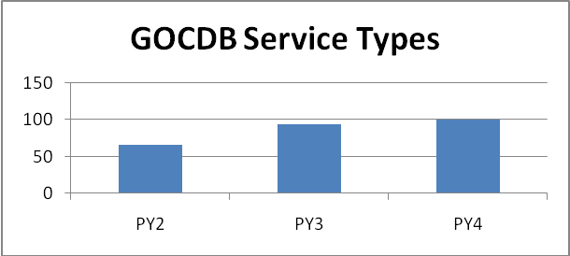
Figure 5: Number of service types registered in the GOCDB at the end of each project year.
The inclusion of new middleware and resource types in the accounting system is discussed in section 3.

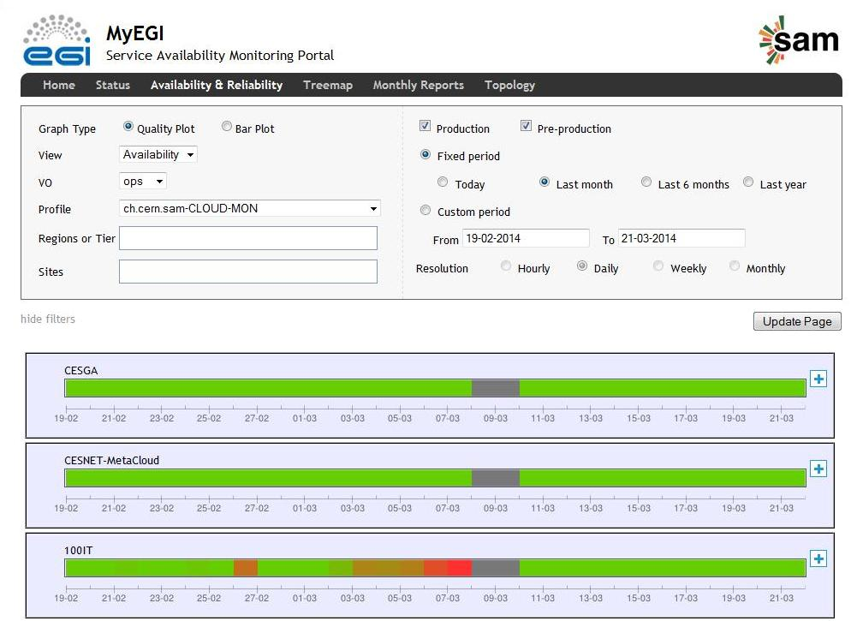
Figure6: MyEGI - Cloud sites availability.

GGUS is also indirectly affected by the inclusion of new middleware in the production infrastructure, in particular in what concerns the support units to be added to the technology helpdesk that must handle specific tickets. The new SU units are: EGI DMSU [R 47], EMI [R 48], IGE, SAGA[R 49], QosCosGrid, EGI Federated Cloud [R 50], International Desktop Grid Federation (IDGF) [R 51], CVMFS [R 52] and EDUPERT [R 53]. The procedure to create a new support unit is described in the GGUS documentation [R 54].

Concerning the tools to operate the federated cloud infrastructure, JRA1 representatives continued to attend and actively participate in the EGI Federated Cloud task force activities. JRA1 led two working groups (also called Scenarios), one for monitoring (Scenario 5 [R 55]) and one for implementing an accounting system (Scenario 4 [R 56]) of the cloud infrastructure. PY4 activities focused on completing the developments needed to make the operational tools prepared to move EGI Federated Cloud into production. For monitoring, a specialized SAM instance [R 57] has been deployed and ad-hoc probes developed. Availability and reliability results collected by this new SAM instance are showed in the MyEGI central instance [R 58] together with the data collected from the grid infrastructure. Figure 6 shows the availability values for cloud sites in the current MyEGI central instance. The evolution of the accounting system to support the EGI Federated Cloud is described in the following section.

Accounting for different resource types
Several new resource types have been integrated into EGI’s production infrastructure and JRA1 has worked to include them in EGI’s accounting system.
The task responsible for the needed development is TJRA1.4 – Accounting for different resource types – which is a 3 year task started at the beginning of PY2 [R 59].
After a first year focused on the investigation of what is currently available for the accounting of new resource types, identifying overlaps and possible stakeholders collaborations, TJRA1.4 developed the solutions defined at the end of PY2 during PY3 and PY4 As a result, the following resources types could be accounted in the new EGI Accounting Repository based on SSM v2:
- Cloud;
- CPU;
- Parallel Jobs;
- Storage;
and significant steps have been performed to gather accounting data for:
- Applications;

The development of the accounting system was driven by the outcome of the TCB’s Inter Projects Accounting Task Force [R 60] created to get requirements about the integration of new middleware stacks (beyond ARC, UNICORE, gLite and Globus).

Billing

Another TJRA1.4 target is to evolve the accounting system to support an economic model that could contribute to the sustainability of EGI and significant steps on this topic were achieved during PY4. The new extensibility mechanism provided by the GOCDB v5.2, which allows to add custom parameters to the GOCDB entities (services, sites, etc), has been elected as the way to associate charging attributes to the EGI infrastructure entities. See Figure 7 for an example of charging values associated to an EGI site. Furthermore the Accounting Portal has been enriched with a module able to get these attributes from the GOCDB and use them, in association to the accounting data, as input parameters of a billing function.

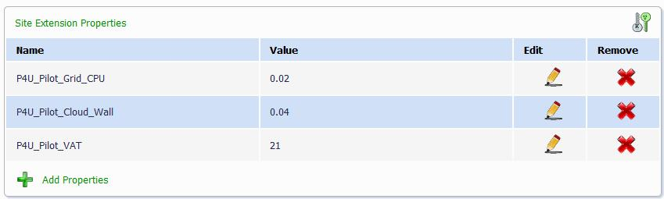
Figure 7: GOCDB - Charging values associated to a site.

This new mechanism is the ground on which the EGI Pay-for-Use proof of concept, started in January 2014, is founding its activity. Currently, two simple billing functions have been implemented in the Accounting Portal, one for the Grid resources and the other for the Cloud resources:
- Grid:(CPU rate per HSPEC06/hour) * (number of HSPEC06 hours accounted)
- Cloud:(CPU rate per wallclock-time/hour) * (number of wallclock time hours accounted)
However, any kind of function defined by the Pay-for-Use working group, requiring as input parameters values associated to the GOCDB entities and data accounting, could be easily and quickly developed on the accounting portal exploiting the above described mechanism. The EGI Pay-for-Use proof of concept foresees to conclude the implementation of all technical specifications related to its first phase, in April 2014 in conjunction with the JRA1 activities. In PY5 the JRA2 activity will continue to support the proof of concept through the task TJRA2.2 dedicated to further evolutions of the accounting system.

Clouds
The JRA1 accounting product team continued to actively participate in the work of the project’s Federated Cloud taskforce, and led the so-called “Scenario4- Accounting” activities with the mandate to include into the accounting system records coming from the Federated Cloud infrastructure.
During PY4 the SSM 2.0 protocol has been adopted and specific work has been done in collaboration with the EGI Federated Cloud Task Force, to compare and make consistent, in term of format and type of data, the cloud accounting records collected from the resource providers employing different cloud technologies (OpenStack [R61], OpenNebula [R 62], Okeanos [R 63], etc.). Currently, 17 cloud sites based on OpenNebula, OpenStack and StratusLab technologies [R 64] are sending accounting data to APEL repository using SSM 2.0 through EGI Message Broker infrastructure.

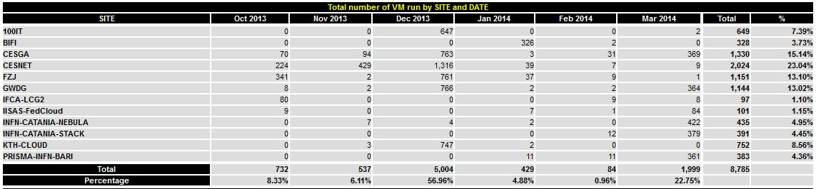
Figure 8: Cloud Accounting - Number of VMs created for each site in the last 6 months.

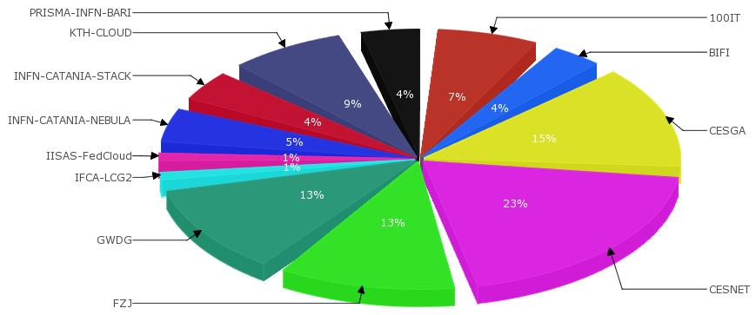
Figure 9: Cloud Accounting - Percentage of VMs created for each site.
The Accounting Portal team developed the visualisation of the cloud accounting data. This view is currently under test and is now available in the Accounting Portal testing instance [R 65]. It uses as input the daily summary data sets sent by the Accounting Repository using SSM 2.0 and the EGI Message Broker infrastructure. Figure 8 and 9 show snapshots of the Accounting Portal cloud view.

The cloud accounting will be deployed in production in April 2014.

Parallel Jobs
In the past years the JRA1 team actively participated to the definition of the parallel jobs accounting usage record within standardization bodies (i.e. OGF UR-WG [R 66]).. When the type of information to account for parallel jobs was agreed, the team started the development. The parallel jobs data has been added to the CAR [R67] (Compute Accounting Record, largely based on the OGF UR [R 68]) and, after the release of EMI-3 that includes the new EMI-APEL client (April 2013), such data can be stored in the Accounting Repository.
The most relevant differences regarding the collected data for parallel jobs with respect to normal sequential jobs are the number of cores and the number of worker nodes used by the applications. APEL EMI-3 parser supports LSF [R 69], PBS [R 70], SLURM [R 71] and SGE [R 72] batch systems.
During PY4, the Accounting repository team has worked extensively to re-route the data flow of the existing repository backend. Currently, accounting data was sent to the accounting portal from the EMI-2 APEL system, with an additional monthly summary sent from the EMI-3 APEL system. In PY5 (PQ18) this mechanism will be reversed : the data will be sent by the EMI-3 APEL system and accounting data coming from sites still using EMI-2 will be sent with a monthly summary. In the meantime a temporary solution will be deployed in May 2014 to allow the Accounting Repository to send the Parallel Jobs accounting data, available only from EMI-3 sites, to the Accounting Portal through SSM,.
The Accounting Portal team already developed the views to show the parallel jobs accounting data using a database dump provided by the APEL team. These views are currently visible in the Accounting Portal testing instance [R 73]. The views will be moved in production as soon as the APEL repository starts to send the parallel jobs accounting data through the standard SSM channel.
Figure 10 shows a snapshots of the Accounting Portal parallel jobs view.
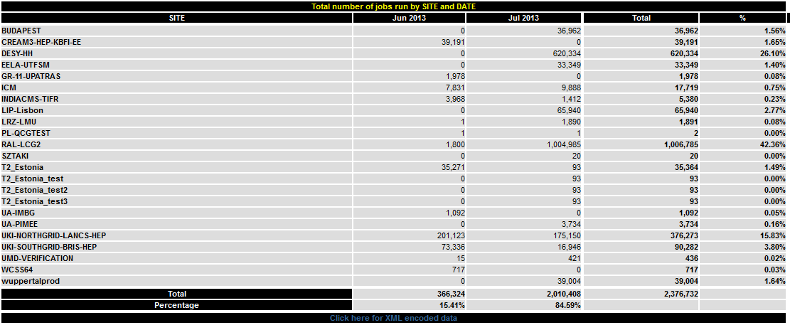
Figure 10: Parallel Jobs Accounting - Number of parallel jobs per site executed in June-July 2013.

Storage
The JRA1 product team also continued to participate in the definition of the storage accounting record within standardization bodies (i.e. OGF UR-WG). Meanwhile an interim standard (Storage Accounting Record – StAR) has been defined in EMI [R 74] reflecting practical, financial and legal requirements concerning storage location, usage and space and data flow. StAR contains information about the type of storage, the number of files accounted, the capacity used, the time interval of the measurement, etc. The definition might be the base for a standardized schema or an extension of an existing record like the OGF UR.

At the end of PY3, the JRA1 team integrated new storage records in the Accounting Repository coming from dCache and DPM storage systems, and sent via SSM. . DPM and dCache introduced the StAR support from EMI-3 release. An analysis was done for StoRM to add the support for storage accounting by exploiting its BDII information but the sensors have not been developed yet.
In PY4, APEL team tested and refined the solution with data retrieved from over 50 sites. Currently, they started to integrate production sites and real data are now collected in the repository. A specific activity is running to ensure that storage accounting data received from the different storage clients is comparable across sites. Once this is established, work will continue to define the summaries of storage accounting data.
Storage data will be sent to the Accounting Portal when the data flow re-routing, described in the previous section, is completed. As for parallel jobs a temporary solution will be deployed in May 2014. However, the Accounting Portal team already developed the views [R 75] using a database dump provided by the APEL team. Figure 11 shows the forms to obtain storage accounting data in the Accounting portal.

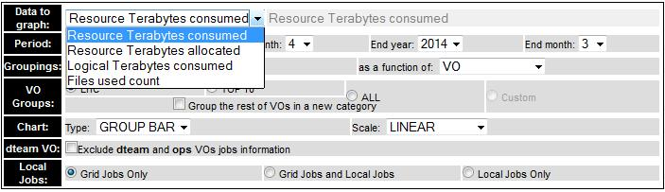
Figure 11: Accounting Portal - form to query storage accounting data.

Others
TJRA1.4 team is still working on the definition of an Application Accounting usage Record (AAR) in XML format and developed a first prototype for Application Accounting. An evolution of this prototype will be showed during the next EGI Community Forum.

Effort assessment and main issues

Effort overview
Task composition of the activity was discussed in details in D7.1 [R 76] and is summarized here:
- TJRA1.1: Management: The JRA1 activity manager coordinates the maintenance and development of the operational tools.
- TJRA1.2: Maintenance and development of the deployed operational tools: The underlying bug fixing and development work for the operational tools
- TJRA1.3: National Deployment Models: Specific development activity needed to support the regionalisation of the tools at the NGI level
- TJRA1.4: Accounting for different resource types: The work needed to evolve the EGI accounting system in order to encompass the different resource types that will be included into the production infrastructure and to support an economic model needed for some EGI sustainability scenarios
- TJRA1.5: Integrated Operations Portal: Dedicated to the development needed for a restructuring of the Operations Portal, its evolution and harmonization with other portal frameworks

The JRA1 tasks follow the time sequencing described in Figure 12.

Figure 12 - JRA1 tasks time sequencing. TJRA1.3 was extended for another year at the end of PY1.
The committed and used effort data for the development tasks, TJRA1.2, TJRA1.3, TJRA1.4 and TJRA1.5 are reported in the tables available in Appendix A. They show the data for the first three years of the project, for the first three quarters of the fourth year and for the sum of the four periods when possible (some tasks may have been inactive in one of the timeslots).
Task by task the following considerations apply:

TJRA1.2
The total TJRA1.2 effort consumption is in line with the committed effort. The GRNET under-reporting has been reduced again in PY4 and it is now only a minor issue. FCTSG/CSIC over-reporting has been mitigated since the partner focused its effort in TJRA1.4 activities as planned in the roadmap defined in MS710 [R 77] at the end of PY3.

TJRA1.3
The task ended at the end of PY2.

TJRA1.4
As foreseen at the end of PY3, TJRA1.4 under-reporting has been considerably reduced in PY4. A slight overall under-reporting is still present at the end of PQ15 but it will again reduce in PQ16 taking into accounting the partners reporting trend during the first three quarters of the PY4. The TJRA1.4 report evolution during the project lifetime has been fairly natural considered the type of activities planned for this task, activities that require a deep study and a careful requirements collection before starting the development phases. FCTSG/CSIC under-reporting has been rather reduced in PY4 and now can be considered acceptable. The INFN under-reporting is yet not negligible, however INFN effort consumption has been strongly increased in PY4 thanks to the activity roadmap defined at the end of PY3 (see D7.3) and it will reach acceptable values at the end of PY4.

TJRA1.5
The task ended at the end of PY3 with no deviations. The Operations Portal maintenance continued in TJRA1.2.

Development vs Maintenance Effort
The evaluation, tool by tool, of how the used effort is split between basic maintenance (bug fixes, interaction with other tools) and development for new features or code restructuring continued during PY4.The evolution of both effort numbers for the entire duration of the project could at least show a trend of the maintenance cost of the tools. Cost in this context is used in terms of effort and not of money, as translating effort to money is outside the scope of this deliverable.
This estimation has been the base to identify the effort needed to proactive maintain the EGI operational tools after the end of the JRA1 activity. Indeed, the resources allocated to the Core EGI Activities [R 78] and related to the operational tools, starting in May 2014 with the aim to guarantee the maintenance for the operational tools, has been assessed taking into account this evaluation.
The split between maintenance and development has been self-assessed by each of the product teams for each of the tools. This assessment for the four years of the JRA1 activity, tool by tool, is reported in Table 1, Table 2 and Figure 13. Table 1 shows the absolute numbers, tool by tool, of the total project effort used, while Table 2 reports the splitting between development and maintenance.
Throughout the project the focus work has changed from the initial development phase to the latter deployment and support phase and, for this reason, the maintenance effort grows for almost all tools during the project lifetime. This reflects the decrease of the number of new features to be developed once several users’ requirements have already been fulfilled and the increase of the effort needed to refine the already delivered capabilities (e.g. bug fixing). The development effort started to decrease when the new functionalities become more stable and the features frozen.
Exceptions to this trend are the GOCDB and Accounting Portal.
The GOCDB product team released the new v5 series during the PY4 implementing many remarkable changes with respect the previous release. The GOCDB v5 includes a completely new data layer able to use different RDBMS platforms (e.g. MySQL, Postgres, Oracle), it can support multiple projects and is used to manage the relationships between different entities (Grid, Cloud, etc.) using a well constrained relational schema. The development of these new features required a complete re-design of the tool that considerably increased the development effort for the PY4.
The Accounting Portal is the last ring of the chain in the EGI accounting system and, for this reason, its developments depend on the activities of the product teams. The product team developed the new features to support the provisioning of new resource types, such as Cloud, Storage, Parallel Jobs, etc, as soon as the data format was agreed and the first data was available in the Accounting Repository during PY3 and PY4. This justifies the increase of the percentage of the development effort in the last two years of the project.

 | Involved Partners |  | PY1 | PY2 | PY3 | PY4 (excluding PQ16)
GOCDB | STFC |  | 5 | 5 | 6 | 6.5
Ops Portal | CNRS |  | 17 | 20 | 24 | 3
GGUS | KIT-G |  | 10 | 13 | 12 | 12
SAM (including messaging support) | CERN  SRCE  GRNET |  | 13 | 11 | 9 | 8.5
Accounting Repository | STFC |  | 1,6 | 7 | 7 | 8.5
Accounting Portal | FCTSG/CSIC |  | 6 | 3 | 6 | 5
Metrics Portal | FCTSG/CSIC |  | 0,6 | 2 | 1 | 0.5
Table 1– Reported effort tool by tool for each project year in PM, excluding PQ16.

Tool | PY1 |  | PY2 |  | PY3 |  | PY4
Tool | Dev | Maint | Dev | Maint | Dev | Maint | Dev | Maint
GOCDB | 50% | 50% | 50% | 50% | 50% | 50% | 50% | 50%
Ops Portal | 80% | 20% | 80% | 20% | 55% | 45% | 50% | 50%
GGUS | 55% | 45% | 55% | 45% | 50% | 50% | 50% | 50%
SAM | 45% | 55% | 35% | 65% | 30% | 70% | 30% | 70%
Accounting Repository | 75% | 25% | 75% | 25% | 75% | 25% | 50% | 50%
Accounting Portal | 20% | 80% | 30% | 70% | 80% | 20% | 80% | 20%
Metrics Portal | 90% | 10% | 90% | 10% | 80% | 20% | 60% | 40%
Table 2 - Maintenance versus Development Effort, tool by tool, for each project year.

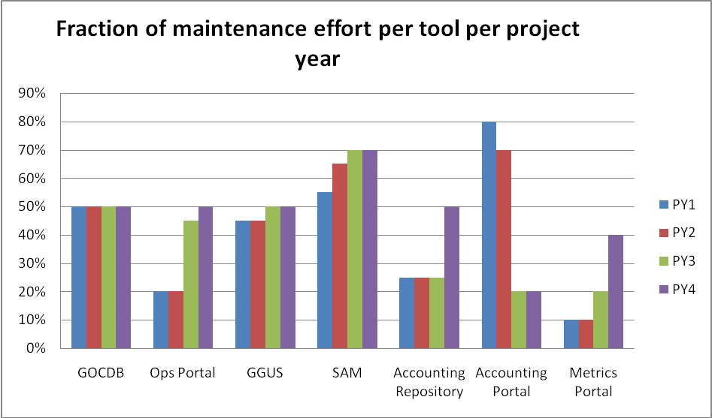
Figure 13: Evolution of the fraction of effort devoted to maintenance tool by tool for the four years of the JRA1 activity.

Major issues
The following major issues have been encountered and addressed during PY4:
- Migration of the SAM central services: As CERN didn’t participate to the bidding for providing the SAM services after PY4, SAM services operated by CERN will be discontinued as of 01 May 2014. The SAM central services have to be migrated to a new consortium of partners (CNRS, SRCE and GRNET).
Mitigation: The main task for the SAM product team during the second half of the PY4 has been the support needed to migrate the SAM central services to the new consortium of partners (CNRS, SRCE and GRNET).This has involved developing a detailed time plan, writing technical documentation necessary for the migration of SAM central services, providing technical support to the consortium as well as organizing SAM migration meetings and workshops to follow up on the transition process and make sure it is implemented in time and within its scope. In addition, documentation has been written in order to finalize monitoring of the local NGI services. Furthermore the deployment of all the needed services (SAM central instance, messaging brokers, etc.) has been moved up in the first months of the 2014 by the new consortium. Currently, they already deployed almost all the needed services and a validation is running, in collaboration with the SAM team, to verify that everything is working fine. Once the validation is completed, the current SAM services installed at CERN could be decommissioned. This plan allows a smooth transition to the new deployment.
- EGI operational tools interoperation after the end of the JRA1 activity: as described in MS711 [R 79] many interdependencies between the EGI operational tools exist and, until now the JRA1 activity has coordinated the development to assure the tool interoperability. With the conclusion of the JRA1 activity at the end of PY4, this coordination will end.
Mitigation: A new EGI.eu board will be created including delegates for each product team to discuss the feature development roadmaps regardless the type of activity (Core EGI Activities, EGI-InSPIRE JRA2 in PY5, other funded projects, etc.) that will support these new developments. The new board will be settled at the start of PY5 and its meeting frequency will be once per month as for the JRA1 meeting.
- Integration of the probes developed through the EMI project in SAM: the development of the probes is out of scope of SAM and JRA1 activities. Several probes have been developed in the context of the EMI project and the JRA1 team should integrate them into the SAM framework. Some problems have been encountered concerning dependencies, environments and configurations in the definition of the packages that EMI should provide to JRA1. Moreover, the roles of EMI and the JRA1 teams in the integration process were not well defined. This caused some delay in the probe integration.
Mitigation: A working group, the EGI SAM probes WG [R 80], composed of experts from NGIs, EMI and EGI, was created to revise the probes developed by the EMI project before they are integrated into SAM framework, and to evaluate probe and monitoring-related improvements. The activity of this WG continued after the end of the EMI project.The main outcomes was that JRA1 provided EMI with a set of requirements to be fulfilled by the EMI packages and the definition of the roles for both teams. EMI was responsible for testing the package contents, while JRA1 tests the integration in SAM.. An integration test-bed [R 27] was created to simplify the communication between the teams during the integration process. The status of the integration process and the main issues identified by the JRA1 team, that have to be fixed by EMI, were reported there. Additionally, after the conclusion of the integration of the probes developed through the EMI project in SAM, an extensive testing and validation of the SAM release was performed before of the deployment in production. Indeed, prior to starting the staged rollout (SR) procedure, a SAM testing release campaign was executed involving many NGIs. Several regions volunteered to join and provided excellent feedback and at the same time helped to identify several critical issues. This has significantly decreased the time and effort needed for the EGI SR. Finally, the integration of the Nagios probes developed through the EMI project in SAM was achieved in full scope by successfully releasing and deploying SAM v. 22 to production in October 2013.

Roadmap
The discussion of the roadmap for each of the JRA1 tools is beyond the scope of this deliverable and is already provided by a recent project milestoneMS711 “Roadmap For The Maintenance And Development Of The Deployed Operational Tools” [R 79] which details the roadmap until the end of the project. However a short list of the major expected developments for each tool that will be carried out during 2014 by JRA1 (until April 2014), EGIcore activities (May-December 2014) and JRA2 (May-December 2014) is provided in the following tables.

Operations Portal
 | PQ16 | PQ17 | PQ18 | PQ19
Refactoring of the portal | X
New disciplines classification | X
Refactoring of the portal – Improving according to the users feedback |  | X
Create a package to simplify the operations portal installation procedure |  |  | X
Table 3- Operations Portal roadmap for 2014.

GGUS
 | PQ16 | PQ17 | PQ18 | PQ19 | TBD
Implementation of alarm processes for EGI tools | X
Additional authentication through shibboleth | X
CMS specific adaptations | X
Merge GGUS and xGUS web frontends to a common platform | X
Implement a bulk submit feature to enable the notification of many sites at the same time | X
New interfaces to PRACE and XSEDE |  |  |  |  | X
Table 4 - GGUS roadmap for 2014.

GOCDB
 | PQ16 | PQ17 | PQ18 | PQ19 | TBD
Multiple Service Endpoints |  | X
Writable PI method to submit downtimes |  | X
Extend data model and add more GLUE2 attributes (e.g. GLUE2 cloud extensions) |  | X
GLUE2 XML rendering of GOCDB data |  |  | X
Web portal interface enhancements |  |  |  |  | X
Table 5 - GOCDB roadmap for 2014.

SAM
 | PQ16 | PQ17 | PQ18 | PQ19
Messaging: Implementation of SAM probes failover capabilities | X
SAM to monitor services and sites not in GOCDB (RT2791) | X
Support for migration of central services | X
Addition of new (2) broker endpoints | X
Removal of current (4) broker endpoints | X
Development of a new web user interface replacing MyEGI |  |  |  | X
Extension of the WebAPI delivered by [R 26] |  |  |  | X
The extension of the Sync Components |  |  |  | X
Creation of a leaner monitoring instance |  |  |  | X
Removal of the Oracle database dependency |  |  |  | X
Table 6 - SAM roadmap for 2014.

Accounting Repository, including TJRA1.4, new resource types accounting
 | PQ16 | PQ17 | PQ18 | PQ19
Confirm Storage Accounting schema | X
Storage Accounting Summaries to Accounting Portal | X
Cloud Accounting to production | X
Send MPI data to portal | X
Application accounting prototype |  | X
Application Accounting usage record finalised |  |  | X
Publishing summaries from Accounting Repository to other sites (OSG/DGAS) |  |  | X
Send all accounting data (including MPI data) to portal in production using the new schema |  |  | X
Migrate sites from SSM1.2 to SSM2 |  |  |  | X
Storage Accounting in production |  |  |  | X
GPGPU accounting prototype |  |  |  | X
Improvement of the cloud accounting to cover storage accounting for transient cloud storage and data usage accounting by the virtual machines |  |  |  | X
Adoption the OGF Usage Record v2 |  |  |  | X
Support to implement Pay-for-Use proof of concept |  |  |  | X
Table 7 - Accounting Repository roadmap for 2014.

Accounting Portal
 | PQ16 | PQ17 | PQ18 | PQ19
Provisioning of MPI accounting (View  Implementation) | X
XML endpoints generalization and  improvement |  | X
SSM implementation for CPU Accounting |  | X
Provisioning of Application accounting (DB  implementation) |  |  |  | X
Provisioning of Application accounting (View  implementation) |  |  |  | X
Scientific Disciplines VT Interface Support |  |  |  | X
Scientific Disciplines VT final Implementation |  |  |  | X
Adoption the OGF Usage Record v2 |  |  |  | X
Support to implement Pay-for-Use proof of concept |  |  |  | X
Regional Portal Implantation in other NGIs |  |  |  | X
Improvements Storage View |  |  |  | X
Improvements Cloud View |  |  |  | X
Improvements MPI View |  |  |  | X
General Improvements |  |  |  | X
Portal extensions to include GPGPU usage information |  |  |  | X
Table 8 - Accounting Portal roadmap for 2014.
Metrics Portal
 | PQ16 | PQ17 | PQ18 | PQ19
Manual metrics expansion and refinement | X
Views enhancement and optimization | X
Table 9 - Metrics Portal roadmap for 2014.

Participation in conferences and project task forces
JRA1 and all its product teams actively attended the annual main project events, the EGI Technical Forum and the EGI Community Forum. During the Technical Forum in Madrid a workshop on the advancement of the EGI operations tools was organised as well as an accounting training. The workshop on the advancement of the EGI operations tools was focussed on the foreseen roadmap for the tools highlighting the new features and allowing the reuse of existing solutions to address typical needs of any distributed research infrastructure. The training on accounting was an opportunity for sites to clarify the procedure to execute the upgrade to the new APEL Client released in EMI-3. In addition, it provided a forum to explore whether deploying a regional APEL Server and Accounting Portal is appropriate for their region. In the EGI Community Forum, that will be held in Helsinki in May 2014, three workshops will be organised: the first about the new operational tools which were added to the EGI infrastructure in the last months (e.g. VAPOR and e-GRANT) and the usage of the EGI tools in the EUDAT infrastructure [R 81], the second will describe the many recent developments in the accounting services and the last will be about the Availability & Reliability monitoring service, which is now operated and further developed by the consortium composed by GRNET, CNRS and SRCE.
JRA1 has been represented in all the project taskforces, groups and bodies that required its presence, including the new GGUS Advisory Board.

Conclusions
This document reported the fourth year of activity of the EGI-InSPIRE work package 7 (JRA1) within each of its tasks. WP7 deals with the maintenance and development of operational tools. JRA1 is composed of five tasks:
- TJRA1.1 is the management task
- TJRA1.2 for the maintenance and the developments for all the tools
- TJRA1.3 devoted to the development of regionalised tools
- TJRA1.4 for the extension of the accounting system to encompass new resource types (other than CPU)
- TJRA1.5 for the development needed for the extension of the Operations Portal and its harmonization with other portal frameworks
TJRA1.5 completed its activities at the end of PY3, while TJRA1.3 ended in PY2.
TJRA1.2 activities proceeded regularly during the year and many new features were added to all the tools, these are described in details in section 2 and among them we can mention:
- Operations Portal:
  - a complete review of the portal to improve the look and feel, the ergonomics and the efficiency;
  - Lavoisier framework has been upgraded to a more flexible and powerful new version (v2.0);
  - new features to make easier the management of the security contacts;
  - new features to get the list of all the EGI users;
- GGUS:
  - the development of the new report generator has been completed;
  - the whole GGUS infrastructure was moved to two independent stacks of virtual machines in different locations and the manual switching mechanisms was implemented;
  - a complete refactoring of the VOMS synchronization has been accomplished to improve its reliability;
  - a dedicated xGUS instance was set up for the MAPPER project.
- GOCDB:
  - the new GOCDB v5 is based on de-facto Object Relational Mapping libraries (Doctrine ORM) that can support different RDBMS;
  - the new scoping mechanism allows different infrastructure entities (Sites, Services, ServiceGroups) to be tagged by one or more scope-tags;
  - an administration interface was developed to simplify and speed-up daily operational tasks for GOCDB administrators;
  - a new extensibility mechanism allows users to associate custom key-value pairs to Sites, Services, and Service Groups;
  - a single GOCDB instance can host now multiple projects.
- Accounting system:
  - ARC, QCG and EDGI Desktop sites in production are now able to send accounting data to the EGI accounting system;
  - regional Accounting Repository and Portal were released.
- SAM:
  - Nagios probes developed through the EMI project has been integrated in SAM as a part of SAM Update-22;
  - new SAM central services were deployed by the consortium composed by CNRS, GRNET and SRCE.
- Metrics Portal:
  - new metrics types added;
  - improved links and navigation.
For what concerns the integration of new (not gLite) middleware types into the operational tools, this was already completed from the perspective of SAM and GOCDB at the end of PY3 for:
- UNICORE
- ARC
- GLOBUS
- Desktop Grids
- QosCosGrid
The regionalisation activities were completed in the first months of PY4 with the end of development of the regional Accounting Repository and Portal. Currently, each tool has its working regionalisation solution o(as independent instances or as views inside the central instance).
TJRA1.4 is close to complete the developments started in PY3 and continued in PY4. Cloud, Storage and Parallel Jobs resource types can be accounted in the EGI Accounting Repository based on SSM and new views were developed in the portal to show these data. To complete these activities the remaining step is the deployment of an automatic system to dispatch the accounting data from the repository to the portal foreseen by the end of PY4.
Another TJRA1.4 important achievement in PY4 is the integration in the Accounting Portal of a module able to get site charging attributes from the GOCDB, and use them, in association to the accounting data, as input parameters of a billing function. The charging attributes can be stored in the GOCDB through the new extensibility mechanism provided by the v5.2. Two provisional billing functions, one for grid resources and the other for cloud, are now available in the Accounting Portal, however any kind of function defined by the Pay-for-Use working group during its activity, requiring as input parameters values associated to the GOCDB entities and data accounting, could be easily and quickly developed on the accounting portal exploiting the above described mechanism.
The main issues identified during the year are reported in section 4.
Section 4 also provides an assessment of the spent effort for all the tools. An estimate of the effort splitting between base maintenance and new feature developments is also presented. This study has been the base to estimate the effort needed to proactive maintain the EGI operational tools after the end of the JRA1 activity. Indeed, the resources allocated to the EGI Core Activities (starting in May 2014) with the aim to guarantee the maintenance for the operational tools, has been assessed taking into account this evaluation. The maintenance effort has grown for almost all tools during the project lifetime. This reflects the decrease of the number of new features to be developed once several user requirements have already been fulfilled and the increase of the effort needed to refine the already delivered capabilities (e.g. bug fixing). Exceptions to this trend are the GOCDB and the Accounting Portal due to the development of GOCDB v5 and the integration of the new resource types in the Accounting Portal.
No OTAG meetings were organized during PY4, tools are now in a consolidation phase and the number of new requirements received decreased. Discussions on requirements continued in RT and OMB mailing lists and during JRA1 meetings.
The future roadmap for the tools is not described in detail in this document however, it was briefly outlined in section 5 as it was the focus of a recent project milestone (MS711).

References
R 1 | JRA1 Main Wiki Page:  https://wiki.egi.eu/wiki/WP7:_Operational_Tools
R 2 | MS705 Operations Portal Roadmap:  https://documents.egi.eu/document/525
R 3 | Lavoisier  http://software.in2p3.fr/lavoisier/index.html
R 4 | EGI VO Security Contact Information  https://documents.egi.eu/document/1920
R 5 | MS410 EGI Helpdesk and the NGI support units:  https://documents.egi.eu/document/522
R 6 | Mapper project  http://www.mapper-project.eu
R 7 | xGUS instance for Mapper  https://xgus.ggus.eu/mapper/
R 8 | Shibboleth  http://shibboleth.net/
R 9 | GGUS Advisory Board indico page  https://indico.egi.eu/indico/categoryDisplay.py?categId=78
R 10 | xGUS web site  http://xgus.scc.kit.edu/
R 11 | GOCDB v5  https://wiki.egi.eu/w/images/d/d3/GOCDB5_Grid_Topology_Information_System.pdf
R 12 | Object-relational mapping  http://en.wikipedia.org/wiki/Object-relational_mapping
R 13 | TSA4.11 - GOCDB Scoping Extensions and Management Interface mini project  https://wiki.egi.eu/wiki/VT_GOCDBExt
R 14 | EGI Pay for Use – Proof of concept  https://wiki.egi.eu/wiki/EGI_Pay-for-Use_PoC:Home
R 15 | OGF GLUE2 XML Rendering  http://www.ogf.org/documents/GFD.209.pdf
R 16 | D7.3 Annual Report on Operational Tool maintenance and development activity  https://documents.egi.eu/document/1562
R 17 | MS 706 Operational Tools Accounting Work Plan:  https://documents.egi.eu/document/531
R 18 | EMI 3 Monte Bianco  http://www.eu-emi.eu/emi-3-montebianco
R 19 | SSM - Secure Stomp Messenger:  https://wiki.egi.eu/wiki/APEL/SSMOverview
R 20 | ARC – Advanced Resource Connector:  http://www.nordugrid.org/arc/
R 21 | QosCosGrid  http://www.qoscosgrid.org/trac/qcg
R 22 | EDGI - European Desktop Grid Initiative  http://edgi-project.eu/
R 23 | Globus  https://www.globus.org/
R 24 | UNICORE  http://www.unicore.eu/
R 25 | Central SAM documentation  https://tomtools.cern.ch/confluence/display/SAMDOC/Home
R 26 | SAM Update-22 Release notes  https://tomtools.cern.ch/confluence/display/SAMDOC/Update-22
R 27 | Integration of EMI probes in SAM – Integration testbed:  https://twiki.cern.ch/twiki/bin/view/EMI/NagiosServerEMITestbed0022012
R 28 | EGI SAM probes Working Group  https://wiki.egi.eu/wiki/Nagios_probes_Working_Group
R 29 | SAM-Gridmon migration plan  https://indico.egi.eu/indico/getFile.py/access?contribId=0&resId=0&materialId=0&confId=1979
R 30 | TSA4.10 - A new approach to Computing A/R reports mini-project  https://wiki.egi.eu/wiki/VT_Comp_Reports
R 31 | Local SAM regional instances:  https://wiki.egi.eu/wiki/SAM_Instances
R 32 | EGI software provisioning process:  https://wiki.egi.eu/wiki/EGI_Software_Provisioning
R 33 | ActiveMQ message system homepage:  http://activemq.apache.org/
R 34 | Message Brokers migration plan  https://indico.egi.eu/indico/getFile.py/access?contribId=1&resId=0&materialId=0&confId=1979
R 35 | GOCDB Service Types Query:  https://goc.egi.eu/gocdbpi/public/?method=get_service_types
R 36 | gLite  http://glite.web.cern.ch/glite/
R 37 | iRods:  https://www.irods.org/
R 38 | BES – Batch Execution System:  http://www.ogf.org/UnderstandingGrids/documents/OGSA-BES-OnePager%20jfe.pdf
R 39 | Torque:  http://www.adaptivecomputing.com/products/open-source/torque/
R 40 | Squid:  http://www.squid-cache.org
R 41 | XRootD:  http://xrootd.slac.stanford.edu/
R 42 | COMPSs:  http://www.bsc.es/computer-sciences/grid-computing/comp-superscalar
R 43 | DIRAC:  http://diracgrid.org/
R 44 | Slipstream:  http://sixsq.com/products/slipstream.html
R 45 | GOCDB documentation – Adding new service types:  https://wiki.egi.eu/wiki/GOCDB/Input_System_User_Documentation#Adding_new_services_types
R 46 | Metrics changed between SAM Update-20 and SAM Update-22:  https://tomtools.cern.ch/confluence/display/SAMDOC/FAQs#FAQs-WhichmetricshavebeenchangedbetweenSAMUpdate20andSAMUpdate22%3F
R 47 | DMSU Main Wiki Page:  https://wiki.egi.eu/wiki/TSA2.5_Deployed_Middleware_Support_Unit
R 48 | EMI Project Homepage:  http://www.eu-emi.eu/
R 49 | SAGA – Simple Api for Grid Application:  www.ogf.org/documents/GFD.90.pdf
R 50 | EGI Federated Cloud Main Wiki Page:  https://wiki.egi.eu/wiki/Fedcloud-tf:FederatedCloudsTaskForce
R 51 | International Desktop Grid Federation (IDGF)  http://desktopgridfederation.org/
R 52 | CernVM File System  http://cernvm.cern.ch/portal/filesystem
R 53 | EDUPERT  http://geant3.archive.geant.net/Services/NetworkPerformanceServices/Pages/eduPERT.aspx
R 54 | GGUS documentation – Adding a new support unit:  https://wiki.egi.eu/wiki/FAQ_GGUS-New-Support-Unit
R 55 | EGI Federated Cloud Scenario5 Wiki Page:  https://wiki.egi.eu/wiki/Fedcloud-tf:WorkGroups:Scenario5
R 56 | EGI Federated Cloud Scenario4 Wiki Page:  https://wiki.egi.eu/wiki/Fedcloud-tf:WorkGroups:Scenario4
R 57 | Cloudmon – SAM instance for cloud resources  https://cloudmon.egi.eu/nagios/
R 58 | Central MyEGI instance  http://mon.egi.eu/myegi
R 59 | TJRA1.4 wikipage:  https://wiki.egi.eu/wiki/Accounting
R 60 | Inter Project Accounting Task Force  https://wiki.egi.eu/wiki/TCB:Accounting_Task_Force
R 61 | OpenStack:  http://www.openstack.org/
R 62 | OpenNebula:  http://opennebula.org/
R 63 | Okeanos:  https://okeanos.grnet.gr/home/
R 64 | StratusLab:  http://stratuslab.eu/
R 65 | Accounting Portal testing instance – Cloudview  http://accounting-devel.egi.eu/cloud.php
R 66 | OGF Usage Record Working Group:  http://www.ogf.org/gf/group_info/view.php?group=ur-wg
R 67 | EMI Compute Accounting Record (CAR)  https://twiki.cern.ch/twiki/bin/view/EMI/ComputeAccountingRecord
R 68 | OGF Usage Record (UR)  http://www.ggf.org/documents/GFD.98.pdf
R 69 | Platform LSF  http://en.wikipedia.org/wiki/Platform_LSF
R 70 | Portable Batch System (PBS)  http://en.wikipedia.org/wiki/Portable_Batch_System
R 71 | Simple Linux Utility for Resource Management (SLURM)  https://computing.llnl.gov/linux/slurm/
R 72 | Sun Grid Engine  http://en.wikipedia.org/wiki/Oracle_Grid_Engine
R 73 | Accounting Portal testing instance – Parallel jobs view  https://accounting-devel.egi.eu/mpi.php
R 74 | EMI StaR – Storage Accounting Record:  https://redmine.ogf.org/issues/74
R 75 | Accounting Portal testing instance – Storage view  https://accounting-devel.egi.eu/storage.php
R 76 | D7.1- Annual Report on Operational Tool maintenance and development activity  https://documents.egi.eu/document/372
R 77 | MS710 - Roadmap For The Maintenance And Development Of The Deployed Operational Tools:  https://documents.egi.eu/secure/ShowDocument?docid=1501
R 78 | EGI Core Activities  https://wiki.egi.eu/wiki/Core_EGI_Activities
R 79 | MS711 - Roadmap For The Maintenance And Development Of The Deployed Operational Tools:  https://documents.egi.eu/document/2069
R 80 | EGI SAM probes WG  https://wiki.egi.eu/wiki/Nagios_probes_Working_Group
R 81 | EUDAT  http://eudat.eu/
R 82 | Metrics Portal  https://wiki.egi.eu/wiki/Metric_Portal

appendix a: jra1 effort tables
 |  | Project Period 1
Task | Partner | Worked PM Funded | Committed PM | Achieved PM %
TJRA1.2 | 10B-KIT-G | 9,612 | 11,750 | 82%
TJRA1.2 | 12B-FCTSG | 5,600 | 3,000 | 187%
TJRA1.2 | 14A-CNRS | 3,059 | 3,000 | 102%
TJRA1.2 | 16A-GRNET | 0,914 | 3,000 | 30%
TJRA1.2 | 17-SRCE | 3,290 | 3,000 | 110%
TJRA1.2 | 34A-STFC | 5,269 | 6,000 | 88%
TJRA1.2 | 35-CERN | 0,533 | 3,000 | 18%
TOTAL PY1 |  | 28,278 | 32,750 | 86%

 |  | Project Period 2
Task | Partner | Worked PM Funded | Committed PM | Achieved PM %
TJRA1.2 | 10B-KIT-G | 13,4 | 11,8 | 114%
TJRA1.2 | 12B-FCTSG | 4,4 | 3,0 | 146%
TJRA1.2 | 14A-CNRS | 3,0 | 3,0 | 100%
TJRA1.2 | 16A-GRNET | 1,9 | 3,0 | 63%
TJRA1.2 | 17-SRCE | 3,5 | 3,0 | 116%
TJRA1.2 | 34A-STFC | 5,3 | 6,0 | 88%
TJRA1.2 | 35-CERN | 5,7 | 3,0 | 189%
Total: |  | 37,1 | 32,8 | 113%

 |  | Project Period 3
Task | Partner | Worked PM Funded | Committed PM | Achieved PM %
TJRA1.2 | 10B-KIT-G | 12,2 | 11,8 | 104%
TJRA1.2 | 12B-FCTSG | 2,3 | 3,0 | 77%
TJRA1.2 | 14A-CNRS | 2,2 | 3,0 | 73%
TJRA1.2 | 16A-GRNET | 2,1 | 3,0 | 70%
TJRA1.2 | 17-SRCE | 3,5 | 3,0 | 117%
TJRA1.2 | 34A-STFC | 6,0 | 6,0 | 100%
TJRA1.2 | 35-CERN | 2,5 | 3,0 | 83%
Total: |  | 30,8 | 32,8 | 94%

 |  | Project Period 4 (QR13-QR15)
Task | Partner | Worked PM Funded | Committed PM | Achieved PM %
TJRA1.2 | 10B-KIT-G | 12,1 | 8,8 | 138%
TJRA1.2 | 12B-FCTSG | 0,4 | 2,3 | 18%
TJRA1.2 | 14A-CNRS | 2,9 | 2,3 | 129%
TJRA1.2 | 16A-GRNET | 1,9 | 2,3 | 84%
TJRA1.2 | 17-SRCE | 2,6 | 2,3 | 116%
TJRA1.2 | 34A-STFC | 6,2 | 4,5 | 138%
TJRA1.2 | 35-CERN | 3,8 | 2,3 | 169%
Total: |  | 29,9 | 24,6 | 122%

 |  | PY1+PY2+PY3+PY4
Task | Partner | Worked PM Funded | Committed PM | Achieved PM %
TJRA1.2 | 10B-KIT-G | 47,3 | 44,1 | 107%
TJRA1.2 | 12B-FCTSG | 12,7 | 11,3 | 113%
TJRA1.2 | 14A-CNRS | 11,2 | 11,3 | 99%
TJRA1.2 | 16A-GRNET | 6,8 | 11,3 | 61%
TJRA1.2 | 17-SRCE | 12,9 | 11,3 | 114%
TJRA1.2 | 34A-STFC | 22,7 | 22,5 | 101%
TJRA1.2 | 35-CERN | 12,5 | 11,3 | 111%
Total: |  | 126,0 | 122,8 | 103%
Table 10: Effort for TJRA1.2 excluding PQ16.

 |  | PY1+PY2
Task | Partner | Worked PM Funded | Committed PM | Achieved PM %
TJRA1.3 | 12B-FCTSG | 2,9 | 3,0 | 96%
TJRA1.3 | 14A-CNRS | 3,5 | 3,0 | 116%
TJRA1.3 | 17-SRCE | 3,6 | 3,0 | 119%
TJRA1.3 | 34A-STFC | 2,9 | 3,0 | 96%
TJRA1.3 | 35-CERN | 4,3 | 6,0 | 72%
 | total | 17,1 | 18,0 | 95%
Table 11: Effort for TJRA1.3.

 |  | Project Period 2
Task | Partner | Worked PM Funded | Committed PM | Achieved PM %
TJRA1.4 | 10H-LUH | 6,6 | 6,0 | 111%
TJRA1.4 | 12B-FCTSG | 0,7 | 6,0 | 12%
TJRA1.4 | 21A-INFN | 1,2 | 8,7 | 14%
TJRA1.4 | 34A-STFC | 6,9 | 9,0 | 77%
Total: |  | 15,5 | 29,7 | 52%

 |  | Project Period 3 (QR9-QR12)
Task | Partner | Worked PM Funded | Committed PM | Achieved PM %
TJRA1.4 | 10H-LUH | 4,8 | 6,0 | 81%
TJRA1.4 | 12B-FCTSG | 4,8 | 6,0 | 79%
TJRA1.4 | 21A-INFN | 3,9 | 8,7 | 45%
TJRA1.4 | 34A-STFC | 6,7 | 9,0 | 74%
Total: |  | 20,2 | 29,7 | 68%

 |  | Project Period 4 (QR13-QR15)
Task | Partner | Worked PM Funded | Committed PM | Achieved PM %
TJRA1.4 | 10H-LUH | 4,3 | 4,5 | 96%
TJRA1.4 | 12B-FCTSG | 5,0 | 4,5 | 111%
TJRA1.4 | 21A-INFN | 6,6 | 6,5 | 102%
TJRA1.4 | 34A-STFC | 8,3 | 6,8 | 123%
Total: |  | 24,2 | 22,3 | 109%

 |  | PY1+PY2+PY3+PY4
Task | Partner | Worked PM Funded | Committed PM | Achieved PM %
TJRA1.4 | 10H-LUH | 15,8 | 16,5 | 96%
TJRA1.4 | 12B-FCTSG | 10,5 | 16,5 | 64%
TJRA1.4 | 21A-INFN | 11,8 | 23,8 | 49%
TJRA1.4 | 34A-STFC | 21,9 | 24,8 | 88%
Total: |  | 59,9 | 81,6 | 73%
Table 12: Effort for TJRA1.4 excluding PQ16.

 |  |  | PY1+PY2+PY3
Task | Partner | Worked PM Funded |  | Committed PM | Achieved PM %
TJRA1.5 | 14A-CNRS | 52,6 |  | 53,0 | 99%
Table 13: Effort for TJRA1.5.

Since many years GGUS releases usually are done on the last Wednesday of a month. The high frequency of releases has the advantage to be able react quickly to the many requests coming from various groups and communities.
The delivery date could be delayed depending on the available effort.
The deployment of all the new SAM components, which will be ready in PQ19, is foreseen for the first quarter of 2015. The deployment and the related bug-fixing activities to install these new components in production will be executed under the context of the EGI core activity for SAM.
Needed to remove the Oracle database dependency and reduce the maintenance cost.
A lean monitoring instance could be supported in an easier way reducing the maintenance cost.

