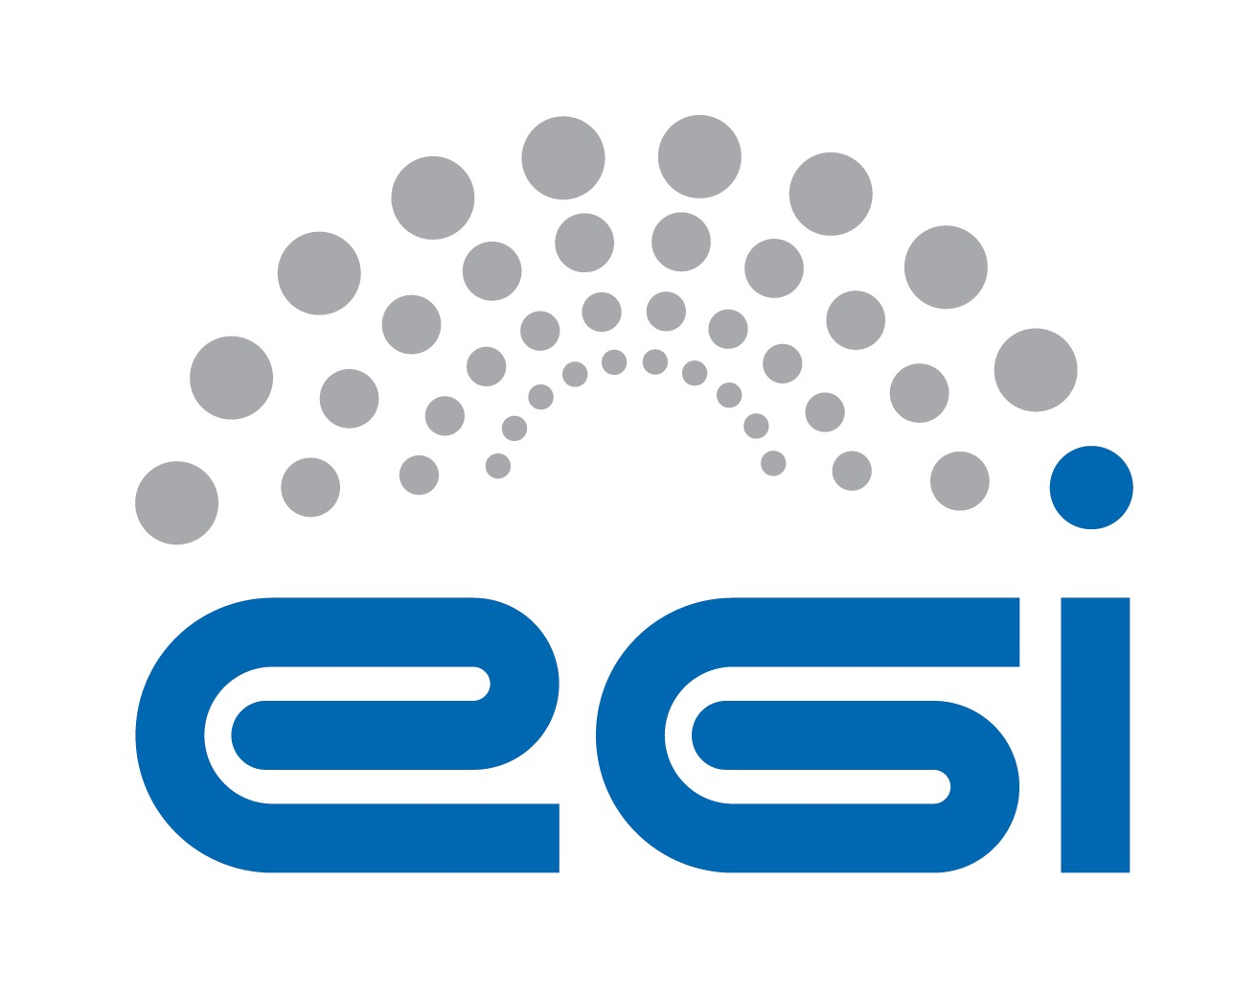
EGI.eu
Operation Level Agreement

Customer | EGI.eu
Provider | CYFRONET
Service | Operations Support
Start Date | 1 May 2014
End Date | 30 April 2015
Version | 1
Document Link: | https://documents.egi.eu/document/2170
- Copyright notice
Copyright © EGI.eu. This work is licensed under the Creative Commons Attribution-NonCommercial-NoDerivs 3.0 Unported License. To view a copy of this license, visit http://creativecommons.org/licenses/by-nc/3.0/ or send a letter to Creative Commons, 171 Second Street, Suite 300, San Francisco, California, 94105, USA.
The work must be attributed by attaching the following reference to the copied elements: “Copyright © EGI.eu (www.egi.eu). Using this document in a way and/or for purposes not foreseen in the license, requires the prior written permission of the copyright holders. The information contained in this document represents the views of the copyright holders as of the date such views are published.

This OLA is based on a template that forms part of the FitSM family – a lightweight standard for IT Service Management that supports federated infrastructures. For more information on FitSM visit www.fitsm.eu or contact info@fitsm.eu. The OLA template this document is based on was licensed with a Creative Commons Attribution 4.0 International License.

This OLA is based on FitSM Template: SLA v1.0.
TABLE OF CONTENTS
1 Introduction 4
2 Scope and description of the services 4
3 Service hours and exceptions 4
4 Services components and dependencies 4
5 Support 5
5.1 Incident handling 5
5.2 Fulfilment of service requests 6
6 Service level targets 6
7 Limitations & constraints 6
8 Communication, reporting & escalation 7
8.1 General communication 7
8.2 Regular reporting 7
8.3 OLA violations 7
8.4 Escalation & complaints 8
9 Information security & data protection 8
10 Additional responsibilities of the provider 8
11 Customer responsibilities 8
12 Review 9
13 Glossary of terms 10
14 References 11

Introduction
This agreement is made between CYFRONET (the Provider) and EGI.eu (the Customer) to cover the provision and support of the service as described hereafter. The relevant contacts and representatives may be found in section 8.1.

This OLA is valid from 1 May 2014 to 30 April 2015.

The OLA is a document discussed and approved between the customer, and the partner or consortium of partners (provider) selected for delivery of the service.

Amendments, comments and suggestions must be addressed to the Customer contact given to the Provider (see section 8.1).

Scope and description of the services

This OLA applies to the following service:
Operations support is auxiliary service needed by the Core Infrastructure Platform and by various operational activities of EGI. Auxiliary activities are needed for the good running of Infrastructure Services. Examples of such are activities for service level management, service level reporting, service management in general and central technical.

Service hours and exceptions
The service operates during support hours.

Services components and dependencies
This service includes the following components:
Central technical support | Central technical support to site administrators, NGI operators, EGI.eu operations staff and new user communities. Support is provided through various tools (the EGI helpdesk, discussion fora, mailing lists etc. depending on the needs) This includes  - technical support to the EGI.eu operations activities  - technical support to ROD teams through target training activities  - coordination of technical working groups  - technical support to new resource centres in their certification phase when requested by the Operations Centre because of lack of sufficient local expertise  - certification and technical support for new infrastructures being integrated by providing assistance and training about EGI operations services, policies and procedures, and developing documentation as needed
Resource allocation | - defining service management processes for resource allocation and other EGI.eu operations services  - training, communicating, adapting, enforcing these at an NGI level  - defining requirements for the operations tools that generate from the provisioning of these new services  - managing resource allocation process (eg. operating e-grant tool)
Coordination | This activity is responsible for the coordination of activities with the EGI.eu operations team, the Operations Management Board and the User Community Board.

Support
The services covered by the scope of this OLA are provided with the following level of support.

Support is provided via the GGUS portal [GGUS], which is the single point of contact for infrastructure users to access the EGI Service Desk. The EGI Service Desk within GGUS is organized in Support Units. Every Support Unit is responsible for one or more services. The number and definition of the EGI Support Units in GGUS is not regulated by this OLA and can change at any time to fulfil the EGI Incident and Problem Management requirements.

Support is available between:
- Monday and Friday
- 9:00 and 17:00 CET/CEST time

This excludes public holidays of hosting organization.

Incident handling
Disruptions to the agreed service functionality or quality will be handled according to an appropriate priority based on the impact and urgency of the incident. In this context, the following priority guidelines apply:
- Three service priorities are defined and the incidents handled related to them through the GGUS system. These are base, medium and advanced.
- The following support priority applies to the service: Medium.

Medium support component priority is as follow:
Ticket Priority | Response time
Less urgent | 5 working days
Urgent | 5 working days
Very Urgent, | 1 working day
Top Priority | 1 working day

Response time is provided as service level target (see section 6).

Fulfilment of service requests
In addition to resolving incidents, standard service requests (e.g. change or information request, documentation) will be fulfilled through the defined support channels in section 5. Response and fulfilment times are provided as service level targets (see section 6).

Service level targets
The following are the agreed service level targets for the service:
- Support priority: Medium (as defined in 5.1)

Limitations & constraints
The provisioning of the service under the agreed service level targets is subject to the following limitations and constraints:
- Support is provided in following language: English
- Failures in the normal operation of the service caused by failures in Federated Operations service components are not considered OLA violations.
- Force Majeure. A party shall not be liable for any failure of or delay in the performance of this Agreement for the period that such failure or delay is due to causes beyond its reasonable control, including but not limited to acts of God, war, strikes or labor disputes, embargoes, government orders or any other force majeure event.

Communication, reporting & escalation

General communication
The following contacts will be generally used for communications related to the service in the scope of this OLA.

Customer contact for the Provider | Peter Solagna  peter.solagna@egi.eu  EGI.eu NGI Operations Manager [EGDB]
Provider contact for the Customer | Marcin Radecki  radecki@agh.edu.pl  Operations Support team manager
Contact for service users | According to defined support channels

Regular reporting
As part of the fulfilment of this OLA and provisioning of the service, the following reports will be provided:
Report title | Contents | Frequency | Delivery
Service Performance Report | The document provides the overall assessment of service performance (per month) and OLA target performance achieved during last 6 months | Every 6 months starting from May 2014 | At least one page document submitted to the Executive Board for assessment and made publicly available at EGI Document server [DS] by  the Customer contact (see section 8.1)

OLA violations
The Provider commits to inform the Customer, if this OLA is violated or violation is anticipated. The following rules are agreed for communication in the event of OLA violation:
In case of violating the service targets specified in this document for two consecutive months it is requested to provide justifications and a plan for service enhancement. The violating party must provide to the EGI.eu contact (see section 8.1) a status report and a plan for the improvement of the service within one month from the date of notification. The Customer will be notified of this situation.

Escalation & complaints
For escalation and complaints, the defined Provider contact (see section 8.1) point shall be used, and the following rules apply:
- In case of violating the service targets for four consecutive months, review of the Agreement will be taken by customer contact (see section 8.1) and reported to parties of the Agreement.
- Complaints should be directed to the customer contact (see section 8.1).
- The provider contact (see section 8.1) will be contacted in case of received complaints.

Information security & data protection
The following rules for information security and data protection apply:
- The Provider must define and abide by an information security and data
protection policy related to the service being provided.
- This must meet all requirements of any relevant EGI policies or procedures [POL] and also must be compliant with the relevant national legislation.

Additional responsibilities of the provider
Additional responsibilities of the Provider are as follow:
- Adhere to all applicable operational and security policies and procedures defined in [POL] and to other policy documents referenced therein;
- Use communication channel defined in the agreement;
- Attend OMB and other operations meeting when needed;
- Accept EGI monitoring services provided to measure fulfilment of agreed service level targets.

Customer responsibilities
The responsibilities of the customer are:
- Raise any issues deemed necessary to the attention of the Provider;
- Collect requirements from the Resource infrastructure Providers;
- Support coordination with other EGI Federated Operations service components [ESLA]
- Provide monitoring to measure fulfilment of agreed service level targets.

Review
There will be reviews of the service performance against service level targets and of this OLA at planned intervals with the Customer according to the following rules:
- Technical content of the agreement and targets will be reviewed on a yearly basis.

Glossary of terms
For the purpose of this OLA, the following terms and definitions apply:
[The key words "MUST", "MUST NOT", "REQUIRED", "SHALL", "SHALL NOT", "SHOULD", "SHOULD NOT", "RECOMMENDED", “MAY", and "OPTIONAL" in this document are to be interpreted as described in RFC 2119. For a complete list of term definitions see the EGI Glossary (http://wiki.egi.eu/wiki/Glossary).

References
[BT] | Broadcast Tool  https://operations-portal.egi.eu/broadcast
[DS] | EGI Document server  https://documents.egi.eu/
[EGDB] | EGI.eu Operations Centre hosting EGI central operations tools  https://goc.egi.eu/portal/index.php?Page_Type=NGI&id=4
[ESLA] | EGI.eu SLA  https://documents.egi.eu/secure/ShowDocument?docid=1093
[GDB] | GOC DB  http://goc.egi.eu/
[GGUS] | EGI Helpdesk  http://helpdesk.egi.eu/
[GLO] | EGI Glossary  http://wiki.egi.eu/wiki/Glossary
[POL] | EGI policies and procedures  https://www.egi.eu/about/policy/policies_procedures.html

