EGI-InSPIRE

EGI Operations Architecture

EU DELIVERABLE: D4.1

Document identifier: | input.doc
Date: | 01/02/2011
Activity: | SA1
Lead Partner: | EGI.eu
Document Status: | FINAL
Dissemination Level: | PUBLIC
Document Link: | https://documents.egi.eu/document/218

Abstract
The European Grid Infrastructure provides a sustainable foundation to the evolution and operation of the European Grid Infrastructure (EGI). In this framework, the EGI Operations Architecture defines the concept of Resource Infrastructures and Service Infrastructures that constitute the overall EGI Infrastructure. The document introduces the role of the Resource Centre, of the Resource Infrastructure Providers, of the Operations Centre and of EGI.eu, and the parts they play in delivering a production infrastructure for multi-disciplinary use. This document expands on the representation and governance model of the EGI operations community and illustrates the internal processes needed to ensure the interworking of operations services, and evolve the production infrastructure in response to the needs of its users.

- Copyright notice
Copyright © Members of the EGI-InSPIRE Collaboration, 2010. See www.egi.eu for details of the EGI-InSPIRE project and the collaboration. EGI-InSPIRE (“European Grid Initiative: Integrated Sustainable Pan-European Infrastructure for Researchers in Europe”) is a project co-funded by the European Commission as an Integrated Infrastructure Initiative within the 7th Framework Programme. EGI-InSPIRE began in May 2010 and will run for 4 years. This work is licensed under the Creative Commons Attribution-Noncommercial 3.0 License. To view a copy of this license, visit http://creativecommons.org/licenses/by-nc/3.0/ or send a letter to Creative Commons, 171 Second Street, Suite 300, San Francisco, California, 94105, and USA. The work must be attributed by attaching the following reference to the copied elements: “Copyright © Members of the EGI-InSPIRE Collaboration, 2010. See www.egi.eu for details of the EGI-InSPIRE project and the collaboration”. Using this document in a way and/or for purposes not foreseen in the license, requires the prior written permission of the copyright holders. The information contained in this document represents the views of the copyright holders as of the date such views are published.
- Delivery Slip
 | Name | Partner/Activity | Date
From | Tiziana Ferrari | EGI.eu/SA1 | 31-01-2011
Reviewed by | Moderator: S. Newhouse  Reviewers: E. Akkoyun,  M. Girone | EGI.eu  TUBITAK ULAKBIM  CERN | 20-01-2011
Approved by | AMB & PMB |  | 1-2-2011
- Document Log
Issue | Date | Comment | Author/Partner
1 | 22-12-2010 | First draft (v1.0) entering internal review | T. Ferrari/EGI.eu
2 | 22-01-2011 | Release of draft 1.4 after various intermediate updates according to internal and external reviews. | T. Ferrari/EGI.eu
2 | 31-01-2011 | Release of draft 1.5 (changes incorporated according to feedback gathered from the OMB). | T. Ferrari/EGI.eu
- Application area
This document is a formal deliverable for the European Commission, applicable to all members of the EGI-InSPIRE project, beneficiaries and Joint Research Unit members, as well as its collaborating projects.
- Document amendment procedure
Amendments, comments and suggestions should be sent to the authors. The procedures documented in the EGI-InSPIRE “Document Management Procedure” will be followed:
https://wiki.egi.eu/wiki/Procedures
- Terminology
A complete project glossary is provided at the following page: http://www.egi.eu/about/glossary/.

- Project summary

To support science and innovation, a lasting operational model for e-Science is needed − both for coordinating the infrastructure and for delivering integrated services that cross national borders.
The EGI-InSPIRE project will support the transition from a project-based system to a sustainable pan-European e-Infrastructure, by supporting ‘grids’ of high-performance computing (HPC) and high-throughput computing (HTC) resources. EGI-InSPIRE will also be ideally placed to integrate new Distributed Computing Infrastructures (DCIs) such as clouds, supercomputing networks and desktop grids, to benefit user communities within the European Research Area.
EGI-InSPIRE will collect user requirements and provide support for the current and potential new user communities, for example within the ESFRI projects. Additional support will also be given to the current heavy users of the infrastructure, such as high energy physics, computational chemistry and life sciences, as they move their critical services and tools from a centralised support model to one driven by their own individual communities.
The objectives of the project are:

- The continued operation and expansion of today’s production infrastructure by transitioning to a governance model and operational infrastructure that can be increasingly sustained outside of specific project funding.
- The continued support of researchers within Europe and their international collaborators that are using the current production infrastructure.
- The support for current heavy users of the infrastructure in earth science, astronomy and astrophysics, fusion, computational chemistry and materials science technology, life sciences and high energy physics as they move to sustainable support models for their own communities.
- Interfaces that expand access to new user communities including new potential heavy users of the infrastructure from the ESFRI projects.
- Mechanisms to integrate existing Resource Infrastructure Providers in Europe and around the world into the production infrastructure, so as to provide transparent access to all authorised users.
- Establish processes and procedures to allow the integration of new DCI technologies (e.g. clouds, volunteer desktop grids) and heterogeneous resources (e.g. HTC and HPC) into a seamless production infrastructure as they mature and demonstrate value to the EGI community.

The EGI community is a federation of independent national and community resource providers, whose resources support specific research communities and international collaborators both within Europe and worldwide. EGI.eu, coordinator of EGI-InSPIRE, brings together partner institutions established within the community to provide a set of essential human and technical services that enable secure integrated access to distributed resources on behalf of the community.
The production infrastructure supports Virtual Research Communities (VRCs) − structured international user communities − that are grouped into specific research domains. VRCs are formally represented within EGI at both a technical and strategic level.

- EXECUTIVE SUMMARY
This document presents the EGI Operations Architecture by defining the Resource Infrastructure and the Service Infrastructure, the two pillars on which the operation of EGI depends.
The EGI Resource Infrastructure is the federation of multiple Resource Infrastructure Providers, which in their turn are constituted by the federation of local Resource Centres. The EGI Service Infrastructure comprises Global and Local Services, which are under the technical responsibility of EGI.eu and the Operations Centres respectively.
The exchange of operational services at different levels is regulated through the definition of Operational Level Agreements, which define the technical services, the associated quality level to be delivered, and other obligations of the partners in delivering these services.
The Operations Management Board (OMB) is the body responsible of leading the evolution of EGI operations through the periodic gathering, discussion and prioritisation of requirements, which are then reviewed by the Technology Collaboration Board (TCB) together with the user requirements coming from the User Community Board (UCB) for inclusion in future technical developments of overall operations architecture.

TABLE OF CONTENTS
1 Introduction 6
2 The European Grid Infrastructure (EGI) 7
2.1 Resource Infrastructure 8
2.1.1 Resource Centres 8
2.1.2 Resource Infrastructure 9
2.2 Service Infrastructure 11
3 Operational Services 13
3.1 Global Services 13
3.2 Local Services 13
4 Service Providers 15
4.1 Operations Centres 15
4.2 EGI.eu Operations Team 15
5 Operations Management Board 17
6 Operational Level Agreements 19
7 Change Management 21
7.1 Technology and Tool Requirements 21
7.2 Policies and Procedures 22
8 Conclusions 23
9 References 24

Introduction
The European Grid Infrastructure (EGI) provides a sustainable foundation to the evolution and operation of a federated distributed computing infrastructure to support the European Research Area. In this framework, the EGI Operations Architecture defines the concept of Resource Infrastructure and Services Infrastructure that constitute the overall production infrastructure. This document defines various roles:
- the Resource Centres and the Resource Infrastructure Providers as components of the EGI Resource Infrastructure;
- the Operations Centres and EGI.eu as providers of operations services for the EGI Service Infrastructure;
- the Resource Centre Operations Managers, the Resource Infrastructure Operations Manager and the EGI.eu Operations Team for the representation of the EGI Operations Community at a EGI level.
The document expands on the representation and governance model of the EGI operations community and illustrates the internal processes needed to ensure the interworking of operations services, and to feed the innovation cycle.
Section 2 defines as the composition of the Resource Infrastructure (section 2.1) and of the Service Infrastructure (section 2.2). Section 3 describes the distributed service-oriented EGI model, and introduces the concept of Global and Local Service, while section 4 defines the EGI service providers and their roles. The EGI operations community’s governance structure is detailed in section 5, while section 6 and 7 define mechanisms to enforce interoperation between different operational domains and the internal process to foster innovation. Finally, section 8 concludes the paper.

The European Grid Infrastructure (EGI)
EGI rests on two pillars: the Resource Infrastructure and the Service Infrastructure.
Resources are geographically distributed, and are contributed by Resource Centres. A Resource Centre is the smallest resource administration domain within EGI. A Resource Infrastructure federates one or more Resource Centres to constitute a homogeneous operation domain.
The Resource Infrastructure (section 2.1) usually encompasses heterogeneous resource types, currently these are mainly high throughput computing, high performance computing, and storage, which are seamlessly made accessible through the deployment of standard interfaces and gateways provided by various Grid middleware stacks such as ARC, gLite, UNICORE and Globus. Other resource types will be integrated as technologies mature during the project, such as instruments, digital repositories, Desktop Grids and virtualization. The current status of resource integration is documented in [MS407].
The Service Infrastructure enables a secure, interoperable and reliable access to distributed resources. EGI services are provided locally by Operations Centres (section 4.1) and globally by EGI.eu. Local and Global Services are mutually dependent, and can be complemented by additional services customised for local Virtual Organisations (VOs) and local Resource Centres. As EGI targets international user communities, this document focuses on the standard Local and Global Services (section 2.2).
Figure 1 illustrates how the complementary role of the EGI Resource Infrastructure and of the EGI Service Infrastructure builds the production infrastructure.
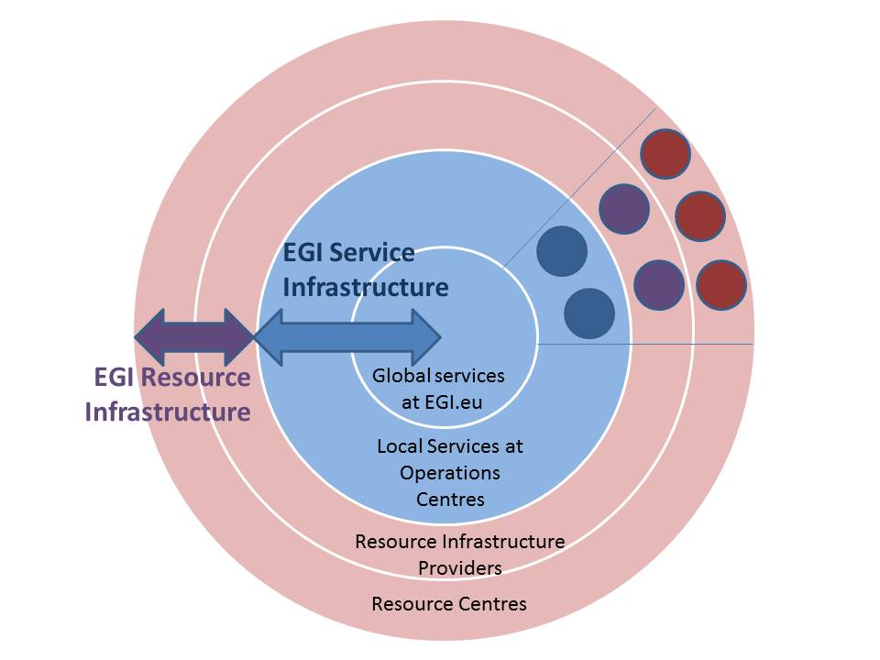
Figure 1. EGI Resource Infrastructure and Services Infrastructure
EGI’s facilities for usage accounting, monitoring and support, are distributed in nature and are constituted by a central set of services that are complemented by the local ones operated by the various Operations Centres. This tiered architecture is generally applicable to all of EGI’s operations services, including the development, maintenance and enforcement of a common set of procedures, policies and best practices, Grid oversight, coordination of software deployment, interoperation, first-line support, the provisioning of core middleware services, and operations security.
The following sections provide more information about the Resource and Service Infrastructures.

Resource Infrastructure

Resource Centres
The Resource Centre is the smallest resource administration domain in EGI. It can be either localized or geographically distributed. A Resource Centre is also known as a “site”. It provides local resources and the Grid functional capabilities necessary to make those resources accessible to authorized users such as Security, Information, Storage, Data Access, Compute etc. [UMD]. Access is granted by exposing common interfaces to users.
The Resource Centre Operations Manager leads the local grid operations, and is the official technical contact person in the connected organisation. He/she is locally supported by a team of Resource Centre administrators. The Resource Centre Operations Managers is responsible of enforcing the Resource Centre Operational Level Agreement – OLA (section 6), the EGI policies and procedures by the Resource Centre.
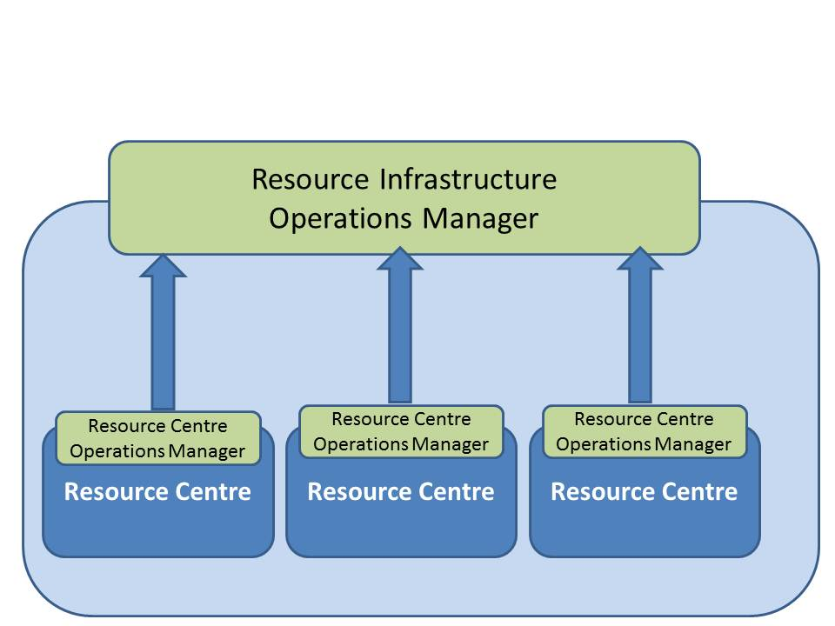
Figure 2. The Resource Centre Operations Manager is the technical contact point for operations at the Resource Centre.
The integration of heterogeneous resources is facilitated by the adoption of common (eventually standard) interfaces to ensure that the resource can be managed, monitored, accounted, supported and properly operated [MS407].
- Management Interface. Information about the status of EGI’s resources needs to be accessible to end-users and operators. For example, resources can be under certification, already certified, in downtime in case of maintenance, or suspended in case of transient problems. GOCDB is the tool that implements the information database of the resource management functions. In order to be registered in GOCDB, services need to be approved, and a consistent naming scheme has to be adopted. The management interface is needed to collect topological and contact information at different levels: node, Resource Centre and Operations Centre.
- Monitoring Interface. The functionality of provided services needs to be periodically monitored. Monitoring information is used to gather quality statistics, to generate notifications to operators in case of failure and to provide a fine-grained view of status information to interested parties. The EGI monitoring infrastructure is based on Nagios, and messaging is used as communication channel for gathering results centrally.
- Accounting Interface. Accounting information is collected to monitor usage patterns at different aggregation levels (e.g. per node, per Resource Centre, per VO, per infrastructure, etc.), and indirectly to assess the activity of individual users and user communities, and to develop new service-oriented business models.
- Support Interface. It is important that the deployed resources are adequately supported by operators and their respective technology providers. Users and operators are supported in EGI at different levels, depending on the severity of the issue reported. In case of critical issues that are a potential indication of malfunction, the problem is reported to the respective technology providers.
- Operations Interface. Monitoring information datasets are collected and displayed in the Operations Dashboard. It provides a detailed overview of the operational status of resources, while giving the possibility to open tickets through the EGI helpdesk to the affected Operations Centres and individual Resource Centres.
At the end of PM3 the EGI Infrastructure included 339 Resource Centres distributed among 56 countries.
More information about the current status of integration of different resources is reported in milestone [MS407], which will be periodically updated to reflect the latest status of EGI integration.

Resource Infrastructure
A Resource Infrastructure is a federation of Resource Centres, and the Resource Infrastructure Provider is the legal organisation that is responsible of establishing, managing and of operating directly or indirectly the operational services to an agreed level of quality needed by the Resource Centres and the user community. It holds the responsibility of integrating them in EGI to enable uniform resource access and sharing for the benefit of their consuming end-users. The Resource Infrastructure Provider liaises locally with the Resource Centre Operations Managers, and represents the Resource Centres at an international level when peering with other EGI Resource Infrastructure Providers and EGI.eu for global operational services and coordination.
Examples of Resource Infrastructure Provider are the European Intergovernmental Research Institutes and the National Grid Infrastructures (NGIs). In Europe Resource Centres are required to be affiliated to the respective NGIs, which (a) have a mandate to represent their national Grid community in all matters falling within the scope of EGI.eu, and (b) are the only organization having the mandate described in (a) for its country and thus provide a single contact point at the national level.
The Resource Infrastructure Provider has a mandate to represent the Resource Centres in the Operations Management Board - OMB (section 5) to bring there their operational requirements, and different requirements for the EGI Council through Resource Infrastructure Provider MoUs as applicable. In order to fulfil this task, the Resource Infrastructure Provider facilitates the liaison between the Resource Centres, other national stakeholders and EGI. In addition, the Resource Infrastructure Provider contributes to the EGI technical bodies regarding international standards, EGI policies and quality criteria.
The Resource Infrastructure Provider is responsible for appointing an Operations Manager who represents the Resource Infrastructure Provider within the OMB.
The internal Resource Infrastructure architecture is illustrated in Figure 3 below.
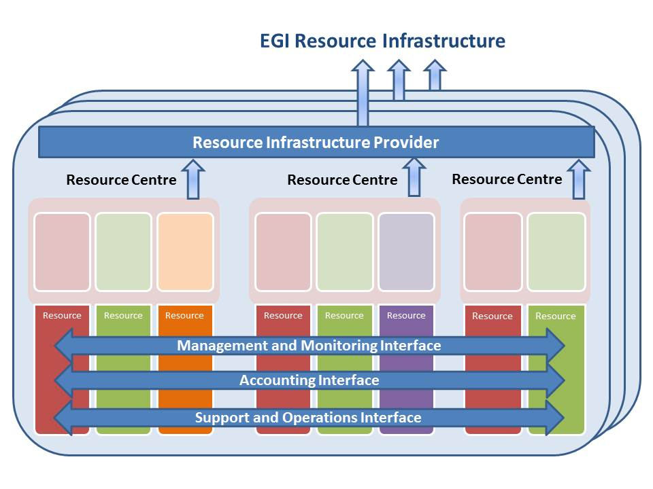
Figure 3. Resource interfaces for integration into the EGI Resource Infrastructure
EGI Resource Infrastructures are interconnected by means of the network services offered by international providers such as the European National Research and Education Networks and GEANT.
The overall EGI Resource Infrastructure architecture is illustrated in Figure 4.
At the end of PM3 the EGI Infrastructure included 43 Resource Infrastructures, of which one from the Asia Pacific region, 38 from Europe, one from Middle East, one from North America and two from South America.
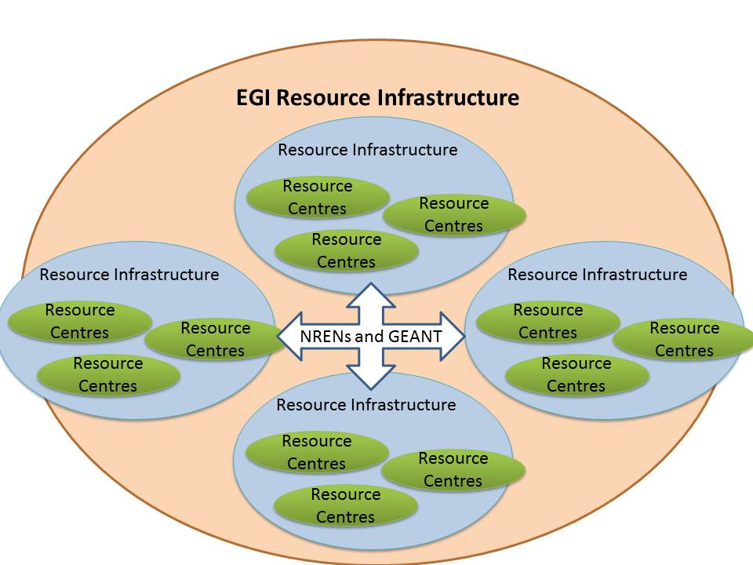
Figure 4. Architecture of the EGI Resource Infrastructure.

Service Infrastructure
A Resource Infrastructure Provider is responsible of delivering services to different groups of clients: primarily user community services (resource access through the UMD capabilities, training, support to application porting, scientific gateways, etc.) and operations services based on the UMD Operations Capabilities such as monitoring and accounting. This section focuses on the latter category – the operations services – that are needed for the management of the Resource Infrastructure. More information about user community services is available at [UCS].
In this context Service is meant to be a “means for delivering value to customers by facilitating outcomes the customers what to achieve without the ownership of specific costs or risks [ITIL]” where customers are mainly the EGI Resource Infrastructure Providers and the Resource Centres.
The service infrastructure includes Local Services, which are provided by the Resource Infrastructure Provider through their respective Operations Centre, and Global Services which are provided by EGI through the coordination of EGI.eu. Local and Global Services (section 3) are complementary and are both necessary for a successful operation of the infrastructure (see Figure 5). For example, the monitoring infrastructure encompasses both central service instances and local instances operated by the Operations Centres. The central components are needed to store and display information that is gathered from the individual local monitoring infrastructures. Interoperability is ensured through common interfaces and a single distributed communication bus. A similar distributed hierarchical architecture is adopted by other operations services, such as the support system and the accounting service.
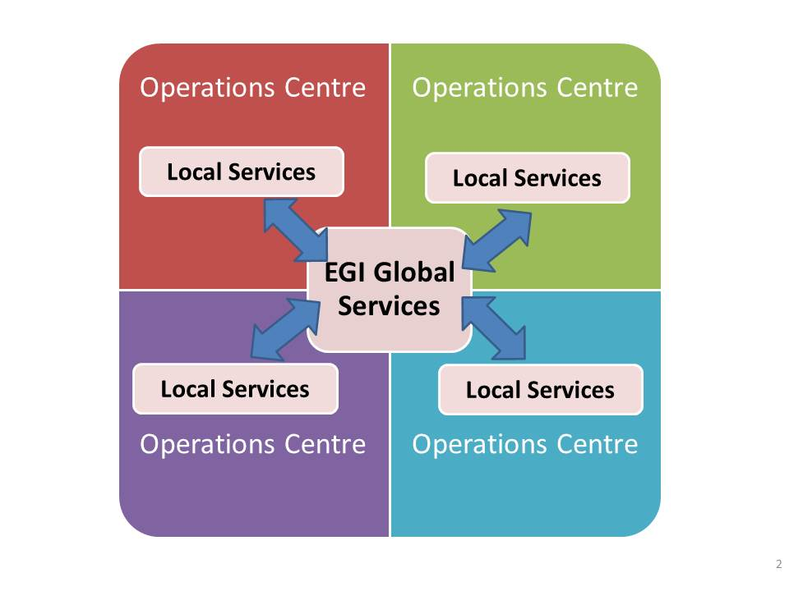
Figure 5. Interoperation between Local Services and EGI Global Services. Several EGI Global Services are technically delivered by Operations Centres (section 4.1).
The service infrastructure includes:
- The operation of tools (locally and/or centrally) such as the EGI configuration repository (GOCDB) [GOC], the accounting repositories, the monitoring and messaging system, the operations dashboard, and monitoring portals.
- First and second-line support for users and Resource Centre administrators, the operation of regional trouble ticketing systems, the central EGI Helpdesk interfaced to them, and activities such as the internal dispatching of trouble tickets to the corresponding Support Units, and the maintenance of the helpdesk to satisfy new user requirements.
- Operational security, authentication of end-users, a distributed security response team with central coordination, security monitoring, the assessment of technology-related vulnerability risks, and the support to resource centers in case of severe vulnerability issues.
- Technology deployment including the phased rollout of new software to the infrastructure, the collection of requirements, and of input in case of deployment issues in coordination with the EGI Deployed Middleware Support Unit.
- The proactive oversight at local and global level of the EGI infrastructure status, the assessment and follow-up of Quality of Service (QoS).
- The management of Resource Centers and Operations Centers from certification to decommissioning.
- The provisioning of middleware technical services both at a local and a global level.
- The development of operational procedures, policies and documentation, including manuals and best practices.
- The liaison with external Resource Infrastructure Providers.

Operational Services

Global Services
The EGI Global Service are provided by EGI and they includes the following components.
- Coordination of operational security, vulnerability assessment and incident response, and user authentication through “catch-all” Certification Authority.
- Technology deployment: coordination of staged rollout of DCI (Distributed Computing Infrastructure (DCI) technologies, gathering of requirements for middleware and operational tools to drive innovation, interoperation, the retirement of obsoleted technologies, and the discussion of end-of-support timelines in collaboration with Resource Infrastructure Providers and the EGI TCB.
- Central tools including [ECT]:
  - EGI configuration repository;
  - Cenral accounting repository and portal;
  - Central Service Availability Monitoring tool instances and the portal ;
  - Operations dashboard and portal;
  - Metrics portal;
  - Messaging infrastructure.
- Support to users and Resource Centre administrators, the operation of a central helpdesk, first-line user and middleware support, coordination of network support and coordination of local Operations Centre support.
- Grid oversight: proactive monitoring of Resource Centres operational issues, of Operations Centre support, and service availability and reliability.
- Coordination and periodic review of procedures, operational policies and documentation.
- Deployment of shared core middleware services (the so-called “catch-all”) for VOs that do not need dedicated middleware services.
- Coordination of operations integration globally with peer Grid infrastructures, and locally with heterogeneous resources and deployed middleware.

Local Services
Local Services are provided by Operations Centres. The ultimate goal of the operations Local Services is to ensure that end-users are provided with a set of resources that are securely and easily accessible regardless of their physical location. This goal is accomplished by defining a common minimal set of services, procedures and policies that are endorsed and enforced by all EGI service providers within the Operations Centres (see Section 4).
The local operational services include the components listed below. Additional Local Services can be provided to meet specific regional user communities and/or operational requirements. The services that are infrastructure-specific (e.g. support structures for contributed software that is not provided by EGI Technology Providers, support to local user communities, etc.), are out of scope in this document.
- Operational security and incident response provided at a resource level, and local user authentication and authorization.
- Technology deployment consisting of:
  - the contribution to the staged rollout of a set of relevant middleware components according to the middleware stacks and tools of interest,
  - gathering of requirements from the Resource Centres coordinated by the Resource Infrastructure Provider,
  - reporting of critical deployment issues by ensuring the regular participation to be-weekly operations meetings.
- Deployment of local tools:
  - a functionality monitoring system for the Resource Infrastructure, supported by the Resource Centres, and centrally operated by the Operations Centre. It consists of a probe execution engine and the ancillary system components, together with a local myEGI portal. This service is mandatory and needs to be supported by the Resource Centres. This monitoring system is complementary to monitoring systems run by the Resource Centres.
  - The optional local deployment of operational tools such as the accounting portal and related usage record repository, the local configuration repository (local GOCDB), the local operations dashboard and portal that integrate with the Global instances.
- Regional support. The Operations Centre is responsible of providing first and second-line support to operational issues – including network support – in order to assist Resource Centres in all stages from certification to decommissioning. GGUS can be used as support system through a set of dedicated central Support Units, or a full local support system interfaced with the central EGI Helpdesk to ensure proper routing of tickets.
- The Operations Centre should deliver training services to the managers of the respective Resource Centres.
- The deployment of core technical services such as those providing job and file transfer scheduling capabilities, user authentication, central file catalogues, etc.
- The Operations Centre is responsible for the proactive monitoring of their local Resource Centres, for the control of the QoS (availability, reliability, response time to tickets, compliance to established procedures and policies), delivered by them and for the certification of the Resource Centres in its operational domain.

Service Providers

Operations Centres
Resource Infrastructure Provider services are delivered by an Operations Centre. In order to contribute resources to EGI a Resource Infrastructure Provider must be associated to an Operations Centre.
Many EGI Resource Infrastructures are currently operated by a single Operations Centre. However, for reasons of economy of scale, an Operations Center can be federated, i.e. it can be responsible for operating multiple Resource Infrastructures at a time. Federation of operations can be a cost-effective approach for Resource Infrastructure Providers wishing to share their effort and services, or in order to operate the infrastructures in an early stage of maturity.
The Operations Centre provides services in collaboration with the respective Resource Centres via the Resource Centre Operations Manager, and globally with EGI.eu and other Operations Centres. Locally, Operations Centres are responsible for supporting the Resource Centres, for monitoring their QoS, for collecting requirements and of representing them in the various EGI operations boards. Globally they are in charge of contributing to the evolution of EGI operations, and to the development of the EGI operations roadmap.
Global Services are in some cases technically distributed and run by some Operations Centres on behalf of the whole community in order to leverage existing local expertise.
During the transition from the EGEE-III project to EGI-InSPIRE, the Operations Centre distribution has changed significantly. The largest multi-national Centres (for example, Central Europe Regional Operations Centre - ROC, and South East Europe ROC) have been evolving into a collection of independent national Operations Centres. Central Europe ROC was decommissioned in July 2010, while South East Europe ROC will be closed in 2011. At the same time, other countries have been consolidating their federated operational structure, such as Portugal and Spain. Some EGEE legacy ROCs will continue their operations, while others are now ready for decommissioning.
The list of active Operations Centre is accessible from the EGI configuration repository GOCDB [GOC]. Resource Centres are “certified” in GOCDB only if they subscribe to EGI policies, procedures and to the Resource Centre OLA.

EGI.eu Operations Team
The EGI Chief Operations officer and the EGI.eu Operations Team staff handle the co-ordination and execution of EGI operational service provision. The Operations Team monitors the performance of EGI Global Services and of Local services, and handles liaison with the EGI Operations Centres, and the Resource Infrastructure Providers in the framework of the OMB, and with the Resource Centre Operations Managers via each Resource Infrastructure Provider. This channel of communication ensures the smooth management of the operational services from connected Resource Centres.
The role of the EGI.eu Operations Team is to provide support, coordination and monitoring of EGI Global and Local operational services. EGI.eu Operations are responsible for:
- supervising the daily running of the EGI operations center;
- ensuring that services are consistently evolved according to the needs of all partners;
- liaising with EGI technology providers on behalf of the operations community in the framework of the EGI TCB;
- collecting requirements regularly;
- chairing of the OMB and liaising with external Grid infrastructures.

Operations Management Board
The OMB is the operations body which develops strategy and technical priorities concerning the deployment and operation of the production infrastructure, oversees the status and progress of the global EGI operational services and of the Operations Centre services. Responsibilities of the OMB [OMB] are:
- to define the roadmap leading the short, medium and long-term evolution of EGI operations.
- to identify possible or actual problem areas that are not being addressed, and propose corrective actions;
- to develop and approve policies and procedures that require formal consensus from the Resource Infrastructure Operations Managers and their Resource Centres;
- to collect information on critical technology deployment issues, gather and prioritize input on new requirements from all parties about grid middleware, and bring this input to the Technology Collaboration Board (TCB) [TCB] in order to define and evolve the Unified Middleware Distribution (UMD) roadmap [UMD] (see section 7). Gathering of requirements for operational tools is in the scope of the Operational Tools Advisory Group (OTAG) [OTAG] to which all Resource Infrastructure Provider representatives can participate.
- to discuss operational requirements from Virtual Research Communities (VRCs) through the User Community Board (UCB) [UCB].
- to advise the EGI.eu Director on strategic and technical issues related to the operation of the production infrastructure.
Members of the OMB are:
- the Chief Operations Officer and his/her deputy (chairman).
- the Operations Manager of any Resource Infrastructure that officially contribute resources to the EGI infrastructure. Such providers are those that participate to the EGI Council, the EGI-InSPIRE partners, or have signed a Memorandum of Understanding with EGI. Groups of providers can be represented by a single Operations Manager if they wish to do so. The Operations Manager is appointed ex-officio by the respective Resource Infrastructure Provider. It is important to note that in case of a federated Operations Centre, every individual Resource Infrastructure Provider operated by that Centre is individually represented in the OMB, as illustrated in Figure 6.
- leaders of EGI-InSPIRE SA1 tasks.
- providers of EGI Global Services.
- the EGI-InSPIRE JRA1 activity manager and other experts who do not formally represent any constituency, can be invited to join OMB meetings when their contribution is relevant to the OMB agenda.

This group works with the Policy Team at EGI.eu, with the TCB for discussion of technology issues, and with OTAG for matters concerning the operations tools.
The OMB is responsible to the EGI Council, through the EGI.eu Director and the EGI.eu Executive Board. Detailed information can be found in the OMB Terms of Reference [OMB].
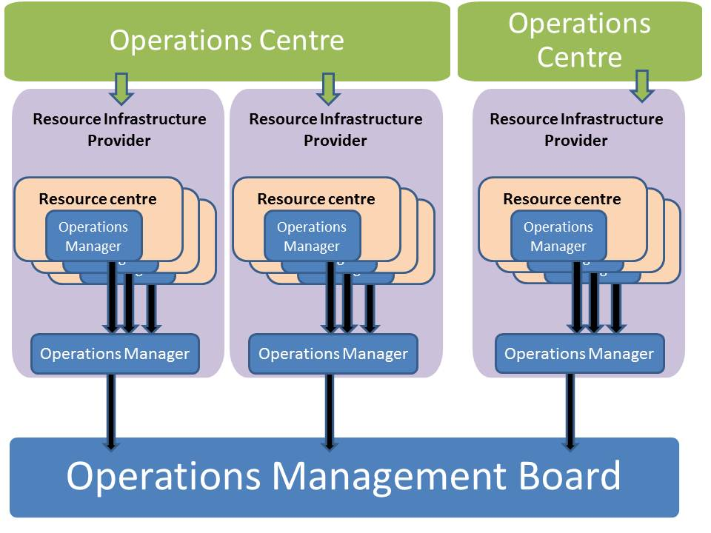
Figure 6. Representation hierarchy of Resource Centres and Resource Infrastructure Providers within the OMB. In case of a federated Operations Centre, every Resource Infrastructure Provider in the scope is individually represented in the OMB.

Operational Level Agreements
The OLA is the mechanism adopted in EGI to integrate resource providers into the pan-European production infrastructure while ensuring interoperation of operational services, QoS, and to enforce a common set of policies and procedures.
As detailed in section 2.2, EGI has adopted a distributed service-oriented model – based on Global and Local Services – where different stakeholders play the role of service provider. The term “Service” is used in this context to either refer to Global Services and Local Services defined in sections 3.1and 3.2.
Crucial to EGI is the maximization of the QoS experienced by the end-user, which eventually depends on the overall quality offered by the EGI service providers. It is therefore important that the providers commit to a minimum set of requirements to jointly offer a predictable, secure and highly available service infrastructure.
The first OLA prototype was consolidated in the framework of the EGEE project series, to define the minimum set of services and the corresponding quality to be exchanged between Resource Centres and ROCs. EGI has extended this to a more general framework to define:
- Resource Centre OLA: the minimum set of required operational procedures and policies to be endorsed and enforced locally, and the minimum set of necessary Local Services to be offered by the Resource Centre, and the corresponding guaranteed QoS.
- Resource Infrastructure Provider OLA: the minimum set of necessary operational procedures and policies to be endorsed and enforced locally by Resource Infrastructure Providers and the corresponding Operations Centre, and the minimum set of necessary Local Services provided by the Operations Centre and the guaranteed QoS.
- EGI.eu OLA: the set of EGI Global Services that the Resource Infrastructure Provider wishes to use, and the respective minimum guaranteed QoS provided by EGI.eu through its providers.
The Resource Centre OLA, the Resource Infrastructure Provider OLA and EGI.eu OLA all together constitute the EGI OLA. EGI.eu, all Resource Centres and Resource Infrastructure Providers will be requested to adhere to the relevant parts of such OLA (Figure 7).
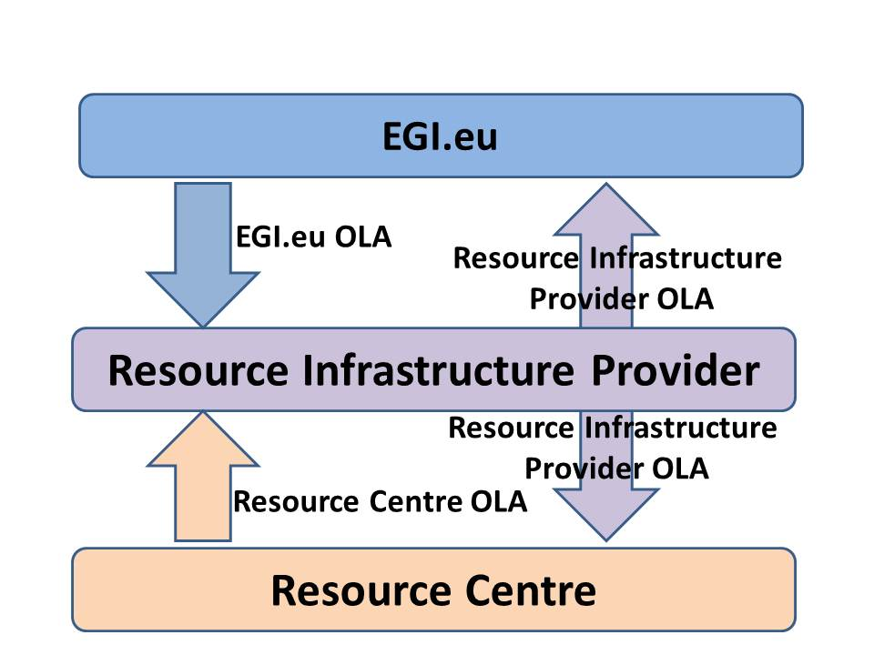
Figure 7. This diagram illustrates the relationship between the various parts of the EGI OLA and the respective stakeholders.
Resource Infrastructure Providers that are either represented in the EGI Council or are partners of EGI-InSPIRE, will be requested to endorse the OLA once approved by the OMB. For all other Resource Infrastructure Providers, the OLA will be defined and subscribed to, in the framework of an Infrastructure Provider Memorandum of Understanding.
The EGI OLA can be extended by Resource Infrastructure Providers to meet additional requirements that are only applicable in their domain, provided that the extensions introduced do not contradict with the EGI OLA.
The finalisation of the EGI Resource Infrastructure Provider OLA is part of the EGI-InSPIRE roadmap for year 2011.
EGI provides a grid oversight service [COD] to ensure that policies and procedures are properly followed, and that the QoS of Local and Global Services complies to the minimum quality parameters defined in the OLA. Two new procedures for escalation of operational issues and for new QoS follow-up procedure were defined during PQ1 and PQ2 to assist grid oversight activities.
For more information on OLAs, the reader is encouraged to refer to [MS404].

Change Management
In the operations architecture changes are implemented through a requirements gathering process that involves the Resource Centres, the Resource Infrastructure Providers and EGI.eu.
Requirements can concern deployed software, operational tools as well as operational procedures and policies.
For deployed software and procedures, and operational procedures and policies, discussion and prioritisation of requirements takes place in the OMB, which is responsible of feeding information about the required capabilities for integration in the UMD. On the other hand, requirements that concern operational tools are processed in the framework of the OTAG.
Similarly, user community requirement are collected by the UCB, who plays the role of analysing, reviewing and prioritizing the input received. More information on gathering of requirements from the user community is available from [MS305]. Integration of requirements collected from different communities is a responsibility of the TCB (see Figure 8).

Technology and Tool Requirements
UMD is “the set of software components developed for EGI by technology providers to provide the innovation needed by EGI to satisfy its users that cannot be found elsewhere and is therefore endorsed by EGI for use within the production infrastructure” [UMD].
Requirements concerning operational tools are collected through a similar process but are discussed in the OTAG [OTAG]. The UMD Roadmap is the overall resulting framework partitioned into functional, security and operational capabilities relevant to the EGI communities. The UMD Roadmap is periodically reviewed and re-issued every six months, and exists as a ‘living’ document in between these releases to allow a continual process of community comment and feedback. The process by which input from the EGI Community is collected prioritised and integrated into the UMD Roadmap through the TCB [TCB].
The following paragraph describes the operations requirement process.
- Phase 1. A call for operations requirements will be opened in the OMB every three months (beginning of January, April, July and October). The Resource Infrastructure Provider representative in the OMB is then responsible for contacting the respective Resource Centre managers to collect their feedback, prioritize it internally and feed it back to the OMB. Requirements will be handled through the EGI Request Tracker system [RT] within the “requirements” queue.
- Phase 2. Requirements are discussed and prioritised by the OMB in one month time after the opening of the call.
- Phase 3. Input is provided to the TCB by the beginning of the following month (February, May, August and November).
In addition to this top-down process, requirements can be asynchronously fed according to a bottom-up approach by the Resource Infrastructure Provider at any time, by means of the RT requirements queue as in the process described above. These requirements are discussed together with those collected regularly on-demand every three months according to the timing presented above.
It is foreseen that all EGI stakeholders (user community and operations community) will use the requirements queue on RT regardless of technology area (grid middleware, operational tools and user technical services).
Priority, status of the requirement (pending, accepted, rejected etc.) and the estimated time for release in agreement with the respective Technology Provider, will be tracked in the corresponding RT ticket.
The overall requirements gathering process involving the user and operations EGI communities is illustrated in Figure 8.
Figure 8. The three phases of the EGI requirements gathering process involving the user and operations communities and the respective management boards.

Policies and Procedures
All policies and procedures are discussed and approved within the relevant EGI board (i.e. OMB, UCB and TCB) that owns the particular issue. Policies and procedures of the particular board that cut across various functional areas are required to be reviewed by all the relevant Boards. If no objections are raised within 5 working days from the submission, the procedure proposal is considered final and ready for further distribution.
In case there are comments from other Board(s), the policy or procedure owner collects, collates, and analyses them in order to make appropriate revisions.
The policy owner responds in writing to all Boards who submitted comments, input, and/or recommendations, indicating acceptance or rejection of their advice and reasons for the decision or action. More information on the EGI policy and procedure development process is available from [PDP].

Conclusions
This document presents the EGI Operations Architecture. It introduces new terminology to better define roles and responsibilities of EGI operations stakeholders, and it describes the relationships between the various entities.
The document defines the EGI Infrastructure as the composition of a Resource Infrastructure and a Service Infrastructure. The Resource Infrastructure is constituted by the federation of multiple Resource Infrastructures, which in their turn are a federation of local Resource Centres. Resource Infrastructure Operations Managers are members of the OMB. The OMB is the body responsible of leading the evolution of EGI operations through the periodic gathering, discussion and prioritisation of requirements, which are further reviewed by the TCB together with the user requirements.
The EGI Service Infrastructure comprises Global and Local Services, which are under the technical responsibility of EGI.eu and the Operations Centres respectively. The exchange of operational services at different levels is regulated through the definition of OLAs, which technically define the services, the associated quality level to be delivered, and other obligations of the partners.
The EGI operations stakeholders contribute to innovation through their requirements that are periodically gathered, discussed, and prioritised in the framework of the OMB and of the TCB. New requirements are necessary to evolve established procedures and policies, to ensure that the deployed software meets the needs of users and Resource Centre administrators, and to ensure the advancement of Local and Global services.
The EGI Operations Architecture herein presented will be reviewed and re-issued on an annual basis during the course of the project.

References
MS407 | Integrating Resources into the EGI Production Infrastructure, EGI-InSPIRE Milestone MS407, Nov 2010 (https://documents.egi.eu/document/111)
UMD | UMD Roadmap, EGI-InSPIRE Deliverable D5.1, Aug 2010 (https://documents.egi.eu/document/100)
UCS | User Community Support Process, EGI-InSPIRE Deliverable D3.1, Aug 2010 (https://documents.egi.eu/document/106)
ITIL | van der Veen, A.; van Bon, J.; Foundations of IT Service Management Based on ITIL V3, Van Haren Publishing, 2007, ISBN: 9789087530570
GOC | Mathieu, G., Casson, J. (2010) GOCDB4, a New Architecture for the European Grid Infrastructure; in the Proc. of the Grid Computing Int. Symposium on Grid Computing (ISGC 2010), Taipei, Taiwan
ECT | EGI Operations Tool Information, EGI wiki (https://wiki.egi.eu/wiki/Operations_tools_information)
TCB | Technology Collaboration Board Terms of Reference (https://documents.egi.eu/document/109)
UCB | User Community Board Terms of Reference (https://documents.egi.eu/document/120)
OMB | Operations Management Board Terms of Reference (https://documents.egi.eu/document/117)
COD | Grid Operations Oversight (https://wiki.egi.eu/wiki/Grid_operations_oversight)
MS404 | Operational Level Agreements (OLAs) within the EGI production infrastructure, EGI-InSPIRE Milestone MS404, July 2010 (https://documents.egi.eu/document/65)
OTAG | Operations Tools Advisory Board Terms of Reference (https://documents.egi.eu/document/103)
MS305 | User Feedback and Recommendations, EGI-InSPIRE Milestone MS305, Jan 2011 (https://documents.egi.eu/document/211)
RT | EGI Request Tracker (https://rt.egi.eu/rt/)
PDP | EGI Policy Development Process (PDP), Dec 2010 (https://documents.egi.eu/document/169)

A EGI Technology Provider “is an organisation or a project that is collaborating with EGI to develop or deliver software for use within the production infrastructure or its user community” [UMD].
The Operations Centre can deploy an additional set of tools of choice, either contributed by third-party software providers, or developed in-house. These tools are out of the Operations Architecture scope.

