Staged Rollout Report
The Early Adopter team should fill the “grey” areas
NGI | NGI_IBERGRID
Site Name | IFIC-LCG2
EA team names | Álvaro Fernández, Pablo Briongos
EA team contacts | alvaro.fernandez@ific.uv.es, pablo.briongos@ific.uv.es
Product | WMS (EMI-3) | Version | 3.6.5-sl6-x86_64 | RT ticket ID | 7176
The “outcome” is one of: OK, WARN, FAIL, NA (Not Aplicable), Nver (Not verified/Not tested).
Copy/paste any results from your commands where you see fit.
Metric | <OK|WARN|FAIL  |NA|NVer> | WEB URLs, Command used, other comments  (please always fill this table with as much information as possible, and as you see fit)
Release notes and other  documentation | OK | http://www.eu-emi.eu/releases/emi-3-monte-bianco/updates/-/asset_publisher/5Na8/content/update-17-11-06-2014-v-3-8-0-1#WMS_server_v_3_6_5
Installation or upgrading (specify which) | OK | Upgraded from a previous EMI-3 WMS 3.6.4 version, in a Scientific Linux 6.5 (carbon) node
(RE-)configuration (if using yaim, specify command used) | OK | Not needed
Functionality (including start stop of deamons, and which) | OK | /etc/init.d/gLite start | stop | restart | status | version  No errors reported
SAM/Nagios/Gstat or any other monitoring framework  (specify the name of the machine) | OK | cg08.ific.uv.es tested by Nagios (Ibergrid and EGI):  *Ibergrid Nagios (rnagios.ibergrid.cesga.es) includes 4 probes for:  -Certificate lifetime  -GridFTP check  -WMS Job State  -WMS Job Submit  *EGI Nagios (midmon.egi.eu) includes 2 probes for:  -EMI-1  -EMI-2  -WMS-SHA-2  All probes are OK.
Interaction integration with other components (specify which) | OK | WMS 3.6.5 collocated in same node with EMI-3 LB 4.1.1 SL6
Behaviour in production environment (after a few days). Specify VO’s using the service when applicable | OK | *The version is not affected by the recent issues found in last EMI update (Upadate 17) related to package glite-lb-common (glite-lb-common-9.1.0-1 is not included in the PPA)  -------------------------------------------------------------------------  * CRL failures:  ERROR CRL verification failed for 10ae1877/0 (LIPWLCA)  ERROR CRL verification failed for CNIC/0 (CNIC)  ERROR CRL verification failed for e2a50798/0 (LIPWLCA)  ERROR CRL retrieval for EG-GRID failed. 24h grace expired. CRL not updated  ERROR CRL retrieval for HIAST failed. 24h grace expired. CRL not updated  ERROR Cannot find any CA for e2a50798.0 in /etc/grid-security/certificates  -------------------------------------------------------------------------  *1-week chart:  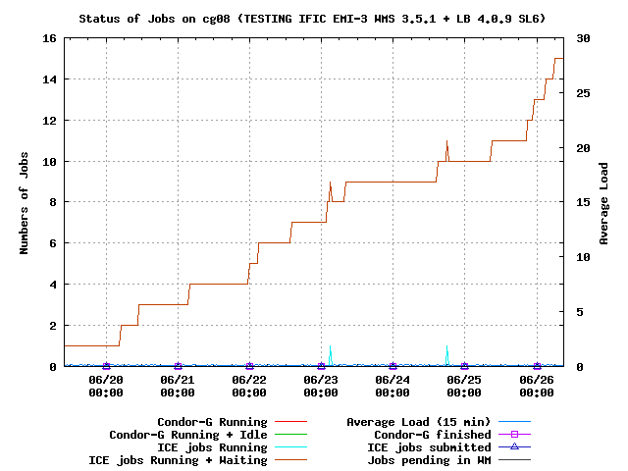
GGUS tickets opened: please insert the URLs of the tickets
Log files: usefulness, clarity, etc., any other comments on where/how to improve them. | OK
Error messages: please specify or comment any issues with error messages, if they are not correct, not clear, useful, etc. . | NA

