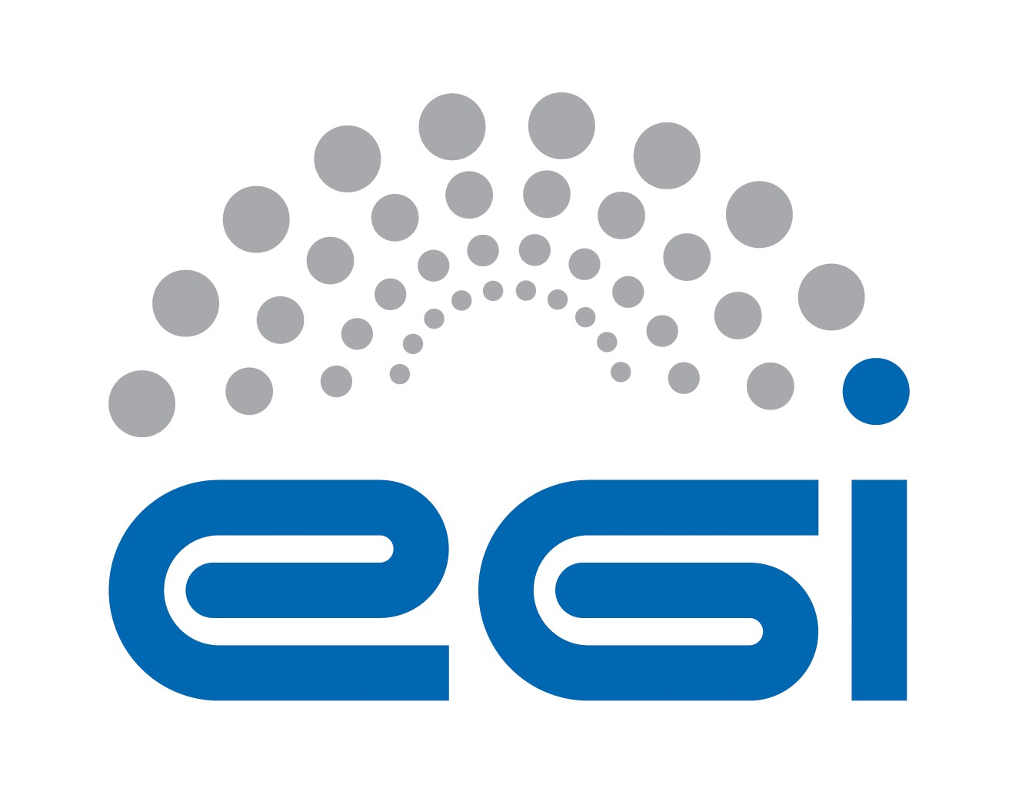
Technology Provider
Service Level Agreement

Customer | EGI.eu
Provider | XXXX
Service | XXXX Support
Start Date | XX/XX/XXXX
End Date | XX/XX/XXXX
Version | 3
Document Link: | XX
- Copyright notice
Copyright © EGI.eu. This work is licensed under the Creative Commons Attribution-NonCommercial-NoDerivs 3.0 Unported License. To view a copy of this license, visit http://creativecommons.org/licenses/by-nc/3.0/ or send a letter to Creative Commons, 171 Second Street, Suite 300, San Francisco, California, 94105, USA.
The work must be attributed by attaching the following reference to the copied elements: “Copyright © EGI.eu (www.egi.eu). Using this document in a way and/or for purposes not foreseen in the license, requires the prior written permission of the copyright holders. The information contained in this document represents the views of the copyright holders as of the date such views are published.

This SLA is based on a template that forms part of the FitSM family – a lightweight standard for IT Service Management that supports federated infrastructures. For more information on FitSM visit www.fitsm.eu or contact info@fitsm.eu. The template this document is based on was licensed with a Creative Commons Attribution 4.0 International License.

This SLA is based on FitSM Template: SLA v1.0.
TABLE OF CONTENTS
1 Introduction 4
2 Scope of the services 4
3 Service hours 4
4 Support 4
4.1 Incident handling 5
4.2 Fulfilment of service requests 5
5 Service level targets 5
6 Limitations & constraints 5
7 Communication, reporting & escalation 6
7.1 General communication 6
7.2 SLA violations 6
7.3 Escalation & complaints 6
8 Information security & data protection 7
9 Additional responsibilities of the provider 7
10 Customer responsibilities 7
11 Review 7
12 Glossary of terms 8
13 References 8

Introduction

the reference for the Software Provisioning Process in the DocDB wold be
https://documents.egi.eu/public/ShowDocument?docid=68
but I'm sure there is also a newer version. Unfortunatelly I cannot find it .
've read te template and the only thing that came to my mind is that probably the only section that can create discussion can be the section 8 "Informatio Security & Data Protection"
It mentions the rules "it must define & abide .. a security policy" butdoesn't say where is that policy, , when it has to be ready, and more than that - who will check thati it "meet al requirements of any relevant EGI policies and procedure". Is it needed to have a reference to this document when the SLa is signed?
Then the part that can "scare" the Tch. Providers is the fact that it is said " must meet all requirements of any relevant EGI policies or procedures". Shouldn't we make easier the identification of these policies & procideures so that they do not think we are talking about ALL policies, and alsogive them the possibility to say 'I thought I should comply only policy X"?
This agreement is made between XXXX (the Provider) and EGI.eu (the Customer) to cover the provision and support of the service as described hereafter. The relevant contacts and representatives may be found in section 8.1.

This SLA is valid from XX/XX/XXXX to XX/XX/XXXX.

The SLA is a document discussed and approved between the customer, and the partner or consortium of partners (provider) selected for delivery of the service.

Amendments, comments and suggestions must be addressed to the Customer contact given to the Provider (see section 8.1).

Scope of the services

The Provider agrees to deliver software components to EGI that, in total, implement the functionality of one or more capabilities defined in the UMD Roadmap [Error: Reference source not found]. The Provider agrees to indiscriminately apply the service levels defined herein to all software components delivered to EGI that are part of any version of UMD that EGI supports according to the UMD support plans.

This SLA applies to provision of support for following components:
- XXXXXXXXXXXXXXXXX

Service hours
The service operates during support hours (see section 4).

Support
The services covered by the scope of this SLA are provided with the following level of support.

Support is provided via the GGUS portal [GGUS], which is the single point of contact for infrastructure users to access the EGI Service Desk. The EGI Service Desk within GGUS is organized in Support Units. Every Support Unit is responsible for one or more services. The number and definition of the EGI Support Units in GGUS is not regulated by this SLA and can change at any time to fulfil the EGI Incident and Problem Management requirements.

Support is available between:
- Monday and Friday
- 9:00 and 17:00 CET/CEST time

This excludes public holidays at the same time in all hosting organizations.

Incident handling
Disruptions to the agreed service functionality or quality will be handled according to an appropriate Quality of Support level based on the impact and urgency of the incident. In this context, the following guidelines apply:
- Three GGUS Quality of Support (QoS) levels have been defined: base, medium and advanced.
- The following QoS levels apply to the service: XXX

Base level defines a response time of 5 working days regardless of the GGUS ticket priority.
Medium level:
Ticket Priority | Response time
Less urgent | 5 working days
Urgent | 5 working days
Very Urgent, | 1 working day
Top Priority | 1 working day

Advanced level:
Ticket Priority | Response time
Less urgent | 5 working days
Urgent | 1 working day
Very Urgent, | 1 working day
Top Priority | 4 working hours

Response time is provided as service level target (see section 6).

Fulfilment of service requests
In addition to resolving incidents, standard service requests (e.g. change or information request, documentation) will be fulfilled through the defined support channels in section 5. Response and fulfilment times are provided as service level targets (see section 6).

Service level targets
The following are the agreed service level targets for the service:
- QoS level: XXXXXX (see section 5.1)
I've starte reading the SLA with the tech providers, and I think there was no mention of the security vulnerabilities
[13:47:27] Peter Solagna: If it's true we should add some targets also there, they're tracked in RT not in GGUS but are tracked

Limitations & constraints
The provisioning of the service under the agreed service level targets is subject to the following limitations and constraints:
- Support is provided in following language: English
- Failures in the normal operation of the service caused by failures in Federated Operations service components (i.e. GGUS) are not considered SLA violations.
- Force Majeure. A party shall not be liable for any failure of or delay in the performance of this Agreement for the period that such failure or delay is due to causes beyond its reasonable control, including but not limited to acts of God, war, strikes or labor disputes, embargoes, government orders or any other force majeure event.

Communication, reporting & escalation

General communication
The following contacts will be generally used for communications related to the service in the scope of this SLA.

Customer contact for the Provider | Peter Solagna  peter.solagna@egi.eu  EGI.eu NGI Operations Manager [EGDB]
Provider contact for the Customer | Name  email  Support team manager
Contact for service users | According to defined support channels

SLA violations
The Provider commits to inform the Customer, if this SLA is violated or violation is anticipated. The following rules are agreed for communication in the event of SLA violation:
In case of violating the service targets specified in this document for two consecutive months it is requested to provide justifications and a plan for service enhancement. The violating party must provide to the EGI.eu contact (see section 8.1) a status report and a plan for the improvement of the service within one month from the date of notification. The Customer will be notified of this situation.

Escalation & complaints
For escalation and complaints, the defined Provider contact (see section 8.1) point shall be used, and the following rules apply:
- In case of violating the service targets for four consecutive months, review of the Agreement will be taken by customer contact (see section 8.1) and reported to parties of the Agreement.
- Complaints should be directed to the customer contact (see section 8.1).
- The provider contact (see section 8.1) will be contacted in case of received complaints.

Information security & data protection
The following rules for information security and data protection apply:
- The Provider must define and abide by an information security and data
protection policy related to the service being provided.
- This must meet all requirements of any relevant EGI policies or procedures [POL] and also must be compliant with the relevant national legislation.

Additional responsibilities of the provider
Additional responsibilities of the Provider are as follow:
- Adhere to all applicable operational and security policies and procedures defined in [POL] and to other policy documents referenced therein;
- Use communication channel defined in the agreement (see section 7.1);
- Accept EGI monitoring services provided to measure fulfilment of agreed service level targets.

Customer responsibilities
The responsibilities of the customer are:
- Raise any issues deemed necessary to the attention of the Provider;
- Collect requirements from the Resource infrastructure Providers;
- Provide monitoring to measure fulfilment of agreed service level targets.
- Provide the EGI Service Desk, through the GGUS portal
- Provide the Unified Middleware Distribution (UMD), that integrates Provider services, after successfully passed through the UMD Software Provisioning Process [add reference] and is deployed on the EGI’s production e-infrastructure
- Provide the UMD software provisioning infrastructure composed of:
  - UMD repositories, supporting multiple operating systems
  - Community repositories - through AppDB [add ref] Provider has access to a repository-as-a-service platform to upload their software release
  - Web front-end – containing information about UMD releases (release notes, list of components, configuration configuration)
- To support the Provider in fulfilling the duties described above, EGI agrees to the following.

- EGI will communicate requirements and use cases collected from its end user and operations communities to the Provider through the Technology Coordination Board. These prioritised requirements may span new or existing features related to the maintained software components, and are communicated publicly and indiscriminately to any technology provider partaking in the TCB.

- EGI will define and publish the environment (or environments) that the maintained software components are required to work in.

- EGI will provide generic acceptance criteria related to all software components contributed to EGI.

- EGI will provide specific acceptance criteria related to all software components maintained by the Provider.

- EGI will inform the Provider of issues reported to EGI related to the maintained software components in use on EGI’s production infrastructure.

- EGI will include the Provider in the triaging of the issues mentioned above through the appointed DMSU.

- EGI will provide access to boards, process and knowledge of EGI’s SVG to the Provider in order to develop and contribute corrections necessary to the maintained software components.

- EGI will provide contact points for issue management, vulnerability management and general roadmap and requirements issues. The respective personnel will respond within 2 working days to issues raised by the Provider.

Review
There will be reviews of the service performance against service level targets and of this SLA at planned intervals with the Customer according to the following rules:
- Content of the agreement and targets will be reviewed on a yearly basis.

Glossary of terms
For the purpose of this OLA, the following terms and definitions apply:
[The key words "MUST", "MUST NOT", "REQUIRED", "SHALL", "SHALL NOT", "SHOULD", "SHOULD NOT", "RECOMMENDED", “MAY", and "OPTIONAL" in this document are to be interpreted as described in RFC 2119. For a complete list of term definitions see the EGI Glossary (http://wiki.egi.eu/wiki/Glossary).

References
[APPDB] | EGI Applications Database  http://appdb.egi.eu
[EGDB] | EGI.eu Operations Centre hosting EGI central operations tools  https://goc.egi.eu/portal/index.php?Page_Type=NGI&id=4
[GGUS] | EGI Helpdesk  http://helpdesk.egi.eu/
[GLO] | EGI Glossary  http://wiki.egi.eu/wiki/Glossary
[POL] | EGI policies and procedures  https://www.egi.eu/about/policy/policies_procedures.html
[UMD] | UMD Software Provisioning Process  https://wiki.egi.eu/wiki/UMD_Provisioning

Software component delivery

Component roadmap and release plan
The Provider will publish a roadmap for each component it wishes to release to EGI. The roadmap may be consolidated into one document with the roadmaps for other components if the Provider releases more than one component to EGI. The roadmap must contain:
- All planned major component releases
- All planned minor component releases
- Planned new features in the component
- Incompatibilities between releases

The Provider will update the roadmap(s) every half year (six calendar months) at least one calendar month before EGI publishes the UMD Roadmap on its scheduled dates [Error: Reference source not found].

The Provider will make available a release plan for each component published in the Provider’s software repository. The Provider may consolidate release plans of more than one component into a consolidated series of one or more documents, for a better overview. The release plan must provide the planned release dates for all maintained software components for at least one year into the future and must include the release dates for
- All major releases
- All minor releases

The Technology Provider agrees to inform EGI whenever the release plan is changed.

Release delivery and format
The Provider agrees to deliver releases on a regular basis and provides electronic access to the release contents as described in [Error: Reference source not found]. The new release must be delivered by creating a tracker artefact in GGUS containing XML based technical description of the release [Error: Reference source not found].

Quality Assurance
The Provider understands and accepts the Software Provisioning Process as described in EGI-InSPIRE Milestone MS503 [Error: Reference source not found] and its designated successors.

Acceptance Criteria
The evolution of acceptance criteria is a normal process considering the settings within which EGI and the Provider operate.

Through active participation in the TCB the Provider advises EGI on the effort required to implement any changes to generic or specific acceptance criteria that may affect any of the maintained software components that are part of, or considered to be part of, the UMD.

Test plans
The Provider agrees to formally provide or make available to EGI the complete test plans and results of continuous testing and integration of each maintained software component.
The test plan for a given release of one particular component must include:
- All tests available, or at least an executive overview of all tests available
- The complete, detailed list of all tests executed for the given release of the component in question
- The complete, detailed result of each executed test
- References to and descriptions of any required 3rd party software necessary to execute the test plans.

The test plan as described above must be made available to EGI prior to the planned release date for review:
- Major release: At least 20 working days
- Minor release: At least 15 working days
- Revision release: At least 10 working days
- Emergency release: N/A

Prior to entering EGI’s Software Provisioning Process [Error: Reference source not found] and upon request of EGI’s appropriate management unit, the Provider, in collaboration with EGI, agrees to the best of their ability to:
- Rerun the complete test plan for major releases
- Run a subset of the tests of the test plan (chosen by EGI) for minor releases

Issue management
The Provider has appointed personnel for technical issues concerning the maintained software components. Those technical contacts must be fully authorised to act as the Provider’s representative in collaboration with EGI DMSU [Error: Reference source not found] regarding the triaging, assessment and resolution of any technical issues concerning the software components developed and maintained by the Provider.

Issue management infrastructure
EGI uses GGUS for 2nd level (DMSU) support. For 3rd-level support, EGI provides the Technology Provider with a provider-specific Support Unit (SU) in GGUS as 3rd level support interface. Monitoring and reporting of provider performance is implemented through this SU.

Issue Resolution
The Provider constructively works in close collaboration with EGI DMSU on jointly investigating issues raised against software components maintained by the Provider. The investigation includes triaging the issue or incident, the problem and any known impacts. The details of the process of collaboration with the DMSU are outlined in [Error: Reference source not found].

In case the triage resolves to the production of a new release of the affected software component DMSU and the service provider jointly agree on an Estimated Time of Availability (ETA) of the necessary new release of that software component.

The Provider agrees to prioritise the effort to resolve and fix reported issues according to their priority as set in GGUS, in the following order, while respecting the constraint of the agreed ETA:
- Top priority
- Very urgent
- Urgent
- Less Urgent

Vulnerability management
The Provider has appointed personnel for vulnerability issues concerning the maintained software components. Those security contacts must be fully authorised to act as the Provider’s representative in collaboration with EGI SVG [Error: Reference source not found] and related boards regarding the triaging, assessment and resolution of any vulnerability issues concerning the software components developed and maintained by the Provider.

Any appointed security contact for any delivered software component must respond to any request by the EGI SVG and associated groups (e.g. RAT). The response must be as soon as possible, or at least within 2 working days.

Vulnerability Resolution
The Provider agrees that any software vulnerability found in their delivered software while running on EGI production infrastructure must be handled using the SVG process [Error: Reference source not found].

The Provider agrees that any software vulnerability in their delivered software found otherwise must be reported to the EGI SVG. If the vulnerability is reported before a fix is available, the vulnerability must be treated and resolved as if found on EGI production infrastructure, i.e. it must be handled using the SVG process. If the vulnerability is reported after a fix is available, the Provider coordinates with SVG to make available the new release including an appropriate advisory for SW release on EGI production infrastructure.

The Provider agrees to prioritise vulnerability resolution according to their risk assessment, in the following order:
- Critical
- High
- Moderate
- Low

For any vulnerability found in any software component delivered by the Provider, the Provider agrees to the best of their ability that no information about the vulnerability shall be disclosed to the public without consent of the SVG. Other Software Vulnerability groups may be informed without prior consent of the EGI SVG, provided they have a non-disclosure policy, which is compatible with that of the EGI SVG. Also, IGE and any other vulnerability groups informed must ensure that a fix is available in the UMD prior to public or other widespread disclosure of the vulnerability.

Metrics
Each metric is a positive integer number, including 0 (zero). “Secondary” metrics (i.e. metrics with an ID counter larger than 1) are constrained in that they cannot reach numbers greater than the pertinent “main” metrics (i.e. M.*.1).
All metrics are collected on a monthly basis, starting on the first calendar day of the month, and ending on the respective last day of the month.

Metric ID | Metric | Explanation
M.SVG.1 | Number of confirmed new vulnerabilities per month | The total number of vulnerabilities discovered in all maintained software components, whether within EGI activities or outside, are collected and published.  Aggregated during the reporting month.
M.SVG.2 | Number of fixes delivered within TD | All fixes that are delivered within TD and have passed the SW Rollout process are counted.  Aggregated during the reporting month.
M.SVG.3 | Number of fixes delivered after TD | All fixes that are delivered after TD and have passed the SW Rollout process are counted.  Aggregated during the reporting month.
M.SVG.4 | Number of confirmed open vulnerabilities which have exceeded the TD | Number of confirmed vulnerabilities, which have not been fixed and have passed the TD at the time of calculating.  Current value taken at the end of the reporting month on the last working at 18:00 CE(S)T.
M.SVG.5 | Total number of open vulnerabilities | Current value taken at the end of the reporting month on the last working day at 18:00 CE(S)T.
M.SVG.6 | Number of requests to the Provider | The total number of requests for information and/or participation in investigation of issues to IGE concerning vulnerabilities.  Aggregated during the reporting month.
M.SVG.7 | Number of contact responses below 2 day target | Each request made by the SVG or associated boards that were not reacted upon within 2 working days are counted.  Aggregated during the reporting month.
M.DMSU.1 | Number of issues assigned to the Provider | The total numbers of confirmed issues that require the Provider’s effort to produce a new release are counted.  Aggregated during the reporting month.
M.DMSU.2 | Number of issues with revised ETA | The total number of issues for which the Provider changed the ETA are counted.  Aggregated during the reporting month.
M.DMSU.3 | Number of fixes delivered within ETA | All fixes that are delivered within ETA and have passed the SW Rollout process are counted.  Aggregated during the reporting month.
M.DMSU.4 | Number of fixes delivered within ETA + 1 week | All fixes that are delivered within ETA + 1 calendar week and have passed the SW Rollout process are counted.  Aggregated during the reporting month.
M.DMSU.5 | Number of fixes delivered within ETA + 1 month | All fixes that are delivered within ETA (+ 1 calendar month) and have passed the SW Rollout process are counted.  Aggregated during the reporting month.
M.REPO.1 | Number of releases delivered to EGI | The total number of releases made available to EGI through the SW Rollout process is counted.  Aggregated during the reporting month.
M.REPO.2 | Number of releases that passed the quality criteria verification. | All releases that passed the quality criteria verification process are counted. Release submissions that result in changes of quality criteria applicable to the pertinent component are not counted in this metric.  Aggregated during the reporting month.
M.REPO.3 | Number of releases that passed StageRollout verification | All releases that passed the StageRollout phase of the SW rollout process hence are accepted for production use, are counted.  Aggregated during the reporting month.
M.MISC.1 | Number of violations of service request response times | Every occurrence of a violation of the service request response times agreed to in section Error: Reference source not found is counted.  Aggregated during the reporting month.
M.MISC.2 | Number of releases that failed any mandatory Generic Documentation Quality Criterion | Documentation quality is a critical software quality criterion, but not part of the decision to accept or reject software based on technical failures.  Aggregated during the reporting month.

Objectives
Objectives are decimal numbers with a precision of 2 decimals rounded. In case of any main metric, at the point of collection, has the value 0 (zero) the related objective shall have the value “0.00%”
Objectives are calculated using monthly metering of the metrics defined in section .

Objective ID | Objective | Calculation | Target
O.SVG.1 | Proportion of issues fixed within TD | 100 * M.SVG.2 /  (M.SVG.2 + M.SVG.3 + M.SVG.4) | n/a
O.SVG.2 | Proportion of open issues beyond TD | M.SVG.4 / M.SVG.5 * 100 | n/a
O.SVG.3 | Responsiveness of security contacts to vulnerability issues | (M.SVG.7 / M.SVG.6) * 100 | n/a
O.DMSU.1 | Success rate of timely delivery within ETA | (M.DMSU.3 / M.DMSU.1) * 100 | n/a
O.DMSU.2 | Success rate of timely delivery within ETA + 1 week | (M.DMSU.4 / M.DMSU.1) * 100 | n/a
O.DMSU.3 | Success rate of timely delivery within ETA + 1 month | (M.DMSU.5 / M.DMSU.1) * 100 | n/a
O.REPO.1 | Formal quality of component releases | (M.REPO.2 / M.REPO.1) * 100 | n/a
O.REPO.2 | Functional quality of component releases | (M.REPO.3 / M.REPO.1) * 100 | n/a
O.MISC.1 | Service response time violation | M.MISC.1 | 0
O.MISC.2 | Documentation quality failure | M.MISC.2 | 0

Due to the expected small number of software Products contributed by IGE a sensible relation-based metering of objective targets is not possible. Instead, IGE and EGI agree that objectives undergo quarterly review collecting input across EGI management bodies and activities (SVG, RAT, DMSU, TCB, etc.) and a formal overall ratification that collected metrics are within reason.
The performance of IGE in said activities will be individually reviewed and assessed on the following scale:
- Performance above expectations
- Performance as expected
- Performance below expectation
The review will include assessment of the past period, and expectations for the subsequent period.

