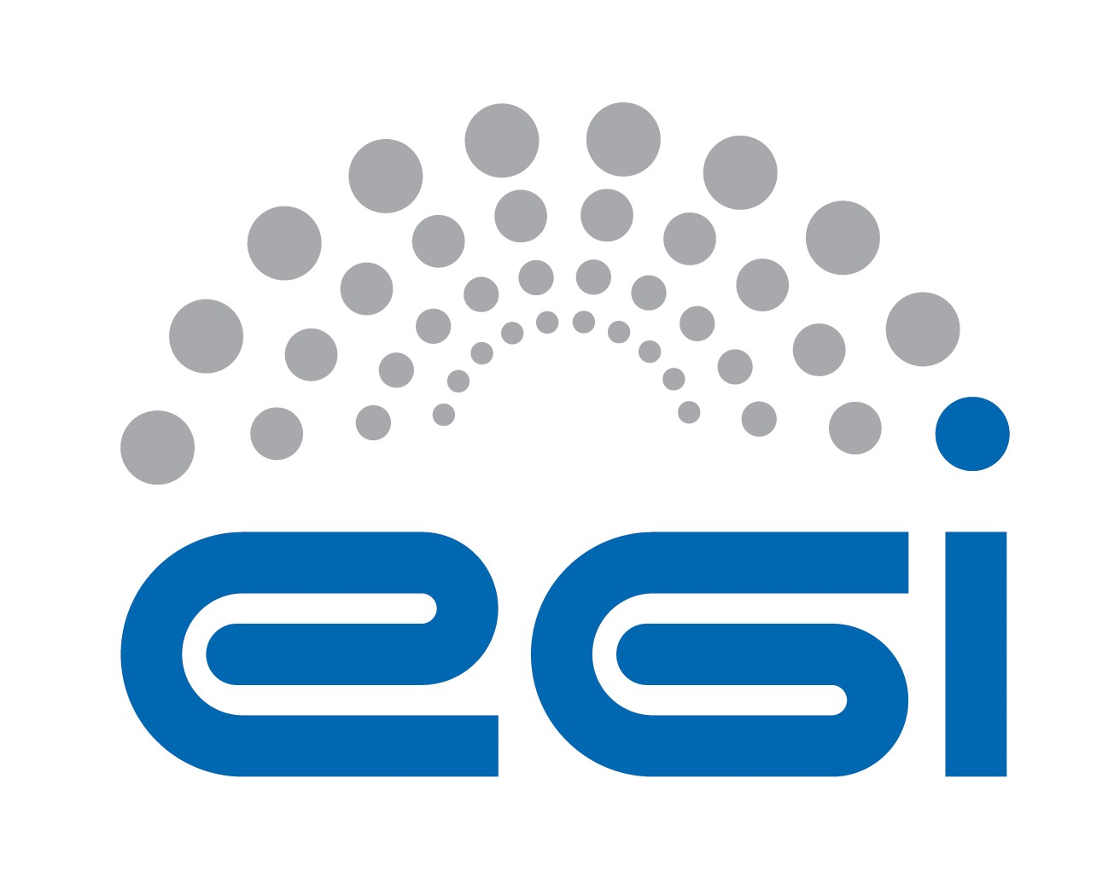
Technology Provider
Underpinning Agreement

Customer | EGI.eu
Provider | XXXX
Service | XXXX Support
Start Date | XX/XX/XXXX
End Date | XX/XX/XXXX
Version | 1.0 Final
Document Link: | XX
- Copyright notice
Copyright © EGI.eu. This work is licensed under the Creative Commons Attribution-NonCommercial-NoDerivs 3.0 Unported License. To view a copy of this license, visit http://creativecommons.org/licenses/by-nc/3.0/ or send a letter to Creative Commons, 171 Second Street, Suite 300, San Francisco, California, 94105, USA.
The work must be attributed by attaching the following reference to the copied elements: “Copyright © EGI.eu (www.egi.eu). Using this document in a way and/or for purposes not foreseen in the license, requires the prior written permission of the copyright holders. The information contained in this document represents the views of the copyright holders as of the date such views are published.

This agreement is based on a SLA template that forms part of the FitSM family – a lightweight standard for IT Service Management that supports federated infrastructures. For more information on FitSM visit www.fitsm.eu or contact info@fitsm.eu. The template this document is based on was licensed with a Creative Commons Attribution 4.0 International License.

This agreement is based on FitSM Template: SLA v1.0.
TABLE OF CONTENTS
1 Introduction 4
2 Scope of the services 4
3 Service hours 4
4 Support 4
4.1 Incident handling 5
4.2 Fulfilment of service requests 5
5 Service level targets 5
6 Limitations & constraints 5
7 Communication, reporting & escalation 5
7.1 General communication 5
7.2 Agreement violations 6
7.3 Escalation & complaints 6
8 Information security & data protection 6
9 Additional responsibilities of the provider 6
10 Customer responsibilities 7
11 Review 7
12 Glossary of terms 7
13 References 7

Introduction

This agreement is made between XXXX (the Provider) and EGI.eu (the Customer) to cover the provision and support of the service as described hereafter. The relevant contacts and representatives may be found in section 7.1.

This agreement is valid from XX/XX/XXXX to XX/XX/XXXX.

The agreement is a document discussed and approved between the Customer, and the partner or consortium of partners (the Provider) selected for delivery of the service.

Amendments, comments and suggestions must be addressed to the Customer contact given to the Provider (see section 7.1).

Scope of the services
This agreement applies to provision of support for following components:
- XXXXXXXXXXXXXXXXX

Service hours
The service operates during support hours (see section 4).

Support
The services covered by the scope of this agreement are provided with the following level of support.

Support is provided via the GGUS portal [GGUS], which is the single point of contact for infrastructure users to access the EGI Service Desk. The EGI Service Desk within GGUS is organized in Support Units (SU). Every SU is responsible for one or more services. The number and definition of the EGI SUs in GGUS is not regulated by this agreement and can change at any time to fulfil the EGI Incident and Problem Management requirements.

The SU name related to services at a time of signing this agreement: XXX.

Support is available between:
- Monday and Friday
- 9:00 and 17:00 CET/CEST time

This excludes public holidays at the same time in all organizations providing the service.

Incident handling
Disruptions to the agreed service functionality or quality will be handled according to an appropriate Quality of Support level based on priority of the incident [PRIO]. In this context, the following guidelines apply:
- Three GGUS Quality of Support (QoS) levels have been defined: base, medium and advanced [GGUS QoS]
- The following QoS levels apply to the service: XXX

Response time is provided as service level target (see section 5).

Fulfilment of service requests
In addition to resolving incidents, standard service requests (e.g. change or information request, documentation) will be fulfilled through the defined support channels in section 4. Response and fulfilment times are provided as service level targets (see section 5).

Service level targets
The following are the agreed service level targets for the service:
- QoS level: XXXXXX [GGUS QoS]

Limitations & constraints
The provisioning of the service under the agreed service level targets is subject to the following limitations and constraints:
- Support is provided in following language: English
- Failures in the normal operation of the service caused by failures in Federated Operations service components (i.e. GGUS) are not considered SLA violations.
- Force Majeure. A party shall not be liable for any failure of or delay in the performance of this Agreement for the period that such failure or delay is due to causes beyond its reasonable control, including but not limited to acts of God, war, strikes or labor disputes, embargoes, government orders or any other force majeure event.

Communication, reporting & escalation

General communication
The following contacts will be generally used for communications related to the service in the scope of this agreement.
Customer contact for the Provider | Name  e-mail  Support team manager
Provider contact for the Customer | Peter Solagna  peter.solagna@egi.eu  EGI.eu NGI Operations Manager [EGDB]
Contact for service users | According to defined support channels

Agreement violations
The Provider commits to inform the Customer, if this agreement is violated or violation is anticipated. The following rules are agreed for communication in the event of agreement violation:
In case of violating the service targets specified in this document for two consecutive months it is requested to provide justifications and a plan for service enhancement. The violating party must provide to the EGI.eu contact (see section 7) a status report and a plan for the improvement of the service within one month from the date of notification. The Customer will be notified of this situation.

Escalation & complaints
For escalation and complaints, the defined Provider contact (see section Error: Reference source not found7) point shall be used, and the following rules apply:
- In case of violating the service targets for four consecutive months, review of the Agreement will be taken by customer contact (see section Error: Reference source not found7) and reported to parties of the Agreement.
- Complaints should be directed to the customer contact (see section Error: Reference source not found7).
- The provider contact (see section Error: Reference source not found7) will be contacted in case of received complaints.

Information security & data protection
The following rules for information security and data protection apply:
- The Provider must define and abide by an information security and data
protection policy related to the service being provided.
- This must meet all requirements of any relevant EGI policies or procedures [POL] and also must be compliant with the relevant national legislation.

Additional responsibilities of the provider
Additional responsibilities of the Provider are as follow:
- Adhere to all applicable operational and security policies and procedures defined in [POL] and to other policy documents referenced therein;
- Use communication channel defined in the agreement (see section Error: Reference source not found);
- Accept EGI monitoring services provided to measure fulfilment of agreed service level targets;
- Handle security issues in timely manner;
- Deliver service components according to EGI Software Component Delivery procedure [SCD].

Customer responsibilities
The responsibilities of the Customer are:
- Raise any issues deemed necessary to the attention of the Provider;
- Provide monitoring to measure fulfilment of agreed service level targets.
- Provide the EGI Service Desk, through the GGUS portal
- Provide the Unified Middleware Distribution (UMD), that integrates Provider services, after successfully passed through the UMD Software Provisioning Process [USPP] and is deployed on the EGI’s production e-infrastructure
- Provide the UMD software provisioning infrastructure composed of:
  - UMD repositories, supporting multiple operating systems
  - Community repositories - through AppDB [APPDB] Provider has access to a repository-as-a-service platform to upload their software release
  - Web front-end – containing information about UMD releases (release notes, list of components, configuration configuration)
- Communicate collected and prioritized requirements and use cases from EGI community.
- Define generic and specific acceptance criteria related to all software components contributed to EGI.
- Involve the Provider in the triaging of the issues mentioned above through the appointed EGI second level support team.
- Provide access to boards, process and knowledge of EGI’s Software Vulnerability Group [SVG] to the Provider in order to develop and contribute corrections necessary to the maintained software components.

Review
There will be reviews of the service performance against service level targets and of this SLA at planned intervals with the Customer according to the following rules:
- Content of the agreement and targets will be reviewed on a yearly basis.

Glossary of terms
For the purpose of this OLA, the following terms and definitions apply:
[The key words "MUST", "MUST NOT", "REQUIRED", "SHALL", "SHALL NOT", "SHOULD", "SHOULD NOT", "RECOMMENDED", “MAY", and "OPTIONAL" in this document are to be interpreted as described in RFC 2119. For a complete list of term definitions see the EGI Glossary (http://wiki.egi.eu/wiki/Glossary).

References
[APPDB] | EGI Applications Database  http://appdb.egi.eu
[EGDB] | EGI.eu Operations Centre hosting EGI central operations tools  https://goc.egi.eu/portal/index.php?Page_Type=NGI&id=4
[GGUS] | EGI Helpdesk  http://helpdesk.egi.eu/
[GGUS QoS] | EGI GGUS Quality of Service Leveles  https://wiki.egi.eu/wiki/FAQ_GGUS-QoS-Levels
[GLO] | EGI Glossary  http://wiki.egi.eu/wiki/Glossary
[POL] | EGI policies and procedures  https://www.egi.eu/about/policy/policies_procedures.html
[USPP] | UMD Software Provisioning Process  https://wiki.egi.eu/wiki/EGI_Software_Provisioning
[SCD] | EGI Software Component Delivery  https://wiki.egi.eu/wiki/EGI_Software_Component_Delivery
[SVG] | Software Vulnerability Group  https://www.egi.eu/about/policy/groups/Software_Vulnerability_Group_SVG
[PRIO] | EGI Priority Scheme  https://wiki.egi.eu/wiki/FAQ_GGUS-Ticket-Priority

