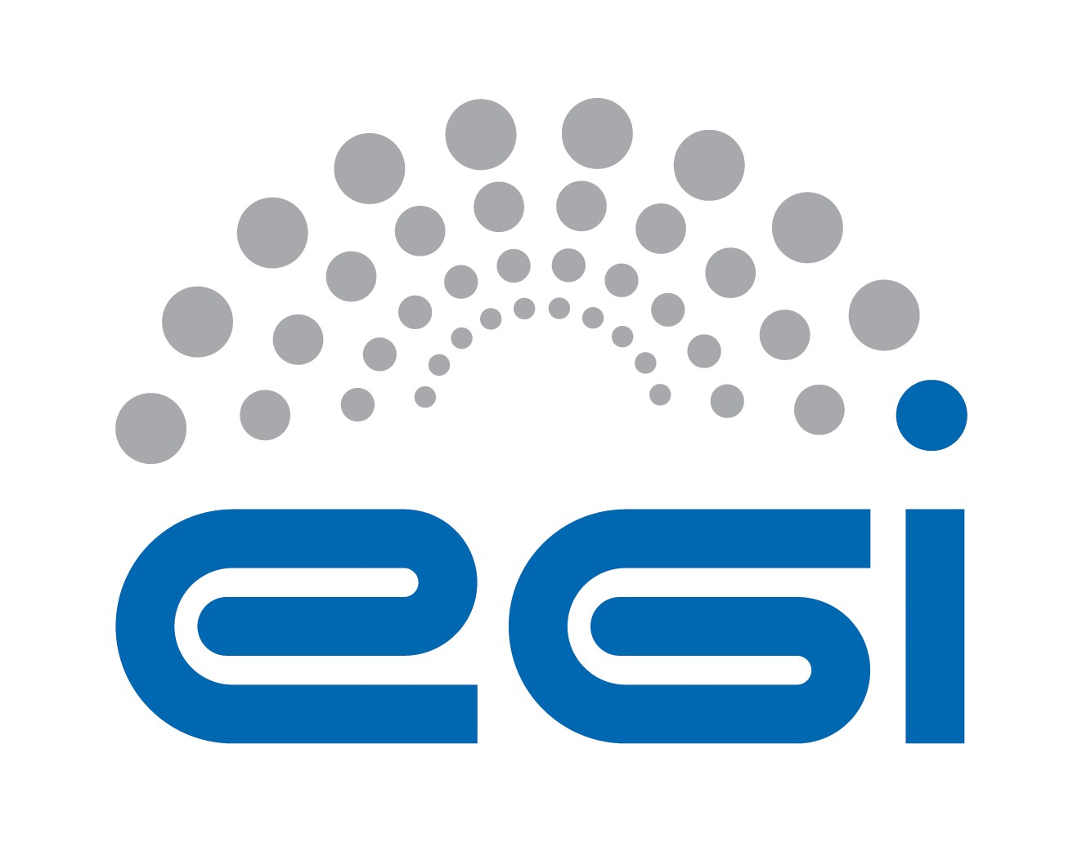
EGI.eu
OLA Performance Report

Title | EGI.eu OLA – SAMCentralService performance report
Provider | GRNET, CNRS, SRCE
Service | SAMCentralService
Produced by | Christos Kanellopoulos  skanct@grnet.gr  Site Operations Manager
Audience | EGI.eu Operations  operations@egi.eu
Purposeą | Report on performance of the service
Period | 01/05/2014 – 31/10/2014
Related agreements | EGI.eu-OLA- SAMCentralService -v1.doc
Document Link: | https://documents.egi.eu/document/2170
- Copyright notice
Copyright © EGI.eu. This work is licensed under the Creative Commons Attribution-NonCommercial-NoDerivs 3.0 Unported License. To view a copy of this license, visit http://creativecommons.org/licenses/by-nc/3.0/ or send a letter to Creative Commons, 171 Second Street, Suite 300, San Francisco, California, 94105, USA.
The work must be attributed by attaching the following reference to the copied elements: “Copyright © EGI.eu (www.egi.eu). Using this document in a way and/or for purposes not foreseen in the license, requires the prior written permission of the copyright holders. The information contained in this document represents the views of the copyright holders as of the date such views are published.

This report is based on a template that forms part of the FitSM family – a lightweight standard for IT Service Management that supports federated infrastructures. For more information on FitSM visit www.fitsm.eu or contact info@fitsm.eu. The SLA template this document is based on was licensed with a Creative Commons Attribution 4.0 International License.

This report is based on FitSM Template: Report v0.2

TABLE OF CONTENTS
1 General overview of performance in the period 3
2 Performance agaisnt Service Targets 3
3 Issues arising in the period 4
4 Measures planned 4
5 Foreseen events and changes 4

General overview of performance in the period
The Service is part of the EGI Core Infrastructure Platform, which supports the daily operations of EGI. Central systems are needed for accessing and archiving infrastructure monitoring results of the services provided at many levels (Resource Centres, NGIs and EGI.EU), for the generation of service level reports, and for the central monitoring of EGI.eu operational tools and other central monitoring needs.
During this period the service exceeded all service targets. Two incidents occurred, but they had not impact to the overall service performance.

Performance agaisnt Service Targets

The following table shows performance against targets:

Service level parameter | Target | M1 average | M2 average | M3 average | M4 average | M5 average | M6 average
Availability | 99% | 100% | 100% | 100% | 100% | 100% | 100%
Reliability | 99% | 100% | 100% | 100% | 100% | 100% | 100%
Support priority | Medium | - | - | - | - | - | -
[Other parameter] | - | - | - | - | - | - | -

Issues arising in the period

In this period there were two issues with the service:
- Issue 1: Between May 1st and May 12th, SAM-CENTRAL and the Message Broker Network have experienced a set of chained failures that resulted in the loss of a large portion of the metric results that were published by the SAM NGI Instances. The loss of these messages will result in an unusually high number of UNKNOWNS in the May A/R reports, but the actual A/R numbers will not be affected as UNKNOWNS are not take into account. No other services have been affected. We have taken all the necessary measures in order to resume normal operations.

- Issue 2: On July 12th, a power failure at the data center hosting the GRNET Message Broker instance results in inavailability of that specific instance. The Message Broker Network continued to operate with 1 instance only running at SRCE. Most of the clients seamlessly switched over to the SRCE instance, but not the client used by the SAM Worked Node Framework. As a result several sites have been witnessing errors for duration up to 4 days after the incident

Measures planned

Issue 1:
- The chain of event started when the rate of database inserts dropped significantly. The reason for this was identified to be another application that was hosted on the same Oracle database, which started misbehave and consume a large amount of resources. When the DBA at CNRS identified the issue, he promptly ensured that the proper amount of resources are allocated for SAM-CENTRAL.
- When the performance of Oracle was restored, SAM-CENTRAL continued to consume messages at a very low rate from MSG-GRNET although the load on MSG-GRNET was well within the operational limits. The fact that the consumption rate was rapidly increased when SAM-CENTRAL switched to MSG-SRCE, requires further investigation. A possible explanation might be the existence of a traffic shaper somewhere between SAM-CENTRAL and MSG-GRNET or due to the limited rate that occurred at SAM-CENTRAL in the first place. (Due to the overloading performed on the Oracle the central instance was too slow to receive messages. When a consumer receives any messages from an activemq broker an acknowledgment is sent back. However, when the rate of these acknowledgments is too low the broker will refuse to send new messages even though it may handle them because the service assumes a problem on the other side is taking place. When the issue on the Oracle was resolved this behaviour may have continued in a reciprocable manner.)
- After 1 day that SAM-CENTRAL connected to MSG-SRCE, MSG-SRCE started producing log entries at a very high rate. This behavior was something we have never seen in the past. Investigating the problem further, we believe that it is associated with the bug [AMQ-4239] that has been reported for ActiveMQ 5.7 and which might be triggered in situations like we were facing. Although MSG is running on ActiveMQ 5.8, we consider that the problem in the code base might continue to exist in 5.8 as it was never resolved but rather closed as "not reproducible".
- The previous three issues although critical, they did not result in data loss. It was not until MSG-SRCE was restarted, that messages were lost. This was an unexpected behavior and we investigating why the messages did not persist after the restart of MSG-SRCE.
More information about this incident can be found at: http://goo.gl/SzlFH2
Issue 2:
- The “mta-simple” client implementation that ships with the “Worker node framework” and which is unmaintained at the moment, needs to be removed or to be updated in order to be able to take advantage of the high availability features of the Message Broker Network.
- Currently the Message Broker Network consists only of 2 Message Broker instances due to resource limitations. As a result a failure in any of the Message Broker instances has a wide impact on the Service. This should be remedied in EGI-ENGAGE.
- Using the TOP-BDII for Service Discovery has been serving as well, but it is clear that it is not meant to be used as a mean for service discovery in real time. We will start a discussion with the people responsible for the Information System, in order to identify whether real-time service discovery can be part of a central service or it should be something that is dealt by each specific service individually.
More information about this incident can be found at: http://goo.gl/7N0yKb

Foreseen activities and changes

In the next period starting from November 2014 until April 2015, we plan to release the SAM-Update-23 and to prepare for SAM-Update 24, which will pave the way for the transition from the SAM Central Services to the ARGO Service.

