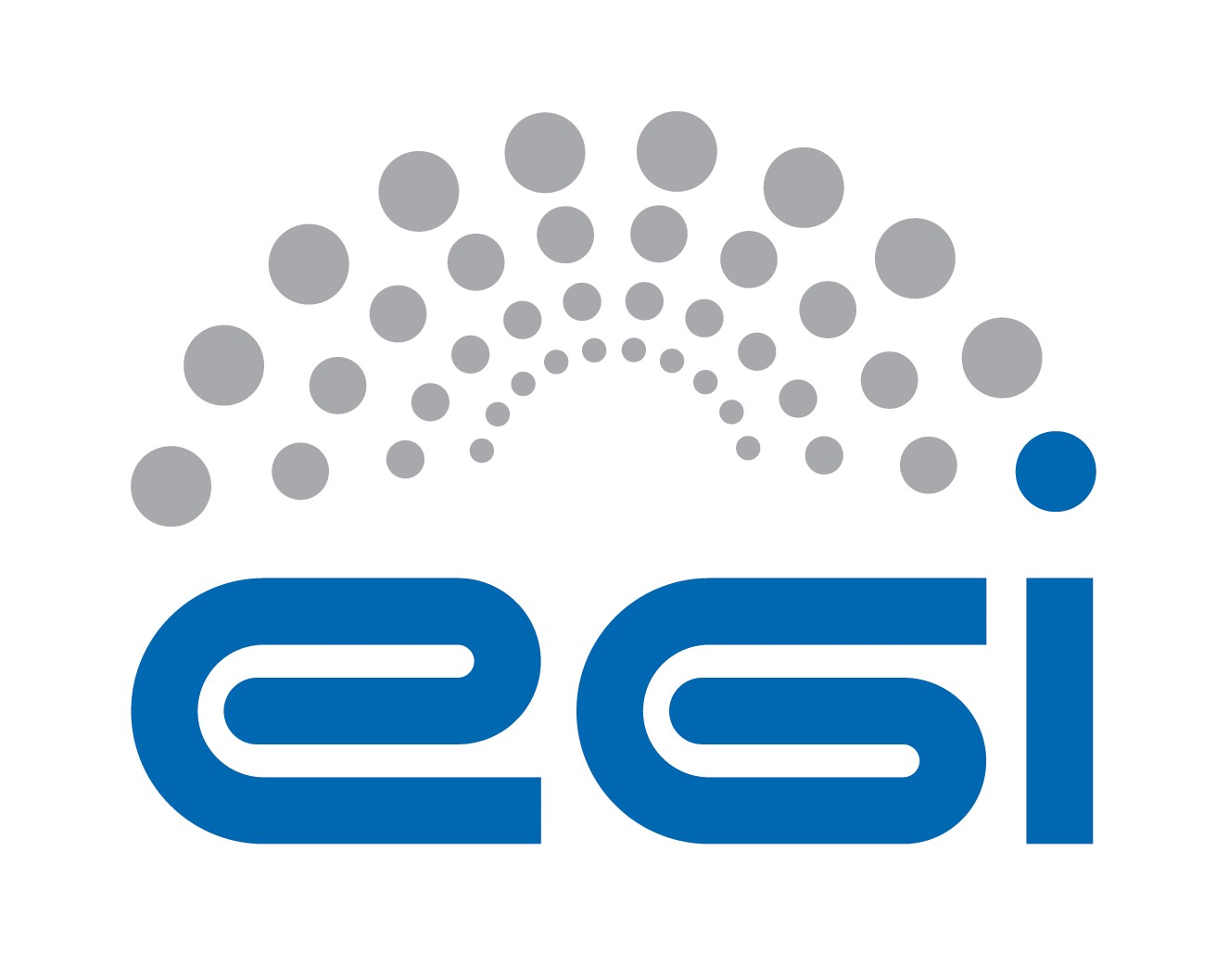
EGI.eu
OLA Performance Report

Title | EGI.eu OLA – Operations Support performance report
Provider | CYFRONET
Service | Operations Support
Produced by | Marcin Radecki  m.radecki@cyfronet.pl  Operations Support team manager
Audience | EGI.eu Operations  operations@egi.eu
Purposeą | Report on performance of the service
Period | 01/05/2014 – 31/10/2014
Related agreements | EGI.eu-OLA-OperationsSupport-v1.doc
Document Link: | https://documents.egi.eu/document/2170
- Copyright notice
Copyright © EGI.eu. This work is licensed under the Creative Commons Attribution-NonCommercial-NoDerivs 3.0 Unported License. To view a copy of this license, visit http://creativecommons.org/licenses/by-nc/3.0/ or send a letter to Creative Commons, 171 Second Street, Suite 300, San Francisco, California, 94105, USA.
The work must be attributed by attaching the following reference to the copied elements: “Copyright © EGI.eu (www.egi.eu). Using this document in a way and/or for purposes not foreseen in the license, requires the prior written permission of the copyright holders. The information contained in this document represents the views of the copyright holders as of the date such views are published.

This report is based on a template that forms part of the FitSM family – a lightweight standard for IT Service Management that supports federated infrastructures. For more information on FitSM visit www.fitsm.eu or contact info@fitsm.eu. The SLA template this document is based on was licensed with a Creative Commons Attribution 4.0 International License.

This report is based on FitSM Template: Report v0.2

TABLE OF CONTENTS
1 General overview of performance in the period 3
2 Performance agaisnt Service Targets 3
3 Issues arising in the period 4
4 Measures planned 4
5 Foreseen events and changes 4

General overview of performance in the period
Operations Support activities covered the following three areas:

- Central technical support
There were substantial changes in the Operations Dashboard version 3 (released on April 2014 as well) and new ROD teams expressed a need for a training. As a ROD support action our team prepared training materials covering operational procedures and their handling in new Operations Dashboard and organized a ROD training through Adobe Connect. The training was carried out on 03.10.2014 and gathered 11 participants from various NGIs. The training slide set and full recording are published for an off-line use on ROD web page: https://wiki.egi.eu/wiki/ROD#Manuals_and_procedures. This web page was reviewed and updated to reflect changes after April 2014. We also provided support for a couple of questions from new ROD teams via e-mails to operations support mailing list. Another related activity was a consultancy for new Operations Dashboard features (e.g. checking compliance with existing procedures) and GUI usability testing. If continued, this activity needs to be better defined to ensure repeatable results. We foresee to continue this activity through involvement in Dashboard Advisory Group.

Another large part of work was related to technical support to the EGI.eu. We performed different types of campaigns with sites (e.g. EMI-2 decomissioning, new VOMS services for LHC and OPS VO to be configured at sites, Argus, FedCloud). Although simple in nature this actions are usually laborious due to large communication with sites, RODs and NGI managers. A campaign takes usually 3 months during which 40 tickets are opened and must be supervised. Progress is reported on weekly basis. The sites present full spectrum of responses, where some must be reminded and escalated.
We also handle introduction of new NGIs into EGI (IDGF, AfricaArabia, NGI_CHINA) according to PROC02 and adding new operations tests accroding to PROC07. We carry out works towards new broadcast policy to avoid spam and participate in works on upgrading PROC19 which relates to other core processes.

- Resource allocation
The Operations Support was assigned a responsibility for managing Resource Allocation process in EGI. This was partially motivated by opportunity of a synergy existing in common localization of the RA operations and e-Grant development teams. Our team operate the RA process in e-Grant. In total we handled 8 requests, however we had a lot of communications with the customers clarifying their needs, explaining EGI environment and instructing them through the RA process.
As a result we were consequently improving user-side documentation and raised issues and feature requests to the e-Grant developers. We are also communicating with Resource Providers to organize pool creation process. We reported to OMB an issue with a relatively low number of pools and unability to match request to available pools. To investigate this, a survey for resource providers was run and results were reported twice to OMB (June, September). The survey revealed a structural problem with providers being open only to a given science and limitations in their local policies to support arbitrary fields of science. We also raised an issue with missing support for individuals without any experience using EGI resources.
Operations Support also participated in the development of Resource Allocation process by extending it to FedCloud resources. We designed a way how FedCloud resources can be expressed to users with FedCloud representatives. The design was then passed by us to the e-Grant developers and was implemented. Operations Support took part in testing new e-Grant versions. After the release of the new functionality Operations Support coordinated action of creating FedCloud pools in e-Grant. Currently we have 12 pools in e-Grant. Documentation for the Providers was created and published on https://wiki.egi.eu/wiki/Resource_Allocation web page.

- Coordination
As a result of involvement in above mentioned works the Operations Support attended to a number of meetings: 1) Operations Management Board - reporting progress on Resource Allocation for HTC pools, identifying and reporting problems from RA survey for NGIs and sites. Reporting progress on software decomissioning and other campaings 2) FedCloud Task Force meetings presenting the design and inviting to participation in pool creation 3) FedCloud User Support meeting with the aim to present a common vision of presenting FedCloud activity in e-Grant, so it will be consistent with Resource Allocation process. Metrics for FedCloud resources were discussed and agreed on, a cooperation with other EGI operations tools like AppDB and EGI Accounting Portal was initiated and we presented several use cases worth considering in implementing in FedCloud activity. 4) Pay-For-Use meeting in planning consistency of Pay-For-Use solutions with EGI Resource Allocation process.

Performance againSt Service Targets
Operations Support team at CYFRONET is responsible for handling tickets in two GGUS support units:
- EGI Operations Support (renamed from COD)
- Resource Allocation
Ticket handling for the entire period was within Service Level Targets. The following table shows performance against targets:

Service level parameter | Target | M1 average  [working days] | M2 average | M3 average | M4 average | M5 average | M6 average
EGI Operations Support Response Time | Medium level of QoS | 1.24 | 1.55/ 1.32 | 0.59 | 0.33 | 0.24 | 0.49
Resource Allocation Response Time | Medium level of QoS | n/a | n/a | n/a | n/a | n/a | n/a

Issues arising in the period
There were no issues such as OLA violations or problems in performance which affected the service. However, it is worth to mention that for more effective collaboration it was agreed with EGI.eu operations staff on the following:
- have a short weekly teleconferences
- report task progress in an on-line spreadsheet

Measures planned
No measures are necessary.

Foreseen activities and changes
In the next period the Operations Support team at CYFRONET plans to perform the regular tasks agreed by the OLA related to Central technical support, Resource Allocation and Coordination.
Additionally, concerning activities agreed with EGI.eu Operations staff we plan to:
- Create EGI broadcast communication policy for operations to avoid spam
- Prepare for takeover of PROC07 based on experiences from past campaigns
- Complete Resource Allocation documentation on wiki
- Supporting EGI Operations in creating procedures (e.g. PROC19)

There was also agreed that new regular tasks or activities may be agreed during weekly teleconferences depending on the expertise and load at Operations Support team.
When created we plan to join Dashboard Advisory Group to evaluate and test dashboard features.

