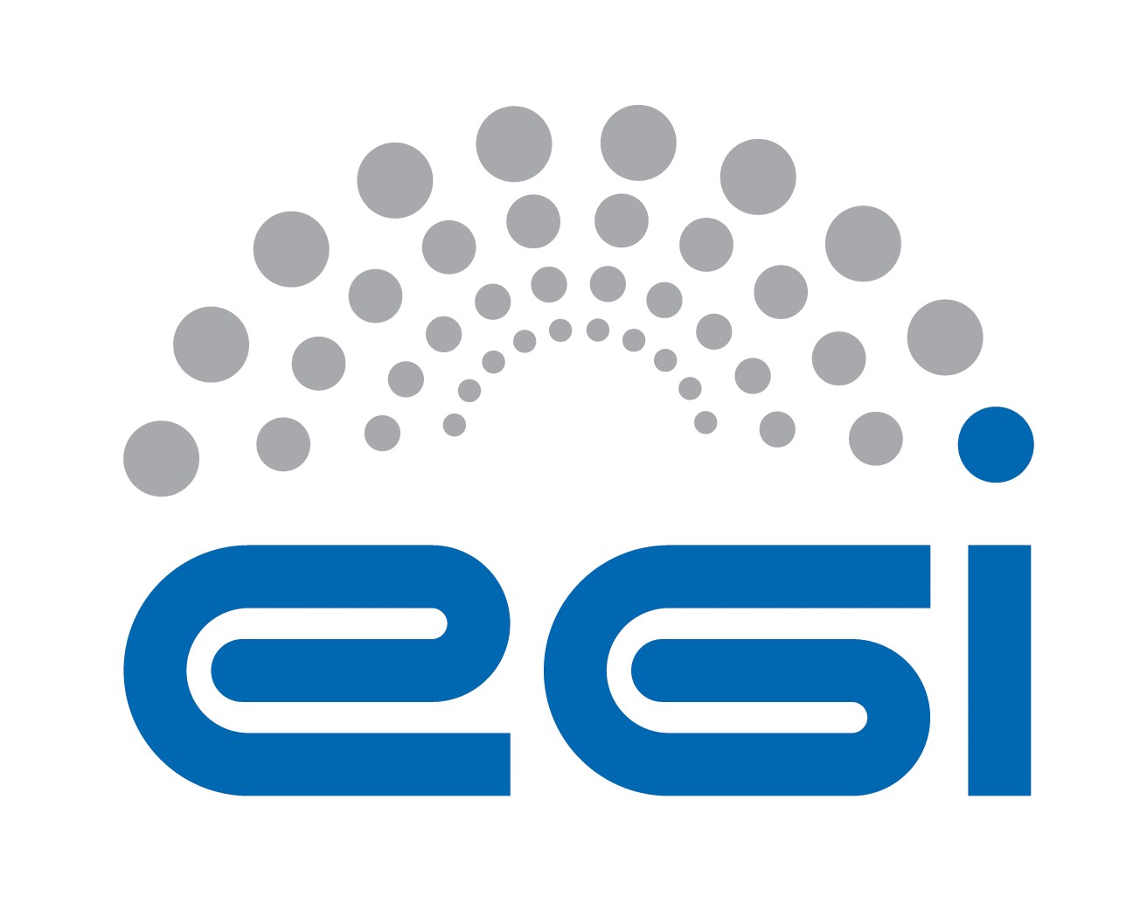
EGI.eu
OLA Performance Report

Title | EGI.eu OLA – ServiceRegistryGOCDB performance report
Provider | STFC
Service | ServiceRegistryGOCDB
Produced by | David Meredith  david.meredith@stfc.ac.uk  Site Operations Manager
Audience | EGI.eu Operations  operations@egi.eu
Purposeą | Report on performance of the service
Period | 01/05/2014 – 01/10/2014
Related agreements | EGI.eu-OLA- ServiceRegistryGOCDB -v1.doc
Document Link: | https://documents.egi.eu/document/2170
- Copyright notice
Copyright © EGI.eu. This work is licensed under the Creative Commons Attribution-NonCommercial-NoDerivs 3.0 Unported License. To view a copy of this license, visit http://creativecommons.org/licenses/by-nc/3.0/ or send a letter to Creative Commons, 171 Second Street, Suite 300, San Francisco, California, 94105, USA.
The work must be attributed by attaching the following reference to the copied elements: “Copyright © EGI.eu (www.egi.eu). Using this document in a way and/or for purposes not foreseen in the license, requires the prior written permission of the copyright holders. The information contained in this document represents the views of the copyright holders as of the date such views are published.

This report is based on a template that forms part of the FitSM family – a lightweight standard for IT Service Management that supports federated infrastructures. For more information on FitSM visit www.fitsm.eu or contact info@fitsm.eu. The SLA template this document is based on was licensed with a Creative Commons Attribution 4.0 International License.

This report is based on FitSM Template: Report v0.2

TABLE OF CONTENTS
1 General overview of performance in the period 3
2 Performance agaisnt Service Targets 3
3 Issues arising in the period 4
4 Measures planned 4
5 Foreseen activities and changes 4
6 Appendix 1 6
7 Appendix 2 8

General overview of performance in the period

The Gocdb service performed well during the period with no major issues or unscheduled outages.

Performance agaisnt Service Targets
The following table shows performance against targets:

Service level parameter | Target | M1 average | M2 average | M3 average | M4 average | M5 average | M6 average
Availability | 99 | 99.03 | 76.83 100 | 99.9 | 99,95 | 100 | 99,46
Reliability | 99 | 100 | 76.83 100 | 100 | 100 | 100 | 100
Support priority | Medium | No response time violations | No response time violations | No response time violations | No response time violations | No response time violations | No response time violations

Please note, I contest the Availability and Reliability values provided by EGI for the M2 period as shown in the report at:
https://documents.egi.eu/public/RetrieveFile?docid=2324&version=1&filename=2014-05%20Ops%20tools%20Ava%20Rel%20report.pdf

This report shows an apparent low availability and reliability score for Gocdb, with a value of 76.83% for both A+R. This is both unrealistic and not true (Gocdb was not unavailable for ~7.5 days). As shown in Appendix 1, according to My EGI portal, GOCDB shows 100% reliability for this period (01st to 30th June). This is corroborated by our internal Nagios monitoring as shown in Appendix 2.

Issues arising in the period
- No issues or OLA violations.
- Failover testing revealed an expected behaviour of the DNS switching mechanism for the Gocdb failover procedure; If the failover is engaged and the DNS is switched, different sites across Europe will experience service outages of unknown periods of time (1~2 hrs). This is due to the caching nature of DNS which can take an undetermined period of time to update all upstream caching DNS servers. The Gocdb OLA states that outages caused due to DNS issues are not a violation.

Measures planned
N/A

Foreseen activities and changes

N/A – The Gocdb roadmap and planned developments should not affect the OLA for the next period, which include Pay For Use (P4U) developments and Authentication extensions.

Appendix 1
Monitoring shows 100% reliability for Gocdb during M2 period (01st to 30th June)

http://mon.egi.eu/myegi/sa/?view=2&graph=1&vo=104&profile=23&filters-value-Regions_or_Tiers=165&filters-value-Sites=170&production=1&preproduction=0&period=pM&dateorperiod=dt&startdate=01-06-2014&enddate=30-06-2014&resolution=D

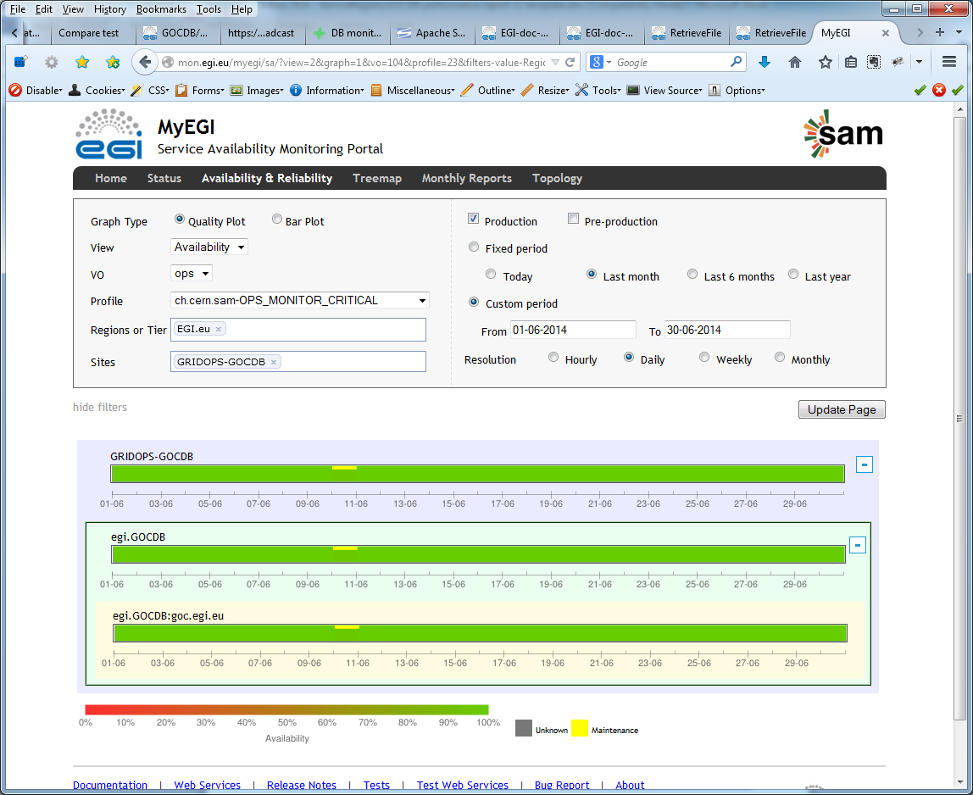
http://mon.egi.eu/myegi/sa/?view=2&graph=2&vo=104&profile=23&filters-value-Regions_or_Tiers=165&filters-value-Sites=170&production=1&preproduction=0&period=pM&dateorperiod=dt&startdate=01-06-2014&enddate=30-06-2014&resolution=D

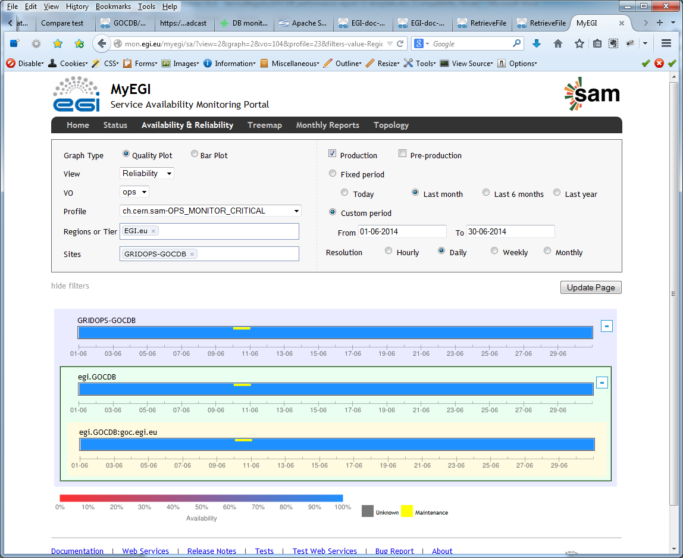

Appendix 2
STFC internal Nagios montioring also shows 100% reliability for M2 period (01st to 30th June)

