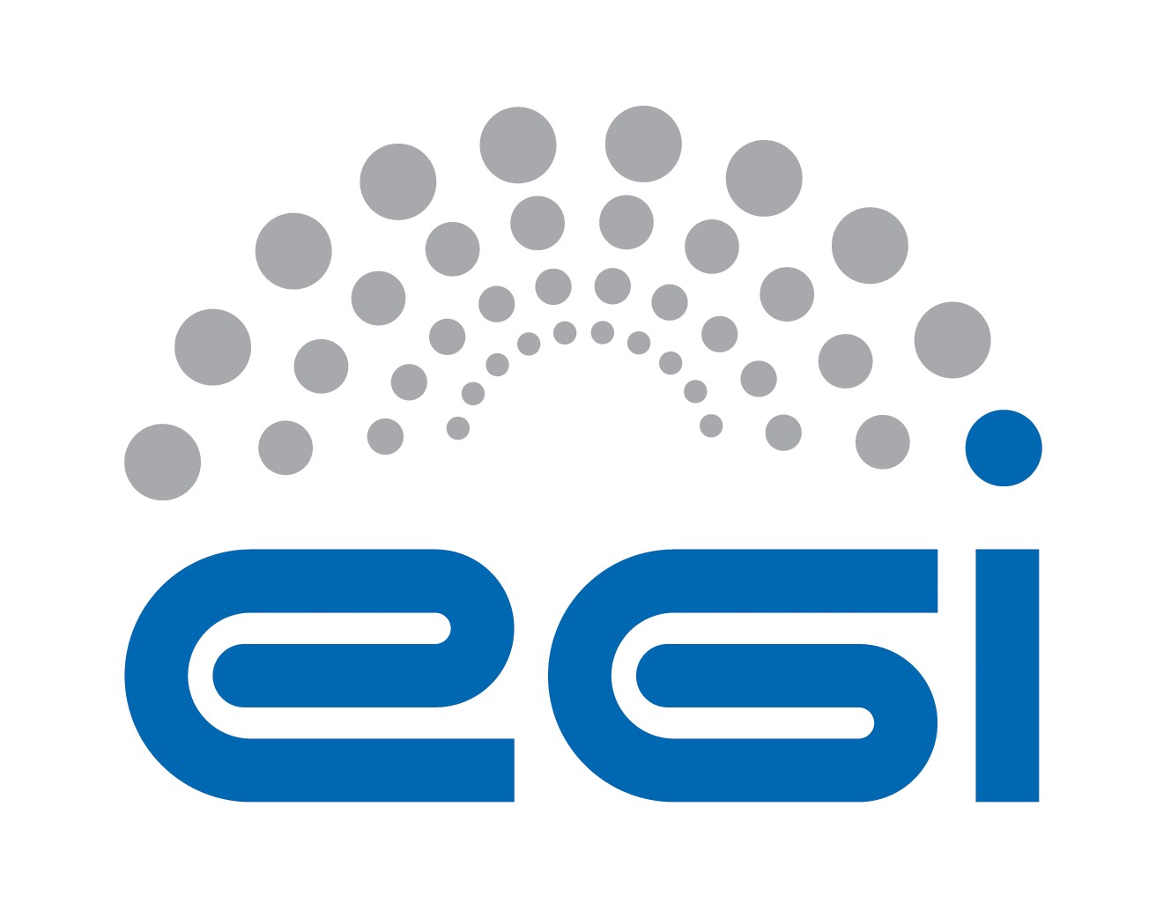
EGI.eu
Operation Level Agreement

Customer | EGI.eu
Provider | IBERGRID
Service | Acceptance Criteria
Start Date | 1 May 2015
End Date | 30 April 2016
Version | 1
Document Link: | https://documents.egi.eu/document/2456
- Copyright notice

This work by EGI.eu is licensed under a Creative Commons Attribution 4.0 International License. To view a copy of this license, visit http://creativecommons.org/licenses/by/4.0/

This OLA is based on a template that forms part of the FitSM family – a lightweight standard for IT Service Management that supports federated infrastructures. For more information on FitSM visit www.fitsm.eu or contact info@fitsm.eu. The OLA template this document is based on was licensed with a Creative Commons Attribution 4.0 International License.

This OLA is based on FitSM Template: SLA v1.0.
TABLE OF CONTENTS
1 Introduction 4
2 Scope and description of the services 4
3 Service hours and exceptions 4
4 Services components and dependencies 4
5 Support 5
5.1 Incident handling 5
5.2 Fulfilment of service requests 6
6 Service level targets 6
7 Limitations & constraints 6
8 Communication, reporting & escalation 7
8.1 General communication 7
8.2 Regular reporting 7
8.3 OLA violations 7
8.4 Escalation & complaints 8
9 Information security & data protection 8
10 Additional responsibilities of the provider 8
11 Customer responsibilities 8
12 Review 9
13 Glossary of terms 10
14 References 11

Introduction
This agreement is made between IBERGRID (the Provider) and EGI.eu (the Customer) to cover the provision and support of the service as described hereafter. The relevant contacts and representatives may be found in section 8.1.

This OLA is valid from 1 May 2015 to 30 April 2016.

The OLA is a document discussed and approved between the customer, and the partner or consortium of partners (provider) selected for delivery of the service.

Amendments, comments and suggestions must be addressed to the Customer contact given to the Provider (see section 8.1).

Scope and description of the services

This OLA applies to the following service: Acceptance Criteria.
The Acceptance Criteria are the functional and non-functional requirements that a product must fulfil to be released in UMD, these include generic requirement applicable to every product, and specific requirements applicable to the capabilities supported by a component.

Service hours and exceptions
The service operates during support hours.

Services components and dependencies
Incremental definition | The task must evolve the current set of quality criteria published in the |QC Document, removing the criteria no more relevant for the UMD distribution and adding the new criteria coming from operational requirements and new capabilities. The document drafts must be disseminated among the EGI technology providers and discussed to collect feedback from the developers. The task must maintain comprehensive wiki pages with the documentation to properly test the criteria, to be used during the verification, as well as the mapping products vs criteria. The task must also analyze the new products, and discuss with the software providers the capabilities relevant for the EGI communities.
Verification of acceptance criteria | All the products released in UMD must be verified against the relevant acceptance criteria. Products must be deployed in a controlled environment. Every product in UMD must have a verification report associated, with the results of the verification process. The verifiers must be familiar with the core products used in EGI, the most common site configurations and third parties components such as DBMS and LRMS.
Coordination | The task must coordinate the verifications when the process is outsourced to developers or user communities, this means: overview to advancements in the process and collect the reports produced during verification, making sure that the relevant information (GGUS tickets opened, known issues) are properly propagated to the UMD release.
Operation | The verification for the most critical UMD components must be performed within this core activity.

Support
The services covered by the scope of this OLA are provided with the following level of support.

Support is provided via the GGUS portal [GGUS], which is the single point of contact for infrastructure users to access the EGI Service Desk. The EGI Service Desk within GGUS is organized in Support Units. Every Support Unit is responsible for one or more services. The number and definition of the EGI Support Units in GGUS is not regulated by this OLA and can change at any time to fulfil the EGI Incident and Problem Management requirements.

The SU name related to services at a time of signing this agreement: EGI UMD Quality Assurance

Support is available between:
- Monday and Friday
- 9:00 and 17:00 CET/CEST time

This excludes public holidays at the same time in all organizations providing the service.

Incident handling
Disruptions to the agreed service functionality or quality will be handled according to an appropriate Quality of Support level based on priority of the incident [GQoS]. In this context, the following guidelines apply:
- Three GGUS Quality of Support (QoS) levels have been defined: base, medium and advanced [GQoS]

- The following QoS level applies to the service: Base.

Base level defines a response time of 5 working days regardless of the GGUS ticket priority.

Response time is provided as service level target (see section 6).

Fulfilment of service requests
In addition to resolving incidents, standard service requests (e.g. change or information request, documentation) will be fulfilled through the defined support channels in section 5. Response and fulfilment times are provided as service level targets (see section 6).

Service level targets
The following are the agreed service level targets for the service:
- Incremental definition
  - New document version is produced every year, following two public drafts.
- Verification of acceptance criteria
  - The verification activities must support the UMD releases. The estimated number of products to verify in one year is 200 PPA.
- QoS level: Base (see section 5.1)

Limitations & constraints
The provisioning of the service under the agreed service level targets is subject to the following limitations and constraints:
- Support is provided in following language: English
- Failures in the normal operation of the service caused by failures in Federated Operations service components are not considered OLA violations.
- Force Majeure. A party shall not be liable for any failure of or delay in the performance of this Agreement for the period that such failure or delay is due to causes beyond its reasonable control, including but not limited to acts of God, war, strikes or labor disputes, embargoes, government orders or any other force majeure event.

Communication, reporting & escalation

General communication
The following contacts will be generally used for communications related to the service in the scope of this OLA.

Customer contact for the Provider | Peter Solagna  peter.solagna@egi.eu  EGI.eu NGI Operations Manager [EGDB]
Provider contact for the Customer | Pablo Orviz  orviz@ifca.unican.es  Acceptance Criteria team manager
Contact for service users | According to defined support channels

Regular reporting
As part of the fulfilment of this OLA and provisioning of the service, the following reports will be provided:
Report title | Contents | Frequency | Delivery
Service Performance Report | The document provides the overall assessment of service performance (per month) and OLA target performance achieved during last 6 months | Every 6 months starting from May 2015 | At least one page document submitted to the Executive Board for assessment and made publicly available at EGI Document server [DS] by  the Customer contact (see section 8.1)

OLA violations
The Provider commits to inform the Customer, if this OLA is violated or violation is anticipated. The following rules are agreed for communication in the event of OLA violation:
In case of violating the service targets specified in this document for two consecutive months it is requested to provide justifications and a plan for service enhancement. The violating party must provide to the EGI.eu contact (see section 8.1) a status report and a plan for the improvement of the service within one month from the date of notification. The Customer will be notified of this situation.

Escalation & complaints
For escalation and complaints, the defined Provider contact (see section 8.1) point shall be used, and the following rules apply:
- In case of violating the service targets for four consecutive months, review of the Agreement will be taken by customer contact (see section 8.1) and reported to parties of the Agreement.
- Complaints should be directed to the customer contact (see section 8.1).
- The provider contact (see section 8.1) will be contacted in case of received complaints.

Information security & data protection
The following rules for information security and data protection apply:
- The Provider must define and abide by an information security and data
protection policy related to the service being provided.
- This must meet all requirements of any relevant EGI policies or procedures [POL] and also must be compliant with the relevant national legislation.

Additional responsibilities of the provider
Additional responsibilities of the Provider are as follow:
- Adhere to all applicable operational and security policies and procedures defined in [POL] and to other policy documents referenced therein;
- Use communication channel defined in the agreement;
- Attend OMB and other operations meeting when needed;
- Accept EGI monitoring services provided to measure fulfilment of agreed service level targets.

Customer responsibilities
The responsibilities of the customer are:
- Raise any issues deemed necessary to the attention of the Provider;
- Collect requirements from the Resource infrastructure Providers;
- Support coordination with other EGI Federated Operations service components [ESLA]
- Provide monitoring to measure fulfilment of agreed service level targets.

Review
There will be reviews of the service performance against service level targets and of this OLA at planned intervals with the Customer according to the following rules:
- Technical content of the agreement and targets will be reviewed on a yearly basis.

Glossary of terms
For the purpose of this OLA, the following terms and definitions apply:
[The key words "MUST", "MUST NOT", "REQUIRED", "SHALL", "SHALL NOT", "SHOULD", "SHOULD NOT", "RECOMMENDED", “MAY", and "OPTIONAL" in this document are to be interpreted as described in RFC 2119. For a complete list of term definitions see the EGI Glossary (http://wiki.egi.eu/wiki/Glossary).

References
[BT] | Broadcast Tool  https://operations-portal.egi.eu/broadcast
[DS] | EGI Document server  https://documents.egi.eu/
[EGDB] | EGI.eu Operations Centre hosting EGI central operations tools  https://goc.egi.eu/portal/index.php?Page_Type=NGI&id=4
[ESLA] | EGI.eu SLA  https://documents.egi.eu/secure/ShowDocument?docid=1093
[GDB] | GOC DB  http://goc.egi.eu/
[GGUS] | EGI Helpdesk  http://helpdesk.egi.eu/
[GQoS] | Levels of Quality of Support  https://wiki.egi.eu/wiki/FAQ_GGUS-QoS-Levels
[GLO] | EGI Glossary  http://wiki.egi.eu/wiki/Glossary
[POL] | EGI policies and procedures  https://www.egi.eu/about/policy/policies_procedures.html

