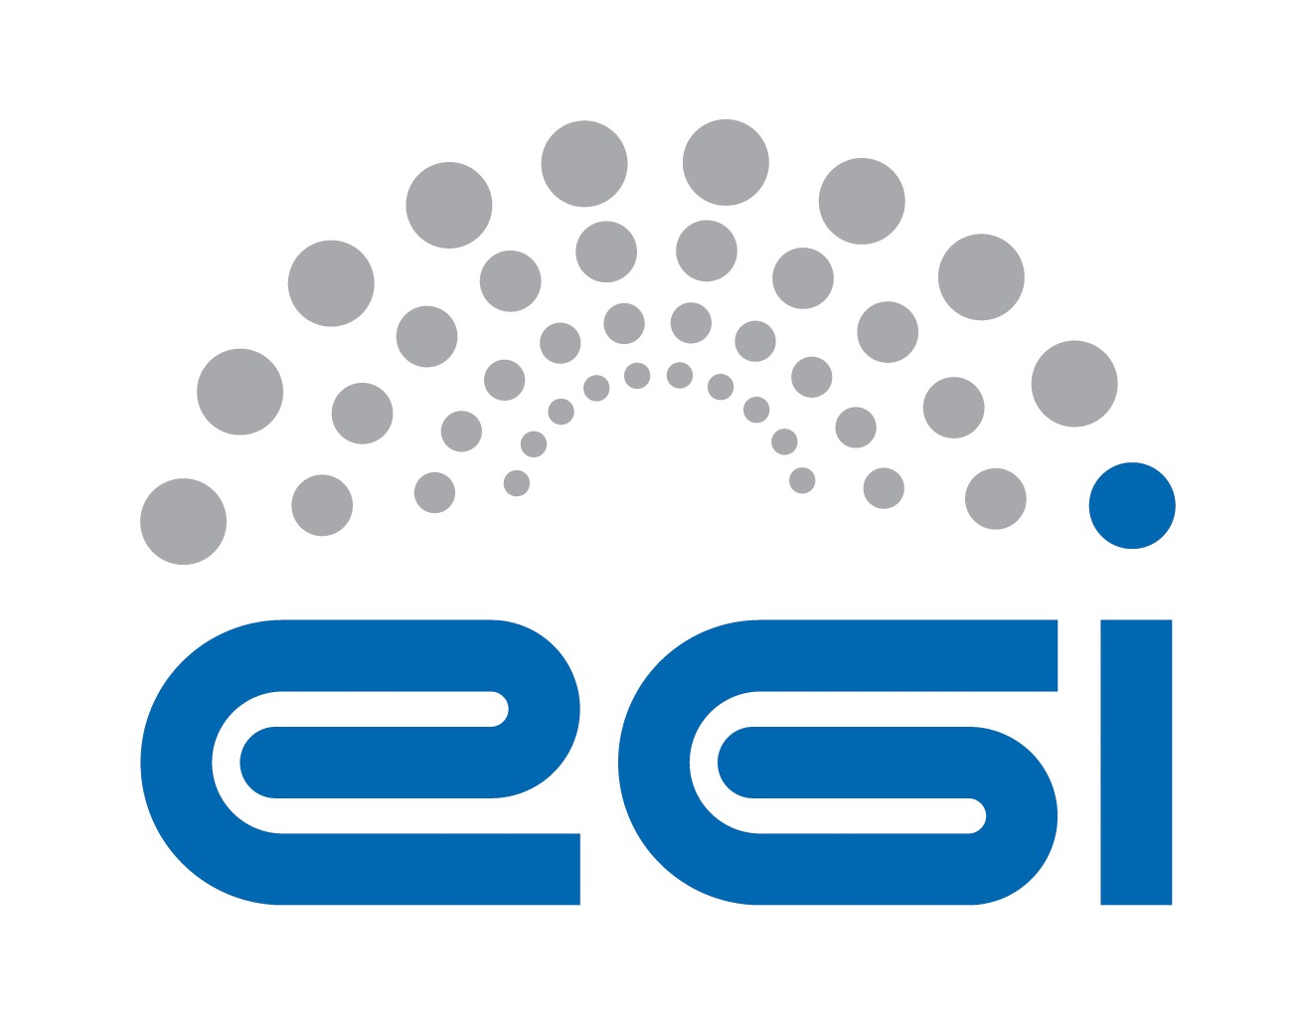
EGI.eu
OLA Performance Report

Title | EGI.eu OLA – CollaborationTools performance report
Provider | CESNET
Service | Collaboration Tools
Produced by | Martin Kuba  makub@ics.muni.cz  Miloš Liška  xliska@fi.muni.cz  Site Operations Manager
Audience | EGI.eu Operations  operations@egi.eu
Purpose | Report on performance of the service
Period | November 2014 - April 2015
Related agreements | EGI.eu-OLA- CollaborationTools -v1.doc
Document Link: | https://documents.egi.eu/document/2170
- Copyright notice
Copyright © EGI.eu. This work is licensed under the Creative Commons Attribution-NonCommercial-NoDerivs 3.0 Unported License. To view a copy of this license, visit http://creativecommons.org/licenses/by-nc/3.0/ or send a letter to Creative Commons, 171 Second Street, Suite 300, San Francisco, California, 94105, USA.
The work must be attributed by attaching the following reference to the copied elements: “Copyright © EGI.eu (www.egi.eu). Using this document in a way and/or for purposes not foreseen in the license, requires the prior written permission of the copyright holders. The information contained in this document represents the views of the copyright holders as of the date such views are published.

This report is based on a template that forms part of the FitSM family – a lightweight standard for IT Service Management that supports federated infrastructures. For more information on FitSM visit www.fitsm.eu or contact info@fitsm.eu. The template this document is based on was licensed with a Creative Commons Attribution 4.0 International License.

This report is based on FitSM Template: Report v0.2

TABLE OF CONTENTS
1 Effort 3
2 General overview of Activity in the period 3
3 Performance against Service Targets 3
4 Issues arising in the period 4
5 Measures planned 4
6 Foreseen activities and changes 4

Effort

6 PM

General overview of Activity in the period
The services provided within the scope of the EGI.eu Collaboration Tools were delivered without any significant issues which would violate the OLA in the reporting period.

Performance against Service Targets
The performance of the services provided within the scope of the EGI.eu Collaboration Tools is stable and well in the scope of the agreed level targets. The numbers in the table below are averages of the availability of all monitored services provided.

We do not have exact numbers as for the provided level of support. There were only 5 requests for the Collaboration Tools SU in the GGUS during the whole reporting period. The rest of the requests came via emails through the it-support@egi.eu. We have received over 160 requests during the reporting period. All of them were resolved in timely manner.

The following table shows performance against targets:

Service level parameter | Target | M1 average | M2 average | M3 average | M4 average | M5 average | M6 average
Availability | 90.00% | 100.00% | 100.00% | 100.00% | 100.00% | 100.00% | 100.00%
Reliability | 90.00% | 100.00% | 100.00% | 100.00% | 100.00% | 100.00% | 100.00%
Support priority | Medium | Achieved | Achieved | Achieved | Achieved | Achieved | Achieved

Issues arising in the period

No significant issues have arisen during the reporting period.

Measures planned

We do not plan to introduce any additional measures or procedures on top of current operations with regard to the current performance.

Foreseen activities and changes

We do not foresee any activities or changes.

