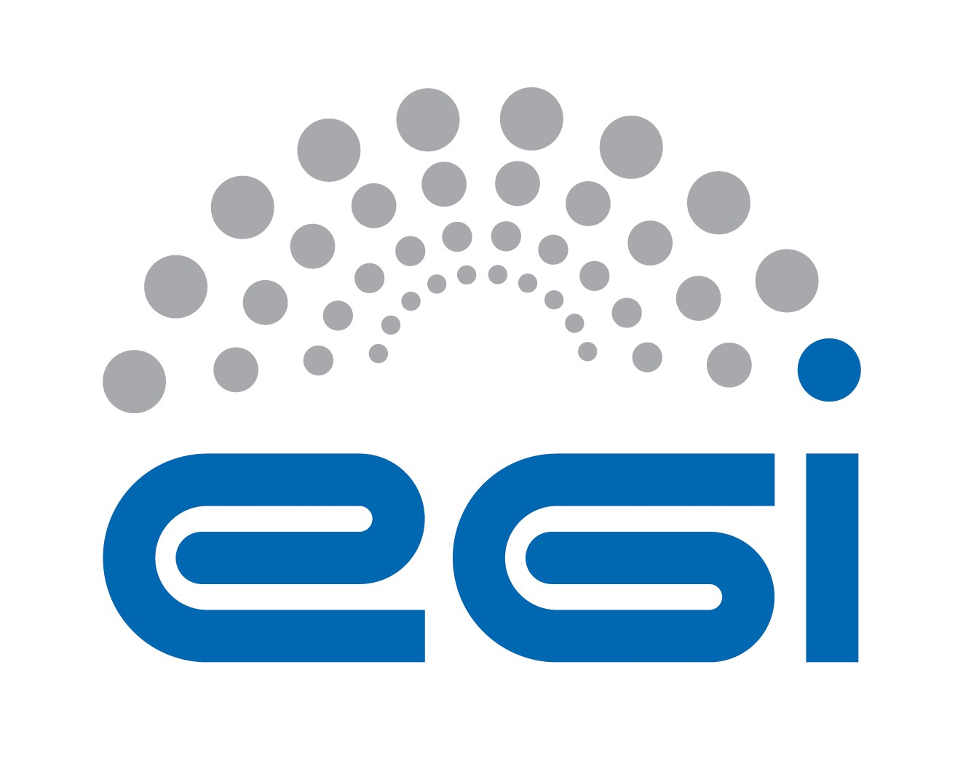
EGI.eu
OLA Performance Report

Title | EGI.eu OLA – SecurityCoordination performance report
Provider | STFC, FOM-Nikhef , SNIC
Service | SecurityCoordination
Produced by | David Kelsey  david.kelsey@stfc.ac.uk  Security Team manager
Audience | EGI.eu Operations  operations@egi.eu
Purposeą | Report on performance of the service
Period | 01/11/2014 – 30/04/2015
Related agreements | EGI.eu-OLA- SecurityCoordination -v1.doc
Document Link: | https://documents.egi.eu/document/2170
- Copyright notice
Copyright © EGI.eu. This work is licensed under the Creative Commons Attribution-NonCommercial-NoDerivs 3.0 Unported License. To view a copy of this license, visit http://creativecommons.org/licenses/by-nc/3.0/ or send a letter to Creative Commons, 171 Second Street, Suite 300, San Francisco, California, 94105, USA.
The work must be attributed by attaching the following reference to the copied elements: “Copyright © EGI.eu (www.egi.eu). Using this document in a way and/or for purposes not foreseen in the license, requires the prior written permission of the copyright holders. The information contained in this document represents the views of the copyright holders as of the date such views are published.

This report is based on a template that forms part of the FitSM family – a lightweight standard for IT Service Management that supports federated infrastructures. For more information on FitSM visit www.fitsm.eu or contact info@fitsm.eu. The template this document is based on was licensed with a Creative Commons Attribution 4.0 International License.

This report is based on FitSM Template: Report v0.2

TABLE OF CONTENTS
1 Effort 4
2 General overview of Activity in the period 4
3 Performance AGAINST Service Targets 5
4 Issues arising in the period 5
5 Measures planned 6
6 Foreseen activities and changes 6

Effort

The effort spent by each partner during the 6 months was:
FOM-Nikhef 3.5 PM
SNIC 1.7 PM
STFC 4.0 PM
TOTAL 9.2 PM

Note: SNIC was less than the planned 2.5 PM because of the departure of the IRTF co-leader at the end of February 2015.

General overview of Activity in the period
The Security Coordination function performed well during another busy 6-month period for operational security. Central Security coordination activities were carried out as expected, including regular weekly/monthly/face to face meetings and presentations at major events.
The main operational activities of the CSIRT had as ever to be given priority, namely the Incident Response Coordination (IRTF) and the Software Vulnerability Group (SVG) Coordination. IRTF handled 5 new security incidents, completed work on 11 old security incidents and issued 4 advisories. SVG handled 25 new vulnerabilities and issued 10 advisories. Four of the advisories were assessed as “Critical” risk.
Policy coordination continued with activity in Federated Identity Management, in particular with IGTF and preparation for H2020 AARC and in leading the new activity (SIRTFI) building a Trust Framework for security operations in the national federations and eduGAIN. An SCI meeting was also held in January 2015. Work on new and revised security policies started with an SPG meeting in March 2015 and this will be taken forward in EGI-Engage.

For the trust fabric maintenance, the monthly updates were distributed in this period according to the regular update process. The trust fabric and associated policies continue to evolve. The EGI security coordination works through the IGTF in expressing the EGI trust requirements in a technology-agnostic way working towards policy alignment and coordination with other R&E federated identity infrastructures globally.

Work on evolving our security operations for Clouds continued particularly during the EGI Federated Cloud Workshop in January 2015.

Performance AGAINST Service Targets
The Security Coordination function was fully available during normal office hours (and in many cases also outside of these hours).

Response times to GGUS tickets assigned to “EGI/Security Management” are shown in the table below. We wish to stress again that evaluating the Security team on the basis of this small number of tickets is completely false as all of our work is recorded on large numbers of much more important tickets in EGI RT-IR.

The GGUS tickets amount to a total of just 7 tickets in 6 months. 6 of these were due to expired CA CRLs or other CA issues. These do not need to be followed up in GGUS as IGTF has its own automated CRL-checking system and CAs are already notified immediately of problems

In the same 6-month period a total of 245 tickets in EGI RT-IR were handled by the EGI CSIRT. There were 212 new tickets and 33 older tickets which were updated during the 6 months. These related mainly to the operational handling and tracking of security incidents and vulnerabilities and form the bulk of the high-priority operational activities of the security coordination activity.

The following table shows GGUS performance against targets:

Service level parameter | Target | M1 average | M2 average | M3 average | M4 average | M5 average | M6 average
Availability
Reliability
Support priority | Medium
Response time to GGUS tickets (all related to CA issues except for one on VOMS) |  | Zero tickets | 0.34 wd  (1 ticket) | Zero tickets | 0.2 wd  (2tickets) | - wd  (1ticket) | 0.22 wd  (3tickets)

Issues arising in the period

We continue to be short of effort in all security teams, i.e. IRTF, SVG and SPG. We did attract some new participants during this period but at the same time we lost some other key people. We will continue to give priority to handling critical urgent issues to keep services available and secure wherever possible.

Seven of the vulnerabilities handled by SVG were related to Grid/UMD middleware, the rest were various other types including Linux kernel, Xen hypervisor, and various VO specific and other software items. A lot of these have taken considerably more time to handle, as they have had to work out what to do as they went along. This illustrates the need to evolve the issue handling procedure to better handle the wider variety of software items being deployed on the infrastructure. Plans are being made to evolve this procedure in the coming months.

Measures planned

Revision of the SVG issue handling procedure is required as the situation has changed, including the relationship with software providers. Revision is needed partly due to cloud technology and partly due to greater use of VO specific software both in the Grid and cloud.

For CSIRT, SPG and the EGI federated Cloud, we still need to involve security-aware participants and a clear specification of security use cases will be essential (this needs to come from the Cloud activity).

Foreseen activities and changes

We need to (re)involve more new partners in security activities, meetings and discussions. We plan to re-vitalise our collaboration with other security teams, such as PRACE and EUDAT and also involve new experts, if they can be found, from other activities such as the EGI Federated Cloud. The additional funding now available in EGI-Engage will be used to continue progress on addressing the evolution required in all the security sub-teams.

Plans are also in place for a new security threat risk assessment with cloud focus. In order to do this we need to be clear what we are assessing, so we will write down the cloud model along with the security and responsibility model in order to be able to assess the situation.

