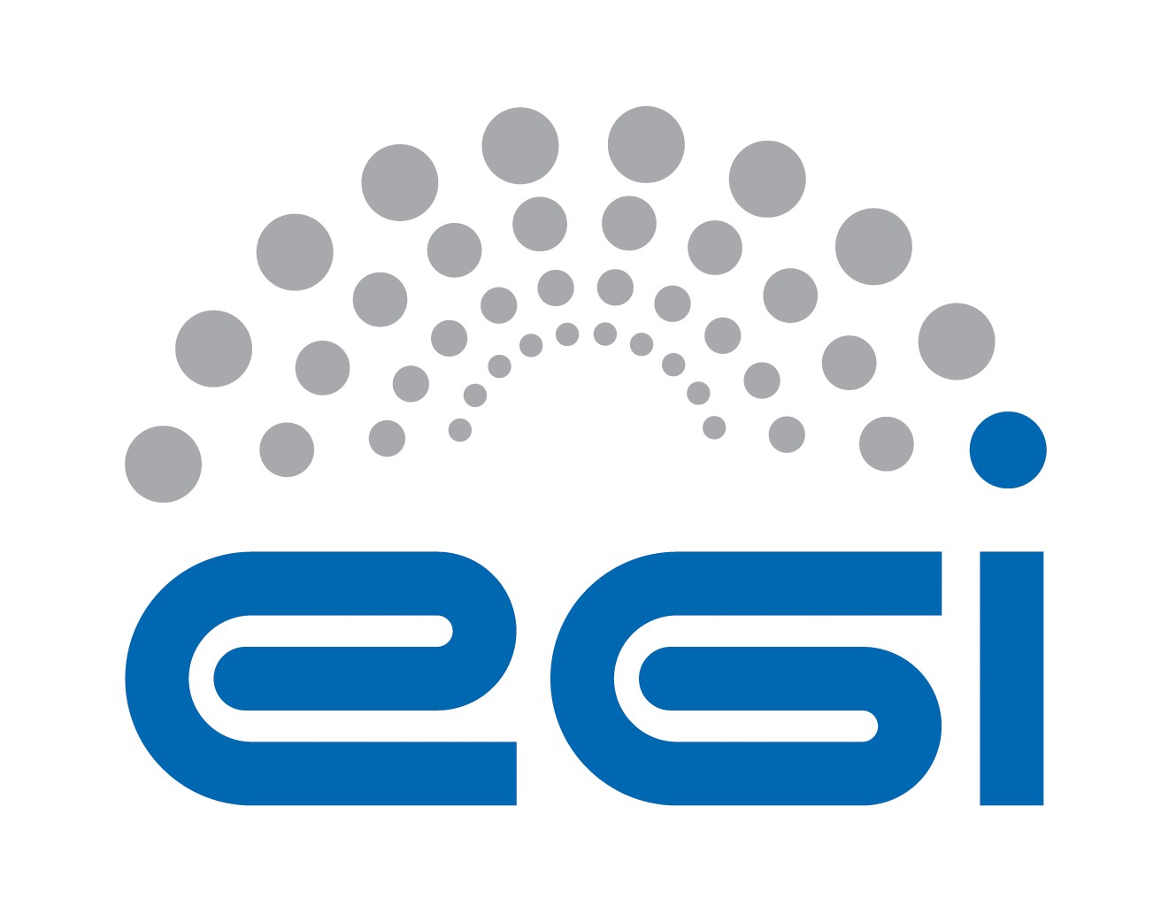
EGI.eu
OLA Performance Report

Title | EGI.eu OLA – ServiceRegistryGOCDB performance report
Provider | STFC
Service | ServiceRegistryGOCDB
Produced by | David Meredith  david.meredith@stfc.ac.uk  Site Operations Manager
Audience | EGI.eu Operations  operations@egi.eu
Purposeą | Report on performance of the service
Period | 01/11/2014 – 30/04/2015
Related agreements | EGI.eu-OLA- ServiceRegistryGOCDB -v1.doc
Document Link: | https://documents.egi.eu/document/2170
- Copyright notice
Copyright © EGI.eu. This work is licensed under the Creative Commons Attribution-NonCommercial-NoDerivs 3.0 Unported License. To view a copy of this license, visit http://creativecommons.org/licenses/by-nc/3.0/ or send a letter to Creative Commons, 171 Second Street, Suite 300, San Francisco, California, 94105, USA.
The work must be attributed by attaching the following reference to the copied elements: “Copyright © EGI.eu (www.egi.eu). Using this document in a way and/or for purposes not foreseen in the license, requires the prior written permission of the copyright holders. The information contained in this document represents the views of the copyright holders as of the date such views are published.

This report is based on a template that forms part of the FitSM family – a lightweight standard for IT Service Management that supports federated infrastructures. For more information on FitSM visit www.fitsm.eu or contact info@fitsm.eu. The template this document is based on was licensed with a Creative Commons Attribution 4.0 International License.

This report is based on FitSM Template: Report v0.2

TABLE OF CONTENTS
1 Effort 3
2 General overview of Activity in the period 3
3 Performance againSt Service Targets 3
4 Issues arising in the period 4
5 Measures planned 4
6 Foreseen activities and changes 4

Effort
3 PMs for Ops support.

General overview of Activity in the period
Mostly ok: All performance targets were achieved except for one GGUS Quality of Service violation (see section 3 for details). There were two production releases during the period; Version 5.3 introduced multiple endpoints per service and v5.3.1 introduced support for federated authentication and many smaller improvements [1].

[1] https://github.com/GOCDB/gocdb/blob/master/changeLog.txt

Performance againSt Service Targets
All performance targets were achieved except for one quality of service (QoS) violation during period M5 where the target is 1 day response time, and actual was 1.25 days.

The following table shows performance against targets:

Service level parameter | Target | M1 average | M2 average | M3 average | M4 average | M5 average | M6 average
Availability | 99 | 99.78 | 99.45 | 99.54 | 99.9 | 99.56 | 99.83
Reliability | 99 | 99.92 | 99.45 | 99.54 | 99.98 | 99.56 | 99.83
Support priority | Medium  Less ur: 5  Urgent: 5  V.ur: 1  Top: 1 | Less urgent  Urgent  Very urgent  Top priorty | 0.04  0.13  -  - | 0.45  0.55  -  - | 1.24  0.01  -  - | 0.79  -  -  1.25 | -  -  -  -

Issues arising in the period
- The single OLA violation was due to support staff unavailability - only a single member of GOCDB team was employed during the period (DM). See section 5 for mitigation measure.
- The federated identity login to GOCDB was disabled soon after its release due to concerns regarding the release of certificate DN attributes and level of assurance (e.g. is an x509 DN attribute released from the EGI IdP if a certificate has been revoked?). These concerns have been reported to EGI operations. It is suspected that EGI wide policy agreement may be needed to address this issue which is being looked at in the AAI TF.
- A bug was found with the popular third party SimpleSAMLPhp library [1] that prevents its deployment against the EGI IdP. A work around was found but this will not work when using the library with multiple IdPs that implement the SAML Single Logout Profile. It is possible that the SSPhp project may not even address this issue because the EGI IdP does not implement a common best practice to always return the NameID in the Subject of the response. This issue has been reported to EGI operations.
[1] https://github.com/simplesamlphp/simplesamlphp/issues/143

Measures planned
- Another support staff member has since started (from April) to share operational support (John Kewley).

Foreseen activities and changes
- There are no foreseen activities/changes that should directly affect this OLA.
- However, it is worth noting that a DB upgrade is planned, moving GOCDB to a newer Oracle release or to MySQL. While this should not require any changes to the OLA, there may be issues that are currently unforeseen. A plan is being put in place within STFC to test the data migration and DB upgrade.

