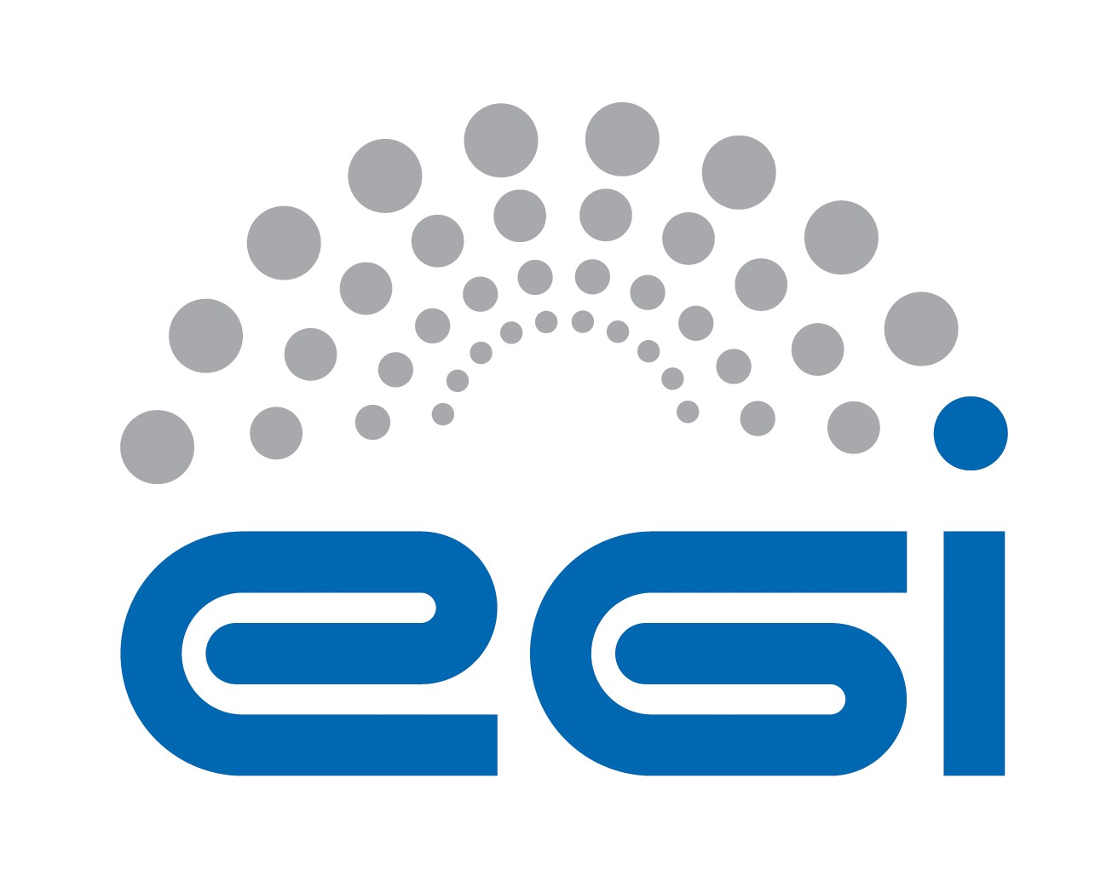
EGI.eu
OLA Performance Report

Title | EGI.eu OLA – SecurityCoordination performance report
Provider | STFC, FOM-Nikhef , CERN
Service | SecurityCoordination
Produced by | David Kelsey  david.kelsey@stfc.ac.uk  Security Team manager
Audience | EGI.eu Operations  operations@egi.eu
Purpose | Report on performance of the service
Period | 01/05/2015 – 31/10/2015
Related agreements | EGI.eu-OLA- SecurityCoordination -v1.doc
Document Link: | https://documents.egi.eu/document/xxxx
- Copyright notice
Copyright © EGI.eu. This work is licensed under the Creative Commons Attribution-NonCommercial-NoDerivs 3.0 Unported License. To view a copy of this license, visit http://creativecommons.org/licenses/by-nc/3.0/ or send a letter to Creative Commons, 171 Second Street, Suite 300, San Francisco, California, 94105, USA.
The work must be attributed by attaching the following reference to the copied elements: “Copyright © EGI.eu (www.egi.eu). Using this document in a way and/or for purposes not foreseen in the license, requires the prior written permission of the copyright holders. The information contained in this document represents the views of the copyright holders as of the date such views are published.

This report is based on a template that forms part of the FitSM family – a lightweight standard for IT Service Management that supports federated infrastructures. For more information on FitSM visit www.fitsm.eu or contact info@fitsm.eu. The template this document is based on was licensed with a Creative Commons Attribution 4.0 International License.

This report is based on FitSM Template: Report v0.2

TABLE OF CONTENTS
1 Effort 4
2 General overview of Activity in the period 4
3 Performance AGAINST Service Targets 5
4 Issues arising in the period 5
5 Measures planned 6
6 Foreseen activities and changes 6

Effort

The effort spent by each partner during the 6 months was:
FOM-Nikhef 3.5 PM
CERN 2.5 PM
STFC 4.0 PM
TOTAL 10.0 PM

CERN took over the leadership of IRTF from SNIC.

General overview of Activity in the period
The Security Coordination function performed well during yet another busy 6-month period for operational security. Central Security coordination activities were carried out as expected, including regular weekly/monthly/face to face meetings and presentations at major events.
The main operational activities of the CSIRT had as ever to be given priority, namely the Incident Response Coordination (IRTF) and the Software Vulnerability Group (SVG) Coordination.
IRTF handled three new security incidents ("Metacloud", EGI-20150611-01 (Elasticsearch), EGI-20150925 (IHEP)) involving 5 sites plus 4 academic campuses (non EGI or uncertified sites). IRTF also handled 137 vulnerability cases, mostly due to CVE-2015-3245 (libuser: 103 cases) leading to 3 sites being suspended. Two sites were suspended for other reasons: no security contact & no proper certification. The EGI-CSIRT Critical Vulnerability Handling procedure was rewritten (from EGI document to wiki/SEC03) and approved.
SVG handled 22 new vulnerabilities and issued 16 advisories, 13 from SVG and 3 from the CSIRT. From now on all advisories will be on the SVG wiki. Three of the advisories were assessed as “Critical” risk (VENOM, RH root vulnerability, Xen VM breakout) and 4 were “High”. The SVG procedure has been revised and approved, see https://documents.egi.eu/secure/ShowDocument?docid=2538

Policy coordination continued in collaboration with AARC and IGTF on Federated Identity Management and with EGI-Engage on policy evolution. The work on new and revised security policies in collaboration with EGI-Engage included a new AUP, a revised VM Endorsement policy, a scoped policy for the Long Tail of Science and work on a new Data Protection Policy (this one also with WLCG). Work has also started on investigating and understanding operational issues related to the use of IPv6, in collaboration with the HEPiX IPv6 working group, with the aim of producing guidance documentation on best practices.

For the trust fabric maintenance, the monthly updates were distributed in this period according to the regular update process. The trust fabric and associated policies continue to evolve. The EGI security coordination works through the IGTF in expressing the EGI trust requirements in a technology-agnostic way working towards policy alignment and coordination with other R&E federated identity infrastructures globally.

A number of security sessions, including security training, were delivered at the EGI Conference in Lisbon and plans were made for the Bari Community Forum for November.

Work on evolving our security operations for Clouds continued both at the Lisbon EGI Conference and through discussions/meetings with the EGI Federated Cloud team in collaboration with EGI-Engage.

A very successful 1st security workshop (called “WISE”) was planned, organised and held in Barcelona in October. This was a joint workshop between two main communities; SCI involving EGI, PRACE, EUDAT and the Human Brain Project together with the GEANT SIG-ISM group consisting mainly of senior members of the NREN security teams. This workshop explored areas of common interest, particularly in operations, standards and best practices. This concluded that there were many areas where future collaboration will indeed be useful. Some working groups will start soon together with a second WISE meeting in one year’s time.

Performance AGAINST Service Targets
The Security Coordination function was fully available during normal office hours (and in many cases also outside of these hours).

Response times to GGUS tickets assigned to “EGI/Security Management” are shown in the table below. We wish to stress again (as ever!) that evaluating the Security team on the basis of this small number of tickets is completely false as all of our work is recorded on large numbers of much more important tickets in EGI RT-IR.

The GGUS tickets amount to a total of just 4 tickets in 6 months. All of these were handled well within the time limits. In the same 6-month period a total of 381 tickets in EGI RT-IR were handled by the EGI CSIRT. There were 218 new tickets and 163 older tickets which were updated during the 6 months. These related mainly to the operational handling and tracking of security incidents and vulnerabilities and form the bulk of the high-priority operational activities of the security coordination activity.

The following table shows GGUS performance against targets:

Service level parameter | Target | M1 average | M2 average | M3 average | M4 average | M5 average | M6 average
Availability
Reliability
Support priority | Medium
Response time to GGUS tickets |  | 1.73 wd  (1 ticket – less urgent) | 1.94 wd  (1 ticket – less urgent) | 0.24 wd  (1 ticket – less urgent) | Nothing | - wd  (1 ticket – very urgent) | Nothing

Issues arising in the period

We continue to be short of NGI effort in all security teams, i.e. IRTF, SVG and SPG. We will continue to give priority to handling critical urgent issues to keep services available and secure wherever possible.

The software we are using for tracking incident (RT/RT-IR) is old and vulnerable, leading to poor user experience, especially for statistical analysis.

Issues in the security monitoring: identified several false positive/negative (when managing CVE-2015-3245), data missing from the Security Dashboard (e.g. which Worker Node). This lead to the system being simply unusable, forcing each security officer on duty to manually verify each result.

Poor practices from some in the Fedcloud service: poor incident reporting (we had to specifically ask to discover some incidents), no reaction to site broadcast, etc.

Measures planned

A new/updated security risk assessment is being carried out in collaboration with EGI-Engage. This will help identify areas where future work is required.

An update of the incident tracking software (RT/RT-IR) has been planed by the service provider.

Several bugs in the security monitoring have been fixed, still waiting for a better Security Dashboard integration.

Discussions to improve matters with the FedCloud service are underway, again in collaboration with EGI-Engage. A security challenge is very desirable.

Foreseen activities and changes

All of the activities will continue as before with the coordination of incident response and monitoring/handling vulnerabilities our top priority.

We will rewrite the EGI CSIRT Security Incident Handling Procedure (->SEC01), extend SEC03 with "Vulnerability affecting Virtual Appliances" and extend SEC01 with user-managed VMs.

