
EGI-Engage

Report on the evolution of the EGI Operations Infrastructure
D5.1

Date | 19 February 2016
Activity | SA1
Lead Partner | EGI.eu
Document Status | DRAFT
Document Link | https://documents.egi.eu/document/2670

Abstract

This documents presents the status of the EGI Operations infrastructure at the end of the first year of EGI-Engage, and reports on the improvements and evolution of services and processes that has been implemented during the first reporting period. This deliverable gives an overview of the deployed services that are provided to users and members of the federation, the amount of resources available, trends, and the activities that support service provisioning across the EGI federation.
The roadmap for evolving the current set of services is presented as well with links to other EGI-engage work packages.

COPYRIGHT NOTICE

This work by Parties of the EGI-Engage Consortium is licensed under a Creative Commons Attribution 4.0 International License (http://creativecommons.org/licenses/by/4.0/). The EGI-Engage project is co-funded by the European Union Horizon 2020 programme under grant number 654142.
DELIVERY SLIP
 | Name | Partner/Activity | Date
From:
Moderated by:
Reviewed by | Tiziana Ferrari | EGI.eu/NA1 | 26-02-2016
Approved by: | AMB and PMB

DOCUMENT LOG
Issue | Date | Comment | Author/Partner
v.1
...
...
v.n

TERMINOLOGY
A complete project glossary is provided at the following page: http://www.egi.eu/about/glossary/

Contents
1 Introduction Error! Bookmark not defined.
2 The EGI Production infrastructure Error! Bookmark not defined.
2.1 Resources distribution and available capacity Error! Bookmark not defined.
2.2 The HTC services Error! Bookmark not defined.
2.3 The Cloud services Error! Bookmark not defined.
2.4 Capacity consumption Error! Bookmark not defined.
2.5 Service level availability performances Error! Bookmark not defined.
3 Evolution in the operational coordination 5
3.1 Evolution of the operational procedures and processes 50
3.2 The EGI core activities 52
3.3 The UMD software provisioning 58
4 The evolution of the security operations 50
4.1 Security policies 70
4.2 Security procedures 72
4.3 Security risks assessment 73
5 Roadmap for the EGI production infrastructure 74
6 Figures and captions Error! Bookmark not defined.
6.1 Pictures Error! Bookmark not defined.
6.2 Tables Error! Bookmark not defined.
Appendix I. Appendix example Error! Bookmark not defined.

Executive summary
EGI is a publicly funded e-infrastructure put together to give scientists access to more than 650,000 logical CPUs, 500 PB of online and near-line storage capacity to drive research and innovation in Europe. The infrastructure provides both high throughput computing and cloud compute/storage capabilities by federating advanced computing services provided and funded at national level and by international research organizations, namely EMBL-EBI and CERN. Two are the main technical platforms that support research virtual research environments: a federated cloud platform offering storage and compute IaaS services and a high-throughput data processing and analysis platform for data-intensive applications. EGI is the largest research advanced computing infrastructure for research worldwide in terms of geographical research and amount of aggregated storage and computing offered.
The EGI infrastructure is constantly evolving, both in terms of services provided and service management processes and tools for federated IT service management across the federation.
Both the available resources (+23%) and the aggregate usage of the capacity (+20%) have considerably increased during 2015.

The overall quality of the service provided by EGI is good, availability and reliability are in line with the previous years. The central services supporting the federation have been provided with no deviations, also considering the very high quality targets defined for these core tools.
List the main achievements here [ develop them as text, not bullet point list narrative ]
- advanced set of security policies
- security risk threat assessment
- adapted procedures for the EGI federated cloud
- new set of AAI services under piloting
- start of implementation of IT service management system based on FitSM
- revised service catalogue
- establishment of SLAs with user communities and new SLA negotiation procedures
- growing international landscape of interoperable e-Infrastructures with MoU with Compute Canada
For the first time EGI has broken the wall of 650,000 federated logical cores and exceeded the average computational workload of 1.6 Mjobs/day.
The EGI production infrastructure roadmap is moving along several paths. The first is strengthening the existing production services, enhancing the user experience in particular for the relatively new services of the federated cloud. While the individual cloud providers are often solid, the federation layer is still fragile, and this is causing a non uniform use experience for the cloud users. The production services need to evolve, with more reliable and consistent federation capabilities that can ensure high productivity for the users and low overhead for the service providers.
The services offered will be extended through EGI-Engage and the collaboration with other projects and with the EGI Marketplace with inputs from the user communities and other service providers. EGI will ensure the quality of the service provided, integrating these services with the operations framework.

The EGI Infrastructure
Being the EGI an international federation of data centres, multiple distributed resource and service providers contribute to the delivery of services. These can be either aimed at providing capabilities for the end-users, or to enable the federation of national infrastructures (NGIs) and ICT infrastructures operated by CERN and EMBL-EBI (European Research Infrastructure Organizations – EIROs). EGI federates individual capabilities while fully delegating the operations and policies for service access to the individual providers. By doing so, EGI leverages the specializations and competencies of EGI partners and opens up capabilities otherwise accessible just to local research communities. By doing so, international research collaborations and projects supported by multiple countries, find in EGI a natural environment where advanced computing capabilities are accessible to the entire collaboration, and in-house private infrastructures and services – where available - can be federated to join EGI at the same time and shared with other research communities where applicable.
Capital and operational expenditures for the delivery of EGI services are completely funded by the EGI participants. EGI-Engage contributes to fund the coordinated operations of the federation, so that a minimum set of interoperable service management processes and tools are maintained, innovated and operated. This ensures that national e-Infrastructures can be “interconnected” and transformed into a single international research system: the largest distributed computing infrastructure in the world for research that is open for access to any researcher in the world.
The high-performance analysis platform started its operations in 2004, while the federated cloud platform went into go-to-market stage in May 2014.

EGI Service Portfolio
The first edition of the EGI service portfolio was developed during 2013 to improve service orientation and clarify the unique offering that current and potential beneficiaries can request. This first version focused mainly on services internal to EGI as essential to enable the federation to work together and serve international research communities. This work was initiated in the context of improving the maturity in managing services by developing and implementing best practices for ensuring clarity of service offering and warranties and meeting the expectations of beneficiaries.
Following the improved maturity in designing and delivering services, the EGI service portfolio now covers both services that are internal to the EGI and services that EGI collectively delivers to the beneficiaries (researchers and SMEs/Industries).
In July 2015, EGI.eu has established the Services and Solutions Board (SSB) as a new body responsible for managing the portfolio of services and solutions regarding EGI.eu and the EGI federated services, ensuring transparency across functions, and advising the EGI Council. Following the creation of the SSB, the group has worked extensively to implement the service portfolio process (SPT) from FitSM, to define the templates and to update the EGI service portfolio. According to the established practice, each service is described in a Service Design and Transition Package (SDTP) document composed of the following sections: value proposition, the business case, the service design, and the service transition plan. The expected impact of this activity includes:

The improvement of service orientation

The improvement of capabilities to promote EGI services and their value
- The improvement of management of services
- The alignment with the EGI strategy
- The management interoperability in federated environments
- A better understanding of all the components, dependencies and processes behind service delivery

EGI Service Portfolio
The following table presents a summary view of the proposed update to the EGI service portfolio. For each document, you can access individual SDTPs in [5].
Service Category | Service name | EGI federation | Research | SME/Industry
Compute  Aimed at individual researchers, or national and international research collaborations that want to run their data- and computing-intensive experiments. | Cloud Compute | √ | √ | √
 | Cloud Container Compute | √ | √ | √
 | High-Throughput Compute | √ | √ | √
Storage  Targeted at researchers and research communities that need to access digital resources on a flexible environment. | Object Storage | √ | √ | √
 | File Storage | √ | √ | √
 | Archive Storage | √ | √ | √
Data Management  Aimed to help individual researchers, and research communities that have large-scale data management and computational capacity requirements. | File Transfer | √ | √ | √
 | Content Distribution | √ | √ | √
 | Federated Data Manager | √ | √ | √
 | Metadata Catalogue | √ | √ | √
Software and Service Platform  Primarily aimed at Research Infrastructures and Resource Centers already within the European Grid Infrastructure EGI community or wishing to become part of it. It can also help other IT service providers that are geographically and/or structurally dispersed, and wish to organize themselves for federated service provision. | Configuration Database | √
 | Accounting | √
 | Service Monitoring | √
 | Helpdesk | √
 | Attribute Management | √
 | Identity Provider Proxy | √
 | Marketplace | √ | √ | √
 | Training Infrastructure | √ | √ | √
 | Training Marketplace | √
 | Validated Software and Repository | √
 | Operations Tools | √
 | Virtual Research Environments | √ | √ | √
 | Collaboration and Community Management Tools | √
 | Configuration Database | √
Coordination and Support  Primarily aimed at Research Infrastructures and Resource Centres already within the European Grid Infrastructure EGI community or wishing to become part of it. | Project Management and Planning | √
 | Operations Coordination and Support | √
 | Technical Coordination | √
 | Security Coordination | √
 | Community Coordination and Development | √
 | Strategy and Policy Development
 | ITSM Coordination | √
 | Communications and Promotion | √
Training and Certification  Targets any organization providing or supporting the delivery of IT services. | FitSM | √ | √ | √

The EGI services and solutions can be accessed through the following access policies:
- Policy-based: users are granted access based on policies defined by the EGI resource providers or by EGI.eu; such policies usually apply to resources being offered “free at point of use” to meet some national or EU level objective; for instance, a country may offer free at point of use resources to support national researchers involved in international collaborations.
- Wide access: users can freely access scientific data and digital services provided by EGI resource providers.
- Market-driven: users can negotiate a fee to access services either directly with EGI resource providers or indirectly with EGI.eu.
Services allowing access to rival resources (e.g. computing capacity or storage space) are usually provided under a policy-based or market-driven access policy. On the other hand, services allowing access to non-rival resources (e.g. software packages or scientific data) are usually provided under a wide access policy.
All access policies may not be available for each and every resource, service or scientific data set. Services and solutions are primarily intended for research purposes, but EGI is working on developing its business by tailoring existing services and developing new ones for the education sector and for the commercial exploitation.
From a service management point of view, EGI services are hosted by Resource Centres, the smallest resource administration domain in EGI. It can be either localised or geographically distributed. It provides a minimum set of local or remote IT Services compliant to well-defined IT capabilities necessary to make resources accessible to the users whose access is granted by exposing common interfaces to the users.

EGI Operations
The resource providers manage and operate (directly or indirectly) all the operational services required to an agreed level of quality as required by the Resource Centres and their user community. They are also responsible for the maintenance, coordination and integration of the resource centres that build their individual e-infrastructures. The Resource infrastructure Providers liaise locally with the Resource Centre Operations Managers, and represent the Resource Centres within EGI.
The EGI resource infrastructure providers are:
- Council-members resource providers: National Grid Initiatives (NGIs) and European Intergovernmental Research Organizations (EIROs), who are represented in the EGI Council and directly contribute to the sustainability of EGI.
- Integrated resource providers: International organizations who contribute resources and have a collaboration agreement with EGI through a Memorandum of Understanding:
  - Asia Pacific Region (including resources from Australia, China, India, Iran, Japan, Malaysia, New Zealand, Pakistan, Philippines, South Korea, Taiwan, Thailand, Vietnam)
  - "Africa Arabia" (including resources from South Africa, Egypt, Morocco, Tanzania, Kenya, Nigeria, Algeria, Senegal, Ethiopia, Tunisia, Ghana)
  - Ukrainian National Grid (UNG)
  - Latin America (including resources from Brazil, Chile, Mexico)
  - IHEP (China)
  - Canada
- Collaborating resource providers: Other international organization who have strong collaborations with EGI:
  - Open Science Grid (USA)
  - ComputeCanada
  - C-DAC (India)
The following map shows the international e-Infrastructure and the representative partners EGI is collaborating with.
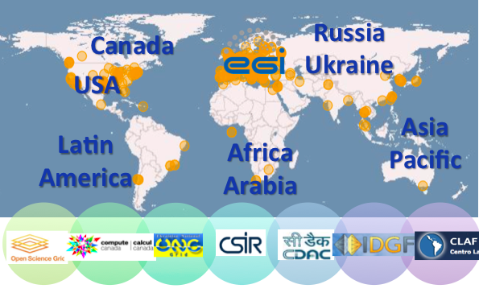
Figure 1. Map of EGI international collaborations. Dots in yellow correspond to the EGI resource centres in the federation.

Status
In February 2016 EGI comprises resources provided across 58 countries and 2 European Intergovernmental Research Institute (CERN and EMBL), of which 26 are EGI council members. From an operational point of view there is no difference between the integrated resources and the Resource Centres from the EGI council participants, all these receive the same level of support (this ensures the possibility to deliver professional services to third countries and developing ones). EGI Resource Centres, and must fulfil a minimum set of requirements and accept EGI policies and service management procedures.
The peer resource providers are infrastructures with which EGI has interoperations agreements, and common user communities, but do not share the EGI operational infrastructure.

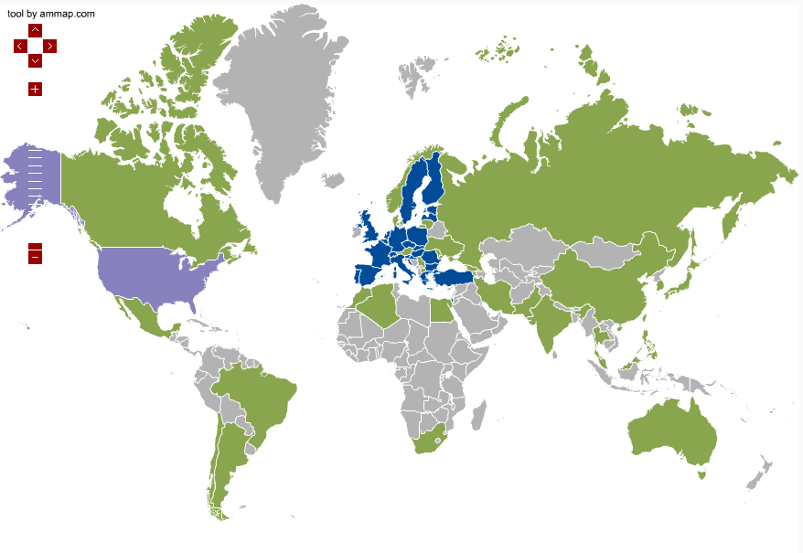
Figure 1 Worldwide presence of EGI Resource Centres: EGI council members in blue, integrated RPs in green, collaborating RP in purple
EGI operational procedures are being revised with the purpose of simplifying them and facilitating the integration of new resource providers while reducing the human effort for operating the national infrastructures.

Distribution of capacity
The EGI national participants – the NGIs – are organisations set up to manage the resources provided in their countries by the resource centres to the European Grid Infrastructure (EGI). They represent the country's single point of contact for EGI as well as to liaise with government, research communities and resource centres as regards ICT services for e-Science.
Each NGI operations are supported by an Operations Centre, defined as a centre offering operations services on behalf of the Resource infrastructure Provider [GLO], and it can serve multiple RPs. Examples of these services are supporting the sites in the certification process, deploying the monitor services at NGI level or information system, and liaise with EGI during the software upgrade campaigns.
EGI currently comprises 27 national operations centres and 7 federated operations centres encompassing multiple NGIs (Table 1). The federated centres in Europe NGI_IBERGRID, NGI_NL and NGI_IT, each containing two countries, are the result of a collaboration agreement that is expected to continue in the next PYs. In contrast, integrated federated centres in Asia Pacific and Latin America encompass a large number of countries, as in those regions Resource Centres are sparse and their number does not justify the overhead for the creation of a national operations centre, but suggests that an international collaboration is in place. The creation of new NGIs in those regions will depend on their expansion plans and on national policies.
In Table 1 shows the resource centres number per country and per operation centre.
Table 1 Number of certified Resource centres per NGI and per country
Operations Centre | Country (RCs Number) | Resource Centres
AfricaArabia | Algeria (1), Egypt (1), Morocco (2), South Africa (5) | 9
AsiaPacific | Australia (1), China (1), India (2), Iran (1), Japan (2), Malaysia (3), Pakistan (2), South Korea (4), Taiwan (6), Thailand (4) | 26
CERN | Switzerland | 1
IDGF | Hungary | 1
NGI_AEGIS | Serbia | 6
NGI_ARMGRID | Armenia | 1
NGI_BG | Bulgaria | 2
NGI_CH | Switzerland | 6
NGI_CHINA | China | 2
NGI_CZ | Czech Republic | 6
NGI_DE | Germany | 19
NGI_FI | Finland | 10
NGI_FRANCE | France | 17
NGI_GE | Georgia | 1
NGI_GRNET | Greece | 16
NGI_HR | Croatia | 4
NGI_HU | Hungary | 3
NGI_IBERGRID | Portugal (5), Spain (18) | 23
NGI_IL | Israel | 5
NGI_IT | Austria (2), Italy (45) | 47
NGI_MARGI | FYROM | 2
NGI_MD | Moldova | 2
NGI_NDGF | Denmark (1), Estonia (2), Finland (11), Latvia (2), Lithuania (1), Norway (1), Sweden (2) | 20
NGI_NL | Belgium (3), Netherlands (15) | 18
NGI_PL | Poland | 13
NGI_RO | Romania | 10
NGI_SI | Slovenia | 2
NGI_SK | Slovakia | 8
NGI_TR | Turkey | 3
NGI_UA | Ukraine | 15
NGI_UK | United Kingdom | 24
ROC_Canada | Canada | 8
ROC_LA | Brazil (3), Chile (3), Mexico (3) | 9
Russia | Russia | 9
Total OCs: 34 | Total Countries: 53 | Total RCs: 335

Table 2 Number of certified EGI Resource Centres (February 2016) compared to December 2014.
Resource Centres | Number of RCs (February 2016) | Number of RCs (December 2014)
From integrated Infrastructures (AfricaArabia, Canada, China, Latin America) | 46 | 42

As shown in Table 2, the total number of certified RCs in February 2016 amounts to 335, of which: 289 are contributed by European NGIs/EIROs that are Council members and 46 by integrated RPs namely in the following regions: Africa-Arabia, Canada, China and Latin America.
CERN is an EIRO that comprises a single resource centre.
Of the 289 RCs mentioned above, 26 are contributed by Asia Pacific NGIs.

In December 2014 the total number of certified RCs was 352: this decrease may be explained by the fact that the missing sites were RCs with a low amounts of resources, both in terms of hardware and personnel, and for them it was difficult maintaining a level of service in accordance to the EGI operational level agreement, so they have been suspended when the issues they are facing require more time to be solved, than it was allowed. Currently 39 RCs are in the status of suspended on GOCDB, some of them are already in the process of being re-certified. The suspension of a resource centre is needed to ensure that the services that users expect to be production ensure the level of quality required to be used productively.
We usually distinguish between two categories of services: HTC and Cloud. There are also some RCs that provide both categories of service, so they are counted in both of them (Table 3).
In the following sections they will be analysed separately.
Table 3 Number of HTC Resource Centres and Cloud providers (February 2016)
Number of HTC resource centres | 314
Number of cloud providers | 21
Number of mixed HTC/cloud providers (also included in the totals above) | 7

High Throughput Computing
The HTC services offered by a resource centre can be grouped in two categories:
- Grid compute: allows users to run computational tasks on high quality IT resources, accessible via a standard interface and supporting authentication/authorization based on a membership within a virtual organization.
- Grid storage: allows files to be stored in and retrieved from high quality IT resources, accessible via a standard interface and supporting authentication/authorization based on a membership within a virtual organization.

According to the OLA [RCOLA], each site may provide one or both of this kind of services.
The HTC compute platforms supported in EGI are: ARC, CREAM, UNICORE and GLOBUS.
Since the UNICORE and GLOBUS resources are not published in the information system, for them we can provide only the number of the certified instances registered in the GOC-DB.

The total grid compute capability is shown in the Table 4.

Table 4 EGI grid compute capacity (February 2016)
 | Logical cores | HEP-SPEC 06
2014 (December) | 527248 | 4211709,28
2016 (February) | 651748 | 5841854,648
Yearly increase | 23.61% | 38,71%

At the end of 2014 the total amount of logical cores was 433,957, so the relative increase exceeds 23%. This is in-line with the trends of the last years, as shown in the following graph.
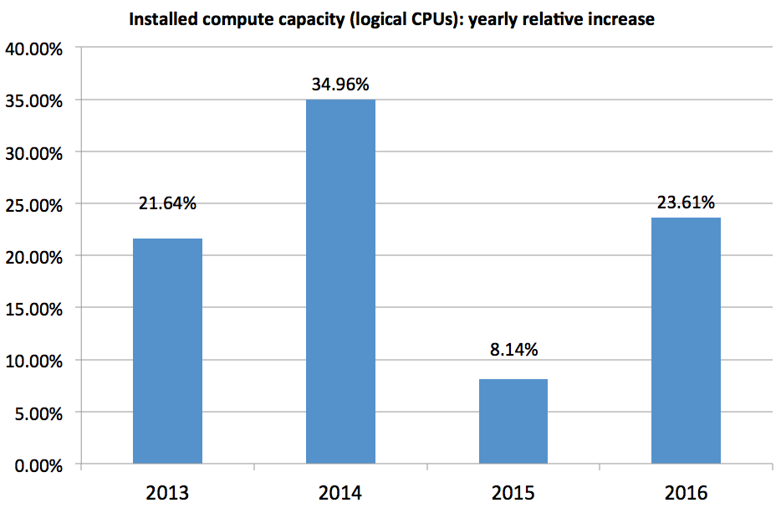
Figure 2. Yearly relative increase of the number of installed logical CPUs in the EGI HTC platform (2013-2016). As shown in this diagram, the yearly increase is very variable, however, in 2016 the relative increase shows a significant increase when compared to 2015, as is in-line with the figures recorded in 2013 and 2014.
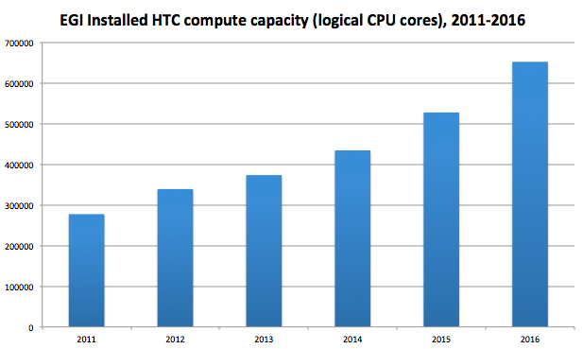
Figure 3. In 2016 the installed capacity of EGI (High Throughput Computing platform) broke the wall of 650,000 installed logical CPU cores
Nevertheless the total number of RCs is slightly decreased (Table 2), the certified ones grew in size in terms of resources, increasing the total capacity of the infrastructure. As shown in Figure 31, where the logical cores and Hep-spec06 power distribution is shown in as well.

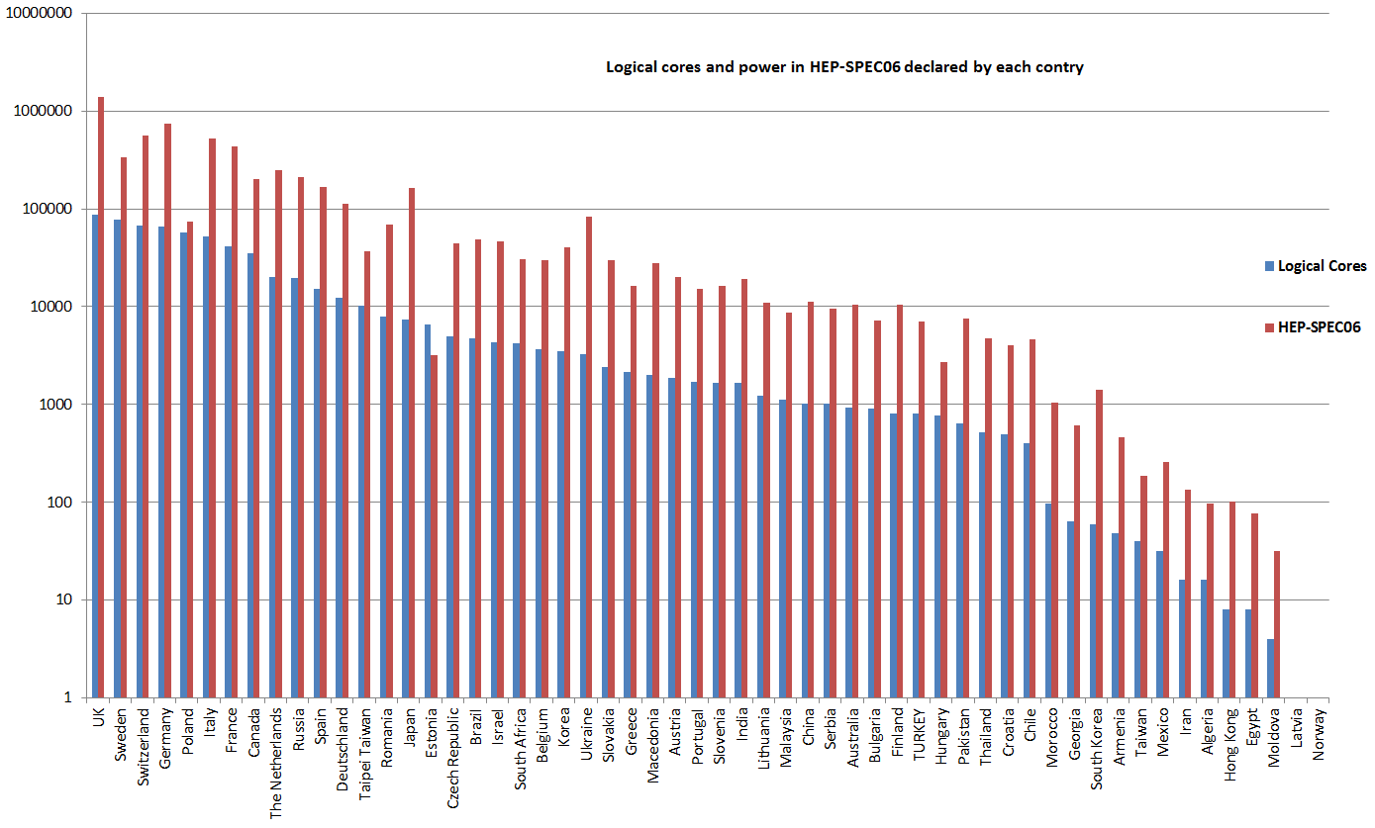
Figure 4, Logical cores and hep-spec power provided by each country.

Figure 42 shows the distribution of computing element types across the NGIs.

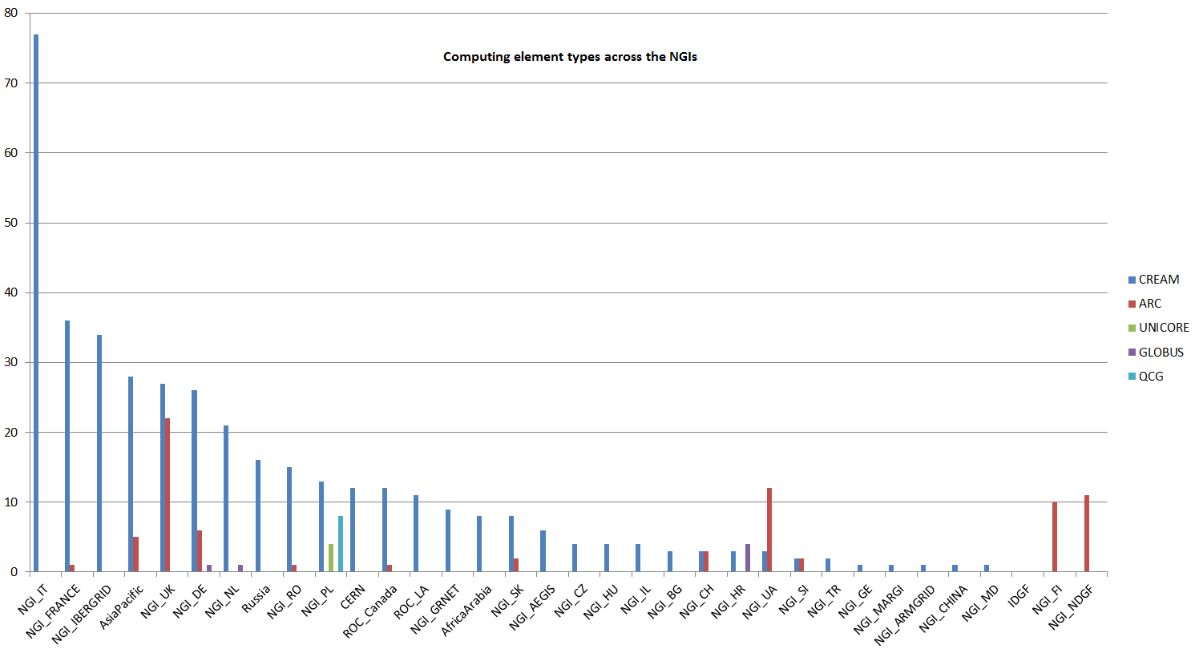
Figure 5 Computing Elements distribution across the NGIs grouped by type of interface (CREAM, ARC, UNICORE Globus and QCG)

The EGI infrastructure provides also compute resources for parallel jobs. The number of resource centres that support parallel computing via MPI jobs are 54 as results in February 2016 (Error! Reference source not found.), or rather 67 computing elements in total. In 2014 there were 76 RCs supporting MPI: as explained above, MPI compting was concentrated on a fewer larger Resource Centres, and the overall capacity offered considerably increased.
Information about MPI capabilities is not only published by services via the Information Discovery Service, but they are also registered into the EGI service registration facility GOCDB. A more accurate mechanism to estimate the MPI support in the infrastructure is available. In addition, during 2015 a new accounting publisher was deployed that is capable of reporting accounting information of multi-core jobs where computation is parallelized by running concurrent threads on different cores. As accounting records are accumulated over time, MPI accounting capability will be a more accurate indicator of the amount of parallel computing workload supported by EGI; this type of new accounting has been adopted by an increasing number of Resource Centres during 2015..

Figure 6 Number of EGI RCs supporting MPI jobs (February 2016, source: GOC-DB)

Three main data management products are available in EGI to provide access to geographically distributed data: DPM, dCache and STORM.
The total amount of storage certified service end-points is 313, which corresponds to a total disk capacity of about 311.7 PB. In April 2014 the total disk capacity reported was 250 PB, so it increased by 24.68%. Instead the total tape capacity (also called nearline storage), which is mainly provided by CERN and WLCG Tier-1 RCs amounts to 239.8 PB. In April 2014 the corresponding value was 168.8 PB, so the increase was 42.06%.
The distribution of disk storage resources among the EGI operations centres is shown in Error! Reference source not found., which shows that the disk capacity is concentrated across five NGIs: NGI_IT, NGI_UK, NGI_DE, NGI_IBERGRID and the Asia-Pacific region in descending order.

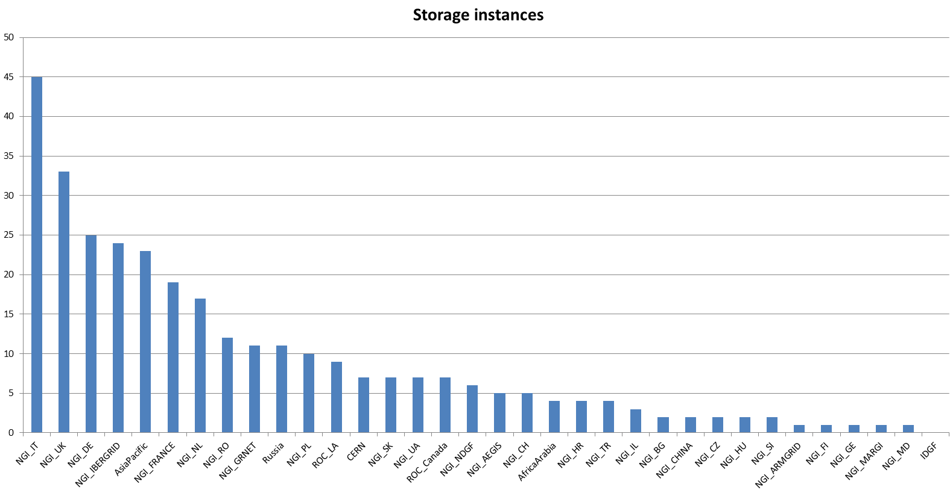
Figure 7 certified storage elements across the NGIs (February 2016, source: GOC-DB)

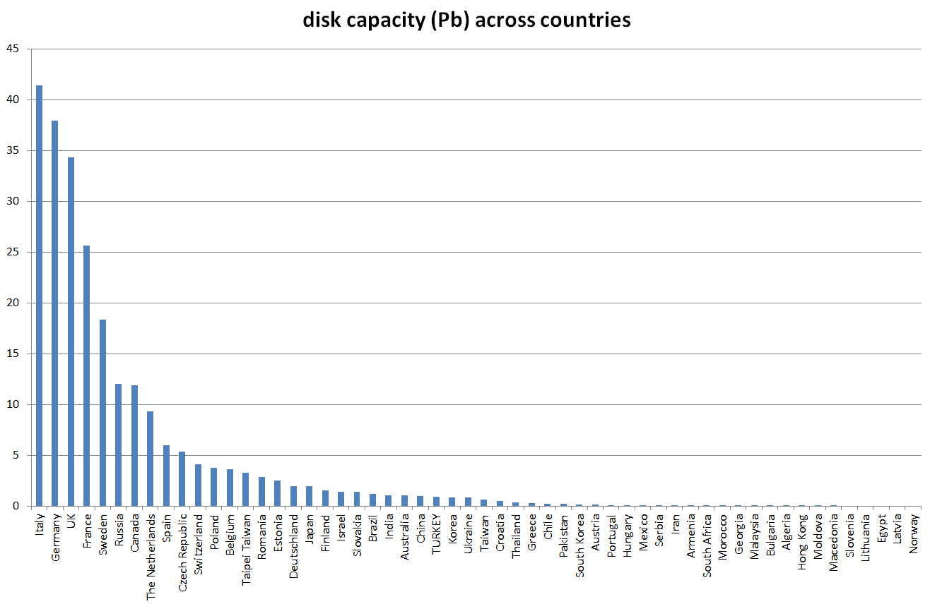

Figure 8.
Disk capacity distribution across the NGIs (source: GSTAT)

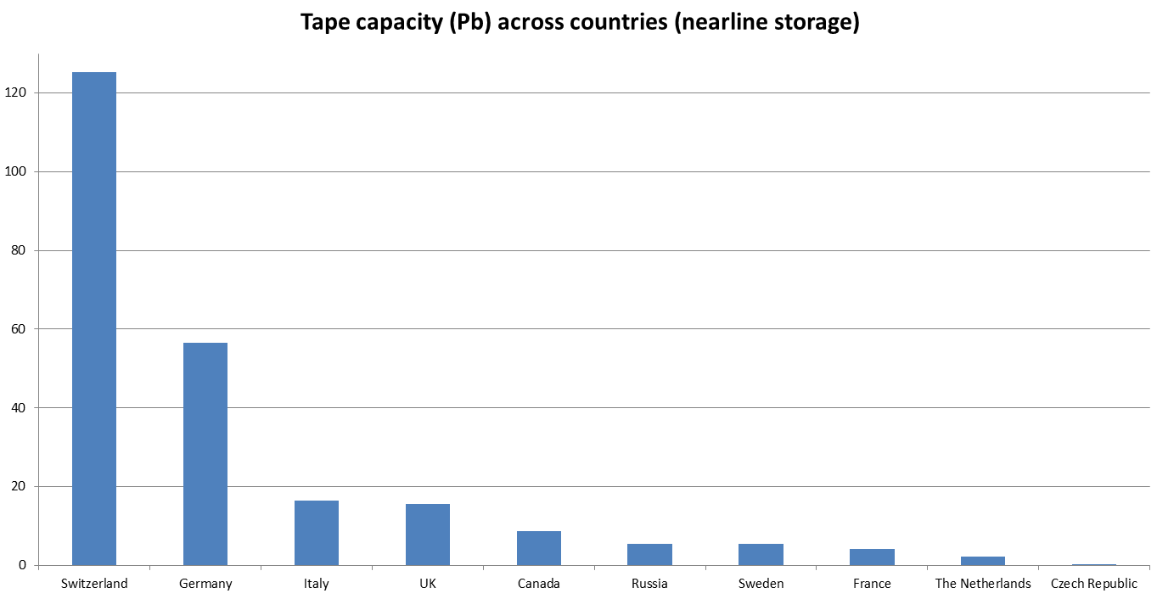
Figure 9 Tape capacity (online storage) distribution in PB across the NGIs and CERN (Switzerland region) (source: GSTAT)

Cloud services
The EGI Federated Cloud is part of EGI production infrastructure, a seamless grid of academic private clouds and virtualised resources, built around open standards and focusing on the requirements of the scientific community. It is in production since mid May 2014.
The Federated Cloud is targeted at researchers and research communities that need to access digital resources on a flexible environment, using common standards to support their data- and computing intensive experiments.

Cloud federation model
The impact of cloud computing on science, scientific development and education is undoubtedly increasing. Researchers and research institutes, projects, communities turn to clouds more and more often when they need a platform to store, share, process or archive large research data in a reliable and user-friendly way. The number of cloud services and service providers who target specifically the research and educational sectors is growing. OpenStack is becoming the de-facto standard for building both private and public clouds for this domain. Current trends indicate that in the future research communities will demand capabilities to federate services from multiple providers in order to support complex, community-specific, cross-institutional or international use cases.
Given it’s long-running experience in federating IT services for research and education, EGI is ideally positioned to be a key player in the federated cloud computing landscape and specialise on building federated clouds for research and educational use cases.
The EGI Federated Cloud collaboration includes technology providers, resource/cloud providers, user support and system administration personnel from various communities, including the EGI community itself. The collaboration members:
- Identify and integrate open source tools and services that enable cloud federations for research and education.
- Develop and maintain of tools and services to fill gaps in third party solutions to reach production quality cloud federations.
- Provide consultation and training for communities on how to build a federated cloud to meet custom community demands under certain constraints.
- Provide training and support for existing and potential users of cloud federations about topics, such as how to port or develop cloud-based applications; how to operate services in the cloud, how to join a cloud federation with a service.
- Facilitate the reuse of cloud federation tools and services across participating cloud federations to lower total cost of development and to improve cloud sustainability.
- Promote Platform as a Service (PaaS) and Software as a Service (SaaS) environments that are proven to be robust and reusable across communities to interact with federated IaaS clouds.
- Provide service management and security oversight for participating clouds and cloud federations.
- Act as a discussion forum where cloud federations can be discussed and specific questions can be analysed with top-world experts.
- Organise dissemination and marketing events, workshops and conferences relating to the topics of the collaboration.
Joining the EGI Federated Cloud collaboration can bring various benefits:
- Participate in the review and selection of tools and technologies that enable cloud federations for research and education.
- Participate in software development and integration projects that build solutions for cloud federations.
- Become or act as an advisor towards scientific communities about building federated clouds.
- Became or act as a trainer and consultant of users who want to use federated clouds offered by members of the collaboration.
- Offer technological solutions (IaaS, PaaS, SaaS) that can be used in various federated clouds to satisfy demands in the research and education sectors.
- Become a service management and/or security expert specialised on clouds and cloud federations and contribute to the work of the security and operational oversight group.
- Promote community-specific, but reusable federation solutions and approaches to other communities within and beyond the EGI collaboration.
Federating clouds
A cloud federation is an interconnected cloud environment between two or more service providers. Such setups are typically motivated by:
- Distributed capacities or capabilities: A single cloud provider cannot provide all the capacity or all types of cloud services that the community requires. Cloud bursting is a typical example for such a setup.
- Restrictive data policies: Certain policies may restrict for an institute or for a community as a whole to move data from its current location. Data providers must therefore have to become cloud providers to allow users to send processing algorithms to the data - in the form of virtual machine images.
- ‘Too large’ data sets: Certain datasets may be too large to move from their existing locations. Data providers must therefore become cloud providers and allow users to send processing algorithms to the data.
- Distributed investments: A community may decide to build cloud services (or purchase cloud services) at multiple sites - for example to stimulate local economies.
- Distributed expertise: A community may decide to procure from multiple cloud providers to create knowledge hubs at multiple locations.
Scientific communities can have different motivations for building/using federated clouds. They can be at different stage in implementing a federated cloud, moreover they may be already committed to certain technological solutions that need to be incorporated into their cloud federation. One federation approach cannot fit all, therefore the EGI Federated Cloud collaboration needs to provide ad-hoc solutions for building cloud federations.
Services in a federated cloud
What makes a cloud federation? Cloud services - IaaS, PaaS or SaaS - are a necessity. But besides this, there is also the need for services that interconnect these cloud environements. Despite the large diversity in the type of cloud federations, a relatively small number of building blocks (or federator services) can be identified in almost all of them. Federation models can be loose of tightly coupled depending on the number of common requirements the members of the federation need to comply to. The table below shows how different cloud infrastructures can be federated through EGI services.
Table 1. EGI services for the implementation of a cloud federation.
Federator service | Capabilities offered to the federation | EGI product
Service registry | Having a registry where all the federated cloud sites and services are registered and state their capabilities. The registry often provides the ‘big picture view’ about the federation for both human users and online services (such as service monitors). | GOCDB
Information system | Having a database (often with a web interface) that provides real-time view about the actual capabilities and load of federation participants. The information system can be used by both human users and online services. | BDII
Virtual Machine image catalogue | Having a catalogue of Virtual Machine images (VMIs) that are usable by the IaaS cloud providers and encapsulate those software configurations that are useful and relevant for the given community (typically, pre-configured scientific models and algorithms). To maximise usability of VMIs across cloud sites the images should be in a format that’s supported at every federation member site (or at least that can be converted to such formats) | AppDB
Image replication mechanism | Having a system that automatically replicates VMIs from the VMI catalogue to the federation member sites, as well as removes them when needed. Automated replication can ensure consistency of capabilities across providers and is very often coupled with a VMI vetting process to ensure that only properly working, and relevant VMIs are replicated to the cloud sites of the community. | VMCaster, VMCatcher
Single sign-on for users | Allow users of the federated services to register for access only once while accessing distributed trusted services. Single sign-on is increasingly implemented in the form of identity federations in both industry and academia. | X509 Certificates from IDGF and PERUN
Integrated view about resource/service usage | Complete usage (accounting) reports from the federated providers, integrating information and presenting it in such a way that both individual users as well as whole communities can monitor their own resource/service usage across the whole federation. | APEL accounting system and portal
Integrated interfaces or user environments | Having interfaces through which users and user applications can interact with the services offered by the various cloud providers. In case of an IaaS cloud federation these interfaces offer compute, storage and network management capabilities. The interfaces can be harmonised across all participating cloud providers - in which case the providers are responsible for implementing the agreed standard - or can be native at the different sites. In this latter case centrally maintained user environment or portals can hide heterogeneity from the users and can translate user requests to diverse native formats. | OCCI API and rOCCI client
Integrated helpdesk and user support | Having a helpdesk and user support process that offers a single point of entry for users and ensures issue resolution on a timely manner despite the distributed, federated landscape. | GGUS with national and topical support teams
Offloading excess workloads
Shared operational practices | The participating service/resource providers may share certain operational tools and practices at the level of the federation, for example use a shared system to collect availability and reliability statistics about their site, or to share and respond to security alerts. | ARGO monitoring system;  EGI Operation teams at national and site levels

The EGI Federated Cloud model
The EGI Cloud federation is an hybrid cloud composed by public, community and private clouds, all supported by a the EGI Core Infrastructure Platform (AAI, Service Registry, Accounting, Monitoring and Federated Service Management). The EGI Federated Cloud is composed by multiple “realms”, each realm having homogeneous cloud management interfaces and capabilities. A Community Platform provides community-specific data, tools and applications and can be supported by one or more realms.
EGI Cloud Federation: hybrid cloud (private, community, public).
EGI Cloud Realm: subset of cloud providers exposing homogeneous cloud management interfaces and capabilities. The Open Standards Cloud Realm supports OCCI and CDMI.
Community Platform: set of community-specific data, tools, applications, and brokering tools, which can be supported by one or more realms of the federation.

PLATFORM ARCHITECTURE (EGI Core Infrastructure Platform, Cloud Realms and Community Platforms)
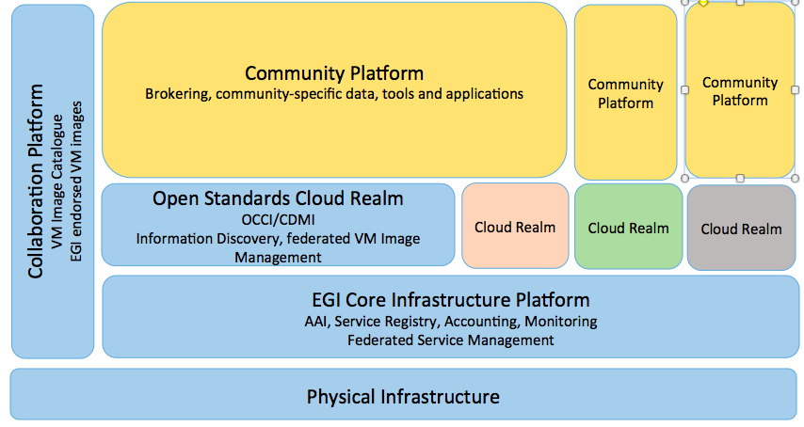
Figure 10. EGI platform architecture showing how the relationship between the core infrastructure providing the federation services, the cloud realms and the community platforms that can be hosted by cloud providers.
The EGI Cloud Federation offers different types of realm federation model, the requirements on the cloud providers vary depending on the type of model of choice (see following table).

Table 2. Requirements for cloud providers in order to be part of the EGI Federated Cloud. Various federation models apply depending on the model of choice.
EGI Cloud Federation requirements for cloud providers
Requirements | EGI Cloud Realms |  | Peer Realms
Requirements | Open Standards Realm | Other Realms | Peer Realms
EGI AAI compliance | yes | yes | yes
EGI federated service management (processes, activities and policies) adoption | yes | yes | yes
Service registry | yes | yes | optional
Accounting | yes | yes | optional
Monitoring | yes | yes | optional
Information discovery | yes | optional | optional
IaaS open standards compliance - OCCI, CDMI | yes | optional | optional
VM image catalogue | optional | optional | optional
federated VM image management | yes | optional | optional
CMW native interfaces | optional | optional | optional
EGI endorsed VM images | optional | optional | optional

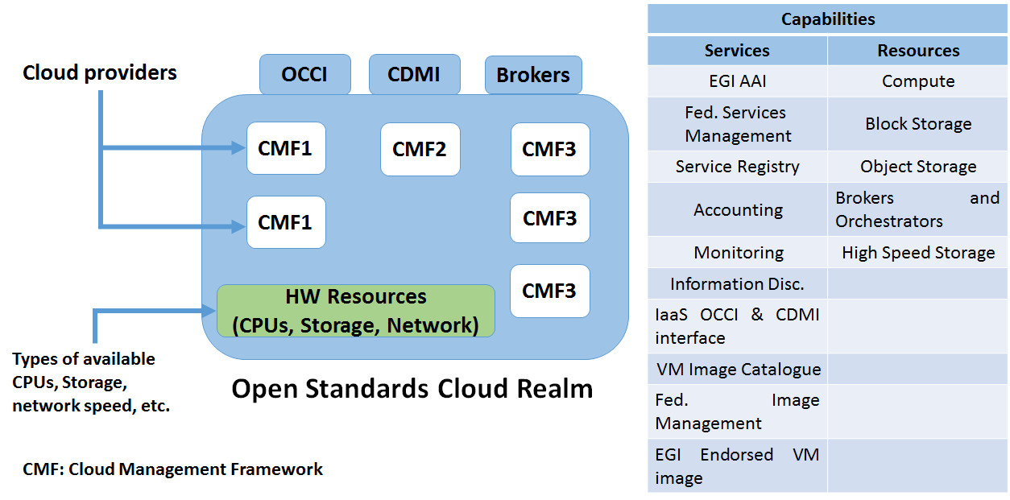
Figure 11. Requirements and configuration model of a cloud provider contributing the Open Standards cloud realm. In order to be part of this federation, the OCCI and CDMI open standard interfaces need to be exposed to ensure full portability.
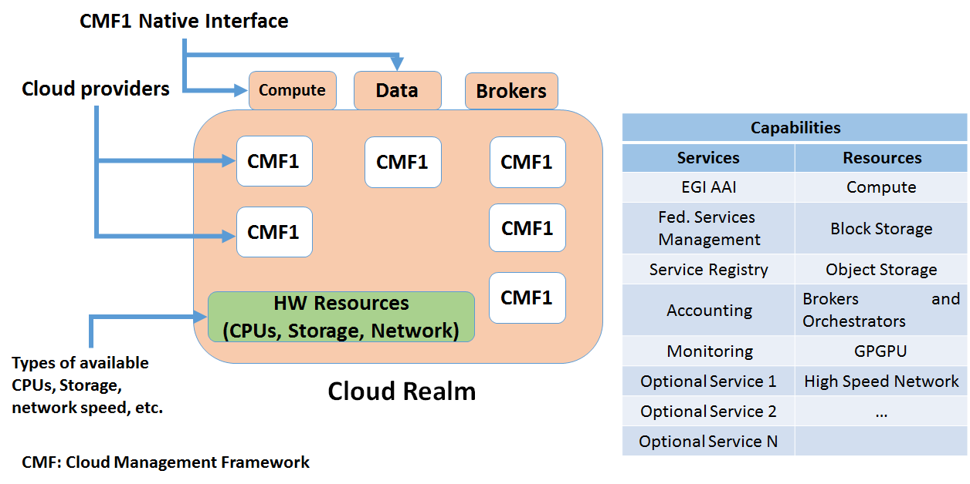
Figure 12. Requirements for a cloud provider joining a cloud realm of choice. In this case users interact via CMF native interfaces, so that portability is only ensured within the realm.

Cloud Infrastructure
Several resource centres joined to the Federated Cloud since its beginning: at the end of PY1 (beginning of February 2016) 21 RCs are part of the cloud infrastructure (Table 5) and other providers, once undergone to the certification procedure, are expected to join in (Table 6). From Table 5 we can see how the Federated cloud activity is led, in terms of resource provisioning, by IBERGRID, NGI_IT, NGI_SK and NGI_DE.
A EGI cloud provider offers at least one the following service types:
- Cloud compute IaaS: including Virtual Machine (VM) management, block storage, a Virtual Appliance catalogue, software and data distribution). The service allows scientists to manage VMs on demand, with customizable set of hardware, network and storage resources.
- Cloud storage: block storage allows end-users and service providers to store files, images and other generic objects that can be accessed from any device with integrated basic processing capabilities.

The unique value proposition of the EGI federated cloud is the portability of applications across different providers, which make the environment particularly suitable for data-driven modern research applications based on data virtualization. The federated cloud is suitable for the processing and analysis of large data sets by bringing VM images to where the data resides (when online access to data or moving data do not scale) and for accessing data whose hosting cannot be accommodated by other countries/organizations for legal reasons. Both use cases are being addressed by the technical developments of EGI-Engage WP4 – the open data platform, which aims at implementing a federated data infrastructure suitable for publishing, using and reusing open distributed datasets.
Resource centres are free to use any Cloud Management Framework with the requirement that the CMF exposes interfaces compliant to the FedCloud standards.
Common CMF used are OpenStack and OpenNebula, but also Synnefo is supported in the federation. The common interfaces provided to access the virtualized resources are Open Cloud Computing Interface (OCCI) and Cloud Data Management Interface (CDMI).

Table 5 EGI cloud providers
Resource Centre | NGI | Number of cores declared | Amount of disk space declared | Cloud Management Framework
100IT | NGI UK | 120 | 16 TB | OpenStack
BIFI | NGI IBERGRID | 720 | 36 TB | OpenStack
CESGA | NGI IBERGRID | 448 | 6 TB | OpenStack
CESNET-MetaCloud | NGI CZ | 416 | 56 TB | OpenNebula
CETA-GRID | NGI IBERGRID | 184 | 5 TB | OpenStack
CYFRONET-CLOUD | NGI PL | 200 | 20 TB | OpenStack
FZJ | NGI DE | 216 | 50 TB | OpenStack
GoeGrid | NGI DE | 192 | 40 TB | OpenNebula
HG-09-Okeanos-Cloud | NGI GRNET | 70 | 1 TB | Synnefo
IFCA-LCG2 | NGI IBERGRID | 2288 |  | OpenNebula
IISAS-FedCloud | NGI SK | 176 | 50 TB | OpenStack
IISAS-GPUCloud | NGI SK | 96 | 6 TB | OpenStack
IN2P3-IRES | NGI FRANCE | 192 | 5 TB | OpenStack
INFN-CATANIA-NEBULA | NGI IT | 16 | 5 TB | OpenNebula
INFN-CATANIA-STACK | NGI IT | 16 | 16 TB | OpenStack
INFN-PADOVA-STACK | NGI IT | 144 | 5 TB | OpenStack
MK-04-FINKICLOUD | NGI MK | 100 | 1 TB | OpenNebula
NCG-INGRID-PT | NGI IBERGRID | 80 | 3 TB | OpenStack
PRISMA-INFN-BARI | NGI IT | 300 | 50 TB | OpenStack
TR-FC1-ULAKBIM | NGI TR | 336 | 40 TB | OpenStack
UPV-GRyCAP | NGI IBERGRID | 128 | 5 TB | OpenNebula
Total declared |  | 6438 | 416 TB

Table 6 Cloud providers in the certification phase
Cloud providers under integration
Italy/RECAS-BARI: new name of the cloud provider “PRISMA-INFN-BARI” just appointed (resources are being contributed and shared leveraging the investments of regional structural funds for the south of Italy)
Germany/SCAI: moving its resources from HTC to CLOUD
UK/EMBL-EBI: integration of a OpenStack infrastructure with OCCI is in progress
Sweden/SNIC: exchange of information on requirements for integrating the national cloud infrastructure

In a distributed, federated Cloud infrastructure, users will often face the situation of efficiently managing and distributing their VM Images across multiple resource providers. Users need a catalogue of Virtual Machine images (VMIs) that are usable on the IaaS cloud provider sites and encapsulate those software configurations that are useful and relevant for the given community. (typically pre-configured scientific models and algorithms). To maximise usability of VMIs across cloud sites the images should be in a format that’s supported at every federation member site (or at least can be converted to such formats). Users also need a system that automatically replicates VMIs from the VMI catalogue to the federation member sites, keeps them updated or removes them when not needed anymore. Automated replication can ensure consistency of capabilities across sites and it is being coupled with a VMI vetting process to ensure that only properly working, and relevant VMIs are replicated to the cloud sites of the community.
The EGI AppDB service has been extended to provide a Virtual Appliance Marketplace that stores metadata and access information on virtual machine images designed to run on a given virtualization platform.
AppDB's Virtual Appliance Marketplace provides the ground for managing and publishing versioned repositories of virtual appliances, in a way that integrates with the existing HEPiX VMCaster and VMCatcher framework, currently in use by the EGI.
Research Communities are responsible for creating and updating VM Images stored the Research Community, and for publishing a VM Image list using AppDB. Federated Cloud Providers use these lists to make the VMI available for instantiation at site level for the supported VOs, this process is automated through VMCaster/VMCatcher.
In a federated environment, brokering of computation to data requires information about the cloud resources being available in the federated environment. In the EGI federated cloud we are information published in the BDII (a LDAP-based service pulling information from service end-points). We are adopting the GLUE2 standard, and actively evolving it the GLUE2 working group of the Open Grid Forum to further extend the schema (v 2.1) to represent Cloud Computing, Storage and in the future Platform and Software services. The proposed extensions are currently under discussion in the working group.
All cloud services are registered in GOCDB (the EGI service registry) and are monitored with a cloud-specific instance of the EGI monitoring infrastructure based on Nagios: the monitoring service is an instance of the Service Availability Monitoring (SAM) production distribution, which features a set of cloud-specific probes. The replacement of SAM with the second generation product version of SAM named “ARGO” is planned.

Capacity consumption
EGI accounting information is gathered and stored centrally and accessible through the accounting portal. Accounting information is aggregated by Operations Centre, whose list is obtained from GOCDB.

Table 7 Compute resource usage in the last three years
 | 2015 | 2014 | 2013
Total normalized CPU time consumed (Billion HEP-SPEC 06 hours) | 20.56 | 16.27 | 14.62
Total number of jobs (Million) | 584.9 | 535 | 522.8
Average number of jobs per day (Million) | 1.60 | 1.47 | 1.43

The overall quantity of computing resources used in 2015 amounts to 20.56 Billion HEP-SPEC 06 Hours as shown in Table 7, with an increment of 26% from 2014 (the increment in the 2014 compared to 2013 was 11%). The total number of jobs executed on the infrastructure is 584.9 Million, which corresponds to an average of 1.60 Million job/day.
The increase of the wall clock time registered in 2015 (20%) higher than the increased number of jobs (~10%) may be explained by the submission of multi-core jobs that consume more resources than the single core ones. During the 2015 the number of multi core/parallel jobs has enormously increased, showing the results of the effort of adapting scientific applications to the modern CPU architectures.
It is reported in Error! Reference source not found. and in Error! Reference source not found. the monthly trends about the HEP-SPEC06 hour usage and the number of jobs of the last 3 years respectively. The less increasing trend of the number of jobs can be explained by the increasing popularity of parallel jobs, which use more resources than jobs running on a single job slot. CPU time consumption has increased constantly. The impact of the increasing adoption of multi-threading in jobs, can be noticed in the trends of increasing CPU consumption (CPU normalized hours) from 2008 to date, as plotted in Figure 12 below.
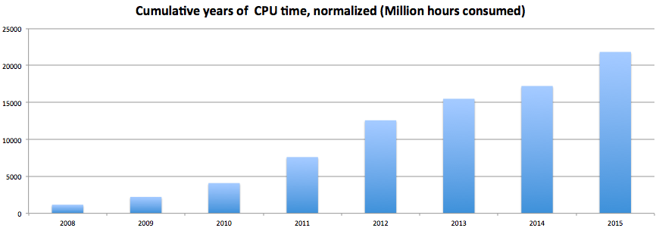
Figure 13. CPU time consumption (normalized time) from 2008 to date.
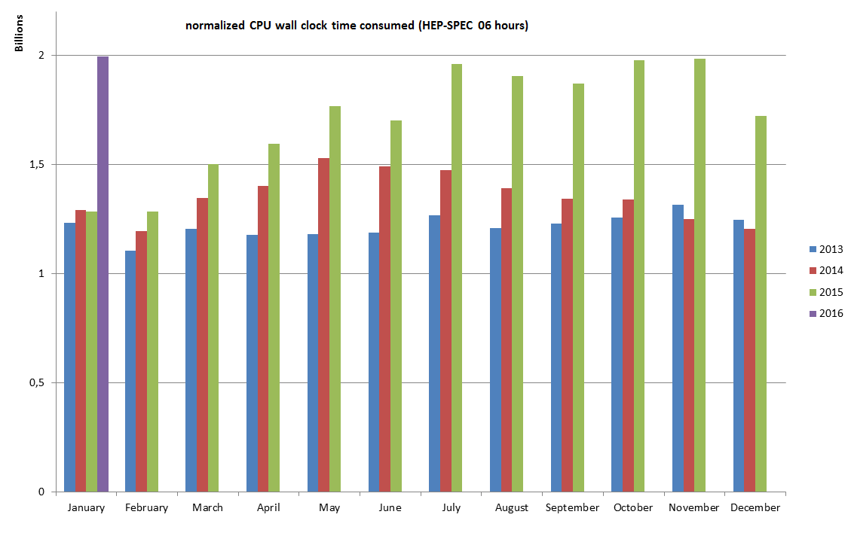
Figure 14 HEP-SPEC 06 Hours monthly usage of the last three years (source: accounting portal).

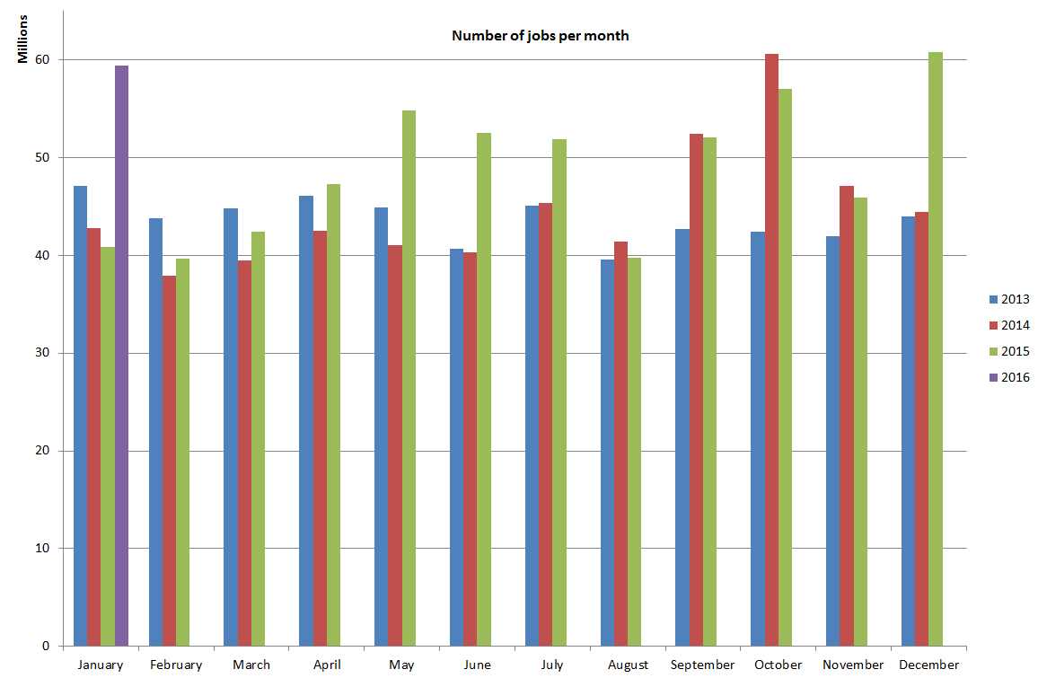
Figure 15Number of jobs per month of the last three years (source: accounting portal)

The diagrams in Figure 29 and in Figure 310 shows the total number of jobs per VO and per Operations Centre respectively, in the period between January 2015 and January 2016.
The usage expressed in HEP-SPEC 06 Hours of CPU wall time across the various resource infrastructures of EGI is plotted in Figure 411, where infrastructures are grouped by operations centre. The diagram also shows the distribution between the four LHC VOs atlas, cms, alice and lhcb (red bars) and the other VOs (blue bars).
The most used infrastructures in absolute terms by the different scientific disciplines (in decreasing order) are: NGI_DE, NGI_UK, NGI_IT, NGI_FRANCE and CERN. Usage distribution naturally reflects availability of installed capacity (Section 1.6), however the level of multidisciplinary support varies considerably across the infrastructures. Figure 512 plots the distribution of used HEP-SPEC 06 CPU wall clock hours of non-HEP user communities. NGI_IT is the infrastructure with the largest absolute amount of resources used by non-LHC communities with almost 626 Million CPU wall time hours, followed by NGI_DE, NGI_FRANCE, NGI_UK and NGI_TR.
The Figure 613 shows how support of LHC VOs and high-energy physics is dominant in large resource infrastructures, while other disciplines dominate in various countries in Eastern-South Europe. While the LHC VOs altogether account for the largest fraction of resources used in absolute terms, this fraction has been decreasing over during the last years as the services have been increasingly used by new disciplines and projects. Today LHC VO users are less than 50% of the active registered users. The smallest NGIs in terms of number of sites usually support only few VOs, making some NGIs almost discipline-specific. Instead, the larger NGIs that include also large RCs and more regional scientific communities, have the possibility to provide resources to a diverse set of research projects.

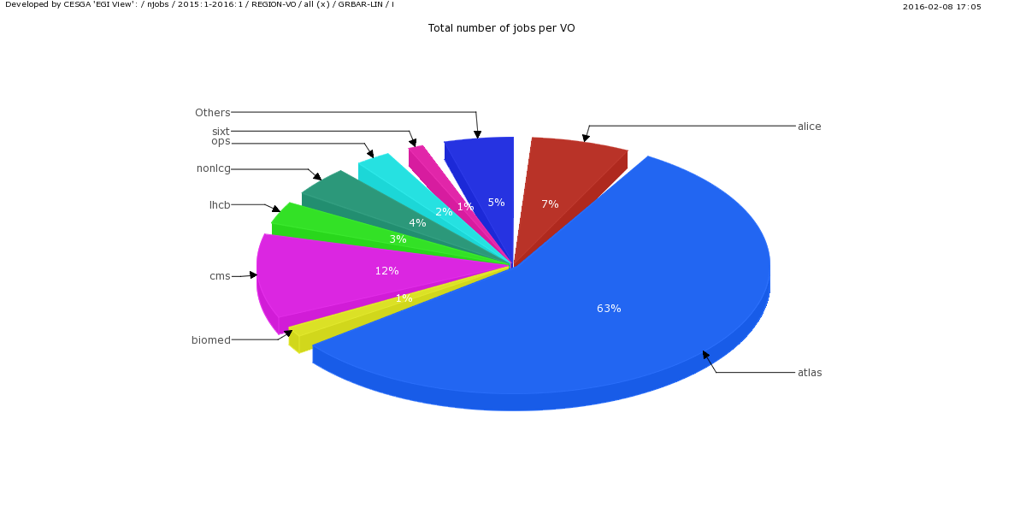
Figure 2 Total number of jobs per VO (Jan 2015 - Jan 2016, source: Accounting Portal)

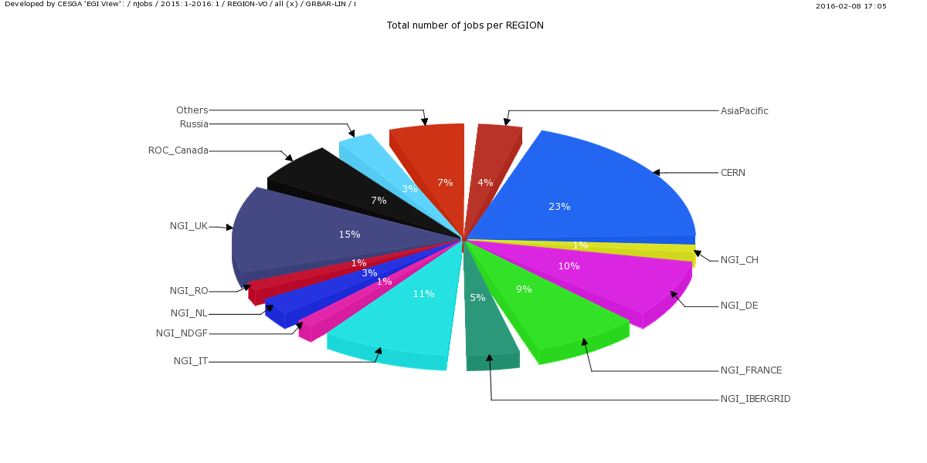
Figure 3 Total number of jobs per NGI/EIRO (Jan 2015 - Jan 2016, source Accounting Portal)

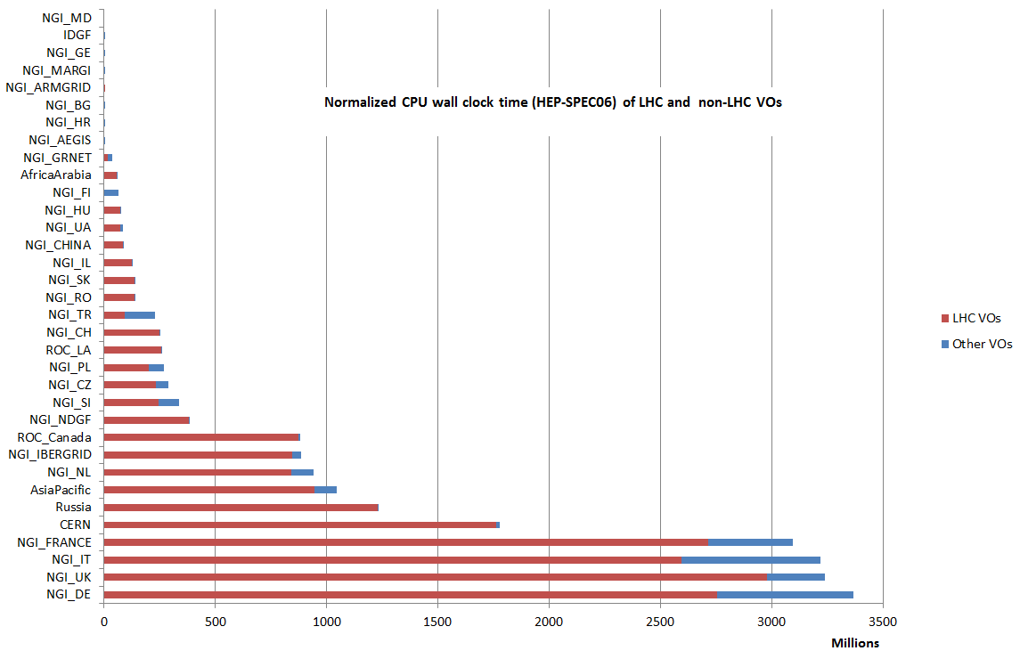
Figure 4 HEP-SPEC 06 Hours from January 2015 to January 2016 (source: accounting portal). LHC usage is displayed in red while the aggregated usage of the rest of VOs is in blue

Figure 5 Distribution across EGI Operations Centres of aggregated usage of non-LHC VOs (CPU wall clock time in HEP-SPEC 06 hours) from January 2015 to January 2016 (source: accounting portal).

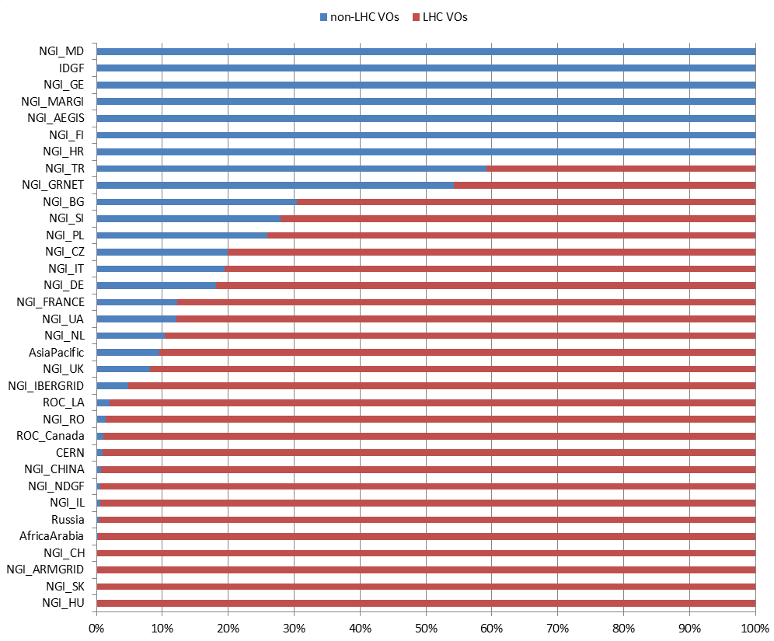
Figure 6 Distribution of resource usage (%) across HEP and non-HEP VOs from January 2015 to January 2016 (source: accounting portal).

As mentioned before, during 2015 accounting of multicore jobs was rolled to production: the not-normalized CPU time consumed by this kind of jobs is reported in Figure 1510, while in Figure 1611 a comparison of used resources between the single and multi-core jobs is plotted.

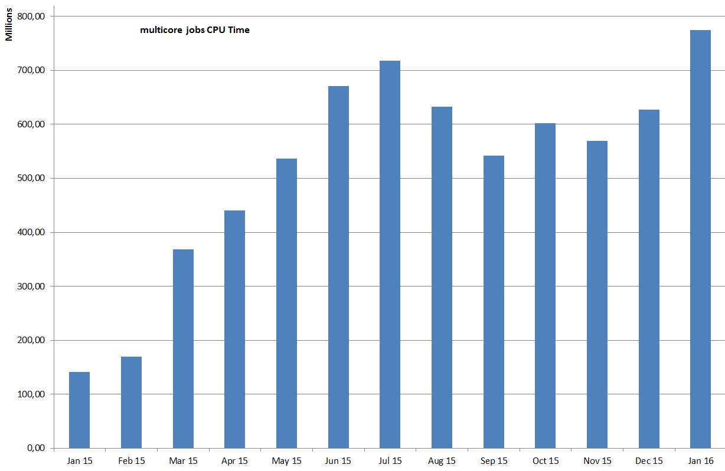
Figure 16. Total (normalised) CPU elapsed time * number of processors. This diagram provides an approximation of the cumulative wall time-equivalent consumption of CPU for multicore jobs.

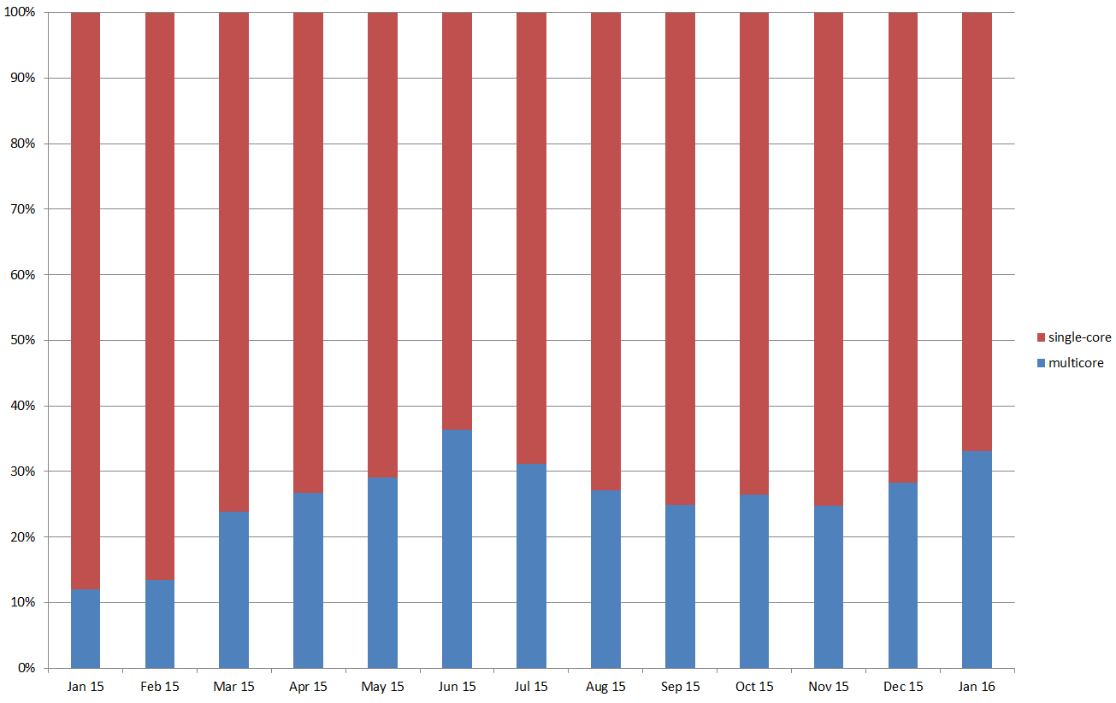
Figure 17 Resource percentage utilization of single and multi-core jobs.
With regards to cloud, the number of virtual machines instantiated since January 2015 is shown in Figure 1712, while Figure 1813 plots the percentage of total CPU time consumed in the Federated Cloud across the various providers.

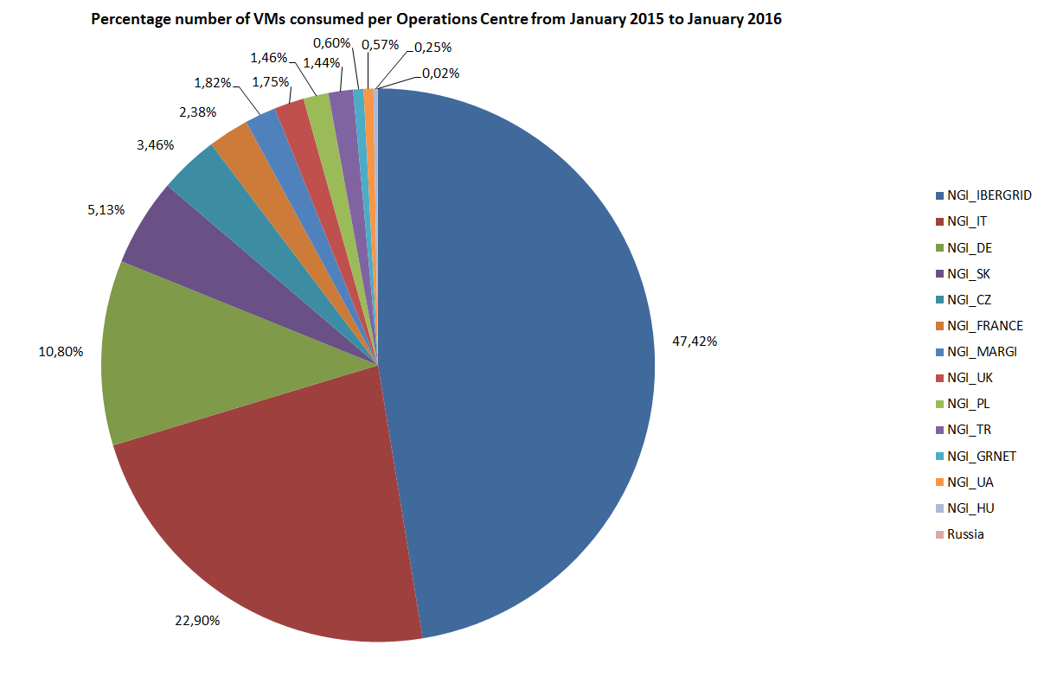
Figure 18 VMs instantiated in the Federated CLOUD per Operations Centre from January 2015 to January 2016 (source: accounting portal)
Cloud usage during 2015
Total # of VMs instantiated | 557,836
Total CPU time consumed (CPU hours) | 1924000
Table 3 Overall usage of the federated cloud resources between Jan 2015 and Jan 2016
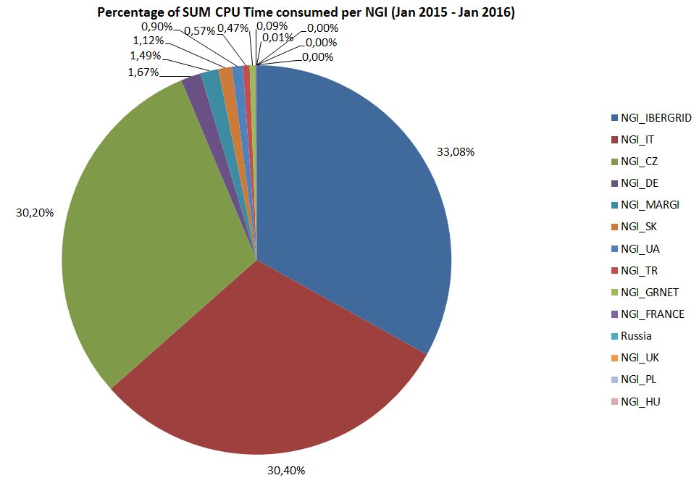
Figure 19 Percentage of total CPU time consumed by cloud services per NGI from January 2015 to January 2016 (source: accounting portal).

Disciplines, Virtual Organizations and users
This section provides information about the evolution of the user community (users registered in VOs) in some of the main scientific disciplines currently identified by EGI at the infrastructure level, namely: Engineering and Technology, Medical and Health Sciences, Natural Sciences, Agricultural Sciences, Social Sciences, Humanities, Support Activities and Others. We should keep in mind that users have different ways of authenticating when accessing services in the distributed infrastructure (e.g. via credentials released by the home organization, personal certificates, and, in the future – where possible – via social network accounts. In addition to this, access can be mediated by platforms or Virtual Research Environments which provide customer-specific tools and services, while relying on baseline e-Infrastructure services. Because of this complexity, the number of active users can only be estimated.
The overall number of international and national projects (also known as Virtual Organizations) registered in the Operations Portal at the beginning of February 2016 amounts to 233.
Use of robot certificates
The use of gateways to provide users with a native user-friendly environment to the infrastructure services is increasing. Quite often user portals provide users with the capability of using institutional credentials to authenticate themselves, these credentials are then mapped to robot certificates (often owned by the VO managers). By doing so it is not necessary for a user the request of a personal X.509 certificates and the registration to a VO: this contributes to increase the user friendliness of the platforms. Use of robot certificates is internally accounted for by the portals in compliance to the VO Portal policy. In February 2016 the number of robot certificates embedded in user gateways is 157; robot certificates are used by 51 VOs in total. Almost 11,000 users can potentially use scientific gateways; this is increased by the number of registered users to active VOs, which amounts to be 46246 in February 2016.
The increase in the number of Robot Certificates indicates that users, in particular new user communities, are looking for alternative authentication mechanisms different from the plain X.509 certificates. Within EGI-Engage JRA1 EGI is exploring different authentication technologies and is revising its trust model in order to accommodate the support of different levels of assurance, or to work on a better integration of robot certificates with the production infrastructure.
The diagram in Figure 716 shows the trend in use of robot certificates and VOs since November 2011.

Figure 7 Use of robot certificates and related VO in EGI since 2011.

VOs and user distribution across scientific fields
The distribution of VOs per discipline is illustrated in Figure 817

Figure 8 Distribution of number VOs per discipline (February 2016, source: Operations Portal).
The largest discipline in terms of number of registered users is Natural Sciences (65.98%): it is remarkably larger than the other ones because it includes 153 VOs (more than the half of the total VOs). Then there is the Support Activities discipline (9.09%), followed by Medical and Health Science (6,46%) and by Engineering and Technology (6.32%). The complete users distribution is shown in the Figure 918.

Figure 9 Users distribution per discipline (February 2016, source: Operations Portal)

Resource utilization per disciplines
Table 8 and Figure 1011 report on the resources usage in 2015 by the 10 mostly used disciplines compared with the data from 2014: the larger disciplines augmented the usage in 2015. Neurosciences and medical imaging scored a significant relative reduction and investigations are in progress to correlate this with service status and plaresearch project activities and sat

Table 8 Increase/decrease of normalised CPU time utilization in 2014 and in 2015 by the 10 most used disciplines (source: accounting portal), ordered by utilization.
DISCIPLINE | Norm. CPU time 2015  compared to 2014
Physics | +28,93%
High Energy Physics | +31,72%
Particle Physics | +27,96%
Nuclear Physics | +43,06%
Space Science | +12,33%
Astrophysics | +12,33%
Astronomy | +9,20%
Neurosciences | -38,34%
Medical imaging | -38,45%
Comput. chemistry | -30,94%

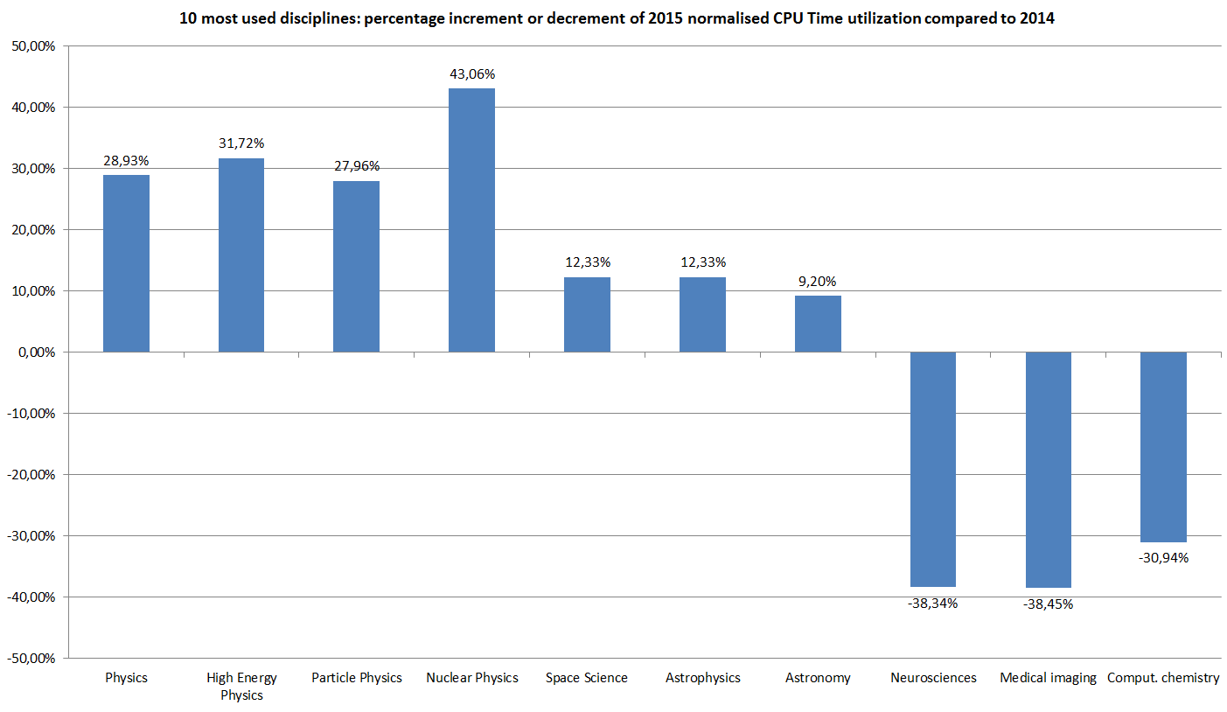
Figure 10 2015 increment or decrement of normalised CPU time utilization compared to 2014 by 10 most used disciplines

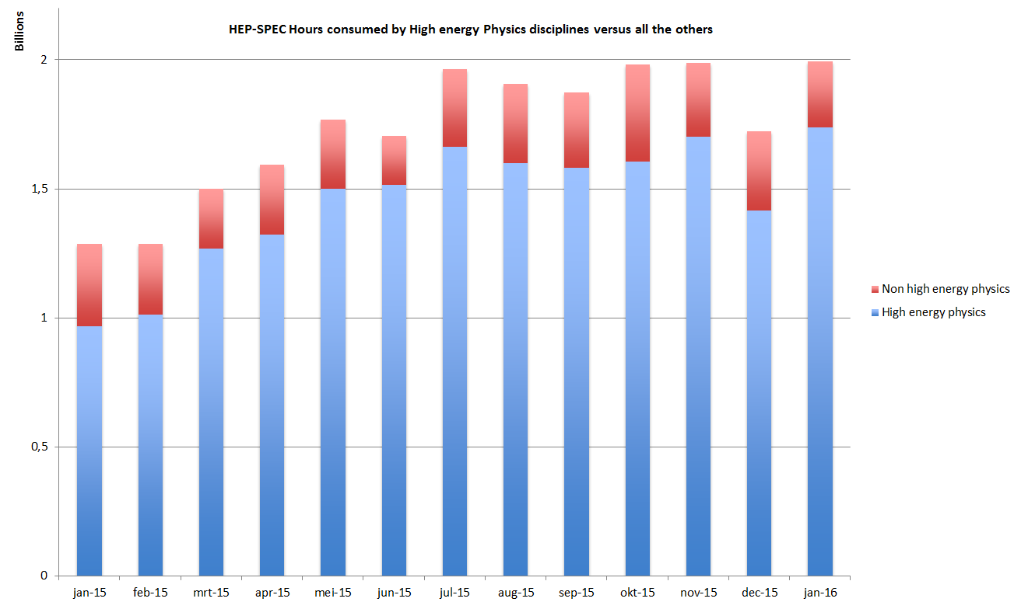
Figure 11 High energy Physics usage compared with all the other disciplines.

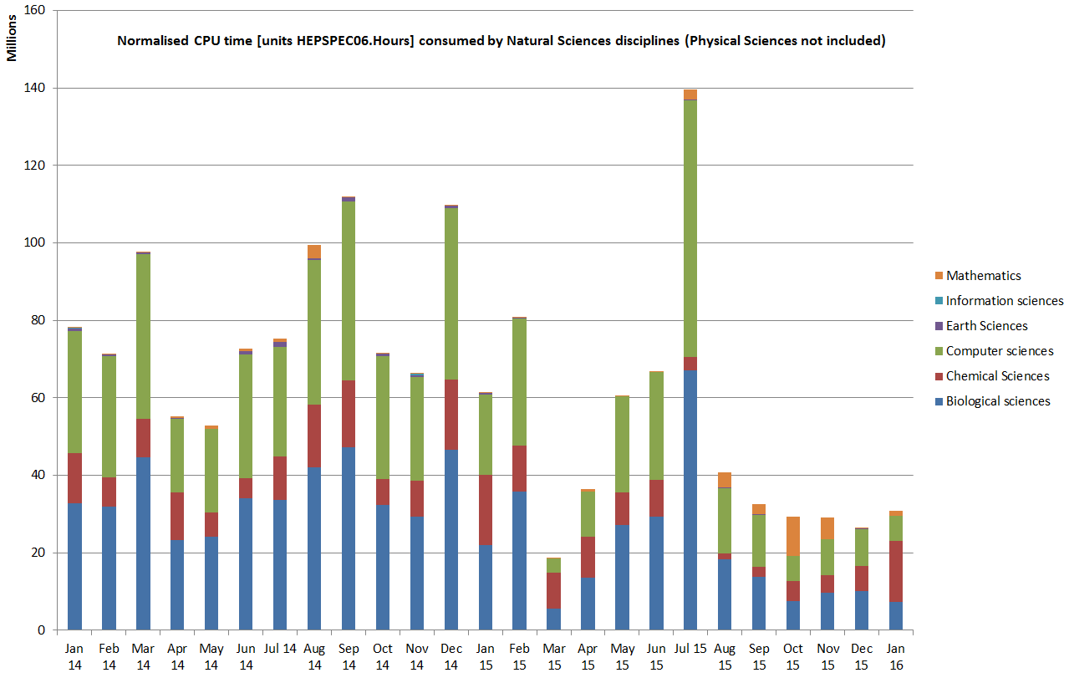
Figure 20. Natural Sciences disciplines resources usage (Physical Sciences excluded).

Service level availability performances
Services are monitored at three different levels:
- Resource Centre Services;
- Resource infrastructure Provider Services
- EGI.eu central Services.
For each category a different set of service levels and targets are defined and periodically reviewed (see the chapter 3 for details). For each set of service levels various reporting systems are available, and are detailed in the following section. The service levels and targets are formally defined in the RC Operational Level Agreement [RCOLA], in the RP Operational Level Agreement [RPOLA] and EGI.eu Operational Level Agreements.

RCs availability and reliability
The quality of grid services deployed by Resource Centres is being measured since 2008 with availability and reliability metrics, computed from the results of periodic tests performed at all certified centres through the Service Availability Monitoring framework (SAM) [SAM]. Availability and reliability metrics were defined to quantitatively express the level of functionality delivered by grid services to end-users with the ultimate goal of identifying areas of the infrastructure needing improvement.
The capability of closely reflecting the experience of the end-user depends on the tests performed. The EGI monthly availability and reliability reports are based on tests (run using the OPS VO) that are sufficiently generic to allow a comparison across all Resource Centres of the infrastructure.
Availability of a service (or a site, depending on the level of aggregation) represents the percentage of time that the services (or sites) were up and running ([uptime / total time] * 100), while Reliability is the percentage of time that the services (or sites) were supposed to be up and running, excluding scheduled downtime for maintenance and other purposes ([uptime / (total time – scheduled down time)] * 100) [AVL].
Certified Resource Centres need to guarantee 80% minimum availability and 85% minimum reliability for their services (in a distributed environment, workload is distributed across the infrastructure with resilient mechanisms, meaning that the temporary unavailability of a service does not impair the end-user experience, as the workload can be redirected to other service ned-points). The minimum availability and reliability values accepted for a Resource Centre are defined in Operational Level Agreements established with EGI.eu and are periodically updated.
Increasing the overall performance delivered to users has been an on-going effort since the introduction of service level management.
The trend of the overall EGI RC availability and reliability is shown the following two diagrams.

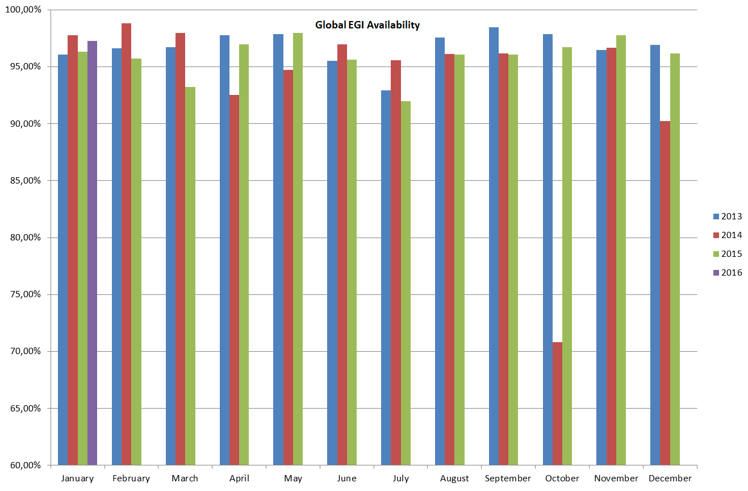
Figure 21 Monthly Availability of resource centres averaged across EGI.

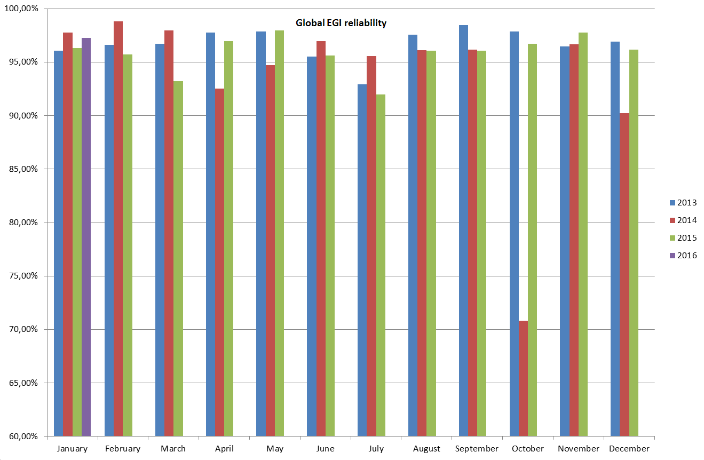
Figure 22 Monthly Reliability of resource centres averaged across EGI, for the last three years.

The overall average availability of the EGI production infrastructure has kept constant and exceeded 95% for almost all the months of 2015. Although it has not improved significantly from the previous year, average 95% of availability is a good result considering that the highly distributed nature of the infrastructure allows users to use another site if one is not available. Moreover availability is also strictly considering all the site’s services, and – for example – if a user is using only the computing services may not be affected by an outage of the storage services.

Figure 23 Monthly availability and reliability trends of Federated CLOUD.

Figure 2116 shows the availability and reliability trends for the cloud providers: differently from the values computed for the EGI Production Infrustructure, they are not weighted on the size of RCs, so that small RCs influence the global trends in the same way than the bigger ones; besides the occurrence of problems in small RCs is higher than in the larger ones, so this explains why the average availability and reliability figures of Federated CLOUD are lower than the EGI ones.
As already written, the Federated Cloud Infrastructure started in mid-May 2014. The reports were produced separately from the EGI production infrastructure ones because the Federated Cloud was a test environment during the first part of its life, but in the second half of 2015 there was a general improvement of the quality of the service provided. By now the federated Cloud reached a level of maturity that allows the services to be included in the global EGI availability and reliability computation. As decided In January 2016, EGI federated cloud providers will be subject to the same follow-up operational procedures valid for the HTC RCs, and this is expected to become valid starting as of June 2016.

Evolution in the operations coordination
The operations of the EGI production infrastructure are organized at different levels:
- European level: operations of the federation are coordinated by EGI.eu and the EGI Operations Management Board
- National level: operations are organized by the NGI Operations Centres (NOC)
- Local level: operations are managed by the data centre staff
This chapter focuses on the operations at e-Infrastructure European level, these include:
- Operational processes, procedures, manuals, best practices and policies

- Software provisioning and distribution
- EGI federation services (“core activities and services”)

Evolution of the operational procedures and processes
Documents are produced by EGI Operations to establish coherent and repeatable procedures for the partners of EGI. While manuals are technical documents that provide guidelines focused on a specific task, procedures are step-by-step descriptions of processes requiring actions from several partners. The purpose of a procedure is to define a workflow. Procedures are approved by the OMB and periodically reviewed. Applicable areas for procedures are:
- Ticket management
- Operations Center Management
- Resource Centre Management
- Availability and monitoring
- Security Incident Handling
- Vulnerability Issue Handling
In the first year of the project, effort concentrated on the development and adaptation of operational procedures and processes for the EGI federated cloud. Pre-existing operational procedures and processes (already adopted for the management of the distributed HTC platform) were adopted as much as possible.
The list below defines the documents includes both new and old documents revised during the last year. The whole collection of operational documents is available on the EGI wiki and it includes: 23 procedures, 12 manuals, 18 HOWTOs, and 10 "Frequently Asked Questions”.

Title | New/Updated | Description
Setting up Cloud Resource Centre https://wiki.egi.eu/wiki/MAN10 | Updated | It provides very detailed instructions to integrate a cloud infrastructure in the EGI federation. The manual provides information for different cloud middleware stacks supported in the EGI Federated Cloud.  Contributions come from both developers of the tools and administrators themselves. The steps to set up a cloud infrastructure in EGI are now well known and straightforward.
Per-User Sub-Proxy https://wiki.egi.eu/wiki/MAN12 | New | This manual shows how to set up a per-user sub-proxy (PUSP), which allows identification of the individual users under a common robot certificate. This new feature, defined and developed in the Federated Cloud context, allows a web portal to map a group of users (i.e. VO users) creating a proxy credential from the robot credential. This is fundamental to enable science gateways.
Quality verification of monthly availability and reliability statistics https://wiki.egi.eu/wiki/PROC04 | Updated | The document describes the process of how to handle justification for poor monthly performance, with the goal of maintaining a given level of quality for the overall EGI infrastructure.  The main update to this procedure is represented by a new step in the procedure for communicating with underperforming sites. In case the NGI does not respond to the GGUS ticket in 10 working days, a direct email is sent to the NGI for comments, improving reliability of the communication with the NGI in case of issues through the GGUS ticket, especially with NGIs that are experiencing a frequent personnel turn-over or temporary manpower issues.
Support for CVMFS replication across the EGI Infrastructure https://wiki.egi.eu/wiki/PROC22 | New | The procedure describes the process of creating a repository within the EGI CVMFS infrastructure for an EGI VO. This has been entirely defined and tested in the EGI-Engage context.
Production tools release and deployment process https://wiki.egi.eu/wiki/PROC23 | New (still drafted) | The procedure describes the process of release and deployment in EGI production infrastructure for Production tools.

The EGI core activities
The EGI core activities and services are fundamental, as they represent the glue that puts together Resource Centres and user communities (Virtual Organizations) implementing the policies between the different partners of EGI. As a consequence, it is very important that they maintain very high levels of availability and reliability. EGI-Engage does not support the operational costs of any of the services operated either at national level or at central level, however, it supports operations coordination, which is responsible for defining the technical specifications, the procurement and the delivery of EGI core activities and services – the EGI service “backbone” providing the glue to federate national services. The EGI core activities and services are partly funded by the EGI participants’ yearly fees and partly contributed as in-kind contribution to the federation by the technical partners of EGI.
The specifications of EGI core activities and services are available at:
https://wiki.egi.eu/wiki/EGI_Core_Activities_Bidding#PHASE_II_May_2016-December_2017.
EGI-Engage was responsible for coordinating the procurement of for the period May 2016-December 2017. The bidding process took place during Summer 2015. A new service was added, the Application Database, which he EGI Applications Database (AppDB) is a central service that provides:
- Information about software solutions in the form of native software products and virtual appliances, linking the programmers and the scientists who are involved, and the publications derived from the registered solutions.
- The tools for the distribution of the virtual machine images in the cloud sites part of the the federated cloud
Three types of software solutions are offered through the EGI Applications Database:
- Software items, in its classical sense, i.e. applications, tools, utilities, etc.
- Virtual Appliances: composed by one or more pre-configured virtual machine images packaged with an operating system and software application(s).
- Software Appliances: one or more a set pairs of a virtual appliance and a contextualization script. A Contextualization Script (CS) is the script launched on VM boot time and could be used for installing, configuring and preparing software upon boot time on a pre-defined virtual machine image.

The following paragraph provides an overview of the EGI operations services and activities’ level targets formally agreed between resource providers, and periodically reported on a monthly basis.

Name | Description | Documentation or service URL
Message Broker Network | The message broker network is a fundamental part of the operations infrastructure ensuring message exchange for monitoring, the operations dashboard and accounting. As such it is a critical infrastructure component whose continuity and high availability configuration must be ensured. The Message Broker Network is part of the EGI Core Infrastructure Platform which is needed to support the running of tools used for the daily operations of EGI.
Operations Portal | The Operations Portal provides VO management functions and other capabilities which support the daily operations of EGI. It is a central portal for the operations community that offers a bundle of different capabilities, such as the broadcast tool, VO management facilities, a security dashboard and an operations dashboard that is used to display information about failing monitoring probes and to open tickets to the Resource Centres affected. The dashboard also supports the central grid oversight activities. It is fully interfaced with the EGI Helpdesk and the monitoring system through messaging. It is a critical component as it is used by all EGI Operations Centres to provide support to the respective Resource Centres. The Operations Portal provides tools supporting the daily running of operations of the entire infrastructure: grid oversight, security operations, VO management, broadcast, availability reporting. | http://operations-portal.egi.eu/
Accounting Repository | The Accounting Repository stores user accounting records from various services offered by EGI. It is part of the EGI Core Infrastructure Platform, which supports the daily operations of EGI. The EGI Accounting Infrastructure is distributed. At a central level it includes the repositories for the persistent storage of usage records. The central databases are populated through individual usage records published by the Resource Centres, or through the publication of summarised usage records. The Accounting Infrastructure is essential in a service-oriented business model to record usage information. | http://accounting.egi.eu/egi.php
Accounting and Metric Portal | The Accounting Portal provides data accounting views for users, VO Managers, NGI operations and the general public. The Accounting Portal is part of the EGI Core Infrastructure Platform which supports the daily operations of EGI. The EGI Accounting Infrastructure is distributed. At a central level it includes the repositories for the persistent storage of usage records. The central databases are populated through individual usage records published by the Resource Centres, or through the publication of summarised usage records. The Accounting Infrastructure is essential in a service-oriented business model to record usage information.  The Metrics Portal aggregates metrics from the EGI Infrastructure from activity leaders and NGI managers in order to quantify and track the infrastructure evolution. | http://accounting.egi.eu/egi.php
SAM central services | The Service is part of the EGI Core Infrastructure Platform which supports the daily operations of EGI. Central systems are needed for accessing and archiving infrastructure monitoring results of the services provided at many levels (Resource Centres, NGIs and EGI.EU), for the generation of service level reports, and for the central monitoring of EGI.eu operational tools and other central monitoring needs.  The system is currenty going to be moved from the old distributed MyEGI to the new (central) ARGO infrastructure. | http://argo.egi.eu/  https://wiki.egi.eu/wiki/SAM_Instances
Monitoring central services | Monitoring Central Services is supporting monitoring of activities to be conducted centrally, like monitoring of e.g. UserDN publishing in accounting records, GLUE information validation, software versions of deployed middleware, security incidents and weaknesses and EGI.eu technical services. Central Monitoring Services is part of the EGI Core Infrastructure Platform, which supports the daily operations of EGI.
Security monitoring and related support tools | Security monitoring and related support tools are part of the EGI Core Infrastructure Platform which supports the daily security operations of EGI. EGI is an interconnected federation where a single vulnerable place may have a huge impact on the whole infrastructure. In order to recognise the risks and to address potential vulnerabilities in a timely manner, the EGI Security Monitoring provides an oversight of the infrastructure from the security standpoint. Also, sites connected to EGI differ significantly in the level of security and detecting weaknesses exposed by the sites allows the EGI security operations to contact the sites before the issue leads to an incident. Information produced by security monitoring is also important during assessment of new risks and vulnerabilities since it enables to identify the scope and impact of a potential security incident. | https://wiki.egi.eu/wiki/EGI_CSIRT:SMG
Service registry (GOCDB) | Service Registry (GOCDB) is a central registry to record information about different entities such as the Operations Centres, the Resource Centres, service endpoints and the contact information and roles of people responsible for operations at different levels. GOCDB is a source of information for many other operational tools, such as the broadcast tool, the Aggregated Topology Provider, the Accounting Portal, etc. GOCDB is part of the EGI Core Infrastructure Platform, which supports the daily operations of EGI. | http://goc.egi.eu/
Catchall services | Catch-All services are auxiliary services needed by the Core Infrastructure Platform and by various operational activities of EGI. Auxiliary services and activities are needed for the good running of Infrastructure Services. Examples of such services are VOMS service and VO membership management for infrastructural VOs (DTEAM), the provisioning of middleware services needed by the monitoring infrastructure (e.g. top-BDII and WMS), and catch-all services for emerging user communities. | https://wiki.egi.eu/wiki/Catch_All_Grid_Core_Services
Operations support | Operations support is auxiliary service needed by the Core Infrastructure Platform and by various operational activities of EGI. Auxiliary activities are needed for the good running of Infrastructure Services. Examples of such are activities for service level management, service level reporting, service management in general and central technical.
Security coordination | Central coordination of the security activities ensures that policies, operational security, and maintenance are compatible amongst all partners, improving integrity and availability and lowering access barriers for use of the infrastructure.
Acceptance criteria | The Acceptance Criteria are the functional and non-functional requirements that a product must fulfil to be released in UMD, these include generic requirement applicable to every product, and specific requirements applicable to the capabilities supported by a component.
Collaboration tools/IT support | Collaborations tools are services needed by the EGI back-office and supporting EGI collaboration. | https://wiki.egi.eu/wiki/EGI_Collaboration_tools
Staged Rollout | The Staged Rollout is an activity by which certified updates of the supported middleware are first tested by Early Adopter (EA) sites before being made available to all sites through the production repositories. This procedure permits to test an update in a production environment that exposes the product to more heterogeneous use cases than the certification and verification phase. This allows the discovery of potential issues and potentially to add mitigation information to the UMD release notes.
Software provisioning infrastructure | The software-provisioning infrastructure provides the technical tools to support the UMD release process from pulling packages from the developers’ repositories to the build of a release. | https://wiki.egi.eu/wiki/EGI_Software_Component_Delivery
Incident management helpdesk | Incident Management (Helpdesk) is the central helpdesk provides a single interface for support. The central system is interfaced to a variety of other ticketing systems at the NGI level in order to allow a bi-directional exchange of tickets. GGUS is part of the EGI Collaboration Platform and is needed to support users and infrastructure operators. | http://helpdesk.egi.eu/
1st and 2nd level support (core platform, community platform) | First level support is responsible for ticket triage and assignment. This activity is also responsible for the coordination with teams responsible for 2nd level and 3rd level support. Software-related tickets that reach the second level of support are analysed and if necessary are forwarded to 3rd line support units only when there are clear indications of a defect (in software, documentation, etc.).
AppDB | The EGI Applications Database (AppDB) is a central service that stores and provides to the public, information about software solutions in the form of native software products and/or virtual appliances, the programmers and the scientists who are involved, and publications derived from the registered solutions. | https://appdb.egi.eu/
e-Grant | e-GRANT is a tool supporting Resource Allocation process. It allows researchers to request an amount of compute and storage resources, or FedCloud resources, for a given amount of time. e-GRANT handles all activities involved in RA Process which leads to SLA signing. | https://e-grant.egi.eu/slaneg/auth

During EGI-Engage the provision of the core activities, has been regular and – with minor deviation – in the boundaries set by dedicated OLA signed by the service providers.

The UMD software provisioning
The Software Provisioning infrastructure provides the technical tools to support the UMD release process from pulling packages from the developers repositories to the build of a release. The main goals of the overall Software Provisioning process are:
- Distributing the software provided by the Technical Providers (i.e. development teams) through a central repository
- Verify that the software fulfils a given set of Quality Criteria
- Deploy the software into the infrastructure in a controlled way, so that a software is installed on sites only if it has been tested in a real production context (Early Adoption).
The UMD Software Provisioning activity is made of several components:
- Software Provisioning Process, made of 3 sub-processes
  - Software Delivery, when Technology Providers (i.e. the development/product teams) submit new software releases; this is made by email or GGUS ticket. Software delivery is performed using one of the three different user interfaces available, i.e. a web form, e-mailing and a web service interface, that create tickets including all the necessary information about the software delivered in order to be processed. GGUS forwards the tickets to RT creating one RT ticket per Product per Platform and Architecture (PPA)
  - Software Assessment, consisting in
    - Quality Assurance, which assures that the software fulfils the Quality Criteria to be released in UMD; these include generic requirements applicable to every product, and specific requirements applicable to the capabilities supported by a component. During the last year, a new version of the Quality Criteria has been produced: http://egi-qc.github.io/
    - Staged Rollout, which is a procedure by which certified updates of the supported middleware are first tested by Early Adopter (EA) resource centres before being made available to all sites through the production repositories. This procedure permits to test an update in a production environment that exposes the product to more heterogeneous use cases than the certification and verification phase. This allows the discovery of potential issues and the addition of corresponding mitigation information to the UMD release notes.
  - Reporting, which is about informing TPs about the outcome of the Software Provisioning Process
- UMD Release Process, collecting tested Products per Platform and Architecture (PPAs) into UMD Releases.
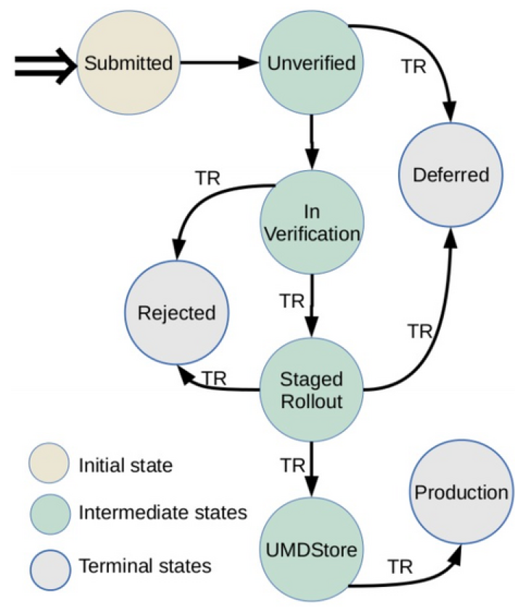
Figure 24 - Status of products through the Software Provisioning Process
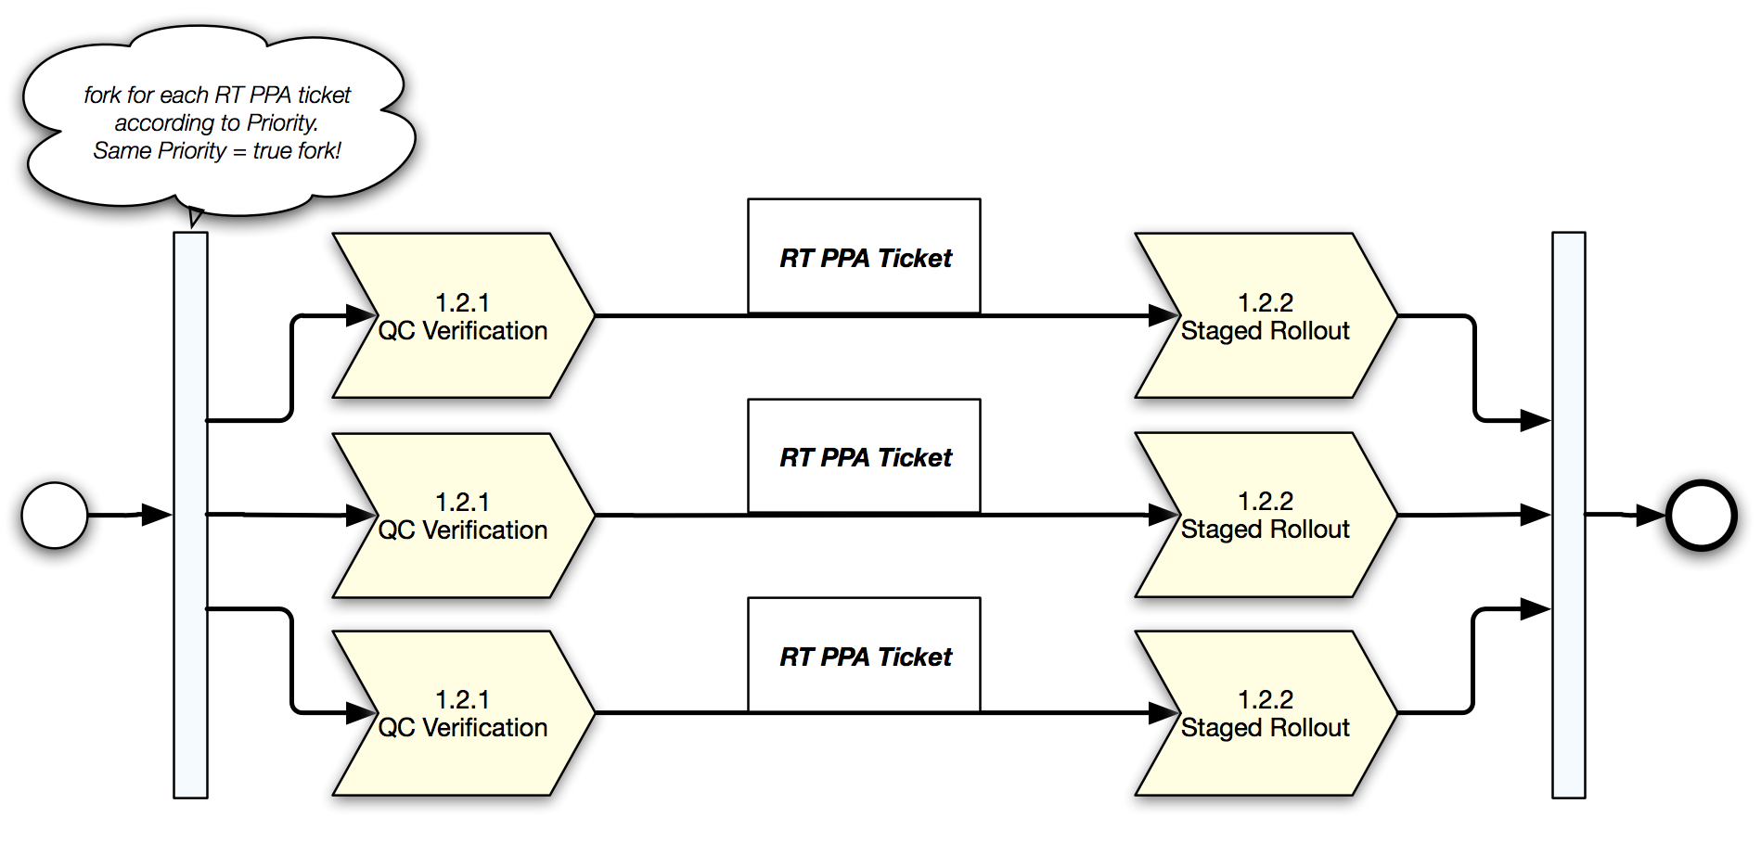
Figure 25 - Software assessment
The Software Provisioning infrastructure is composed by several components. The most important are:
- RT (Request Tracker) tracks the status of the product in the software provisioning process, for a given release of a given product;
- Repository Back-End automates the movement of packages between repositories, validating the individual product releases submissions
- Composer, a web-based interface for bundling versioned software products that have successfully passed the UMD verification process, into a robust UMD release ready to be deployed
- Web frontend publishing the information about UMD releases
- Repositories to be maintained for every operating system and major release supported; they are:
  - Untested: contains the packages to be installed during the verification
  - Testing: contains the packages to be installed during staged rollout
  - Base: contains the packages released in the first major release
  - Update: contains the packages released in the update releases
  - Release Candidate: it is generated before a UMD release, to simulate the production repositories after the UMD release under preparation. This is used to test the installability of the newly released components, as well as the products already in production.
The Software Provisioning infrastructure supports multiple operating system (EL-based, Debian-based) and major releases. At the moment, the UMD4 structure provides support to CentOS7, SL6, and Ubuntu.
The infrastructure provides also a “Preview” repository where products are quickly released without verification; this is not an official UMD repository, but it follows the same procedures and has the same features.
The UMD Release Team (URT) has been working during the last year on releasing the middleware distribution according to the criteria of the Software Provisioning Process developed in the EGI context.
The documentation and the procedures used by the URT have been modified to improve the performances and the reliability of the whole process. In particular, a new guide has been written to make the whole process more transparent, to provide tracking of the packages and feedback during the followed steps. The provisioning procedure is organized as a process compatible with FitSM standard. Moreover, several optimizations to the release workflow allow now to make the release time more predictable (about 2 months) and more reliable (no products out of the UMD radar).
At the moment, EGI is supporting two different major releases of UMD:
- UMD3, supporting two EL-based platforms (Scientific Linux 5 and Scientific Linux 6) and Debian;
- UMD4, supporting two EL-based platforms (CentOS7, Scientific Linux 6) and Ubuntu
The choice of the new platforms for UMD4 has been driven by:
- Almost full backward compatibility with previous releases (CentOS with SL, Ubuntu with Debian)
- Explicit preference of the Resource Centres in using CentOS/Ubuntu instead of SL/Debian (survey presented on May 2015).
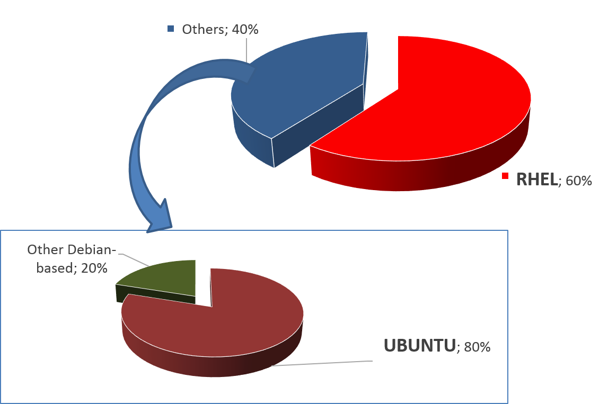
Figure 26. Use CentOS and Ubuntu in the EGI Federated Cloud
A new release of the UMD has been released in January 2016 (UMD 4.0.0). The first release focuses on the adoption of CentOS7. The UMD4 release will soon host also the products developed in the EGI Federated Cloud and specifically in EGI-Engage JRA1 (Cloud Management Framework) for Ubuntu 14.04 LTS.. Considering that SL5 is under the decommissioning phase (the deadline was April 2015), and the SL6 porting from UMD3 to UMD4 is currently ongoing, the decommissioning of UMD3 can be planned at the beginning of PY2 in favour of UMD4.
During 2015 there have been 9 releases of UMD3, 4 of which are minor releases and 5 revisions or fixes.
Capability | Product/Technology
Compute, Job Execution, Job Scheduling | CREAM, Globus GRAM5, QCG-Computing, UNICORE TSI, UNICORE/X, ARC, WMS
Accounting | APEL
Attribute authority | VOMS Server, UNICORE XUUDB
Authentication | Globus GSI, UNICORE-Gateway
Authorization | ARGUS-PAP
Client tools | GFAL2 utils, VOMS clients
Credential management | MyProxy, ProxyRenewal
Data access | DAVIX
File Access, File Transfer, Storage Management | StoRM, dpm-xroot, XRootD, CVMFS, dCache, DPM/LFC, Frontier SQUID, Globus GRIDFTP, XROOTD
File Transfer Scheduling | FTS3
Information Discovery | Globus InfoProviderService, UNICORE Registry
Other | BLAH, CGSI-gSOAP, CREAM TORQUE module, CREAM GE module, DMLITE, GFAL2, GFAL2-python, SRM-ifce, classads-libs, edg-mkgridmap, fetch-crl, ARC Nagios probes
Figure 27. Products updated in UMD3 during 2015

User software distribution
While UMD aims at distributing the “middleware” to the Resource Centres, other ways are necessary to distribute user applications: in these cases the life cycle management of the application must be decoupled from the operating system and the middleware as much as possible.
CVMFS (CERNVM File System) fits perfectly to the case and its delivery was improved in 2015. CVMFS is a network file system based on HTTP and optimized to deliver experiment software in a fast, scalable, and reliable way. Files and file metadata are downloaded on demand and locally cached, without interfering with the base system.
Several VOs are asking for migrating to CVMFS to distribute their software. EGI has formalized a procedure to drive the Virtual Organizations through setting up CVMFS for their software in the EGI infrastructure, making the software automatically available at the Resource Centres by means of the preinstalled CVMFS clients.
Effort has been spent to ensure interoperability between the CVMFS services provided by EGI and OSG: as anticipated, a procedure (https://wiki.egi.eu/wiki/PROC20) has been set, and recently refined, to ensure that VOs managing the CVMFS area are supported by Resource Centres in both OSG in the united states and EGI.

Virtual Appliance distribution and VA Endorsement
The AppDB acts basically as a catalogue of virtual appliances (VA): for each VA, it maintains a set of metadata, among which a description, an identifier, and the URL of the VA itself, which is not stored on the AppDB itself. Versioning of the VAs is supported as well. After publishing a new appliance, or a new version of an existing appliance, everybody is able to download the instance.
The VO manager manages a “VO image list”; he can add a VA to his VO image list. Then the members of a VO can run the images of their VO image lists on the Resource Centres supporting their VO; this means that the VO manager decides which images can be run on the EGI Federated Cloud by the VO members by simply listing the allowed images in the VO image list. This is the reason why the act of adding a VA to a VO image list is called endorsement: the VO managertakes the responsibility for stating that the image is “trusted” and can be used in the context of his/her VO.
The images available in AppDB can be classified in two types:
- EGI images, which are general purpose images, based on broadly used OSes
- VO-specific image, which are VO specific images, available to a specific VO and customized for specific purposes
Procedures are available that can assure that a given virtual appliance published in AppDB, under control of a given VO manager/endorser, is well-configured, secure and up-to-date. A checklist has been drafted to schedule and execute the maintenance of the appliances; the work done so far is available on wiki: https://wiki.egi.eu/wiki/Virtual_Machine_Image_Endorsement

In order to make the VAs of a specific VO list available at the Resource Centres supporting the VO, two tools are used: vmcatcher and vmcaster. In particular, vmcaster is a tool for managing and updating published virtual machines image lists on the AppDB side. On the other hand, vmcatcher is the corresponding counterpart on the Resource Centre side: for each supported VO, it downloads the corresponding image list, and synchronizes locally a fresh copy of each image; if the list is updated, the vmcatcher takes care of reflecting the modifications locally (adding new images, deleting old images, overwriting old versions with new ones). In fact, this allows the endorser of the images to decide which images should be available at the Resource Centres in a very simple way and centrally for the whole federation.
At the time of writing, the Application Database includes 83 virtual appliances and 10 software appliances.

These two graphs provide a general positive trend in the total number of Virtual Appliances and Software Appliances stored by Virtual Organizations, especially in the last 6 months.

Figure 28. Registered virtual appliances and software appliances in the Application Database since the start of the EGI federated cloud production phase.
The number of VOs publishing appliances on AppDB doubled during the course of the last year according to the linear increase plotted in the figure above.

Figure 29. Distribution of virtual appliances and software appliances per VO
Taking into consideration only the VOs publishing appliances, the number of appliances published by a single VO increased on average by +25% for both software and virtual appliances in 6 months).

IT service management
During the first year of the project, WP5 has been working towards improvement of EGI service delivery and quality of its services. The
ITIL/ISO20k-based standard FitSM was chosen as reference standard, being it a community standard, developed in the context of a EC project, and lightweight for facilitating service management in IT service provision, including federated scenarios. The main goals of FitSM are:
- Create a clear, pragmatic, lightweight and achievable standard that allows for effective IT service management (ITSM).
- Offer a version of ITSM that can cope with federated environments, which often lack the hierarchy and level of control seen in other situations.
- Provide a baseline level of ITSM than can act to support ‘management interoperability’ in federated environments where disparate or competing organisations must cooperate to manage services.
A significant amount of effort was devoted to clarify the definition of services that are provided through EGI Production infrastructure. This involved the creation of a new dedicated board, the Services and Solutions Board.

In addition to this,
EGI revised its engagement process: after the pre-production phase, a Service Level Agreement is established for each new user community, such that the research community participates in the process of estimating its service requirements, and service providers (EGI participants at national/international level and Resource Centres locally) are engaged in committing to service levels and long term service provisioning. The new process is already being applied in the engagement with user groups. EGI is working with a number of organizations, research communities and VRE operators (DRIHM, BILS, Terradue, Mobrain, Pancancer, Life Science Grid Community, iMARINE, EXTRAS project, Human Brain Project and the nanotechnology research community) to establish a Service Level Agreement (SLA) with resource providers. SLAs are not legal contracts but, as agreements, they outline the clear intentions to collaborate and support research. To support this work a process of SLA negotiation has been defined and followed to ensure effectiveness and repeatability of this activity.
Once an SLA is agreed, EGI continues to support the effort between the resource providers to enable the research community on the promised resources as well as future monitoring.
The base for SLA negotiations with research communities are the Resource Center (RC) and Resource infrastructure Provider (RP) Operational Level Agreements established in 2014. Both documents ensure that resource providers are properly integrated with the EGI Infrastructure and provide minimum required availability and reliability of resources.
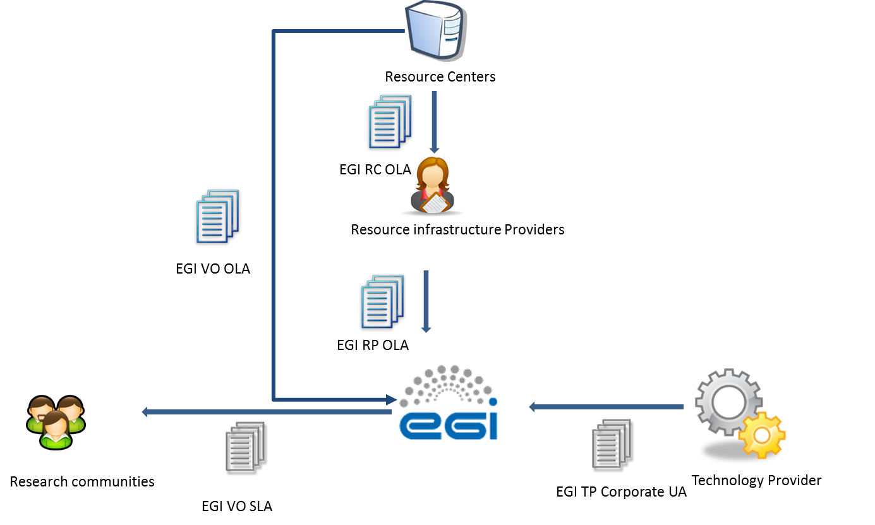

The figure above illustrates the process to negotiate the SLAs/OLAs that engages providers, EGI.eu and the research communities.. EGI negotiates centrally the SLA with the research communities, liaising with the NGIs/EIROs and the resources centres The outputs of this internal negotiation are the VO-specific OLAs who are extending the RC OLA and RP OLA, these documents support the VO SLA, ensuring that the targets of this last agreement are fulfilled by the service providers.
Another area the project has been improving is suppliers and customer relationship management where suppliers and customers for each service have been identified and unified approach has been defined to manage performance, satisfaction and complains.
To support production tools release and deployment process a new procedure is in preparation which aims to define steps that needs to be performed before new release of services under Software and Service Platforms category can be introduced into production infrastructure. Thanks to this procedure it will be ensured that each release is properly tested and documented, and will not impact the Infrastructure in a negative way.
In the coming year EGI will work towards implementation of the remaining processes defined in the FitSM standard:
- Service Reporting Management
  - Defining all service reports and ensure they are produced according to specifications in a timely manner to support decision-making.
- Service Availability & Continuity Management
  - Ensuring sufficient service availability to meet agreed requirements and adequate service continuity in case of exceptional situations
- Capacity Management
  - Ensuring sufficient capacities are provided to meet agreed service capacity and performance requirements.
- Information Security Management
  - Managing information security effectively through all activities performed to deliver and manage services, so that the confidentiality, integrity and accessibility of relevant information assets are preserved
- Problem Management
  - Defining way to investigate the root causes of (recurring) incidents in order to avoid future recurrence of incidents by resolving the underlying problem, or to ensure workarounds / temporary fixes are available
- Configuration Management
  - Defining way to provide and maintain information about all services and their relationships and dependencies
- Change Management
  - Ensuring changes to the services are planned, approved, implemented and reviewed in a controlled manner to avoid adverse impact of changes to services or the customers receiving services

The evolution of the security operations
Security operations, policies, procedures and best practices, have been evolved during PY1 to meet the requirements of new trust models, new developments and new usage scenarios of EGI services. As usual, developments in policies and procedures have been driven by risk assessment of the security requirements and trust models of the new EGI services, including the use of Federated Identity Management, the EGI Federated Cloud platform and the services for the Long Tail of Science.
In this section we present the results achieved so far and the planned ones to take place in PY2.

Security policies
A meeting of the EGI Security Policy Group at the start of EGI-Engage considered which security policies were most in need of revision to address the new EGI-Engage services. It was decided that the "Grid Acceptable Use Policy" and "The Security Policy for the Endorsement and Operation of Virtual Machine Images" [ENDSP] should be addressed by EGI-Engage in its first year. This work has been done in parallel with the production of new policies for the Long Tail of Science service (LToS) allowing for a simplified identity vetting procedure for users that do not belong to a community VO, and of a draft of a new general policy addressing Data Protection issues. All of this policy work is required to ensure managerial controls on the operation of new services developed in EGI-Engage, thereby mitigating the related security risks.
The new AUP, now called "Acceptable Use Policy and Conditions of Use" [AUP], has been generalised to include all EGI service offerings (Grids, Clouds, LToS, etc.). At the same time wording was changed to require appropriate acknowledgement of use of resources and support in publications. The policy on VM Endorsement has been modified to better fit the policy and trust issues in the EGI Federated Cloud service. The new policy may be found at [Ref: https://documents.egi.eu/document/2729].
A large number of users and communities would benefit from expanded use of credentials based on Federated Authentication (“FedAuth”) for accessing services instead of employing personal certificates either installed in browsers or used to create proxy certificates. Secure use of FedAuth on the infrastructure relies on two capabilities:
a) A translation of FedAuth credentials to a form understood by the services, and b) some agreed mechanism to retain the current credential assurance levels and confidence in identity vetting. In this context, it is important to realize that user communities may be structured in different ways, and that, depending on the internal structure, coherence, and level of organization of the user community, it may or may not be able to provide user traceability, assurance, or identity vetting. Of the many user communities supported by EGI, only a small sub-set is so stringently organized as to be able to independently perform high-assurance identity vetting. In other cases (in particular in the context of the specific provisions for the Long Tail of Science), EGI centrally takes a responsibility of providing higher-assurance identity and traceability information independent of the user community. In the majority of cases, the communities actually rely on external identity vetting information in enrolling their members.
Only for highly organized communities, and for those cases where EGI independently provides assurance, FedAuth can be leveraged early since only minimal information (a persistent non-reassigned identifier) is needed from the identity providers in the FedAuth infrastructure. For those cases, and for the first concrete implementation of a prototype around the ‘Federated Identity Management for Research’ (FIM4R) pilots (e.g. the WLCG WebFTS use case), a co-existence model and policy needs to be in place in order to support both these highly structured as well as the more dynamic communities on the same infrastructure. To advance the development of a coordinated trust policy that will in the future be able to more dynamically accommodate differentiated trust models, WLCG in collaboration with EGI has developed a co-existence model and evolution for a sustained implementation. This model was developed with support from EGI-Engage and is documented in the evolving document “Considerations on the coexistence of controlled and flexible community models” [DIFFTRUST].
Also the “Long Tail of Science” specific policy leverages differentiated and redistributed responsibilities. Here the policy distributed specific elements of the end-to-end risk assessment to the registrars within the EGI community, the centralized “User Management Portal” of the EGI LToS service, and the participating resource centres, aiming to contain any residual risks exposed through the LToS service towards other, non-participating resource centres and NGIs. The policy aims to enable a low-barrier Service to be offered to a wide range of research users in Europe and their collaborators world-wide, by any Resource Centre organisation that elects to do so. In offering such LToS Services, the Resource Centre shall not negatively affect the security or change the security risk of any other Resource Centre or any other part of the e-Infrastructure. In particular, security incidents originating in the LToS Service should not impact the IT Infrastructure in ways that are incompatible with the operational model of other, more tightly controlled, parts of the infrastructure. This document also provides guidelines on the implementation of security procedures and controls to facilitate offering of the Service by Resource Centres and Science Gateways.
The Guidelines [LTOSSP] also contain normative information on how to implement the Policy.
A version of the new AUP specific to LToS has also been produced and adopted [LTOSAUP].
Future work on security policies during year 2 of the project will be aimed at making other additional policies more applicable to the new EGI-Engage use cases. This will include a revision of the top-level overall Security Policy document and a revision of the Virtual Organisation Membership Management Policy to apply to the wider range of user communities now being addressed in EGI-Engage.

Security procedures
In order to provide efficient Operational Security in evolving infrastructures the security procedures constantly have to be developed further.
The technological aspect of the procedure development aims to exploit new possibilities in incident response required by the newly integrated technologies. In addition the new players (e.g. cloud resource providers) have to be integrated into the overall incident response concept. This activity is reflected in the EGI CSIRT Security Incident Handling Procedure. This procedure was presented to OMB for approval.
To maintain a properly patched infrastructure and make sure that CRITICAL Vulnerabilities are handled adequately by all involved entities the EGI-CSIRT Critical Vulnerability Handling procedure was further developed. This procedure is currently in draft, here the new developed supporting policies (e.g. [ENDSP], see above) need to be approved.
In addition to the procedure development, also security monitoring and incident response tool development will be addressed in project year 2. The aim is to be able to monitor and enforce the policies developed here and to preserve the central user management capabilities as for the extended set of services provided by EGI. The EGI Software Vulnerability group vulnerability issue handling procedure has been revised and approved by the EGI Operations Management board.
Previously during EGI-InSPIRE the main focus of the EGI issue handling was on the Grid Middleware distributed in the EGI UMD, and additionally to assist EGI CSIRT in the risk assessment of other software vulnerabilities, mainly in the Linux operating system. Technology is changing, in particular related to the emergence of the EGI Federated cloud. A much wider variety of software is in use such as Cloud enabling software, software within VMs, VMs themselves, VO specific software. SVG cannot control what software is in use. Some of this software is commercial; produced by large or small companies or organisations. Some is produced by EGI partners. Some software is released in the EGI UMD by resource providers with which EGI has a service level agreement, some such as operational tools for EGI infrastructure is released by the EGI team, as well as VOs, which take their software from a much wider variety of sources. This means we needed to revise the way we minimize risk arising from software vulnerabilities to the EGI infrastructure.
The advisory template has also been revised, taking account of comments from various site administrators, including so that the basic information and what is required of sites is displayed in the e-mail preview page and to make it more mobile friendly.
It has been found that various Virtual Organisations and user groups have been developing or using software which is not as secure as we would like, or configured in a way that is not secure or compliant with policy. Also this wider variety of software means the SVG cannot be experts on much of the software deployed in the EGI infrastructure. For this reason we included a Software security Checklist to help those who are developing or selecting software avoid some of the most common problems. This has been made available on the EGI Wiki
For technology on which the EGI federated cloud heavily relies, a Technology Provider questionnaire was produced to ensure that the technology is reasonably secure and suitable for use in the EGI infrastructure. The idea is that this questionnaire is filled in for any technology which is deployed on the EGI infrastructure, and on which EGI relies. This provides some assurance that at least at the time this questionnaire is filled in, it does not contradict EGI security policy. It is not a full security analysis of the software. This questionnaire may be filled in by the developers, which is the case for software being developed for use on our infrastructure. Or it may be filled in by someone who is selecting a technology, or who has expertise in that technology in EGI.
A version of the Technology provider questionnaire was approved at the EGI Operations management board in September 2015.

Security risks assessment
EGI Security Threat Risk assessment with focus on the EGI Federated cloud and the changing EGI environment is being carried out at the time of writing and is near completion. A similar approach to that in 2012 is being carried out. First a team of people to carry out the work was established, this included people from CSIRT, the Sosftware Vulnerbility Grou, the EGI Federated cloud, Security Policy Group, and others. Then a draft set of threats was produced, starting from the list from 2012 but adding new ones both from general experience since then and those associated with Virtualization and the Federated Cloud. These threats were divided into various categories, and members of the team were asked to take one or two categories each and improve on them, and provide a description of or update the current situation. Then the team were invited to comment, add others. A list of 103 threats was produced, in 18 different categories. Then all members of the team were invited to provide their opinion on the 'likelihood' and 'Impact' of each threat, according to certain guidelines. In all 10 members of the team returned a spreadsheet with their opinion of likelihood and impact, and the average risk was computed from this. At present, the report is being prepared, including suggestions for mitigation of some of the highest risk threats, and is due shortly.

Roadmap for the EGI production infrastructure
The roadmap for the EGI Operations is developing in two directions:
- Consolidating the current production services, increasing their performances, and their reliability, with the final goal of improving the user experience.
- Integrating in the production infrastructure the new platforms and services that are produced by the EGI-Engage project, and other activities related to EGI.
These two main themes are described in detail in the next sub-sections.

Consolidating current production services
The production services of EGI must continue to evolve with the goal to improve the user experience. All services are periodically assessed to understand where there are issues degrading the quality of service perceived by our users. The HTC services, considering the longer experience, have reached a good maturity level, with a considerably decreasing number of issues also helped by the fact that the middleware software is not being updated frequently, with major changes.
The federated cloud services are in production for less than two years at the moment of writing, and although in constant improvement the quality of the service provided to the user is not very uniform being dependent on local configurations and settings, and then can thus vary much depending on the service provider used at the moment.
This is caused primarily by the following main reasons:
- Non complete documentation for the service providers
- Non complete testing of all the capabilities by monitoring
- Lack of integration with the cloud management system of the federated cloud extensions
- Lack of proper software and release management of the “plugins” developed by EGI for the cloud management system
This is how these issues will be tackled.
Documentation.
At the moment the documentation is fairly complete, what is partially missing is a top-down structure, that would lead the cloud sites from the first approach to EGI through the integration and certification process. In particular documentation should highlight the different deployment scenarios in order to help the cloud provider in choosing the best architecture to federate with EGI. A restructure of the documentation is being carried out at the moment of writing.
Monitoring
The automatic monitoring of the services is covering the basic functionalities of the services, for example virtual machine instantiation and removal. The user experience can though be affected by a number of other factors. One example is the availability of the virtual machine images, or advanced contextualization features, that are needed by the use cases, whose distribution at the moment are not monitored.
The current plan is to start a detailed assessment of the status of the sites in the federated, through manual testing actually replicating the work of the users, at least touching most of the functionalities expected by users. This will achieve two results: sites with issues will be asked to fix their issues, and recurring issues will generate monitoring probes that are closer to user intended behaviour.
Integration testing with the cloud management system and software packaging.
At the moment, to federate private clouds, EGI is developing and maintaining a set of extensions to the community based cloud management system (e.g. Open Stack and open Nebula). Maintaining these components requires keeping the compatibility with the new version of the cloud management system, and make the EGI development available to the site managers who need to install them.
The integration tests with new CMS are currently implemented with some of the components, for example the OCCI integration with OpenStack is tested by the developers as soon as a new version of OpenStack is pre-released by the OS collaboration, but other components are not validated with the new releases of the main CMS, not with a reliable and repeatable process at least. This will have to improve with dedicated testbed resources, and automated testing procedures to validate new developments on both sides (EGI and the CMS).
Good testing of new releases will be the main building block for a proper distribution of the releases to the EGI sites. The distribution in UMD, or equivalent process, of the federated cloud components will force the developers to achieve: proper packaging and testing, clear documentation, plus a trusted single entry point for the download of the federating software.

Besides the federated cloud, another improvement deployed in the coming months is a centralized monitoring, that will free the NGIs from the burden of deploying a dedicated Nagios instances to submit probes to their sites, by deploying a centralized group of Nagios services that can support the whole infrastructure. This will reduce the maintenance cost of the Nagios services, and at the same time it will make much more flexible the monitoring system, which will not require a deployment campaign of a new version to add new probes or similar changes that now require NGIs intervention.

Integrating new services in production
In order to integrate new services in EGI, some prerequisites must be fulfilled:
- Technical support for the EGI AAI infrastructure
- Support for the EGI Accounting infrastructure, if relevant
- Monitoring probes to be integrated with the EGI monitoring infrastructure
- Fulfilment of EGI security policies
In some cases, it is acceptable to have a roadmap for the development of the requirements above, if the services need to be quickly integrated and made available to the users. Service provider must sign an OLA with EGI, where the targets for the service are defined.
Besides technical integration, EGI must ensure that the quality of the software supporting the services is production-ready. This is implemented by ensuring the software support by the developers, through an underpinning agreement, as described in section 2.4 and through the software quality assurance process described in section 2.3.
In EGI-Engage a number of services are being developed. Many Competence centres (CC) will integrate high-level discipline specific services targeting the represented communities. These services, or part of them, will be technically integrated and offered as EGI services to a wider community. This is one of the changes foreseen for the EGI production infrastructure, the users will not only access the resources, through services providing plain computing or storage, but will use also platforms that, underpinned by EGI resources, will provide high level services.
The new platforms can be of different level of abstraction, from a PaaS to a Virtual Research Environment, operated by EGI partners, or by the VOs.
To support these new platforms, EGI Operations must focus the effort in different directions, for example to develop the security policies and processes to assess the policy compliancy of the new technologies and access paradigms, and to properly react to any security issue that could involve the new platform, as it is done for every EGI service.
At the moment the operational infrastructure is hierarchically organized in NGIs/EIROS and resource centres. Every service is provided by a resource centre, and every resource centre is connected to an NGI. If EGI integrates services offered by other entities, e.g. communities or external providers, the hierarchical structure will have to be extended to include in the operational framework other entities providing services part of the EGI portfolio.
While the technical implementation of monitoring should not change from any development done for the current services, the reporting, how the monitoring results are used, will have to change. Currently any deviation in performance is handled by the NGI and by the site staff, but adding on top of these services a platform operated by – let’s say – a VO, introduces a new level of complexity. Availability of the platform can be monitored and reported, to the entity operating the service, as well as the supporting resources, can be monitored and reported to the resource centres operating the resources.
The development of the EGI Marketplace will push the boundaries of the scenario described above. On top of what the CCs will integrate in EGI, through the marketplace a number of new services will be added. While at the moment of writing the structure and the policies behind the marketplace are not yet defined, we can anticipate that the services accessible through the Marketplace will be very diverse, for example in the form of virtual appliances and datasets. As every service provided by EGI, Operations will have to work with the providers in order to understand how service availability can be monitored, reported, and how targets should be set, and ultimately upon which events EGI Operations can remove a service from production, preventing users to access it. Moreover, at least a subset of the services in the marketplace will have to be monitored and the status information be made available to the users who want to access them.
The evolution of the AAI infrastructure, under the JRA1 work package, is one of the topics of EGI-Engage with the biggest impact on operations at all levels. The most important impact is the new capabilities offered to the users, who will be able to use their institutional credentials to access EGI, and this will affect all the layers of the production infrastructure. Once the AAI layer will be enabled for federated authentication the current EGI services must implement the support for the new authentication services.
Ultimately, AAI layer is composed by a number of components that need to be rolled in production, and integrated in the set of core services provided by EGI to our stakeholders. The deployment of these production instances must be planned, and appropriate resources be allocated, but also the components must be monitored and supported by appropriate OLAs and policies to be production-ready.
The other big change that is being introduced by EGI-Engage is the Open Data Platform. Similarly to other new services, the outputs of the JRA2 work package will have to be integrated in the operations framework. But beside the operational details, the new set of services of the open data platform will be a big shift in the EGI service provisioning, adding to the current one, compute-centric, a new data-centric resource provisioning. Users will be able to use EGI as a data infrastructure, and use computing associated to data. These features will be supported by appropriate monitoring and accounting, and offered through the marketplace.
Some of the current and the new services will be also offered through the long tail of science, as described in [D5.2], which is an access mode to get basic services, and limited resources, without the overhead of setting up a virtual organization, or ask for a grant of resources. The long tail of science access mode can be also considered a tool to offer a “try before you buy” mode, that could consequently evolve in a long-term collaboration with a community.
Ultimately EGI production infrastructure will hopefully incorporate also the outputs of other activities with a strong collaboration with EGI, such as the INDIGO DataCloud project, which will release both infrastructure/service providers oriented developments and PaaS and SaaS for the user communities.

References
GLO, EGI Glossary: https://wiki.egi.eu/wiki/Glossary
RCOLA RC Operations Level Agreement: https://documents.egi.eu/document/31
AUP Acceptable Use Policy https://documents.egi.eu/document/2623
ENDSP: https://documents.egi.eu/document/771
DIFFTRUST: https://documents.egi.eu/document/2745
LTOSSP: https://documents.egi.eu/document/2734
LTOSAUP: https://documents.egi.eu/document/2635
GLO: https://wiki.egi.eu/wiki/Glossary

http://fitsm.itemo.org/
https://documents.egi.eu/document/2374
https://documents.egi.eu/document/2550
https://wiki.egi.eu/wiki/Glossary#Resource_Centre
At the moment of writing the status of the desktop grid operations centre – offering volunteer computing – is on hold, since the leading institution asked for decommissioning but the procedure has not been finalized yet.
https://documents.egi.eu/document/31
https://w3.hepix.org/benchmarks/doku.php
In the GSTAT monitoring tool, based on th
https://wiki.egi.eu/wiki/PROC09
Solutions for federated object storage management as additional new capabilities are being tested.
https://wiki.egi.eu/wiki/Federated_Cloud_Architecture
https://appdb.egi.eu/
https://github.com/hepix-virtualisation/vmcaster
http://glue20.web.cern.ch/glue20/
http://accounting.egi.eu/egi.php
“Others” is a category of user communities that do not belong to the other disciplines that are part of the current classification. The scientific discipline classification of EGI is being reviewed.
https://wiki.egi.eu/wiki/Scientific_Disciplines
https://wiki.egi.eu/wiki/Documentation
http://fitsm.itemo.org/
Documentation about vmcatcher/caster: https://github.com/hepix-virtualisation/vmcatcher https://github.com/hepix-virtualisation/vmcaster
EGI BILS VO SLA and OLAs https://documents.egi.eu/public/ShowDocument?docid=2701
https://documents.egi.eu/public/ShowDocument?docid=31
https://documents.egi.eu/public/ShowDocument?docid=463
: https://wiki.egi.eu/wiki/SEC01
[ref: https://wiki.egi.eu/wiki/SEC03]
https://wiki.egi.eu/wiki/SVG:Software_Security_Checklist

