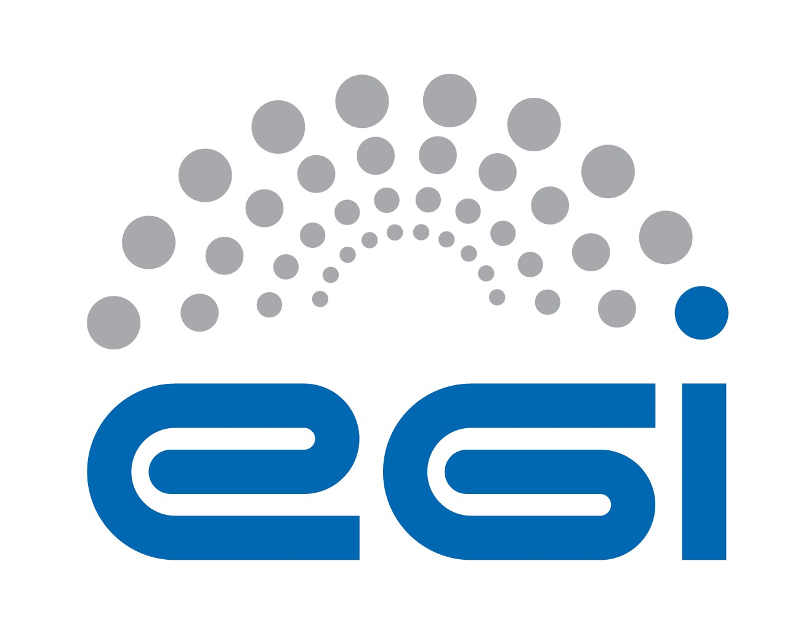
Resource Centre
Operational Level Agreement

Customer | Resource infrastructure Provider
Provider | Resource Centre
Service | High-Throughput Computing Platform and/or Cloud Computing Platform services
Version | 2.1
Document Link: | https://documents.egi.eu/document/31
- Copyright notice
Copyright © EGI.eu. This work is licensed under the Creative Commons Attribution-NonCommercial-NoDerivs 3.0 Unported License. To view a copy of this license, visit http://creativecommons.org/licenses/by-nc/3.0/ or send a letter to Creative Commons, 171 Second Street, Suite 300, San Francisco, California, 94105, USA.
The work must be attributed by attaching the following reference to the copied elements: “Copyright © EGI.eu (www.egi.eu). Using this document in a way and/or for purposes not foreseen in the license, requires the prior written permission of the copyright holders. The information contained in this document represents the views of the copyright holders as of the date such views are published.

This OLA is based on a template that forms part of the FitSM family – a lightweight standard for IT Service Management that supports federated infrastructures. For more information on FitSM visit www.fitsm.eu or contact info@fitsm.eu. The template this document is based on was licensed with a Creative Commons Attribution 4.0 International License.

This OLA is based on FitSM Template: SLA v1.0.
TABLE OF CONTENTS
1 Introduction 4
2 Scope and description of the services 4
3 Service hours and exceptions 4
4 Services components 4
5 Support 5
5.1 Incident handling 5
5.2 Fulfilment of service requests 5
6 Service level targets 6
7 Limitations & constraints 6
8 Communication, reporting & escalation 6
8.1 General communication 6
8.2 Regular reporting 6
8.3 OLA violations 7
8.4 Complaints 7
9 Information security & data protection 7
10 Additional responsibilities of the provider 7
11 Customer responsibilities 8
12 Review 9
13 Glossary of terms 10
14 References 11

Introduction
This agreement is made between Resource Centre (the Provider) and Resource Infrastructure Provider (the Customer) to cover the provision and support of the service as described hereafter. The relevant contacts and representatives may be found in section 8.1.

Once approved, this Agreement is valid for as long as the Provider is part of the EGI production infrastructure, i.e. until the Provider registered in the central configuration repository GOCDB with ‘Infrastructure’ status equal to “Production”, is not turned into “Closed” status [GOC].
The Provider retains the right to terminate the Agreement at any time. If parties agree to end the Agreement, then the Provider is no longer part of EGI Infrastructure.

The OLA is a document discussed and approved by the EGI Operations Management Board (OMB) [OMB]. Amendments, comments and suggestions must be addressed by the Customer to the OMB by opening a GGUS [GGUS] ticket to the Service Level Management (SLM) support unit. The Customer will promptly inform the Provider about changes introduced to the requirements, service levels and targets defined in this document, and will ensure that the impact of the changes is understood.

Scope and description of the services

This OLA applies to High-Throughput Computing Platform and/or Cloud Computing Platform services.

Service hours and exceptions
The service operates during the following hours:
Twenty four hours a day, seven days a week, 365 days a year.

The following exceptions apply:
- Planned maintenance windows or interruptions.
To be communicated in a timely manner i.e. 24 hours before, to the Customer through the Broadcast Tool [BT]. Duration must not exceed period of 1 month, otherwise justification needs to be provided.

Services components
This service includes the following components:
High-Throughput Computing Platform
  - Grid compute - allows scientists to run computational tasks on high quality IT resources, accessible via a standard interface and supporting authentication/authorisation based on a membership within a virtual organisation.
  - Grid storage - allows files to be stored in and retrieved from high quality IT resources, accessible via a standard interface and supporting authentication/authorisation based on a membership within a virtual organisation.
Cloud Computing Platform
  - Cloud compute - is an Infrastructure-as-a-Service for the scientific community. The service allows scientists to allocate virtual servers on demand, with customisable set of hardware, network and storage resources.
  - Cloud storage - is an Infrastructure-as-a-Service for the scientific community. It allows end-users and service providers to store files, images and other generic objects that can be accessed from any device with integrated basic processing capabilities.

Support

Support is provided via the GGUS portal [GGUS], which is the single point of contact for infrastructure users to access the EGI Service Desk. The EGI Service Desk within GGUS is organized in Support Units. Every Support Unit is responsible for one or more services.

Service communication support is available:
- between Monday and Friday
- 8h a day during the regular working hours of supporting organization

This excludes public holidays of the supporting organization.

Incident handling
Disruptions to the agreed service functionality or quality will be handled according to an appropriate priority based on the impact and urgency of the incident. In this context, the following priority guidelines apply:
- Three service priorities are defined and the incidents handled related to them through the GGUS system. These are base, medium and advanced.
- The following support priority applies to the service: Medium

- The Provider SHOULD endeavour to resolve incidents within five working days.

Medium support component priority is as follow:
Ticket Priority | Response time
Less urgent | 5 working days
Urgent | 5 working days
Very Urgent, | 1 working day
Top Priority | 1 working day

Fulfilment of service requests
In addition to resolving incidents, standard service requests (e.g. change or information request, documentation) will be fulfilled through the defined support channels in section 5. Response and fulfilment times are provided as service level targets (see section 6).

Service level targets
All targets are per month if not stated otherwise.

The following are the agreed service level targets:

Service level parameter | Target
Availability | Minimum 80% (as a percentage per month)
Reliability | Minimum 85% (as a percentage per month)
Unknown | Maximum 10% (as a percentage per month)
Support priority | Medium (as defined in 5.1)

Limitations & constraints
The provisioning of the service under the agreed service level targets is subject to the following limitations and constraints:
- Support is provided in following language: English
- Downtimes caused due to upgrades for fixing critical security issues are not considered OLA violations.
- Failures in the normal operation of the service caused by failures in service provided by the Customer are not considered OLA violations.
- Force Majeure. A party shall not be liable for any failure of or delay in the performance of this Agreement for the period that such failure or delay is due to causes beyond its reasonable control, including but not limited to acts of God, war, strikes or labor disputes, embargoes, government orders or any other force majeure event

Communication, reporting & escalation

General communication
The following contacts will be generally used for communications related to the service in the scope of this OLA:
- Customer contact for the Provider: NGI Operations manager in respective NGI [NGOC]
- Provider contact for the Customer: Site Operations manager in respective Site [SGOC]

Regular reporting

Reports of the Provider availability, reliability and unknown statistics will be performed on a monthly basis at [AVREL].
The Provider violating the service parameters specified in Section 6 will be requested to provide justifications by the Customer. The violating provider MUST provide a report. Information is exchanged through GGUS [GGUS] ticket.

OLA violations
The Provider commits to inform the Customer, if this OLA is violated or violation is anticipated. The following rules are agreed for communication in the event of OLA violation:
In case of violating the service targets specified in this document for three consecutive months it is requested to provide justifications and a plan for service enhancement. The Provider must submit a status report and a plan for the improvement of the service within 10 working days from the date of notification to the Customer. In case of no or not satisfactory justification EGI.eu can remove (suspend) the Provider from infrastructure.

Complaints
For complaints, the defined Provider contact (see section 8.1) point shall be used, and the following rules apply:
- Complaints should be directed to the customer contact (see section 8.1).
- The provider contact (see section 8.1) will be contacted in case of received complaints.

Information security & data protection
The following rules for information security and data protection apply:
- The Provider must define and abide by an information security and data
protection policy related to the service being provided.
- This must meet all requirements of any relevant EGI policies or procedures [POL] and also must be compliant with the relevant national legislation.

Additional responsibilities of the provider
Additional responsibilities of the Provider are as follow:
- Adhere to all applicable operational and security policies and procedures defined in [POL] and to other policy documents referenced therein;
- Use communication channel defined in the agreement (see section 8.1);
- Provide access to a minimum set of Capabilities as follows:
  - at least one local or remote service to publish information on the Functional Capabilities provided into the site Information Discovery System (e.g. site-BDII);
  - at least one Functional Capability (e.g. Cloud Computing, File Transfer, Storage Management, Data Access, Metadata Catalogue, Compute, additional Information Discovery capability).
    - If the Compute Capability is provided, then also Storage Management (either local or off-site) is needed. (Not applicable for Cloud Platform);
  - Accounting Capability to be accounted centrally.
- Ensure the accuracy of the information in GOCDB [GDB]:
  - The Provider contact details (name, phone number, e-mail address) of a set of contact points for security, operational and administrative emergencies;
  - Components of the service are registered;
  - The services that are offered by the Provider must be specified;
- Enable and support
  - the OPS VO and DTEAM VO;
  - at least one either national or global non-monitoring/troubleshooting user group (e.g. managed using an interoperable VO management service), which must be registered in the Operations Portal [OP].
    - The Provider is encouraged to support as many user groups as needed. Specific agreements between the Provider and individual user groups are covered in separate agreements.
- Enable
  - service monitoring, performed by the Resource Infrastructure Provider,
  - central security monitoring, performed centrally by EGI.eu,
  - testing and troubleshooting from outside.
- Ensure
  - at least oneError: Reference source not found system administrator reachable during working hours of supporting organization;
  - sufficient computational and storage resources and network connectivity to support the proper operation of its services, as indicated by passing all relevant Monitoring Service tests.
  - the provisioning of services in itself not create any intellectual property rights in software, information and data provided to the services provided by the Provider, or in data generated by the services provided;
- Operate UMD-compliant Middleware supported by the Customer – applicable for High-Throughput Computing Platform.
  - The Provider is encouraged to stay abreast of updates in order to benefit from the latest improvements and features.

Customer responsibilities
The responsibilities of the Customer are:
- Collect requirements from the Provider and raise any issues deemed necessary by the Provider to the attention of EGI and to ensure that these issues are properly dealt with;
- Raise any issues deemed necessary to the attention of the Provider;
- Register the Provider and its administrators in GOCDB and in the available helpdesk facilities as applicable;
- Provide first and second-level support by helping in the resolution of advanced and specialised operational problems that cannot be solved by the Provider;
  - If necessary, the Customer will propagate and follow-up problems with higher-level operational or development teams;
- Monitor progress of incident and problem records and to ensure that the Provider works on records opened against them;
- Respond to incident and problem records from the Provider in a timely manner;
- Provide the operational services defined in Resource infrastructure Provider OLA [RPO] and ensure their interoperation with the EGI.eu ones as applicable;
- Provide monitoring to measure fulfilment of agreed service level targets.
- Coordinate and support the deployment of UMD-compliant middleware by the Provider;
- Coordinate local operational security activities and provide operational security support;
- Support coordination with other Providers;
All responsibilities of the Customer are listed in Resource infrastructure Provider Operational Level Agreement document [RPO].

Review
There will be reviews of the service performance against service level targets and of this OLA at planned intervals with the Customer according to the following rules:
- At least on yearly basis (more frequently if required);
- At the Operations Management Board (OMB) meeting

Glossary of terms
For the purpose of this OLA, the following terms and definitions apply:
[The key words "MUST", "MUST NOT", "REQUIRED", "SHALL", "SHALL NOT", "SHOULD", "SHOULD NOT", "RECOMMENDED", “MAY", and "OPTIONAL" in this document are to be interpreted as described in RFC 2119. For a complete list of term definitions see the EGI Glossary (http://wiki.egi.eu/wiki/Glossary).

References
[BT] | Broadcast Tool  https://operations-portal.egi.eu/broadcast
[GDB] | GOC DB  http://goc.egi.eu/
[GGUS] | EGI Helpdesk  http://helpdesk.egi.eu/
[GLO] | EGI Glossary  http://wiki.egi.eu/wiki/Glossary
[NGOC] | List of National Grid Initiatives in GOC DB  https://goc.egi.eu/portal/index.php?Page_Type=NGIs
[OMB] | Operations Management Board  https://wiki.egi.eu/wiki/Operations_Management_Board
[OP] | Operations Portal  http://operations-portal.egi.eu/
[AVREL] | Monthly reports of the Provider availability and reliability statistics  https://wiki.egi.eu/wiki/Availability_and_reliability_monthly_statistics
[POL] | EGI policies and procedures  https://www.egi.eu/about/policy/policies_procedures.html
[RPO] | Resource infrastructure Provider OLA  https://documents.egi.eu/public/ShowDocument?docid=463
[SGOC] | List of Sites in GOC DB  https://goc.egi.eu/portal/index.php?Page_Type=Sites

