EGI-InSPIRE

NGI International Task Review

EU MILESTONE: MS109

Document identifier: | input.doc
Date: | 16/05/2011
Activity: | NA1
Lead Partner: | EGI.eu
Document Status: | FINAL
Dissemination Level: | PUBLIC
Document Link: | https://documents.egi.eu/document/315

Abstract
The National Grid Initiatives within the European Grid Infrastructure undertake a number of specific tasks in the areas of operations, user support, dissemination and policy that interface with the central coordination provided by EGI.eu. The undertaking of these tasks is self-assessed by the parties undertaking the work by identifying issues that need to be addressed and by scoring their performance. The raw responses are documented and an analysis of common issues provided in this document.

- Copyright notice
Copyright © Members of the EGI-InSPIRE Collaboration, 2010. See www.egi.eu for details of the EGI-InSPIRE project and the collaboration. EGI-InSPIRE (“European Grid Initiative: Integrated Sustainable Pan-European Infrastructure for Researchers in Europe”) is a project co-funded by the European Commission as an Integrated Infrastructure Initiative within the 7th Framework Programme. EGI-InSPIRE began in May 2010 and will run for 4 years. This work is licensed under the Creative Commons Attribution-Noncommercial 3.0 License. To view a copy of this license, visit http://creativecommons.org/licenses/by-nc/3.0/ or send a letter to Creative Commons, 171 Second Street, Suite 300, San Francisco, California, 94105, and USA. The work must be attributed by attaching the following reference to the copied elements: “Copyright © Members of the EGI-InSPIRE Collaboration, 2010. See www.egi.eu for details of the EGI-InSPIRE project and the collaboration”. Using this document in a way and/or for purposes not foreseen in the license, requires the prior written permission of the copyright holders. The information contained in this document represents the views of the copyright holders as of the date such views are published.
- Delivery Slip
 | Name | Partner/Activity | Date
From | Steven Newhouse | EGI.eu/NA1 | 24/02/2011
Reviewed by | AMB | EGI.eu | 02/05/2011
Approved by | AMB & PMB |  | 14/05/2011
- Document Log
Issue | Date | Comment | Author/Partner
1 | 24/02/2011 | Table of Content | Steven Newhouse, Sergio Andreozzi, Sy Holsinger, Tiziana Ferrari/ EGI.eu
2 | 05/04/2011 | First draft | Steven Newhouse et al.
3 | 20/04/2011 | Final version | Steven Newhouse et al.
- Application area
This document is a formal deliverable for the European Commission, applicable to all members of the EGI-InSPIRE project, beneficiaries and Joint Research Unit members, as well as its collaborating projects.
- Document amendment procedure
Amendments, comments and suggestions should be sent to the authors. The procedures documented in the EGI-InSPIRE “Document Management Procedure” will be followed:
https://wiki.egi.eu/wiki/Procedures
- Terminology
A complete project glossary is provided at the following page: http://www.egi.eu/about/glossary/.
- PROJECT SUMMARY
To support science and innovation, a lasting operational model for e-Science is needed − both for coordinating the infrastructure and for delivering integrated services that cross national borders.
The EGI-InSPIRE project will support the transition from a project-based system to a sustainable pan-European e-Infrastructure, by supporting ‘grids’ of high-performance computing (HPC) and high-throughput computing (HTC) resources. EGI-InSPIRE will also be ideally placed to integrate new Distributed Computing Infrastructures (DCIs) such as clouds, supercomputing networks and desktop grids, to benefit user communities within the European Research Area.

EGI-InSPIRE will collect user requirements and provide support for the current and potential new user communities, for example within the ESFRI projects. Additional support will also be given to the current heavy users of the infrastructure, such as high energy physics, computational chemistry and life sciences, as they move their critical services and tools from a centralised support model to one driven by their own individual communities. The objectives of the project are:

- The continued operation and expansion of today’s production infrastructure by transitioning to a governance model and operational infrastructure that can be increasingly sustained outside of specific project funding.
- The continued support of researchers within Europe and their international collaborators that are using the current production infrastructure.
- The support for current heavy users of the infrastructure in earth science, astronomy and astrophysics, fusion, computational chemistry and materials science technology, life sciences and high energy physics as they move to sustainable support models for their own communities.
- Interfaces that expand access to new user communities including new potential heavy users of the infrastructure from the ESFRI projects.
- Mechanisms to integrate existing infrastructure providers in Europe and around the world into the production infrastructure, so as to provide transparent access to all authorised users.
- Establish processes and procedures to allow the integration of new DCI technologies (e.g. clouds, volunteer desktop grids) and heterogeneous resources (e.g. HTC and HPC) into a seamless production infrastructure as they mature and demonstrate value to the EGI community.

The EGI community is a federation of independent national and community resource providers, whose resources support specific research communities and international collaborators both within Europe and worldwide. EGI.eu, coordinator of EGI-InSPIRE, brings together partner institutions established within the community to provide a set of essential human and technical services that enable secure integrated access to distributed resources on behalf of the community.

The production infrastructure supports Virtual Research Communities (VRCs) − structured international user communities − that are grouped into specific research domains. VRCs are formally represented within EGI at both a technical and strategic level.

- EXECUTIVE SUMMARY
This report provides a self-assessment of the NGI based tasks that take place within the EGI-InSPIRE project provided by the NGIs across the services they provide. This focuses primarily on the tasks taking place within NA2 (Policy & Dissemination), NA3 (User Support) and SA1 (Operations). These tasks are categorised into Human Services (coordination activities) and Infrastructure Services (technical activities to integrate the production infrastructure).

The assessment was undertaken by asking each NGI to complete a wiki table (https://wiki.egi.eu/wiki/NGI_International_Task_Review_MS109) that allows them to assess both in text and numerically as to how well they feel they have delivered these services, and to describe how they felt the service they provided could be improved in future years. These comments have been analysed by the relevant activity leader and summarised herein. A PDF version of this wiki based material is available [R2].

The establishment of NGI International Tasks across the operations, user support, dissemination and policy across infrastructure and human services has been largely successful. This has enabled activities to be devolved down to the national level and then federated together through the central coordination provided by EGI.eu.

However, this process has exposed some structural and resourcing weaknesses in some NGIs. The internal coordination that some NGIs are able to provide in the areas of policy and dissemination is particularly concerning – ineffectiveness in these areas will inhibit NGIs from reaching their true potential. The number of NGIs unable to provide responses to this survey, and many other activities during the year is a concern. The importance of effective management communication from EGI.eu to the NGIs, from the NGIs to EGI.eu, and between the NGIs, has become an area of concern and will be a focus for PY2.

TABLE OF CONTENTS
1 Introduction 7
2 Definitions 8
2.1 User Services 8
2.1.1 Human Services 8
2.1.1.1 Requirements Gathering 8
2.1.1.2 Application Database 8
2.1.1.3 Training 8
2.1.1.4 Consultancy 8
2.2 Operations 8
2.2.1 Human Services 8
2.2.1.1 Requirements Gathering 9
2.2.1.2 Operations Coordination 9
2.2.1.3 Security 9
2.2.2 Infrastructure Services 9
2.2.2.1 Software Rollout 9
2.2.2.2 Monitoring 9
2.2.2.3 Accounting 9
2.2.2.4 Configuration repository and Operations Portal 9
2.2.2.5 Helpdesk 9
2.2.2.6 Core Services 10
2.3 Other 10
2.3.1 Policy Development 10
2.3.2 Dissemination 10
3 Analysis 11
3.1 User Services 11
3.1.1 Requirements Gathering 11
3.1.2 Application Database 13
3.1.3 Training 13
3.1.4 Consultancy 13
3.2 Operations 13
3.2.1 Human Services 15
3.2.1.1 Requirements Gathering 15
3.2.1.2 Operations Coordination 15
3.2.1.3 Security 15
3.2.2 Infrastructure Services 15
3.2.2.1 Software Rollout 16
3.2.2.2 Monitoring 17
3.2.2.3 Accounting 17
3.2.2.4 Operations Portal and Configuration Repository 18
3.2.2.5 Helpdesk 18
3.2.2.6 Core Services 19
3.3 Policy Development 20
3.4 Dissemination 22
4 Conclusions 25
4.1 User Services 25
4.2 Operations 25
4.3 Policy 26
4.4 Dissemination 26
4.5 Summary 26
5 References 27

Introduction
This report provides a self-assessment of the NGI based tasks that take place within the EGI-InSPIRE project provided by the NGIs across the services they provide. EGI-InSPIRE targets the project’s effort into three areas: central coordination activities, activities in the NGIs to interface with this coordination activity, and explicit support for operational tools and heavy user communities. This report focuses primarily on the tasks taking place within the NGIs within NA2 (Policy & Dissemination), NA3 (User Support) and SA1 (Operations). These tasks are categorised into Human Services (coordination activities) and Infrastructure Services (technical activities to integrate the production infrastructure).

The assessment was undertaken by asking each NGI to complete a wiki table (https://wiki.egi.eu/wiki/NGI_International_Task_Review_MS109) that allows them to assess both in text and numerically as to how well they feel they have delivered these services, and to describe how they felt the service they provided could be improved in future years. The numerical scores are assigned on the basis of the overall level of satisfaction judged by the service provider:
- 0 = not applicable
- 1 = An unacceptable level of service was delivered
- 2= A level of service that was below expectations was delivered
- 3= An acceptable service level has been delivered
- 4= A level of service that exceeded expectations was delivered, but there is scope for even further improvement.
- 5= An excellent service has been delivered that should be considered as best practice
These comments have been analysed by the relevant activity leader and summarised herein. The completed wiki pages with the responses from the NGIs are available as a printable document (http://go.egi.eu/xgynr). The original NGI contributions will remain on-line for review.

The rest of this provides a definition of the NGI Services (section 3), and analysis of the NGI responses including a summary table (section 4) and finally common concluding issues for followup in the next project year (section 5).

Definitions
The NGI International Tasks are the responsibility of the individual NGI to deliver the task to a satisfactory level, funded through the NGI‘s own budget with currently a contribution from the EC through the EGI-InSPIRE project. Staff in EGI.eu is there to coordinate the staff undertaking the NGI International Tasks – they have no managerial control over them.

User Services
These are services that interact and expose with the end-user communities or their representatives within EGI.

Human Services
Human services are those that need to interact or coordinate with people, gathering opinions and views across the distributed community.

Requirements Gathering
While new requirements are gathered centrally, the collection of new requirements starts in the NGIs and EIROs. They have the contacts with the users and operations staff that are using or operating the EGI resources on a daily basis and can identify issues that need to be resolved.

Application Database
The application database provides a mechanism for users to discover which applications are in use, or are being ported to use the production infrastructure. NGI staff has a vital role to play in adding new entries and keeping entries up to date as they work with their respective user communities.

Training
Many NGIs are able to provide generic or specific training courses to help user communities use EGI resources. The training services (calendar, register of trainers and digital library) provide a means of enabling the coordination that NGIs need to do locally in collaboration with other NGIs to support particular user communities.

Consultancy
The staff within the NGIs represents an excellent source of local expertise for new users or new sites wishing to make use of e-Infrastructure. This expertise can be disseminated through training, but more frequently requires in depth one on one work with particular applications or user groups.

Operations
The Operations services are those directly related to delivering a high-quality production infrastructure to its user communities.

Human Services
Human services are those that need to interact or coordinate with people, gathering opinions and views across the distributed community.

Requirements Gathering
While new requirements are gathered centrally, the collection of new requirements starts in the NGIs and EIROs. They have the contacts with the users and operations staff that are using or operating the EGI resources on a daily basis and can identify issues that need to be resolved.

Operations Coordination
NGIs are responsible for coordinating internal operational activities and to participate to the OMB for coordination at the EGI level.

Security
NGIs contribute to software vulnerability assessment and to internal Computer Security Incident Response activities.

Infrastructure Services
Infrastructure Services operated at the NGI–level are needed to integrate and complement the Global Tasks operated by EGI.eu.

Software Rollout
While EGI.eu is responsible of the coordination and supervision of the process, individual Resource Centres are requested to participate as early adopters to staged rollout for proper verification of new deployed software releases in the production infrastructure.

Monitoring
The EGI Monitoring Infrastructure is distributed. The NGI Monitoring Infrastructure is responsible of running periodic functionality checks. Results are stored and displayed locally through NGI portals, and are collected centrally at an EGI-level to provide an overall view of the EGI Resource Infrastructure status.

Accounting
Usage records are collected by each Resource Centre. Depending on the customisable set-up chosen by the NGI, the data gathered can be directly published in the central databases, or alternatively can be persistently stored at an NGI level and summarised for publication at an EGI level. NGIs are responsible of the validation of the data gathered and to supervise the record publication process to make sure that records are regularly collected centrally.

Configuration repository and Operations Portal
Prototypes of the central configuration repository (GOCDB) and of the Operations Dashboard have been recently released for NGI deployment. These NGI tools are designed to allow for a greater level of customisation at an NGI-level. The deployment of such tools is currently optional.

Helpdesk
A NGI support system fully integrated with the central instance – GGUS – is often required to support local users and Resource Centre administrators. This is typically required by medium and large NGIs. For small-scale NGIs operating a limited number of Resource Centres, the local support system can be simply implemented centrally through a dedicated support unit.

Core Services
Core middleware services for user information discovery, authentication, workflow management, file cataloguing etc., are often provided by NGIs to support users and the local Infrastructure Services. The actual set of services operated can vary, and depends on the scale of the NGI and on the number of VOs supported.

Other

Policy Development
Local policy development activities are integrated with those taking place within the EGI.eu Policy Development Team that supports the development of policies and procedures at a European level. It is the local partner who implements policies and procedures locally. Therefore, most of the NGIs responsibilities include implementing EGI policies and procedures, developing EGI policies and procedures by participation in EGI policy groups, communicating with national governments and national research councils about policy priorities for the DCIs, establishing agreements with Resource centres, and drafting national policies and procedures that are in alignment with EGI ones.

Dissemination
This activity is coordinated by EGI.eu on behalf of the European NGIs and projects, and other international partners. The aim is to communicate the work of the EGI and its user communities and target audiences for the dissemination outputs to new and existing user communities, journalists, general public, grid research and standards communities, resource providers, collaborating projects, decision makers and governmental representatives. Means for dissemination include the project website, wiki site, materials and publications, media and public relations, social media channels and attendance at events in order to market EGI to new users.

Analysis

User Services
The survey asked NGIs to assess their achievements in four human services provided for user communities. Table 1 provides a summary of answers and marks received before publication.

Requirements Gathering
25 responses have been received to this category (zeros ignored), the average score is 3.08.
A transparent requirement processing system is needed so that the user or operations community can enter requirements, or to share them within the whole EGI community. All of the gathered requirements are investigated, analysed and prioritised within a transparent and structured process. The prioritised requirements can then be acted upon by other parties as appropriate. Depending on the domain and potential impact, identified needs might be met by the User Support Teams or Operations within EGI or by technology providers external to EGI be they community-based, project-based or commercial. The progress and outcomes of whichever solutions are adopted will be fed back to the requesting community on a regular basis.

The User Community Support Team (UCST) of EGI.eu with other EGI stakeholders has defined a transparent requirement gathering and processing workflow and earlier this year has setup a Requirement Tracker (RT) system that implements and supports the workflow. The operation of this RT system and the requirement management process are the responsibilities of EGI IT-support and UCST. NGIs, technology providers and user communities are involved in the process as (1) requirement submitters and/or as (2) solution providers.
- NGIs claim that they collected (and probably addressed) requirements, but often neither the requirements nor the solutions are visible at the international level (e.g. through RT, or some multi-level system).
- Most of the NGIs do not have any system to keep track of requirements and solutions. Should EGI open its RT system for this purpose for NGIs that wish to use it? A single system that provides national and international views could enable NGIs to collect requirements and to share these with the wider community if they wish.
- NGIs found it hard to engage with ESFRI communities. Although we hear that the EC wants such communities to use EGI, this does not seem evident on the ground. Better communications from the EC, or between the ESFRI management and EGI management would help improve.

Country | Any Response | Requirements gathering | Application Database | Training | Consultancy | Effort (PMs)
Albania | ✗ | - | - | - | - | 31
Armenia | ✗ | 3 | 0 | 2 | 3 | 6
Belarus | ✓ | - | - | - | -
Bulgaria | ✗ | - | - | - | - | 8
Bosnia and Herzegovina | ✓ | - | - | - | -
Croatia | ✓ | - | - | - | -
Cyprus | ✓ | 3 | 2 | 3 | 2 | 8
Czech Republic | ✗ | - | - | - | - | 28
Denmark | ✗ | - | - | - | - | 20
Finland | ✓ | 3 | 2 | 4 | 4 | 24
France | ✓ | 3 | - | 4 | - | 54
Georgia | ✓ | 3 | 0 | 2 | 3 | 6
Germany | ✓ | 3 | 3 | 5 | 4 | 66
Greece | ✓ | 3 | 4 | - | 4 | -
Hungary | ✓ | - | - | - | - | 32
Ireland | ✓ | 3 | 3 | 2 | 3 | 14
Israel | ✓ | 3 | 0 | 4 | 3 | 13
Italy | ✓ | 4 | 4 | 5 | 3 | 40
Latvia | ✓ | 3 | 2 | 3 | 4
Lithuania | ✗ | - | - | - | -
Macedonia | ✓ | 3 | 1 | 3 | 3
Moldova | ✓ | 2 | 3 | 3 | 3 | 9
Montenegro | ✓ | - | - | - | -
Netherlands | ✓ | - | - | - | - | 9
Norway | ✓ | 3 | 3 | 3 | 4 | 27
Poland | ✓ | 3 | 4 | 3 | 5 | 35
Portugal | ✓ | 3 | 3 | 4 | 4 | 28
Romania | ✓ | 2 | 2 | 2 | 3
Russian Federation | ✗ | - | - | - | - | 7
Serbia | ✓ | 4 | 4 | 5 | 4 | 16
Slovakia | ✓ | 3 | 2 | 3 | 3 | 38
Slovenia | ✓ | 4 | 2 | 3 | 4 | 19
Spain | ✓ | 2 | 3 | 3 | 2 | 27
Sweden | ✓ | 3 | 3 | 4 | 4 | 9
Switzerland | ✓ | 3 | 3 | 3 | 3 | 12
Turkey | ✓ | 4 | 3 | 4 | 4 | 36
Table 1: Responses from the NGI User Community Support Teams. Scores are from 0 (not applicable) to 5 (excellent), 'X' means no answer
UK | ✓ | 4 | 3 | 4 | - | 28

Application Database
21 responses have been received to this category (zeros ignored), the average score is 2.80.
The application database provides a mechanism for users to discover which applications are in use, or are being ported to use the production infrastructure. NGI staff has a vital role to play in adding new entries and keeping entries up to date as they work with their respective user communities.
- The database is still not known by every NGI and by every person who would benefit from this in the NGIs. More dissemination is needed, using different channels than before to make sure that the message gets to application/portal developers and to end users, the main beneficiaries of the service.
- Many of the applications ported by NGIs are very specific to the needs of a local group or individual and cannot be reused by other members of the EGI collaboration, OR the applications use commercial packages that cannot be offered to others. How could user communities move from commercial or custom software to generic reusable applications?

Training
23 responses have been received to this category (zeros ignored), the average score is 3.43.
Many NGIs are able to provide generic or specific training courses to help user communities use EGI resources. The training services (calendar, register of trainers and digital library) provide a means of enabling the coordination that NGIs need to do locally in collaboration with other NGIs to support particular user communities.
- Collaboration on training should be improved. The new features of the recently established Training Marketplace [R1] (defined by the NGI representatives participating in the Training working group) will hopefully improve the situation.
- E-learning is interested, but the production of e-training material requires either too much overhead to keep up-to date, or due to infrequent usage of tools the content would be constantly out-of-date. What are the topics on which e-learning material could be economically produced? What would be a simple way to produce and share e-learning content?

Consultancy
21 responses have been received to this category, the average score is 3.47.
The staff within NGIs represent an excellent source of local expertise for new users or new sites wishing to make use of e-Infrastructure. This expertise can be disseminated through training, but more frequently requires in depth one on one work with particular applications or user groups.
The NGIs are generally very satisfied with their service, although some expressed possibilities to improve:
- Interest to receive contacts of broad communities from EGI, so NGIs could approach the local delegates of these communities.

Operations
Table 2 below shows the assessments provided by NGI for the International Tasks [R1 has all responses]. Assessments are missing from Albania, Denmark, Lithuania and Russia.
 | Human services |  |  | Infrastructure services
Country | Requirements gathering | Operations coordination | Security | Software rollout | Monitoring | Accounting | Configuration repository and Operations Portal |  | Helpdesk | Core services
Albania | N/A | N/A | N/A | N/A | N/A | N/A |  | N/A | N/A | N/A
Armenia | 3 | 0 | 0 | 0 | 0 | 0 |  | 0 | 3 | 0
Belarus | N/A | 3 | 2 | 3 | 3 | 3 |  | 3 | 5 | 3
Bosnia and Herzegovina | 3 | 4 | 4 | 3 | 5 | 2 |  | 3 | 3 | 3
Bulgaria | 4 | 4 | 4 | 4 | 5 | 5 |  | 4 | 4 | 4
Croatia | 3 | 4 | 3 | 3 | 4 | 4 |  | 3 | 5 | 5
Cyprus | 3 | N/A | 3 | 4 | 4 | N/A |  | 3 | 4 | N/A
Czech | 3 | 4 | 4 | 2 | 4 | 4 |  | 3 | 5 | 5
Denmark | N/A | N/A | N/A | N/A | N/A | N/A |  | N/A | N/A | N/A
Finland | 4 | 3 | 4 | 4 | 3 | 4 |  | 0 | 3 | 4
France | 3 | 3 | 4 | 3 | 4 | 4 |  | 4 | 3 | 4
Georgia | 3 | 0 | 0 | 0 | 0 | 0 |  | 0 | 3 | 0
Germany | 3 | 4 | 4 | 4 | 3 | 3 |  | 4 | 5 | 4
Greece | 4 | 4 | 5 | 4 | 4 | 3 |  | 4 | 5 | 5
Hungary | 0 | 4 | 5 | 2 | 4 | 0 |  | 3 | 0 | 4
Ireland | 3 | 4 | 4 | 3 | 4 | 4 |  | 4 | 4 | 4
Israel | 4 | 2 | 2 | 0 | 2 | 0 |  | 4 | 4 | 2
Italy | 3 | 4 | 3 | 2 | 4 | 4 |  | 2 | 4 | 4
Latvia | 4 | 4 | 3 | 2 | 3 | 3 |  | 4 | 5 | 3
Lithuania | N/A | N/A | N/A | N/A | N/A | N/A |  | N/A | N/A | N/A
Rep. of Macedonia | 0 | 4 | 3 | 4 | 3 | 2 |  | 3 | 3 | 3
Moldova | 3 | 2 | 3 | 2 | 1 | 1 |  | 2 | 3 | 2
Montenegro | 4 | 4 | 4 | 4 | 4 | 3 |  | 3 | 3 | 3
Netherlands | N/A | N/A | N/A | 5 | 5 | 5 |  | N/A | 4 | 5
Norway | 4 | 4 | 5 | 4 | 5 | 5 |  | - | 5 | 4
Poland | 3 | 3 | 3 | 3 | 5 | 4 |  | 4 | 5 | 5
Portugal | 3 | 4 | 4 | 4 | 4 | 4 |  | 4 | 3 | 4
Romania | 3 | 4 | 4 | 0 | 4 | 4 |  | 4 | 4 | 3
Russia | N/A | N/A | N/A | N/A | N/A | N/A |  | N/A | N/A | N/A
Serbia | 4 | 4 | 4 | 4 | 4 | 5 |  |  | 4 | 5
Slovakia | 2 | 3 | 3 | 2 | 3 | 3 |  | 0 | 3 | 3
Slovenia | 4 | 3 | 4 | 5 | 5 | N/A |  | N/A | 3 | 5
Spain | 3 | 4 | 4 | 4 | 4 | 4 |  | N/A | N/A | 3
Sweden | 4 | 4 | 5 | 4 | 4 | 4 |  | 0 | 3 | 4
Switzerland | 4 | 4 | 5 | 5 | 4 | 3 |  | 5 | 4 | 5
Turkey | 4 | 4 | 3 | 3 | 5 | 4 |  | 3 | 3 | 5
United Kingdom | 4 | 5 | 4 | 3 | 3 | 5 |  | N/A | 4 | N/A
Table 2: Responses from the NGI Operations Teams. Scores are from 0 (not applicable) to 5 (excellent), 'N/A' means no answer.

Human Services

Requirements Gathering
Average score: 3.2
A new requirements gathering process started in the Operations Community in January 2011. Requirements gathering concerns operational tools and deployed middleware. In this first iteration of the process a limited number of NGIs contributed input. The largest Resource Infrastructure Providers have sufficient effort to collect the requirements from the local operations community during dedicated meetings (this is not the case for the smaller NGIs), and in some cases they expressed the need for dedicated tools that could be interfaced with the EGI requirements collector tool.
For the second year of the project NGIs need to be encouraged to provide more input. The process and in particular the related timing, will be improved by offering better tools for survey management by planning deadlines well in advance.

Operations Coordination
Average score: 3.6
Participation to the Operations Management Board meeting was satisfactory, however just a fraction (approximately 2/3) of the NGIs have managed to attend meetings regularly. Participation from small NGIs needs to be encouraged. In additional, ad hoc meetings need to be organized for international Resource Infrastructure Providers operating in different time zones, to ensure more effective communication.
The majority of the NGIs manage their own operations communities with regular meetings, by phone or face to face, and a number of dedicated mailing lists. Even with regular meetings, for the most populous NGIs it is difficult to reach all the site managers, and coordinate their activity. Only few, small, NGIs coordinate their operations only by mail.

Security
Average score: 3.6
The NGIs have performed well in presence of critical security issues. No Resource Centres were suspended in case of critical vulnerabilities. Most of the NGIs have the people and the workflows to manage the security issues. The biggest NGIs have dedicated security task forces in order to ease the handling of security issues.

Infrastructure Services
The level of integration of NGIs with multiple Grid middleware development stacks is growing. Eight NGIs are planning to deploy (or are already deploying) two or more middleware stacks, while the remaining ones will support just one type of middleware.
As to HPC, the current number of Resource Centres supporting MPI amounts to 90 (see Figure 1: Number of Resource Centres supporting MPI jobs in PQ3 (source: project quarterly reports and GridMap)), and 54 HPC clusters were deployed at the end of PQ3.
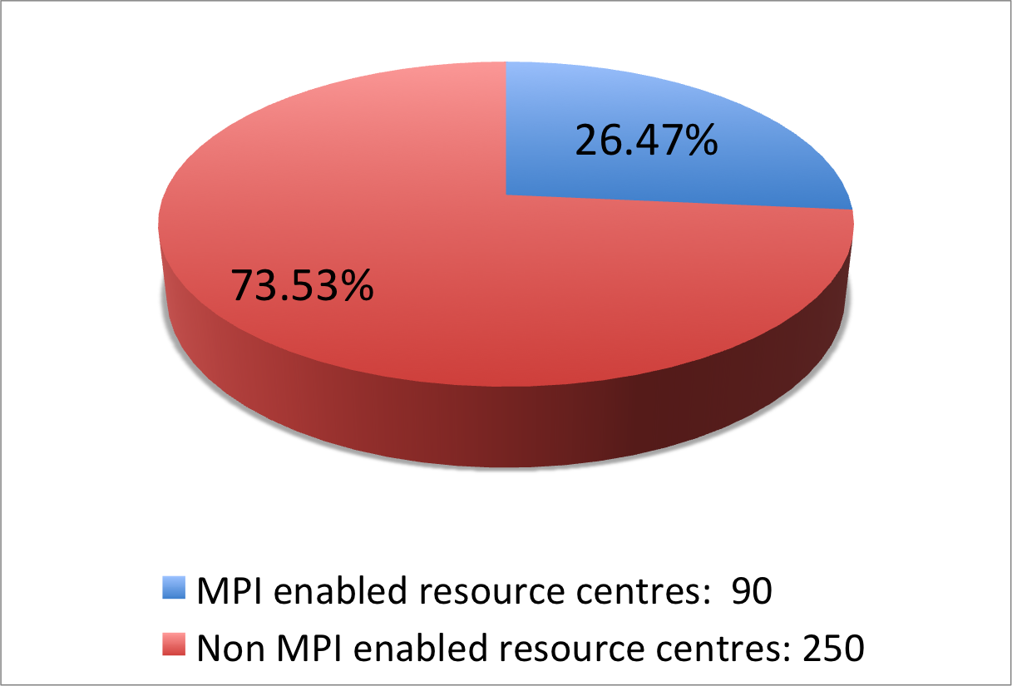
Figure 1: Number of Resource Centres supporting MPI jobs in PQ3 (source: project quarterly reports and GridMap)
The average monthly Availability and Reliability of most of the EGI-InSPIRE partners exceeded 90%. A few NGIs scored below this target. In almost all cases the Operations Centres of these NGIs started operations during PQ3 so availability and reliability statistics started to be gathered only recently. The performance of these NGIs will be monitored during the second year of the project and a specific support action will be implemented if needed.

Software Rollout
Average score: 3.2
The Staged Rollout Infrastructure currently comprises 39 Resource Centres. Several early adopting Resource Centres are participating to the Staged Rollout of two or more software components. Presently the Staged Rollout Infrastructure covers completely the gLite (release 3.1 and 3.2) and ARC middleware stacks, most of UNICORE and Globus components, and one Operational Tool (the SAM framework and Nagios probes). As shown Figure 2 there are seven NGIs providing more than five Staged Rollout instances, these are: Germany, Greece, Italy, Portugal, Switzerland, and United Kingdom. As show in the diagram, relatively small NGIs (in terms of number of production Resource Centre) are currently significantly contributing to Staged Rollout. A larger contribution from medium and large NGIs will be promoted in the second year of the project.
NGI Staged Rollout teams have had to become familiar with the workflow of the task during the year and have had to deploy their own workflows in order to increase their responsiveness.
Some NGIs asked for a well-defined schedule for the major Software Rollout, and reported issues in communications between early adopters and product teams.

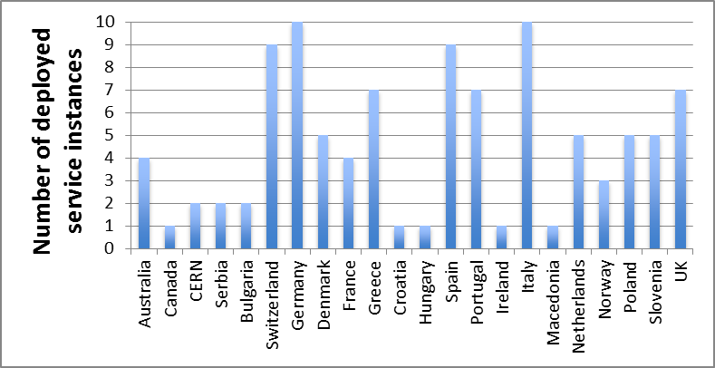
Figure 2: Number of deployed service instances in Staged Rollout by NGI.

Monitoring
Average score: 3.7
The operation of local monitoring services is mandatory for an EGI Operations Centre, so at the moment the EGI monitoring infrastructure is fully distributed. 31 individual Nagios instances are currently run in EGI.
To improve the monitoring service, some countries are planning to deploy VO-specific monitoring systems, and network monitoring tools.
There are issues for countries not deploying gLite middleware. The probes have been introduced more recently for these other middleware distributions and therefore have been in use for a shorter time and by fewer Resource Centres. They are still being validated in production.

Accounting
Average score: 3.3
The accounting infrastructure is at the moment completely centralized as accounting regionalization development activities were shifted with respect to the original JRA1 timetable. Six NGIs are deploying at the moment a fully own regionalized accounting infrastructure: Denmark, Finland, Norway, Sweden (based on SGAS), Italy (based on the Distributed Grid Accounting System), and Turkey.
Many countries are waiting for the release of the regionalized service. Germany reported that publishing directly usage records into the central repositories raises privacy issues for some communities. The German NGI will be contacted to verify if policy “Grid Policy on the Handling of User-Level Job Accounting Data” needs extensions.
Very few countries are periodically validating the accounting data in the central repository.

Operations Portal and Configuration Repository
Average score: 2.8
The NGI Operations Portal is currently deployed in production in 5 countries (in Turkey a custom operations portal is deployed), in addition 6 partners are planning to deploy for a total of 11 partners (34% of the partners who provided feedback). 21 partners declared that the central instance will be deployed instead for the time being (66%). The same percentage applies to the NGI Configuration Repository. At the moment many NGIs tested the local GOCDB instance, but due to missing synchronization with the central instance, they are using the global service.

Helpdesk
Average score: 3.6
The EGI Helpdesk is a distributed system with central integration (GGUS). Because of the transition of the EGEE Regional Operations Centres to a set of independent NGIs that took place during the first year of the project, every new NGI support system had to be integrated with GGUS.
Currently 28 NGIs support systems are fully integrated in GGUS, 20 of which as support units (human interface) and 8 with an automatic interface. Of these 8, three NGIs (DE, CH, AEGIS) deploy xGUS instances, and 5 run their own regional ticket system (RT is the most popular system). The plan is to have all NGIs connected by September 2011, and to increase the number of automatic interfaces – such as messaging and Web services – through xGUS or other regional ticket systems.
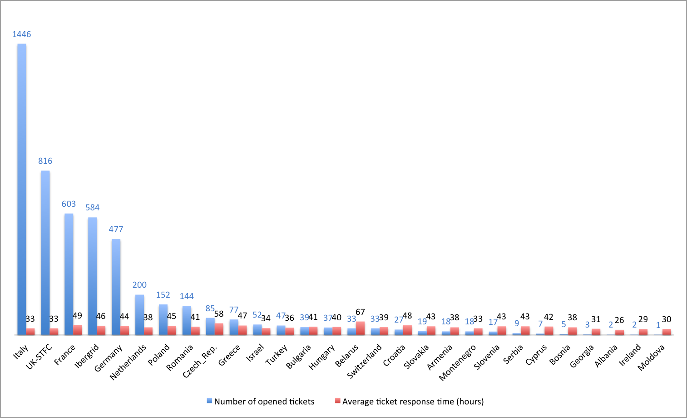
Figure 3: Number of tickets opened and average response time per country
The chart in Figure 3 shows the number of tickets opened, grouped by country, and the average response time. The big difference in the number of tickets between countries is due to the different number of Resource Centres managed by the Operations Centres and to the different communication workflow between ROD and Sites.

Core Services
Average score: 3.6
Resource Infrastructure Providers are required to operate core Grid middleware services according to the needs of the local and global VOs that are supported locally. The overall number of EGI core services amounts to 338 units. 135 of them are WMS instances (this count comprises WMS services needed by the Nagios-based monitoring infrastructure), 44 are gLite LFC file catalogues, 118 are top-BDII instances and 41 are VOMS servers.
As shown in Figure 4, the Resource Infrastructure with the largest amount of services is Italy (46 instances), followed by CERN (37 instances), Germany (34), France (27), Spain (22), and United Kingdom (22) followed by the other countries in the range [1, 20] instances. As expected, the number of services is correlated with the amount of installed capacity provided and with the size and activity of the supported VOs.
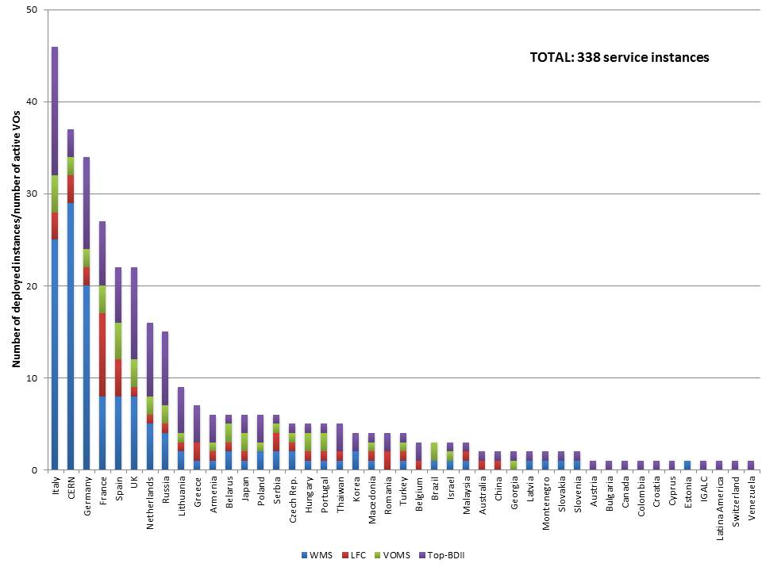
Figure 4: Distribution of core services deployed - March 2011 (source: Information Discovery System)
Some NGIs deployed most of the core service in high availability configuration, but several smaller NGIs have not yet configured their services in this way.
The overall availability reached is very satisfactory, the effort to manage all services has diminished thanks to the techniques of high availability and the developed procedures. During 2011 specific best practices will be developed to boost the high availability configurations for core services, for all the NGIs

Policy Development
Among 37 countries represented in the EGI-InSPIRE project, only 18 receive funding for policy development as an NGI International Task. Self-assessment forms were provided by a total of 24 NGI’s meaning that countries not funded by EGI-InSPIRE also provided their feedback. However, six funded countries have not provided their self-assessment, namely Albania, Cyprus, Denmark, Slovenia, Turkey and the UK.
The main focus on the activities in the first year of the project has been on developing national policies and adapting them to match the EGI’s. Resource allocation and security are two relevant areas that were mentioned in the responses. Checking for alignment with the EGI policies is one activity that is partially affected by the lack of or small funded effort, leading it to be run on a best-effort basis.

# | Country | Answer | Score | Contracted Effort (PMs)
1 | Albania | ✗ | n/a | 5
2 | Armenia | ✗ | n/a | 0
3 | Belarus | ✗ | n/a | 0
4 | Bulgaria | ✓ | 3 | 0
5 | Bosnia and Herzegovina | ✓ | 2 | 0
6 | Croatia | ✓ | n/a | 0
7 | Cyprus | ✗ | n/a | 2
8 | Czech Republic | ✓ | 4 | 4
9 | Denmark | ✗ | n/a | 7
10 | Finland | ✓ | 4 | 5
11 | France | ✓ | 4 | 14
12 | Georgia | ✓ | n/a | 0
13 | Germany | ✓ | 4 | 7
14 | Greece | ✓ | 4 | 0
15 | Hungary | ✗ | n/a | 0
16 | Ireland | ✓ | 3 | 3
17 | Israel | ✓ | 3 | 2
18 | Italy | ✓ | 2 | 4
19 | Latvia | ✓ | 3 | 0
20 | Lithuania | ✓ | ? | 5
21 | Macedonia | ✓ | 2 | 0
22 | Moldova | ✓ | 3 | 0
23 | Montenegro | ✓ | n/a | 0
24 | Netherlands | ✗ | n/a | 0
25 | Norway | ✓ | 5 | 3
26 | Poland | ✓ | 3 | 6
27 | Portugal | ✓ | 3 | 4
28 | Romania | ✗ | n/a | 0
29 | Russia | ✗ | n/a | 0
30 | Serbia | ✓ | 3 | 4
31 | Slovakia | ✓ | 3 | 4
32 | Slovenia | ✗ | n/a | 3
33 | Spain | ✓ | 4 | 12
34 | Sweden | ✓ | 4 | 4
35 | Switzerland | ✓ | 4 | 7
36 | Turkey | ✗ | n/a | 4
37 | UK | ✗ | n/a | 4
Table 3: Responses from the NGI Policy Contacts. Scores are from 0 (not applicable) to 5 (excellent), 'X' means no answer

Among the provided suggestions for future directions of work or improvement of the NGI policy development activity are:
- Expand policies to include cloud and virtualized resources
- Discuss at EGI level resource allocation policies to then be harmonized at NGI level
- Speed up policy drafting process and aim at adopting first official versions at earliest convenience
- Need to further assess EGI policies to meet national constraints
- Need for more funding to be more effective
- Desire to contribute more to EGI policies and procedures development
- Define and publish national policies complying with EGI
- Make good policies/procedures as best practices for other NGIs
- Check that all EGI policies/procedures comply with NGI ones

Dissemination
The results from the NGI self-assessment scores for dissemination are summarised in Table 4. No responses have been received from Albania (5PM), Czech Republic (4PM), Denmark (5PM) and Russia (4PM).
A common theme running through the dissemination responses is that there is a minimum amount of funded effort available for dissemination activities within the project. No individual country has sufficient effort to dedicate a full or even half-time person to dissemination activities purely based on project funding. Consequently, these activities are largely carried out either on a best effort basis, or as an addition to an existing role. This role may or may not be dedicated to dissemination within that NGI but may instead be added to a technical role.
Self-assessed scores for dissemination activities by the NGIs largely fall into two types – a fairly low self-assessment score due to the lack of available effort (Ireland, Israel, Latvia, Norway, Portugal, Slovenia, Spain, Sweden, Turkey) or a higher score which takes into account the low effort available (Bulgaria, Cyprus, Finland, France, Germany, Hungary, Italy, Poland, Serbia, Slovakia) and assesses the impact derived despite this factor. The United Kingdom has additional funding for dissemination through the GridPP and NGS projects and is able to report a score of 5. However, this situation is likely to change in the future. Apart from Sweden, who work with the Swedish Grid User Support Initiative, the other NGIs do not specifically report that there is funding available for dissemination for their NGIs from other national sources to supplement the EGI-InSPIRE funding.
Activities reported as dissemination activities include running websites, production of materials such as leaflets, newsletters and posters, outreach to businesses, contact with journalists, attendance at trade shows, presentations to policy makers, messaging, case studies, booths at international events, production of videos, user surveys, news items, organisation of local events such as a Café Grid event, press conferences and publication of journal articles. Also reported as dissemination activities are publishing of scientific papers, training events, and presentations at international conferences. These last activities could perhaps be more properly attributed to other tasks such as NA1 or the technical activities. However, for partners with low or no levels of dissemination funding (such as Greece, Bosnia and Herzegovena, Macedonia and Moldova) these are useful dissemination activities. Countries with higher levels of effort should expect to plan dissemination activities beyond normal attendance at conferences and submission of papers, such as websites, dedicated dissemination events and dissemination materials.
Country | Score | Contracted Effort (PMs)
Bulgaria | 5 | 8
Cyprus | 4.5 | 3
Finland | 4 | 8
France | 4 | 7
Germany | 4 | 10
Hungary | 4 | 4
Ireland | 2 | 3
Israel | 3 | 2
Italy | 4 | 12
Latvia | 3 | 22
Lithuania | N/A | 11
Norway | 3 | 3
Poland | 4 | 6
Portugal | 3 | 6
Serbia | 4 | 8
Slovakia | 4 | 4
Slovenia | 2 | 24
Spain | 3 | 12
Sweden | 3 | 4
Turkey | 3 | 8
United Kingdom | 5 | 12
Boznia and Herzegovina | 3 | 0
Greece | 3 | 0
Macedonia | 3 | 0
Moldova | 4 | 0
Table 4: Responses from the NGI Dissemination Teams. Scores are from 0 (not applicable) to 5 (excellent), 'X' means no answer
Lessons for the future stated by the NGIs include:
- Focus efforts on smaller scale, high impact events, e.g. lectures, workshops, discussions and organise follow up events once initial events are held.
- Use the website to increase NGI visibility, for example by establishing mutual links with the EGI websites.
- Improve web based information for users and non-users of the infrastructure.
- Improve communication of local activities and events to the central EGI.eu team for wider dissemination and greater impact.
- Task leaders should work more closely with NGIs to remind them of the resources available to them from the central team – dissemination materials are expected to be issued by the central team at EGI.eu.
- Liaise with the local training teams to ensure that dissemination materials are available to those being trained on the infrastructure.
- Nurture a relationship with journalists to spread general knowledge of the grid and its uses, and improve visibility in the media.
- Improve visibility of the NGIs nationally and regionally, particularly to policy makers.
- Target national conferences with dissemination activities to reach users.
- Build communities inside the NGI.
- Improve collaboration between NGIs to maximise the impact of dissemination activities regionally.

Conclusions

User Services
The survey has provided some very useful insights into the NGIs and helps EGI.eu to better understand how these human services and related software tools are used by NGIs, even if the original goal has not been fully achieved – as the answers demonstrate several common misunderstandings, typically:
- Instead of considering the human aspect of the services (e.g. using the EGI AppDB to register and reuse applications) NGIs often answered about usage and provision of local software and tools that they use or need (or not need) to provide such a service (e.g. We do not have a local Application Database and we do not feel the need to have one.)
- While the mark given to a service by an NGI is good (4 or 5) the textual description suggests just the opposite – e.g. the service is underutilized, not found attractive by local end users.
As a consequence this assessment was more an exercise to review how the NGIs operate their services than assessing the performance and achievements on these topics. The answers have clarified where and what sort of misunderstandings exist within the community about these services, so now targeted actions can be performed to address these issues. The most important of all these actions – and common to all the four human services – is that the available EGI software services (such as Application Database, Requirement Tracker) will have to be promoted even further. We should also promote related “best practices of using these services by NGIs”. Many of the NGIs and NGI support team members still do not know that all of these services exist and that furthermore, alternative, especially local solutions are not sustainable in the long term. EGI.eu should find alternative communication channels, should perhaps do more “community-wide short broadcasts” to reach such communities. Improvement in local dissemination performed by NGI dissemination teams is also needed.
A detailed review and analysis of the user support-related data has been prepared and this will be used to both guide remedial action over the second year of the project and also enable us to measure improvements beyond these interventions.

Operations
During the first year of the project a major transition took place and the 14 federated Operations Centre active in April 2010 evolved into 32 independent Operations Centres. Because of this the level of maturity, the needs and the amount of effort available to run operational activities vary greatly from NGI to NGI. Nevertheless, a common set of human and infrastructural services is required, as a basic set of requirements needs to be met by all Resource Infrastructures.
These differences were in some cases reflected in the quality of the human services delivered: small and medium NGIs had difficulties in providing feedback and in regularly attending OMB meetings. A strategy will be put in place to facilitate the active collaboration of all partners. On the other hand, the quality of the infrastructure services is more homogeneous. All NGIs are providing monitoring services and for most of them the quality of service of the infrastructure delivered exceeds the project targets.

Small and medium NGIs are successfully and significantly contributing to Staged Rollout activities, sometimes exceeding the level of involvement of larger infrastructures. The portion of core middleware services operated varies enormously: a few largest NGIs are currently managing the majority of the instances in EGI. In any case the core infrastructure is consolidating and most of the NGIs are deploying or planning to deploy services in high-availability configuration. EGI will support these activities through best practices with the contribution of the DMSU. The performance of the new NGIs will be monitored in the coming months; a targeted support action will be put in place if needed.

Policy
The Policy Development Team at EGI.eu could help this activity by:
- Provide clear indication on what are the NGI priorities for policy development in relationship with EGI
- Identify good policies/procedures at the NGI level which could become best practices for the other forming NGIs and circulate them
- Establish a permanent forum for discussion on policy matters which is a generalization of the NA2.3 mailing list and that can be broadened to all countries, included the not funded ones

Dissemination
The major themes to be drawn from these lessons include enhancing EGI.eu’s role as a central coordination point for the NGIs, in order to improve their visibility nationally and internationally and also to act as a collaboration point between NGIs in different regions. Face-to-face meetings and Birds of a Feather sessions will be held at EGI events in order to facilitate this process, as these can be used as opportunities to discover the key requirements from the NGIs from EGI.eu and vice versa. NGIs will be encouraged to use central EGI channels such as the website, press contacts, newsletters, mailing lists, wiki and social media networks to disseminate their activities more widely. Templates for materials such as newsletters, press releases and publications will also be shared with the NGIs and adapted to their needs as required.

Summary
The establishment of NGI International Tasks across the operations, user support, dissemination and policy across infrastructure and human services has been largely successful. This has enabled activities to be devolved down to the national level and then federated together through the central coordination provided by EGI.eu.
However, this process has exposed some structural and resourcing weaknesses in some NGIs. The internal coordination that some NGIs are able to provide in the areas of policy and dissemination is particularly concerning – ineffectiveness in these areas will inhibit NGIs from reaching their true potential. The number of NGIs unable to provide responses to this survey, and many other activities during the year is a concern. The importance of effective management communication from EGI.eu to the NGIs, from the NGIs to EGI.eu, and between the NGIs, has become an area of concern and will be a focus for PY2.

References
R 1 | NGI International Tasks Metrics (Operations), March 2011 (https://documents.egi.eu/document/475)
R 2 | NGI Self Assessment Survey  Taken from https://wiki.egi.eu/wiki/NGI_International_Task_Review_MS109  (https://documents.egi.eu/document/475)

Armenia (64.6%), Belarus (85.86 %), Georgia (85.67%), Macedonia (85.50%), Montenegro (60.50%) and Turkey (87.71%).
https://wiki.egi.eu/wiki/SAM
https://wiki.egi.eu/wiki/SAM_Instances
https://dgas.cnaf.infn.it/hlrmon/report/charts.php
https://documents.egi.eu/document/85
https://www.ggus.eu
http://xgus.scc.kit.edu/

