


D11.1 Training materials about common services and thematic services
Lead Partner: | DANS-KNAW
Version: | 1
Status: | FINAL
Dissemination Level: | Public
Document Link: | https://documents.egi.eu/document/3416

Deliverable Abstract
This report outlines the training plan that will be delivered during the first year of the EOSC-hub project. The training program is aimed at service providers, individual researchers and research communities to use, integrate the Thematic and Common services. The training program also consists of training on data management planning and on the management of IT services (by means of the FitSM standard). An overview of training events organised in the first year of the project is provided and a registry for Training Material and Training Events is set up.

COPYRIGHT NOTICE

This work by Parties of the EOSC-hub Consortium is licensed under a Creative Commons Attribution 4.0 International License (http://creativecommons.org/licenses/by/4.0/). The EOSC-hub project is co-funded by the European Union Horizon 2020 programme under grant number 777536.
DELIVERY SLIP
 | Name | Partner/Activity | Date
From: | René van Horik | DANS-KNAW WP11 | 11 December 2018
Moderated by: | Malgorzata Krakowian | EGI Foundation
Reviewed by | Alexandre Bonvin  Sara Coelho | UU  EGI Foundation | 8 January 2019
Approved by: | AMB

DOCUMENT LOG
Issue | Date | Comment | Author
v0.1 | 22.10.2018 | Initial ToC | René van Horik/DANS-KNAW
v0.2 | 19.11.2018 | Additional contributions added | Giuseppe La Rocca/EGI Foundation  Yin Chen/ Sy Holsinger
v0.3 | 22.11.2018 | First major internal review | Giuseppe La Rocca/EGI Foundation
v.04 | 5.12.2018 | Second major internal review | René van Horik/DANS-KNAW
v1.0 | 07.12.2018 | Open for input from reviewers | Alexander Bonvin/UU  Sara Coelho/EGI Foundation
v2.0 | 11.01.2019 | Incorporation of feedback and comments from reviewers | René van Horik/DANS-KNAW  Giuseppe La Rocca, Yin Chen and Sy Holsinger from EGI Foundation

TERMINOLOGY
https://wiki.eosc-hub.eu/display/EOSC/EOSC-hub+Glossary

Contents
1. Introduction 6
2. The training strategy 9
2.1 Establishment of the EOSC-hub training programme 9
2.2 EOSC-hub training target audience 11
3. Implementation of the on-line training catalogue 12
3.1 Evaluation of the different solutions to create the Training Registry 12
3.2 The INFN Open Access Repository 13
3.3 The ELIXIR Training Platform (TESS) 14
3.4 DashOne Dash 14
3.5 U2Universe 15
3.6 Drupal CMS 15
3.7 The EOSC-hub online Training Catalogue 15
3.8 The catalogue of training events 17
3.9 The catalogue of training materials 18
4. Training activities in 2018 20
4.1 Data Management Planning 20
4.2 IT Service Management 22
4.3 Training materials about Common Services 24
4.4 Training materials about Thematic Services 28
5. Future plans 31
5.1 Task 11.1 – Training programme and online services for training 31
5.2 Task 11.2 – Data Management Planning 31
5.3 Task 11.3 – Federated Service Management Training and Certification 32
5.4 Task 11.4 – Training about common and federated services 32
5.5 Task 11.5 – Domain-specific training to data providers and data scientists 32
6. Conclusions 34
7. APPENDIX I - Guide for EOSC-HUB trainers 35
7.1 Prepare for Training 35
7.2 Best Practises for Developing Training Materials 35
7.3 Best Practises for Running a Training Event 36
7.3.1 Tips for promoting your events 38
7.3.2 Delivery 39
7.4 Report for Training 42
7.4.1 Technical Support 44
8. APPENDIX II - Training catalogue 45
8.1 How to add new entries in the Training Catalogue 46
8.1.1 Login 46
8.1.2 Add a new contact 46
8.1.3 Add a new training material 47
8.1.4 Add a new training event 49
8.1.5 Manage training roles 51

Executive summary
This document outlines the training plan delivered during the first year of the EOSC-hub project, and provides the first set of training content, about common and thematic services, available in the online training catalogue.

Overall, the training program is aimed at service providers, individual researchers and research communities to use, integrate the Thematic and Common services. Broadly speaking, the training plan is aimed at promoting the establishment of a “knowledge network” for helping researchers to facilitate the uptake of the FAIR principles and Open Science paradigm, engage and train end-users, and support the implementation of their Data Management Plans (DMPs). To address this goal a training programme is delivered on a wide range of topics, including: DMP planning, FAIR data, Cloud services and services for open science to incorporate into national roadmaps and ecosystems, a dedicated joint activity has been created, in collaboration with the EOSC-hub and the OpenAIRE-Advance projects. More details about this collaboration, including the list of training events organized in 2018, is reported in this document in Section 5.

The strategy adopted by WP11 to set up the calendar of training events and the on-line registry of training materials for the EOSC-hub project, including the cost-analysis of the different evaluated solutions, is described in the first part of the document (Section 2), while the implementation of the training calendar and training materials is described in Section 3.
A description of the training events held by the project to provide a baseline support for training activities, with a particular focus on common and thematic services, is reported in Section 4.

Finally, a brief overview of the training programme for the second year of the project is also outlined in Section 5. Section 6 covers future plans of the WP11 activities.

WP11 has created a guide to prepare, develop, run and evaluate training. This guide is presented in Appendix I of this report. Appendix II outlines how new content (e.g.: event and material) can be registered in the training catalogue.

Introduction
By mobilizing e-Infrastructures comprising more than 300 data centres worldwide and 18 pan-European infrastructures, the EOSC-hub project is a ground-breaking milestone for the implementation of the European Open Science Cloud (EOSC). Overall, the project creates the integration and management system (the hub) of the future European Open Science Cloud that delivers a catalogue of services, software and data from the EGI Foundation, EUDAT CDI, INDIGO-DataCloud and major research e-Infrastructures. Services and data will be provided ensuring confidentiality, integrity and accessibility in compliance with EU regulations by defining and enforcing community-defined policies and controls. Where personal data is concerned, controls will be introduced to comply with the upcoming European General Data Protection Regulation (GDPR) and its adaptations in the national regulations. The resulting hub acts as a single contact point for researchers and innovators to discover, access, use and reuse a broad spectrum of resources for advanced data-driven research.

In this scenario the overall objective of WP11 – Training and Services for Service Operators, Research and Higher-Education – is to improve skills and knowledge among researchers and service operators by delivering specialised trainings to foster the use of digital infrastructures, promote the values of open science, and support research data management plans.

The high level objectives can be broken down into the following activities:

- Training programme and online services for training (T11.1). The EOSC-Hub training programme is based on materials and events delivered by service providers and by trainers and training providers of relevant partner initiatives, especially the OpenAIRE-Advance project and the EOSCpilot project.
- Support the implementation of proper data management planning for helping research communities to manage their research data efficiently (T11.2).
- Deliver of IT service management trainings to learn the fundamentals of IT service management processes and support the professional development of EOSC-hub services (T11.3).
- Define and deliver training contents about common and federated services for supporting scientific activities of TS, CCs and research communities (T11.4), and domain-specific training for data providers and data scientists (T11.5).

To define and deliver a sound training plan aiming at promoting the establishment of a “knowledge network” to help researchers to better integrate advanced digital services, tools and data to achieve excellence in science, research and innovation, WP11 relies on the services already included in the services catalogue. The catalogue provides an initial set of mature services that, during the project, will be extended to include additional local/national services, in compliance to the EOSC-hub rules of participation for service providers, to expand and reach a wider user base. When a new service is included in the catalogue, WP11 will be supported by T10.3 – Community Requirement Analysis and Technical support – to finalize the preparation of the training documentation and the training programme.

From a technical perspective, when referring to the service catalogue, we need to make a distinction between:

- External service catalogue: the set of live services as published on the website: https://eosc-hub.eu/catalogue
- Internal service catalogue: the set of live services part of the EOSC-hub internal service portfolio.

During the first year, a significant amount of time was spent by WP11 to configure the EOSC-hub training catalogue which is composed by an online registry of training materials and a calendar of training events (for further details, please refer to Section 3). This activity has been also complemented by the preparation of a financial procedure to facilitate the organization of training events for those trainers not directly involved in WP11, and the configuration of the tools (e.g.: conference medias, guidelines for trainers, etc.) to facilitate the organization and the delivery of training events. Training materials available in the catalogue have been produced by WP11 jointly with other project partners (e.g. WP4 and WP5) and other H2020 projects (e.g. OpenAIRE-Advance).
The present document is organized as follows:
- Section 2 presents the EOSC-hub strategy to develop an effective training program.
- Section 3 describes the high-level architecture of the online training catalogues and the main design considerations.
- Section 4 outlines the training plan delivered by WP11 during the first year of the project.
- Section 5 introduces the training plan for the second year of the project.
- Section 6 draws conclusions about the described work.
- Appendix I introduces the best practices, developed by WP11, to develop training materials and deliver training events using EOSC-hub efforts.
- Appendix II presents an extensive description and manual of the EOSC-hub training catalogue.

The training strategy

Establishment of the EOSC-hub training programme
The establishment of the EOSC-hub training programme contains four steps.
- Collect the training needs:
  - The starting point of the EOSC-hub training strategy was to look at the training needs of the Competence Centres, Thematic Services and Business pilots involved in the project. Which skills, knowledge, and expertise do they require to achieve their goals? To collect such training needs, WP11 established a communication channel with the WP7, WP8 and WP9 managers starting from the project kick-off meeting.

- Identify skill gaps:
  - WP11 worked with WP leaders to collect and analyse the requirements and identify audiences. The collected feedback and comments contributed to the identification of the missing skills and competences to be addressed.

- Develop the training programme:
  - WP11 developed a catalogue of training events. Then, WP11 clustered the training needs in areas such as: Authentication and Authorization (AAI), Storage, Compute, DMP, IT Security, IT Service Management, FAIR, etc.

- Plan and deliver the training:
  - Building on the activities described above the yearly training plan is formulated that serves as a blueprint for the project training activities in the future.

The gap analysis and prioritization allowed us to design a programme focusing on the following four areas:
- Research Data Management (RDM) training activities. RDM training events aimed at transferring skills and expertise in this field, with an emphasis on the creation and follow-up of Data Management Plans (DMPs). A Data Management Plan, which is now required by all the projects participating in the extended Open Research Data (ORD) Pilot, describes the data management life cycle for the data to be collected, processed and/or generated by a Horizon 2020 project. As part of making research data findable, accessible, interoperable and re-usable (FAIR), a DMP should include information on:
  - The handling of research data during and after the end of the project;
  - What data will be collected, processed and/or generated;
  - Which methodology and standards will be applied;
  - Whether data will be shared/made open access;
  - How data will be curated and preserved after the end of the project.
- FitSM trainings for all the IT services management processes. The training delivered by WP11 with this lightweight standard will ensure that there is a clear understanding of all concepts, terminology and activities to be carried out to plan, deliver, operate and control all EOSC-hub services. FitSM training scheme is structured in three levels: Foundation, Advanced and Expert and is accredited by an external Certification Authority.
- Training events on common and federated services registered in the EOSC-hub service catalogue for Competence Centres and Thematic Services. These training events have been delivered in collaboration with the service providers. To facilitate the preparation and the delivery of training events about these topics, WP11 has identified a set of tools and services, and prepared a set of guidelines for helping the trainers to plan and organize a training plan, create (or reuse) training material, and to report and evaluate the training outcomes. In addition, a training infrastructure with the initial set of resources operated by WP11 is offered to carry out the training events.
- Domain-specific training events to target data providers and data scientists structured in scientific communities linked to the EOSC-hub Competence Centres and Thematic Services. During this first year, the focus was Thematic Services trainings. Most of the Competence Centres Services spent most of their efforts in integrating the common and federated services provided by the project. With the ramp-up of the integration activities, we expect to have more training contributions next year.
Training is a key element to help employees gain new skills and competences and boost the efficiency and productivity of working place in public and private sectors. In the EOSC-hub project, WP11 developed a training strategy to achieve the target goals, to improve the use of digital infrastructures and promote the uptake of project results. The EOSC-hub training strategy is grounded on the project’s commitment to maintain an ongoing training programme.

The programme, as described in the DoW, focus on the following specific areas:
- Data Management Planning (in cooperation with the OpenAIRE-Advance project);
- Federated Service Management Training and Certification (FitSM);
- Common and Federated services relevant for the selected Thematic Services (TS’s) and Competence Centres (CC’s);
- Domain specific training to targeted researchers organized in CC’s and using TS’s.

EOSC-hub training target audience
The training events organised and the training material created in the EOSC-hub project have three main audiences: service providers, individual researchers and research communities. The table below provides the core learning goal for each of the target audiences.

Target audience for training | Learning goals
Service providers | To learn how to integrate the EOSC-hub services  To learn how to manage IT services
Individual researchers | To learn how to use the services to manage research data (using, creating, analysing, etc.)
Research communities | To learn how to support (domain specific) communities in managing research data (using, creating, analysing, etc.)
Table 1. Target audiences and learning goals for EOSC-hub training

Implementation of the on-line training catalogue
Training is defined as an organized activity aimed at imparting information and/or instructions to improve the recipient’s performance or to help him or her attain a required level of knowledge or skill. The training event is where the knowledge transfer occurs.
EOSC-hub aims to organise face-to-face training events as part of conferences or other related meetings. This format lowers the threshold for participants to join as they can combine the training with attending the conference, and it is more cost-effective as the costs for facilities are shared. EOSC-hub will also use online conference systems (such as GoToMeeting) to facilitate training events in virtual formats.
WP11 created two online registries:
- The training calendar contains descriptions of training events (in the past and the future) that have a relation with the EOSC, not only related to the EOSC-hub project, but also connected to related projects such as OpenAIRE-Advance.
- The training material catalogue stimulates reuse so the same material can be used at different training events. Training materials can have different forms; the PowerPoint presentation, however, is omnipresent. Other examples of types of training material are recordings or other multimedia files, exercises, services, software (e.g. Jupyter Notebooks, Docker containers) and texts. The catalogue does contain the documentation of training material, whereas the training material itself is stored in another repository. A link to this repository is provided in the documentation.
WP11 provides an overview of repositories were the training material can be stored. A low-threshold way to share training material is to use the B2DROP cloud storage service. Preference is given, however to B2SHARE and Zenodo as repositories to share training material, as these services make the material accessible by a PID as part of the documentation.
The process to establish the registry of training events and materials is described in more detail below in the following sections.

Evaluation of the different solutions to create the Training Registry
During the first year of the EOSC-hub project, a significant amount of time has been allocated by T11.1 to set-up the online training registry where all members of the project can contribute by publishing training events and upload training materials. Different solutions to implement the training registry, developed by members of the consortia involved in WP11 and also by third-party solutions developed by external partners, were evaluated. In order to identify the solution that best matches the WP11 requirements, a costs-benefits analysis was conducted and, for each solution, a list of advantages and disadvantages was produced. This analysis takes also into account an estimation about the overall effort requested to maintain and operate the on-line registry during the project and afterwards.
The solutions evaluated by the WP11 during this phase were:
- The INFN Open Access Repository.
- The ELIXIR Training Platform (TESS).
- DataOne Dash.
- U2Universe.
- Own development based on Drupal CMS.

To reduce the effort and maximize the effectiveness, at the end of this analysis WP11 decided to implement the online training registry using the Drupal CMS and re-use the expertise already available within the consortium.
A short report about the costs-benefits analysis conducted on each of the solutions evaluated, to better clarify this selection, is available in the next subsections.

The INFN Open Access Repository
The solution adopted by INFN to implement the Open Access Repository is Invenio and the main motivations for this were the following:
- It is fully compliant with all most important library standards, such as OAI-PMH;
- It is co-developed by institutes such as CERN, DESY, EPFL, FNAL, SLAC and used as institutional DAMS by about 30 scientific institutions worldwide;
- INSPIRE, SCOAP³ and ZENODO (the OpenAIRE flagship archive) repositories are based on Invenio;
- The CERN Document Server operates since 2002 and manages more than 1.3 million records in high-energy physics, covering articles, books, journals, photos, videos, and more.

Unfortunately, notwithstanding the positive evaluation and the feedback reported by INFN, this solution has not been selected due to the limited effort of the partner in WP11. This effort is required to adapt the system for EOSC-hub requirements, e.g. to apply the EOSC-hub house style and enable the federated authentication support.

The ELIXIR Training Platform (TESS)
TeSS, ELIXIR's training platform provides a place where trainers and trainees can discover online information and content, including training materials, events and interactive tutorials. For ELIXIR Nodes, TeSS provides opportunities to promote training events and news, and to contribute to a growing catalogue of materials; for trainers, the portal offers an environment for sharing materials and event information; for trainees, it offers a convenient gateway via which to identify relevant training events and resources, and to perform specific, guided analysis tasks via customised training workflows. ELIXIR is a distributed infrastructure for life-science information.
It was not difficult to install, manage and test the ELIXIR training platform, although it has not been specifically designed to be a general purpose training tool. The TeSS developer team was very responsive and they helped much during the evaluation phases, providing useful information about current product capabilities and any possible feature implementation to best match the EOSC-hub training catalogue requirements.
TeSS had almost everything needed by the EOSC-hub training catalogue and even more capabilities than necessary such as the training paths, the automated ingestion of training materials, etc. However TeSS was not adopted principally because it was not designed to serve communities outside the Life Sciences domain and any customisation was only possible applying changes to TeSS source code.

DashOne Dash
DashOne focuses on an integration of services to provide a combined approach for the provisioning of resources. It is aimed on the provision of access to datasets and adjustments are required to make the system suitable as a training registry for EOSC-hub. For this, external expertise is required which made this solution less attractive.

U2Universe
U2Universe utilises the European level OER (Open Educational Resource) metadata standard and the metadata aggregation service (eduOER) to harvest data. The eduOER service is designed to search, find and re-use trusted, quality, educational and research multimedia content. The project is coordinated by GEANT and aims to provide an innovative learning platform building on cloud-based tools and services. The platform is based on a MOODLE Learning Management System and includes functionality for learning analytics (source EOSCpilot D7.2 Page 36-37). In order to make the platform usable for EOSC-hub some re-designing was required and also the graphic user interface would have to be adjusted. It turned out that the project does not have enough resources to do this and this option was discarded.

Drupal CMS
Drupal is a free, open source and scalable open platform for web content management. Compared to other CMSs like WordPress and Joomla, Drupal is suitable to build huge sites with additional features and unlimited customizations. In the context of the project, the CMS already provides functionalities to implement the moderation of the published materials and support the OpenID Connect (OIDC) protocol to implement federated authentication. Last but not least, since the EOSC-hub web site is based on Drupal, and project partner TRUST-IT has a long-running experience in using this framework to set up project web portals, we decided to adopt the same technology to implement the EOSC-hub online training registry.

The EOSC-hub online Training Catalogue
The first release of the EOSC-hub online training catalogue was announced during the EOSC-hub All Hands Meeting (AHM) in Malaga in April 2018. The online registry allows users to register new training events and upload training materials developed by project members. The overall architecture of the training catalogue is based on Deliverable 7.2 of EOSCpilot. This deliverable not only contains an overview of information systems that can be used to create a training registry (as discussed in the previous section), but also an overview of description fields for metadata for training material and training events. The selection of the metadata fields applied in the registry is based on this overview.

The EOSC-hub training catalogue (also referred as catalogue in the rest of this document), includes two web areas:

- Training Materials: Initially, we distinguish two categories of training materials:
  - Generic training materials for EOSC-hub services: these training materials will finally be linked to EOSC-hub service catalogue providing as reference documents for users to get to know about the services.
  - Other materials related to EOSC-hub service training, e.g. from various training events.
- Training Events: this area will include all the events delivered in the context of the project, including: webinars, face-to-face training, tech. talks, workshops, etc.
Only authorised members can add and/or modify training related content. Each authorised member may have one of the following access rights:
- Training Editor (TE): This user can only insert and modify contents into the training catalogue.
- Training Admin (TA): This user not only can only insert and modify contents into the training catalogue as the TE, but he/she can also moderate the publication and deletion of training materials. TAs can also grant or deny roles to other members.
In order to make it possible to add and/or edit any content in the training catalogue, the trainer has to ask for the ‘Training Editor’ role.
An extensive description and manual of the training catalogue can be found in Appendix II. To facilitate the registration of new events, and the upload of new contents, WP11 organized a webinar with all the trainers involved in the project.
The EOSC-hub training catalogue of events and materials can be reached through the EOSC web site under the menu-option “Resources” (Figure 1).
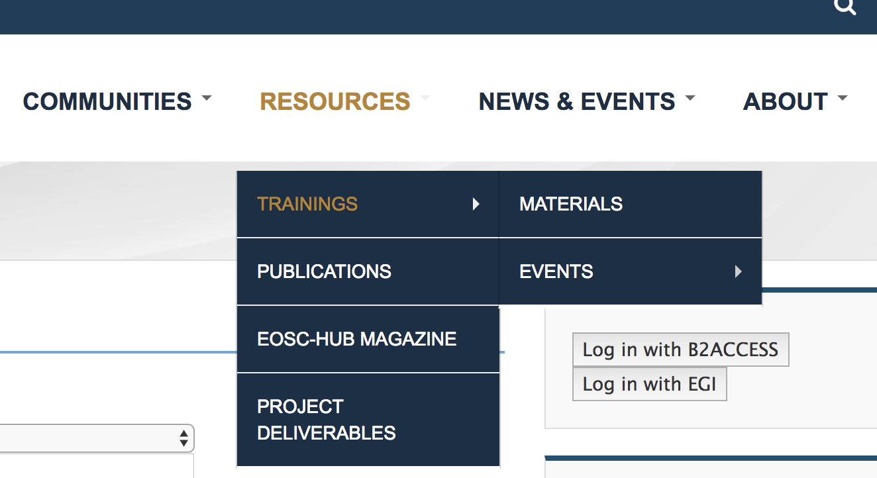
Figure 1. The catalogue of training events and materials as integrated in EOSC-hub website

In the next sections, more details on the training catalogue will be provided.

The catalogue of training events
As depicted in Figure 2, the catalogue of training events is organized in four main areas:
- On the top, the catalogue provides filters that users can use to sort their search criteria and find results quickly.
- On the right is shown a list of past training events organized by the project. Clicking on one of these past events the user is redirected to the proper page where additional information can be found.
- In the centre, in a table view, are listed the upcoming training events organized by the members of the project.
- On the top right authorized users can login to create new events, or update already existing ones. The access to the catalogue is allowed for authorized users only. To facilitate the access to the catalogue using the federated authentication mechanisms WP11 adopted the EGI Check-In and B2ACCESS AAI solutions.

By default, all events are shown sorted by ‘date created’ field and one or more search filters can be applied using several filters specified at the top of the page.

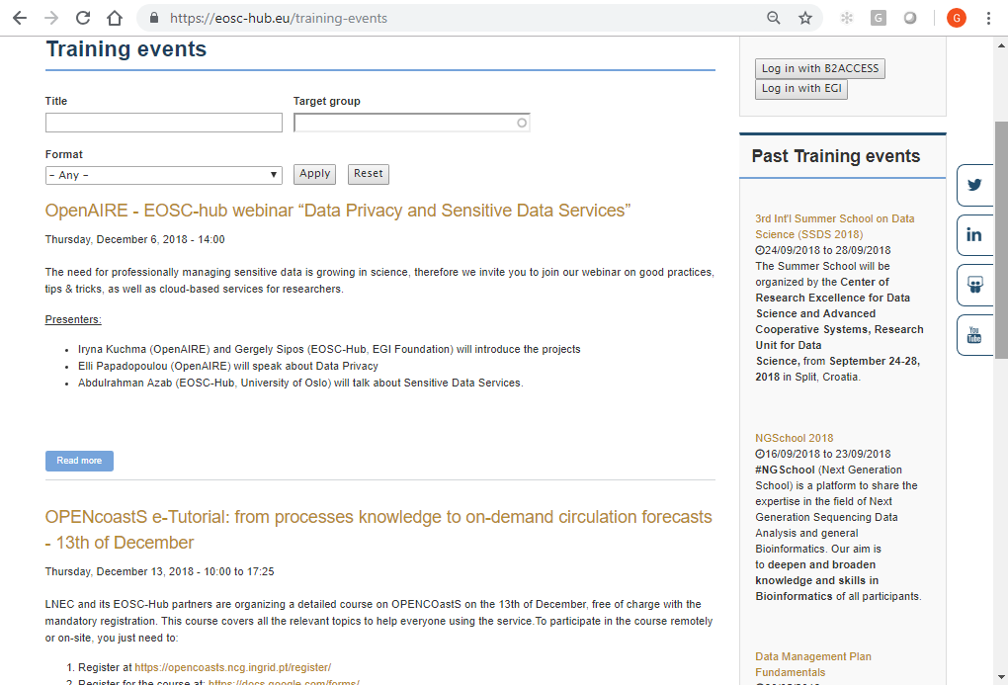
Figure 2 - The catalogue of training events

The catalogue of training materials
The catalogue of training materials follows the same structure of the catalogue of events (Figure 3). A Training Editor can add new training content in the catalogue. Final publishing, in order to make the information visible for all, can be done by the Training Admin (for further details, please refer to Appendix II).

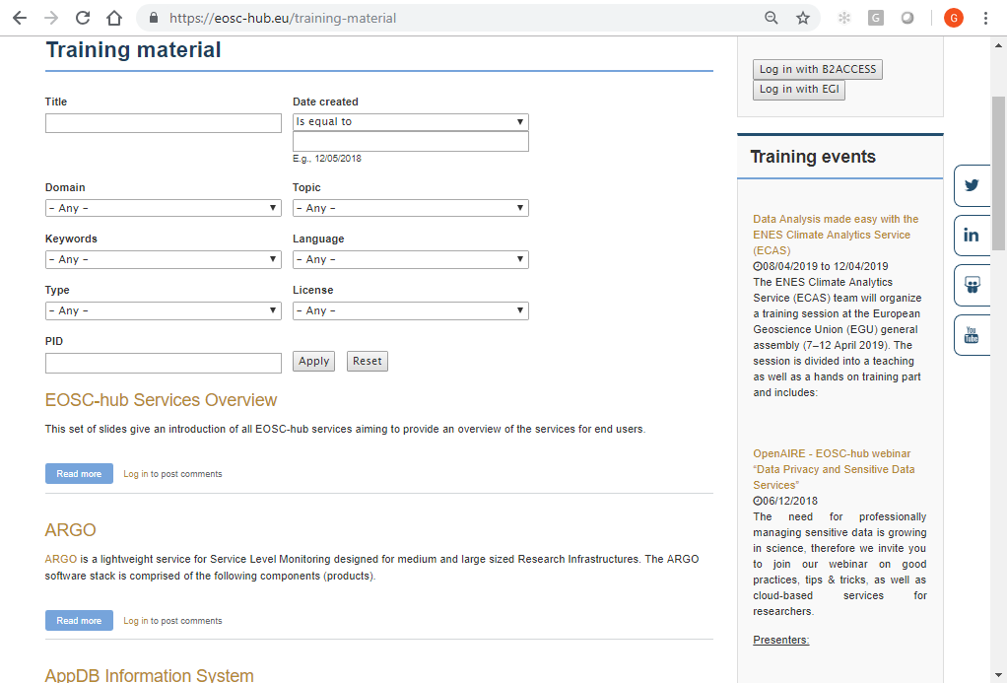

Figure 3 Interface of Training Material Registry as part of the EOSC-hub website

Training activities in 2018
This section provides an overview of training activities carried out by WP11 in 2018, after the project kick-off which took place in Amsterdam.

Data Management Planning
Task 11.2 concerns training on research data management and data management planning. Data management refers to the development, execution and supervision of (research) plans, policies, programs and practices that control, protect, deliver and enhance the value of (research) data and information assets. A data management plan (or DMP) is a formal document that outlines how to handle data both during research and after the research is completed.
The EOSC-hub project and the OpenAIRE-Advance project were invited by the EC to cooperate and produce results for a broad range of stakeholders, including research groups, decision makers and policy makers at national and European level, citizens, Industry/SMEs, service and content providers, and research administrators and managers.
In this regard, JA2.2 – Common Support and Training is the joint activity plan created to delivery of training and support on a range of topics to facilitate the uptake of their services. During the first year of the project, the two projects cooperated to prepare a joint training programme and deliver training events on a wide range of topics, including: DMP planning, FAIR data, Cloud services and services for open science to incorporate into national roadmaps and ecosystems.
The following training events on data management and Open and FAIR data were organised in 2018 by the joint activity task (JA2.2):

Event | When | Contacts | Target audience | Comments
EOSC-hub - OpenAIRE-Advance Webinar for national entities (NGIs  and NOADs) | 24/04/2018 | Gergely Sipos (EOSC-hub), Najla Rettberg (OpenAIRE) | Research infrastructures | A total of 50 participants attended the webinar
Webinar: How to manage your data to make them Open and FAIR | 15/05/2018 | Ellen Leenarts (EOSC-hub), Marjan Grootveld (OpenAIRE) | Researchers, research support staff and data librarians | A total of 230 participants attended the webinar
Workshop: Towards cultural change in data management – data stewardship in practice | 24/05/2018 | Ellen Leenarts (EOSC-hub), Marjan Grootveld (OpenAIRE) | Researchers, research support staff, funders/policy makers. | A total of 20 participants attended the workshop.
Data Management Plans Fundamentals | 30/05/2018 | Renè van Horik (EOSC-hub) | Individual researchers and project managers | A total of 13 participants attended the meeting
Workshop: How to make training FAIR | 04/06/2018 | Ellen Leenarts (EOSC-hub) and Cees Hof (EOSC-hub) | Target audience: ELIXIR community | A total of 30 participants attended the workshop
Workshop “Train the trainer: Exploring tools for FAIR data” | 17/08/2018 | Marjan Grootveld (OpenAIRE) | Target Audience: Researchers, librarians and research support staff. | A total of 30 participants attended the workshop
Planning early, following through: Data Management Planning in the EOSC | 09/10/2018 | Renè van Horik (EOSC-hub), Francesca Maria Iozzi (OpenAIRE), and Shaun de Witt (EOSC-hub) | Researchers and research communities | A total of 18 participants attended the training event
Data Privacy and Sensitive Data Services webinar | 06/12/2018 | Gergely Sipos (EOSC-hub), Iryna Kuchma and Elli Papadopoulou (OpenAIRE) | Academic and research community revolve around processing of data, particularly with respect to workflows/processes, tools and good practices for sensitive data sharing and curation. | A total of 45 participants attended the webinar
Table 2. Joint training events organized by the EOSC-hub and OpenAIRE-Advance projects

In addition, T11.2 published the story “How to make your data Open and FAIR” in the 2nd issue of the EOSC-hub magazine.
The number of training events organized and delivered by T11.2 is monitored by the project specific metric M11.2:

Metric ID | Definition | Baseline | Value M06 | Value M12 | Target PY01
M11.2 | Number of DMP events organized | 0 | 5 | 9 | 4
Table 3 - WP11 metric for T11.2

IT Service Management
Task 11.3 is dedicated to preparing and delivering FitSM trainings to all EOSC-hub project partners and collaborators. The training offered with this standard ensures that there is a clear understanding of all IT Service Management (ITSM) concepts, terminology and activities to be/being carried out to plan, deliver, operate and control all EOSC-hub services. The FitSM training scheme is structured in three levels: Foundation, Advanced and Expert and is accredited by an external certification authority, ICO-Cert. Formal certification is offered to anyone attending the courses. The objective of the first year of activities was to focus initially on the Foundation level to trying to get as many people as possible trained. The upper-level courses will be offered during the 2nd and 3rd year of the project in parallel to continued Foundation courses.

Overall, T11.3 organized 4 FitSM Foundation training events, 2 webinars and 2 individual FitSM process grouping webinars for EOSC-hub task leaders. A total of 60 attendees has been formally certified in FitSM (backed by Certification Authority ICO-Cert); 10 of 13 WP Managers and more than half of the attendees were task leaders.
The full list of F2F events organized by T11.3 is given in the table below:

Event | When/Where | Comments
FitSM Foundation Level (co-located with EOSC-hub Kick-off meeting) | 09 Jan. 2018, Amsterdam, The Netherlands | A total of 16 participants attended the initial FitSM Foundation level training.
FitSM Foundation Level (co-located with EOSC-hub All-Hands Meeting) | 20 Apr. 2018, Malaga, Spain | A total of 21 participants attended the training event.
FitSM Foundation Level (formally supported by EOSCpilot) | 23 May 2018, Amsterdam, The Netherlands | A total of 10 participants (6 from EOSC-hub) attended the training event.
FitSM Foundation Level (co-located with DI4R 2018) | 12 Oct. 2018, Lisbon, Portugal | A total of 20 participants attended the training event.
Table 4 – Training events organized by T11.3

In addition, to promote the lightweight service management for Research Infrastructures based on the FitSM approaches, the following webinars have been organized:

Event | When | Comments
CORBEL | 06 February 2018 | A total of 50 participants attended the webinar.
ENVRIplus | 20 March 2018 | A total of 15 participants attended the webinar.
Table 5 – FitSM webinars organized by T11.3

Last but not least, two individual meetings held with EOSC-hub SMS Process Managers and Task Leaders prior to being able to attend a formal training course.
The costings table of the FitSM Foundation courses organized during the first year of the project is reported in Table 6. The remaining training budget will be monitored during the second project year of EOSC-hub to ensure overall training target will be achieved. In year 3, costs could be offset by moving to cost of the certification exams from the project to the individual participant/institution. It was foreseen at the project start that the exams would be covered until the available training budget was exhausted.

 | Total Budget | Consumed Budget | Remaining Budget | # of Events Held | Avg. Spent per Event | Avg. # of Potential Events Remaining | Target # of Events | # of Events Held + Remaining Budget | Event Forecast vs. Target
FitSM Certification | €20,000 | €5,494 | €14,506 | 3 | €1,831 | 8 | 15 | 11 | -4
Table 6 - Budget FitSM training

The number of FitSM training events organized and delivered by T11.3 is monitored by the project specific metric M11.3:

Metric ID | Definition | Baseline | Value M06 | Value M12 | Target PY1
M11.3 | Number of FitSM training events delivered during the project | 0 | 7 | 8 | 5
Table 7 - WP11 metric for T11.3

Training materials about Common Services
The objectives of T11.4 are to define and deliver training contents about Common and Federated services to support scientific activities of Thematic Services and Competence Centres and research communities.
Task T11.4 coordinates training delivery for EOSC-hub services, however the training delivery is largely depending on EOSC-hub service providers in WP5 and WP8, and trainers in WP11. In order to scale up the training delivery and in order to improve training quality, we follow a ’Train the Trainer’ approach, that is to train potential instructors or less experienced instructors on the best ways to deliver training materials to others. This will help to establish a talent pool of trainers, and the aim is to improve overall EOSC-hub training effectiveness and productivity.
We prepared a “Guidelines and Best Practices on Training Delivery” (see Appendix I) and published it on the project wiki. It introduces the WP11 training management process, elaborating on how to deliver training material and events, and a detailed user manual on how to use EOSC-hub online training catalogues. It is group work, and the intention is to collect best practices from our experienced trainers and share their experiences. This support document will be kept updated and will include more advanced topics that are being discussed within WP11, such as quality control, badging and certification.
Based on this guideline, we organised a ‘train the trainer’ webinar to inform EOSC-hub trainers about the WP11 training management process, and to equip them with the skills they need to prepare training materials and conduct training events. The course covered the topics such as effective training methods and ‘learner-centred’ approach, seven steps for developing training materials, tips for training promotion, and how to develop e-Learning courses. We would like to continue such courses, and in the future to cover more advanced topics, such as, how to organise a successful summer school, gamification, how to reduce training costs, etc.
Concerning training materials, Table 8 shows the collection status. Firstly, by checking with service owners, WP5 and WP6 leaders, and WP11 trainers, we have identified persons responsible for all 40 EOSC-hub core services. By the time of writing, we collected information on 25 core services. In line with WP2 task on service portfolio management, we gave priority for the services published on the EOSC-hub online service catalogue, and collected training materials for 75% of them. Some services are not end-user faced, such as, BDII, DPMT, SVMON, and we do not push to have training materials from them. On the other hand, we had a problem that some of the service owners didn’t respond to our requests and offers of support.

Service Name | Service Status* | Training Materials Status** | Links to the online Training Materials
Common Service
EGI HTC | Published | Preparation
EGI Cloud Compute | Published | Published | https://www.eosc-hub.eu/training-material/egi-cloud-compute
EGI Cloud Container | Published | Published | https://www.eosc-hub.eu/training-material/egi-cloud-container-compute-training-material
EGI Workload Manager (DIRAC4EGI) |  | Published | https://www.eosc-hub.eu/training-material/egi-workload-manager
EGI Online storage | Published | Published | https://www.eosc-hub.eu/training-material/egi-online-storage
EGI DataHub | Published | Published | https://www.eosc-hub.eu/training-material/egi-datahub
B2HANDLE | Published | Published | https://www.eosc-hub.eu/training-material/b2handle
B2FIND | Published | Published | https://www.eosc-hub.eu/training-material/b2find
B2DROP | Published | Published | https://www.eosc-hub.eu/training-material/b2drop
B2SAFE | Published | Published | https://www.eosc-hub.eu/training-material/b2safe-and-b2stage
B2STAGE | Published | Published | https://www.eosc-hub.eu/training-material/b2safe-and-b2stage
B2SHARE | Published | Published | https://www.eosc-hub.eu/training-material/b2share
B2NOTE | Published | Preparation
ETDR |  | In contact with service owner
Sensitive Data Service | Published | Preparation
Advanced IaaS |  | In contact with service owner
TOSCA for Heat |  | Published | https://www.eosc-hub.eu/training-material/tosca-heat
OPIE |  | In contact with service owner
Synergy |  | In contact with service owner
BDII |  | Not for end user
IM |  | Published | https://www.eosc-hub.eu/training-material/im
PaaS Orchestrator |  | Published | https://www.eosc-hub.eu/training-material/paas-orchestrator
CVMFS | Published | Preparation
IAM |  | Published | https://www.eosc-hub.eu/training-material/iam
Collaborative
AppDB |  | Published | https://www.eosc-hub.eu/training-material/appdb  https://www.eosc-hub.eu/training-material/appdb-information-system
Marketplace |  | In contact with service owner
Federation
Accounting |  | In contact with service owner
ARGO |  | Published | https://www.eosc-hub.eu/training-material/argo
Check-In | Published | Published | https://www.eosc-hub.eu/training-material/egi-check-service
GGUS |  | Published | https://eosc-hub.eu/training-material/ggus
GOCDB |  | Published | https://www.eosc-hub.eu/training-material/gocdb
Marketplace |  | In contact with service owner
Operations Portal |  | Published | https://www.eosc-hub.eu/training-material/operations-portal
RC Auth |  | Published | https://www.eosc-hub.eu/training-material/rc-auth
SPMT |  | Published | https://www.eosc-hub.eu/training-material/spmt
DPMT |  | Not for end user
WaTTS |  | In contact with service owner
B2ACCESS | Published | Published | https://www.eosc-hub.eu/training-material/b2access
TTS |  | In contact with service owner
SVMON |  | Not for end user
Table 8 - Status of Training Materials for EOSC-hub Core Services

*Service Status: PUBLISHED -- the service is published in the EOSC-hub online service catalogue
**Training Material Status:
- Published -- the training material is published at the EOSC-hub online training catalogue
- Preparation -- the training materials is under preparation by the service owner or responsible person
- In contact with service owner -- wait for response from service owners
- Not for end user -- the service is not for end user and we do not push for the training materials
With the opening up of the EOSC Portal and the EOSC Portal Marketplace in November 2018 we would like to check the online services in the EOSC Portal, and aim to make the training materials and information documentation in place, in order to give better support to end users for understanding and using the services.
During the analysis of the initial “training needs” most of the Competence Centres and Thematic Services involved in the project expressed the interests in the areas of (1) to methods of integrating the AAI solutions and (2) better understanding of the cloud computing and storage solutions. No particular requests have been collected from the Business Pilots. To bridge this gap, WP11 in collaboration with WP10 and the service providers, arranged the following training events:
- 1 EOSC-hub tech. talk on Storage Technologies.
- 1 EOSC-hub tech. talk on Identification, Authentication and Attribute Management.
- 1 EOSC-hub tech. talk on Clouds, container and orchestration.
This list of training events on Commons and Federated services has been complemented by the organization of two operational IT-Security training events for users, VM Operators and VM Endorsers.
The number of training events on common, security forensics and federated services organized and delivered by T11.4 is monitored by the project specific metric M11.3:

Metric ID | Definition | Baseline | Value M06 | Value M12 | Target PY1
M11.4 | Number of training events on common, security forensics and federated services | 0 | 4 | 5 | 13
Table 9 - WP11 metric for T11.4

Training materials about Thematic Services
T11.5 coordinates the training activities for Thematic Services and Competence Centres services, and responds by defining and delivering training contents about domain-specific training for data providers and data scientists. Fort the first year of the project, the focus has been on Thematic Services. This is because Competence Centres are working on service integration, and we expect the first set of training materials from CCs in the second year.
Just as in T11.4, we apply the ‘train the trainer’ approach. The aim is to give support to our trainers in Thematic Services and Competence Centres, and provide help including, promotion of their trainings, e-Infrastructure setup, train the trainer courses, guidelines and training delivery information etc. In particular, we would help TSs and CCs to prepare a roadmap of training EOSC to their communities – this would help EOSC to reach out and be heard by more community users.
Table 10 shows the status of the collection of training material for EOSC-hub Thematic Services. Out of the 10 services in the list, we managed to collect and publish training materials for 8 services. For the 2 services that not yet provided training materials, we reminded the service owners to provide input.

Service Name | Service Status* | Training Materials Status** | Links to the online Training Materials
Thematic Services
ECAS | Published | Published | https://www.eosc-hub.eu/training-material/ecas
DARIAH SG | Published | Preparation
OPENCoastS | Published | Published | https://www.eosc-hub.eu/training-material/opencoasts-service
GEOSS |  | Published | https://www.eosc-hub.eu/training-material/geo-discovery-and-access-broker-geo-dab
EO Pillar |  | Published | https://www.eosc-hub.eu/training-material/eo-pillar-services-geohazards-thematic-exploitation-platform
WeNMR | Published | Published | https://www.eosc-hub.eu/training-material/wenmr-suite-structural-biology
DODAS | Published | Published | https://www.eosc-hub.eu/training-material/dodas-service
LifeWatch |  | In contact with service owner
CLARIN | Published | Published | https://www.eosc-hub.eu/training-material/component-metadata-infrastructure-services
Other
RDM |  | Published | https://www.eosc-hub.eu/training-material/why-good-data-management-plan
Table 10 - Status of Training Materials for EOSC-hub Thematic Services

*Service Status: PUBLISHED -- the service is published at the EOSC-hub online service catalogue
**Training Material Status:
- Published -- the training material is published at the EOSC-hub online training catalogue
- In contact with service owner -- wait for response from service owners

The number of training material collected by T11.5 is monitored by the project specific metric M11.5:
Metric ID | Definition | Baseline | Value M06 | Value M12 | Target PY1
M11.5 | Number of training materials delivered to target date providers and data scientists linked to Thematic Services and Competence Centres | 0 | 13 | 103 | 10
Table 11 - WP11 metric for T11.5

Future plans
This section contains information on the training activities to be carried out during the remainder of the EOSC-hub project.

Task 11.1 – Training programme and online services for training
T11.1 will continue to operate the training infrastructure, and extend the online training registry with a new module to implement moderation of the training materials already available in the catalogue. An updated version of the training programme will be provided in 2019 taking into account the training needs coming from the TSs and CCs. The portfolio of available services/tools will be enhanced with an open-source learning platform (e.g.: Open EdX with Open Badge support) to support the organization, management and the delivery of training events.
Concerning the Training Catalogue, in 2019 attention will also be paid to quality control of the content. This is both related to the quality of the documentation as well as the training material itself. The title of the training material for instance should be rich enough to give the reader an impression of what the training will contain. Another example is the checking of the user licenses, of course with an emphasis on stimulating to apply open access licenses (given the fact that this is possible). Quality control also means a consultation with the experts of the training material asking them whether the training material is still up to date and asking them for adjustment or improvement. In the communication with the experts also the re-use of training material will be discussed.
Concerning the actual storage of the training material, WP11 envisions several solutions. Examples are storage of the material in the B2DROP, B2SHARE, the EGI document server or Zenodo. In 2019, WP11 will actively encourage that the training material is identified with a PID (and this PID is part of the documentation in the training Catalogue), preferably using the B2SHARE service that is part of the EOSC-hub service catalogue.

Task 11.2 – Data Management Planning
In the second year new DMP trainings will be organised also in cooperation with the OpenAIRE-Advance project. The strategy is to organise trainings as part of bigger meetings such as conferences and to organise virtual meetings, such as webinars that will be recorded so people can learn at the most convenient moment in time. We see that the awareness of the importance of data management planning is growing and the tools to support DMP are getting more mature. WP11 will take these developments into consideration when organising trainings, for example, by asking ask more mature research communities to share their experiences with others (as use-cases) or help research communities to improve the quality of the DMP.

Task 11.3 – Federated Service Management Training and Certification
FitSM trainings will continue to be run in 2019 with plans to introduce the Advanced level courses in the first half of 2019. A Foundation level training is foreseen to be co-located with the EOSC-hub week (09-12 April), which is once again feasible as the Foundation course is only 1 day. Regarding, the Advanced courses, as these are 2 days each, a different approach needs to be taken regarding the selection of dates and location. Current thinking is to organise both Advanced courses (Service Planning and Delivery - SPD; Service Operation and Control - SOC) within a single week as a standalone event. Availability and preferences may be obtained by sending a Doodle pool to all current Foundation certificate holders to find the best timeframe (suggesting Amsterdam as a central location). Additional opportunities in the second half of the year will be evaluated as the post-summer meetings, events, conferences and activities are scheduled. This will be communicated to the WP11 Manager via regular meetings as well as through bi-weekly reporting to the AMB.

Task 11.4 – Training about common and federated services
In the next year, we are going to collect additional training needs and continue support TSs and CCs by updating them with new EOSC-hub core service developments and provide advanced trainings with focused technology details. Deliver trainings and promote EOSC-hub to TSs and CCs and their communities.

Task 11.5 – Domain-specific training to data providers and data scientists
In 2019, we will continue the training delivery in relation to the Thematic Services. On the other hand, according to Competence Centres’ work plans, many of them will be able to produce training materials for their service. T11.5 will aim to collect the first set of training materials from CCs. Continued support will be provided to TSs and CCs trainers – the plan is to help them to prepare a training roadmap of the EOSC targeting to their own communities. This will help EOSC reach “closer” to domain-scientific communities.

Conclusions
The EOSC-hub project brings together a wide range of types of services and tools aimed at both specific scientific disciplines and for scientific use in general. The challenge of WP11 is to provide a service in which producers and consumers of the services and tools can deposit and find training material and training events. Besides the training in relation to the Thematic and Common services also training is provided concerning the transfer of knowledge on data management planning and service management.
In the first year of the EOSC-hub project WP11 has formalised a workflow on training delivery. The guidelines and best practices are aimed at providers of Thematic and Common services and is meant to help them create an effective training programme. Based on a review of existing solutions WP11 has created a training catalogue that will be further populated with content. The first year of the project was to a certain extend a familiarisation process to get acquainted with all directions and new partners in the project and established a sound foundation on training upon which further activities for the remainder of the project can stand.
Overall, WP11 delivered a total of 36 training events spanning from IT Service Management, Data Management Planning, IT Security, training on Commons and Federated services and an initial set of domain-specific training in collaboration with the Thematic Services involved in the project. In addition, the project targets also external users and community not directly involved in the project such as: CODATA-RDA, INSTRUCT, ENVRIplus, NGSchool and CORBEL. By the time of writing, a total of 890 people have been trained during the first year of the project.

APPENDIX I - Guide for EOSC-HUB trainers
This is a support guide for those who develop training materials and deliver training events using EOSC-hub efforts. The purpose is for WP11 to efficiently manage training delivery and improve the quality of these events. This document also intends to collect best practices from our experienced trainers - this will help to share experiences within EOSC-hub and beyond. It is a snapshot of a google shared doc, which is use to collect group inputs and will be kept alive for updating.

Prepare for Training
When you prepare for any trainings:
1. Please inform WP11 members about new upcoming training events.
- Write to training@mailman.eosc-hub.eu specifying:
- The title of the event; The date of the event; The place of the event.
- Website providing information on the training (if applicable).
- The type of the event (e.g.: webinar, f2f, hackathon, workshop, tech talk, etc.).
- The organizer and a key contact for the event.
- The target audience.
2. When needed, get support for:
- Training e-Infrastructure.
- Review and feedback on training materials and delivery.
- Promotion of the trainings.
- Financial supports.
3. Register the upcoming events /materials in the Training Catalogue:
- See HowTo: Training Catalogue (see Appendix II).

Best Practises for Developing Training Materials
Training materials can be in various formats, including but not limited to:
- Slides: at the basic level all EOSC-hub service will be provided with one set of training materials in the form of presentation slides, e.g., ppt, pdf.
- Slides with recording: e.g., ppt with recording of voice and demos.
- Videos clips: e.g., camera recording of a live course etc.
- Self-study materials.
- Hands-on exercises.
Here we consider the slide presentation which is the basic request for EOSC-hub services training material. We recommend that an introduction level training material should cover the following aspects:

Contents | Description
Basic Information | Title, authors, contact of authors, dcate, versions
Goal | Stating the learning objective of the training material
Target audience | Type of people for who this training material is relevant for
Context | Where is the service located in the EOSC-hub architecture  The service can be used to support which phases of a research  (data) lifecycle - this would be easily understood by users service  providers’ information.  Development backgrounds
Introduction | Short and clear describe what the service does
Why should users choose to use the service | What are the problems the service tries to resolve  How good the service is comparing to existing technology.  What benefits can the service bring to the users  Who have already been using the service (existing user base)
How can users use the service | Access interfaces and options  Usage modes (provide examples and use cases)
Reference | User guide to get started  Help desk information
Quiz or exercise | e.g. using Survey Monkey
Table 12 - Aspects of training material

Best Practises for Running a Training Event
Training is to develop abilities through practice with instruction (or supervision). Training is different from university teaching. Teaching is to provide knowledge, instruction or information. Training is more practical and specific, it focuses on doing. Tone of a trainer should be encouraging and enthusiastic rather that critical/skeptical as a school teacher.
Training events can be in various formats, for example:
- Webinars;
- Technical talk;
- Hand-on classroom style Instructor-led trainings
  - Advanced level including hand-on sessions.
  - Popular requested by TS/CC.
  - Core services training should consider to co-organise with EOSC-Hub conferences.
  - Thematic and CC services should aim at community events (e.g. RI annual meetings).
- Hackathon, Summer/winter school.
- Private coaching, individual hand-on instructor.

Preparation
When preparing for the events, one can consider the following activities:

Activities | Descriptions
Develop a training plan | - Setting training goals  - Assess end users’ needs, e.g. use a pre-event survey to gather training requirements  - Design the course using different training methods:  - Presentation.  - Teach dialogue.  - Individual work.  - Team work.  - Role play.  - Games.  - Creating a training programme
Prepare training material | See: Best Practices for Developing Training Materials section
Book training facilities and resources | Including, e.g.:  - The available EGI training e-Infrastructure  - Meeting rooms, arrangement for catering, projectors, etc. Feedback forms or online survey.  - Staffs.  - Request for financial support (if needed).
Create the agenda | For example, using the online training catalogue, and describing:  - Time.  - Location / connection methods.  - Introduction of the events.  - Trainers’ information/organisation.  - Target audiences.  - Requirements for audience.  - Registration links.
Promote the event | - Prepare advertising message.  - Promote the training through appropriate communication channels, e.g.,  - TCs/CCs mailing list and their communities.  - EOSC-Hub news, twitter etc. (WP3).  - OpenAIRE Advance (if the event is relevant for the project)
Get supports | If technical support is needed, please contact: training@mailman.eosc-hub.eu
Table 13 - List of activities to organise a training plan

The following checklist can be used to ensure things are ready for the events:
- Materials (VMs/containers/slides/guides): completed and reviewed.
- Advertising message: completed and reviewed.
- Event webpage: created and online.
- Event is promoted via right communication channel.
- Event facilities: arranged.
- Registration and logistic information: provided.
- Request for trainees: provided.
- Involved people: confirmed.
- (Budget): approved.
- Feedback forms: ready for distribution.

Tips for promoting your events
Tip 1: Choose a date that works for your audience: Tuesdays and Thursdays make for good meeting days, avoid holidays and Fridays. Don’t compete with similar events. Send out save the dates early. Build your schedule/agenda early and communicate it to your audience
Tip 2: Write an attractive and convincing message. Consider who are your main targets audience (industry, senior, academic, PhD/PostDoc), write a message that attractive (one-lines, joke, visual), and convincing ("what is in it for me", well know/respected trainers, quotes from participants, 'bring your own data/use cases/work')
Tip 3: Promotion time: 3 weeks in advance for webinars -- people get next two-week calendar full. But don’t be too early either -- people will forget. Send Reminder one-week, then 1-day before. For face-to-face events, at least 4 months in advance for small to medium size events.
Tip 4: Promote via right communication channels. Ask your joint organisers, your speakers, attendees, partner project or organisations for help with the promotion. Promote at conferences, mailing list; Use flyers, posters, etc. Advertise on social media and consistently updates with information about your events including registration page. Using google ad (small cost to put your adv at the top), Twitter, LinkedIn, etc.
Tip 5: The communications office is there to help. The EOSC-hub communications team (communications@eosc-hub.eu) is happy to support you in the promotion of your event and can redistribute your announcements in their channels. They can also help with writing the announcement, designing a promotion poster or leaflet and defining an attractive message for your audience.

Delivery
When coming to the event day, the trainers can consider the following activities:
Activites | Descriptions
Pre-training activities | - Check with event facilities, e.g. projector, microphone, remote connection.  - Print the participants attending form (see Report for Training).  - Print the materials if there are needed.  - Print feedback forms if they are needed (see Report for Training) (it is also possible to use an online tool such as SurveyMonkey. However, experience shows that using a print-out version can guarantee to receive feedback before students leave the room).
Training activities | - Circulate the participants attending form to collect the list of participants attending the training event.  - Deliver the training content.  - Take photos of the events for dissemination purposes (ask permission for faces).  - Final discussion on feedback for the services - will the participants use the services in future, and how?.  - Distribute feedback/evaluation forms (and collect them if they are physical copies).
Post-training activities | - Upload materials to the event webpage.  - Collect feedback forms if they are not in the electronic forms, or reminder the students to fill an online feedback form.  - Clean up the EGI training e-Infrastructure after planned time if used.  - Report feedback/evaluation to WP11 (see Report for Training).  - Contact communication team for a newsletter, twitter, with pictures taken from the events.
Table 14 - List of activities to prepare a training

Effective Training Techniques
Tips1: Combine different training styles:
- Powerpoint presentation.
- Blackboard or whiteboard.
- Video portion.
- Storytelling.
Tips2: Engage with audiences, use interactive methods, such as: styles:
- Quizzes.
- Small group discussion.
- Team work.
- Individual work.
- Case studies.
- Teach dialogue.
- Active summaries.
- Q&A sessions.
- Role-playing.
- Demonstrations.
- Participant control: Create a subject menu of what will be covered. Ask participants to review it and pick items they want to know more about. Call on a participant to identify his or her choice. Cover that topic and move on to the next participant.
- Games (treasure hunt to find learning information, competition or cooperation team works).
It may take longer time. Some methods, such as participant control, can be less structured. Trainers need to make sure that all necessary information is covered.
Tip3: Hands-on training:
- Demonstration: are attention-grabbers. Combined with the opportunity for questions and answers, this is powerful, engaging form of training. Give demonstration before letting the learners try.
- Hand-on exercise:
  - Can be either individual work or break-up groups.
  - Depending on exercise, can consider either to group people with similar knowledge background or different expertise so they can learn from each other’s.
  - Can encourage participants to bring their own data, work on own use cases/issues.
  - The trainer should be active to:
    - Answer questions.
    - Suggest more effective strategies.
    - Correct errors.
    - Guide toward goals.
    - Give support and encouragement.
    - Provide knowledgeable feedback.
You may need assistants for a large group (>20). Ask local host for volunteers.
The latest trends in training
- Mobile learning: meets the needs of millennial professionals, who want (and expect) instantaneous access to information. Look for more innovations in microcontent (short, mobile-optimised content, usually on a single topic and intended to spark curiosity), such as a brief (two- to three-minute) videos, charts, graphs, chat features, audio files and surveys that convey learning materials in a quick, easy-to-absorb format on smartphones or other type of portable electronic devices.
- Social and Collaborative learning: People get more of their information from social media platforms. Social learning tools take elements of popular social media channels and contextualise them within an organisation to allow team members to share and collaborate on content in new ways.
- Microlearning: By delivering short, fast learning modules that take less than five minutes to complete, people can get the information they need, when they need it.
- Gamification: using game mechanics to spur involvement in learning. Friendly competition is a great incentive for learning. Video games, simulations and other online games relating to workplace scenarios boost creative thinking and enhance problem-solving abilities.
- Emphasizing Quality over quantity.
- Improved tracking: how learners responded to training, what concepts need follow-up
MOOC (Massive Open Online Courses): it is an interactive approach where people from different parts of world share their knowledge in the form of communities. you can take course from the world’s best university with the world’s best teacher, it is completely free https://en.wikipedia.org/wiki/Massive_open_online_course.
- TED (Technology, Entertainment, Design) : experts of the subject share their insights. Short, inspiring, story-driven.
- Virtual Reality.

Reuse of Existing Materials
It is possible to reuse existing training material. However, the information should be checked and kept up-to-date.
Review
It is highly recommended that to have contents checked before publishing on an online training catalogue.
Evaluation should consider the following aspects:
- Recommended contents are covered.
- Technology description is sound, logic is clear.
- Keep target audience in mind, the contents are easily understood, expressions are simple and clear.
- Licence issues - special care should be taken whether there are contents related to licence or copyright issues.
It is recommended to have a lightweight review process, e.g., identify 2 reviewers:
- A technical expert.
- A user expert who has experiences of working with end users.
Training Materials Developing Tools
Some nice tools for developing training courses including:
Teachable https://training.robustperception.io/p/introduction-to-prometheus (quite nice, lots of features, seems to be generally praised by the users, there is also a free offer with unlimited courses but limited to one authors, and the interesting offer (5 authors) is 83 $/month).
Thinkific: https://www.thinkific.com/(a recurrent alternative to teachable).
Podia: https://www.podia.com/features (a newcomer, trying to get some clients from teachable).
Newkajabi: https://newkajabi.com/ (most expensive (and maybe just too expensive for us) but seems nice wrt features).

Templates and Tools
- Communication toolkit, including project logo, word and Powerpoint templates are available at: https://wiki.eosc-hub.eu/display/EOSC/Communications+Toolkit
- The current list of tools and/or services available for supporting the delivery of training events.

Report for Training
- WP11 collects feedback and statistics of training delivery. WP11 has prepared the following document templates:
  - EOSC-hub_Training_Evaluation_Form_v1
    - This document is used to collect feedback about the training event. It has to be distributed to the participants for example at the beginning of the training session (people may leave before the end of the training, so it would be good to distributed it early).
    - Participants to training events are kindly invited to fill in the evaluation form before to leave the training room and return it back to the trainers.
    - Trainers are tasked to collect the evaluation form at the end of the event.
  - EOSC-hub_Training_Event_Reporting_form
    - After the event, the trainers are kindly invited to use this template to produce a report about the event. The report will be used to monitor the work plan and produce metrics.
    - The report has to be sent to: giuseppe.larocca@egi.eu.
    - Care should be taken for data protection issues, e.g., all personal information of participants should be removed if there are not permit from them.
- After the event, WP11 members and/or organiser also need to populate:
  - The list of EOSC events.
  - The dissemination activities.

Filling the forms:
The training feedback forms are MANDATORY for each training event. It will be used for project reports.
All the document templates are available at: https://documents.egi.eu/document/3296
- Training Attendance record: 1 printout, distributes at the beginning, and collect at the end of the event.
- Training evaluation form: fill the part marked as [RED], N print out depending on participation, distribute at the beginning and collect before people leave.
- Training Event Reporting form: summary report after the training event, sent back to giuseppe.larocca@egi.eu.
IMPORTANT NOTICE
Several pages may have restricted access. To get an access to internal pages one needs to create EGI SSO account https://www.egi.eu/sso and contact eosc-hub-po@mailman.egi.eu providing user name, with WP/task leader in CC.

Technical Support
For generic questions or inquiries related to the organisation of training events, please contact: training@mailman.eosc-hub.eu

APPENDIX II - Training catalogue
The training catalogue is an online webspace within EOSC-hub website for publishing training materials and advertising training events.
It is based on Drupal (v7.58), and supports local and Identity Federation mechanism based on the OIDC protocol. The overall architecture of the catalogue is based on the EOSCpilot “D7.2 – Interim report and catalogue of EOSC skills training and educational materials”.
The EOSC-hub Training Catalogue (also referred as catalogue in the rest of this document), includes two web areas:
- Training Materials: https://www.eosc-hub.eu/training-material/. Initially, we distinguish two categories of training materials:
  - Generic training materials for EOSC-hub services: these training materials will finally be linked to EOSC-hub service catalogue providing as reference documents for users to get to know about the services.
  - Other materials related to EOSC-hub service training, e.g. from various training events.
- Training events: https://www.eosc-hub.eu/training-events/, this area will include all the list events delivered in the context of the project, including: webinars, face-to-face training, tech. talks, workshops, etc.
Only authorised members can add and/or modify training related content. Each authorised member may have one of the following access rights:
- Training Editor (TE): This user can only insert and modify contents into the training catalogue.
- Training Admin (TA): This user not only can only insert and modify contents into the training catalogue as the TE, but he/she can also moderate the publication and deletion of training materials. TAs can also grant or deny roles to other members.

Before to add and/or edit any content in the training catalogue, the trainer has to ask for the ‘Training Editor’ role.

HowTo: To get this role, please contact: training@mailman.eosc-hub.eu.

How to add new entries in the Training Catalogue
Before to insert a new ‘Training Event’, a good practice suggests to start fill first ‘Contacts’ related to involved people, then the ‘Training Materials’. It is also possible to insert directly the Training Event but the insertion procedure becomes much more complex and requires a little skill in Drupal web content insertion.

Login
Connect to the EOSC-hub web site and access selecting one of the available authentication services. You can select the authentication services to access from the right side of the web pages related to the training:

Figure 4 - The training catalogue login session
Warning: In case you decide to access the catalogue with the EGI AAI Check-In service, please remember that you need to be registered as a member of the EGI community. To join this community, just visit first the website: https://aai.egi.eu/signup and follow the instructions.

Add a new contact
If you have the correct rights, in the top level menu of the EOSC-hub web site, it is possible to select the voice: Add Content ➔ Contact.
A web form appears and once it has been completed it will be possible to preview or save the new content. Mandatory fields are marked with a red asterisk beside the form labels.
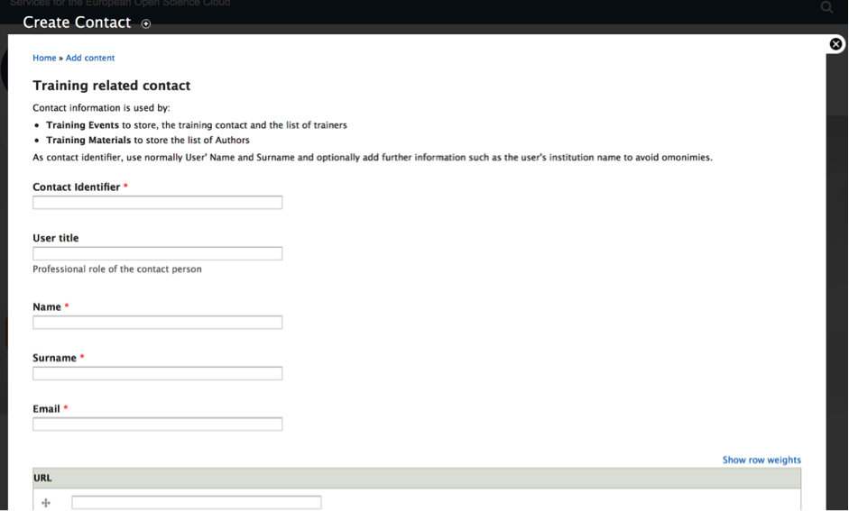
Figure 5 - The form to create a new contact
Repeat this procedure for all people involved in the training event and responsible of training materials.

Add a new training material
Training materials are viewable by the URL: https://www.eosc-hub.eu/training-material.
All events are shown sorted by ‘date created’ field and one or more search filters can be applied using several filters specified at the top of the page.
In case training materials are already available in the agenda of the training event, there is no need to register training materials in the catalogue, since the link of the training home page or agenda is one of the requested fields. It is also possible to register external referenced training materials in the training events catalogue.
To insert a new training material, select from the top menu: Add Content ➔ Training Material.
Figure 6 - Add a new training material
and provide the information requested in the dedicated web form:
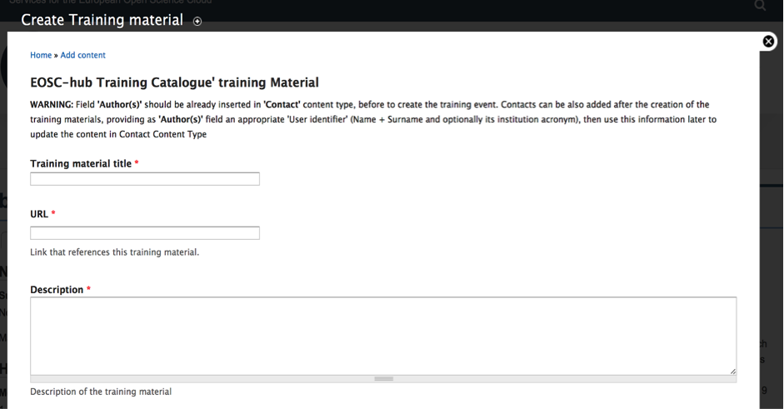
Figure 7 - The web form to add a new training material
Mandatory fields are marked with a red asterisk. Once the web form has been completed it will be possible to preview or save the new content. Repeat this procedure for all training materials involved in the training event.
At the end of data insertion, please pay attention to properly assign the Training Material authorship to the right Training user, as explained by the figure below:
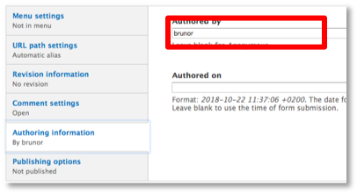
Figure 8 - Assign the trainer’s authorship
Training materials require the moderation of ‘Training Admin’ users who can decide to public the new material and make it publicly available or reject it.
To publish the new material, the ‘Training Admin’ has to select the check box ‘Publish’ under Publishing Options placed at the bottom of the insertion/edit web form as shown in the figure below:

Figure 9 - Enable the publishing of the material

Add a new training event
The full list of training events sorted by the event’ starting date are available at: https://www.eosc-hub.eu/training-events. One or more filters can also be selected to search for some specific events.
To insert a new training event, select from the top menu: Add Content ➔ Training Event
Figure 10 - Add a new training event
and provide the information requested in the dedicated web form:
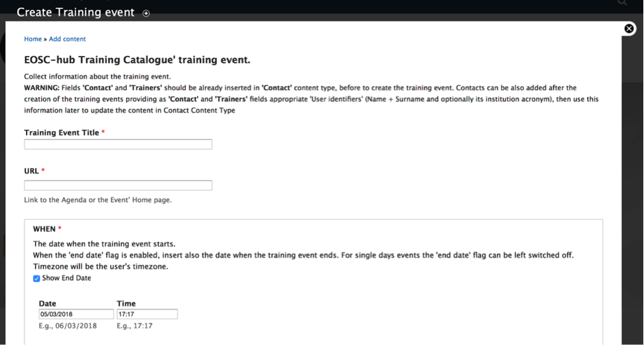
Figure 11 - The web form to add a new training event
Mandatory fields are marked with a red asterisk. Once the web form has been completed it will be possible to preview or save the new content.
Training events DO NOT require the moderation of ‘Training Admin’ users, so that the publishing responsibility is directly assigned to the user compiling the form. In order to publish the content, just select the check box ‘Publish’ under Publishing Options placed at the bottom of the insertion web form.
Figure 12 - Enable the publishing of the training event

Manage training roles
Role management may be necessary to grant or revoke the Training roles: Training Admin (TA) or Training Editor (TE) among registered members. Only users with the Training Admin role can grant or revoke training roles to other users.
To manage training roles:
- Select ‘People’ from the top bar menu.
- Identify the user from the list.
- Access to the user’s profile page and set the role.
- Save the preferences.
At this point, the list of all registered members will be displayed and the user to grant/revoke training roles has to be identified in the list. Then, click on the edit label in the user record in order to access the user’ details page. In the new displayed page, under the label ‘Roles’ it is possible to add/revoke one of the two training roles. At the end, press ‘Save’ button to apply the changes.

See: https://egi.eu/
See: https://www.eudat.eu/eudat-cdi/
See: https://www.indigo-datacloud.eu/
See: https://www.openaire.eu/advance/
See: https://www.eoscpilot.eu/
The FitSM standard defines a service catalogue as a Customer-facing list of all live services offered along with relevant information about these services. The service catalogue can be regarded as a filtered version of and customers’ view on the service portfolio. More information on the FitSM standards can be found at: https://fitsm.itemo.org/
An overview of the EOSC-hub service portfolio can be found at: https://documents.egi.eu/document/3277
https://wiki.eosc-hub.eu/display/EOSC/PROC07+Allocating+financial+support+for+trainers+to+attend+f2f+events
https://wiki.eosc-hub.eu/display/EOSC/Guidelines+and+Best+Practises+on+Training+Delivery?src=contextnavpagetreemode
Work done by the EOSCpilot project provided valuable input for the activities to create a training registry, in particular Deliverable 7.2: Eileen Kuhn and Achim Streit. “Interim report and catalogue of EOSC skills training and educational materials” (2017). Available at: https://eoscpilot.eu/content/d71-skills-landscape-analysis-and-competence-model
See: http://www.openaccessrepository.it/
http://www.invenio-software.org/
https://www.openarchives.org/pmh/
http://www.cern.ch/
http://www.desy.de/
http://www.epfl.ch/
http://www.fnal.gov/
http://www.slac.stanford.edu/
https://inspirehep.net/
http://scoap3.org/
https://zenodo.org/
http://www.openaire.eu/
https://tess.elixir-europe.org/
See: https://www.dataone.org/software-tools/dash
See: https://up2university.eu/
See: https://oer.geant.org/
https://www.eoscpilot.eu/content/d72-interim-report-and-catalogue-eosc-skills-training-and-educational-materials
https://eosc-hub.eu/training-events
https://eosc-hub.eu/training-material
Deliverable 7.2: Eileen Kuhn and Achim Streit. “Interim report and catalogue of EOSC skills training and educational materials” (2017). Available at: https://eoscpilot.eu/content/d71-skills-landscape-analysis-and-competence-model
https://www.eosc-hub.eu/training-material/
https://www.eosc-hub.eu/training-events/
The slides and recordings of the webinar can be found at: https://indico.egi.eu/indico/event/4281/
https://www.eosc-hub.eu/
https://www.egi.eu/services/check-in/
https://www.eudat.eu/services/b2access
Definitions taken from Science Europe Data Glossary. Available at: http://sedataglossary.shoutwiki.com/wiki/Main_Page
https://indico.egi.eu/indico/event/3920
https://www.eosc-hub.eu/events/webinar-how-manage-your-data-make-them-open-and-fair
https://www.eventbrite.com/e/towards-cultural-change-in-data-stewardship-in-practice-ticket-44014458430
https://events.prace-ri.eu/event/622/
https://www.elixir-europe.org/events/elixir-all-hands-2018
https://www.deic.dk/da/datamanagement/aktiviteter/Train-the-Trainers
https://indico.egi.eu/indico/event/3973
https://dans.knaw.nl/en/current/news/openaire-eosc-hub-webinar-data-privacy-and-sensitive-data-services
https://eosc-hub.eu/news/how-make-your-data-open-and-fair
http://www.corbel-project.eu/webinars/fitsm-approach.html
https://indico.egi.eu/indico/event/3906
WP11 “train the trainer” webinar: https://indico.egi.eu/indico/event/4281/
EOSC-hub online service catalogue: https://eosc-hub.eu/catalogue
EOSC portal marketplace: https://marketplace.eosc-portal.eu/
https://indico.egi.eu/indico/event/3930/
https://indico.egi.eu/indico/event/4086/
https://indico.egi.eu/indico/event/4100/
https://open.edx.org/
https://openbadges.org/
https://wiki.egi.eu/wiki/Training_infrastructure
https://wiki.eosc-hub.eu/display/EOSC/Requesting+financial+support
https://wiki.egi.eu/wiki/Training_infrastructure
https://wiki.eosc-hub.eu/display/EOSC/Online+tools+and+services+for+supporting+training
https://wiki.eosc-hub.eu/display/EOSC/Events
https://wiki.eosc-hub.eu/display/EOSC/Dissemination+Activities
https://eoscpilot.eu/content/d72-interim-report-and-catalogue-eosc-skills-training-and-educational-materials

