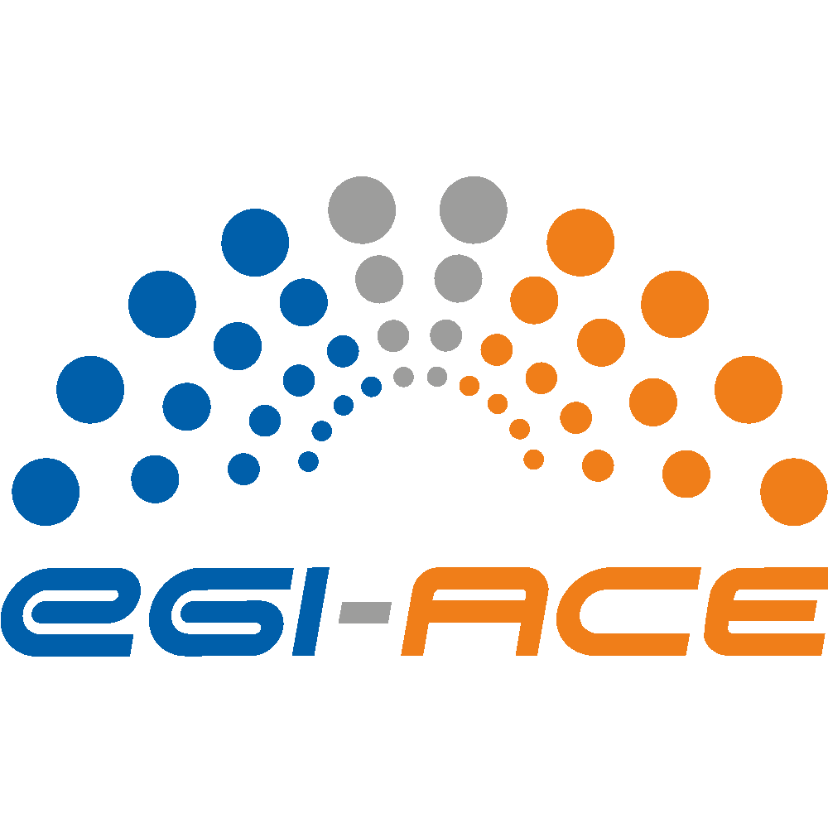
D2.6 Communication and engagement plan

Lead partner: | EGI.eu
Version: | 1
Status: | Approved by the EC
Dissemination Level: | Public
Keywords: | Communication, engagement
Document Link: | https://documents.egi.eu/document/3805

Deliverable Abstract
EGI-ACE is a 30-month project coordinated by the EGI Foundation with a mission to empower researchers from all disciplines to collaborate in data- and compute-intensive research through free-at-point-of-use services.

Building on the distributed computing integration in the EOSC-hub project, EGI-ACE will deliver the EOSC Compute Platform and will contribute to the EOSC Data Commons through a federation of cloud compute and storage facilities, PaaS services and data spaces with analytics tools and federated access services.

In this document all communication and engagement plans will be described, with the related activities and expected results. The document is an updated version of D2.1 Communication and engagement plan, a formal project deliverable submitted and accepted by the EC in 2021, and reflecting on the latest needs of the project and its stakeholders.

COPYRIGHT NOTICE


This work by parties of the EGI-ACE consortium is licensed under a Creative Commons Attribution 4.0 International License. (http://creativecommons.org/licenses/by/4.0/).
EGI-ACE receives funding from the European Union's Horizon 2020 research and innovation programme under grant agreement no. 101017567.

DELIVERY SLIP
Date | Name | Partner/Activity
From: | Magdalena Brus  Sergio Andreozzi  Gergely Sipos  Giuseppe La Rocca  Gwen Franck  Smitesh Jain  Enol Fernández | EGI.eu/WP2  EGI.eu/WP2 (WP lead)  EGI.eu/WP2  EGI.eu/WP2  EGI.eu/WP2  EGI.eu/WP2  EGI.eu/WP3
Moderated by: | Małgorzata Krakowian | EGI.eu/WP1
Reviewed by: | Charis Chatzikyriakou | EODC/C-SCALE
 | Mischa Salle | NIKHEF
 | Giacinto Donvito | INFN

DOCUMENT LOG
Issue | Date | Comment | Author
v0.1 | 10.6 | Updated version of D2.1 for comments | Magdalena Brus  Sergio Andreozzi  Gergely Sipos  Giuseppe La Rocca  Gwen Franck
v0.2 | 14.6 | Comments received and included in the draft | Magdalena Brus  Gwen Franck  Smitesh Jain  Enol Fernández
V1 | 27.7. | Final version | Magdalena Brus

Table of Contents
1 Introduction 7
2 Strategy and methodology 10
2.1 Stakeholder mapping 10
2.1.1 Stakeholder group: Researchers 11
2.1.2 Stakeholder group: International projects and research infrastructures 12
2.1.3 Stakeholder group: Industry/SMEs 12
2.1.4 Stakeholder group: Public sector 12
2.1.5 Stakeholder group: Academic HTC/Cloud providers 13
2.1.6 Stakeholder group: HPC providers 13
2.1.7 Stakeholder group: Data Space providers 13
2.1.8 Stakeholder group: EOSC Association 14
2.1.9 Stakeholder group: EOSC Advisory Groups (AGs) & Task Forces (TFs) 14
2.1.10 Stakeholder group: Providers of EOSC Core 14
2.1.11 Stakeholder group: EOSC Future project and INFRAEOSC-07 projects 15
2.1.12 Stakeholder group: GAIA-X 15
2.1.13 Stakeholder group: EOSC-like initiatives outside Europe (GOSC) 15
2.2 Engagement activities 17
3 Implementing stakeholder engagement 19
3.1 Engagement with the Users 19
3.1.1 Methodology 19
3.1.2 Analysis of the current (customers) landscape 20
3.1.3 Prioritization 20
3.1.4 Underrepresented communities/domains 20
3.1.5 Action plan to reach/engage with emerging communities 22
3.1.6 Consultancy and co-design activities 23
3.1.7 Expand the users base 23
3.1.8 Technical Support 23
3.1.9 Training events and Webinar Programme 25
3.1.10 Learning Management System (LMS) 25
3.1.11 Participation to conferences 25
3.1.12 Tracking of new Users 26
3.2 Engaging with service and content providers 26
3.2.1 Service Providers 26
3.2.2 Content Providers 26
3.2.3 Tracking of Service and Content Providers opportunities 27
4 Communications 28
4.1 Dissemination and engagement support 28
4.2 Brand development and internal communications 34
4.3 EGI-ACE communication channels 35
4.3.1 EOSC Portal 35
4.3.2 EGI-ACE website 36
4.3.3 Newsfeed and newsletter 38
4.3.4 Social media 38
4.3.5 Direct communications 39
5 Events 40
5.1 EGI-ACE events 40
5.2 Joint events with relevant projects 41
5.3 Participation and support to external events 41
6 Publications 42
o 6.2 Brochures, flyers 42
7 Measuring progress and success – Key performance indicators 43
8 Conclusions 44

Executive summary
EGI-ACE aims to empower researchers to collaborate in data- and compute-intensive research through free-at-point-of-use services. Ensuring that the project’s activities, developments, and outputs are observed by the target audiences and stakeholders, it is crucial to have a clear communications strategy. Ensuring recognition of the work is however not the only important factor to reach the project’s objectives. In addition to disseminating content and raising awareness, it is paramount to focus on engagement. The Communications and Engagement Plan provides an in-depth description on how project results, developments and branding will be communicated throughout the project as well as engagement with the targeted audiences, a clear dissemination strategy, and the description of promotion, consultancy, outreach, training and co-design activities.

The document introduces the plan with a stakeholder overview. The main stakeholder categories that are identified are: users, service and content providers for research, EOSC Governance and Core, and peer initiatives. For each of them, specific target groups have been identified. The plan continues with actionable and practical steps to ensure that the main target audiences (users and compute providers) are aware of the services and opportunities the project offers. This is based on input from the technical work packages (WP3, 4, 5, 6 and 7) which are providing the communication and engagement tasks in WP2 with input about the uptake and onboarding of services, the adoption of use cases, and the development of the data spaces.

There is a great number of actors and activities involved in raising the awareness of the project. Therefore, the project has created a dissemination tracker to easily present which type of engagement and communication activities have been conducted and how many audiences have been reached. The communication tracker included in the first periodic report demonstrated the overall very high communication and dissemination activity of the project team. Such activities will continue through the project’s lifetime. Additionally, there is a list of KPIs and objectives that supports the monitoring and evaluation of the planned activities.

With the various activities, training sessions, webinars, attending/organising events, online communication, digital and printed communications material, direct engagement activities, to name a few, the communications and engagement taskforce of the EGI-ACE project ensures all audiences and stakeholders receive the information, knowledge and content they would be interested in, and will become aware on how to benefit from the services and potential collaborations the project offers.

This document is an updated version of the original Communication and engagement plan (D2.1). It reflects on the project’s results after the first 18 months, especially its communication and engagement efforts, latest needs of different Work Packages in EGI-ACE as well as those of their key target groups, the comments from the first periodical project review, and finally, on the situation and latest developments within the landscape where EGI-ACE operates.

Introduction
EGI-ACE is a large-scale, multi-organisation distributed project that “strengthens Europe’s capabilities and infrastructures for hosting, processing and using data, interoperability”. The project contributes to this vision by enabling all researchers from all disciplines to be empowered to collaborate and to carry out data- and compute-intensive science and innovation across national borders through free at point of use service offerings.
To respond to the proposed general objectives of the EOSC Partnership EGI-ACE:
- Delivers a free-at-point-of-use distributed compute facility that pools national and international capacities and removes today’s barriers that prevent transnational and cross-disciplinary access to high-end compute facilities.
- Offers a sustainable hyperscale facility with the capabilities and capacities to host large research datasets and data analytics to address the complex digital needs of research.
- Develops the EOSC Compute Platform as an open infrastructure that can expand thanks to the adoption of common technical specifications and management processes.
- Provides a heterogeneous computing infrastructure with different cost and performance systems, which can ensure that communities get the resources they need with the best return on investment for European funding supporting them.
The project builds on:
(1) EOSC-hub results, co-design and requirement gathering activities;
(2) Data and applications from research collaborations;
(3) The operational capacity and expertise of the EGI Federation.

With the established results from previous projects and the EGI Federation, stakeholder engagement activities are strongly supported as there are sufficient early adopters to showcase the impact of EOSC services on the research work. New user communities are targeted during the course of the project, which is one of the main objectives of the communication task. Additionally, the following activities are playing a key role in order to support the project’s general objectives:
- Promote the EOSC Portal and especially the EOSC Compute platform to show the ease of accessing services.
- Showcase the importance of the EOSC Compute platform to invite (external) data community services.
- Invite new providers and present the successful onboarding of data spaces.
- Communicate about webinars and training opportunities to improve the uptake within the target groups.
- Ensure all the services, especially the underused and the newest are utilised by promoting them towards new groups of users.

These activities, with support from activities in other WPs, are intertwined and complement each other, in order to identify prospective stakeholders and engage them into the EGI-ACE environment. Additionally, there are a number of projects from the same call (INFRAEOSC-07) and the EOSC Future project that conducts supporting activities, contributing to the EOSC strategy and mission. It is therefore important to align the communication and engagement activities with these projects (C-SCALE, DICE, OpenAire Nexus, RELIANCE), to reach a wider audience during joint events and cross-project dissemination activities. For this purpose, the project is an active participant in the cross-project and collaboration board meetings.

Deliverable 2.1 showcased an initial strategy to maximise the communication and engagement potential, in line with the project’s objectives. This updated version reflects on the project’s results after the first 18 months, latest needs of different WPs in EGI-ACE as well as those of their key target groups, the comments from the first periodical project review, and finally, on the situation and latest developments within the landscape where EGI-ACE operates. Task 2.4 is continuously reviewing and measuring the performance and impact of the communication activities. The updated version reflects on the performance and impact and suggests improvements to existing actions as well brand new communications activities. Last but not least, the fact that the current epidemical situation allows for travelling and organisation of face to face meetings, is as well considered in this updated communications and engagement plan.

The document is structured in a following way:
- Section 1: Strategy and methodology, describing the initial steps of the plan including the stakeholder analysis.
- Section 2: Implementation of engagement activities, describing planned activities to interact with the identified stakeholders in detail.
- Section 3: Implementation of communication activities, describing the detailed planned activities to increase awareness of the project and communicate about developments, results and events.
- Section 4: Events, describing the planned events to be organised and attended.
- Section 5: Impact indicators and KPIs, describing the monitoring activities of the plan.
At the end of the document there is a concise conclusion to sum up the plan and its expected outputs.

Strategy and methodology

Before diving into the action plans, it is important to understand who the actions are directed to and how to maximise the intended impact. Therefore, we present here a stakeholder analysis, which allows us to understand the stakeholder groups’ importance to the project and vice versa, how to best reach the groups and how to ensure the engagement and communication activities are sustainable, preferably benefitting the stakeholders even beyond the duration of the project.

Stakeholder mapping
The project targets a great number of audiences, and a specific set of stakeholders. It is important to distinguish these two from each other, as the audiences are merely receivers of content, while the stakeholders are affected by decisions and actions, interact with the content, share their opinions and needs and further exploit potential opportunities.
The first version of the Communication and engagement plan identified four stakeholder categories: users, service and content providers for research, EOSC governance and Core, and peer initiatives. The following table presents an overview of the stakeholder groups within the categories and their main motivation for engagement with the project.

Stakeholder category: Users
Stakeholder group | Main motivation for engagement with the project
Researchers | This group wants to access services provided by the project for short term use (< 1 year).
International projects | This group wants to access services provided by the project for mid-term use (<3 years).
Research Infrastructures (RIs) | This group is interested in the service offerings of the project for long term, customised use (>3 years).
Industry/SMEs | This group wants to use the EOSC Compute platform for prototyping applications, and to receive technical support for the integration of applications/platforms with the EOSC Compute continuum.
Public sector | This group is an early adopter of academic compute services and could use the project to access services in the EOSC Compute platform and to receive technical assistance for architecting and implementing compute-setups.
Stakeholder category: Service and content providers for research
Academic High-Throughput Compute (HTC)/Cloud providers | This group will make use of the project’s wider reach to ensure their services are used across borders.
HPC providers | This group will be interested to learn about the project’s HPC integration and guidelines and follow them to become providers in EOSC.
Data Space providers | This group will be interested in how to interact with the services offered by the project to offer data spaces (i.e. scientific datasets and applications all integrated on scalable compute platforms).
Stakeholder category: EOSC Governance and Core
EOSC Association | This group will benefit from the contributions of the project to the EOSC and will be interested in learning about the results, impact and development of the EOSC Compute Platform also with respect to competing/complementing solutions ‘out there’.
EOSC Advisory Groups (AGs) & Task Forces (TFs) | This group will be interested in receiving expertise from the project for specific topics to collaborate seamlessly on EOSC matters.
Providers of EOSC Core | This group will be eager to receive feedback and requirements on the services to continuously develop them.
Stakeholder category: Peer initiatives
INFRAEOSC-07 projects | This group will benefit from the joined activities, promotion and collaboration to further serve the EOSC mission and raise awareness.
GAIA-X | This group will be interested in learning about approaches to similar activities.
EOSC-like initiatives outside Europe (GOSC) | This group will be interested in learning about practices and technical solutions used/delivered by EGI-ACE to adopt those for the support of computing for Open Science.
EOSC-Future Project | This group will share a similar motivation as the ‘INFRAEOSC-07 projects’ and is interested in integrating their activities with that of the project where relevant.
Table 1: Overview of stakeholder categorisation and subgroups, including the motivation for engagement

Stakeholder group: Researchers
This is the group of stakeholders that makes use of the services and are the end-users of all EOSC initiatives. All activities in the project aim to support this group, as the intention is to empower researchers from all disciplines to collaborate in data- and compute-intensive research across borders. By delivering the EOSC Compute Platform and contributing to the EOSC Data Commons, the project services address the needs of this stakeholder group, and therefore it is highly important to ensure engagement and communication activities are targeting the group appropriately.

Stakeholder group: International projects and research infrastructures
EGI-ACE offers a variety of open calls to actively invite international projects and RIs to make use of the offering. Not only do we want to clearly communicate about the services, but also engage these stakeholders by providing training sessions, handbooks and consultancy services. As mentioned before, this stakeholder group also provides an excellent opportunity to reach researchers. It is considered a highly important stakeholder with great influence for interaction with the project output.

Stakeholder group: Industry/SMEs
Commercial entities can be relevant for the EOSC Compute platform as either provider (making commercial services accessible for EOSC via EGI-ACE), users (using EGI-ACE services to e.g. develop new platforms/tools/applications), enablers (giving related work/good practices/reusable services/business models for academic providers in EGI-ACE). Engagement with this sector is not a priority for EGI-ACE, because it’s not a priority for EOSC in its current phase of development (See EOSC Roadmap timeline in Figure 1 below), and because the EOSC Digital Innovation Hub of the EOSC Future project is promoted as the front-end of EOSC for industry. EGI-ACE and the EOSC DIH are both coordinated by the EGI Foundation, and the two parties already agreed to work together on commercial support. Particularly, EGI-ACE acts as service provider, supporter, advisor for any ‘business pilot’ that is supported by the EOSC Digital Innovation Hub (DIH) in the computing area, and the DIH provides visibility to the EGI-ACE services and effort in its communication/engagement activities.

Stakeholder group: Public sector
This group is not considered the main target audience of the project because it is not a main target group for EOSC in its current phase of development (See EOSC Roadmap timeline in figure 1 below). However, the group is still included in this plan as it remains an important stakeholder for any EOSC related content in the long term. Similar to the previous group, success stories and use cases will be of great influence to showcase the importance of open science and its services to scientific output. The project will not provide country-specific reports, but the outputs of data spaces will provide sufficient information for policy makers to understand the impact for their national, regional or international roadmaps.

Stakeholder group: Academic HTC/Cloud providers
HTC/Cloud providers from academia are the core constituencies of EGI. Providers with national/institutional mandates are sitting in the EGI Council, and over 20 of such providers are already in the consortium. Academic providers are tasked by their funding agencies/ministries to support science at the national and/or international level.

The project should keep the already onboarded HTC/cloud providers engaged in the EOSC compute platform delivery and should reach out to currently unrepresented sites and countries to broaden geographical coverage, and compute diversity.

The primary goal for engagement is to establish long-term relationship with the new providers, i.e., sign them up into the EGI Council and reach full integration into the EGI HTC and/or EGI Cloud infrastructures, ensuring commitment for international infrastructure support beyond the EGI-ACE project. A secondary option is MoU-based integration, which can still ensure participation in relevant use cases and infrastructure development activities but may not lead into long-term service provisioning after the project.

The project works on this stakeholder group in T7.4 International cloud integration.

Stakeholder group: HPC providers
One of the action lines of the project is the development and provisioning of interoperability guidelines for HPC systems on how to onboard and participate in the EOSC Compute platform. T7.3 explores how HPC systems should be exposed to the EOSC portal and how users should interact with them. 4 HPC providers and 4 scientific use cases participate in this action as consortium members. While the work itself (e.g. development and promotion of the guidelines) is done by the consortium, the outcome is relevant for HPC providers outside, and exploitation of the results will need engagement with them for validating and adopting the guidelines more broadly, resulting in a compute continuum ranging from HTC through Cloud to HPC.

Stakeholder group: Data Space providers
A Data Space is defined in EGI-ACE as a collection of scientific data, and related data analytics/visualisation/AI applications that are offered for access on scalable compute/storage resources. From a technical perspective, the access to the data space can be subjected to conditions set by relevant data subjects and data owners. Interoperability with other data and services, both in- and outside the data space, is also possible. This group is considered one of the main target audiences of the project. The EGI-ACE project consortium in WP5 already includes 13 data spaces in different scientific domains and implemented data space as an integrated multi-supply offer of research data, application tools and the necessary federated compute and storage infrastructure needed for hosting, processing and analysis. The project looks for additional communities who could become data space providers by bringing scientific datasets and analytics applications to the generic compute-platform-access layers of the project.

Stakeholder group: EOSC Association
The EOSC Association is an important stakeholder for the EGI-ACE project as it represents the EOSC stakeholders towards the European Commission in the context of the EOSC Co-Programmed Partnership. It is important that they are made aware of the results of the project and the contribution in implementing the EOSC SRIA.

Stakeholder group: EOSC Advisory Groups (AGs) & Task Forces (TFs)
The new EOSC governance will engage the stakeholders in developing recommendations in different areas based on a number of advisory groups and task forces that are being formed. Draft charters are made available and there is an open application process. Once the groups are formed and active, it will be important for the EGI-ACE project to define engagement strategies with those groups, to make sure that relevant results from the project are fed into them and vice versa.

Stakeholder group: Providers of EOSC Core
EGI-ACE offers services in EOSC and therefore acts as a user of the EOSC Core. Besides using the core services through their user interfaces (GUI/APIs) the project also engages with the core providers about feedback, development suggestions. One-to-one channels are already established to several core services (Marketplace, Accounting, AAI) where such feedback is being reported.

Note that several elements of the Core are also included in EGI-ACE Task 7.6 ‘Service Management Tools’: Accounting, Monitoring, Helpdesk, AAI, Configuration DB, Operations Portal. The scope of work is complementary for these services in the two projects: Their focus in the EOSC Core is to serve the whole EOSC community, the focus in EGI-ACE is to use and improve them for serving computational services and use cases. The funding lines are separated accordingly (in the EOSC Future for the Core developments, in EGI-ACE for the compute-specific developments).

Stakeholder group: EOSC Future project and INFRAEOSC-07 projects
EGI-ACE works in close collaboration with EOSC Future and other 07 projects on activities of common interest across all of them. The joint activities include:
- Coordinated service resource provisioning;
- Architecture & Technical Interoperability;
- Requirements Gathering & Analysis (about core services);
- Aligned user engagement and communication;
- Integrated training.

The first EOSC 07 Collaboration Board meeting was organised in February 2022 and is organised quarterly. In addition, regular cross-project meetings focusing on technical developments, support for user uptake and coordinated training approach, are organised.

Stakeholder group: GAIA-X
There are strong synergies between EOSC and GAIA-X, both seeking to seamlessly integrate data and services across a range of sectors and research domains. The project is actively engaging with GAIA-X, through a combination of EGI Foundation staff participating in GAIA-X Working Groups and Open Work Packages and project partner representatives also participating in Open Work Packages. EGI-ACE representatives recently published a paper about the compared Governance, Architectures and Business Models for Data and Cloud Federations in EOSC and GAIA-X. The paper was sent to, and is already used by, the EOSC Association in alignment meetings with GAIA-X.

Stakeholder group: EOSC-like initiatives outside Europe (GOSC)
The Global Open Science Cloud (GOSC) represents an opportunity to extend the geographic scope of EOSC beyond Europe across the globe. Efforts related to GOSC are early stage and diffuse, spanning UNESCO and CODATA to the Research Data Alliance to a variety of regional initiatives around the world such as the Malaysia Science Platform and the Africa Open Science Platform. It is important for the project to track and support these efforts and share knowledge in order to build collaborative peer-to-peer relations that will create a common ground for understanding as well as compatible and interoperable approaches that will allow EOSC to interwork with GOSC participants worldwide. EGI engaged with GOSC before EGI-ACE and organised a GOSC workshop as part of the EGI Conference 2020 event. The project continues to engage with GOSC efforts, particularly those with a focus on federating infrastructure, in order to create a community of practice upon which future cooperation can build. One of the next steps is contributing to the GOSC workshop 2022 event.
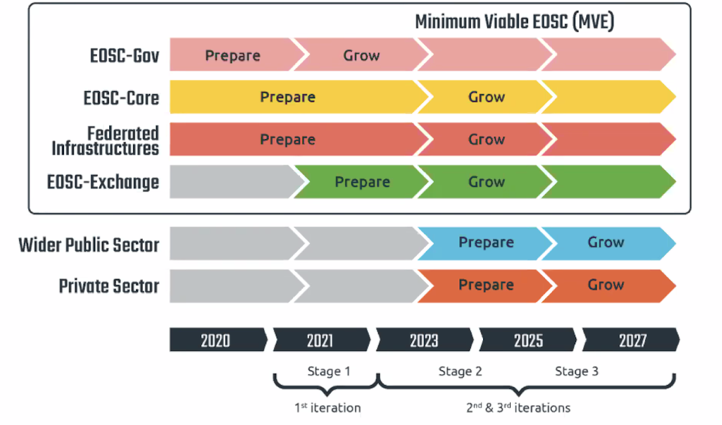
Figure 1: Timeline of EOSC iterations towards a Minimum Viable EOSC (MVE)

Engagement activities
The following table provides an overview of the engagement activities the project performs and will keep performing, and the linkage/relevance of those to the different stakeholder groups. The various activities are then detailed one-by-one. These activities are supported by the communication activities, which are described in further detail in the communications section of this report.

Engagement instrument |  | Users |  |  |  |  | Service and content providers |  |  | EOSC Governance and Core |  |  | Peer initiatives
Name | Priority | Researchers  (long-tail of science) | International projects | RIs | Industry/SMEs | Public sector | Cloud, HTC | Co-located Cloud and HPC | Data space providers | EOSC Association | EOSC AGs/TFs | Providers of EOSC Core | 07 projects | GAIA-X | GOSC | EOSC-Future
Name | Priority | Low | Medium | High | Low | Low | High | High | High | High | High | High | Medium | Medium | Medium | High
Webinars | High | May respond | Targeting them | May respond | May respond |  | Relevant content is provided
Training (live and self-training) | Medium | May respond |  |  | May respond |  | Relevant content is (should be) provided
Call for use cases | High | May respond | Primary instrument | May respond | May respond | May respond
Direct (one-on-one interactions) | High | --- |  | Primary way |  |  | OMB (existing)  1-on-1 meetings&workshops | Via WP7 partners+EuroCC  EuroHPC | Interaction w. BDVA | EGI.eu is member (rep is WP2 coord) | EGI-ACE representatives involved | Primary instrument | Regular 07 coordination meetings for technical collaboration, training and user uptake | Participation in their TFs | GOSC workshops | Regular EOSC Collaboration Bord meetings
How others did it (use case examples) | Medium | Usage examples (on the website) |  |  |  |  | Provider experiences (how NGI x benefits from EGI)
Publications (incl. Newsletters) | Medium | Informing about project results, updates and upcoming activities and events (more detailed in communications section)
EGI conferences | High | Informing about project results, updates and upcoming activities and events. Additionally offering all audiences to interact, share knowledge and discuss relevant topics.
Topical workshops | Medium |  |  | Important instrument
Demos/talks/… @ external events | High | Participation to external events
Table 2: High level overview of planned engagement activities and prioritised stakeholder

Implementing stakeholder engagement
The engagement with scientific communities and researchers is one of the key activities pursued by the project to consolidate the outreach network of existing communities and reach out potential new researchers.
In Section 3.1 the main stakeholders of the engagement strategy are represented by Internationals Projects and Research Infrastructures (RIs) belonging to the User target group reported in Table 2, while in Section 3.2 we will focus on the strategy for targeting services and content providers.

Engagement with the Users
EGI-ACE already includes 13 Data Spaces addressing the following disciplines: Health and Medicine (4); Climate Research (2); Energy and Physical Sciences (2); Environmental Sciences (4); and Social Sciences and Humanities (1). The project also supports additional 7 international Early Adopters scientific communities to expand the initial capabilities offered by the project and will run an engagement programme to reach even more scientific communities and users. Last but not least, we have so far supported more than 30 use case applications from different scientific areas, helping to increase the user base of the EOSC Compute Platform.

Methodology
To expand the users base in EGI-ACE, the following activities are being pursued:
- Perform a gap analysis to understand the current customer landscape.
- Identify emerging areas and underrepresented disciplines.
- Organize marketing and targeted activities to reach the new stakeholders.
- Provide technical support on computational and compute-related data management activities, propose advanced solutions and provision resources for supporting the integration plans.
- Organize sound training plans to address the needs of the different stakeholders.
- Annually record and plan the engagement opportunities. Analysis of the current (customers) landscape.

The starting point for improving the strategy for reaching out potential new stakeholders is to analyse the current customers landscape, identify potential gaps represented by underrepresented disciplines, and define a targeted plan for helping new stakeholders to enter the engagement process.

To have a full understanding of the current landscape we have considered all the customers supported by EGI before the start of the project. Currently EGI is supporting 78K users from different scientific areas. The largest scientific communities in EGI are Medical and Health Sciences, High Energy Physics, and Earth and Environmental Sciences, together representing more than 75% of the total user base. Some of these communities are now supported as EGI-ACE Data Space providers or Early Adopters.

Analysis of the current (customers) landscape
The starting point for improving the strategy for reaching out potential new stakeholders is to analyse the current customers landscape, identify potential gaps represented by underrepresented disciplines, and define a targeted plan for helping new stakeholders to enter the engagement process.

Prioritization
- Strategic communities: Communities with the biggest growth potential in terms of user base, service consumption, and funding.
- Biggest communities: Communities already using the resources and the solutions offered by EGI but without a formal SLA/MoU.
- Strategically important growing communities: Communities already using EGI resources with a formal SLA/MoU that are interested to use EGI any further.
- Experimental communities: Communities with uncertain growth potential and with commitment to use EGI resources currently limited to projects.
- Other: Small group of researchers with limited scope, short timeline, and low or uncertain impact at European scale.
The adoption of this prioritization produced the following results:
- Strategic communities: BELLE II, DARIAH, ELIXIR, EMSO-ERIC, Joint Research Centre (JRC), METROFood, and OBSEA.
- Biggest communities: CLARIN, D4Science, IceCube, KM3NET, LifeWatch, LSGC, NBIs, VIRGO and WeNMR.
- Strategically important growing communities: CNIC/CAS, EISCAT-3D, ELI/ELI-NP, European Marine Board (EMB), Fusion, GEO-DAB, and OPERAS.
- Experimental communities: C-SCALE, PolicyCLOUD, DIGITbrain, EUHubs4Data, EOSC Synergy, DANUBIUS, and PaNOSC.
- Other: Several piloting activities coming from Early Adopters programme and long-tail of science users.
The results of the gap analysis are reported in the next section.

Underrepresented communities/domains
A clear evidence of the results of this landscape analysis is lack of key areas/communities. To bridge this gap, potential new stakeholders, from new emerging areas, will be selected based on the Horizon Europe (HE) and Digital Europe Work Programmes. The main objective of the Horizon Europe Programme is to tackle climate change and boost the EU’s competitiveness and growth. More specifically, the HE Programme is organized in 3 Pillars:

- Pillar I: Excellent Science,
- Pillar II: Global Challenges and European Industrial Competitiveness, and
- Pillar III: Innovative Europe.

The EGI Engagement programme will focus more on the Clusters supported by the Pillar II of the HE Programme:

- Health,
- Culture, Creativity and Inclusive Society,
- Civil Security for Society,
- Digital, Industry and Space,
- Climate, Energy and Mobility, and
- Food, Bioeconomy, Natural Resources, Agriculture and Environment.

From the HE Work Programme, the following top priority have been identified:

Scientific Domain | Main players | Actions
Earth Observation (EO) | ESA | Find personal contact
Earth Observation (EO) | Joint Research Centre (JRC) | We have already started a collaboration in EOSC-Hub.  Continuing the collaboration started with Joint Research Centre (JRC) providing the essential compute needs of the European Earth Observation community to build out functionalities that are relevant for the user community. This activity will be jointly supported in the context of the EGI-ACE and C-SCALE projects.  Supporting JRC by deploying larger sets on multiple-GPU instances to be able to cross-validate amongst data sources and to integrate the  higher complexity of Common Agriculture Policies (CAP) specific evidence (e.g. grassland management, recognition of special flower mixes, new  inter-row cropping practices). This should enable new options from a wider set of adequate, but more resource demanding DL models, perform faster hyper-parameter tuning and test large banks of models against extensive test sets.
Earth Observation (EO) | C-SCALE | We already signed a MoU and collaborate thanks to established mechanisms for EOSC 07 project cooperation.  From the EGI-ACE Open Call we have identified a potential use case (Pangeo) that is interested in accessing Copernicus data.
Health and Medicine | BBMRI | A collaboration strategy was agreed on the following key areas:  - Helping national healthcare institutes that often are the home of national biobank, to scale up nationally with 1-1 agreements with local cloud providers, capacities have to be secure enough to be able to scale up (by a factor of three).  - Central hosting capabilities, currently supported by CNR and CESNET (aconet offering was already evaluated).  - Trusted Research Environments - secure data processing and deposition through trusted research environments - secure storage is key, sw is audited and not allowed to export data.
Health and Medicine | ELIXIR | We already started a collaboration in EOSC-hub.  Activity took new direction (DataHub)
Agricultural | Food Nutrition Security Cloud (FSN-Cloud) | Engaging with this community to further develop the Food Security Platform and leverage on the EGI cloud-based infrastructure to better support applications exploiting Copernicus Sentinel-1 and Sentinel-2 datasets
Agricultural | MetroFood (ESFRI) | Initial contacts were established to expand the AAI collaboration towards cloud and data spaces
Table 3: Top priority scientific communities that will be engaged

Action plan to reach/engage with emerging communities
A detailed strategy and action plan for reaching out to the top priority communities reported in Table 3. is described in the EGI Engagement Plan. However, it is important to mention that in the second period of the project, the focus is shifting from the engagement and onboarding of the new communities to ensuring the existing end-user satisfaction.

Consultancy and co-design activities
To support the integration of new scientific use cases, services and content providers in the EOSC Compute Platform, dedicated co-design activities (e.g.: workshops, and bootcamps) are organized by the project.
More specifically, this activity supports:
- Compute providers to become interoperable and mature providers in the EOSC Compute Platform.
- Scientific users who wish to use EGI-ACE services in EOSC.
- Scientific communities and RIs who want to establish their data spaces on top of the EGI-ACE infrastructure.
- On-boarding new services in EOSC.

Expand the users base
Additional user communities are identified and supported via different channels. The list of relevant channels includes:
- The EGI-ACE open call to promote the project services for adoption, consolidate the outreach network of existing research communities, and reach out for potential new customers and users of the EGI-ACE services. With this open call, the project offers access to infrastructure and platform services, dedicated user support and training. The services, support and training offered by the project are sponsored by the European Commission and various national funding agencies and are freely accessible for the use cases that will be selected through the call.
- The cross-project collaboration established between EOSC Future and the INFRAEOSC-07 projects.
- Scientific use cases supported in collaboration with national research infrastructures, ESFRI data clusters, collaborating projects in INFRAEOSC-07.
- Promotion through the EGI Federation links with national and international user communities.
- Promotion through non-European international collaborations.

Technical Support
The technical support to expand and to serve the users base in EGI-ACE is mainly provided in T2.3. The main purpose of the user engagement activities in T2.3 is the following:
- Support the Data Spaces and the Early Adopters in the uptake of the EGI-ACE core services (infrastructure + platform) and support them in reaching scientific end users with the software as a service products.
- Reach new user communities that are underrepresented or not present in the current user landscape but have high potential for the exploitation of EGI-ACE services.
- Enhance the user experience of the users that we already serve.
To expand the users base, T2.3 set-up the following support pipeline:
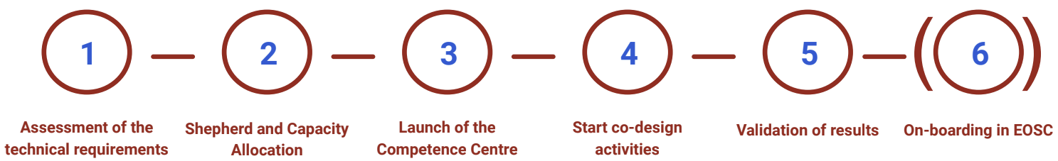
The support pipeline starts assessing the technical requirements of the use case application. For this task, 3 reviewers are assigned. During the consensus meeting, the reviewers, together with the EGI-ACE SDS board members, decide whether the application can be accepted or not. In case of positive assessment:
- The proper level of technical support is agreed.
- An initial capacity allocation of resources (WP3) is offered to the application.
- A technical expert from the consortium is assigned to liaise with the principal investigator of the use case application and the different providers.
- A Competence Centre is launched with all the parties involved in providing support to the use case. In the framework of this Competence Centre, co-design activities are executed, temporary progress are monitored, and preliminary results are validated before proceeding with the on-boarding of the new service in EOSC.
The top priority for the project during the second part is to closely monitor the integration plans of the already selected use cases, and monitor the usage of the WP3 resources provided via the VA mechanism. Ideally, the project will make sure that each use case application will reach a good level of maturity and contribute to the EOSC Exchange on-boarding new services in EOSC (if possible). To achieve this objective the project will review the initial capacity allocations (WP3) with the principal investigators to ensure service uptake. If extra spare resources will be available, these resources will be allocated for supporting additional scientific communities and use cases.
The uptake of EGI-ACE services is also supported by the EOSC Platform Early Adopter Programme, organised in collaboration with other INFRAEOSC-07 projects and coordinated by EOSC Future. The EOSC Platform Early Adopter Programme offers a rich set of resources and expertise to research communities and service providers. It specifically looks to support use cases in need of EOSC resources from different disciplines or e-infrastructures and the integration of new services into the EOSC-Core. During the second part the project will intensify the collaboration with several EOSC Future cluster projects, including PaNOSC and ESCAPE.
One of the goals is to help the PaNOSC community to support the integration of the EU portal for processing Serial Crystallography Data in EOSC. The support offered by EGI-ACE for scaling up the resources for the processing of serial crystallography data will provide three main benefits:
- Give the users of large analytical facilities an easier access to recent software and analysis techniques.
- Provide resources for quicker processing results.
- Users will be able to gather, compare and combine data from different RIs on a common EOSC platform for analysis, which will significantly enhance scientific productivity.
The support and the opportunistic resources offered to the ESCAPE community will contribute to set-up the ESCAPE Data Infrastructure for Open Science in the European Open Science Cloud. This Data Infrastructure will be used to store, distribute and provide data and software access to the broad dark matter scientific community.

Training events and Webinar Programme
To nurture the knowledge sharing, promote the uptake of the EGI-ACE services, and facilitate their adoption, the project will continue to organize webinars, and face-to-face training events to target the needs of our main stakeholders: researchers, and service operators. The first part of the EGI Webinar programme started in April 2021 focused more on the advanced solutions for targeting the needs of international projects and researchers. The programme also includes additional topics to target the needs of service and content providers (e.g.: on-boarding of new novel services in EOSC). During the second part of the project, the EGI Webinar programme will focus on the promotion of Data Spaces and Thematic Services and promote under-used services from WP3,4 and WP6. During 2022 we plan to organise at least 10 online webinars.
With the reduction of the pandemic restrictions, during the second part the project will start planning face-to-face training events. During the EGI2022 conference that will take place in Prague, Czech Republic (21-24 September, 2022) several training sessions and workshops have been already included in the conference programme. This tailored training programme will be complemented by additional domain-specific events from the supported Thematic Services involved in T2.3 and WP5.

Learning Management System (LMS)
To facilitate the engagement with participants in courses, provide unlimited access to e-learning materials, track attendance to courses, send online tests, and give tailored educational material based on their skill profile, the project will explore how to develop new training contents in the EOSC Knowledge Hub (KH) developed in the framework of the EOSC Future project. This KH will also include a Learning Management System based on Moodle for helping educational institutions and organizations to create and organize learning materials in one place and track the progress of their trainees or students.
In the second period the project will develop and make available video courses and hands-on exercises for users about the EOSC Compute Platform. The primary delivery channel is the EOSC KH, however other delivery channels, such as Udemy Inc are also considered.

Participation to conferences
A proactive way to reach out potential new scientific communities and international projects is to participate in their annual conference meetings or invite them to contribute to the annual event organized by the project. WP2 is closely monitoring all the relevant events, ensuring the representation of the project. As the COVID-19 pandemic situation in Q1 of 2022 improved, the project proactively seeks for the opportunities for physical participation at events.

Tracking of new Users
All the users entering the engagement process are recorded in the EGI Confluence space.

Engaging with service and content providers
To deliver and operate the European Open Science Cloud Compute Platform for serving the present and future needs of data-centric, research-focused computing in Europe, expand the supply-side, and promote the development of an open, data-centric, distributed, hybrid and secure infrastructure, the project foresees several engagement opportunities.
In the next sections we describe the activities that will be carried out to engage with the Service and the Content Providers.

Service Providers
To expand the compute service providers base in EGI-ACE, the following activities will be pursued:
- Finalise integration of the MoU-based cloud providers into the EOSC Compute platform (Georgia, Moldova, Latvia, T-Systems, and CloudFerro).
- Integrate existing national clouds into the EGI Cloud from EGI-ACE partners: SZTAKI (Hungary), IICT-BAS (Bulgaria), UKIM (Macedonia).
- Negotiate integration with emerging national e-infrastructure consortia, including Lithuania, Austria, Ireland, and Taiwan.
  - Technical activities with Ireland to support marine communities will start in Sept. 2022.
  - A dedicated workshop to support the Austrian users will be organized in Q4 2022.
- Discuss alignment (technical) and technology/experience exchange with peer-infrastructures outside Europe: OSG (USA), TRIUMF (Canada), ARDC (Australia), NDRIO (Canada), C-DAC (India), CLAF (Latin America), and CSIR MERAKA (South Africa).
- Reach out to new countries where national infrastructure may exist: Belorusia, Israel.
- After the HPC integration activity brings its first results, reach out to HPC sites/projects both external and internal to the EGI-ACE consortium to inform them about the results, to validate those, and to facilitate uptake for sharing HPC systems in EOSC.

Content Providers
To expand the content providers base (Data Spaces) in EGI-ACE, the following activities will be or are being pursued:

- Promote the EGI-ACE call to scientific communities that are providing scientific data but assumed to lack infrastructure for data exploitation.
- Continue the engagement with Big Data Value Association (BDVA). Monitoring the work done in the context of the BDVA TF10 - Data Sharing Spaces which focuses on supporting the realisation of the potential of European Data Sharing Spaces.
- Monitor the Horizon Europe / Digital Europe work programmes to find relevant calls in this topic and prepare a consortium with content providers.

Tracking of Service and Content Providers opportunities
The engagement opportunities for supporting new service and content providers is tracked in the EGI Confluence space and Jira.

Communications
Communication activities within the EGI-ACE project support the outreach and visibility of the project. This section of the deliverable describes an updated plan, focusing on the most appropriate content for the relevant target audiences. Communication activities create content and disseminate this through the relevant channels, whereas the engagement activities focus more on creating interactions, offering room for initial exploitation of the project results, which has been described in the previous section of this plan. In the context of EGI-ACE, lessons learned from the first 18 months of the project as well as previous relevant projects (e.g., EOSC-hub), and established relationships with other projects and infrastructures, serve as valuable input.

Dissemination and engagement support
The earlier phase of the project mainly focused on digital dissemination and engagement activities. As the global pandemic did not allow for face-to-face events, online webinars and meetings were the main tools to ensure all target audiences and stakeholders stay up to date on the latest developments of the project. However, the organisation of virtual webinars proved to be an efficient way to allow broader participation of various target groups. The project will therefore continue its online webinar programme, with additional community support events and other engagement events organised physically.
A more detailed dissemination plan is embedded in D1.4 Dissemination and Exploitation plan, which also includes IP management, exploitation paths, and adoption. In this deliverable, an overview of the dissemination activities is mentioned in support of the communication plans.
Online communication channels play an important role in the dissemination of the project. Platforms and tools such as social media, newsletters, and websites are populated with case studies, call for proposals, news items, explanatory videos and infographics. The project outcomes and results additionally benefit from scientific journals, online events/webinars and training sessions, depending on the audience.
The dissemination activities, in support of communication, for each stakeholder category is displayed below. The table includes examples, objectives and appropriate indicators to measure the impact.

Target audience 1 - stakeholder category: users
Communication activity | Objective(s) | Dissemination output(s) and example(s) | Impact indicators | Notes
Promote call for use cases | Inform users about the offering and how it supports their activities. This includes informing about the application process. | - Dedicated webpage on the call  - Newsletter items  - r Programme  - Include/mention in relevant events, webinars, training sessions | # of applicants gained through the dissemination outputs | In the second period of the project, onboarding of new communities is not anymore a top priority.
Write use cases/success stories to illustrate the service uptake | Create awareness of the impact of the EGI-ACE services. | - Populate use cases section on website  - Newsletter items  - Social media posts  - Add to relevant scientific journals  - Presentations during relevant events | - Engagement statistics on online platforms  - # times use case(s) used in presentations during relevant events  - # of scientific journals use case(s) are included | In the second reporting period, the success stories will focus on promoting Integrated clouds to reach out to more cloud providers and users in the countries where the clouds are present.
Promote the added value of EGI-ACE and demonstrate how it supports research for EOSC | Summarise the key use cases and demonstrate the added value for long tail of science, industry and data space providers | - Develop an extensive brochure / publication | - Number of views | Towards the end of the project
Promote webinars, training sessions and other events | Inform and invite users to informative and interactive knowledge sharing events. | - Highlighted webpage on EGI-ACE events  - Newsletter items  - Social media posts  - Targeted emails to relevant mailing lists | - Engagement statistics on online platforms  - Click-through statistics to registration forms on online platforms  - # of participants finding out about the event via the used channels (newsletter, social media, email, webpage) | In the second period, we will focus on more targeted promotion of the Webinar programme to specific audiences (e.g. through targeted email campaigns)
Publish specific impact reports of Data Spaces | Inform, create awareness, share impact of EGI-ACE for the Data Spaces | - Brochure/leaflet on the project’s impact for each Data Space available online and for print  - Social media posts  - Targeted emails to relevant mailing lists | - # of clicks and downloads  - # printed versions collected during events
Promote services | Inform, create awareness, highlight benefits of our service offering | - Website  - Social media  - video | - increased usage of the services | In the second part of the project, we will focus on Promotion of HPC services as soon as they are available (most likely in July 2022)
Promote the underused services | Inform, create awareness, highlight benefits of services that are not being used enough | - Promotional campaign highlighting the benefits of specific services  - the campaign will include short videos shared through Social Media platforms highlighting the functionalities of different services  - Persons responsible for different services will be contacted by Task 2.4 to find the optimal way to communicate each specific service | - increased usage of the services | In the second period, we will focus on the promotion of those services that are not used as widely as other services. Examples include: RUCIO, FTS, DODAS,DEEP, PaaS Orchestrator and MasterPortal
Promote EOSC Compute Platform | Inform, create awareness of the value for users | - Digital version , to be shared through communications channels  - Printed version; to be distributed at physical events | - # of clicks and downloads  - # printed versions collected during events

Target audience 2 - stakeholder category: service and content providers for research
Communication activity | Objective(s) | Dissemination output(s) and example(s) | Impact indicators
Create guidelines on how to join the EOSC Compute Platform | Get information across on how to join the EOSC Compute Platform | - Infographic style quick guide available online and for print  - Targeted emails to relevant mailing lists | - # of clicks and downloads  - # of printed versions collected during events  - interactions after targeted emails sent
Demonstrate (HPC) integration in EOSC | Show the impact of EGI-ACE as means of integration in EOSC | - Use cases available online  - Newsletter item  - Targeted emails to relevant mailing lists | - # of page visits and other relevant page statistics  - requests to partner with the project or use guidelines
Setting up and operating Data Spaces | Focus on explaining:  - what are the data spaces and what they bring to different target groups  - How are they useful  - Step-by-step introduction of how to set up a data space | - Brochure | - # of views

Target audience 3 - stakeholder category: EOSC Governance and Core
Communication activity | Objective(s) | Dissemination output(s) and example(s) | Impact indicators
Vocalise and visualise the project’s contributions to EOSC in various communication materials | Show the impact and importance of EGI-ACE to EOSC and the association | - Use cases available online  - Data Spaces impact reports available online and offline  - Social media posts directly targeting the EOSC Association  - Presentations during relevant events  - Posts on EOSC Liaison platform  - Posts on the Horizon Results platform  - Promotion of the EGI-ACE quarterly impact report  - Infographics  - Video  - Participation and organisation of events | - Page statistics  - # of printed versions collected  - Social media engagement statistics  - Engagement after presentations
Inform relevant EOSC task forces about activities, results, engagement possibilities | Proposing synergies and collaborations between the relevant EOSC task forces | - Targeted emails to specific mailing lists  - Posts on EOSC Liaison platform | - # of joint presentations or booth attendances  - # engagement activities leading to collaborative activities
Interact with providers of EOSC Core | Contribute to development and improvement process of EOSC Core services | - Direct communication | Implementation of feedback

Target audience 4 - stakeholder category: peer initiatives
Communication activity | Objective(s) | Dissemination output(s) and example(s) | Impact indicators
Reach out to INFRA-EOSC07 projects and EOSC Future | Keep projects informed and engaged to cross-promote relevant content | - All relevant communication/dissemination material that showcase results, calls, highlighted activities  - Cooperation through cross-project and collaboration board meetings | - # materials/posts shared via communication channels of projects  - # responses to relevant communication material
Continuously communicate and engage with initiatives such as GAIA-X and GOSC to share and align approaches and lessons learned | Contribute to and from similar approaches to Open Science | - Direct communication  - Presentations at relevant events | - # meetings and/or joint activities organised to exchange and align approaches
Document the best practices and lessons learned | To communicate e.g. the set up of Data Spaces and Innovation management | - Scientific papers | - # downloads  - # views
Table 4: Communications objectives, examples and measures to maximise the impact

Brand development and internal communications
To ensure project visibility, we have focused on creating a branding guideline and populating the project ‘Communication Toolkit’. Next to the logo, colour scheme, and presentation/document templates, we have included an infographic and video which both can be used for explanatory purposes during presentations or events, as well as project promotional material such as social media banners. The toolkit will be further expanded as the project progresses, especially once physical events can take place and more offline, printed, materials will be required (e.g., project leaflets and posters). All produced materials have been shared with the consortium members and are widely available to the public via the project website.

The project has established several communication channels, which will be described in more detail in the following subsection. In terms of internal communication, the project started with an internal project kick-off meeting where each project member and, subsequently, work package leader, were offered the opportunity to familiarise themselves with the project, its objectives, main activities and the relevant colleagues. Each work package leader then started to have their specific meetings and their own reporting space on the project Confluence page.
Each governance body of the project also has its own internal communication activities. The image below presents an overview of the project governance and the main interactions with the relevant bodies. The chairs are responsible for organising regular meetings to ensure transparency and provide opportunities for the members to share important updates.
The Project Management Office (PMO), Service Delivery and Support Board (SDS), and Strategy Foresight Expert Group (SFG) are considered fundamental in terms of internal communication as they serve as the intermediaries between the management- and operational side of the project. Additionally, these three bodies have the shortest communication lines with the European Commission.
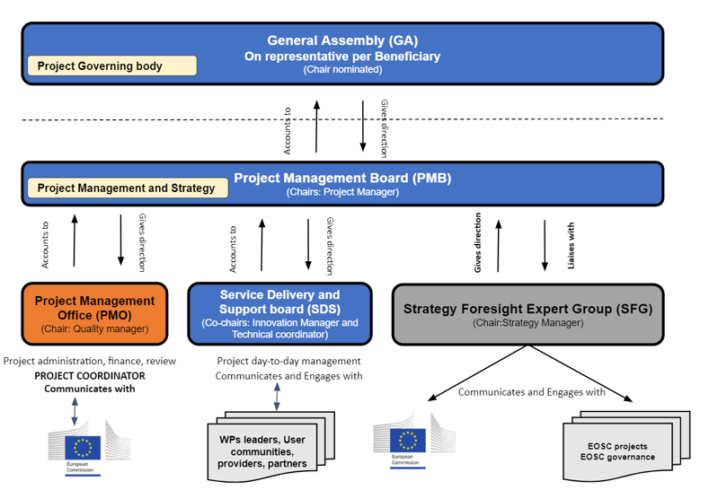

EGI-ACE communication channels
The communication task focuses on creating and maintaining the appropriate communication channels, in order to support the enhancement of promotion and dissemination, but also to ensure these channels can serve as the main sources of information for audiences seeking for more information on the project and its outputs. This section of the report will provide an overview of the channels, their purposes and objectives.

EOSC Portal
The EOSC Portal serves as one of the most suitable platforms to inform the stakeholders about the services the project offers. The tool is a gateway to information and resources in EOSC and therefore widely used as a reliable source of information, funding opportunities, developments, news, events, relevant policies and important documents for any EOSC related audience. The Portal catalogue and the EOSC Marketplace act as the entry point for resources to researchers, which shows the importance of the platform for the EGI-ACE project in terms of promoting and offering the services and data spaces.

EGI-ACE website
As the decision has been made to align the project’s branding with that of EGI, there was no need to have a separate project website. Both EGI and the EGI-ACE project provide relevant information, which has been the main argument to keep all content on the same website. The EGI-ACE website has a dedicated menu (and sub-items) for audiences to easily navigate to the specific project content.
In the spring of 2022, EGI launched its brand new website, and so did the EGI-ACE project. The new website was designed with a deep understanding of users, what they need, what they value, their abilities, and also their limitations. The current design, headless content management and the fact our new website is cookie-free, creates a great user experience.
The landing page contains an overview of the project, project partners, WPs and Key exploitable results. The page features an introductory video, a video presenting the impact of the project after its first 15 months, and an infographic that visualises the project in a nutshell.
EGI-ACE’s project webpages serve as a repository useful for researchers, policy makers, the project consortium, service providers, and the general public. Additionally, the objectives of this communication channel are:

- Provide visibility of the project’s outputs, highlights and results;
- Display the project’s structure including information on governance, work packages and an overview of the consortium;
- Highlight the latest news items, newsletter articles and events;
- Promote the call for use cases and provide full submission guidelines;
- Present deliverables and milestones that are accessible to the public.
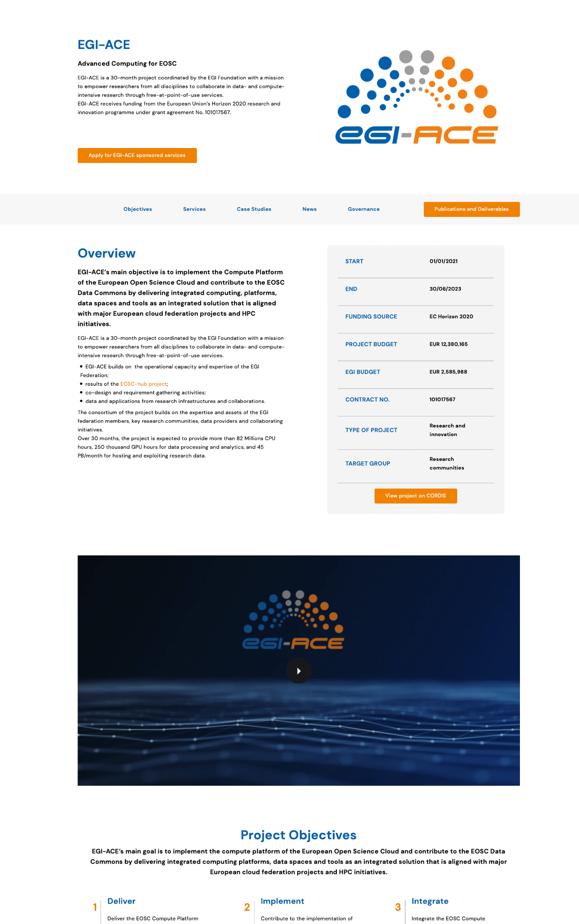

Newsfeed and newsletter
The dedicated newsfeed serves as the home for any project related news. This page will be fed frequently by the communications task, with contributions from the consortium. The purpose of this activity is to provide external audiences with the latest information, highlights, and updates from the project or from relevant stakeholders. In the beginning of the project, we have injected the page with articles on the project launch event and the call for use cases, however, as the project progresses, we focus more and more on projecting results and the project’s impact.

Similar to the website, the decision has been made to implement EGI-ACE items to the EGI newsletter. In the first year of the project, the newsletter was published quarterly, however, from the month 12, we changed the frequency of the newsletter and issue new issues every month. This means that over the course of the project, there will be around 28 newsletter items about the project. These items will often present a recap of activities or a dedicated topic (e.g., call for use cases, impact report, success stories, etc.).

Next to updating stakeholders and the general public the news articles will:
- Invite audiences to engage with the project (e.g. respond to the call for use cases);
- Remind audiences to (project) events;
- Promote use cases and success stories.

Social media
Twitter and LinkedIn accounts of EGI are being used to further disseminate the content of the project. The use of social media is mainly targeting the general public, peer initiatives and projects, as well as researchers. The purpose is to:

- Enhance digital engagement allowing stakeholders to interact with the project on a more low-barrier and frequent basis;
- Draw attention to publications, articles, use cases, open calls and drive the audience to longer types of content on the webpages;
- Support other communication channels;
- Promote and remind audiences about project events.

Twitter
- Handle: @EGI_eInfra
- Project hashtag: #EGIACE (#egiace)
- Planned activities;
- Disseminate content, tagging relevant Twitter accounts (EOSC related accounts, EC accounts) which causes direct notifications to appear on these accounts;
- Create and use Twitter specific visual material (e.g. short videos);
- Live tweets during project related events.

LinkedIn
- Link to profile
- Project hashtag: #EGIACE (#egiace)
- Planned activities:
  - Disseminate content, mentioning relevant accounts (similar to Twitter activity)
  - Create events which can be easily shared and joined on the LinkedIn platform
  - Invite audiences to engage with content by using the tool correctly. In comparison with Twitter, LinkedIn knows no wordcount and seems to be more attractive for online audiences to engage with
- In the following months, we are planning to create Showcase page for EGI-ACE on LinkedIn, which will keep the integration with EGI while allowing more regular and more targeted communication.

Direct communications
In the communication section of this report, we mentioned the types of communication activities and provide some examples of dissemination activities. The table in that section shows that there are several mailing lists that reach specific stakeholder groups. Depending on the content we will share certain information directly or to specific platforms such as the Horizon Europe platform, the EOSC Liaison Platform, and in the case of scientific publications there will be submissions made to relevant journals.

Events
The EGI-ACE project organises and participates to events with the aim to:
- Raise awareness of the project and its outputs;
- Provide user training and support;
- Invite new service providers to onboard;
- Influence policy makers and research communities;
- Present collaboration activities to peer initiatives and projects.

EGI-ACE events
As mentioned in the engagement section, the project started with a series of online webinars. From the experience from the first period of EGI-ACE, and previous experience within the EOSC-hub project and EGI, we have noticed that the online webinars are popular tools to use for the purpose of discussing services, which do not only show in the number of participants but also show in the number of views of published recordings.
In the following months, we plan to organise about 10 webinars. The preliminary topics include:
- Research data spaces and processing tools, EGI-ACE services with relevant new content since 2020 (e.g DataHub), webinars sharing the user experience from EGI-ACE call applicants and experiences of new compute sites, etc.
- Training for the EGI use case supporters from the NGIs (esp. EGI-ACE use case shepherds) explaining what are the resources, practises, processes that supporters should use / follow. The training session will focus on EGI-ACE service portfolio, Support tools, and good practices in user support.
- Training for EOSC Compute Platform target users (compute and platform users) to learn the details of specific EGI-ACE services with focus on AI/ML, Reproducible analysis w. Notebooks-Binder, Data integration and processing in the Cloud, etc.
In the first year the project contributed to the EGI conference of 2021, which allowed for demonstrations, sessions and presentations. Another EGI-ACE flagship event will be organised in September 2022 and will be integrated into EGI conference 2022 organised in Prague. The plan for the EGI-ACE flagship event is to gather both internal and external audiences to share success stories and brainstorm on future opportunities to collaborate and contribute to the development of the EOSC compute platform and data spaces. Moreover, it will help to disseminate project results and opportunities and communicate future developments and needs in the area of EOSC and scientific computing. Examples of session organised during the conference include:
- EOSC Compute Platform Data Spaces Bootcamp.
- ‘HPC in the EOSC Compute Platform’ promotion event.

We expect over 300 participants attending the event.

We are also actively looking for opportunities to organise sessions, side events, booths or stands colocated with relevant events. Examples include:
- Organisation of the satellite event at ICRI 2022.
- Contribution to booths/stands/demonstrators at international events and conferences (e.g. EGU, IBERGRID, ML for Astrophysics, etc).

An extensive overview of all the relevant events including those organised on international as well as those organised on the national level, and reaching to a diverse audience is kept and regularly updated.

As online events remain to be an excellent alternative to physical events, we keep organising them. Examples of onlines event foreseen in 2022/early 2023 include:
- EOSC Compute Platform - What’s in it for non-European providers and users? focusing on non-European audience.
- EOSC Compute Platform User Support Workshop - this workshop is based on EGI-ACE D2.5. The first edition organised in April 2022 was very successful and therefore, we plan to organise another edition in Autumn 2022.

Joint events with relevant projects
Together with EOSC Future and the INFRAEOSC-07 projects that have previously been mentioned, the project collaborates on organising events focusing on EOSC, in support of widening the uptake of EOSC and its related resources. The events allow researchers to learn more about the latest developments in the landscape, policy makers to share best practices, service providers to offer their latest updates and more.

Additionally, webinars and training events are co-organised in order to facilitate knowledge sharing opportunities for relevant services. Examples of the training events organised with EOSC Future include:
- Ask me anything webinars, to showcase the resources available via the EOSC platform.
- EOSC Provider days, a crash course on what can be made available through the EOSC portal and marketplace and how this can be done.

Participation and support to external events
WP2 is closely monitoring all the relevant events, ensuring the representation of the project. As the COVID-19 pandemic situation in Q1 of 2022 improved, the project proactively searches for the opportunities for physical participation at events.
EGI-ACE will also actively look into opportunities where we can support and participate in the relevant events organised on the national level.

Publications

6.2 Brochures, flyers
A number of digital and printed material was and will be developed for the project to promote different types of information to different types of audiences. The examples include:
- EOSC Compute platform proposition for users brochure.
- Flyers promoting the project and open call for use cases.
- “Setting up and operating Data Spaces - Services and Experiences from EGI.

Measuring progress and success – Key performance indicators
Measuring the performance of the engagement and communication activities is done on a quarterly basis and formally reported in relevant deliverables. The following impact indicators are measured and adjusted in case necessary:

- Number of visitors and clicks on the webpages (and other relevant web statistics).
- Number of events organised and the number of attendances.
- Number of external events attended and the number of attendances for the EGI-ACE specific sessions.
- Number of entries in the internal dissemination tracking overview on Confluence.
- Number of joint collaborations organised/initiated.
- Number of submissions call for use cases (including referral statistics).
- Social media statistics (shares, retweets, comments and more).
- Number of (communication) materials shared by other projects, peer initiatives etc.
- Number of printed materials collected by audiences during physical events.

Other important metrics are gathered by work packages 3 until 7, which are continuously shared in the monthly Service Delivery Support team meetings and on Confluence. This information is important for the communication and engagement tasks to gather, as it may influence the efforts. The most important metrics to monitor are:
- Number of services onboarded.
- Number of papers/journals EGI-ACE is acknowledged.
- Number of new users of EGI-ACE services.
- Number of use cases adopted.

Conclusions
This document presented the project’s stakeholders, indicated which have a higher or lower priority in terms of engagements, and shared planned communication activities that will support the interaction with the target audiences. Also, it clearly provided impact indicators that will be able to analyse whether an objective has been achieved, which will support the reporting activities and allow to improve engagement and communication plans.

In addition to engaging and communicating broadly with and about EGI-ACE, there is a great number of webinars, training sessions and events organised (and attended) to allow stakeholders to obtain and share knowledge, which supports the development of the EOSC Compute platform, collaborations, and service uptake, all leading to a better understanding of the value of Open Science.

As a summary, this updated plan has a clear strategy on communicating with new and existing audiences, keeping them engaged in a sustainable fashion over the course of the project and thereafter.

European Strategy for Data, COM (2020) 66 final, 19-02-2020, Pillar B https://ec.europa.eu/transparency/documents-register/detail?ref=COM(2020)66&lang=EL
https://eosc-hub.eu
https://www.egi.eu/
https://eosc-portal.eu/
https://ec.europa.eu/info/funding-tenders/opportunities/portal/screen/opportunities/topic-details/infraeosc-07-2020
https://eoscfuture.eu/
https://c-scale.eu/
https://www.dice-eosc.eu/
https://www.openaire.eu/openaire-nexus-project
https://www.reliance-project.eu/
https://www.gaia-x.eu/
https://eosc-dih.eu/
https://www.eosc.eu/news/draft-charters-eosc-association-task-forces-published
Mark Dietrich, Tiziana Ferrari: Governance, Architectures and Business Models for Data and Cloud Federations: the EOSC and GAIA-X Case Studies. Available at https://zenodo.org/record/5081865#.YO6R_-gzY2w
https://indico.egi.eu/event/5882/
https://www.udemy.com/
https://confluence.egi.eu/display/EGIACE/
https://www.egi.eu/projects/egi-ace/
www.egi.eu/egi-ace-news
https://www.linkedin.com/company/egi-foundation

