EGI-InSPIRE

Operations Portal work plan

EU MILESTONE: EGI-M701

Document identifier: | input.doc
Date: | dd/06/yyyy
Activity: | JRA1
Lead Partner: | CNRS
Document Status: | FINAL
Dissemination Level: | PUBLIC
Document Link: | https://documents.egi.eu/document/39

Abstract
Define the roadmap for the CIC Operations Portal taking into account the CIC Operations regionalisation of the Portal work plan operational tools and new resource types being used on the infrastructure

Copyright notice:
Copyright © Members of the EGI-InSPIRE Collaboration, 2010. See www.egi.eu for details of the EGI-InSPIRE project and the collaboration.
EGI-InSPIRE (“European Grid Initiative: Integrated Sustainable Pan-European Infrastructure for Researchers in Europe”) is a project co-funded by the European Commission as an Integrated Infrastructure Initiative within the 7th Framework Programme. EGI-InSPIRE began in May 2010 and will run for 4 years.
This work is licensed under the Creative Commons Attribution-Noncommercial 3.0 License. To view a copy of this license, visit http://creativecommons.org/licenses/by-nc/3.0/ or send a letter to Creative Commons, 171 Second Street, Suite 300, San Francisco, California, 94105, USA. The work must be attributed by attaching the following reference to the copied elements: “Copyright © Members of the EGI-InSPIRE Collaboration, 2010. See www.egi.eu for details of the EGI-InSPIRE project and the collaboration”.
Using this document in a way and/or for purposes not foreseen in the license, requires the prior written permission of the copyright holders.
The information contained in this document represents the views of the copyright holders as of the date such views are published.

Delivery Slip
 |  | Name |  | Partner/Activity |  | Date
From
Reviewed by |  | Moderator:  Reviewers:
Approved by | AMB & PMB

Document Log
Issue | Date | Comment | Author/Partner
1.0 | 24/06/2010 | First draft | L’Orphelin Cyril / CNRS
2.0
3.0
4.0
Table of contents
Introduction 4
1.1. Purpose 4
1.2. Application area 4
1.3. References 4
1.4. Document amendment procedure 4
1.5. Terminology 4
1.6. CONTEXT: 5
1.7. Migration to SYMFONY. 6
1.7.1. VO Id Card 6
1.7.2. Broadcast Tool 7
1.7.3. Notifications Mechanisms 8
1.8. Regional PACKAGE 8
1.9. Dashboard 10
1.10. Lavoisier 2.0 11
1.10.1. The role of Lavoisier 11
1.10.2. Re-factoring of the core engine 12
1.10.3. Programmatic Interface 12
1.10.4. Integration of new resources 13
1.11. GOC DB Harmonization 14
Conclusions 15

Introduction

Purpose
This document describes the roadmap for the Operations Portal.
This document will focus on the coming developments and the main technical technological directions that will be put in place in the coming year.

Application area
This document is a formal deliverable for the European Commission, applicable to all members of the EGI-InSPIRE project, beneficiaries and Joint Research Unit members, as well as its collaborating projects.

References
Table 1: Table of references

R 1 | Http://cic.gridops.org
R 1 | Https://operations-portal.in2p3.fr
R 1 | http://www.symfony-project.org/
R 1 | https://edms.cern.ch/document/1070320/1
R 5 | https://cvs.in2p3.fr/operations-portal/package/
R 6 | https://cvs.in2p3.fr/operations-portal/package/validation.pdf?revision=HEAD
R 7 | https://edms.cern.ch/file/1015741/3/dashboardHOWTO.pdf
R 8 | http://grid.in2p3.fr/lavoisier
R 9 | https://goc.gridops.org

Document amendment procedure
Amendments, comments and suggestions should be sent to the authors. The procedures documented in the EGI-InSPIRE “Document Management Procedure” will be followed:
https://wiki.egi.eu/wiki/Procedures

Terminology
A complete project glossary is provided in the EGI-InSPIRE glossary:
http://www.egi.eu/results/glossary/.

CONTEXT:

The portal is an integration platform, allowing for strong interaction among existing tools with similar scope but also filling up gaps wherever functionality has been lacking. Moreover some features implement numerous work flows derived from procedures in place in the EGEE project. These features came out of requirements expressed by end users or administrators of Virtual Organizations (VO), Regional Operations Centres (ROC) or Resources Centres and Operations Coordinations Centre of EGEE, OCC.

The displayed information is retrieved from several different distributed static and dynamic sources – databases, Grid Information System, Web Services, etc. – and gathered onto the portal. This resulted in numerous tools that turned precious to sites like user tracking mechanism or subscription to monitoring failures notifications. Criss-crossing this information has enabled us to display high level views where static and dynamic data yield relevant views of the EGEE, now EGI production grid.

Complementary to this goal, processing securely information and workflows, the portal also fosters communication between different actors of the project, through channels like EGEE broadcast, and Downtime Notification Mechanisms.

The Operations Portal is currently divided into 2 instances:
- The historical Portal [R1]: CIC Portal that deals with operational information related to VO, sites and Regional Organization.
- The new portal [R2]: Operations Portal based on the framework Symfony.

One of the historical applications namely the dashboard for Operations has been the first module to be migrated under the new application. The migration is now achieved with a complete re-engineering of the feature to cope with:
- potential tool regionalisation
- standard and generic developments

The architecture is the same for the 2 instances and is composed with 3 modules:
- A database – to store information related to the users or the VO
- A web module which is currently step by step into the Symfony framework ()
- A Data Aggregation and Unification Service named Lavoisier (1.9)

The objectives for the coming year are the following:

- Migration of the remaining key features of the historical Portal to Symfony and the new Portal
- Provide regional modules when possible of these features
- Provide a systematic standard access to all information handled by the Operations Portal
- Provide new adapters to Lavoisier Web Service to cope with new information sources
- GOC DB harmonization (single point of access)
- Provide requested improvements on the existing features and customization to the different actors of the EGI project.

Migration to SYMFONY.

Symfony [R3] is a web application framework written in PHP which follows the model-view-controller (MVC) paradigm. Released under the MIT license, Symfony is free licensed software.
Symfony aims to speed up the creation and maintenance of web applications and to replace repetitive coding tasks. Symfony permits development of a custom-made website build on proven techniques and standards.
Symfony is aimed at building robust applications in an enterprise context, and aims to give developers full control over the configuration: from the directory structure to the foreign libraries, almost everything can be customized. To match enterprise development guidelines, Symfony is bundled with additional tools to help developers test, debug and document projects.
We apply the framework approach for the new developments of for the improvement of historical features. The benefits we have seen until now are three-fold
- An increase in the efficiency of the Operations Portal application in term of response time to end-user usage.
- A decrease in the time spent on the maintenance
- An increase in the robustness of the application by developing independent modules.
Our aim in the coming year is to keep migrating key features into this framework and to keep only one access point.

VO Id Card

The VO ID Card system records the life cycle of a given VO and links the VO managers to the project management for operations.
The VO ID cards are the static repository for VO with information like:
- the VO contact points ( VO managers , VO User mailing list , VO representatives )
- the VO global information (enrolment URL , status , discipline ...)
- The Acceptable User Policy of the VO
- the VO Core Services
- VOMS information ( Groups And Roles, certificate )
- specific requirements (CPU needed , RAM needed …)

The current interfaces permit to register a new VO and to update the information related to your VO.
This registration and some update are validated by a grid body representing the project operations-wise (currently RAG group).
Otherwise, we use the registered roles (VO Managers and VO deputy) to restrict accesses to the VO ID card update.

The next version in Symfony will propose:
- New “feel and look” of the features revisited for EGI scope
- the integration of new work-flows defined by NA4/SA1 including :
  - yearly registration renewal
  - workflow for VO deregistration

Moreover we will continue providing enhanced current features
- Distribution of available resources on a per VO basis through by a synoptic browser showing the geographical distribution of the resources for a given VO (e.g CPU, Storage or Services).
- all global Information per VO available under several format HTML , RSS or XML
- statistics and metrics according to EGI
- Notifications on demand about changes on the VO ID Cards.

The new work flow [R4] is still under discussion but developments have started, so that
As soon as the work flow is validated the development can be finished within 3 weeks.

Broadcast Tool

With this tool you are able to contact several categories of stakeholders impacted by a problem, an announcement, or a specific release. The aim is to provide to the different actors of the grid community the information by mail or RSS feeds.

The current model is based on information coming from GOC DB (sites or ROC/NGI contacts) and from the CIC DB (VO contacts, mailing lists for operations).
In addition to sending out information we provide also:
- an archiving service,
- A search engine by type of announcement – general or downtime notifications see 1.7.3 - date, target e-mail, body text, subject, and author.

The next version in Symfony will provide:
- A New “feel and look” of the features revisited for EGI scope
- the integration of new mailing lists
- the integration of templates
- the possibility to add customized contact lists
- the possibility to save personal settings for announcements for future use
- the possibility to attach a file to your broadcast.

Moreover we are studying the possibility to extend this tool with the user tracking module which can contact a end-user without having its mail, through his DN certificate.
Indeed, we request the VOMS servers, in agreement with the security policies, in order to collect all users mails supported by any given VO thanks to VO Id Card information registered in the Operations portal
Estimated release date : September 2010 .

Notifications Mechanisms

The mechanism provided is based on the "supply and demand" rule. A site manger registers a downtime (supply) and grid users request to be notified or not (demand) via a subscription through the Operations Portal

When a site or region manager decides to register a downtime, it is done through the GOCDB web interface. The relevant person fills an electronic form and specifies which site is concerned, the time lines for the downtime (start and end dates), and the motives of the expected downtime. This information is stored in the GOCDB databases. All downtime announcements are then collected and sent via the Operations Portal to all grid users who subscribed to receive downtime notifications according to his/her settings.

These subscriptions are done on a voluntary basis: Every registered grid user is entitled to specify his/her downtime notifications settings via email, RSS feed or Ical Feeds. A given user can create, modify and delete his subscriptions. When assigned a managerial role (ROC/NGI, RC, VO manager) on a specific instance (region/country, site, VO), a grid user can create, modify and delete subscriptions for the given entity in his scope..

A subscription consists in one or several filtering rules. A filtering rule is a positive or negative condition which is constructed from scope specifications. A scope is a value that describes region, site, node, service or VO of the GRID.

This solution is currently based on mail notifications or RSS feed. We want to extend this solution to technologies based on messaging system (Java Messaging System - ActiveMQ) .

The main idea is to create on the fly the topics dedicated to a specific downtime at different levels:
- one topic about the downtimes declared for a NGI
- one topic about the downtimes declared for a site
- one topic about the downtimes declared for a service endpoint
- one topic about the downtimes impacting a specific VO .

This re-factoring should take place at the end of this year.

Regional PACKAGE

Since around one year we have started the work on a regional package: the goal of this work is to distribute the different features and modules present into the Central Operations Portal into a regional package for NGIs to cope with NGI needs.

The release of the first production package is from June 8 th and this release includes the dashboard module for the time being. The different part of the package and the documentation are distributed via a SVN repository [R5].

The application is composed of
- a web service named Lavoisier configured to handle Nagios notifications and store and provide data cache from GOC DB, GGUS, generate metrics …
- a Php web application to provide a user interface.

The regional instance is linked with our central instance; and creation, update, delete of records are synchronized not to disrupt global oversight operations

The central and the regional instance have been built on the same model to behave in the same way and to be easily interoperable. A validation procedure [R6] has been established to validate the regional instances when a given region expresses this need. All regions/NGI are able to opt for either the central or the regional instance

This regional package will be constantly improved during the coming year:
- To add some of the other features that will be integrated step by step into the Central Instance.
- To ease up upgrade or set-up of the package in the regions

Dashboard

The dashboard deals with different interfaces to the source core services, as the ticketing system, the monitoring framework, or the central database storing information about sites and services.

The dashboard is a tool designed to follow and track problems at sites.
This tool is an integration platform and provides a synoptic view of different data sources:
- Gstat , monitoring tool of the publication done by sites
- SAM , central framework of submission for VO specific tests
- Nagios , monitoring tool
- GOC DB , sites static database
- GGUS, EGEE/EGI helpdesk: Tickets created by Operators are part of the GGUS System. There is in GGUS a dedicated Helpdesk for this kind of tickets (CIC_Helpdesk). This is the one which is interfaced with the dashboard.
- BDII : dynamic information published by sites

In summary, people track problem with the different results from Monitoring Tools (SAM , Nagios , Gstat) and open and update trouble ticket in GGUS via an interface in the dashboard.
We use also GOC DB and BDII to consolidate monitoring information with downtime information, and dynamic statuses [R7]

As already mentioned, this feature has been the first module to be migrated under Symfony framework.The next steps are as follows:
- Integration of other VO, elsethan OPS
  - through SAM VO specific tests
  - through Nagios boxes dedicated to VOs
- Integration of security monitoring via Pakiti results or dedicated security tests coming from the “security” Nagios Box. The results should be exposed only to relevant people (security officers)

Lavoisier 2.0

The role of Lavoisier

Lavoisier is an Open Source Tool developed at CC-IN2P3 and will be maintained in the long term. Lavoisier has proven effective in increasing maintainability of the Operations portal. Indeed, the unified view it provides has contributed to reduce considerably the amount and complexity of the portal’s coding.

“Lavoisier” [R8] has been indeed developed in order to reduce the complexity induced by the various technologies, protocols and data formats used by its data sources. It is an extensible service for providing a unified view of data collected from multiple heterogeneous data sources. It enables to easily and efficiently execute cross data sources queries, independently of used technologies. Data views are represented as XML documents and the query language is XSL.

Lavoisier has proven effective in increasing maintainability of the Operations portal, by making its code independent from the technologies used by the data sources and from the data cache management policy. Its design and interfaces made easier writing reusable code, and good performances are easily obtained by tuning the cache mechanisms in an absolutely transparent way for the portal code. Indeed, the different components work in a standardized way through the output of the Lavoisier Web Service. The translation of resource information into this standardized output is provided by different plug-ins.

The adapter developer adds to Lavoisier the support for new data sources technologies by implementing a set of required and optional interfaces. Some reusable adapters are provided to access data using various technologies, such as RDBMS, LDAP, Web Services, JMS, XML command line output stream, local and remote flat, XML or HTML files, etc. Other reusable adapters take an existing data view and transform it to another data view, using technologies such as XSL, XQuery, SAX-based XML filtering. Introspection adapters expose data about data views configuration and current cache state.

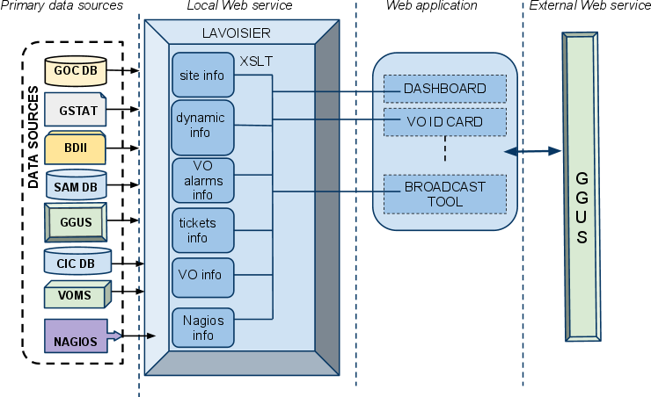

An effort has been put into the configuration of Lavoisier, the structure of its caches and the rules of refreshing to have efficient, scalable and reliable data handling. The schema xx is explaining the organization of the application around Lavoisier:
We retrieve the global information about primary and heterogeneous data sources like GGUS, GOC DB, SAM, VOMS, Nagios with the use of the different plug-ins of Lavoisier .
Then we structure and we organize the information by using XSLT Language with Lavoisier. And we can use at the end of the process all the information onto the Web application side without any further computations - already done by Lavoisier - which increase the efficiency of the Web Interfaces.
This architecture permits to continue to work with the caches, even if a primary source is unavailable; hence you trigger access only to the information you need on the web page: The information is structured and you don't access hundreds of times the primary sources but a subset of them that are already sorted out. Finally, we refresh the data sources only as needed and only when an action has been triggered. Last but not least, it is very easy to add a new data source in this model.
An effort will be put constantly to cope with this architecture to keep a flexible, modular and efficient application. The work of migration under Symfony modules is consequently complemented by a specific work on Lavoisier configuration to offer an easy and quick access to data.

Re-factoring of the core engine

Lavoisier has been more and more used by the Operations Portal, and it is now reaching some limitations. In particular, it has no mechanism to prevent several caches to be refreshed at the same time, and this can lead to memory overload with plug-ins that consume a lot of memory.

Moreover, with the regionalisation of the CIC-Portal, we need to enable communications between distributed Lavoisier instances.

Both problems drive us to perform a re- factoring of the core engine. We will introduce the use of a messaging system to manage events related to data views (access, cache refreshed, published…). The messaging system may be ActiveMQ, with in-memory messages for intra-Lavoisier communications, and OpenWire protocol for inter-Lavoisier communications.

This re-factoring will also be the opportunity to improve reusability of plug-ins by splitting them into connectors and transformers, and to improve extensibility of Lavoisier core-engine by defining plug-in interfaces for some features that are currently hard-coded. These features are the cache content managers (currently 4 hard-coded ones) the cache refresh triggers (currently 8 hard-coded ones).

Programmatic Interface

Lavoisier is currently used internally to “feed” the Operations Portal application. The next evolution is to propose a second instance of Lavoisier but to provide information for external applications without disturbing our own application. We will set-up this specific instance for the end of the year in order to provide a Programmatic Interface.

Moreover the chosen standard is currently XML but we will provide also JSON or more generally information by the technologies of messaging system on this programmatic interface.
Lavoisier currently provides the possibility to cross-query its data-views with XSLT language. We will provide XQuery and XPath as alternative languages. Both will be available in SOAP and REST operations. These additions will allow more flexibility on this programmatic interface.

Integration of new resources

The architecture of the portal has been built in order to extend the number of data sources, and to propose a standard access to information.
This integration is eased by the use of Lavoisier:
In case of known technologies we will add a new view by using an existing plug-in out of a wide-range already available.
And if needed, we will develop new plug-ins to be able to retrieve information from a new provider.

Currently we have identified the needs for optimizing existing plug-in (1) and to develop new plug-ins (2).

(1) A relational database management system plug-in is in development. This plug-in will enable the user to see the entire database as a huge XML document. This XML document will not be built in order to avoid memory overload. Instead, the XPath query will be translated into SQL query, and only the result set will be converted to XML data. The structure of the document will be described by Object Relational Mapping files (Hibernate or Doctrine).
The use of this plug-in will enable cross-querying between the data base and the other data sources, and could also be used easily via the programmatic interface by querying the data base through simple XPath queries.

(2) The integration of different Information Systems present into different middlewares like ARC, Unicore, or globus and Naregi could be done via the implementation of the SAGA Service Discovery specification (OGF) into a Lavoisier plug-in should that will permit to access information of almost any components based
- on the Common Information Service (CIS) like the information service of UNICORE which gathers both static and dynamic information (storage resources, file transfer services and job management services), or .
- on CMI (Common Model Information) schema like ARC middleware.

Lavoisier’s flexibility allows us to be ready to integrate almost any kind of new information if needed and meaningful.

GOC DB Harmonization

This work deals with the integration of GOCDB [R8] and CIC Operations portal under a common interoperable toolkit for grid operations which can be done following 2 main directions:
- Integration of a common central human interface allowing users to access both central services through a single entry point.
- Integration of interoperable back ends for distribution to NGIs as a single package.
Such development will require effort at data representation level as well as at interface and data transfer level.

Both teams aim at first at providing a common web interface to handle both type of information, being transparent to the user.

The solution envisioned is:
- Hosting of the GOC database by RAL.
- providing interfaces in the Symfony framework by the Operations Portal in Lyon

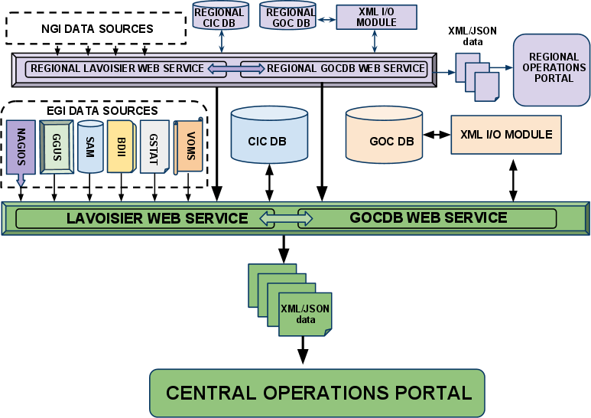

Moreover the 2 tools - GOC DB and Operations Portal- have been designed to have the same behavior with the central and the regional instances.
So we can finally imagine also this harmonization is reflected in the regional package with a single portal but also a single package distributable in the different NGIs interfaced with the central “Operations Portal”. A study of the feasibility will take place at the beginning of next year and the work will start in the first middle of next year.

Conclusions

The work of migration under a new framework is ongoing and we want to finalize as soon as possible this part. The main objective is to finish the migration for the end of the year, to keep only one central point of access. This work should be strengthened with the integration of the GOC DB interfaces.
In the meantime the migration is the opportunity to adapt the different features to the EGI/NGI scopes.
Moreover this re-engineering will be focused also on a modular architecture based on the Lavoisier enhanced Web Service to ensure the flexibility and the extensibility of the application.
In parallel this component will allow us to deliver programmatic interfaces for external applications and to integrate new types of resources coming from other DCI (distributed Computing Infrastructure)

