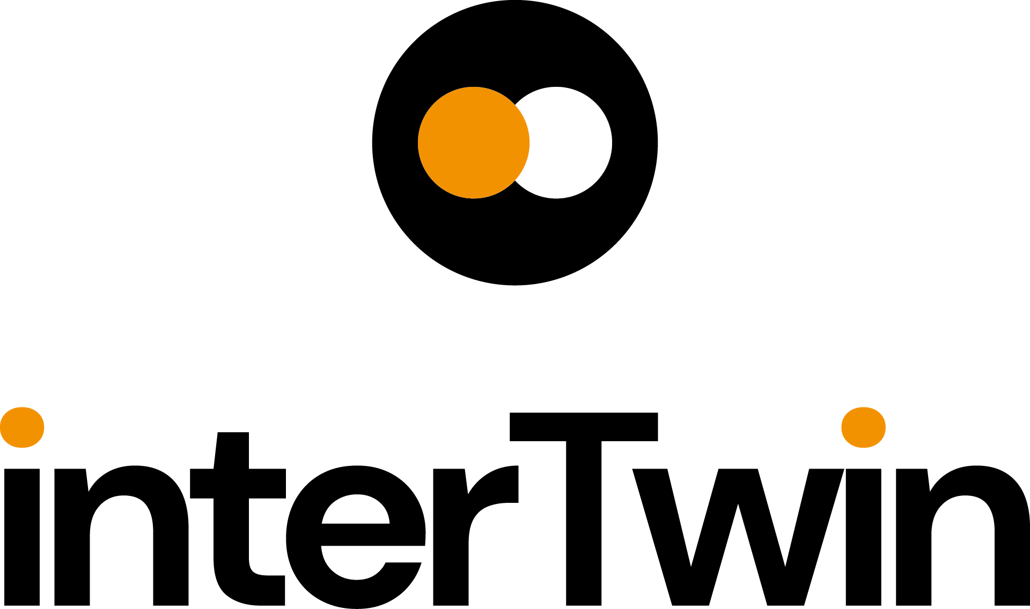

D2.3 Communication, Dissemination and Engagement Activity Report and Updated Plan
Status: UNDER EC REVIEW
Dissemination Level: public
Abstract
Key Words | Communication, dissemination, engagement, target users, measures, impact
This document summarizes T2.2's (Dissemination, Communication, and Engagement) progress in the interTwin project from M1 to M18, with future plans for M19 to M36. Led by EGI.eu under WP2, T2.2 focuses on disseminating Key Exploitable Results (KERs) to diverse audiences, aiming to boost project visibility, user engagement, and stakeholder collaborations. Through refined stakeholder targeting and strategic partnerships, the interTwin DCE strategy seeks to enhance project impact by effectively communicating outcomes and fostering valuable connections within the research and industry domains.

Document Description
D2.3 Communication, Dissemination and Engagement Activity Report and Updated Plan
Work Package number 2
Document type | Deliverable
Document status | UNDER EC REVIEW | Version | 1
Dissemination Level | Public
Copyright Status |   This material by Parties of the interTwin Consortium is licensed under a Creative Commons Attribution 4.0 International License.
Lead Partner | EGI
Document link | https://documents.egi.eu/document/3923
DOI | https://doi.org/10.5281/zenodo.11198684
Author(s) | - Gwen Franck (EGI)
Reviewers | - Isabel Campos (CSIC)  - Daniele Spiga (INFN)
Moderated by: | - Sjomara Specht (EGI)
Approved by | AMB

Revision History
Version | Date | Description | Contributors
V0.1 | 30/04/2024 | ToC and first draft | Gwen Franck (EGI)  Reviewer: Xavier Salazar (EGI)
V0.2 | 13/05/2024 | External review | Daniele Spiga (INFN)  Isabel Campos (CSIC)
V0.3 | 15/05/2024 | Addressed comments | Gwen Franck (EGI)
V1.0 | 15/05/2024 | Final

When the terminology/acronyms are available via link below, please remove this table.
Terminology / Acronyms
Term/Acronym | Definition
AMB | Activity Management Board
DCE | Dissemination, Communication and Engagement
DT | Digital Twin
DTE | Digital Twin Engine
EAB | Ethics Advisory Board
EEAB | External Expert Advisory Board
KER | Key Exploitable Result
WP | Work Package
https://confluence.egi.eu/display/EGIG

Table of Contents
1 Introduction 7
2 Overview of activities 9
2.1 Branding 9
2.2 Website 10
2.3 Social Media 12
2.3.1 LinkedIn 12
2.3.2 YouTube 14
2.3.3 Other 15
2.4 Events 16
2.4.1 Booths 16
2.4.2 Partner Presentations 17
2.4.3 Internal workshops 18
2.4.4 Webinars 19
2.5 Publications 20
2.6 Deliverables and Milestones achieved 21
3 Summary of Dissemination Outputs 22
3.1 Status Review 22
3.2 KPIs for communication and dissemination 23
3.3 Collaborations and partnerships 25
3.3.1 DT-GEO, BIODT, interTwin, DestinE, EOSC Channels 25
3.3.2 interTwin & Digital Twin of the Oceans 25
3.3.3 interTwin & Green Deal Data Space 25
3.3.4 interTwin & National Initiatives 26
3.4 Gaps & Challenges 26
3.5 Stakeholder analysis 27
3.5.1 Stakeholder preferences, behaviour, and needs 27
3.5.2 Specific activities per target audience 28
4 Plan M19-M36 31
5 Annexes 33
Annex 1 – 2022 events 33
Annex 2 – 2023 events 34
Annex 3 – 2024 events 37
Annex 4 – Print Materials 38

Table of Figures
Figure 1 - interTwin brand guide 11
Figure 2 - interTwin Use Cases on the website 12
Figure 3 - interTwin software components on the website 12
Figure 4 - website weekly visitors (source: Matomo Analytics) 13
Figure 5 - example of a LinkedIn specific ‘carousel’ post designed to promote the use cases 14
Figure 6 - example of a partner tagging interTwin on LinkedIn 14
Figure 7 - LinkedIn metrics - organic reach 15
Figure 8 - fragment from the interTwin introduction clip for event booths 15
Figure 9 - demonstration clips for interTwin DTE software components, the first one organised by interTwin, the other two created elsewhere and added to interTwin playlist 16
Figure 10 - YouTube channel analytics 16
Figure 11 - interTwin Quarterly Newsletter header 17
Figure 12 - Shared booth hosted by EGI 18
Figure 13 - interTwin moo cards and interTwin MP4 clip shown on the screen 18
Figure 14 - interTwin presentation by partner EODC 19
Figure 15 - interTwin webinar branding 21
Figure 16 - example of a deliverable fact sheet 21
Figure 17 - example of a deliverable published on Zenodo and its downloads 22
Figure 18 - presentation of interTwin by EGI Foundation at EBDVF2023 27
Figure 19 - interTwin basic banner and adaptation for EGI2023 39
Figure 20 - Moo Card design 39
Figure 21 - Software Module Flyer developed for EGU2024 40
Table of Tables
Table 1 - internal project workshops 19
Table 2 - Webinars 20
Table 3 - Status review of planned T2.2 activities 23
Table 4 - KPI values M18 24
Table 5 - Audiences and the activities they are targeted with 29

Executive summary
This document outlines the progress of T2.2 (Dissemination, Communication, and Engagement, DCE) within the interTwin project from M1 to M18, detailing stakeholder analysis refinements, identified gaps, and future strategies for M19 to M36. Led by EGI.eu under WP2, T2.2 focuses on communication, dissemination, and engagement activities to maximise project impact.
Aligned with the core objectives of interTwin, T2.2's efforts revolve around disseminating Key Exploitable Results (KERs) such as the Digital Twin Engine, an Interoperability Framework, an AI Toolkit, and more to diverse audiences. The strategy aims to enhance project awareness, increase user engagement, and foster collaborations with key stakeholders and research organisations.
By refining stakeholder targeting, amplifying project visibility, and facilitating strategic partnerships, the interTwin DCE strategy seeks to elevate the project's reach and influence, ensuring effective communication of project outcomes and fostering meaningful engagements with core audiences.

Introduction
interTwin is a project to co-design and implement the prototype of an interdisciplinary Digital Twin Engine (DTE), that offers the capability to integrate with application-specific Digital Twins (DTs).
As part of WP2 (Innovation Management and Communications), T2.2 (led by EGI.eu) deals with interTwin Communication, Dissemination and Engagement activities.
This deliverable reports on the period M1-M18 and will lay out the plans for M19-M36 (which will be reported in the final T2.2 deliverable D2.5). It is an update of D2.1, in which the overall plan for DC activities was laid out, mapped to target audiences and stakeholders, set against a timeline where possible, and matched with a suitable set of indicators for success. T2.2 worked on an overall plan to provide indications on how project results, developments, and branding will be communicated, how interTwin intends to engage with stakeholders, a clear dissemination strategy, and the description of promotion, consultancy, outreach, training, and co-design activities, in addition to a dissemination plan to be updated in the next deliverable release.
Main objectives of WP2 are to ensure that project results are captured, disseminated, and exploited for maximum impact, to manage both internal and external communication and dissemination, to liaise with stakeholders from both research and industry, and to organise project events and support participation at external events. T2.2 aligns closely with the activities in T2.1 (Innovation Management and Exploitation) as outlined in the Innovation Management Plan (D2.2) and Innovation Management Progress report D2.4 (in preparation).
The project has identified 6 Key Exploitable Results, which are also the core of the project DCE strategy:
- Interdisciplinary Digital Twin Engine
- Interoperability Framework: Guidelines, Specifications, and Blueprint Architecture
- Toolkit for AI workflow and method lifecycle management
- Quality Framework
- DTE federated infrastructure integrated with EOSC and EU Data Spaces
- interTwin Open Source Community
The core activities of T2.2 focus on the dissemination of these KERs to the various target audiences. For this purpose, the activities are mapped to the stakeholder analysis (see section 3.4)
This interTwin DCE strategy intends to:
- Increase Awareness: Raise awareness about the interTwin project and the project outputs (with focus on the KERs) among all the relevant target audiences, including a finetuning of the existing target audiences
- Increase User Engagement: Ensure engagement of the interTwin core audiences with project outputs
- Foster Collaboration: Foster partnerships and collaborations with relevant organisations and research institutes.

Overview of activities
After creating the brand identity, T2.2 took care of the launch of the website, content creation and its continuous maintenance. Both brand identity and website launch were achieved ahead of schedule (M2). The website includes (at M18) different sections featuring the project team and governance overview, the Key Exploitable Results, the Use Cases, and available results (such as the Digital Twin Engine, published in M19) and links to project outputs (deliverables, presentations, publications).
The uptake of the distribution of project news via the project website and social media increased heavily at the start of PY2, as at the end of M12 the first use cases were published. Overall, this translated into a major increase of our reach. The project has maintained this trend by regularly publishing about deliverables and, by M17, also publishing about the interTwin DTE Software Modules. Additionally, project partners are now presenting the project results on a regular basis at various events, providing valuable dissemination content (presentations and event reports).

Branding
At the start of the project, a large part of the interTwin visual identity, such as the logo, branding elements and document/presentation templates, were developed quickly and distributed amongst partners via the Communications Toolkit and the Project Brandguide. Finally, a short 'blurb' (Co-designing and prototyping an interdisciplinary Digital Twin Engine) was formulated, a paragraph introducing the project, and some small first designs (such as a calling card with the website QR code, a flyer, a sticker, a video animation, and a basic poster) were developed as well. A couple of goodies (sticker, powerbank, webcam shutter), as well as a square 'Moo' card were created to accommodate the presence of interTwin at event booths. For extended documentation about the interTwin branding, see D2.1.
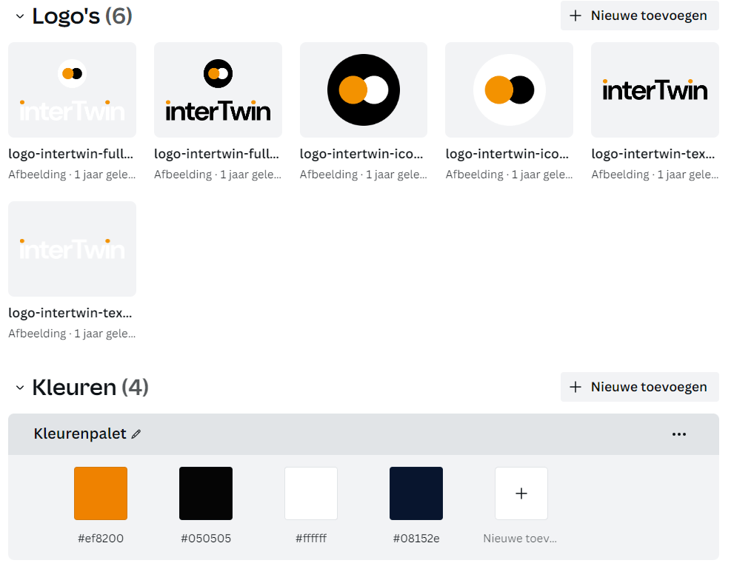
Figure 1 - interTwin brand guide
From M6 onwards, as the first project outputs started to get delivered, the communication tools and processes started to get fine-tuned. Partners have developed their own posters merging their own branding with interTwin logo/ QR codes, the website is used as a channel to disseminate information about published deliverables (in the form of news items with a fact sheet). The use cases and DTE software modules each received their own web pages with specific branding elements, and partners delivered presentations about their contributions to interTwin using the interTwin presentation template (to be found in the interTwin Communications Toolkit available for partners on Confluence).
For the second half of the project, the project will create pintables to showcase the use cases, the DTE Software modules (already in production, see annex 2), and physical brochures showcasing the main project outputs.

Website
The project website intertwin.eu was set up immediately, allowing for a quick communication of the project essential information, such as contact details, team and governance, and overall project goals. The outputs section lists and links to all publicly available deliverables, standardly archived on the Zenodo interTwin community, as well as to publicly available presentations, articles, and visuals created by project partners.

The uptake of the distribution of project news via the project website and social media increased heavily at the start of PY2, as at the end of M12 the first 8 use cases were published. Overall, this translated into a major increase of our reach.
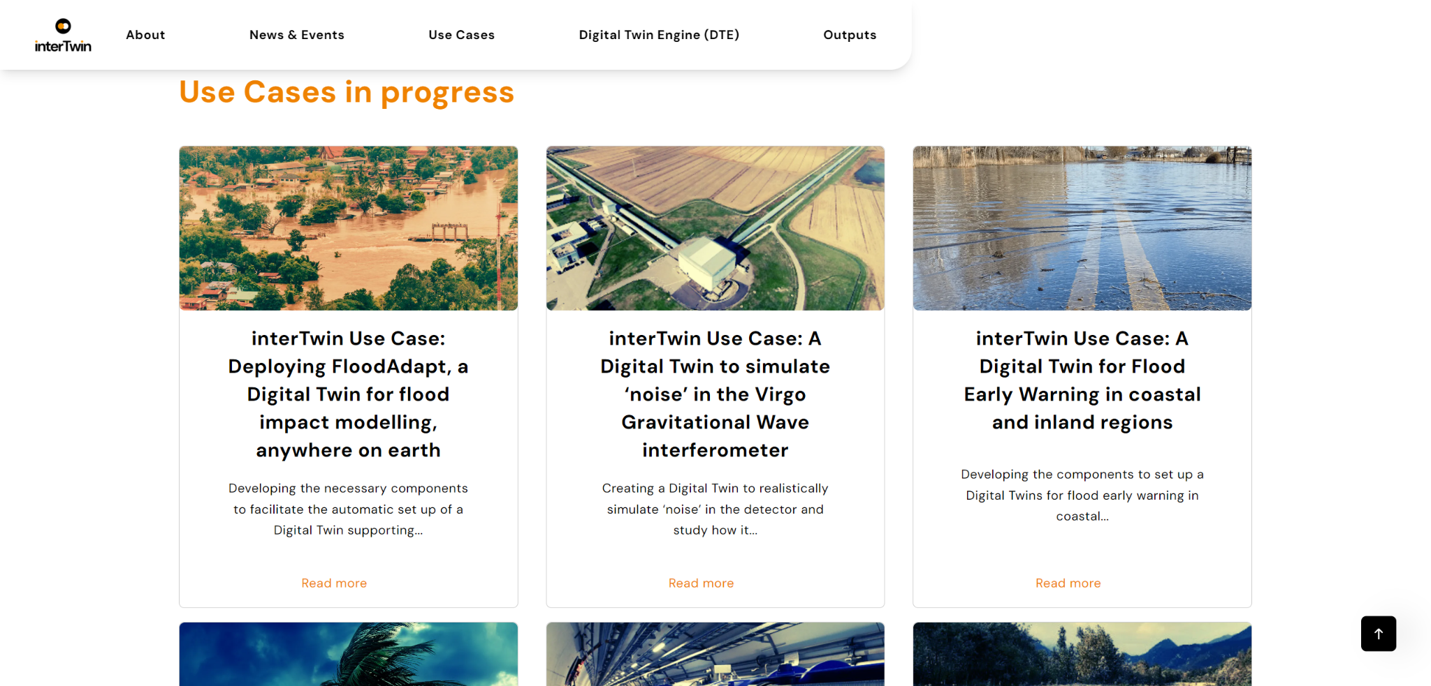
Figure 2 - interTwin Use Cases on the website
The project has maintained this trend by regularly publishing about deliverables and, by M17, also publishing about the interTwin DTE Software Modules. 40+ DTE software modules, matching the work done in the technical work packages, were published on the website, organised in 4 different categories: ‘Core Modules’, ‘Infrastructure Modules’, ‘Environment Modules’ and ‘Physics Modules’.
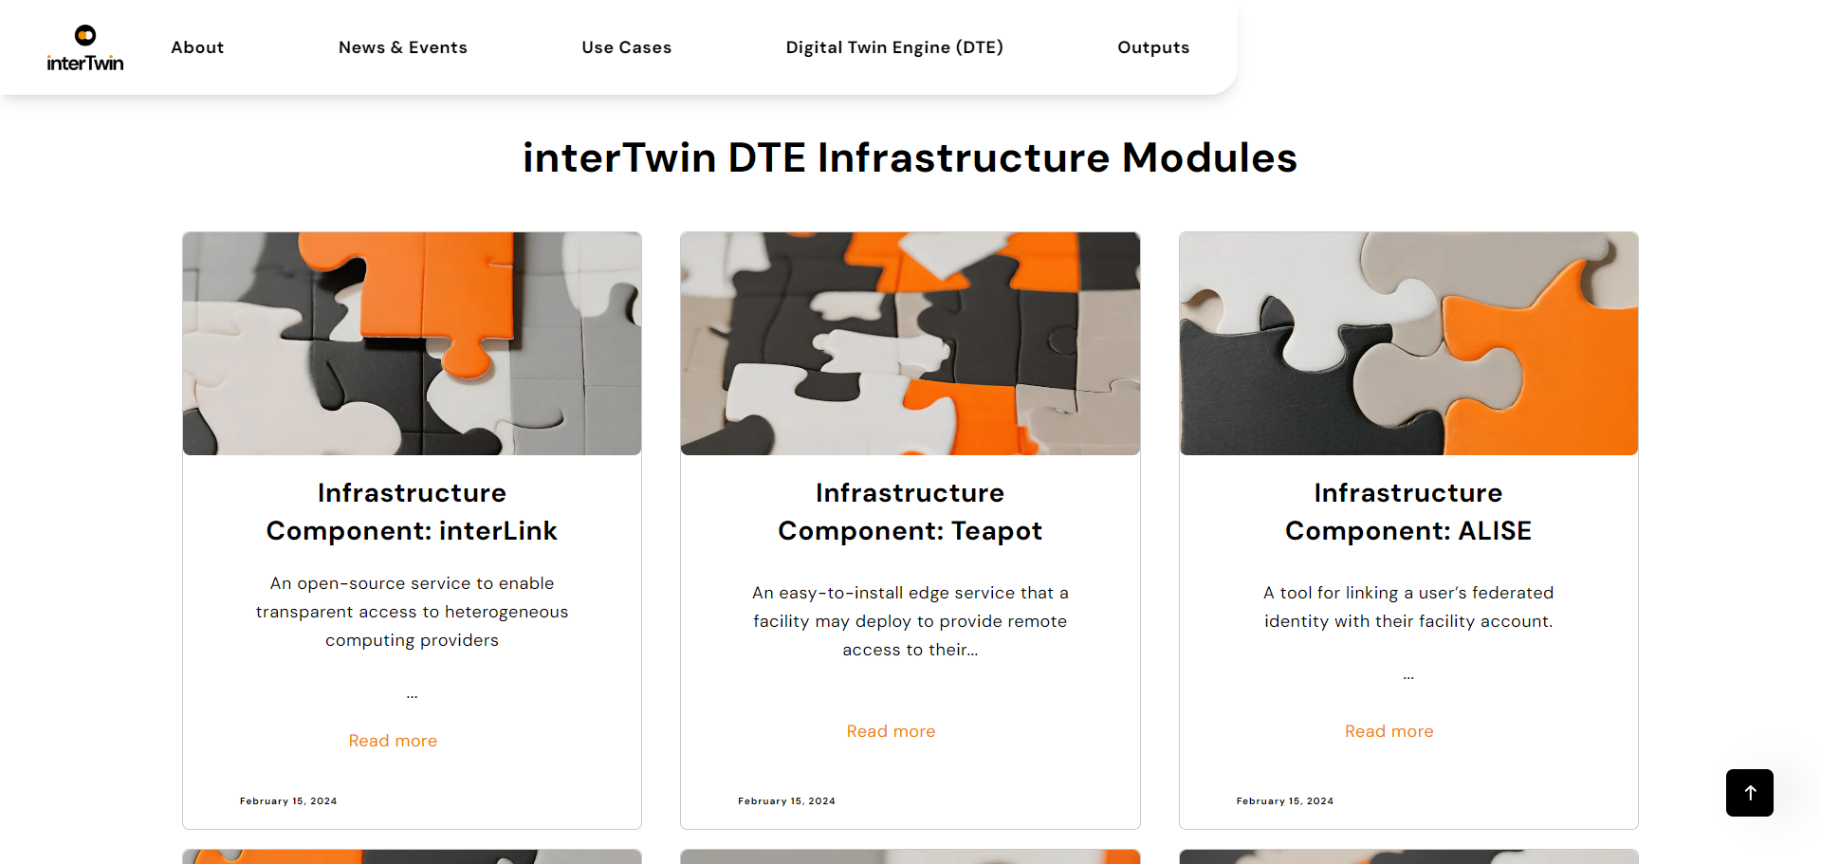
Figure 3 - interTwin software components on the website
With almost 7K visits (overall), with on average 300 visits per month, and more than 9.5K pageviews by the end of M18, the website has proven to be a solid dissemination channel - especially in combination with campaign efforts on social media (LinkedIn) and partner activation (requests to disseminate).
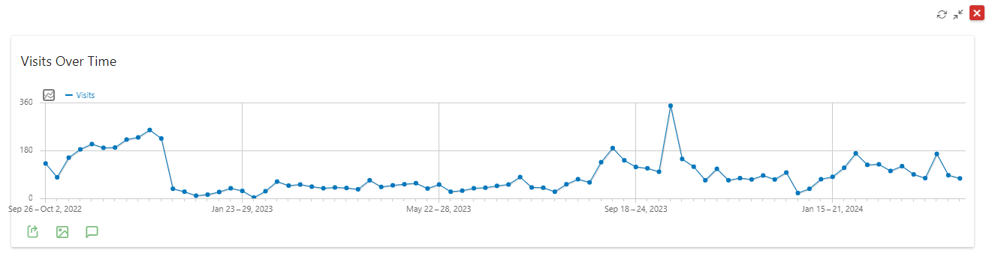
Figure 4 - website weekly visitors (source: Matomo Analytics)
Now that the major sections of the website are in place, the plan for M19-M36 is to expand on the existing sections, mainly by improving and completing the use case and DTE software modules sections, as well as increasing the number of news items about these elements. In parallel, more traffic will be led to the website through a further intensification of social media posts (for example, once per post per software component).

Social Media

LinkedIn
The project LinkedIn page, which has over 350 followers, has shown a consistently high engagement rating ranging between 7.5% and 9.5% which is, very much in line with the results of similar pages (such as: BioDT, DT-GEO, and iMagine). Special attention has been paid to creating ‘LinkedIn-friendly’ visuals such as ‘carousels’, which significantly increased engagement for complex content (for example the physics use cases).
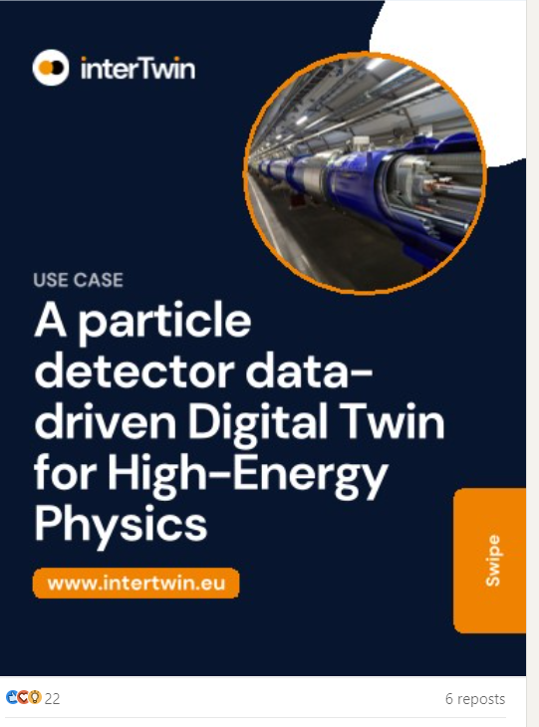
Figure 5 - example of a LinkedIn specific ‘carousel’ post designed to promote the use cases
As the project progresses, partners are gradually coming into the habit of tagging interTwin on LinkedIn for their own project-related posts. As this is a very low-threshold activity that can generate a lot of visibility for the project, we are encouraging the partners to do this, especially those partners who are not in direct contact with T2.2. However, a related challenge is that events like this risk of remaining under the radar in both event-planning and event-reporting, encouraging partners to report events (in advance and afterwards) remains crucial (see section 3.4)

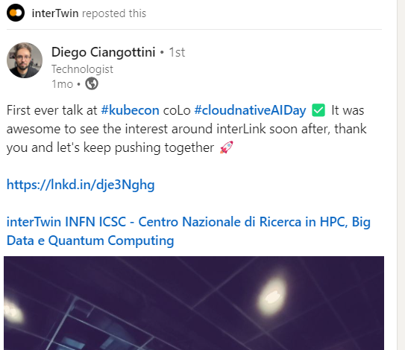
Figure 6 - example of a partner tagging interTwin on LinkedIn
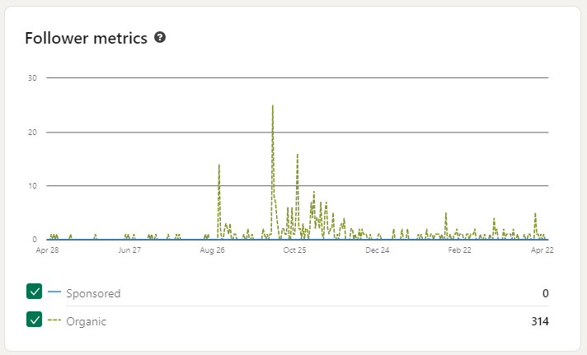
Figure 7 - LinkedIn metrics - organic reach

YouTube
At the recommendation of the project reviewers after the end of RP1, the project has in M16 launched its own YouTube channel with an introduction clip to describe the aim of the project ‘in a nutshell’ - mainly aimed at showing in event booths. The channel is also used to host webinar recordings and demonstration videos (in progress).

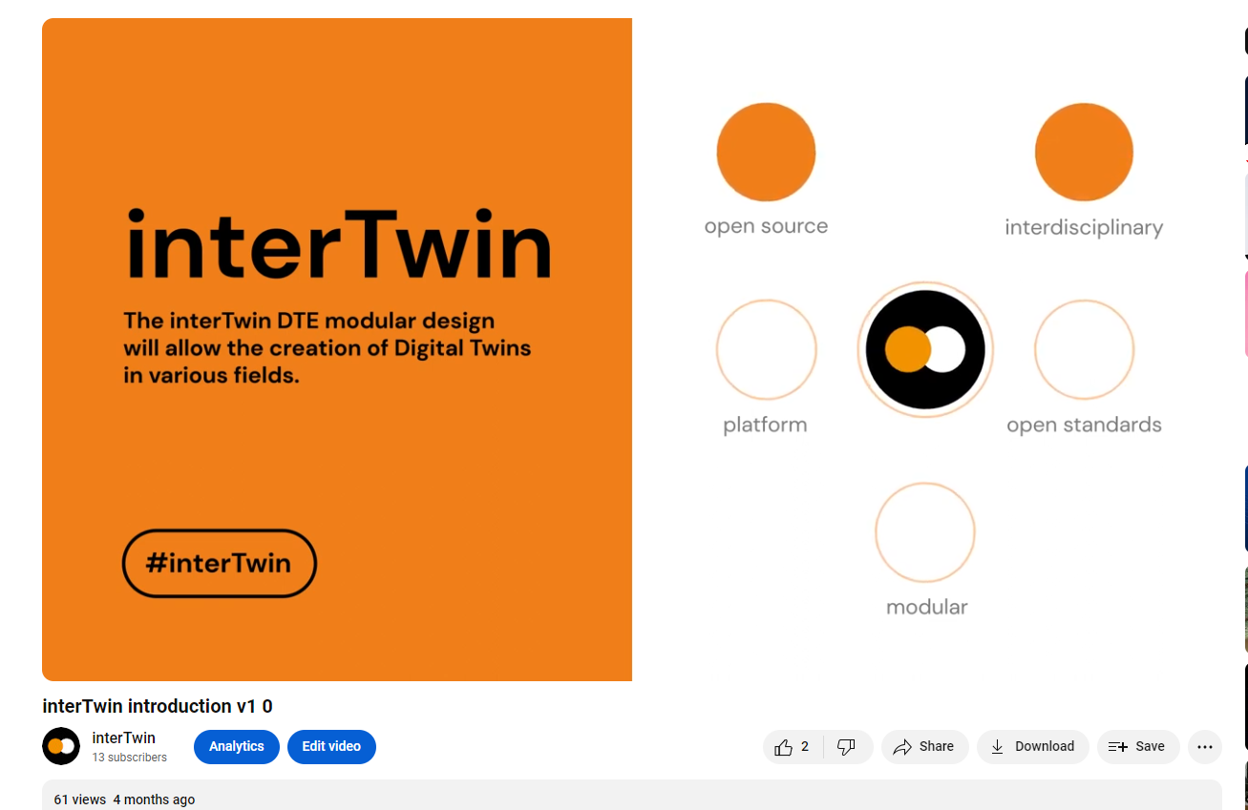
Figure 8 - fragment from the interTwin introduction clip for event booths
An unforeseen but interesting side-effect is that some of the technical partners are in the habit of creating short explainer video’s about their work, sometimes applied to modules available as part of the DTE. The YouTube account allows us to collect these in a separate playlist.

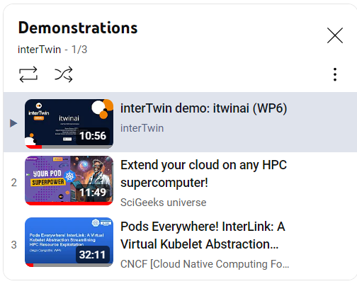
Figure 9 - demonstration clips for interTwin DTE software components, the first one organised by interTwin, the other two created elsewhere and added to interTwin playlist

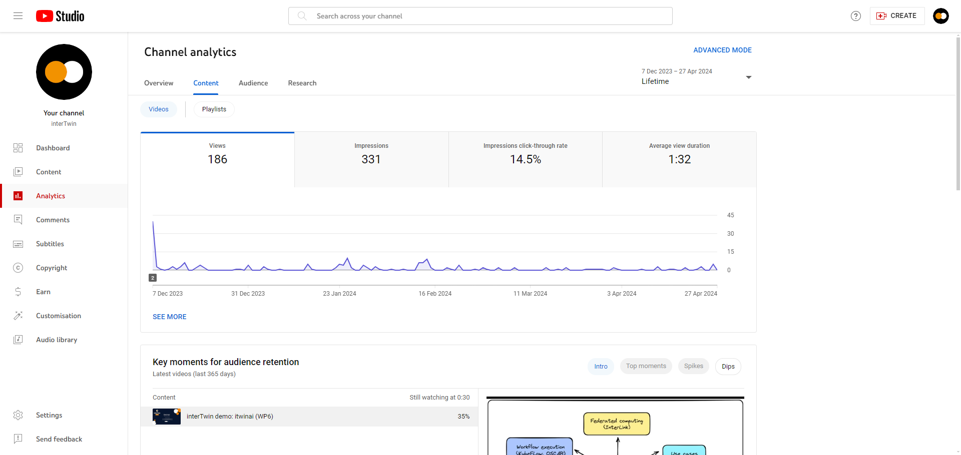
Figure 10 - YouTube channel analytics

Other

Newsletter
The project did not intend to release a public newsletter, but as the first outputs started to be released the need for an internal newsletter became clear - if only as an overarching communication channel towards all partners outside of WP meetings. At the end of M18, four internal newsletters (upDates) have been distributed amongst partners and are archived on Confluence.
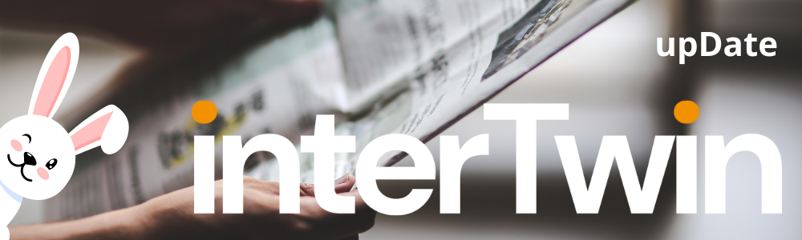
Figure 11 - interTwin Quarterly Newsletter header

Github
Although the interTwin Github community is not managed by T2.2, it is an important dissemination channel for project software development.

X (Twitter)
The project maintains a nominal presence on X (formerly Twitter) by posting copies of LinkedIn content. However, for both practical (use has plummeted) and ethical (government issues at X), the channel has low priority.

Events

Booths
From the start, interTwin has been present at every event booth hosted by project coordinator EGI. M1-M12 focused on awareness raising. Assisted by a striking branding that stands out, the project dissemination materials attracted attention and instigated many conversations at the respective booths. Working in collaboration with the other EGI coordinated projects (such as iMagine and EGI-ACE) has allowed interTwin to reach into audiences that are not necessarily familiar with the concept of Digital Twins (such as EOSC Symposium), or with secondary target audiences (such as businesses during Data Spaces Symposium).
While M1-12 mainly focused on setting up the basic channels and tools, from M13 onwards the strategy has shifted towards differentiation, in line with the various project outputs that have become available. This implied that the communication and dissemination measures are becoming more attuned towards the needs and expectations of the defined target groups, mainly through the organisation and attendance of sector-specific events.
During the second half of the project, interTwin will aim for a booth presence at more domain-specific events, for example EGU (environment), Teratec (HPC and business) and CHEP (physics).
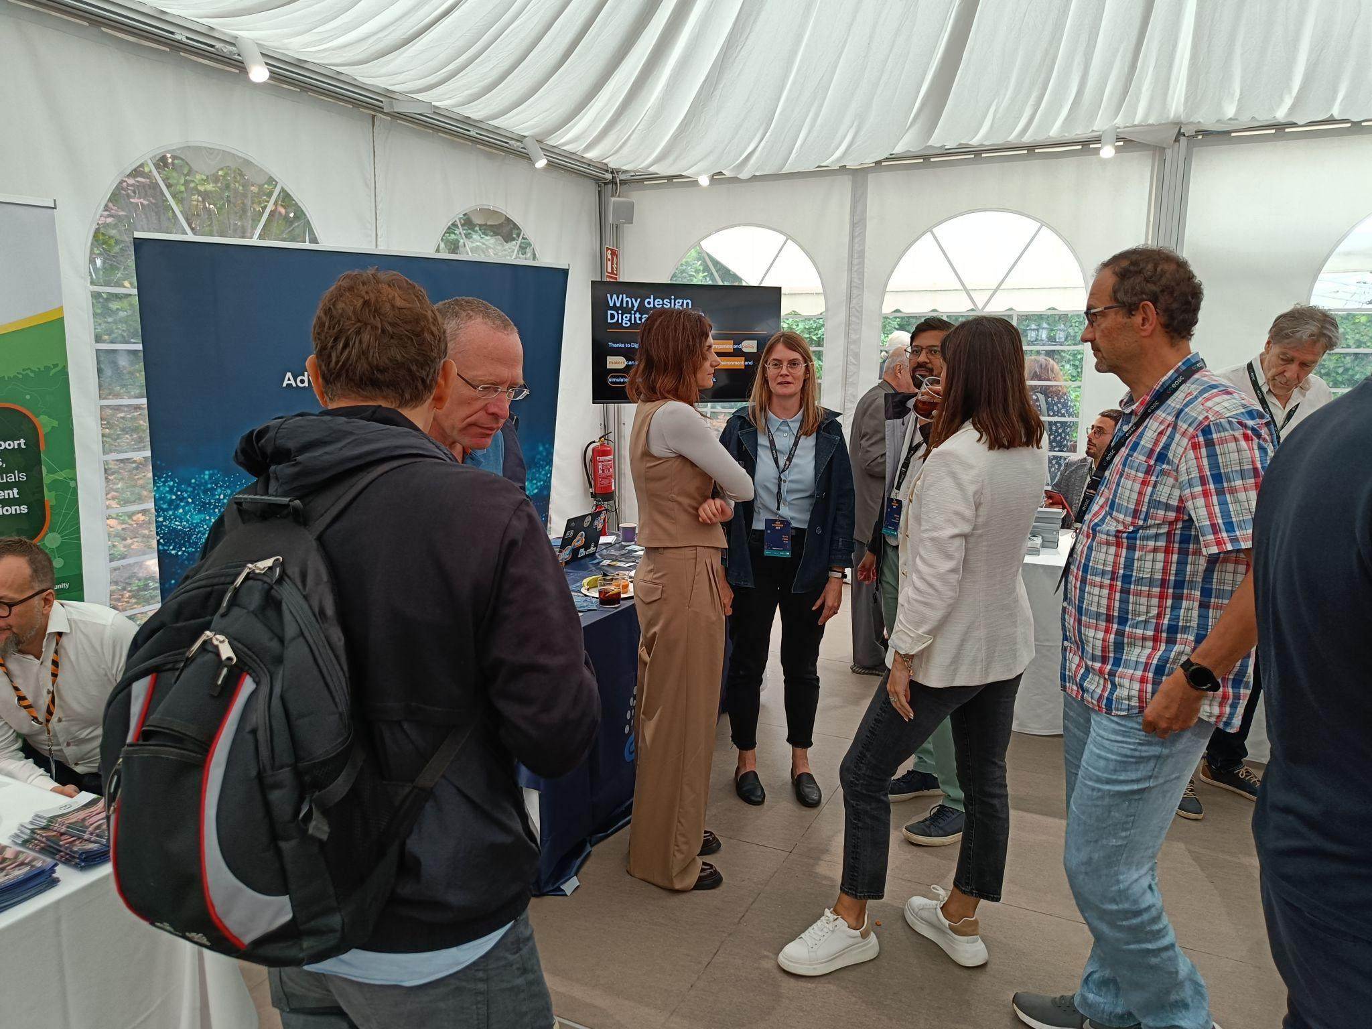
Figure 12 - Shared booth hosted by EGI
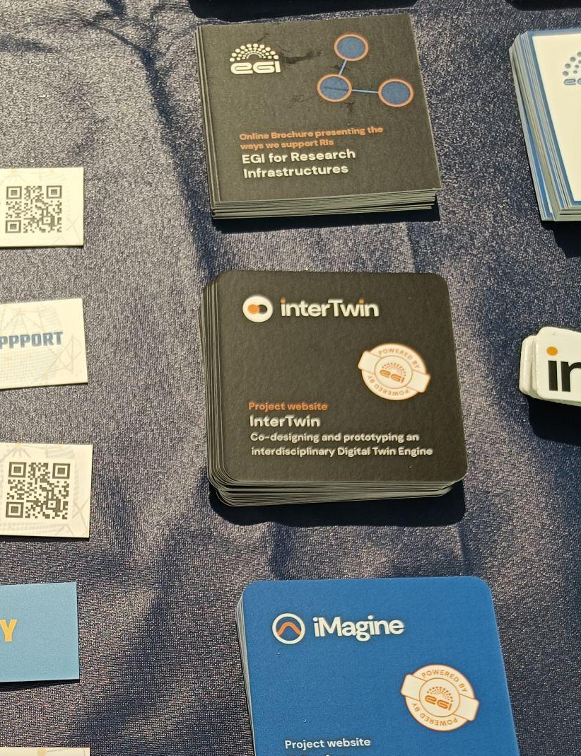
Figure 13 - interTwin moo cards and interTwin MP4 clip shown on the screen

Partner Presentations
Overall, partners have reported on 25 in-person events where interTwin was presented one or multiple times. Based on self-reporting (and excluding exhibition visitors), an estimated reach of these presentations for M1-M18 exceeds 2500 persons.
Partners are requested to both inform the AMB when they plan to attend an event through an event list on Confluence, and to report afterwards through a reporting form. Using this dual approach, the project intends to catch all - including events that are signalled beforehand but not reported on afterwards and vice versa.
Example of events where interTwin has been presented so far include: EGI Conference, Ibergrid, EOSC Symposium, EBDVF, Data Spaces Symposium, CHEP, ISGC, EGU, EODC Forum, IEEE eScience and ISC High Performance. A full overview of events where partners have presented, is provided in annex 1.

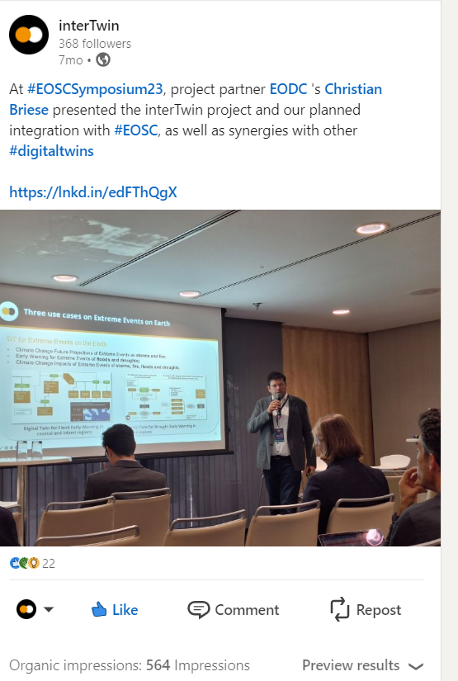
Figure 14 - interTwin presentation by partner EODC

Internal workshops
interTwin hosted the following internal workshops and meetings in the first half of the project. At the request of partners with limited travel budget, some workshops have been organised online rather than face-to-face.
Table 1 - internal project workshops
Date | Name | Description | Who | Link
9-sep-2022 | interTwin pre-kick-off Online | Pre Kick-Off |  | https://indico.egi.eu/event/5923/
19-sep-2022 - 20-sep-2022 | EGI Conference | Kick-Off |  | https://indico.egi.eu/event/5924/
25-jan-2023 - 26-jan-2023 | interTwin F2F meeting | Technical meeting + IEG | All technical WPs | https://indico.egi.eu/event/6004/
22-jun-2023 - 23-jun-2023 | interTwin F2F meeting (EGI 2023) | Technical meeting + EEAB | All technical WPs | https://indico.egi.eu/event/6095/
24-jan-2024 - 25-jan-2024 | interTwin 3rd tech meeting (online) | Technical meeting + IEG | All technical WPs | https://indico.egi.eu/event/6350/

Webinars
Table 2 - Webinars
Date | Title | Who | Details
28-feb-2023 | openEO info sharing | All technical WPs | https://indico.egi.eu/event/6066/
23-nov-2023 | Business Model Workshops - The Innovation Management System at interTwin | Internal consortium | This webinar aimed to refresh interTwin partners on the innovation management processes established within the project, providing examples on how the project is addressing the collection of Results, Key Exploitable Results, and emerging Innovations, and how it is expected to interact with the related exploitation and sustainability plans.
24-jan-2024 | Exploring Ethical Horizons: Insights into EU Funded Projects Ethics Appraisal Procedure | Internal consortium | Webinar hosted by DFKI Ethics Team  Speakers:  Iris Merget (DFKI)  Mihai Maftei (DFKI)

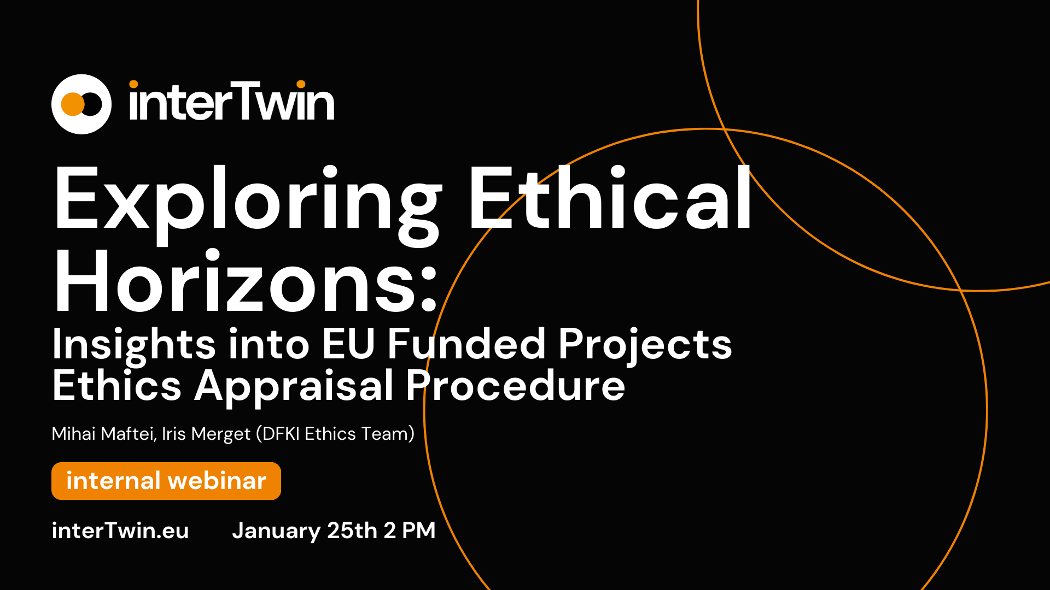
Figure 15 - interTwin webinar branding

Publications
From the start, the project policy has been to archive all project outputs, such as deliverables, presentations and peer-reviewed publications) on the interTwin community page on Zenodo. With more than 1600 downloads (more than 200 downloads for the most popular deliverables), the importance of Zenodo in dissemination is not to be underestimated. (Table 4). This entails a close follow up of the project partners, for example when an event was reported a double check took place to ensure that the accompanying presentation or poster is also available on Zenodo. Related, some training of project partners related to open science, self-archiving, and their importance for project dissemination proves to be crucial.
On our website and social media, each deliverable is accompanied by a ‘fact sheet’ highlighting the key elements of each deliverable, a reference to the partner and to the location of the deliverable on Zenodo.
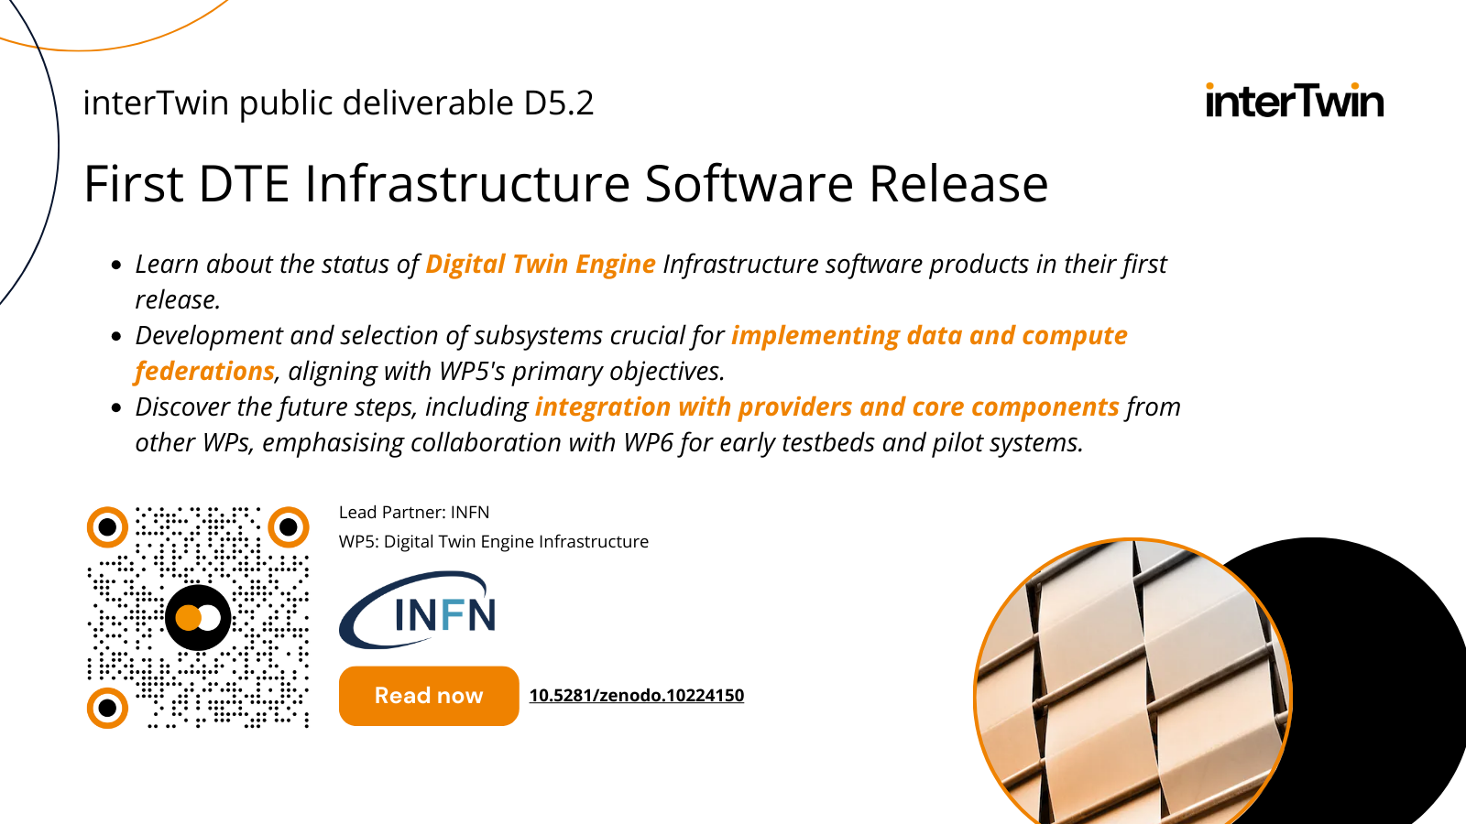
Figure 16 - example of a deliverable fact sheet
interTwin has also been chosen as one of the pilot projects for the Horizon-Zen project run by Zenodo, where a number of new features will be piloted. Within the scope of this pilot, interTwin will, in collaboration with the EGI training programme and iMagine, organise a campaign aimed at partners in EGI-coordinated projects about best practices in self-archiving project outputs.
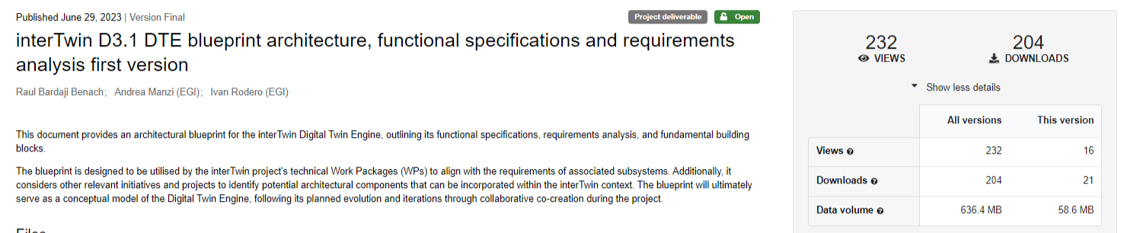
Figure 17 - example of a deliverable published on Zenodo and its downloads

Deliverables and Milestones achieved
Halfway through the project, at the end of M18, T2.2 has achieved the following milestones:
- Organisation of a kick-off event (MS2.1)
- Website launched (M2.2)
- Communication package available (M2.2)
- (First) Business Model workshop held (M2.3)
The first deliverable, D2.1, has been submitted in M5.

Summary of Dissemination Outputs

Status Review
Table 3 offers a status-review of planned T2.2 activities, as described in D2.1, during M1-M18.
Table 3 - Status review of planned T2.2 activities
Description | Comments
Website | Website published and regularly updated (see section 2.2)
Social Media | LinkedIn published and regularly updated  Twitter (passive) (see section 2.3)
Technical Workshops | F2F: Madrid January 2023, EGI2023  Online: January 2024 (see section 2.4.3)
Kick-off | Organised at EGI2022 (see section 2.4.3)
Event participation | Partners have presented interTwin in 25+ events, interTwin was also present at 6 shared event booths.
Consultations and Surveys | consultations were run at WP4 level to identify needs and requirements for the use cases
Repository for publications | Zenodo
Repository for Software | Github
Project Partners and Boards | Team, EEAB, EAB added to website
Project branding | Branding guide delivered
Press | Will be addressed in M19-M36 (see section 3.4)
Scientific Publications | 2 peer-reviewed publications added to Zenodo, Will be addressed in M19-M36 (see section 3.4)
Visual materials | Goodies  Moo Card  Roll-Up  Poster (see section 2.1)  Clip

Unplanned activities:
- Internal Slack Channel: established after feedback from partners.
- Project YouTube channel: In addition to the planned playlist on EGI main channel (which is still used for the internal recordings), a separate YouTube channel was established.

KPIs for communication and dissemination
Table 4 - KPI values M18
KPI | M18 status | Target | Comments
# Page visits | 6560 total visits  Monthly: approx. 300 unique visits  9627 page views  4945 home page visits | Monthly unique visit rate of 250+
# engagement rate on social media | 9.75% on LinkedIn  and 9.74% on Twitter |  | Due to the recent changes that occurred to Twitter now X, metrics might not be entirely accurate.
#deliverable views and downloads (Zenodo) | 1836 views  1619 downloads |  | Most popular: D5.1 (198 downloads), D6.1 (232 downloads), D7.1 (210 downloads), D4.1 (196 downloads) and D3.1 (230 downloads)
Curation/Promotion of Software repository and foster open source community (GitHub) | 18 repositories  0 Discussions in the Forum  35 followers | 50 active members | Specific website for each of the SW Components: https://www.intertwin.eu/intertwin-digital-twin-engine/.  Promotion will be part of a campaign in PR2 and PR3
News items and Newsletters | 19 news articles  4 internal newsletters | Each result is presented at least once | News items about interTwin were included in 6 issues of the monthly EGI newsletter, each with a reach of more than 3000 readers
# attendees during  presentations at events | >700 cumulative (presentations) at 25 events | Each result is presented at least once | In the events where interTwin was presented till M18 (including two EGI Conferences, one EGU General Assembly and various others), a self-reported estimate provided by presenters is that the project was visible to over 2500 event participants so far.  The total number of event participants that had access to promotional materials, and one-on-one conversations at various event booths is estimated to be more than 2000.
Use Cases | 8 use cases published, 2 in development  671 total views | 5 existing use cases  New use cases  20 research communities’ contribution | Reference: https://www.intertwin.eu/use-cases/
Visual Materials | Factsheet for every use case  LinkedIn slide posts for every use case | One non-scientific publication per outcome/result | See section 2.3

Collaborations and partnerships

DT-GEO, BIODT, interTwin, DestinE, EOSC Channels
interTwin has worked in contact with the other DT projects in the same call (DT GEO, BioDT) in order to deliver a common interoperability framework with DestinE, including the drafting of a common architecture, a common DT, and a DTE glossary. A collaboration group between the three projects has been set up and meets on a regular basis. The technical work is focused on the composition of a joint digital twin glossary.
At communications and dissemination level, there have been joint submissions for events (such as Digital twins and EOSC – Insights from BioDT (CSC – IT Center for Science)’ EOSC Symposium). Overall, it is aimed to closer align with DestinE (for example: Participation in DestinE user exchange event).
Considering the growing maturity of interTwin outputs, joint initiatives to reach specific audiences are more feasible than in the beginning of the project (for example, joint submissions for events, joint news items,…). While the first initiatives for this have been taken in M12-M18 this is expected to continue and intensify in the second half of the project.

interTwin & Digital Twin of the Oceans
Following the participation of interTwin and the Digital Twin of the Oceans webinar (together with BioDT and TURTLE) - a collaboration has started to trigger standardisation efforts of Digital Twin of the Earth. interTwin has participated in several preparatory follow up meetings with DT Iliad participants and other experts in order to arrange a working group at IEEE for a Standard for Digital Twin of the Earth.

interTwin & Green Deal Data Space
Following the participation of interTwin at the BDVF 2024 event, together with a.o. GREAT, AD4GD and DestinE, follow up conversations to understand how Digital Twin projects can interoperate with Data Spaces (in particular with the future Green Deal Data Space).

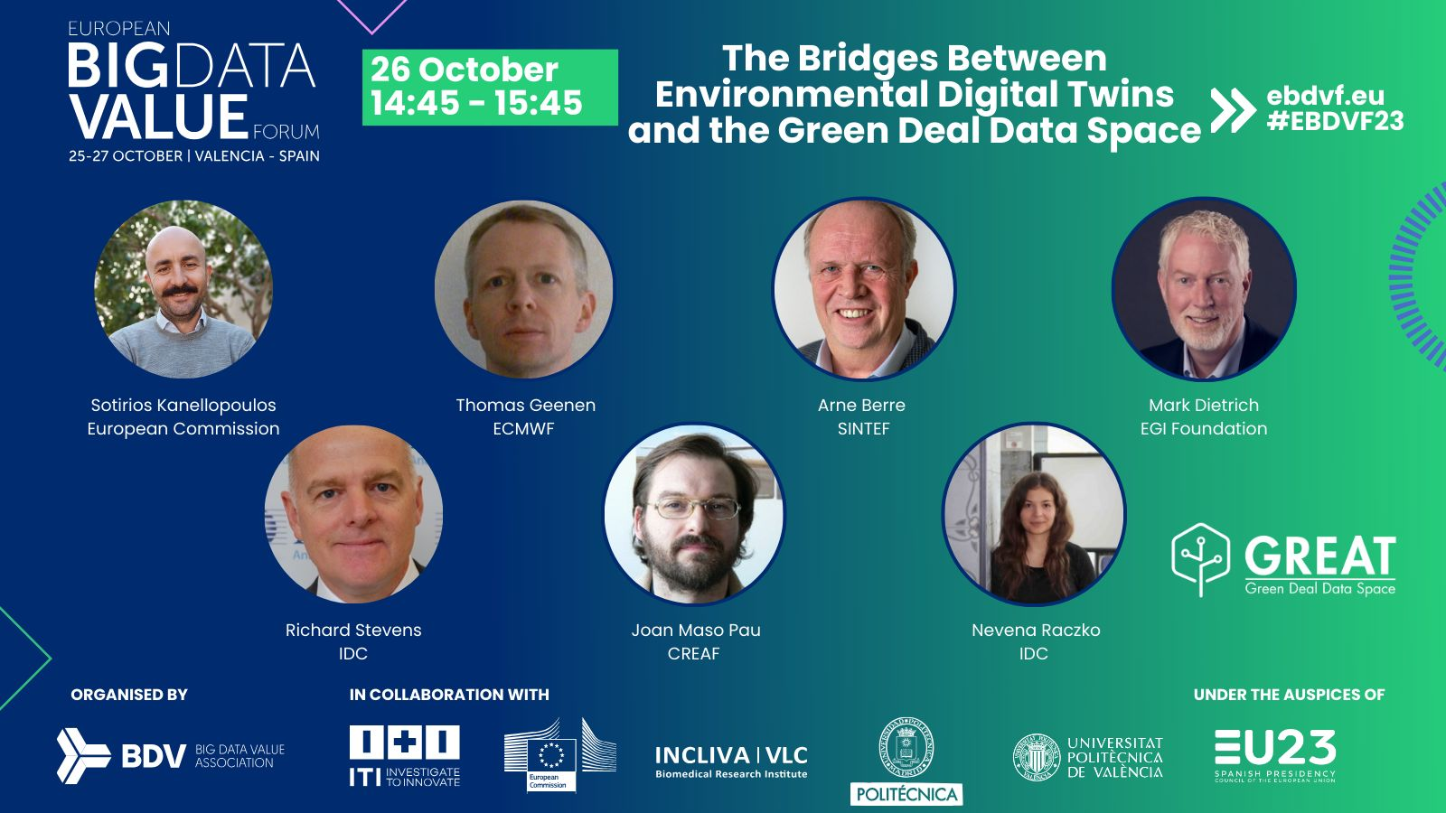
Figure 18 - presentation of interTwin by EGI Foundation at EBDVF2023

interTwin & National Initiatives
Motivated by common needs and goals toward the implementation of compute continuum strategies and solutions, interTwin started a collaboration with the Italian High Performance Computing, Big Data and Quantum Computing Center (ICSC). Technical solutions developed within the context of the interTwin work program have been presented in several domain specific meetings of ICSC. The scientific communities so called Spoke (particularly spoke2 and 3) are both early adopters and contributors, mostly co-designing the enhancements of the proposed solutions.

Gaps & Challenges
As the project is halfway, an evaluation of the DCE activities in the first project half revealed some gaps that will be addressed with concrete actions
So far, two scientific publications supported by interTwin (i.e. mentioning the project in the acknowledgements are known. A potential issue here is that publications related to interTwin might not acknowledge the project. This will be addressed through the AMB and will be part of the ‘Zenodo’ awareness campaign as planned by the EGI communications team in the second half of 2024.
It has been challenging to identify the right press outlets to inform about the project. Thanks to the collaboration with the BioDT and DT-GEO projects, and the linking of interTwin with DestinE, the project plans to address this by embedding the interTwin story into a bigger story about the role of Digital Twins to mitigate the consequences of climate change.
Overall, T2.2 will work closely together with the partners concerned to increase their involvement in making good ‘stories’ about the use cases (linking to the now published related software modules). Partners will also be stimulated to share these use case stories in their own networks, including press outlets. As a project, an effort will be made to identify suitable outlets (such as Horizon Europe Magazine) to plug the project outputs. Potentially, limited publication fees could be considered.
A similar challenge is clear when it comes to reaching the ‘general’ public. Overall, they are not a target audience, but as awareness about Digital Twins can influence the interest of policy makers, who are a target audience, the project will investigate what the options are here - likely, a similar approach to the one for press will be taken, inserting interTwin into a bigger story and investigate some suitable outlets. Given the potential for public engagement of the work in the environment domain, especially the environment use cases offer opportunities to link the interTwin work with the societal topic of climate change.
Another challenge has been related to partner engagement, which can be challenging because of the size of the project and the number of partners. Via the project Slack channel and internal newsletter, partners are actively informed from the project office, but it is more challenging to capture the activity that is going on at partner level, as some of this is very technical and niche. T2.2. relies heavily on partner self-reporting (through the event reporting form, WP meetings, and AMB) in order to kickstart communication or dissemination campaigns. Especially for spontaneous activities (e.g. invitations to present the project at short notice), we are very dependent on the willingness of the partner to self-report, so the project has tried to make this process as low-key as possible.
The ‘open door’ policy on Slack, as well as the encouragement to tag the project on LinkedIn, has allowed a couple of partners who are not in direct contact with T2.2 to quickly reach out and inform us about their work, with interTwin providing a potentially wider dissemination network as an incentive (for example, adding existing demonstration videos for software modules to the interTwin demonstration playlist, or tagging the project on LinkedIn in an event report - sharing existing content and ‘branding’ it as interTwin is easier and quicker than providing content specifically created at the request for T2.2). This will be expected to increase once the campaign promoting the software components is in full motion.

Stakeholder analysis

Stakeholder preferences, behaviour, and needs
The project target audiences have been initially identified in the Description of Work, then further detailed in D2.1 First Communication and Dissemination Plan.
Based on those, a stakeholder analysis, describing for each of them the type of stakeholder, role and relevance for the project and possible dissemination actions. And for those where actions have been triggered - the specific contacts have been mapped indicating the reason for interest, priority, and the expected type of engagement - if we expect them to be informed of the project, for consultation purposes to gather feedback from them or for any further collaboration, use, re-use, or exploitation.

Specific activities per target audience
The target audiences as defined above can be matched to the Horizon Results stakeholders list. In order to optimise tracking of dissemination opportunities and measure their success, we have mapped interTwin stakeholders to those of the HR results platform.
In table 5, we investigate for each target audience which activities have taken place in line with the expectations linked to their stakeholder profile, and what the future plans are.
Table 5 - Audiences and the activities they are targeted with
Stakeholder type | Target audience | Engagement level | Activities | Plans M19-36
User | Scientific Collaborations | Awareness  KER1  KER2  KER3  KER4  KER5  KER6 | Joint collaboration with DTGEO, BioDT, DestinE  Participation in events & webinars (DestinE, TEMA, Digital Twin of the Ocean)  Promotion of Deliverables via social media | Joint campaigns, event participation  Release of DT Glossary Promotion of GitHub repository  Print versions, infographics of key deliverables  YouTube explainer clips
 | SMEs and Industry | Awareness  KER1  KER2  KER3  KER4  KER5  KER6 | Event presence (Data Space Symposium)  Information clip  Branding  Promotion of Deliverables via social media | Targeted event presence (EBDVF, Teratec Forum, DSS, …)  2 Business Model Workshops  Promotion of GitHub repository  Print versions, infographics of key deliverables  YouTube explainer clips
 | Individual Researchers | Awareness  KER1  KER5  KER6 | Information through project partners  Event presence  Information clip  Branding | Booth presence at domain-specific events (EGU, CHEP, …)  YouTube explainer clips, domain-specific webinars
 | Policy Makers & Civil Society | Awareness  KER1  KER5 | Event presence  Information clip  Branding | Presence at specific events (EOSC Symposium- aim for unconference session)  High level closing event at EGI2025  High-quality closing brochure about the DTE Modules  Engagement with Public Authority / Policy Making -related initiatives and projects
Developers | Scientific Collaborations | Co-design and co-creation  Use tools  KER1  KER2  KER3  KER4  KER5  KER6 | Use cases  Event presence  Information clip  Branding  Promotion of Deliverables via social media | Presence at specific events  One-on-one meetings  High-level closing conference  High-quality closing brochure about the Blueprint and DTE Modules, domain-specific webinars, component-specific dissemination
 | RIs and e-infras, Data Space providers |  |  | Presence at specific events  One-on-one meetings  High-level closing conference  High-quality closing brochure about the Blueprint and DTE Modules
 | SMEs and Industry |  | Event presence (Data Space Symposium)  Information clip  Branding  Promotion of Deliverables via social media | Targeted event presence (EBDVF, Teratec Forum, DSS, …)  2 Business Model Workshops  Promotion of GitHub repository  Print versions, infographics of key deliverables
Providers | Scientific Collaborations | Adding services and tools to the DTE  Integrate the DTE  KER1  KER2  KER3  KER4  KER5  KER6 | Event presence  Information clip  Branding  Promotion of Deliverables via social media | Presence at specific events  One-on-one meetings  High-level closing conference  High-quality closing brochure about the Blueprint and DTE Modules
 | RIs and e-infras, Data Space providers |  |  | Presence at specific events  One-on-one meetings  High-level closing conference  High-quality closing brochure about the Blueprint and DTE Modules
 | SMEs and Industry |  | Event presence (Data Space Symposium)  Information clip  Branding  Promotion of Deliverables via social media | Targeted event presence (EBDVF, Teratec Forum, DSS, …)  Business Model Workshops  Promotion of GitHub repository  Print versions, infographics of key deliverables

Plan M19-M36
M19-36 will see an intensification of existing measures, with continuous publication and promotion of project outputs and deliverables, and a continuation of the ongoing promotion of the deliverables and the use cases (including print materials and two webinars focused on the use cases).
As at the end of M18 the first batch of software modules (core, infrastructures, physics, and environment) for the DTE have been published on the website, a dedicated communication campaign (May-June 2024) will focus on these. This campaign will include a series of social media posts highlighting every component, a flyer, a clip for promoting them during events, and a series of webinars presenting the modules to the target audiences. In line with the existing activities on YouTube of certain technical partners, a series of demonstrations of the various DTE modules will also be organised, either through short showcase webinars, or as self-recorded demonstration, to be added to the demonstration’s playlist of the project on YouTube.
In the final stage of the project, a dedicated campaign will showcase the project KERS to demonstrate the impact of interTwin. This campaign will definitely include a series of online news items and stories (to be published on our own website and distributed via partners towards partner’s websites and outlets, press contacts, and event presentations/posters. An evaluation will be made to assess if and what aspects of the project outputs would benefit from a dedicated print publication. These could be a major hand-out at the closing conference but can also serve for post-project dissemination.
Finally, interTwin will increase its presence at various events (visibility through booths and presentations), including some events where we did not have a previous presence. Partners are continuing to submit abstracts for events in M18-M36, and T2.2 is also working closely together with the colleagues in the EGI communication team to streamline event booth participation in as many events as (budgetary and practically) feasible. Event plans for the future are recorded on Confluence to allow for proper coordination’s.
Planned events include:
- EGU24: at the time of writing, a very successful event participation was conducted at EGU24. This will be repeated in EGU25 with again a (larger) shared booth, and a prominent presence in the programme with the environment use cases and software modules.
- EODC Forum: interTwin will be present on the programme and there will be a technical F2F meeting co-located, including a business model workshop for project partners
- Teratec Forum: this event focused at HPC start-ups will take place in Paris, May 24. interTwin will be present with a booth to showcase the relevance of the DTE Software Modules to business and Industry
- TNC24: interTwin will be present with a (shared) booth at this major multi-disciplinary conference
- EGI2024: interTwin will curate a public digital twin focused session in the programme, and will have a prominent place in the shared flagship event booth
- EOSC Symposium: EGI will be present at the shared event booth
- CHEP24: this event will be a major showcase opportunity for the interTwin physics use cases and software modules
- The closing event is planned in June 2025, in co-location with EGI2025.

Annexes

Annex 1 – 2022 events
Event Name | Link | (start) Date | Partner | Reach
IBERGRID 2022 | https://www.ibergrid.eu/2022-ibergrid-faro/ | 10-okt-2022 | EGI | 100
EGI2022 |  | 19-sep-2022 | EGI, all | 250
5th RUCIO community workshop | https://indico.cern.ch/event/1185600/ | 7-nov-2022 | DESY | 60
AGU Fall Meeting 2022 | https://agu.confex.com/agu/fm22/meetingapp.cgi/Session/170965 | 16-dec-2022 | CMCC | 50
EOSC Symposium 2022 | https://events.eoscfuture.eu/symposium2022/programme | 14-nov-2022 | EGI | 30 (+ 250 booth visitors)

Annex 2 – 2023 events
Event Name | Link | (start) Date | Partner | Reach
2023 CERN openlab Technical Workshop | https://indico.cern.ch/event/1225408/ | 16-mrt-2023 | CERN | 100
Data Spaces Symposium | https://internationaldataspaces.org/data-spaces-symposium/ | 21-mrt-2023 | EGI | 150
ISGC 2023 | https://indico4.twgrid.org/event/25/ | 23-mrt-2023 | DESY | 25
XRootD and FTS workshop | https://indico.cern.ch/event/875381/ | 27-mrt-2023 | EGI | 40
DIH World | https://dihworld.eu/event/digital-twins-what-how-why/ | 19-apr-2023 | EGI | 50
EGU2023 | https://meetingorganizer.copernicus.org/EGU23/session/45429 | 23-apr-2023 | CMCC | 50
ASFPM Conference 2023 | https://www.floods.org/conference/2023-asfpm-conference/ | 7-mei-2023 | Deltares | 30
CHEP2023 | https://www.jlab.org/conference/CHEP2023 | 8-mei-2023 | EGI | 100
EODC Forum 2023 | https://events.eodc.eu/event/9/overview | 9-mei-2023 | EGI, CMCC, EODC, EURAC, DELTARES | 60
L International Meeting on Fundamental Physics and XV CPAN days | https://indico.cern.ch/event/1283224/ | 2-jun-2023 | CSIC
EGI2023 | https://whova.com/portal/webapp/egi_202305/ | 21-jun-2023 | EGI, CMCC | 25 (+ 250 booth visitors)
EOSC Symposium 2023 | https://symposium23.eoscfuture.eu/ | 20-sep-2023 | EGI, EODC | 250
IBERGRID 2023 | https://www.ibergrid.eu/ibergrid-2023-benasque/ | 25-sep-2023 | CERN, EGI, CSIC, UPV | 186
EuroGEO Workshop 2023 | https://egw2023.eurac.edu/ | 2-okt-2023 | EGI | 70
IEEE eScience 2023 | https://www.escience-conference.org/2023/ | 9-okt-2023 | CERFACS | 150
Interoperability architectures for Digital Twins of the Ocean | https://www.eventbrite.de/e/interoperability-architectures-for-digital-twins-of-the-ocean-tickets-732174171657?aff=oddtdtcreator | 25-okt-2023 | EGI | 15
Big Data in Space 2023 | https://bigdatafromspace2023.org/ | 6-nov-2023 | EURAC | 300
2nd Destination Earth User eXchange | https://destination-earth.eu/event/2nd-destination-earth-user-exchange/ | 13-nov-2023 | EGI, Deltares | 200
Radio 23 | https://events.mpifr-bonn.mpg.de/indico/event/324/overview | 14-nov-2023 | MPG | 30
AI 4 Sustainability: TEMA webinar | https://tema-project.eu/articles/artificial-intelligence-sustainability-what-role-ai-advancing-targets-sustainability | 14-nov-2023 | EGI | 35

Annex 3 – 2024 events
Event Name | Link | (start) Date | Partner | Reach
IBERGRID 2022 | https://www.ibergrid.eu/2022-ibergrid-faro/ | 10-okt-2022 | EGI | 100
EGI2022 |  | 19-sep-2022 | EGI, all | 250
5th RUCIO community workshop | https://indico.cern.ch/event/1185600/ | 7-nov-2022 | DESY | 60
AGU Fall Meeting 2022 | https://agu.confex.com/agu/fm22/meetingapp.cgi/Session/170965 | 16-dec-2022 | CMCC | 50
EOSC Symposium 2022 | https://events.eoscfuture.eu/symposium2022/programme | 14-nov-2022 | EGI | 30 (+ 250 booth visitors)

Annex 4 – Print Materials
Figure 19 - interTwin basic banner and adaptation for EGI2023

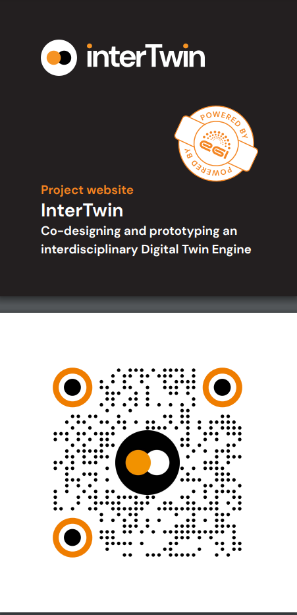
Figure 20 - Moo Card design

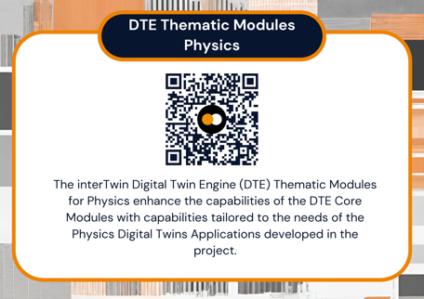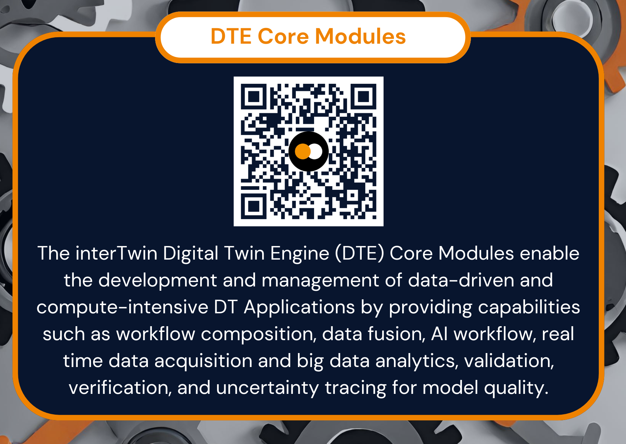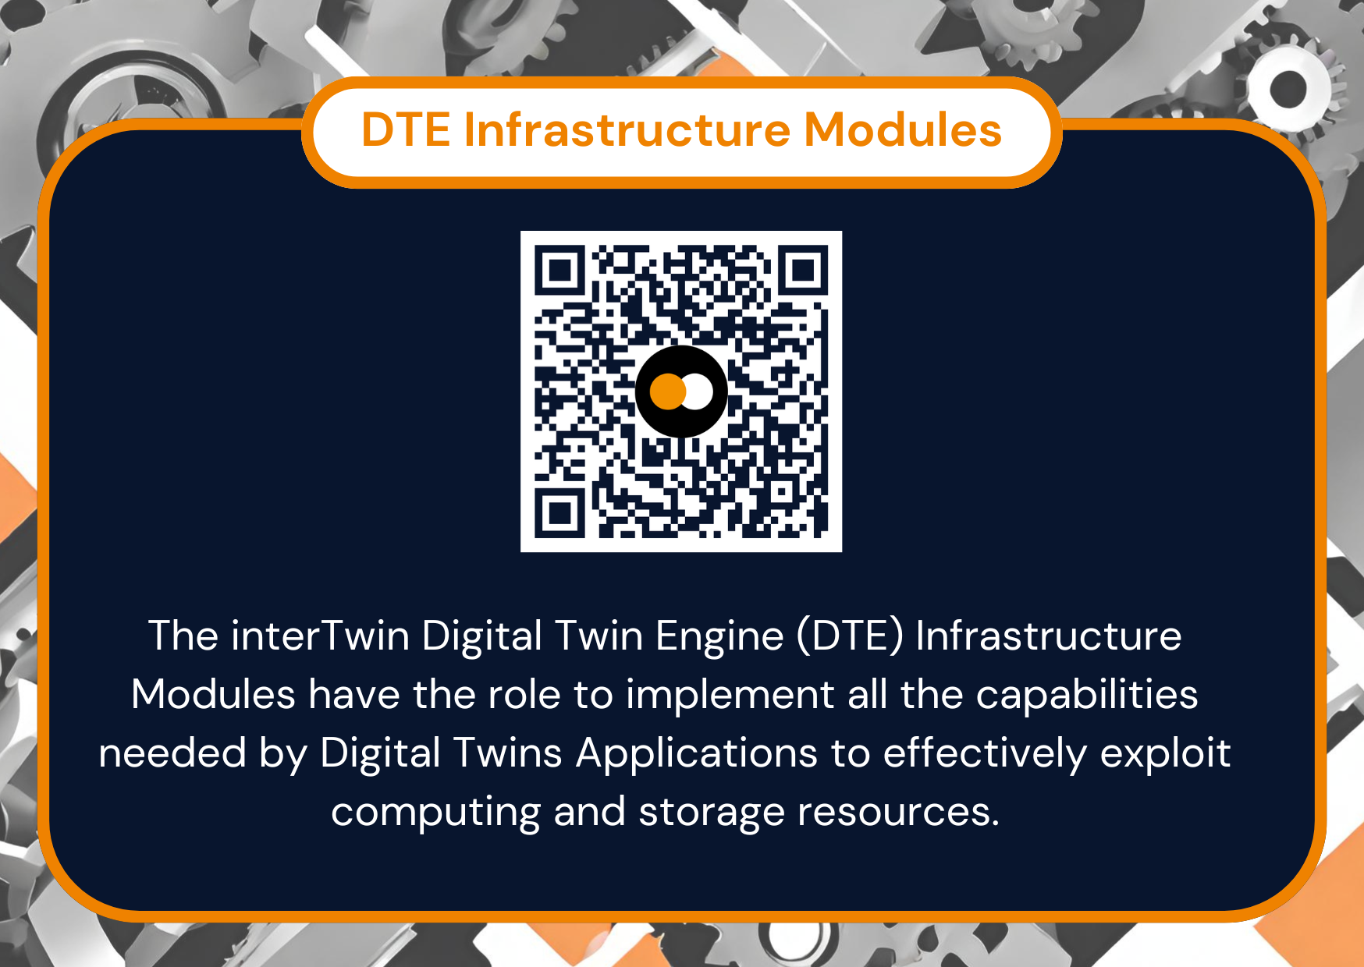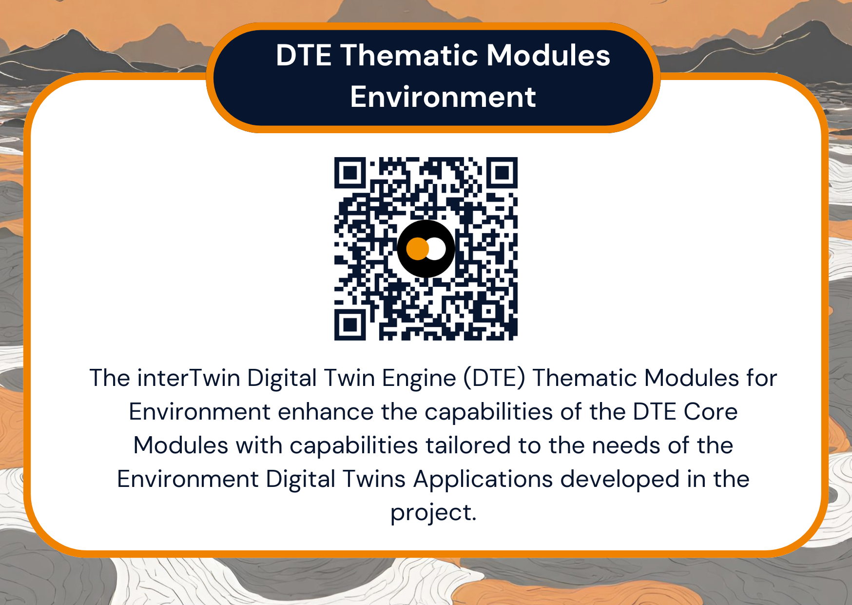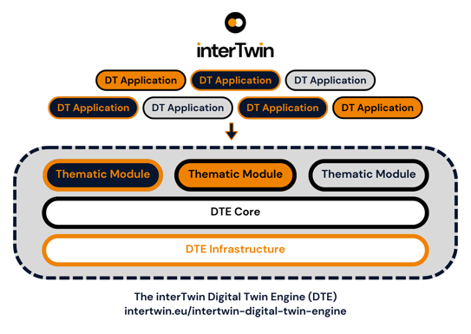
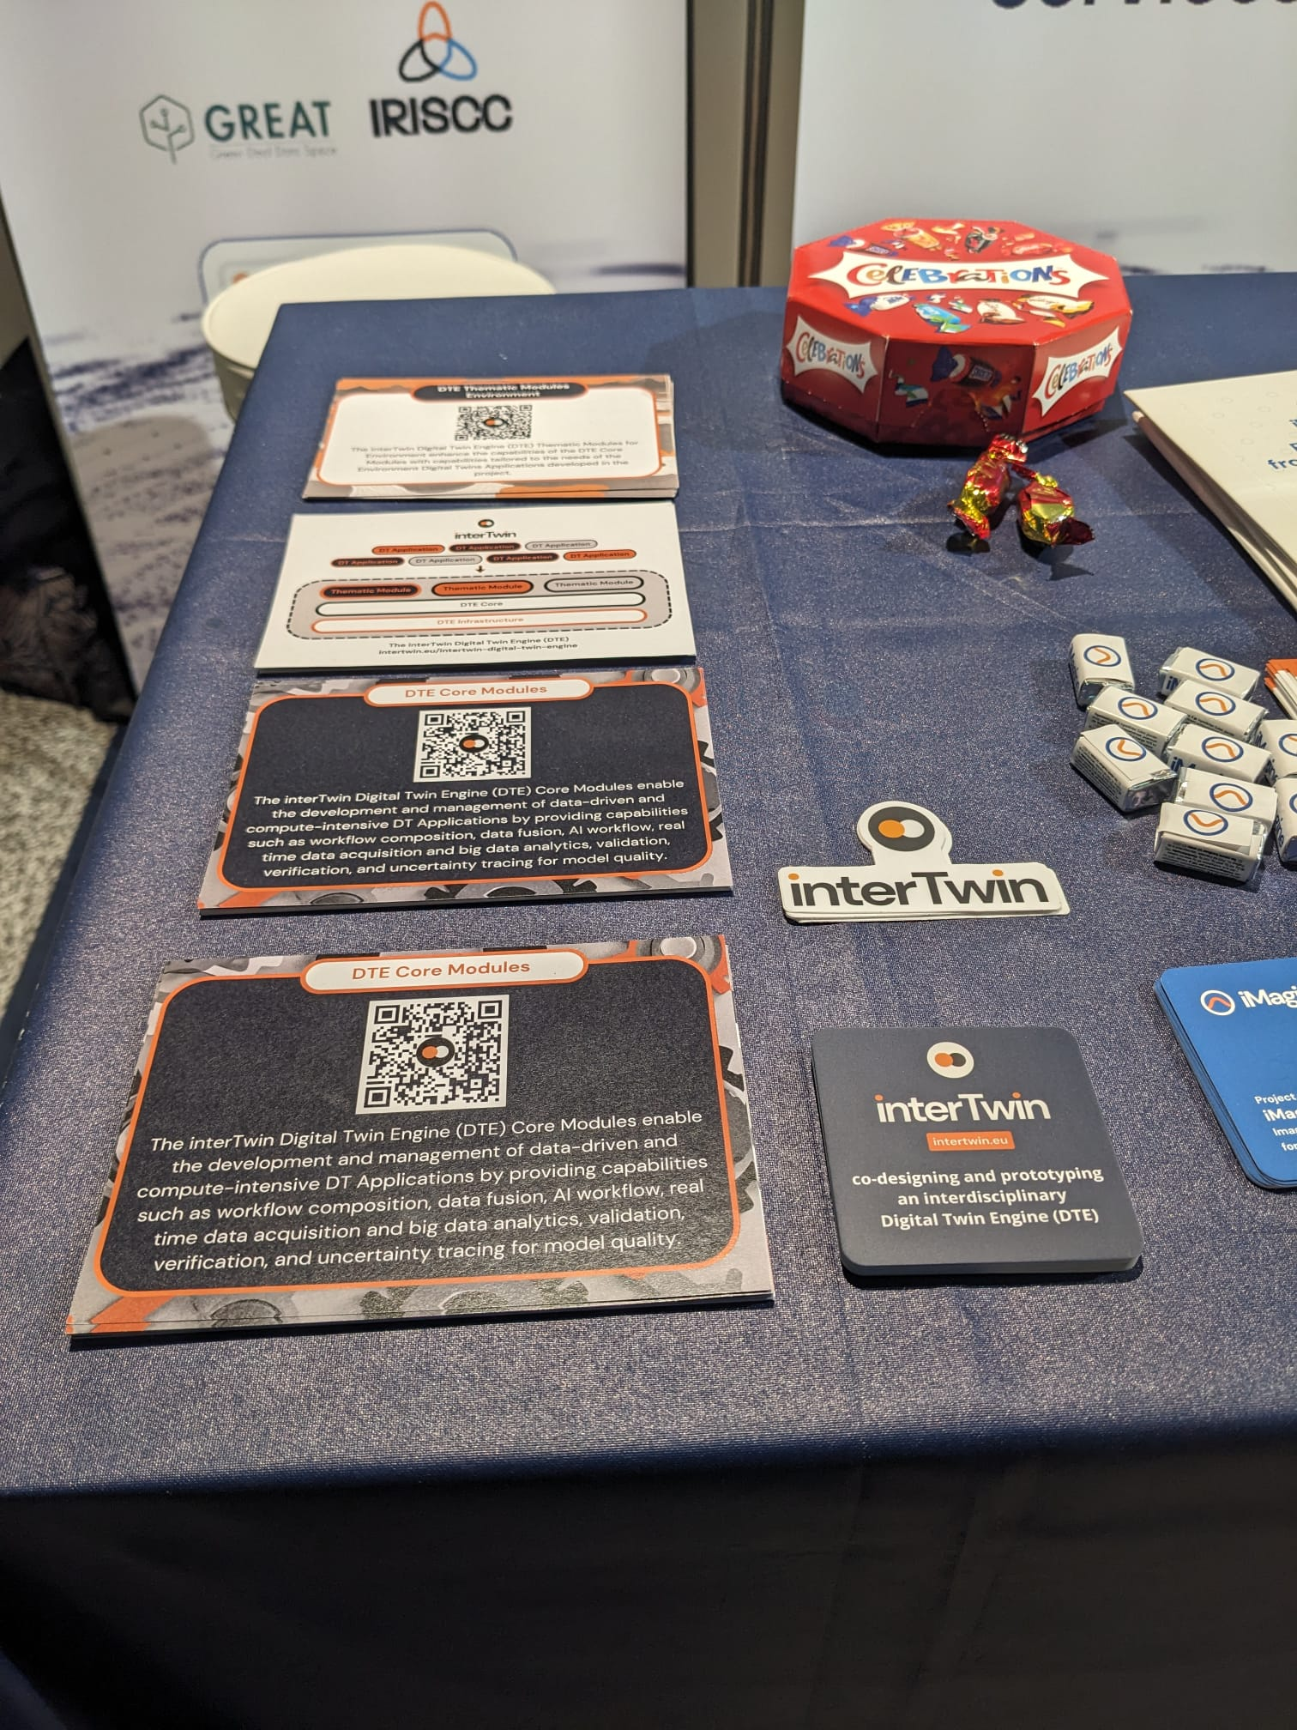
Figure 21 - Software Module Flyer developed for EGU2024

interTwin D2.1 Dissemination, Communication and Engagement Plan, https://www.intertwin.eu/intertwin-key-exploitable-results-kers/
interTwin D2.2 Innovation Management and Exploitation Plan, https://doi.org/10.5281/zenodo.10721988
interTwin Key Exploitable Results, https://www.intertwin.eu/intertwin-key-exploitable-results-kers/
Project Brandguide.
interTwin LinkedIn carousel post, https://www.linkedin.com/feed/update/urn:li:activity:7127946306353782784
Access to the confluence is restricted to the project consortium.
See Annex 2
A first version of this flyer has been tested at EGU2024, see Annex 2
Please note that ‘Reach’ is self-reported. In some cases, presentations take place at large events - in that case only an estimate of the participants in the session(s) where interTwin was presented and/or the event booth reach at the exhibition are given.
Please note that ‘Reach’ is self-reported. In some cases, presentations take place at large events - in that case only an estimate of the participants in the session(s) where interTwin was presented and/or the event booth reach at the exhibition are given.
Please note that ‘Reach’ is self-reported. In some cases, presentations take place at large events - in that case only an estimate of the participants in the session(s) where interTwin was presented and/or the event booth reach at the exhibition are given.

