EGI-InSPIRE

EGI-Repo: Release.xml for External Technology Providers

Document identifier: | input.doc
Date: | 25/02/2011
Activity: | SA2
Lead Partner: | EGI.eu
Document Status: | FINAL
Dissemination Level: | PUBLIC
Document Link:

Abstract
This document is a guide, which aims to provide all the necessary details to an External Technology Provider, for correctly constructing an EGI Repo release.xml file.

- Copyright notice
Copyright © Members of the EGI-InSPIRE Collaboration, 2010. See www.egi.eu for details of the EGI-InSPIRE project and the collaboration. EGI-InSPIRE (“European Grid Initiative: Integrated Sustainable Pan-European Infrastructure for Researchers in Europe”) is a project co-funded by the European Commission as an Integrated Infrastructure Initiative within the 7th Framework Programme. EGI-InSPIRE began in May 2010 and will run for 4 years. This work is licensed under the Creative Commons Attribution-Noncommercial 3.0 License. To view a copy of this license, visit http://creativecommons.org/licenses/by-nc/3.0/ or send a letter to Creative Commons, 171 Second Street, Suite 300, San Francisco, California, 94105, and USA. The work must be attributed by attaching the following reference to the copied elements: “Copyright © Members of the EGI-InSPIRE Collaboration, 2010. See www.egi.eu for details of the EGI-InSPIRE project and the collaboration”. Using this document in a way and/or for purposes not foreseen in the license, requires the prior written permission of the copyright holders. The information contained in this document represents the views of the copyright holders as of the date such views are published.
- Delivery Slip
 | Name | Partner/Activity | Date
From | <<The lead author/editor>>
Reviewed by | Moderator:  Reviewers:  <<To be completed by project office on submission to AMB/PMB>>
Approved by | AMB & PMB  <<To be completed by project office on submission to EC>>
- Document Log
Issue | Date | Comment | Author/Partner
1 | 25/2/2011 | First draft
2
3
- Application area
This document is a formal deliverable for the European Commission, applicable to all members of the EGI-InSPIRE project, beneficiaries and Joint Research Unit members, as well as its collaborating projects.
- Document amendment procedure
Amendments, comments and suggestions should be sent to the authors. The procedures documented in the EGI-InSPIRE “Document Management Procedure” will be followed:
https://wiki.egi.eu/wiki/Procedures
- Terminology
A complete project glossary is provided at the following page: http://www.egi.eu/about/glossary/.
<<The authors should check if the acronyms are covered by the glossary page and if the definition is still correct; all the amendments should be communicated to glossary@egi.eu>>
- PROJECT SUMMARY

To support science and innovation, a lasting operational model for e-Science is needed − both for coordinating the infrastructure and for delivering integrated services that cross national borders.

The EGI-InSPIRE project will support the transition from a project-based system to a sustainable pan-European e-Infrastructure, by supporting ‘grids’ of high-performance computing (HPC) and high-throughput computing (HTC) resources. EGI-InSPIRE will also be ideally placed to integrate new Distributed Computing Infrastructures (DCIs) such as clouds, supercomputing networks and desktop grids, to benefit user communities within the European Research Area.

EGI-InSPIRE will collect user requirements and provide support for the current and potential new user communities, for example within the ESFRI projects. Additional support will also be given to the current heavy users of the infrastructure, such as high energy physics, computational chemistry and life sciences, as they move their critical services and tools from a centralised support model to one driven by their own individual communities.

The objectives of the project are:

- The continued operation and expansion of today’s production infrastructure by transitioning to a governance model and operational infrastructure that can be increasingly sustained outside of specific project funding.
- The continued support of researchers within Europe and their international collaborators that are using the current production infrastructure.
- The support for current heavy users of the infrastructure in earth science, astronomy and astrophysics, fusion, computational chemistry and materials science technology, life sciences and high energy physics as they move to sustainable support models for their own communities.
- Interfaces that expand access to new user communities including new potential heavy users of the infrastructure from the ESFRI projects.
- Mechanisms to integrate existing infrastructure providers in Europe and around the world into the production infrastructure, so as to provide transparent access to all authorised users.
- Establish processes and procedures to allow the integration of new DCI technologies (e.g. clouds, volunteer desktop grids) and heterogeneous resources (e.g. HTC and HPC) into a seamless production infrastructure as they mature and demonstrate value to the EGI community.

The EGI community is a federation of independent national and community resource providers, whose resources support specific research communities and international collaborators both within Europe and worldwide. EGI.eu, coordinator of EGI-InSPIRE, brings together partner institutions established within the community to provide a set of essential human and technical services that enable secure integrated access to distributed resources on behalf of the community.

The production infrastructure supports Virtual Research Communities (VRCs) − structured international user communities − that are grouped into specific research domains. VRCs are formally represented within EGI at both a technical and strategic level.

TABLE OF CONTENTS
1 Introduction 7
2 EGI-REPO - External TP Relase XML 8
2.1 Section release:release 8
2.1.1 Section product:product 9
2.1.1.1 Section product:target 10
2.2 release.xml example 10
3 References 11

Introduction
This document provides necessary information as well as examples that will enable External Technology Providers (TPs) to compose a well-formed release.xml file to escort a software release bundle. An explanatory description of all the xml fields and attributes required is included in this document.

EGI-REPO - External TP Relase XML
The release.xml for External TP document provides vital information in order for the repository to process a new release. For a meaningful release.xml file to be formed, two major logical sections must be indentified:
(a) The general release section,
(b) The delivered product(s) specific section

Each of these sections is defined by an xml element with the appropriate fields. Paragraph 2.1 includes a detailed description of all the sections mentioned, whereas paragraph 2.2, provides one example of a valid release.xml file. A high level view of such an XML file is shown in the figure below.

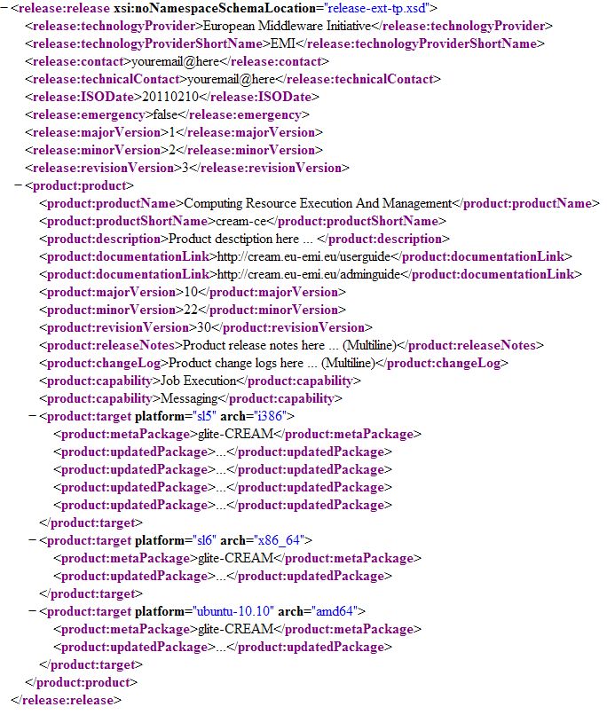

Note: All the elements/fields that appear in the release.xml file, should be declared following the specific order by which they are specified in paragraph 2.1.

Section release:release
The release:release section provides all the general details required for covering a new release submission to the EGI Repository. The point of interest for this section of the release.xml document is the general release and the TP related details, of the release that is to be submitted, such as the provider responsible, the version of the release and so on. However, the most important item that should be declared in this section is the ‘emergency’ one. With this value, the EGI Repo distinguishes between security based releases and the typical, hence, the security ones are handled with High Priority within the EGI workflow. A detailed description of all the fields included in this section can be found in the table below:

Element or Attribute (a:) | Type | Occurrence | Mandatory | Description
technologyProvider | String | 1 | Yes | Full canonical name of the Organization/Technology Provider that created the release
technologyProviderShortName | String | 1 | Yes | Common short name/acronym of the Technology Provider
contact | String | 1 | Yes | Email address of the main responsible contact person who has issued this release.xml instance. In most circumstances this will be the Release Manager.
technicalContact | String | 1 | Yes | The technical contact is the person who is responsible for the automation of the issuance of this release.xml or has technical knowledge on the structure of the release.xml document.
ISODate | ISODate | 1 | Yes | he date of the release in ISO format (YYYYMMDD)
emergency | Boolean | 1 | Yes | A Boolean value that indicates whether the release is an emergency one or not. Emergency Releases are dealt with the Highest Priority within the EGI workflow. In an Emergency Release only the updates of Products that were affected by a bug or security vulnerability should be included.
majorVersion | Number | 1 | Yes | The major version for the release (e.g for version someSoftware 3.2.1, 3)
minorVersion | Number | 1 | Yes | The minor version for the release (e.g for version someSoftware 3.2.1, 2)
revisionVersion | Number | 1 | Yes | The revision version for the release (e.g for version someSoftware 3.2.1, 1)
product:product | Complex | 1..N | Yes | The Product instance(s), describe the products that are released in the respective release by the TP.  For a major release, *all* Products that are part of this major release are expected to be listed here, that are part of the described major release.

Section product:product
A Product is a solution delivered by Technology Providers to EGI and provides the functionality for one, sometimes more Capabilities as one single, undividable unit. More details for the terms ‘prduct’, ‘capabilities’ etc. can be found at [R 1].
The product:product section provides info about the Product instance(s) that are released in the respective release by the TP. For instance, for a major release *all* Products that are part of this major release are expected to be listed here, that are part of the described major release.

Element or Attribute (a:) | Type | Occurrence | Mandatory | Description
productName | String | 1 | Yes | Full canonical name of the released product
productShortName | String | 1 | Yes | Common short name/acronym of the product
description | String | 1 | No | A short description of the product
documentationLink | String | 1..N | Yes | One or more links to documentation of this product release
majorVersion | Number | 1 | Yes | The major version for the product release (e.g for version someSoftware 3.2.1, 3)
minorVersion | Number | 1 | Yes | The minor version for the product release (e.g for version someSoftware 3.2.1, 2)
revisionVersion | Number | 1 | Yes | The revision version for the product release (e.g for version someSoftware 3.2.1, 1)
releaseNotes | Text | 1 | Yes | The release notes text of the product release
changeLog | Text | 1 | Yes | The change log text of the product release
capability | Enum | 1..N | No | Capabilities are optional, ** BUT HIGHLY ** recommended. It provides a list of the capabilites that this product implements, according to the UMD roadmap.  Used to create the association between products and capabilities.  The values for the Capability field will be an enumeration of normative terms taken from the UMD Roadmap. Each time the UMD Roadmap changes, so will the underlying XML schema
product:target | Complex | 1..N | Yes | Indicates in which plaforms and archs this product is available on. It also provides the list of metapackages & packages, that constitute this product on the said platform-arch pair.

Section product:target
The product:target section provides info about, in which platform and arch, the product release it is available on. It also provides the list of metapackages as well as the corresponding affected packages, that constitute this product on the said platform-arch pair. All the fields included in this section are fully described in the table below:

Element or Attribute (a:) |  | Type | Occurrence | Mandatory | Description
a: | platform | String | 1 | Yes | The platform under which, the product release it is available on.
a: | arch | Boolean | 1 | Yes | The arch under which, the product release it is available on.
metaPackage |  | String | 1..N | Yes | The technical metapackage(s) that fully describe the said Product-Platform-Arch triplet.
updatedPackage |  | String | 1..N | Yes | A list of packages that are updated in this Product-Platform-Arch triplet. Obviously, if this product release covers a new major release, a *complete* list of packages that comprise this Product-Platform-Arch triplet, it is expected here.

release.xml example
According to the description of the XML elements presented above, this paragraph includes one indicative release.xml document. [R 2] provides a simple, yet complete example. The data used are fake, although quite representative and meaningful.

References
R 1 | https://wiki.egi.eu/wiki/EGI_SA2_Glossary
R 2 | https://trac.hellasgrid.gr/trac/wp5-egi-inspire.egi.eu/browser/trunk/admin-repo.egi.eu/minimal-xml-parser/release-ext-tp.xml
R 3
R 4
R 5

