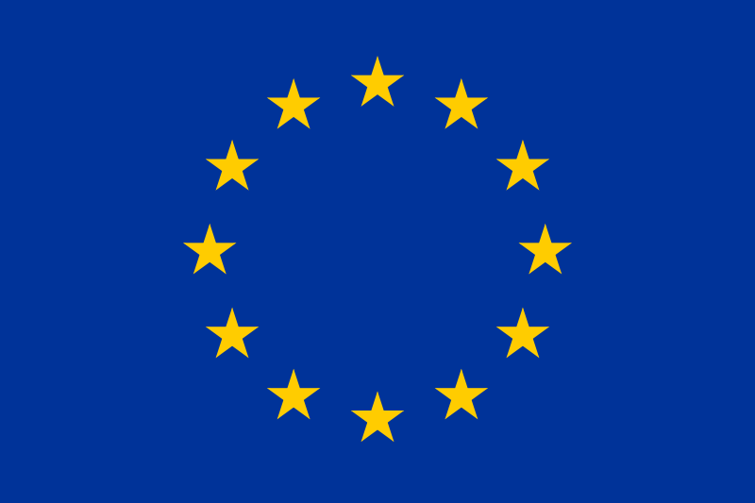
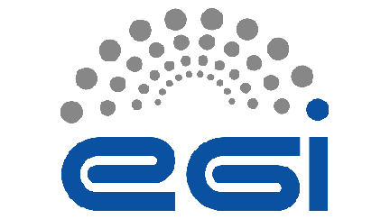
EGI / NGI Policy Session - Survey Analysis
EGI User Forum - 13 April 2011 - Vilnius, Lithuania

The EGI.eu Policy Development Team (PDT) conducted a survey with the National Grid Initiatives (NGIs) and European Intergovernmental Research Organisations (EIROs) participating in EGI. The goal of the survey was to directly engage the community and start a flow of communication regarding key policy issues, obtain updates on NGI legal and organisational status and understand the most pressing issues around sustainability moving into the future.
20 NGIs and EIROs responded to the survey, which has led to an analysis of the current state of play presented in this short report. This offers an opportunity for EGI.eu to understand key questions or concerns from an NGI/EIRO perspective as well as essential feedback for shaping the discussion of the dedicated policy session [R1].
NGI Policy Groups
EGI has set up a variety of policy groups covering key issues surrounding e-Infrastructures. Over 10 policy groups have now been formed through a definition of Terms of Reference defining purpose, composition and operational procedures covering key areas such as Security, Software and Operations. A Policy Development Process (PDP) [R2] was produced regulating how EGI policies and procedures are reviewed, approved and maintained. Thanks to the PDP, a list of valid policy and procedures is now available [R8].
The NGIs/EIROs reported that the vast majority (95%) are aware or somewhat aware when in comes to the EGI policy groups’ activities. The PDT will continue working hard to disseminate activities of EGI policy groups and to further encourage interested NGIs/EIROs to contact the relevant policy group and take part in their policy discussions through specific channels.
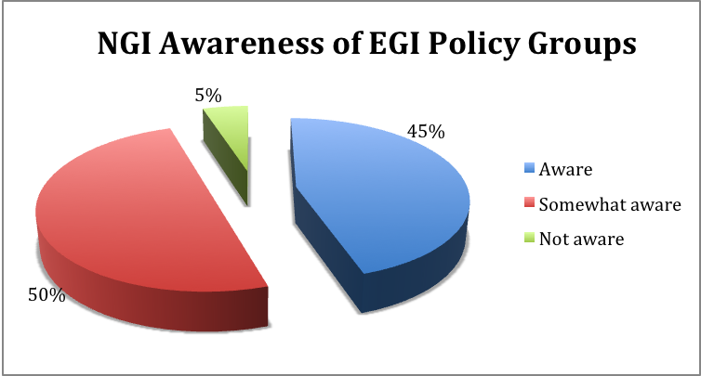
It is therefore also important to understand which groups have been set up within each NGI, commonalities and areas of potential collaboration. The majority of NGIs have at least 1 policy group with only a few smaller NGIs simply nominating a contact point for policy related issues. There are however several NGIs with multiple policy groups (65%). Outlined in the graph are topic specific policy groups that have been established throughout the NGIs, which also highlights the two most popular policy group areas - User & Community Support and Operations, with Security not far behind.
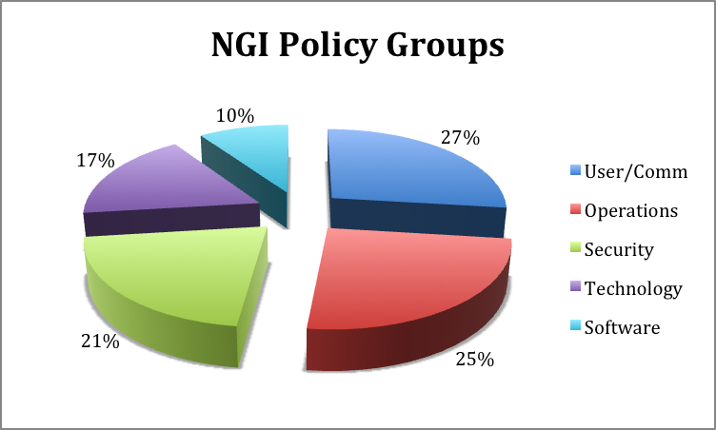
NGI Legal Status
More than half of the NGIs are not legal entities, though still part of EGI.eu through a legal representative, while 35% of the NGIs/EIROs are a legal entity. Only one NGI is represented by its funding body.
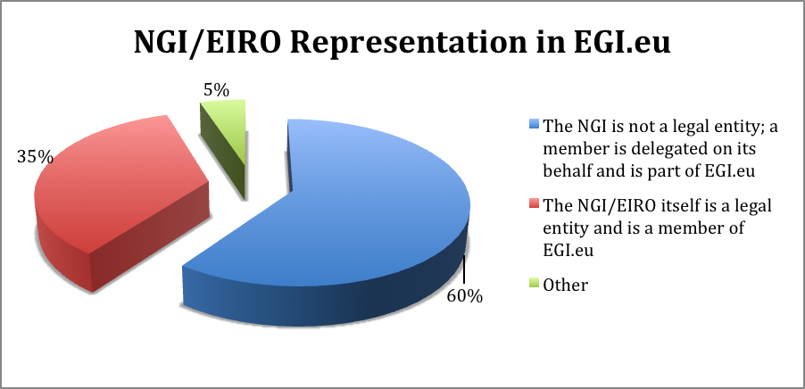
Partnering Up
The size of an NGI does not always represent a “mature” NGI, as some countries have fewer, but larger institutions involved. The largest percentage of NGIs have between 6-10 partners involved (40%), with 75% making of the majority between 1-10 partners.
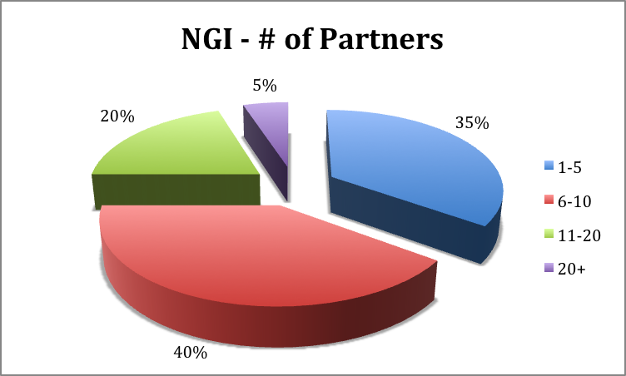
Costs
Coordinating and maintaining a quality infrastructure costs not only time and effort, but most importantly money. As the size of the NGIs increase, operational budgets are foreseen to increase as well. However, the common theme of economic difficulties throughout Europe put a significant emphasis on streamlining effort and reducing costs. Current budget estimates vary over the NGIs, which are outlined in the diagram below.
Overall, the total cost of delivering an integrated pan-European production infrastructure is estimated by the EGI-InSPIRE consortium as €335M over four years. The activity described in the project’s Description of Work [R9] relates to less than 25% of the total effort provided across Europe by its partners. The European Commission’s (EC) contribution of €25M is therefore less than 10% of the overall investment being made by the NGIs and EIROs.
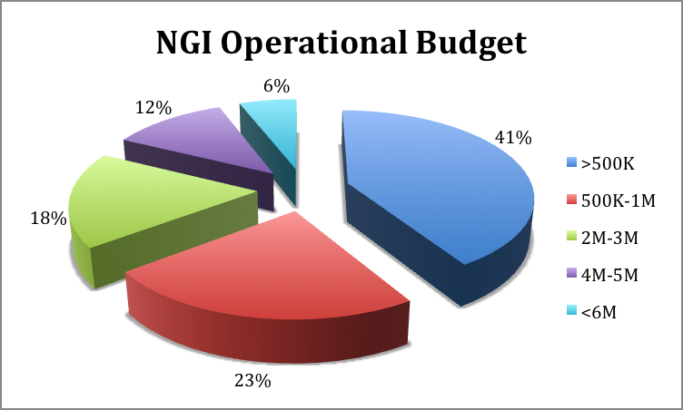
NGI Funding
It is evident that almost all of the NGIs/EIROs are funded at least partially by the European Commission, principally through the EGI-InSPIRE project and in some cases projects funded by European Cohesion funds. The second biggest funding source comes from national public funding (e.g. State, universities, research institutes) while only in 20% comes from membership fees. Additional funding comes from regional, various projects, and Member States in case of EIROs.
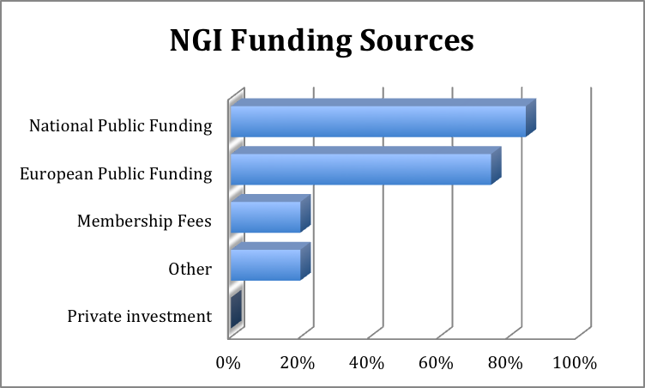
Half of the NGIs/EIROs have a guaranteed funding period for three or more years. On the other side, half of the NGIs funding is guaranteed only on a year-by-year basis or every two years, while for some of them the funding situation is unclear. In the most critical situations, some of the NGIs do not have a fixed budget and are only being funded on-demand for specific activities, or they have applied for national funding but still have not received an answer. It seems that in most cases, a sustainability funding scheme is still not defined and funding beyond 2014 is critical.
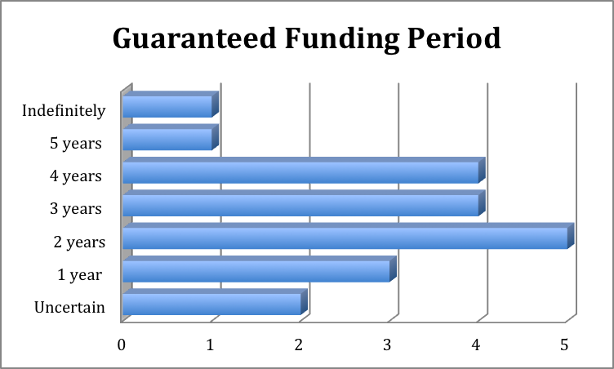
Tax Exemptions
An interesting aspect is NGIs and EIROs who are eligible to obtain tax exemptions for expenditures (e.g. purchasing equipment, staff), though actually very few have this benefit. This could potentially impact two key areas moving into the future. The first is through EGI’s sustainability plan for the integration of cost models and on-going discussions of the ERIC organisational model.
As EGI begins the integration of certain business models and necessary accounting tools, the possibility of using certain NGIs as a channel for purchasing equipment for the infrastructure will have to be investigated – considering the tax and ownership implications locally in the host country. These financial benefits are more suitable for organisations that purchase large quantities of goods and services for use in a few locations, such as CERN.
Under the ERIC model, there are few possible financial/tax benefits, which are potentially interesting, as the majority of NGIs are not eligible for tax exemptions: 1) Exemption from VAT; 2) Exemption from excise duties (depending on the type of ERIC model that could be agreed) [R6]. However, since most of the NGIs in the ERIC survey [R12] prefer a lightweight EGI ERIC (i.e. just a coordination role, without any direct responsibility over the equipment - i.e. the physical infrastructure), it is highly unlikely that EGI can be used as a tax exemption channel. This will be a key topic for discussion during the session, which includes an overview presentation.
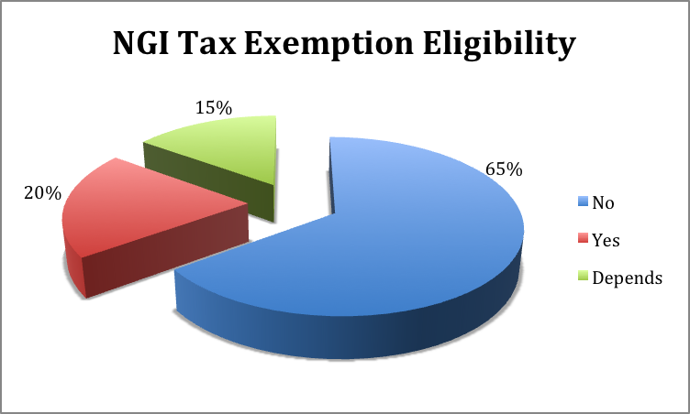

Government Relations
Most of the NGIs (60%) have a formalised relationship with their government, either through direct hierarchical subordination to the Ministry head, having a delegated responsibility from a Ministry or having a Ministry representative as a board member. On the other side, 40% of NGIs have an informal, indirect and looser relationship with their government (e.g. informal meetings with ministerial representatives, tenders).
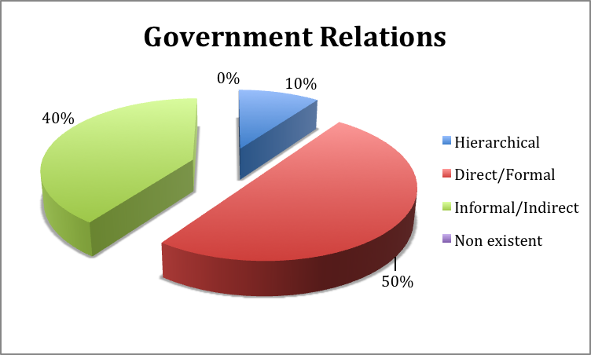
In most of the cases, cooperation with government has been evaluated as satisfactory (62%), however, despite the interaction with their government, a relevant number of NGIs had found their relationship with their government to be unsatisfactory. Some of the reasons stated were: difficulties to gain attention and visibility; further government investments required; no existing government programs to support NGI efforts.
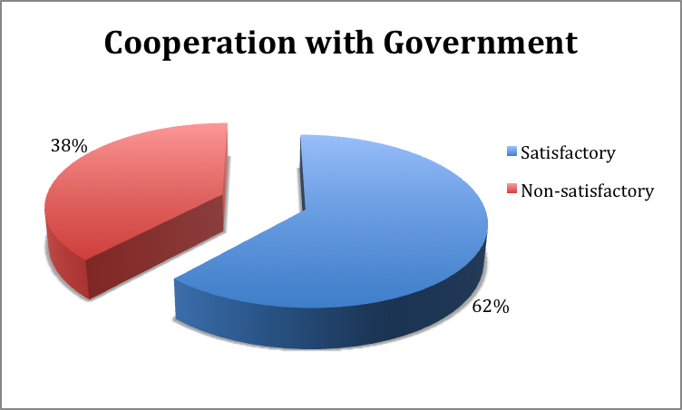
The vast majority of the NGIs do not enforce additional restrictions on the infrastructure in addition to EGI policies. However, few of the NGIs/EIROs have placed additional restrictions in order to support a specific set of VOs, software policies, and additional access restrictions.
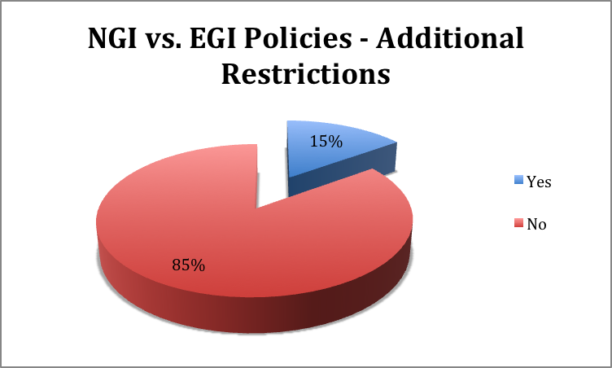

NGI Questions
Constant improvement can only be achieved when the voices of those involved are heard. In response to the requested survey, a number of NGIs voiced a number of questions or concerns regarding key topics from their perspective. Information regarding these points have either been included in the following sections, will be presented or will serve as the basis for discussion during the session.
How to better coordinate policy development?
As expected, several points resulted around policy related issues. A few NGIs expressed the need to coordinate and harmonise policies between EGI and NGIs around things like access to resources, a common approach by EU member state governments towards sustainability and how the use of middleware and tools can enforce national policies.
As a result, EGI understands that there is a need to better demonstrate or present the process of which the variety of actors can access resources and the necessary paths to take. In the same line, due to the complexities of information made available, efforts towards the simplification of how information is presented in terms of lists to policies, policy groups and overall added value of being an NGI / EGI member. For now, a current list of EGI policies can be found in a dedicated wiki page [R8].
What is the difference between VOs and VRCs?
The EGI ecosystem is in constant flux, comprising Service Providers, Technology Providers, Funding Bodies and most importantly, Users. The EGI User Community can be decomposed via two main interconnected types: Virtual Organisations (VOs) and Virtual Research Communities (VRCs). Being sometimes difficult to distinguish or define, EGI is currently working on clarifying these terms. A current definition is as follows.
A VO is a group of people (e.g. scientists, application developers) with common interests and requirements, which need to work collaboratively with other members of their collaboration and/or share resources (e.g. data, software, expertise, CPU, storage space) regardless of geographical location. They join a VO in order to gain access to resources with a set of rules and policies that govern the access and security rights for the users, resources and data in question. EGI currently hosts more than 200 VOs for communities with interests as diverse as Earth Sciences, Computer Sciences and Mathematics, Fusion, Life Sciences or High-Energy Physics.
A VRC is a group of large-scale scientific research collaborations, either covering multiple VOs or simply belong are part of a larger domain area. The VRC model allows a community to have bi-directional interactions through defined points of contact with EGI across broader domain areas.
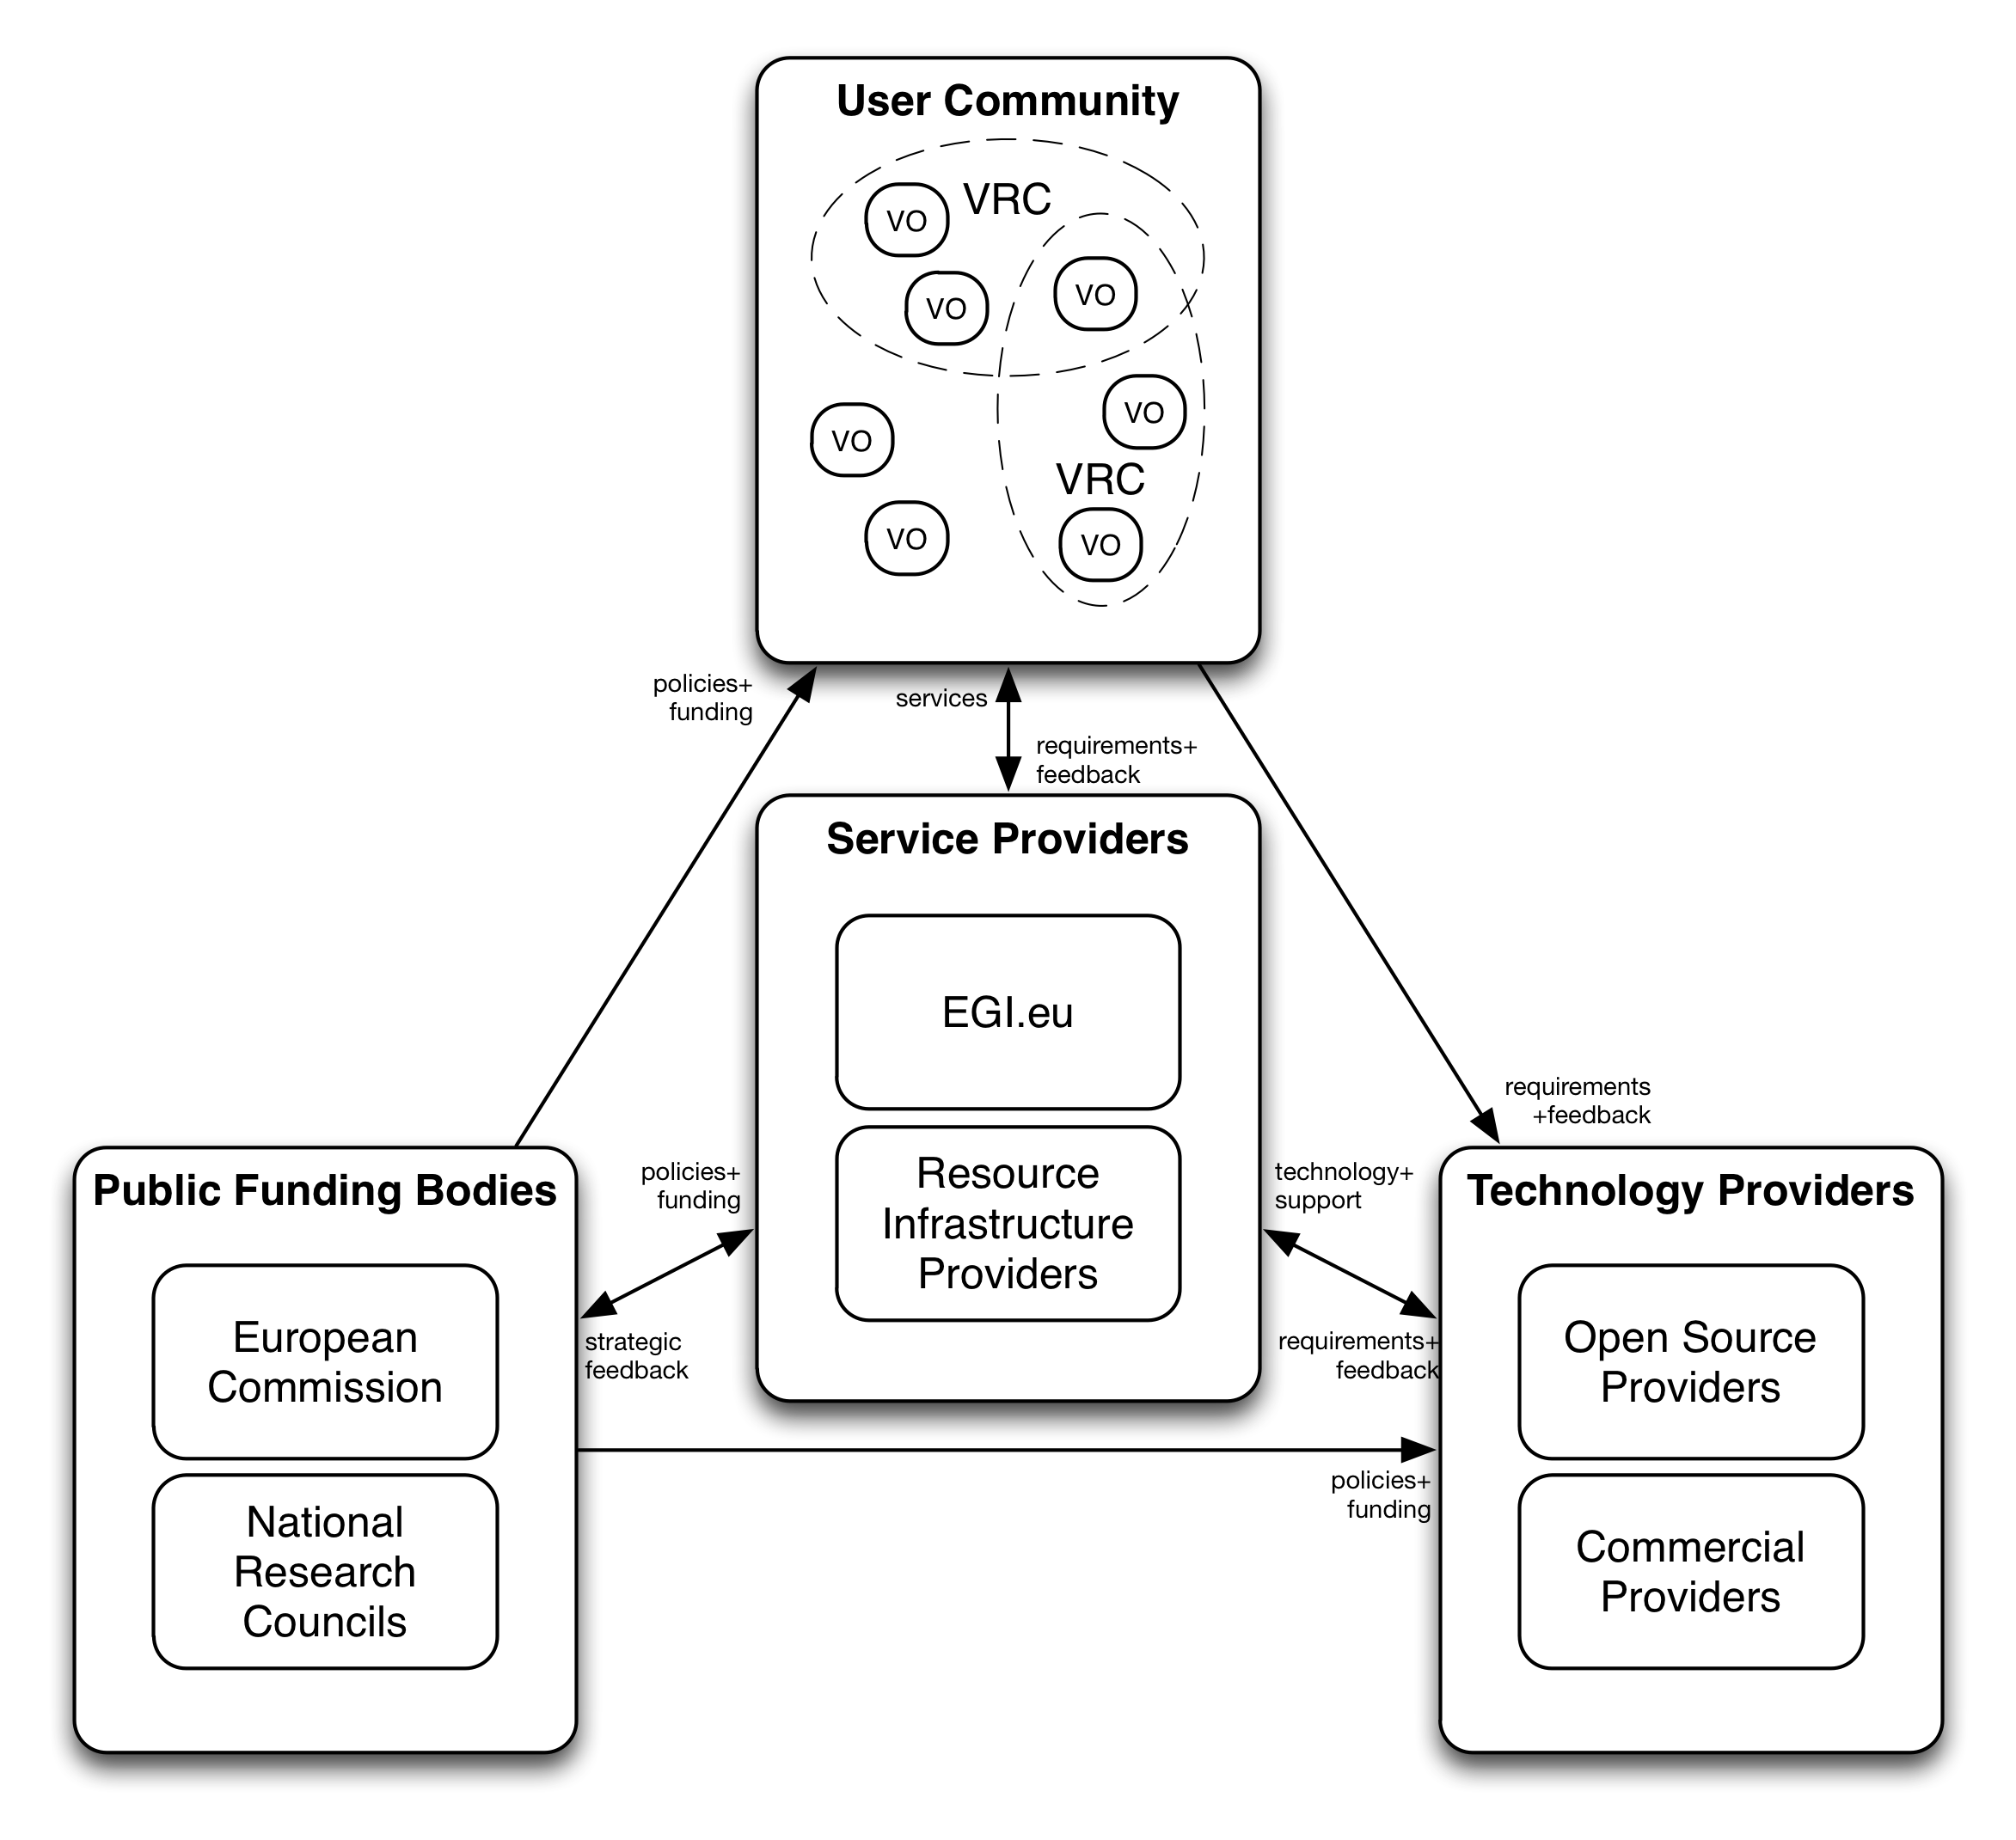
Options for commercial/industry engagement?
Engaging commercial or industrial entities is always an interesting topic. Common themes tend to arise around common policies for resource infrastructure providers towards vendors, overall collaboration for sources of revenue / income as well as leveraging academic and industry requirements. Over the last several years, efforts have gone into working with industry, which needs to be shaped around GEANT restrictions of commercial use.
Commercial organisations have the opportunity within EGI to be technology and service providers, but actual usage takes a different path. Commercial organisations are welcome to get involved with EGI via three principle methods: joint research or collaboration of mutual interest both technically and non-technically; usage of the infrastructure for pre-competitive research; running a proof-of-concept application.
Moving forward, we need to clearly identify and reference the policy with GEANT and compare to how things are done on an individual NGI basis through their NRENs.
How to evolve accounting for EGI usage?
As EGI moves towards implementation of specific business models, one of the key issues will be accounting for the usage/consumption of services provided by the EGI ecosystem. This touches on comments of accounting measures to eventually cover costs and redistribute revenue for services provided. The work plan within EGI-InSPIRE JRA1 already has effort allocated for improving the ability to account for the use of applications, data services, HPC resources and virtualised resources, and to add the ability to convert stored accounting records into bills.
A set of recommendations has been provided through the EGI Sustainability Plan report feeding into JRA1 year two activities that will define an action plan for related activities reported through a milestone report. Coordination between activities and project management will be essential in defining these activities and starting off the second year of the project in the right direction. Discussions will continue at key events such as a dedicated User Virtualisation Workshop in May 2011 [R10], the EGI Technical Forum and EGI Council meetings. EGI.eu will produce a short position paper by year’s end in order to communicate the progress on the analysis of EGI sustainability plans ensuring an open process with the community. All information and monitoring of activities will be officially reported in the next iteration of the sustainability plan next year.
How is EGI improving collaboration with external bodies?
Collaboration with EGI.eu is typically formalised through negotiating and signing a Memorandum of Understanding (MoU) with external partners such as technology providers (including commercial providers), resource infrastructure providers, virtual research communities, dissemination / coordination projects and international policy bodies.
The aim of formal partnerships is to strengthen the ability of the parties involved to mutually solve problems, benefit from the interchange of ideas and practices and strive towards a common goal. MoUs define these objectives and assign roles, responsibilities, communication methods, milestones and monitoring of achievements.
The PDT has currently agreed and signed two MoUs - European Middleware Initiative (EMI) and Initiative for Globus in Europe (IGE) - with several others in various stages of negotiations (e.g. StratusLab and SAGA – to be signed). In addition to driving internal EGI groups, EGI members also participate and contribute to a variety of external policy activities such as e-IRG, EUGridPMA, IPG, IGTF and OGF.
EGI.eu is keen to continue collaborative efforts with other groups as well such as ESFRI projects, EIROs and PRACE. EGI is already in touch with the following ESFRI projects, either directly or indirectly, to ascertain how we can be of assistance: Lifewatch, ELIXIR, CLARIN and DARIAH. CERN is one of the principle EIROs involved in EGI, but potential outreach efforts will be evaluated with organisations such as EFDA JET, EMBL, ESA, ESO, ESRF, European XFEL, and ILL. In addition to current collaborations with PRACE regarding the policy matters, the ERIC organisational model offers new opportunities as a combined e-Infrastructure ERIC in conjunction with PRACE, NRENs, and EU data providers is to be discussed.
How is EGI handling the issue of (Non) Proliferation?
This matter affects the overall distributed computing community, especially in terms of allowing or restricting access to specific countries. This topic has led to a discussion paper produced for the EGI Council at the User Forum. Further discussions will be led by the Council and implementation workshop may be foreseen once a set policy is agreed.
How is EGI committed to Interoperability?
Overall, EGI is committed to being technology neutral and to continuously listen to user community requirements. This is evident through the engagement with different technology providers supporting multiple middleware stacks currently being used by the EGI Resource Centres (gLite, ARC, UNICORE and Globus).
Reaching interoperability amongst organisations and technologies is a long-term activity, which requires reaching consensus through compromises and reworking/rebuilding systems or procedures according to them. Interoperability can be addressed at different levels leading to the identification of different interoperability types.
In the EGI Standards Roadmap [R7], we identified three main types of interoperability: 1) strategic, 2) operational and 3) technical. For each type of interoperability, proper actions should be taken in order to enable it. At the technical level, there are two main approaches: adapter-based and standards-based interoperability. The former envision that adapters between interacting parties are developed to translate the specific requests from the client side to the equivalent format and protocol on the service side. The latter envisions the definition of a common interface and message format as an open standard. In this case, the parties are expected to refactor or appropriately extend their systems in order to comply with the standard specification.
It is widely recognised that standardisation is one of the key facilitators for interoperability of networks, services and equipment. In particular, EGI focuses on open standards as they enhance users’ choice and their ability to scale-up the use of resources when required. They are then mapped into UMD capabilities via the UMD Roadmap [R11]. Standards and UMD Roadmaps represent the evolving path that will be updated and published on a regular basis, while being always open for contributions.
What are the integration plans with HPC and Cloud?
EGI is currently working to integrate Globus and UNICORE (frequently deployed on HPC clusters) into EGI's operational and monitoring infrastructure ensuring equal footing alongside gLite and ARC resources. There are task forces under way in UNICORE and through the collaboration with a taskforce that IGE is developing for Globus.
Integration of network, HTC/HPC and data security policies is an important concern. The EGI SPG has included members from PRACE/DEISA, though EGI policies cannot be forced upon them. Because of that the SPG has started the "Security for Collaborating Infrastructures" activity to discuss the preparation of Policy Standards to which we can all agree. This activity also includes the Open Science Grid, TeraGrid and WLCG.
Non-EU member countries are able to integrate with EGI via an infrastructure MoU. However, the infrastructure MoU states that a cost may be charged at some point in the future; meanwhile the individual costs of these services are currently being defined. If you are a member of EGI.eu, you are entitled to be part of the infrastructure. Otherwise an infrastructure MoU is needed.
Many communities are facing difficulties due to increased network bandwidth requirements for distributed high throughput computing. Such requirements can be met within GEANT with light paths and similar solutions, though potentially costly. While GEANT provides pan-European networking to all, during the EGI_DS, networking was an area that was assumed to come from outside EGI, provided by activities such as GEANT and their network of NRENs. A debate, including TERENA, on networking issues on a regional basis for economically viable solutions could be welcome.
Virtualisation and cloud computing have demonstrated how new technologies can enable dynamic execution environments or on-demand elastic service deployment with new, clear cost measurements and business models. As today’s ICT policies and services tailored to the current e-Infrastructure user communities do not always meet the needs of new communities, EGI needs to evolve to provide a more flexible, efficient e-Infrastructure in order to attract new users from all disciplines. Therefore, EGI.eu has produced a dedicated report designed to build the foundation for integrating virtualisation and cloud technologies into EGI to better address the evolving user needs [R4]. It analyses the technology benefits and issues, economic aspects of delivering such resources, with a short- and long-term view to identifying why, where and how these technologies have a place within the EGI. A more technical document regarding UMD activities is also underway, as well as formal engagement with cloud technology providers (i.e. StratusLab).
How can EGI improve documentation?
Producing a wide range of services for a dynamic user environment is a challenge in itself. This however is only useful when the documentation to run the services provides the users with the right information to do so. This is a time consuming process that the community has made attempts to make readily available.
Current feedback evolves around users and NGI members expressing confusion to the lack of VO documentation on EGI web pages or access point. In addition, others who are now installing all EGI services on new infrastructure by experienced sys admins are still experiencing researchers who must invest significant time and effort instead of following instructions, in turn creating a bottleneck.
This affects the overall coordination of activities, as the majority of tickets processed are not related to bugs, which is backed by an analysis of the DMSU. This analysis report, currently being produced, assesses the current situation and provides a set of recommendations for improving documentation, in turn, improving user satisfaction, and deceasing significant helpdesk effort for non-bug related issues.
Another related topic is high availability architectures of EGI services. Additional efforts in documentation should be created in order to help the NGI's create resilient architecture such as best practice/reference architecture. This is planned to be handled through a lightweight task force being organised, an action within the TCB.
How is EGI tackling future sustainability?
One of the biggest topics of discussions and most pressing issue is sustainability. Due to the interdependencies of the ecosystem and in order for EGI to function, it is paramount that the NGIs and, in turn, EGI.eu are sustainable. It is essential to understand how the individual NGIs are focusing on this area and what future trends EGI could foresee (e.g. increased usage of commercial providers; concentration of resource centres) and what effects this will have on EGI overall. The required flow of communication is the very reason for the survey and the organised session.
It is clear that public funding of all activities is coming under increased scrutiny in the current economic climate and dependency for maintenance and general operations is expected to decrease with each passing year. As coordinating and maintaining a high-quality infrastructure costs money, the focus in the EGI-DS and now EGI-InSPIRE projects has been to move towards ensuring sustainability, therefore transferring recurring operational costs to the communities that benefit from it is the logical next step.
As NGIs provide services to resource centres within a single country, public funding models are very common. Passing these costs onto particular centres or communities through a subscription model is not seen as viable, but usage costs could be passed on to the relevant consumer (e.g. via their institution).
Users (or their NGIs or institutions) will eventually need to pay in some form or another for the resources they currently use for ‘free’. As the community shifts to a more service oriented model, the pressure on the providers to ensure that the services offer ‘value for money’ will certainly increase, as will the community’s ability to compare costs to commercial cloud providers and evaluate the value that e-Infrastructures provide. The revenue gained from charging for service use will make it easier for those services to be maintained sustainably, and for user communities to focus on research rather than being involved in running the services they use. Opportunities will also arise for the community members to provide the necessary services as well.
The EGI Sustainability Plan [R3] has provided a comprehensive list of the wide range of services that the EGI provides and has taken a proactive approach in defining potential business models in order to sustain these services. A preliminary assessment of which services could be supported by a particular business model was made, providing a means to structure and direct future discussions and dedicated activities with JRA1 previously mentioned. This will take place through consultative workshops amongst the stakeholders in the months to come in order to assess the true viability of the different services to different business models using this taxonomy. To enable such discussion, a list of services that could be supported by usage-based business models, but where usage measurements are not currently available, were identified as a priority for future development.
For any suggestions, questions or comments, please contact the EGI.eu Policy Development Team at policy@egi.eu
Many public funding bodies are seeing e-Infrastructures as way to drive innovation and economic growth nationally and across Europe, and do so in a way that is sustainable for the long-term. Although no new funding sources are likely to emerge in the immediate future, the distribution of costs amongst the stakeholders in the EGI ecosystem to better reflect usage is one short-term change that can start to take place.
Summary
It has been an exciting first year with the establishment of EGI.eu and the start of the EGI-InSPIRE project. The EGI.eu Policy Development Team (PDT) has been hard at work achieving a number of results. In addition to establishing policy groups, key strategic reports have been produced and published such as the EGI Sustainability Plan, Integration of Virtualisation & Cloud into EGI, the EGI Role within the Europe 2020 Strategy, Suitability of ERIC Legal Framework for EGI.eu and a Standards Roadmap [R3-7]. In addition, the EGI website has been extended with dedicated policy pages [R8] and wiki pages for providing relevant information to the community.
As the first year of EGI was devoted to establishing the global policy framework, this survey served as a step forwards, reinforcing the connection with NGIs/EIROs regarding policy matters. The outcome of the policy session will help to tackle some of the key issues moving into the future.
References
- EGI UF Policy Session
http://go.egi.eu/policy-session-egiuf2011
- Policy Development Process https://documents.egi.eu/document/169
- EGI Sustainability Plan https://documents.egi.eu/document/313
- Integration of Clouds and Virtualisation into EGI https://documents.egi.eu/document/258
- EGI Role within the Europe2020 Strategy https://documents.egi.eu/document/317
- Suitability of ERIC Legal Framework for EGI.eu https://documents.egi.eu/document/244
- EGI Standards Roadmap https://documents.egi.eu/document/206
- EGI Website Policy Page
http://www.egi.eu/policy/
- EGI-InSPIRE Description of Work https://documents.egi.eu/document/10
- EGI User Virtualisation Workshop http://go.egi.eu/uvw1
- UMD Roadmap https://documents.egi.eu/document/272
- ERIC survey

