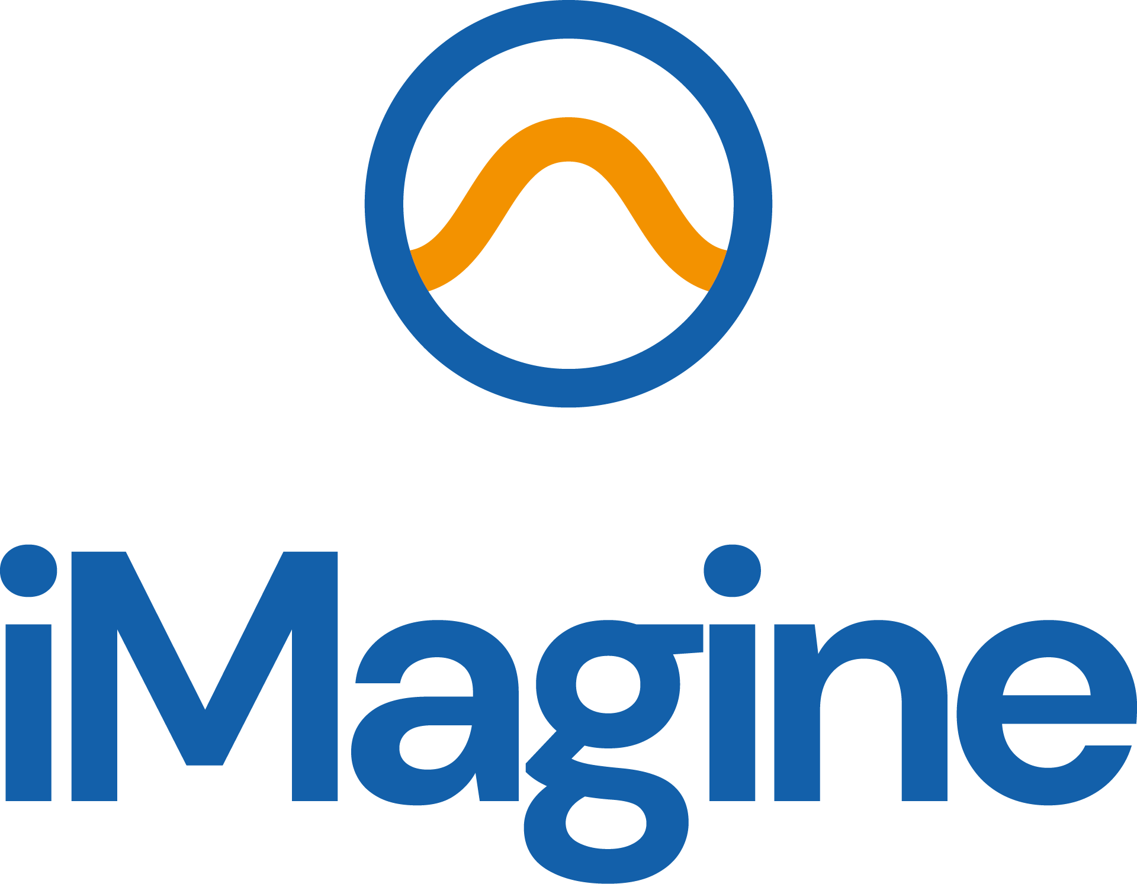

Communication, Dissemination and Engagement Updated Plan
iMagine Deliverable D2.4

30/04/2024

Abstract
This deliverable provides an update to the previous deliverable offering an overview on how project results, developments and branding will be communicated. Moreover, a plan for the engagement with the targeted audiences, a dissemination strategy, the description of promotion, outreach, training, and co-design activities are presented in the document along with a dissemination plan.

Document Description
D2.4 Communication, Dissemination and Engagement Updated Plan
Work Package number 2
Due date | 30/04/2024 | Actual delivery date: | 14/05/2024
Nature of document | Report | Version | 1
Dissemination level | Public
Lead Partner | EGI
Authors | Ilaria Fava (EGI)
Reviewers | Smitesh Jain (EGI), Hien Bui (EGI)
Public link | https://doi.org/10.5281/zenodo.11192926
Keywords | Communication, dissemination, engagement, target groups, impact

Revision History
Issue | Item | Comments | Author/Reviewer
V 0.1 | Draft version | Early draft | Ilaria Fava (EGI)
V 0.2 | First Draft | First version for review | Ilaria Fava (EGI)
V 0.3 | Review | Feedback from the reviewers | Smitesh Jain (EGI)  Hien Bui (EGI)
V0.4 | Revised version based on comments |  | Ilaria Fava (EGI)
V 1.0 | Final

Copyright and license info
This material by Parties of the iMagine Consortium is licensed under a Creative Commons Attribution 4.0 International License.

Table of content
Document Description 2
Table of content 4
Figures 5
Tables 5
Introduction 6
Structure of the document 6
Purpose of the Dissemination, Communication and Engagement plan and the interim progress report 6
Overview of the activities 7
Branding 8
Website 8
Social media 8
Events 9
Exhibition Booths and Events 9
Project presentations 9
Internal workshops 10
Webinars 11
Zenodo 11
Summary of dissemination outputs 11
KPIs for communication and dissemination 12
Collaborations and partnerships 14
EOSC Landscape 14
Aquatic and Environmental projects and RIs 14
Identified challenges 14
Engagement 15
Target Audiences 15
Specific measures per target group 16
Users 16
Similar AI Initiatives 17
Plan M19-M36 18
Annex 20

Figures
Figure 1 - Website visits 8
Figure 2 - Igor Atake presenting the first outcomes of UC4 at EGU24 10
Figure 3 - SEAM further described in D2.5 15
Figure 4 - Project logo variations 20
Figure 5 - Examples of Open Call dissemination visuals 20
Figure 6 - Project Moo Card 21
Figure 7 -Project Leaflet 21
Figure 8 -One of the posters prepared for iMagine 22

Tables
Table 1 - Project Internal workshops 10
Table 2 -Overview of the dissemination outputs 11
Table 3 - Status of KPIs at M18 12

Introduction
The iMagine project aims to deploy, operate, validate, and promote a dedicated iMagine AI framework and platform. The project also develops and delivers five operational and three prototype AI-based image analysis services with image repositories with open access for researchers' exploitation. The project also supports three additional use cases onboarded through a project open call that ran in 2023.
The services on which the use cases are working are currently in the development phase; they will be promoted to their respective users when they are operational on the iMagine AI platform during the second and third years of the project. Therefore, the following plan provides detailed initiatives for the project to continue to achieve this goal.

Structure of the document
- Results and achievements of the first reporting period
- An overview of the activities carried on during the previous period
- Target audiences and the targeted Engagement strategies
- Plans for M19-36

Purpose of the Dissemination, Communication and Engagement plan and the interim progress report
iMagine has the objective to deploy, operate, validate, and promote a dedicated iMagine AI framework and platform connected to EOSC and AI4EU, giving researchers in aquatic sciences open access to a diverse portfolio of AI-based image analysis services and image repositories from multiple RIs, working on and of relevance to the overarching theme of ‘Healthy oceans, seas, coastal and inland waters’.
Within the project, the main objectives of WP2 are to ensure that project results are captured, disseminated, and exploited for maximum impact, to manage both internal and external communication and dissemination, to liaise with stakeholders, and to organise project events and support participation at external events. T2.2 aligns closely with the activities in T2.1 (Innovation Management and Exploitation) as outlined in the D2.2 Innovation Management Plan and D2.5 Innovation Management Progress Report (in preparation). As part of WP2 (Innovation Management and Communications), T2.2 (led by EGI.eu) deals with iMagine Communication, Dissemination and Engagement activities.
The project has identified eight Key Exploitable Results (KER), which are at the core of the DCE strategy:

- Marine litter assessment
- Zooscan – Ecotaxa Pipeline
- Marine Ecosystem Monitoring
- Oil Spill Detection
- Flowcam Plankton Identification
- Prototype Imaging Services
- The iMagine AI Platform
- Best practices
The core activities of T2.2 focus on disseminating these KERs to the various target audiences. For this purpose, the activities are mapped to the stakeholder analysis.
This deliverable updates D2.1, in which the overall plan for these activities was laid out, mapped to target audiences, set against a timeline, and matched with suitable indicators for success. T2.2 worked on an overall plan to provide indications on how project results, developments, and branding will be communicated, how iMagine intends to engage with stakeholders, a clear dissemination strategy, and the description of promotion, consultancy, outreach, training, and co-design activities, in addition to a dissemination plan to be updated in the next deliverable release. This deliverable also reports on the period M1-M18 and will lay out the plans for M19-M36 (which will be reported in the final T2.2 deliverable D2.5).
The objectives of the iMagine DCE plan are three-fold:
- Increase Awareness: Raise awareness about the iMagine project and its services among all the relevant target audiences in the aquatic science community.
- User Acquisition: Attract the users of the services to engage with iMagine.
- Collaboration: Foster partnerships and collaborations with relevant organisations and research institutes.

Overview of the activities
After creating the brand identity, T2.2 took care of the website's launch, content creation, and continuous maintenance. Both brand identity and website launch were achieved ahead of schedule in M3. The website includes (at M18) different sections featuring the project team and governance overview, the KERs, the use cases, available results (such as the iMagine AI Platform and Tips for AI processing) and links to project outputs (deliverables, presentations, publications).

Branding
At the start of the project, a large part of the iMagine visual identity i.e. the logo, branding elements and document/presentation templates, were developed quickly and distributed amongst partners via the Communications Toolkit (available for partners on Confluence) and the Project Brandguide. Various promotional materials such as a calling card with the website QR code, a flyer, a sticker, a video animation, USB cables, sustainable goodies and a general use poster were also developed. For extended documentation about the iMagine branding, see D2.1.
From M6 onwards, as the first project outputs were delivered, the communication tools and processes were fine-tuned. Partners have developed their posters, combining their branding with the project’s (or supported by EGI as task leader if needed). The website is used as a channel to disseminate information about published deliverables (in the form of news items), and partners deliver presentations about their contributions to the project using the iMagine presentation template.
For the second half of the project, the project will create pintables to showcase the services and short videos showcasing each project KER.

Website
The project website, accessible at imagine-ai.eu, was set up immediately, allowing for quick communication of the project's essential information, such as contact details, team and governance, and overall project goals. The section about results and resources, lists, and links provides all publicly available deliverables, presentations, and any other materials created by project partners.
The plan for M19-M36 is to implement the service section, add the use cases onboarded with the open call iterations, and increase the number of news items about these elements.

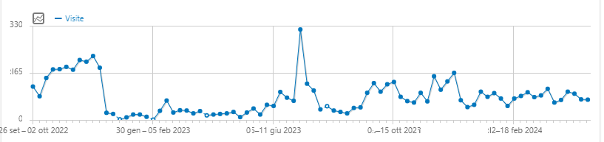
Figure 1 - Website visits
The website analytics show that the most visited pages are the use case pages overall, the page about the iMagine AI Platform, and the call for use cases.

Social media
The project's LinkedIn page, which has over 100 followers, has shown a consistent engagement rating of 5.5% and 7.5%, aligning with similar pages' results (such as Blue-Cloud 2026). Special attention has been paid to creating posts for events where the project was showcased. In the period M19-M36, an effort will be put into creating ‘LinkedIn-friendly’ visuals such as ‘carrousels’ to increase engagement for complex content (e.g. the use cases and the related services). As the project progresses, partners will be encouraged to become habitual in tagging iMagine on LinkedIn for their project-related posts.
X/Twitter remains active but with less investment due to the instability of the social media channel.

Events

Exhibition Booths and Events
From the start, iMagine has been present at every event booth hosted by the project coordinator - EGI. M1-M12 focused on awareness raising. Assisted by a striking branding that stands out, the project dissemination materials attracted attention and instigated many conversations at the respective booths. Working in collaboration with the other EGI coordinated projects (such as interTwin and EGI-ACE) has allowed iMagine to reach audiences that are not necessarily familiar with the concept of aquatic science and technology applied to it (such as EOSC Symposium), or with secondary target audiences (such as businesses during Data Spaces Symposium).
While M1-12 mainly focused on setting up the basic channels and tools, from M13 onwards, the strategy shifted towards differentiation and participation in more domain-specific events. These include the IMDIS conference and EGU (environmental sciences), where iMagine co-hosted an exhibition booth in M19 and where more activities are planned for Y3. An internal workshop with the use cases has also presented additional events where the project could find dissemination venues in Y3.

Project presentations
Partners reported 15 events at which iMagine was presented once or multiple times. The presentations and respective events are listed on the project’s website.
Additionally, excluding the visitors at the exhibitions and the participation in larger events (such as EGU23, ISC23 and EGU24, where the potential attendees number spans from 2,500 to 20,000 participants), self-reporting from the partners let us estimate a reach of over 880 attendees.
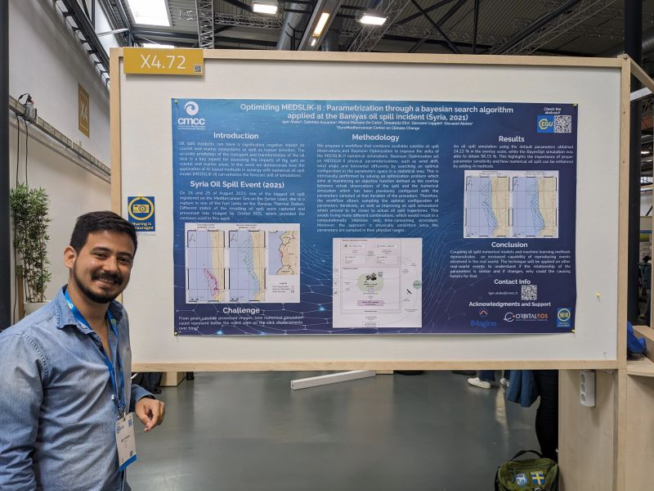
Figure 2 - Igor Atake presenting the first outcomes of UC4 at EGU24

Internal workshops
iMagine hosted the following internal workshops and meetings in the first half of the project:
Table 1 - Project Internal workshops
Date | Topic | Link
14/09/2022 | iMagine administrative kick-off meeting (online) | https://indico.egi.eu/event/5919/
22/09/2023 | iMagine technical kick-off meeting | https://indico.egi.eu/event/5920/
30-31/01/2023 | iMagine First Competence Centre workshop | https://indico.egi.eu/event/5999/
29/09/2023 | Use case Dissemination and Communication Support | https://app.mural.co/t/egi3550/m/egi3550/1695966032458/dd143e781759c7c8b897d667355a638fca3fa6cb?sender=u297868c2869ea72cbfe74783
11/10/2023 | iMagine General Assembly and Project Management Board | https://indico.egi.eu/event/6264/
19-20/03/2024 | iMagine Second Competence Centre Workshop | https://indico.egi.eu/event/6371/

Webinars
The project hosted a webinar on the AI platform for its users on 15/12/2022. For M19-36, T2.2 plans to organise additional webinars with mature use cases and AI experts. In addition to the above, T2.2 organised FiTSM training during the EGI2023 Conference. Additional training is foreseen for Y3, allowing all service owners to deliver their services effectively.

Zenodo
Since its beginning, the project has established a community on Zenodo to showcase iMagine outputs. T2.2 helps the collection and deposit process of the presentations given by partners. Deliverables are also collected in the community. Overall, all documents available in the Zenodo community have received over 920 downloads.
In March 2024, iMagine was selected to participate in the pilot of the HORIZON-ZEN project. As iMagine has started using Zenodo as the repository for all training datasets produced by the project's use cases, being part of this pilot project will allow iMagine customising all metadata fields to best match the aquatic science community's needs. This way, all datasets already available on SEANOE, the open scientific data repository in the marine sciences field, could be cross-referenced on Zenodo for more completeness.
In addition to Zenodo, relevant datasets have been submitted for consideration to the Global Climate Observing System’s Essential Climate Variables. Moreover, iMagine deliverables on best practices are under evaluation for inclusion in the Ocean Best Practices repository.

Summary of dissemination outputs
Table 2 offers a review of planned T2.2 activities, as described in D2.1, during M1-M18.
Table 2 -Overview of the dissemination outputs
Description | Delivered | Comment
Website |  | Website published and regularly updated, see Website
Communications toolkit |  | M3, continuously updated
Social media accounts |  | LinkedIn published and regularly updated, see Social Media
Kick-off meeting |  | Organised at EGI22, see Internal Workshops
Event participation |  | Partners presented iMagine at 15 events, project present at 5 exhibition booths
Repository for publications |  | See Zenodo
Project Branding |  | Branding guide delivered
Dissemination, Communication and Engagement Plan |  | Delivered with D2.1 in M5
Visual Materials |  | See D2.1
Support in event organisation |  | Support to the organisation of the First and Second Competence Centre Workshops (M4.2, M4.4)
Not planned activities:
- Launch of the project Open Call for Use Cases, two iterations, three use cases selected.

KPIs for communication and dissemination
Table 3 - Status of KPIs at M18
Measure description | M18 status | Comments
# Page visits | ~500 per month | Steady number of visits to the website since October 2022 with peaks around the open call campaigns and events
# engagement rate on social media | 4% | average
#deliverable views and downloads (Zenodo) | 921 downloads  1,051 views
News items | 24 news items
# Clicks on project-related content in the EGI newsletter | Avg 4.2% | The open call news was published twice in the EGI newsletter, receiving around 500 clicks (note that the EGI newsletter has over 3,200 subscribers)
# attendees during  presentations at events | Over 880 participants | The number doesn’t consider the participation in larger events such as EGU23 and ISC23 conferences, where the potential attendees to the presentations are over 2500 participants
Use Cases | 11 use cases | The open call helped to onboard 3 new use cases
Visual Materials | - The project logo in different variations  - The project colours and instructions on how to use them  - A moo cards  - A sticker  - Roll-up banner and variations  - Project posters variations  - Zoom backgrounds  - Social media banners  - Document templates  - A general presentation of the project | All visual materials are available to partners from the Communications Toolkit on Confluence. Moreover, EGI has helped partners customise the templates for specific partner events.
Rather than focusing on absolute numbers for reporting social media activities, the project is basing its social media ‘successes’ on two parameters: regularity (all relevant content advertised) and audience engagement rate (benchmarked against other, similar accounts).

Collaborations and partnerships

EOSC Landscape
Following the recommendations from the project review and leveraging the connections in place thanks to the project partners, iMagine has strengthened its relationship with AI and aquatic science-related projects to make the most out of the collaboration with them. In particular, the project collaborated with AI4EOSC and AI4Europe (now AIoD) in the organisation of AI and ML sessions during the EGI2022 and EGI2023 conferences. iMagine use cases have also been showcased in the webinar series organised by ANERIS and AI4EOSC.

Aquatic and Environmental projects and RIs
Moreover, the project established a stronger partnership with Blue-Cloud 2026, together with which it organised the satellite event “The Data We Need for the Ocean We Care For” during the Ocean Decade Conference 2024 and will participate in the EU Maritime Day with a workshop on “Observations to knowledge: Unlocking Ocean Insights”.
Last but not least, the project has collaborated with several environmental landscape projects by participating in an ENVRI cross-collaboration network started by the newly launched ENVRI-Hub NEXT. These projects are IRISCC, ENVRI-Hub NEXT, ENVRINNOV, and Blue-Cloud, and the network has expanded to an additional 10 projects.
A session on unlocking the potential of environmental data is planned at EGI2024.

Identified challenges
Identifying the appropriate press outlets to inform about the project has been challenging. However, with the collaboration of Blue-Cloud 2026, the project will embed the technology and use cases of iMagine into a larger context. T2.2 will closely work with the partners to increase their involvement in creating compelling stories about the use cases. The partners will also be encouraged to share these stories within their networks, including press outlets. The project will try to identify suitable outlets like Horizon Europe Magazine to promote the project outcomes.

Engagement

Target Audiences
The project's target audiences have been initially identified in the Description of the Action and then further detailed in D2.1. Based on a workshop with the use cases and the project objectives, we conducted a further analysis to identify the target audiences we should focus on to ensure iMagine has a stronger impact in M19-M36.
The analysis, aided by the Stakeholder Engagement Assessment Matrix (SEAM) detailed in D2.2 and D2.5, identifies the stakeholders to prioritise based on the assumption that the project will not be able to meet the needs of all stakeholders simultaneously. The prioritisation exercise helps get engagement started. ‘Users’ and ‘Similar AI initiatives’ were identified as the key stakeholders towards whom engagement activities had to be targeted.
Most of the use cases also identify researchers as their users as the main target audience of their developed or to-be-developed services.
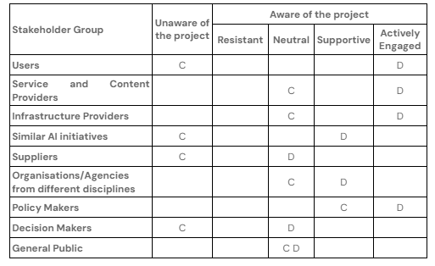
Figure 3 - SEAM further described in D2.5

Specific measures per target group

Users
To promote the project to Users, iMagine will focus on
- Present the use cases and their services: This way, potential users would understand the benefits of the developed services for them to use them in their own research activities.
- Easy access: Improving the project website will make it easier to find the services and will allow users to readily access the resources they are most interested in.
How to? The project will
- Create videos and tutorials, organise webinars to demonstrate the services to users, help them understand the value proposition and see how iMagine services fit their needs.
- Highlight and emphasise the expertise iMagine brings to the table to give the users confidence in the quality and reliability of your services.
- Showcase success stories, further promoting the use cases and using the KER ambassadors to demonstrate how to use the iMagine services to solve a research challenge.
Here are some of the key messages the project will use to promote the iMagine services and AI platform to users.
Benefits
- Automate tedious image analysis. Spend less time manually classifying marine life and focus on ground-breaking research. Our AI-powered image recognition tools analyse vast datasets in seconds, freeing you for in-depth analysis.
- Uncover hidden patterns: Go beyond what the human eye can see. Our ML algorithms detect subtle variations in aquatic imagery, revealing ecological relationships and population trends you might have missed.
- Answer complex ecological questions: Formulate specific queries about species abundance, distribution, or behaviour. Our image processing system extracts insights from massive image datasets, providing data-driven answers to your research questions.
Highlight the Expertise
- Our team combines cutting-edge AI expertise with a deep understanding of aquatic ecosystems. This ensures our image-processing tools are tailored to the specific needs of aquatic science research. - with links to the most advanced use cases on a rotation.
- We are committed to developing and refining our AI models. Our use cases constantly work alongside AI specialists to ensure the accuracy and reliability of our image analysis tools.
- Our support team comprises AI specialists and aquatic science experts, ensuring you will receive prompt feedback on any questions or technical issues related to the iMagine image processing tools.
- Discover the tips on image processing and analysis our experts have already compiled to ease your experience with the iMagine AI platform.
Showcase Success Stories
- OBSEA uses the iMagine AI platform to analyse underwater observatory footage, automating fish classification and expediting the research on species distribution in the Mediterranean Sea.
- The team at IMEV leveraged our AI and ML image recognition service to speed up the zooplankton recognition process, saving up to 1 hour per day on manual identification processes.
The use cases will help further strengthen and refine the messages and support their dissemination to the target audience.

Similar AI Initiatives
Thanks to its existing collaboration with AI4EOSC, iMagine can already foster some joint activities, such as the organisation of online workshops or presentations. However, this liaison should be reinforced and expanded to other initiatives on AI to improve iMagine's reach. By sharing success stories and testimonials from the use cases and the research achievements made possible by the services (e.g. timesaving because of the use of the iMagine AI platform), iMagine will be able to demonstrate the positive impact the project has on research.
Ideally, iMagine could focus on the following activities:
- Identify the relevant AI initiatives to contact
- Keep on organising joint initiatives
- Present the services and offer collaboration opportunities
Identifying relevant AI initiatives should involve two simultaneous steps. First, scope the consortium to find useful links and contacts; second, use CORDIS, the European Commission database, to look for projects with similar objectives (i.e., the development of AI and ML services, irrespective of the domain). The contacts gathered with this exercise will be addressed with at least two mailings - using the EGI newsletter platform - informing the recipients about the project and the opportunities available for them. The mailing will help disseminating the iMagine use cases and their services, calling other AI and ML initiatives to, for example, widening the pool of available tools on the iMagine AI Platform or improving current models based on other initiatives’ experiences. Moreover, bits of advice on protocols and standardisation could also be sought. In addition, the option to participate in joint webinars or conference sessions could also be appealing. The mailing will be aided by communication on LinkedIn, exploring the opportunity for paid campaigns with specific messages, including but not limited to:
We believe in the power of collaboration to accelerate progress in AI-powered aquatic image processing. Let's explore potential areas where our projects can work together.
- iMagine is committed to open communication and knowledge exchange. How can we collaborate to organise workshops or online forums to share best practices and advance the field?
- Imagine the impact of combining our projects' expertise! Let's discuss potential joint publications or presentations to showcase the power of AI in aquatic science.
- We view your project as a valuable source of inspiration. Together, let's push the boundaries of AI-powered image processing in aquatic science through healthy competition.
Combining these strategies to approach the target groups should successfully shift Users and Similar AI initiatives from being unaware of iMagine to being aware, supportive, and engaged.

Plan M19-M36
M19-36 will involve intensifying existing measures, with continuous promotion and publication of project outputs and deliverables. The ongoing promotion of the deliverables and use cases will continue, including creating print materials and webinars focused on the use cases and their services.
The webinars will demonstrate the services, enabling interested users to request access to the platform and use it for training their datasets. During the final stage of the project, a dedicated campaign will showcase the project KERs to demonstrate the impact of iMagine. This campaign will include videos, news items, and stories published on our website and distributed via partners towards partner’s websites and outlets, press contacts, and event presentations/posters.
An evaluation will be conducted to determine if and what aspects of the project outputs would benefit from a dedicated print publication. These could be a major hand-out at the closing event and serve for post-project dissemination. Finally, iMagine will increase its presence at various events through booths and presentations. Partners will continue to submit abstracts for events in M18-M36, and T2.2 will work closely with colleagues in the EGI communication team to streamline event booth participation in as many events as feasible within the budget. Event plans for the future are recorded on Confluence to allow for proper coordination.
Planned events for the second half of the project include:
EGU24: at the time of writing, a very successful event participation was conducted at EGU24. Two posters about the project were presented and iMagine was prominently featured at the EGI booth. This will be repeated in EGU25 with a larger shared booth and a more prominent presence in the programme, e.g. using the opportunity of a training session or a town hall meeting.
TNC24: iMagine will be present with a (shared) booth at this major multi-disciplinary conference.
EGI2024: iMagine will curate a public session on environmental data in the programme and will have a prominent place in the shared flagship event booth.
EU Maritime Day: iMagine will participate in the workshop “Observations to knowledge: Unlocking Ocean Insights” together with Blue-Cloud 2026 and EuroGOOS.
IMDIS 2024: iMagine sponsors the 2024 edition of the International Conference on Marine Data and Information Systems. Posters and talks about the project will be featured during the conference.
EOSC Symposium: iMagine will be present at the EGI shared event booth.
Digital Ocean Forum; however, iMagine's participation in the 2024 edition of the event is not yet confirmed at the time of writing.
As suggested in the workshop with the use cases, the project will investigate additional dissemination opportunities more closely; these venues include the OCEANS conference, the MARTECH workshop, and SeaTechWeek.
Despite the project ending in August 2025, the closing event is planned for June 2025, co-located with EGI2025.

Annex
The Annex presents a few of the visuals created to promote the project.

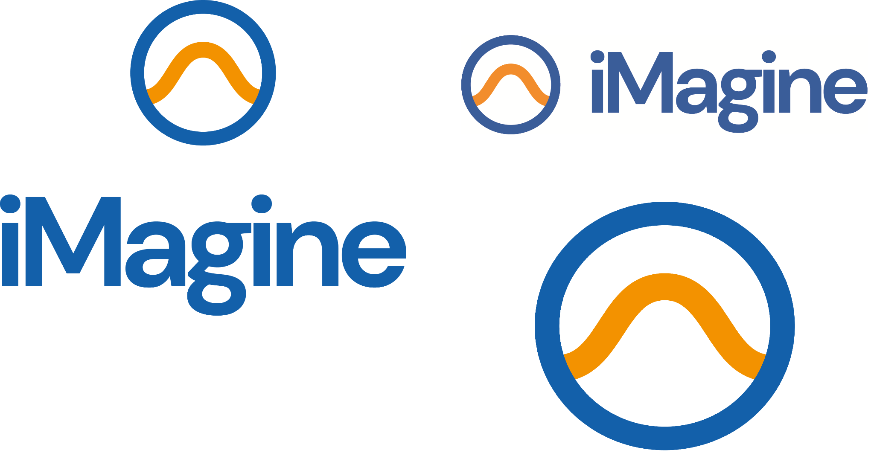
Figure 4 - Project logo variations

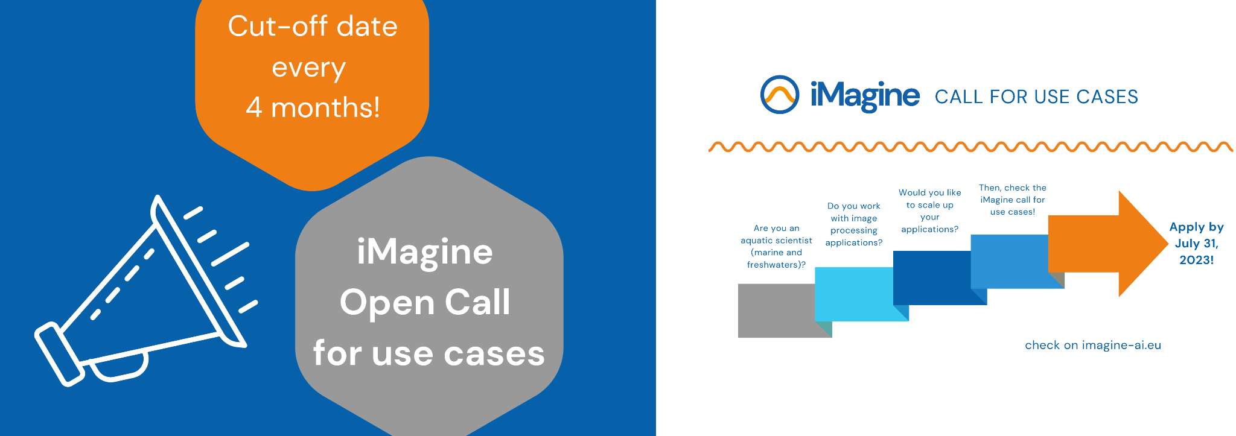
Figure 5 - Examples of Open Call dissemination visuals

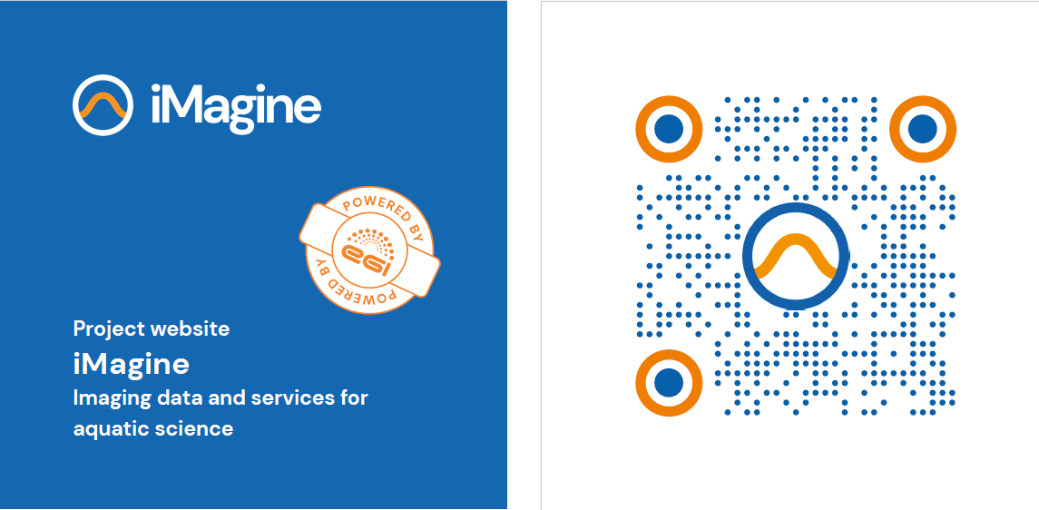
Figure 6 - Project Moo Card

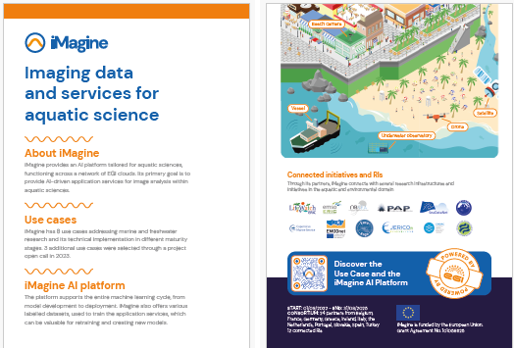
Figure 7 -Project Leaflet

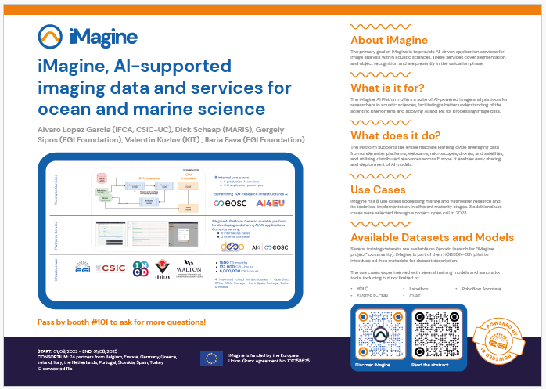
Figure 8 -One of the posters prepared for iMagine

D2.2 First Innovation Management Plan, https://doi.org/10.5281/zenodo.7760155
D2.1 First Communication, Dissemination and Engagement plan, https://doi.org/10.5281/zenodo.7462914
These are AMRIT, GROOM-RI, eLTER, PHENET, LandSeaLot, AQUARIUS, LifeWatch ERIC, MINKE, EVERSE

