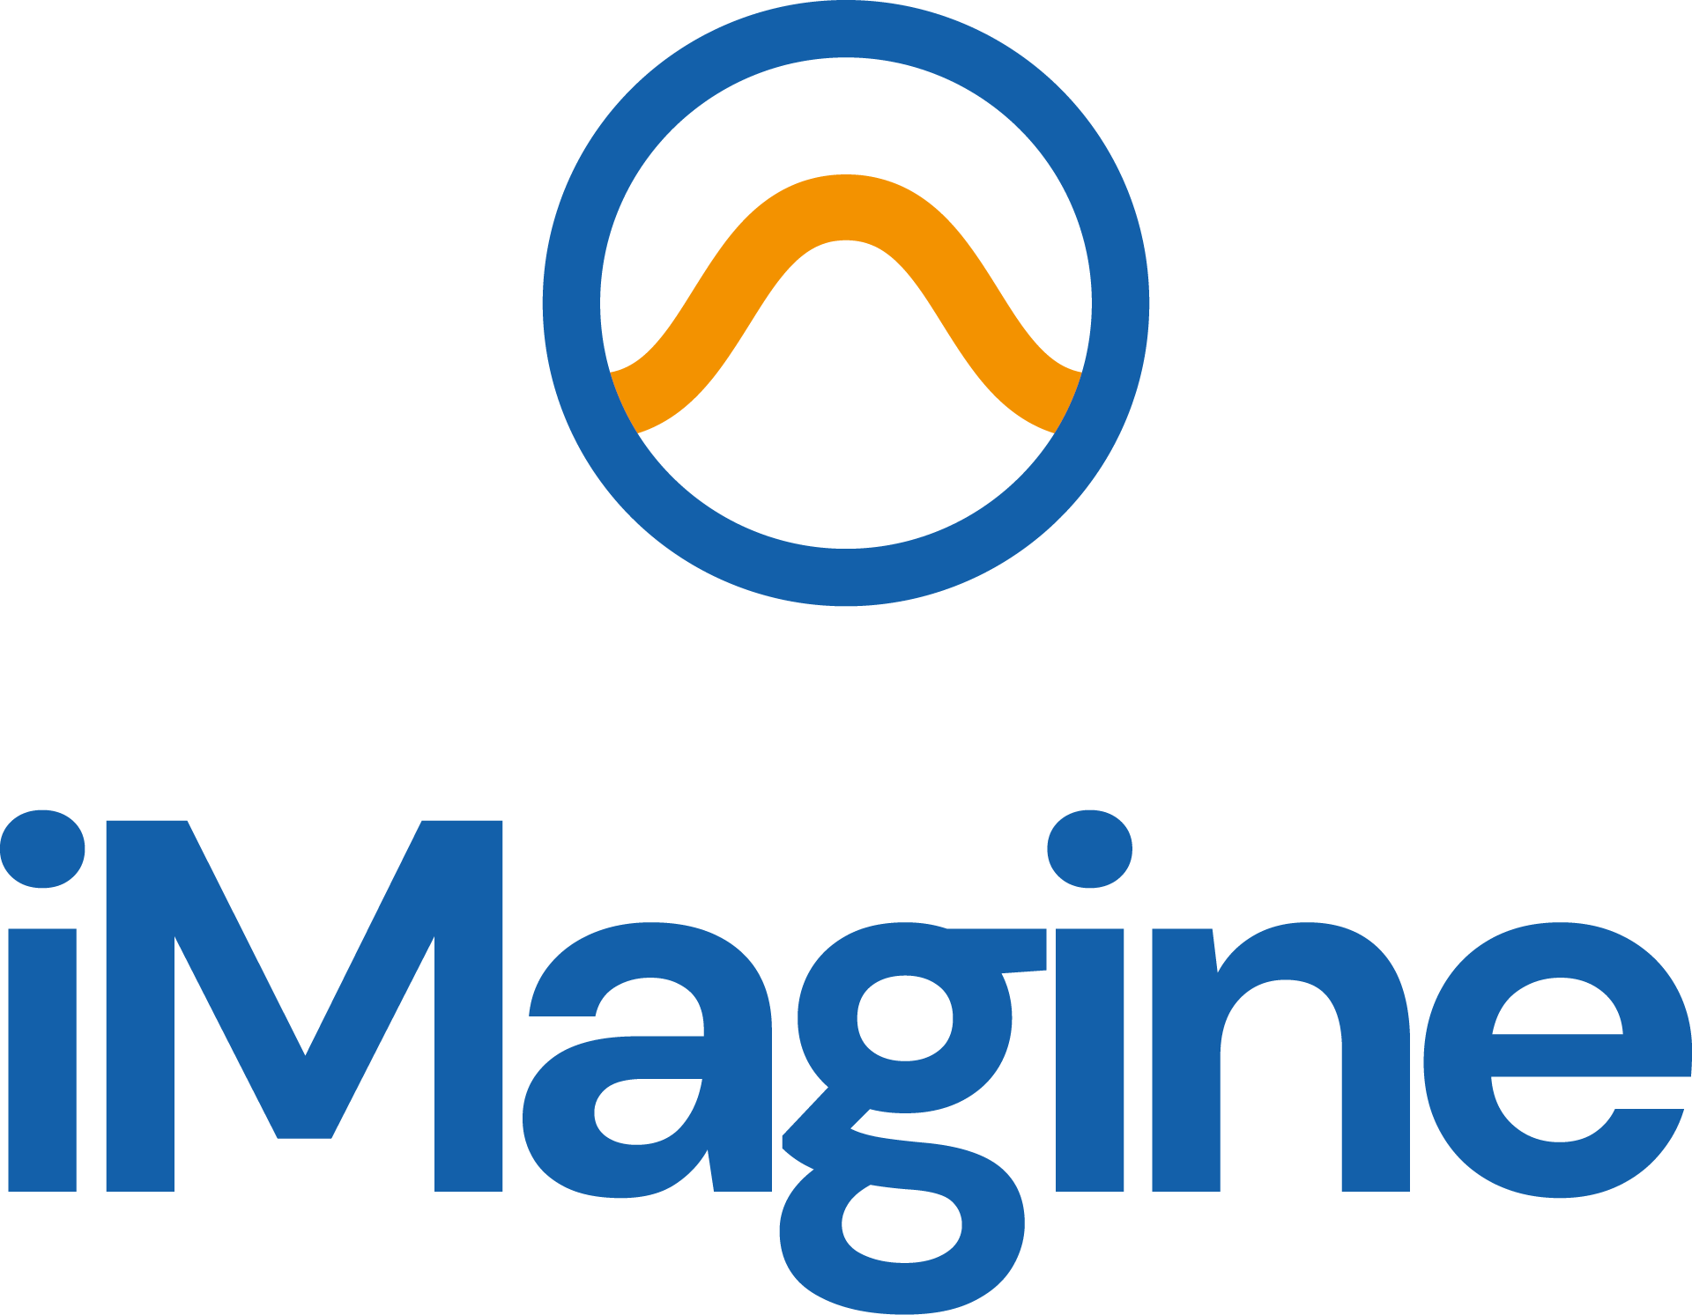

Final Communication, Dissemination and Engagement Plan
iMagine D2.8

28/08/2025

Abstract
This deliverable provides a final report on the communications of project results, highlighting achievements and lessons learned, key performance indicators, audience engagement strategies, and plans for continued dissemination until the end of the project.

Document Description
Final Communication, Dissemination and Engagement Plan
Work Package 2
Due date | 31/08/2025 | Actual delivery date: | 28/08/2025
Nature of document | Report | Version | 2.0
Dissemination level | Public
Lead Partner | EGI
Authors | Ilaria Fava (EGI)
Reviewers | Gwen Frank (EGI)
Public link | https://zenodo.org/records/16943275
Keywords | Communication, dissemination, engagement, target groups, impact

Revision History
Issue | Item | Comments | Author/Reviewer
V 0.1 | Draft version | Document structure and data update | Ilaria Fava (EGI)
V 0.2 | Revised version | Structure check and data finalisation | Gwen Frank (EGI)
V 1.0 | Submitted version |  | Andrea Anzanello (EGI)
V2.0 | Resubmitted version after rejection | Update of information according to EC feedback | Ilaria Fava (EGI), Andrea Anaznello (EGI)

Copyright and license info
This material by Parties of the iMagine Consortium is licensed under a Creative Commons Attribution 4.0 International License.
Table of Contents
Contents
Introduction 4
Structure of the document 4
Purpose of the Dissemination, Communication and Engagement plan and the interim progress report 4
Overview of the activities 5
Branding 5
Website 5
Social media 6
YouTube 7
Events 7
Exhibition Booths and Events 7
Project presentations 8
Internal workshops 8
Webinars and Training 9
Hosted by the project 9
Organised by other organisations or projects 10
FitSM Training 10
Zenodo 10
Publications 10
Metrics for communication and dissemination 13
Collaborations and partnerships 14
EOSC Landscape 14
Aquatic and Environmental projects and RIs 15
Engagement 15
Target Audiences 15
Users 16
Similar AI Initiatives 17
Conclusions 17
Annexes 19
Annex 1 Service Branding 19
Annex 2 Events 20
2022 20
2023 21
2024 22
2025 26

List of Figures
Figure 1 Website visits 7
Figure 2 LinkedIn Engagement Rate 8
Figure 3 Stakeholder engagement based on event reports 16
Figure 4 Service Branding Icons 20

List of Tables
Table 1 Internal events 9
Table 2 Status of KPIs at M36 13
Table 3 Project Events 2022 21
Table 4 Project Events 2023 22
Table 5 Project Events 2024 23
Table 6 Project Events 2025 27

Introduction
During the concluding period of the iMagine project, significant progress was made in deploying, operating, and promoting the iMagine AI framework and platform. The project advanced the development of five operational and three prototype AI-based image analysis services, alongside image repositories that offer open access for researchers. In addition, six new use cases, five of which were onboarded through the open call launched in 2023, have been actively integrated into the development efforts.
Throughout this final phase, activities focused on refining these services and preparing them for broader adoption, ensuring that they are technically mature and ready for their intended user communities via the iMagine AI platform. Communication and dissemination activities during this period were therefore designed to support this transition, from development to outreach and uptake, to ensure that the platform and its services will continue to deliver impact beyond the project’s end.

Structure of the document
The document presents an overview of the activities going into the details of branding, website development, social media, events, publications and collaborations.

Purpose of the Dissemination, Communication and Engagement plan and the interim progress report
iMagine has the objective to deploy, operate, validate, and promote a dedicated iMagine AI framework and platform connected to EOSC and AI4EU, giving researchers in aquatic sciences open access to a diverse portfolio of AI-based image analysis services and image repositories from multiple RIs, working on and of relevance to the overarching theme of ‘Healthy oceans, seas, coastal and inland waters’.
Within the project, the main objectives of WP2 are to ensure that project results are captured, disseminated, and exploited for maximum impact, to manage both internal and external communication and dissemination, to liaise with stakeholders, and to organise project events and support participation at external events. T2.2 aligns closely with the activities in T2.1 (Innovation Management and Exploitation) as outlined in the Innovation Management Plan (D2.2) and Innovation Management Progress Report D2.5 (in preparation). As part of WP2 (Innovation Management and Communications), T2.2 (led by EGI.eu) deals with iMagine Communication, Dissemination and Engagement activities.
The project has identified eight Key Exploitable Results (KER), which are at the core of the DCE strategy:

- Marine litter assessment
- Zooscan – Ecotaxa Pipeline
- Marine Ecosystem Monitoring
- Oil Spill Detection
- Flowcam Plankton Identification
- Prototype Imaging Services
- The iMagine AI Platform
- Best practices
The core activities of T2.2 focus on disseminating these KERs to the various target audiences. For this purpose, the activities are mapped to the stakeholder analysis.
This deliverable reports on the activities of the last project period, accounting for the plan for M19-36 outlined in D2.5.
The objectives of the iMagine DCE plan were three-fold: to increase awareness about the iMagine project and its services among all relevant target audiences in the aquatic science community; to attract users of the services to engage with iMagine; and to foster partnerships and collaborations with relevant organisations and research institutes.

Overview of the activities

Branding
At the start of the project, a large part of the iMagine visual identity i.e. the logo, branding elements and document/presentation templates, was developed quickly and distributed amongst partners via the Communications Toolkit (available for partners on Confluence) and the Project Brandguide. For extended documentation about the iMagine branding, see D2.1.
During the second project period, for every Key Exploitable Result, T2.2 developed recognisable icons to be used in dissemination. The icons corresponding to KER 1 Marine litter assessment, KER 2 Zooscan – Ecotaxa Pipeline, KER 3 Marine Ecosystem Monitoring; KER 4 Oil Spill Detection, and KER 5 Flowcam Plankton Identification also became the corresponding service logo.

To further promote the project after its end, T2.2 is finalising short, animated videos presenting each KER.

Website
At M36, the project website includes various sections featuring the project team and governance overview, the services, the use cases, the project results and relevant highlights.
The homepage features project highlights for immediate visibility. News and Events collects all articles published on the website in chronological order (from the newest to the oldest), including announcements, reports and relevant news. Services include the iMagine AI Platform and related pointers, mature services and useful access information, and datasets developed by use cases. It has to be noted that despite having five mature services on paper, we decided to split those developed by Use Case 3 “Ecosystem monitoring at EMSO sites by video imagery”: each record presents the EMSO-site-related service separately, with the needed level of detail. Each service record includes information about how to access the service itself, a demo of the service, and useful pointers to datasets and other repositories where available.
The project results section includes deliverables, presentations, posters, a list of project publications that has been updated regularly thanks to partners’ contributions, a page collecting the best practice documentation developed by the project, and the iMagine Impact Report. This document has been prepared for the final event held in June 2025 during the EGI202 conference. We are keeping it up to date to ensure it matches the final figures that will be reported in the technical report.
The website analytics show that the service and the best practice pages were the most visited sections over the final project months.

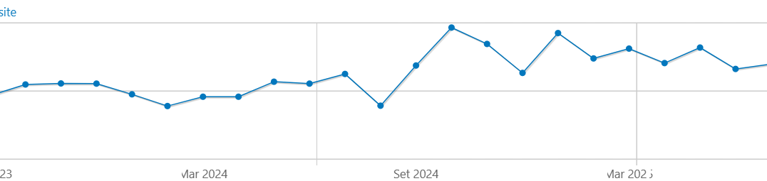
Figure 1 Website visits
At the end of M36, the website had a total of 15,224 unique visitors and 29,494 page views.

Social media
The project's LinkedIn page, which has over 200 followers, has shown a consistent engagement rating ranging between 5.5% and 8.4%, aligning with similar pages' results (such as Blue-Cloud 2026). Special attention has been paid to creating posts for events where the project was showcased.
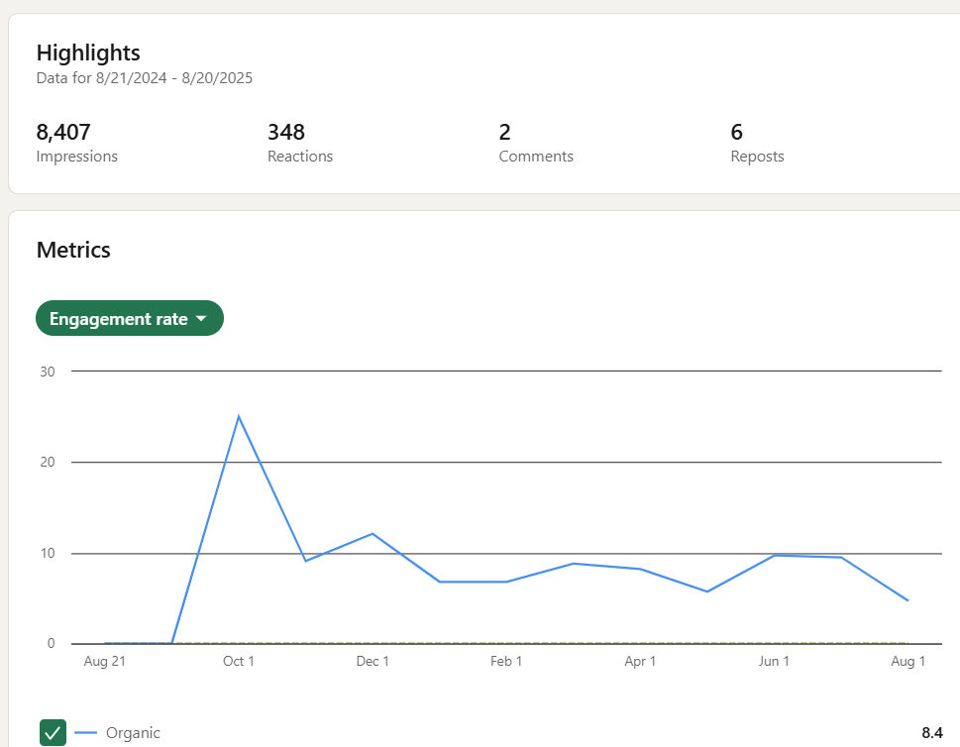
Figure 2 LinkedIn Engagement Rate

YouTube
Despite not having a YouTube account, iMagine utilised the EGI YouTube channel to share service demonstrations and an interview with the project's technical coordinator. The service demonstration videos have accumulated over 370 views by the end of M36.

Events

Exhibition Booths and Events
From the start, iMagine has been present at every event booth hosted by the project coordinator - EGI. Also, co-branded booths were on display at every EGI Conference (from the 2022 to 2025 edition). The project dissemination materials attracted attention and instigated many conversations at the respective booths. Working in collaboration with the other EGI coordinated projects has allowed iMagine to reach audiences that are not necessarily familiar with the concept of aquatic science and technology applied to it (such as EOSC Symposium, the EOSC Tripartite Collaboration or the Research Infrastructures environment, with participation at the first RISE workshop and ICRI2024), or with secondary target audiences (such as businesses during Data Spaces Symposium).
From the second project period onwards, iMagine ensured participation in more domain-specific events. These include the European Maritime Day 2024, IMDIS conference, and EGU conferences 2024 and 2025 for environmental sciences. iMagine also co-organised and participated in the workshop “The data we need for the Oceans we care for”, organised by Blue Cloud 2026, OBPS, EMODnet and Copernicus Marine during the UN Ocean Decade 2024. During the workshop, the project showcased best practices from the EMSO-OBSEA use case. Last but not least, the project was showcased at the Iliad and Blue Cloud 2026 joint workshop during the OCEAN2025 conference.
iMagine hosted its final event during EGI2025 in June 2025. The three-hour session “Addressing AI needs for processing of imaging data: the case of Aquatic Science and the iMagine project” highlighted several project achievements, such as the iMagine AI platform, the Competence Centre, the federated cloud infrastructure, labelled image sets, thematic image analysis applications, and the training and outreach programme. Also, it provided a scientific-technical deep dive through a live demonstration of the FlowCam Phytoplankton Identification service. The session was also the occasion to present the project impact report already mentioned above.

Project presentations
Partners reported 45 events at which iMagine was presented, either once or multiple times, reaching over 17,700 participants during the project's lifetime. A list of events is available in the Annexes.
Partners committed to present project outcomes at conferences also after the end of the iMagine, e.g. with participation at AGU25 and OMS26.

Internal workshops
iMagine organised the following internal workshops during the project duration.

Table 1 Internal events
14/09/2022 | iMagine administrative kick-off meeting (online) | https://indico.egi.eu/event/5919/
22/09/2023 | iMagine technical kick-off meeting | https://indico.egi.eu/event/5920/
30-31/01/2023 | iMagine First Competence Centre workshop | https://indico.egi.eu/event/5999/
29/09/2023 | Use case Dissemination and Communication Support | https://app.mural.co/t/egi3550/m/egi3550/1695966032458/dd143e781759c7c8b897d667355a638fca3fa6cb?sender=u297868c2869ea72cbfe74783
11/10/2023 | iMagine General Assembly and Project Management Board | https://indico.egi.eu/event/6264/
19-20/03/2024 | iMagine Second Competence Centre Workshop | https://indico.egi.eu/event/6371/
27-28/03/2025 | iMagine Third Competence Centre Workshop | https://indico.egi.eu/event/6642/

Webinars and Training

Hosted by the project
As planned in D2.4, the project organised a series of webinars to demonstrate the iMagine mature services. The webinar recordings serve as part of the service documentation.
The Ocean Decade Initiative endorsed the webinar series.
These are the project webinars organised between January and May 2025:
- 16 January 2025: ZooProcess by Sorbonne Université
- 30 January 2025: FlowCam Phytoplankton Classification by VLIZ
- 26 February 2025: EMSO-OBSEA Real-time Fish Detection Service by UPC
- 13 March 2025: iMagine Competence Centre with AI Experts from KIT
- 09 April 2025: WITOIL by CMCC
- 30 April 2025: EMSO-Azores Marine Species Detection Service by Ifremer
- 08 May 2025: Marine Litter Identification Service from DFKI
- 22 May 2025: EMSO-SmartBay Species and Prawn Burrows Detection Services by Marine Institute
The website presents an overview of all webinars with pointers to each service page for recording details.

Organised by other organisations or projects
- 07 December 2023: Image Classification and Segmentation webinar, organised by ANERIS. Presentation by UC3 EMSO OBSEA
- 07 March 2025: AI4EOSC Webinar AI and LLMs from theory to practice, organised by AI4EOSC. Presentation by KIT about YoloV8 applications in iMagine

FitSM Training
The project organised three FitSM training sessions: one was co-located with EGI2023, while the other two took place online in January 2025 (on 10 and 24 January respectively). These online sessions targeted the iMagine use case principal investigators; the project also offered the opportunity for external use case representatives to join the training. Overall, the project trained 15 researchers for the FitSM Foundation Level.

Zenodo
Since its beginning, the project has established a community on Zenodo to showcase iMagine outputs. Participating in the HORIZON-ZEN project has allowed iMagine to implement a specific metadata schema for dataset description (see e.g. https://doi.org/10.5281/zenodo.10554844) that complements the dataset with fundamental information about technical details, image resolution, spatial and temporal coverage, and many more. The metadata schema is available to any other user of Zenodo.
The iMagine outputs on Zenodo have the following number of downloads at M36:
- Deliverables 2,850 downloads
- Datasets 1,820 downloads

Publications
Project partners have contributed to the publication of the following research papers:
- Aishwarya Venkataramanan, Pierre Faure-Giovagnoli, Cyril Regan, David Heudre, Cécile Figus, et al.. Usefulness of synthetic datasets for diatom automatic detection using a deep-learning approach. Engineering Applications of Artificial Intelligence, 2023, 117, pp.105594. 10.1016/j.engappai.2022.105594.
- Aishwarya Venkataramanan, Martin Laviale, Cédric Pradalier. Integrating Visual and Semantic Similarity Using Hierarchies for Image Retrieval. Computer Vision Systems. ICVS 2023, Sep 2023, Vienna (AUT), Austria. pp.422-431, doi: 10.1007/978-3-031-44137-0_35
- Aishwarya Venkataramanan, Assia Benbihi, Martin Laviale, Cédric Pradalier. Gaussian Latent Representations for Uncertainty Estimation using Mahalanobis Distance in Deep Classifiers. 2023 IEEE/CVF International Conference on Computer Vision Workshops (ICCVW), Oct 2023, Paris, France. pp.4490-4499, doi: 10.1109/ICCVW60793.2023.00483.
- Prat Bayarri, O. [et al.]. Tools for ecosystem monitoring based on fish detection and classification using deep neural networks. 11th International Workshop on Marine Technology (MARTECH 2024). “Instrumentation viewpoint”, 2024, núm. 23, p. 74-75.
- Baños Castelló, P. [et al.]. Evaluating the biological impact of an artificial reef using deep learning techniques. 11th International Workshop on Marine Technology (MARTECH 2024). “Instrumentation viewpoint”, 2024, núm. 23, p. 59-60.
- Falahzadehabarghouee, A. [et al.]. Detect and follow a custom object, using OBSEA underwater crawler. 11th International Workshop on Marine Technology (MARTECH 2024). “Instrumentation viewpoint”, 2024, núm. 23, p. 86-87.
- Prat, O. [et al.]. AI-based fish detection and classification at OBSEA underwater observatory. “International Conference on Marine Data and Information Systems: proceedings, volume Miscellanea INGV, 80”. Roma: Istituto Nazionale di Geofisica e Vulcanologia (INGV), 2024, p. 50-52. ISBN 2039-6651.
- Gayá-Vilar, Alberto, Alberto Abad-Uribarren, Augusto Rodríguez-Basalo, Pilar Ríos, Javier Cristobo, and Elena Prado. 2024. “Deep Learning Based Characterization of Cold-Water Coral Habitat at Central Cantabrian Natura 2000 Sites Using YOLOv8” Journal of Marine Science and Engineering 12, no. 9: 1617.
- Aishwarya Venkataramanan, Michael Kloster, Andrea Burfeid-Castellanos, Mimoza Dani, Ntambwe A S Mayombo, Danijela Vidakovic, Daniel Langenkämper, Mingkun Tan, Cedric Pradalier, Tim Nattkemper, Martin Laviale, Bánk Beszteri, “UDE DIATOMS in the Wild 2024”: a new image dataset of freshwater diatoms for training deep learning models, GigaScience, Volume 13, 2024, giae087
- Wout Decrop, Klaas Deneudt, Parecisas Clea, Elena Schall and Elisabeth Debusschere, Transfer Learning for Distance Classification of Marine Vessels Using Underwater Sound,” in IEEE Journal of Selected Topics in Applied Earth Observations and Remote Sensing, 2025, doi: 10.1109/JSTARS.2025.3593779.
- Daniel García-Díaz, Sandra Paola Viaña-Borja, Mar Roca, Gabriel Navarro, Isabel Caballero, Blending physical and artificial intelligence models to improve satellite-derived bathymetry mapping, Ecological Informatics, Volume 90, 2025, https://doi.org/10.1016/j.ecoinf.2025.103328
- Gabriele Accarino, Marco M. De Carlo, Igor Atake, Donatello Elia, Anusha L. Dissanayake, Antonio Augusto Sepp Neves, Juan Peña Ibañez, Italo Epicoco, Paola Nassisi, Sandro Fiore, Giovanni Coppini, Improving oil slick trajectory simulations with Bayesian optimization, Ecological Informatics, 2025, https://doi.org/10.1016/j.ecoinf.2025.103368
- Elnaz Azmi, Khadijeh Alibabaei, Valentin Kozlov, Tjerk Krijger, Gabriele Accarino, Igor Ruiz Atake, Sakina-Dorothée Ayata, Amanda Calatrava, Marco Mariano De Carlo, Wout Decrop, Donatello Elia, Sandro Luigi Fiore, Marco Francescangeli, Jesús Soriano-González, Jean-Olivier Irisson, Martin Laviale, Rune Lagaisse, Antoine Lebeaud, Carolin Leluschko, Germán Moltó, Antonio Augusto Sepp Neves, Enoc Martínez, Damian Smyth, Muhammad Arabi Tayyab, Vanessa Tosello, Alvaro Lopez Garcia, Dick Schaap, Gergely Sipos, Best practices for AI-based image analysis applications in aquatic sciences: The iMagine case study, Ecological Informatics, 2025, https://doi.org/10.1016/j.ecoinf.2025.103306
- Elnaz Azmi, Khadijeh Alibabaei, Valentin Kozlov, Álvaro López García, Dick Schaap, and Gergely Sipos. 2025. IMagine: AI-Powered Image Data Analysis in Aquatic Science. In Proceedings of the Platform for Advanced Scientific Computing Conference (PASC ’25). Association for Computing Machinery, New York, NY, USA, 1–11 https://doi.org/10.1016/j.ecoinf.2025.103306
- Sipos, Gergely, and Dick Schaap. 2025. iMagine: Revolutionising Aquatic Sciences with AI-Driven Image Analysis. ERCIM News, no. 140 (January 21, 2025) https://doi.org/10.5281/zenodo.16963448
- Wout Decrop, Rune Lagaisse, Jonas Mortelmans, Carlota Muñiz, Ignacio Heredia, Amanda Calatrava and Klaas Deneudt (2025) Automated image classification workflow for phytoplankton monitoring. Frontiers in Marine Science 12:1699781. doi: https://doi.org/10.3389/fmars.2025.1699781
For each publication, its open access version is listed on the website and reported on the EC Portal.

Metrics for communication and dissemination
Table 2 Status of KPIs at M36
Measure description | M12 | M24 | M36
# Page visits | 3756 hits on the homepage  690 hits on the call for use cases page  818 cumulative hits for the news items  333 cumulative hits for the use cases  244 hits on the services page | 5695 hits on the homepage  976 cumulative hits for the news items  850 cumulative hits for the use cases  400 hits on the services page | 9145 hits on the homepage  2301 cumulative hits for the news items  2004 cumulative hits for the use cases  2461 hits on the services page
# engagement rate on social media (baseline 3%) | 3.5 on LinkedIn  and 3.075 on Twitter | 5.5% | 6.95%
# clicks on project-related content in the EGI newsletter | News about iMagine were included in the following issues:  - September 2022  - June 2023 | News about iMagine were included in the following issues:  - January 2024  - February 2024  - March 2024  - April 2024  - June 2024  - August 2024 | Special training newsletters  - January 2025  - March 2025  Regular newsletter  - September 2024  - December 2024  - January 2025  - February 2025  - March 2025  - June 2025  - July 2025
# attendees during  presentations at events | >700 | >1,700 | >6,000
# downloads | avg 73 downloads per deliverable | avg 50 downloads per deliverable  avg 24 downloads per dataset | avg 123 downloads per deliverable  avg 104 downloads per dataset

Rather than focusing on absolute numbers for reporting social media activities, the project based its social media ‘success’ on two parameters: regularity (all relevant content advertised) and audience engagement rate (benchmarked against other, similar accounts).
Also, significant effort was dedicated to fostering service adoption by streamlining the user journey. The project implemented a centralised access point for information, datasets, and demonstrations, supported by a formal request-and-follow-up workflow. A key driver of this uptake was the webinar series, which functioned as both an outreach tool and a documentation repository, consistently resulting in measurable spikes in user interest.
To safeguard these results post-project, D2.7 formalised sustainability actions with partners on two main aspects:
- Platform Continuity: all key partners have signed a Letter of Intent to maintain the iMagine AI Platform and Competence Centre for at least two additional years.
- Use Case Evolution: scientific partners have committed to the ongoing development and service delivery of mature use cases through formal Letters of Commitment.

Collaborations and partnerships

EOSC Landscape
Following the recommendations from the project review and leveraging the connections in place thanks to the project partners, iMagine has strengthened its relationship with AI and aquatic science-related projects to make the most out of the collaboration with them. In particular, the project collaborated with AI4EOSC and AIoD in the organisation of AI and ML sessions during the EGI2022 and EGI2023 conferences. iMagine use cases have also been showcased in the webinar series organised by ANERIS and AI4EOSC.

Aquatic and Environmental projects and RIs
Moreover, the project established a strengthened partnership with Blue-Cloud 2026, together with which it organised the satellite event “The Data We Need for the Ocean We Care For” during the Ocean Decade Conference 2024, participated in the EU Maritime Day with a workshop on “Observations to knowledge: Unlocking Ocean Insights” and joined the Iliad-Blue Cloud 2026 Joint Workshop during OCEANS 2026.
Last but not least, the project has collaborated with several environmental landscape projects by participating in an ENVRI cross-collaboration network. iMagine participated in the ENVRI joint booth at EGU25.

Engagement
Based on the activity report from project partners and the workshop described in D2.5, the primary target audience for the project is the scientific community, i.e., actual or potential users of the services. This also matches the type of requests to access the services collected through the form available on each service page; the form recorded 32 requests in the period November 2024-August 2025, which service managers followed up on.
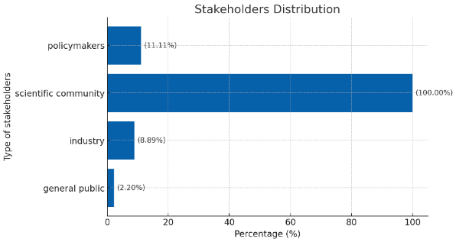
Figure 3 Stakeholder engagement based on event reports

Target Audiences
As mentioned in D2.4, the project's target audiences were further detailed in that deliverable, with a priority given to engaging with ‘Users’ and ‘Similar AI initiatives’.

Users
To promote the project to Users, iMagine focused on
- Presenting the use cases and their services: this way, potential users could understand the benefits of the developed services and how to use them in their own research activities.
- Easy access: improvements to the project website made it easier to find the services and allowed users to access the resources they were most interested in readily.
How did the project do this?
- The project organised webinars to demonstrate the services to users, helped them understand the value proposition, and showed how iMagine services fit their needs.
- Showcased success stories, further promoted the use cases, and used the KER ambassadors to demonstrate how to use the iMagine services to solve research challenges.
Here are some of the key messages the project will use to promote the iMagine services and AI platform to users.

Benefits
- Automate tedious image analysis. Spend less time manually classifying marine life and focus on groundbreaking research. Our AI-powered image recognition tools analyse vast datasets in seconds, freeing you for in-depth analysis.
- Uncover hidden patterns: Go beyond what the human eye can see. Our ML algorithms detect subtle variations in aquatic imagery, revealing ecological relationships and population trends you might have missed.
- Answer complex ecological questions: Formulate specific queries about species abundance, distribution, or behaviour. Our image processing system extracts insights from massive image datasets, providing data-driven answers to your research questions.

Highlight the Expertise
- Our team combines cutting-edge AI expertise with a deep understanding of aquatic ecosystems. This ensures our image-processing tools are tailored to the specific needs of aquatic science research. - with links to the most advanced use cases on a rotation.
- We are committed to developing and refining our AI models. Our use cases constantly work alongside AI specialists to ensure the accuracy and reliability of our image analysis tools.
- Our support team comprises AI specialists and aquatic science experts, ensuring you will receive prompt feedback on any questions or technical issues related to the iMagine image processing tools.
- Discover the tips on image processing and analysis our experts have already compiled to ease your experience with the iMagine AI platform.
Showcase Success Stories
- OBSEA uses the iMagine AI platform to analyse underwater observatory footage, automating fish classification and expediting the research on species distribution in the Mediterranean Sea.
- The team at IMEV leveraged our AI and ML image recognition service to speed up the zooplankton recognition process, saving up to 1 hour per day on manual identification processes.
The use cases will help further strengthen and refine the messages and support their dissemination to the target audience.

Similar AI Initiatives
Thanks to its collaboration with AI4EOSC, iMagine engaged in joint activities such as online workshops and presentations. These exchanges increased the project’s visibility and fostered valuable connections in the AI community. By sharing success stories and testimonials from the use cases, as well as highlighting the research achievements enabled by the services (e.g., time savings through the iMagine AI platform), the project demonstrated its concrete impact on scientific research.
Collaboration with AI4EOSC took different forms, ranging from joint webinars and conference sessions to the exchange of practices on protocols and standardisation. Communication emphasised the value of collaboration to accelerate progress in AI-powered aquatic image processing, the importance of knowledge exchange through joint activities, and the benefits of combining expertise to highlight the role of AI in advancing aquatic science.

Conclusions
The iMagine project’s DCE activities, led by EGI.eu under T2.2, established a structured approach to promoting Key Exploitable Results (KERs) and engaging diverse stakeholders. Over M1–M36, the project implemented a comprehensive strategy aligned with the Innovation Management Plan, combining digital and in-person channels to maximise visibility and impact.
A cohesive visual identity, dynamic website, and strategic collaborations with initiatives such as Blue Cloud 2026, ANERIS, and AI4Life provided a strong foundation for communication. Dissemination outputs included 7 service pages, 14 use cases (six external and unplanned at project start), and a wide range of webinars and workshops, making iMagine’s results accessible to research communities.
Digital-first dissemination ensured agility and sustainability, with LinkedIn emerging as the primary engagement platform. Zenodo supported transparency and accessibility, with over 6,700 downloads (2,850 deliverables, 1,820 datasets). The project website attracted more than 15,200 unique visitors and 29,500 page views, serving as the central hub for information and hosting the online impact report.
Stakeholder engagement was addressed through tailored activities for end-users, with strong participation reported across events and workshops. While overall targets for web, social media, and event participation were met, webinar attendance and recording views were more modest than expected. Some reliance on self-reported data also limited precision in impact tracking.
Overall, iMagine’s DCE activities provided a consistent and professional project presence, strengthened visibility within the European research landscape, and positioned the project as a key contributor to advancing AI applications for environmental and scientific domains.

Annexes

Annex 1 Service Branding
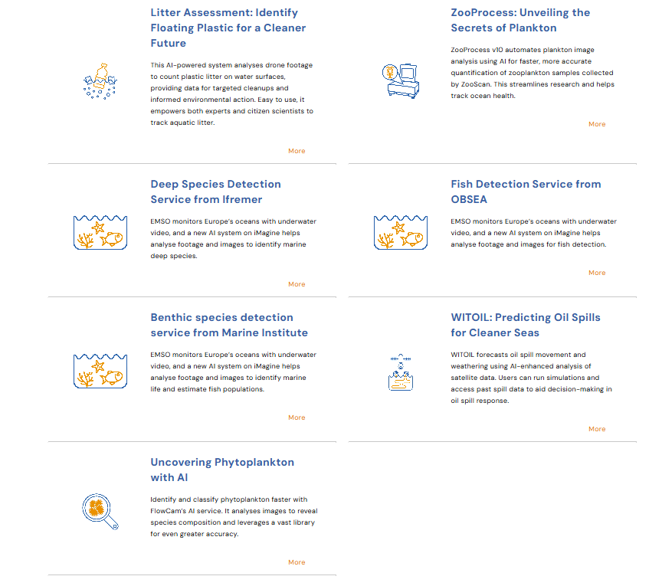
Figure 4 Service Branding Icons

Annex 2 Events

2022
Table 3 Project Events 2022
Date | Event Title | URL | Target Stakeholder Group | Type | Participants
19/09/2022 | EGI2022 | https://indico.egi.eu/event/5882/ | Scientific community (higher education, research) | Exhibition booth | 200
19/09/2022 | EGI2022 | https://indico.egi.eu/event/5882/ | Scientific community (higher education, research) | Presentation | 50
04/10/2022 | 4th Marine Imaging Workshop | https://archimer.ifremer.fr/doc/00883/99473/ | Scientific community (higher education, research) | Presentation | 130
21/11/2022 | SFE²-GfÖ-EEF Joint meeting, International Conference on Ecological Sciences | https://sfe2gfomeeting.sciencesconf.org/ | Scientific community (higher education, research) | Presentation | 50
22/11/2022 | Symposium on Machine learning for ecological images | https://sfe2gfomeeting.sciencesconf.org | Scientific community (higher education, research) | Workshop | 30
13/12/2022 | AI-2022 Forty-second SGAI International Conference on Artificial Intelligence |  | Scientific community (higher education, research) | Workshop | 40

2023
Table 4 Project Events 2023
Date | Event Title | URL | Target Stakeholder Group | Type of contribution | Participants
21/03/2023 | IODC-II | https://oceandataconference.org/programme-2023/ | Policymakers | Presentation | 100
09/05/2023 | 14th European Diatom Meeting (EDM 14) | https://sites.google.com/plantentuinmeise.be/edm-14-meise-botanic-garden/homepage | Scientific community (higher education, research) | Presentation | 120
 | Pint of Sciences Festival 2023 |  | General Public | Presentation | 30
21/05/2023 | ISC HPC 2023 | https://www.isc-hpc.com/ | Scientific community (higher education, research) | Poster | 3000
19/06/2023 | EGI2023 | https://indico.egi.eu/event/6071/ | Scientific community (higher education, research) | Exhibition | 200
19/06/2023 | EGI2023 | https://indico.egi.eu/event/6071/ | Scientific community (higher education, research) | Presentation | 200
23/06/2023 | Bringing your AI models to EOSC | https://indico.egi.eu/event/ 6071/ | Scientific community (higher education, research) | Workshop | 15
31/08/2023 | Internal Section Meeting |  | Scientific community (higher education, research) | Presentation | 20
20/09/2023 | EOSC Symposium | https://eosc.eu/events/eosc-symposium-2023/ | Policymakers | Exhibition booth | 400
09/12/2023 | AGU23 |  | Industry | Presentation | 100

2024
Table 5 Project Events 2024
Date | Event Title | URL | Target Stakeholder Group | Type of contribution | Participants
20/02/2024 | Internal seminar at VLIZ |  | Scientific community (higher education, research) | Presentation UC5 | 13
06/04/2024 | Ocean Decade Conference | https://oceandecade.org/events/2024-ocean-decade-conference/ | Policymakers | Workshop | 1000
15/04/2024 | EGU24 | egu24.eu | Scientific community (higher education, research) | Poster (UC4) | 100
15/04/2024 | EGU24 | egu24.eu | Scientific community (higher education, research) | Poster (iMagine AI Platform) | 100
15/04/2024 | EGU24 | egu24.eu | Scientific community (higher education, research) | Exhibition booth | 2000
16/04/2024 | EOSC Tripartite Event Belgium | https://belgian-presidency.consilium.europa.eu/en/events/the-european-open-science-cloud-eosc-and-nationalregional-open-science-policy/ | Policymakers | Poster | 100
13/05/2024 | ISC HPC 2024 | https://www.isc-hpc.com/ | Scientific community (higher education, research) | Poster | 5000
29/05/2024 | IMDIS 2024 | https://imdis.seadatanet.org/ | Scientific community (higher education, research) | Presentation | 200
30/05/2024 | European Maritime Day | https://cinea.ec.europa.eu/news-events/events/european-maritime-day-2024-2024-05-30_en | Scientific community (higher education, research), Policymakers | Workshop | 200
03/06/2024 | VLIZ Marine Science Day 2024 |  | Scientific community, industry, Policymakers | Poster | 450
06/06/2024 | MARTECH 2024 | https://sarti.webs.upc.edu/martech/ | Scientific community (higher education, research) | Various presentations | 100
06/06/2024 | DCLDE2024 |  | Scientific community (higher education, research) | Poster (UC6) | 100
06/06/2024 | DCLDE2024 |  | Scientific community (higher education, research) | Presentation (UC6) | 100
12/06/2024 | HAICON24 |  | Scientific community (higher education, research) | Poster | 100
17/06/2024 | ICUA2024 |  | Scientific community (higher education, research) | Presentation (UC5) | 200
03/10/2024 | EGI2024 | https://indico.egi.eu/event/6441/sessions/5196/#20241003 | Scientific community (higher education, research) | Various presentations | 100
03/10/2024 | SOMLIT annual intercomparison |  | Scientific community (higher education, research) | Presentation | 30
14/10/2024 | 6èmes Journées Internationales de Limnologie et d'Océanographie (JILO6) | https://jilo-2024.sciencesconf.org/ | Scientific community (higher education, research) | Presentation | 100
22/10/2024 | SFEcologie 2024 |  | Scientific community (higher education, research) | Presentation | 100
28/10/2024 | IBERGRID 2024 |  | Scientific community (higher education, research) | Presentation | 40
02/12/2024 | ICRI2024 |  | Scientific community (higher education, research) | Presentation | 80

2025
Table 6 Project Events 2025
Date | Event Title | URL | Target Stakeholder Group | Type of contribution | Participants
09/04/2025 | Coastal Dynamics 2025 |  | Scientific community (higher education, research) | Presentation UC7 | 60
28/04/2025 | EGU25 | egu25.eu | Scientific community (higher education, research), Industry | Presentation (iMagine AI Platform and Services) | 100
28/04/2025 | EGU25 | egu25.eu | Scientific community (higher education, research), Industry | Exhibition booth | 2000
04/06/2025 | EGI2025 | https://indico.egi.eu/event/6638/ | Scientific community (higher education, research), | Exhibition booth | 200
04/06/2025 | EGI2025 | https://indico.egi.eu/event/6638/ | Scientific community (higher education, research), | Final event | 250
03/06/2025 | HAICON25 |  | Scientific community (higher education, research) | Poster | 100
16/06/2025 | PASC25 |  | Scientific community (higher education, research) | Presentation | 40
16/06/2025 | Iliad and Blue Cloud 2026 workshop at OCEANS 2026 |  | Scientific community (higher education, research), Industry | Presentation | 80

https://www.imagine-ai.eu/key-exploitable-results-kers
https://www.imagine-ai.eu/services/image-analysis-services-for-aquatic-sciences
https://www.imagine-ai.eu/results-resources/imagine-publications
https://www.imagine-ai.eu/results-resources/imagine-impact-report
https://www.imagine-ai.eu/services/best-practices-ai-based-image-processing
https://www.imagine-ai.eu/article/wrapping-up-imagine-at-egi2025
https://oceandecade.org/events/imagine-webinar-series/
https://www.imagine-ai.eu/article/launching-the-imagine-webinar-series
https://aneris.eu/news/aneris-workshops-ai-basics-image-processing
https://www.youtube.com/watch?v=x0wvubPYJpQ
https://www.imagine-ai.eu/results-resources/imagine-publications
https://envri.eu/projects/
https://docs.google.com/forms/d/e/1FAIpQLScTegjPjVc00Zc-bRtNPEx9Sl3tBQ8owU9YnBfBFZcIEXqGlQ/viewform

